Policy Type

Local Planning Policy

Policy Purpose

The Residential Design Codes (R-Codes) is a Western Australian Planning Commission (WAPC) State Planning Policy, which was previously gazetted on 04 October 2002 and was recently updated on 23 October 2015. The R-Codes provide a comprehensive basis for the control of residential development through Western Australia.

The introduction of the single house standards for medium density housing (RMD’s) via the WAPC’s Planning Bulletin 112/2016 applies to medium-density single dwellings in areas zoned ‘Development’. It is based on contemporary housing typologies and incorporates existing R-Codes variations that have been applied to date.

This Local Planning Policy shall outline acceptable variations to the deemed-to-comply provisions of the Residential Design Codes (R-Codes) for medium density single dwellings in areas zoned ‘Development’ under the City’s Town Planning Scheme No. 3 (TPS 3).

This policy applies to all development to which the R-Codes apply and does not exempt compliance with other requirements of the R-Codes, TPS 3, and other Council policies, Local Development Plans (LDP’s) and/or the Building Code of Australia.

Where there are existing LDP’s with conflicting provisions, the approved LDP shall prevail.
Further variations sought to the RMD’s will generally not be supported.

The purpose of this policy is to replace the deemed-to-comply requirements of the following clauses of the R-Codes with those set out in the provisions of this policy:

- Building and Garage setbacks – Clauses 5.12, 5.13 and 5.21;
- Open Space – Clause 5.1.4;
- Parking – Clause 5.3.3;
- Visual Privacy – Clause 5.4.1; and
- Solar Access – Clause 5.4.2.

Implementation

- Development approval will not be required for a single dwelling that complies with the provisions of this policy (and all other deemed-to-comply requirements of the R-Codes), in accordance with Clause 61(4)(c) of the deemed provisions of the Planning and Development (Local Planning Schemes) Regulations 2015.
- This policy will apply where an approved Structure Plan or LDP identifies that the RMD codes Local Planning Policy applies.

- Where a proposal meets the provisions of this policy, advertising to adjoining owners in relation to these provisions is not required.

- Where a proposal does not meet the provisions of this policy, the City will consider the proposal on its merits in accordance with the relevant ‘design principles’ of the R-Codes having due regard to Clause 2.5 (Part 2) of the R-Codes.

Policy Statement

- Definitions

Approved Structure Plan | A Structure Plan or Activity Central Plan that has been approved by the Western Australian Planning Commission (WAPC) under the City’s TPS 3.
Medium density | R25-R60 density codes.
Rear Load | Lots where the primary vehicle access is via the rear of the lot, from a street of right of way (ROW) and the garage/carport is located at the back of the dwelling.
Front Load | Lots where the primary vehicle access is via the front of the lot and the garage/carport is located at the front of the dwelling.
RMD Codes | Single house standards for medium density dwellings.

- Provisions:

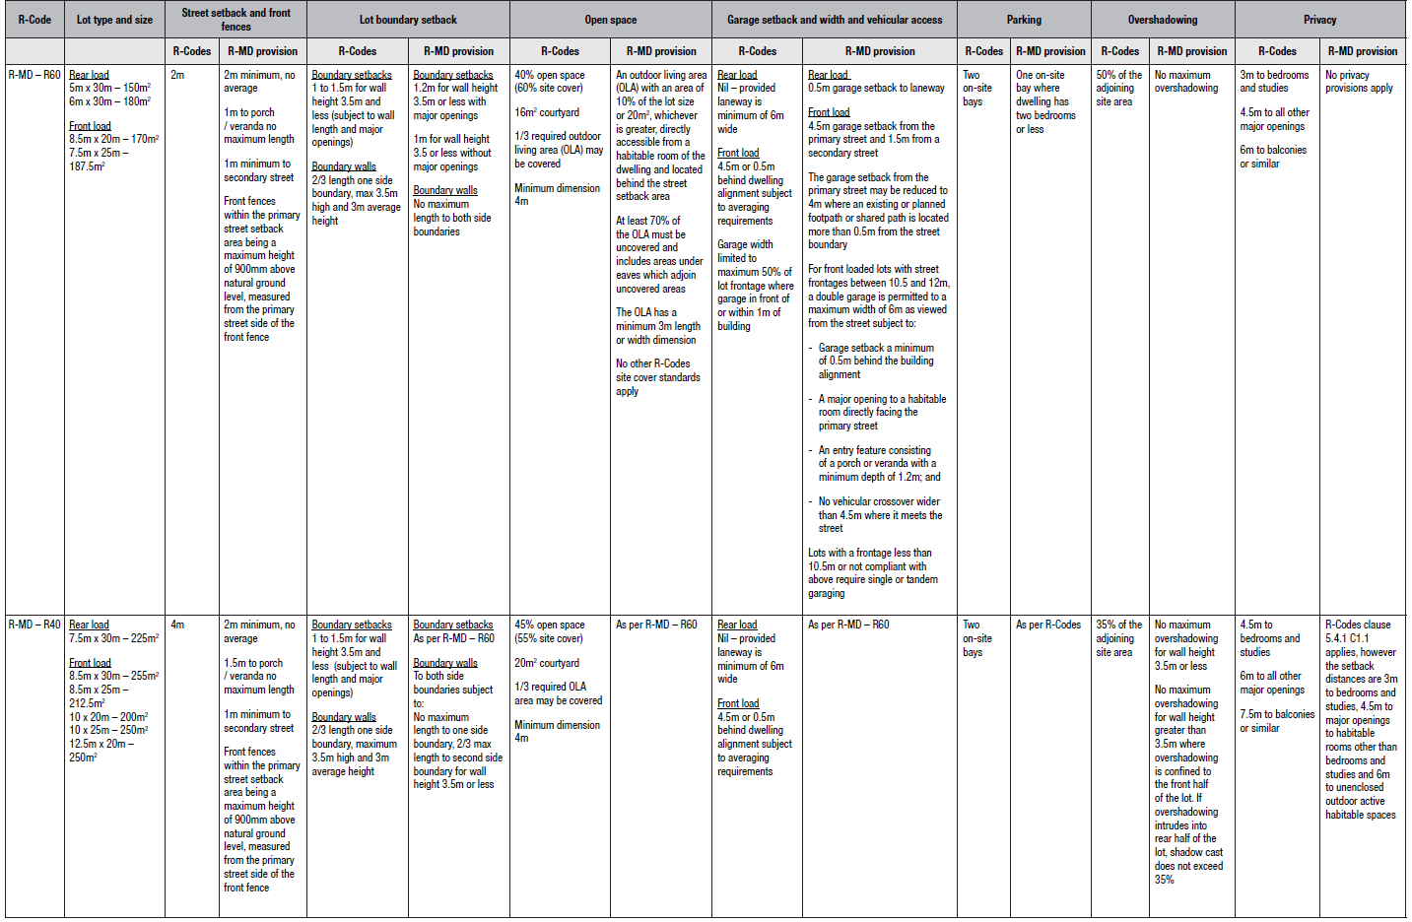

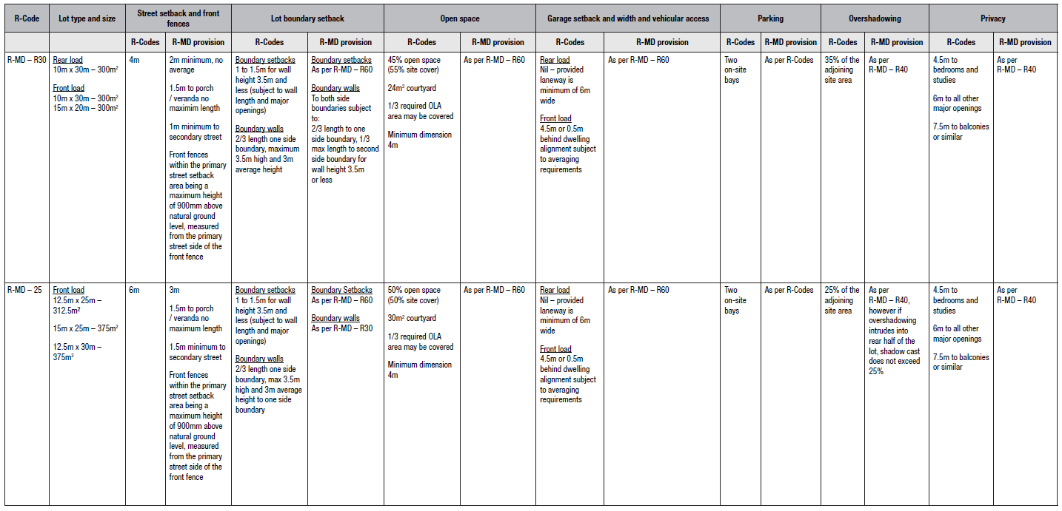

Bookmark 2
Bookmark 3
Strategic Link: | Town Planning Scheme No. 3
Category | Planning - Town Planning & Development
Lead Business Unit: | Statutory Planning
Public Consultation:  (Yes or No) | Yes
Adoption Date:  (Governance Purpose Only) | 10 November 2022
Next Review Due:  (Governance Purpose Only) | November 2024
ECM Doc Set ID:  (Governance Purpose Only) | 5487140

