Policy Type

Local Planning Policy

Policy Purpose

When land adjacent to major/arterial/distributor/important roads is developed for more intensive uses the resulting additional traffic generated by such uses, can cause conflict, especially where pre-existing traffic -volumes are high. This can create dangerous and unattractive road environments.
In these situations, a coordinated approach to vehicle access is required to ensure that development does not introduce any undesirable impacts on the safe and efficient movement for motorists, heavy vehicles operators, public transport users, pedestrians and cyclists.
The purpose of the Policy provides a framework for the planning and development of safe and efficient movement of motorists, public transport users, pedestrians and cyclists, where such a coordinated approach to vehicle access is required.
The Policy will be used by the City of Cockburn to guide the assessment of applications for development, subdivision and Local Development Plans, where a Vehicle Access Plan has been prepared.
The overall objectives for the policy are to:
(1) Provide for safe and efficient movement of motorists, public transport users, pedestrians and cyclists;
(2) Provide for safe and efficient movement of waste management and other service vehicles;
(3) Minimise the potential for conflict between through and local traffic;
(4) Provide visually attractive road environments; and
(5) Provide for reasonable property access that is direct, convenient and safe.

Policy Statement

(1) Vehicle Access Policy Plans:

1. Vehicle Access Policy Plans are to be prepared by the City of Cockburn in consultation with relevant stakeholders, which may include Main Roads WA, the Department of Planning and landowners of affected properties.

2. Vehicle Access Policy Plans are to be adopted by Council for inclusion as an Appendix to the Vehicle Access Policy.

3. The access arrangements in Vehicle Access Policy Plans shall be constructed to public road standards and should consider the following design features to ensure traffic safety and efficiency:
a) road reserve widths;
b) intersection location and spacing;
c) intersection type;
d) traffic control type (i.e traffic signals, roundabout, signage);
e) median location and breaks;
f) the number, location and design of vehicle access points to adjoining private properties;
g) the size and length of vehicles that will be using the access;
h) the volume of traffic that will be using the access;
i) road lighting;
j) mechanisms for organising and securing shared use of crossovers;
k) servicing of properties by waste management and other commercial vehicles; and
l) provision of cyclist and pedestrian facilities and integration with the adjacent path network. .

4. Vehicle Access Policy Plans are to consider pedestrian and cyclist movement patterns and key desire lines, particularly where residential development exists or is planned in proximity to the Vehicle Access Policy Plans area.

5. Vehicle Access Policy Plans are to be prepared with reference to the relevant local/state/national policies, guidelines and Australian Standards as determined appropriate by the Local Government.

(2) Vehicle Access Controls:

1. Crossovers

a) Control over the location, design and number of crossovers will be exercised by the responsible authority to reflect the arrangements shown on a Vehicle Access Policy Plan.

b) There will be a presumption against the creation of new vehicle crossovers across the primary frontage of the lot where alternative access is, or could be made available, to secondary roads and laneways, or via easements in gross arrangements to a nominated crossover as shown on the Vehicle Access Policy Plan.

c) Where a vehicle crossover is permitted under a Vehicle Access Policy Plan, conditions may be imposed on the width and design of the crossover to ensure adequate visibility and to provide for the safe and convenient movement of vehicles entering and leaving the road.

2. Easement in Gross

a) Where indicated on a Vehicle Access Policy Plan, the City of Cockburn will require as a condition of development or subdivision, easements in gross in the form of a public access easement on land titles. The easements in gross are granted for the City of Cockburn to maintain public access across the subject land to the side streets and crossover access points as delineated on the Vehicle Access Policy Plan. These easements in gross on land titles are to be provided at the cost of the developer or landowners of the subject land. The treatment of the area covered by the easement in gross shall be designed and treated to the satisfaction of the City to ensure consistency across lots.

b) In determining development applications where a Vehicle Access Policy Plan requires the provision of a right-of-carriageway and where such access is not available through adjacent properties to a dedicated road, consideration may be given for retention of a temporary access crossover until such time as alternative access is available via the right-of-carriageway system.

c) Provisions for the closure of the temporary crossover shall be provided by way of legal agreement.

3. Parking/Circulation

a) All applications for development approval on land subject to a Vehicle Access Policy Plan will be required to provide for traffic to enter and leave the site in a forward direction and to comply with the City of Cockburn’s car parking and on-site vehicle circulation requirements, as detailed in the City’s Town Planning Scheme No. 3 (TPS 3). This requirement is intended to ensure that there is no traffic congestion on-site which would interfere with the safety and free flow of traffic along the primary road.

4. Variation Clause

a) The precise location of rights of carriageways or crossovers delineated on a Vehicle Access Policy Plan may be varied subject to the agreement of the City of Cockburn provided that the purpose and the intent of the Vehicle Access Policy Plan is maintained.

b) A detailed assessment may be required in the form of a traffic management plan, a traffic impact assessment, a road safety audit, and/or traffic modelling may be required where a variation to a Vehicle Access Policy Plan is proposed. The form and scope of the required traffic assessment will be subject to guidance and agreement by the City of Cockburn.

c) This policy document may be updated with agreement from the City of Cockburn.

d) With specific regard to the Verde Drive Access Plan consideration will be given to the exact location of crossovers and need for an easement (West of Solomon Road) as development occurs. This recognises the likely need to reconfigure long narrow lots and the likely timing of various developments will likely be staged over time. The City at such time(s) will ensure the staging of development in this area is provided with suitable access arrangements and will use discretion by having due regard to the objectives of this policy and the intent of the Plan illustrated at Appendix 2.

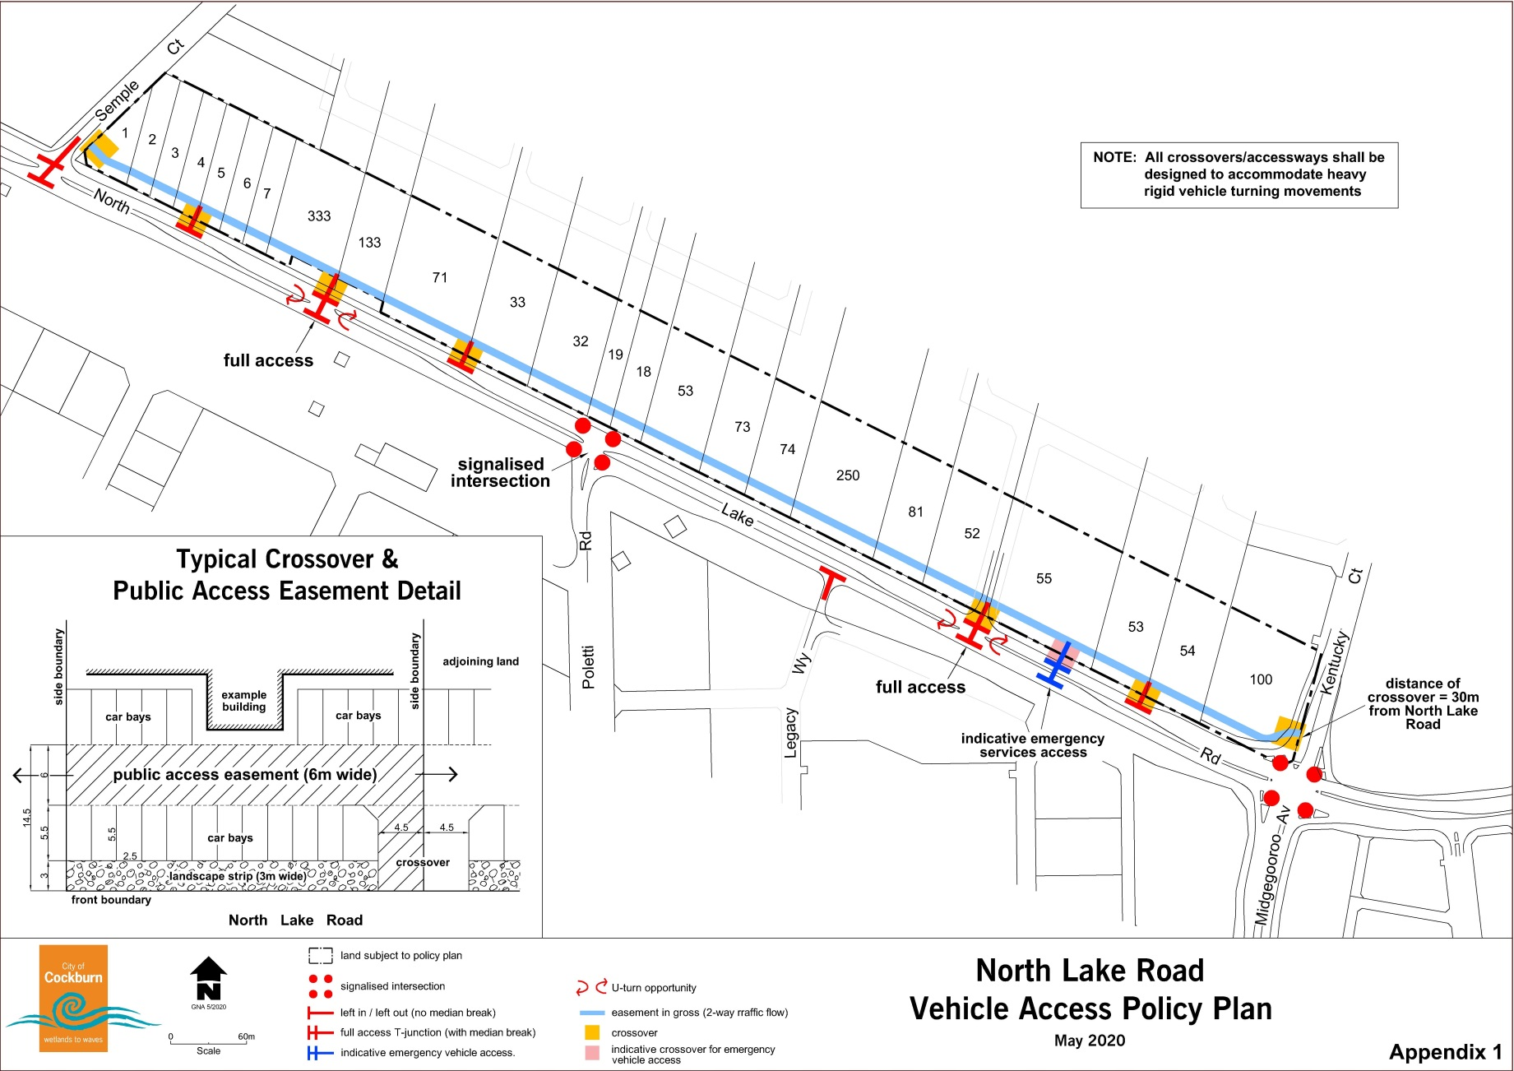
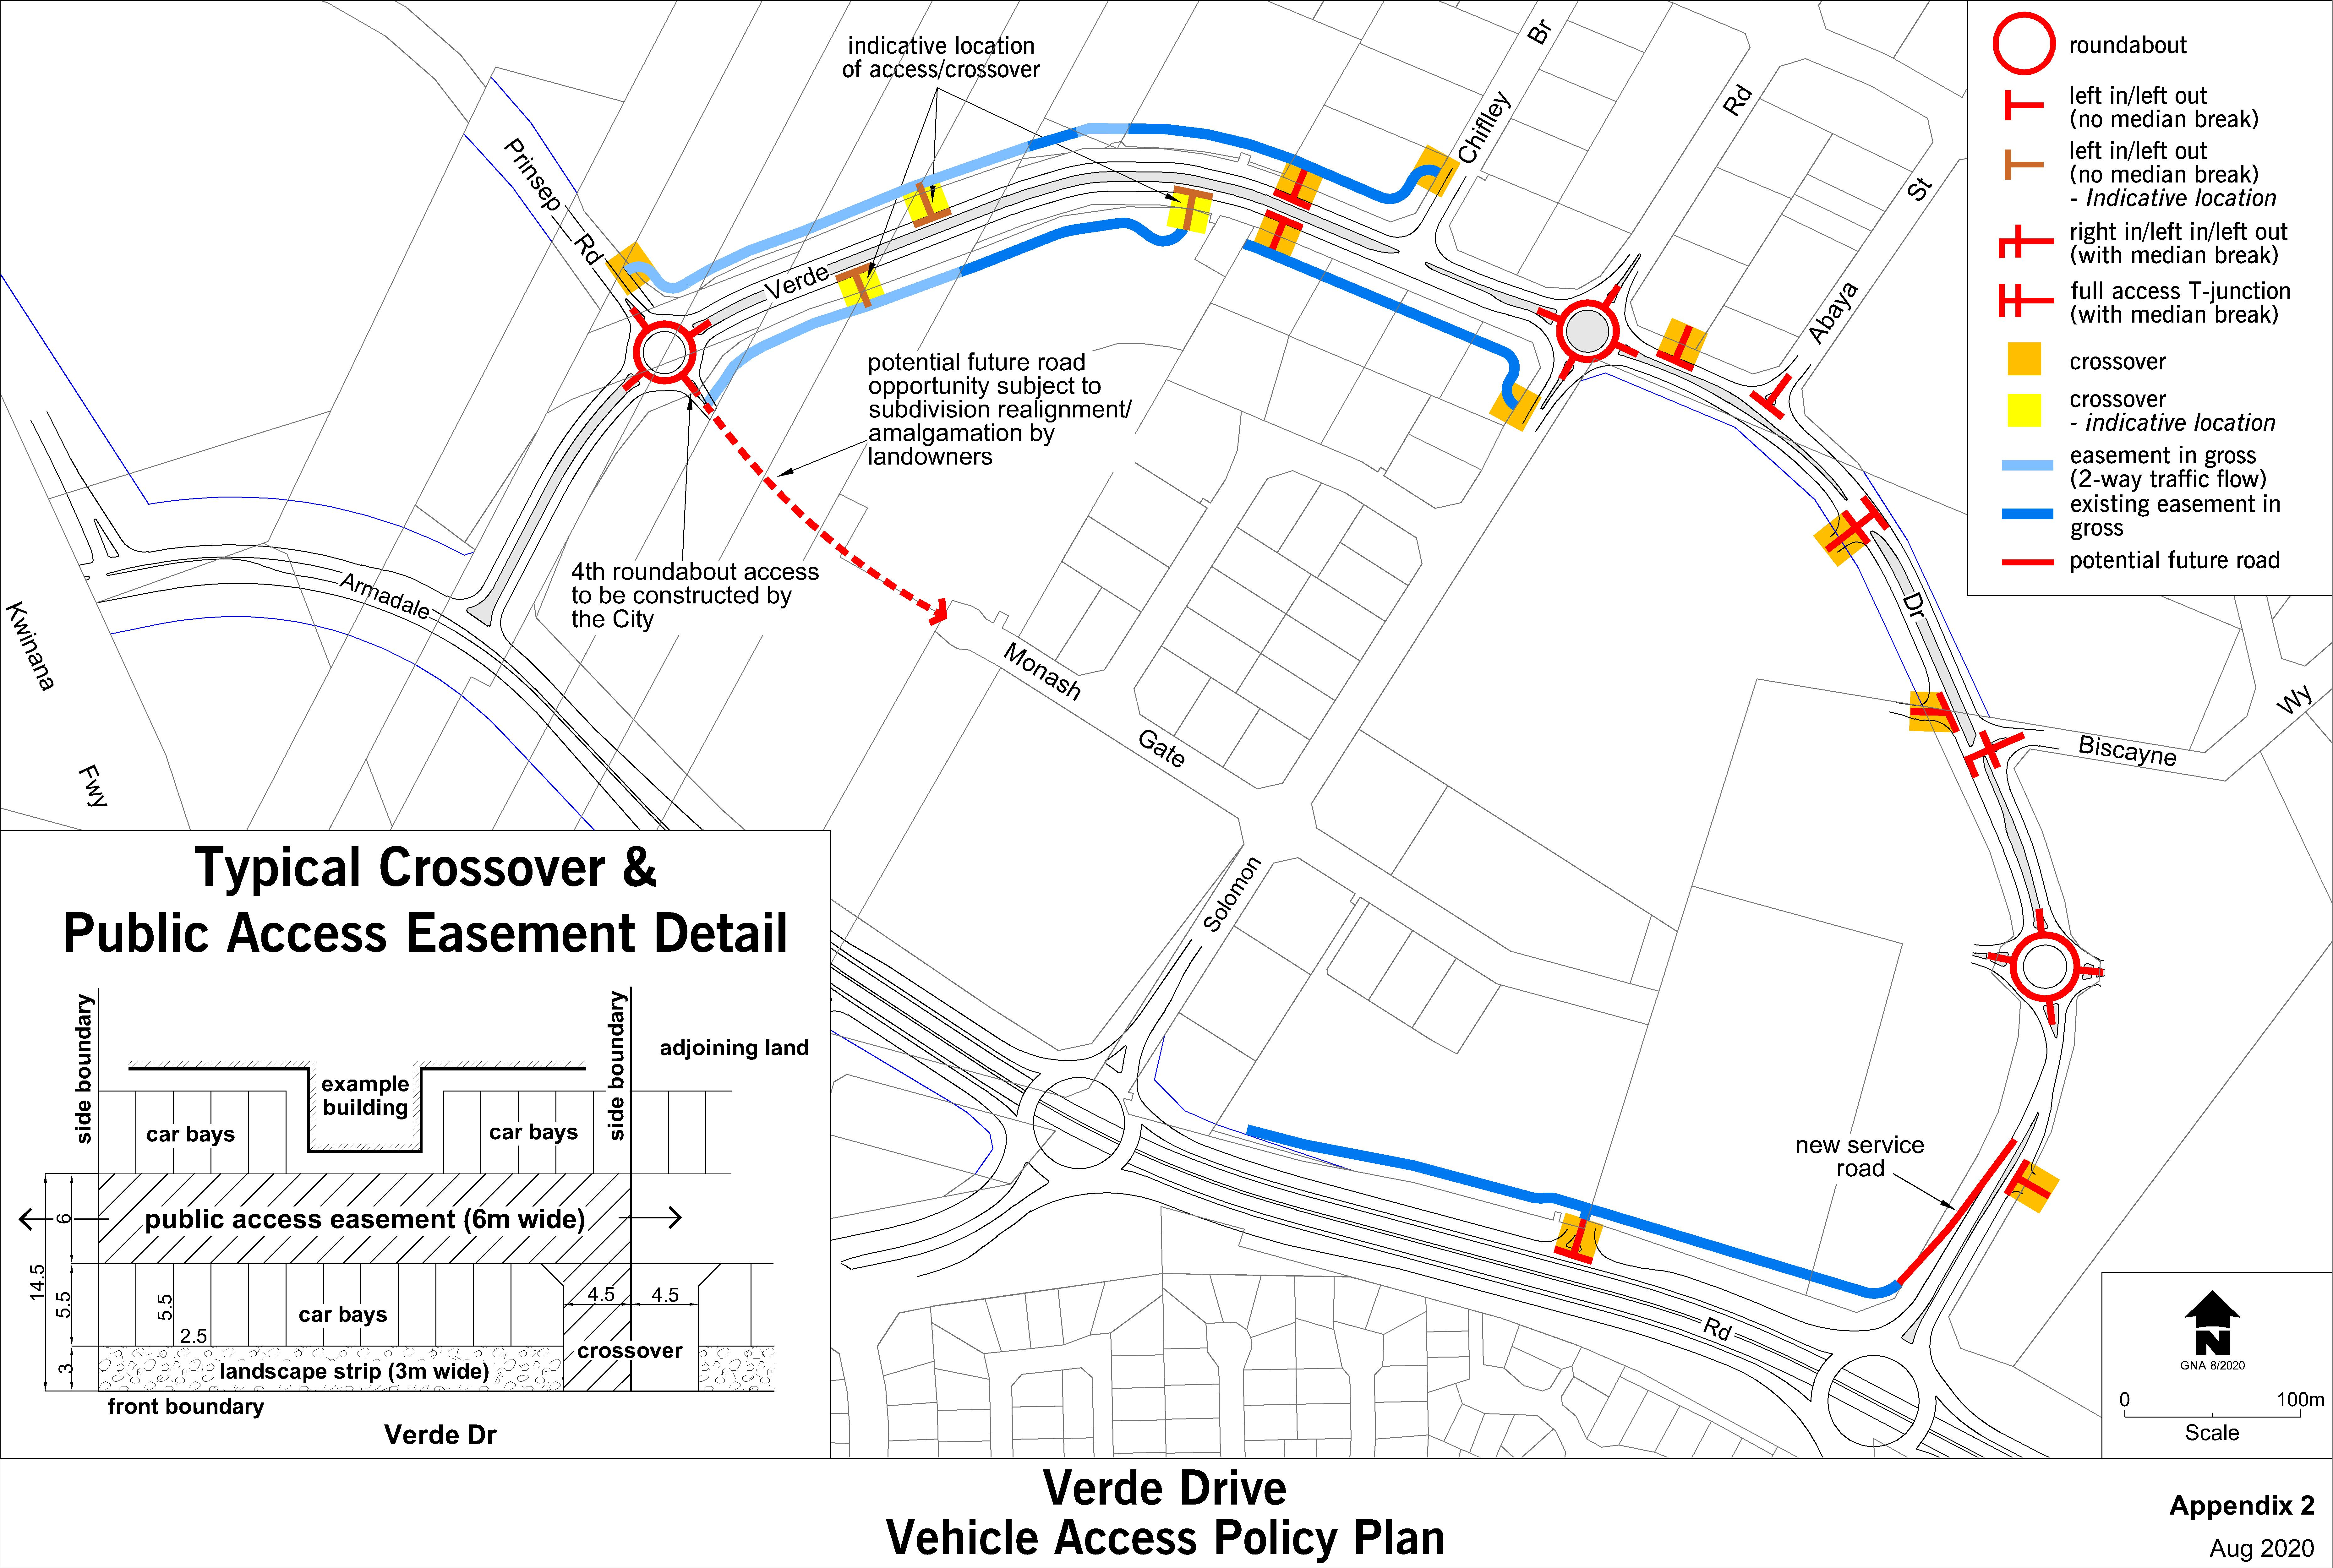

This plan is under review. Access plans require review by the City to ensure consistency with Main Roads WA and the City’s plans. Please contact Strategic Planning for further details before preparing your plan.
Bookmark 3

Strategic Link: | Town Planning Scheme No. 3
Category | Planning - Town Planning & Development
Lead Business Unit: | Development Assessment and Compliance
Public Consultation:  (Yes or No) | Yes
Adoption Date:  (Governance Purpose Only) | 10 November 2022
Next Review Due:  (Governance Purpose Only) | November 2024
ECM Doc Set ID:  (Governance Purpose Only) | 4517299

