Policy Type

Local Planning Policy

Policy Purpose

Increasingly, residential development within the City of Cockburn is occurring within town centres and intense mixed use community areas, with a mix of residential and non-residential land uses. Maintaining the sustainability of the City and encouraging vibrant communities with residential land uses close to transport corridors, places of employment, shops and cafes, requires buildings to be designed and constructed with appropriate noise attenuation measures.

The City of Cockburn requires noise attenuation of residential and other noise-sensitive land uses to protect the long term health and amenity of residents from road, rail and aircraft noise, as well as noise from non-residential land uses and other sources. Appropriate noise attenuation must be demonstrated and implemented through the development process to achieve compliance with appropriate noise legislation, standards and policies.

The purpose of the Noise Attenuation Policy and associated Guidelines is to:

(1) Detail the noise attenuation and noise management reporting process when undertaking development within the City of Cockburn.

(2) Provide details of the City’s requirements for the different types of acoustic reports.
(3) Provide guidance to applicants as to when an acoustic consultant should be engaged and provide information on the type of assistance an acoustic consultant might provide.

Policy Statement

- Acoustic Reports, Noise Management Plans and/or Noise Exposure Forecast Worksheets will be required as per the below Acoustic Reporting Requirements Table:

Development Stage | Acoustic Reporting Requirements
Structure Planning | At Structure Planning stage, the proponent must demonstrate that the proposed development can be made to comply with the relevant requirements. Suitable modelling of existing and/or future noise levels may be required, as well as detail of the anticipated noise mitigation measures. An Acoustic Report must accompany a Structure Plan, variations to a Structure Plan that materially alter the Plans intent, or a Local Development Plan. The Acoustic Report shall be prepared in accordance with the City of Cockburn Noise Attenuation Guidelines where:  1. Noise sensitive development is proposed in the vicinity of an existing or future major road, rail infrastructure or a freight handling facility as required by SPP 5.4;  2. The land is located within either the Core Area or Frame Area for Jandakot Airport as identified by SPP 5.3; or  3. Noise sensitive development and commercial, industrial or light industry land uses or infrastructure facilities are proposed in close proximity.
Subdivision Application | At Subdivision stage the City will request the preparation of either a Noise Exposure Forecast Worksheet OR a suitable Noise Management Plan as a condition of consent, as well as appropriate conditions to implement noise requirements through the development process as described in the City of Cockburn Noise Attenuation Guidelines, as detailed in Clause 1.
Local Development Plan | Where appropriate, the Local Development Plan must implement the requirements of the Noise Exposure Forecast Worksheet or Acoustic Report. Wording of the noise management requirements of a Local Development Plan must be in plain language that is suitably clear for prospective purchasers to understand.
Subdivision (Clearance) | All noise mitigation requirements of the Noise Exposure Forecast Worksheet or Acoustic Report must be implemented for subdivision conditions to be cleared.  Where Quiet House Design packages are recommended, all design requirements (including the provision of fresh air where relevant), must be implemented by a Local Development Plan. Any noise mitigation walls or barriers are to have been constructed prior to clearance being sought. Notifications on title must be suitably demonstrated prior to clearance being sought.
Development Application – including Joint Development Assessment Panel Applications | An Acoustic Report must accompany a Development Application, in accordance with the City of Cockburn Noise Attenuation Guidelines where:  1. Non-residential development that includes plant and equipment which is likely to be a source of noise (such as air conditioning systems, compressors, public address systems, amplified music, musical instruments) within 100m of noise sensitive land uses; or  2. A change of use is proposed that may involve noise emitting activity such as entertainment or amplified music; or  3. A land use which cause large numbers of people to congregate (such as hotels, sporting clubs, taverns and other licensed/non-licensed premises) is proposed, including accommodation premises (such as lodging houses and backpacker establishments); or  4. Noise sensitive developments are proposed in the vicinity of an existing or future major road or rail infrastructure as required by SPP 5.4; or  5. A freight handling facility is proposed in the vicinity of noise sensitive land uses; or  6. Noise sensitive developments within the Core Area or Frame Area for Jandakot Airport as identified by SPP 5.3; or  7. Noise sensitive land uses, mixed use or multistorey residential developments are proposed within intense mixed use community areas such as Cockburn Coast, Port Coogee, Muriel Court, Cockburn Central Town Centre and Cockburn Central West; or  8. An application is deemed likely to contribute to, or be exposed to, heightened ambient noise, at the discretion of the City.
Prior to the submission of the Building Permit Application (as condition of DA) | Final development design must achieve compliance with the identified noise criteria and suitably implement any noise mitigation requirements.  In accordance with the conditions of Development Approval for a development:  An Acoustic Report is to be submitted to the City for approval PRIOR to submission of the Building Permit Application. This Acoustic Report is to detail final design specifications and construction methods with which the proposed development will ensure compliance with the relevant noise criteria.
Building Permit Application | Building Permit Applications must clearly demonstrate compliance with all relevant Planning requirements.  • Where a Building Permit Application is required to comply with a Local Development Plan, the plans must clearly demonstrate that all Noise Management requirements will be incorporated into the structure of the dwelling (for instance specific window suite construction and glazing). Where air conditioning or mechanical ventilation is required, installation details suitable to demonstrate compliance with the noise mitigation requirements must be included on the Building Permit plans.  • Where a Building Permit Application is required to comply with conditions of Development Approval, all relevant documents specified by those condition(s) must be submitted and all relevant conditions complied with. This may include a requirement for written confirmation from a recognised acoustic consultant to that the plans have been checked and confirmed as compliant with the requirements of the relevant Acoustic Reports.
Building Occupancy or Strata Approval Certificates | Upon completion of construction and in accordance with conditions of Development Approval, a Form BA7 Notice of Completion or Form BA15 Building Approval Certificate Strata must be accompanied by written confirmation from the Builder to demonstrate that all requirements of the relevant Acoustic Report(s) were incorporated into the completed development.  Where deemed appropriate, the City may require the builder to provide with the FormBA7 Notice of Completion written confirmation from an acoustic consultant that the building complies with the requirements of the acoustic report or that a final acoustic assessment of the finished development has been undertaken
Important note: All buildings and structures are to comply with the relevant fire rating, safety, BAL and National Construction Code requirements. Noise attenuation methods shall not compromise the safety or structural integrity of the development.

Noise Attenuation Guidelines

March 2022

Table of Contents

1.0 Introduction 1
2.0 Acoustic Reports 1
2.1 Who can help me with preparing an Acoustic Report? 1
2.2 When must I submit an Acoustic Report? 1
2.3 What must the Acoustic Report contain? 2
3.0 What criteria should the Acoustic Report address? 5
3.1 Noise Intrusion (Noise Sensitive Development) 5
3.2 Vibration Intrusion (Noise Sensitive Development) 6
3.3 Noise Emissions (All Developments) 6
3.4 What will happen if the Acoustic Report submitted does not follow these Guidelines? 7
4.0 Noise Source Identification 7
4.1 Noise from Road, Rail and Freight Infrastructure 7
4.2 Vibration from Rail and Freight Infrastructure 8
4.3 Mechanical Plant and Equipment 9
4.4 Co-existing Land Uses 10
4.5 Noise Sensitive Developments in Proximity to Jandakot Airport 10
4.6 Breakout and Street Noise 11
5.0 Noise Treatment Solutions 14
5.1 Development Planning and Design 14
5.2 Construction Methods and Materials 14
6.0 Related Legislation and Documents 16
8.0 Appendix A – Nosie Source Identification Map 19
9.0 Appendix B – Noise Exposure Forecast Worksheet 20

1.0 Introduction

Mixed land use areas, with residential and commercial land uses in close proximity, are actively encouraged by the City of Cockburn in town centre and intense mixed use community areas. A mix of residential and commercial activities provides residents and visitors to an area with access to places of employment, shops and cafes, and can contribute to the vibrancy of a community.

Locating residential land uses close to main roads, marina’s, other transport infrastructure and non-residential areas, assists in maintaining the sustainability of the City and encourages active transport within the locality. However this mix of non-residential and residential land uses, and proximity to transport infrastructure, can result in an increase in ambient noise levels to residential areas.

It is therefore necessary to consider potential noise and amenity impacts throughout the planning process to ensure that appropriate noise attenuation measures are incorporated into the design and construction of developments within the City.

2.0 Acoustic Reports

The purpose of an Acoustic Report is to assess the noise environment either affecting or affected by, a development. It demonstrates how the proposed development will be designed, constructed or otherwise managed, to minimise noise emissions from a development and/or noise intrusion upon a development.

2.1 Who can help me with preparing an Acoustic Report?

The acoustic report must be prepared by a recognised Acoustic Consultant with suitable qualifications, appropriate expertise and local experience in the assessment of transport and environmental noise. They or their organisation must be:

• eligible to hold membership of the Australian Acoustical Society (AAS) in the grade of Member or Fellow (designated by the post-nominal letters M.A.A.S. or F.A.A.S. respectively); and/or
• represent a company holding current corporate membership to the Australian Association of Acoustical Consultants (AAAC); and or
• an acoustics engineer, defined as a person eligible for professional membership to the Institute of Engineers Australia (MIEAust).

An Acoustic Report may not be accepted in the absence of proof of membership, at the City’s discretion.

2.2 When must I submit an Acoustic Report?

An acoustic report must be submitted at the earliest practicable planning stage for a development, in accordance with the City of Cockburn’s Noise Attenuation Policy. Notwithstanding this, an Acoustic Report may be requested after initial assessment of a proposal by the City’s Officers.
Applicants may contact the City’s Environmental Health Service for assistance in determining whether an Acoustic Report is required

2.3 What must the Acoustic Report contain?

The Acoustic Report must address all matters necessary to demonstrate that the outcomes for reporting have been achieved as detailed by these Guidelines, to the City’s satisfaction.

The Acoustic Report should identify the name and qualification/experience of the person preparing the report and include a description of the project with suitably detailed plans.

Details of noise measurements and predictions, as well as the criteria of the assessment and the assessed sources of noise should be clearly identified in the Acoustic Report. Proposed treatment solutions should be clearly identified. Clear calculations and information demonstrating how the assigned noise levels required under the EPNRs have been determined must also be provided.

A summary of the City’s Acoustic Reporting Requirements is described in Table 1 overleaf.

Table 1: Acoustic Reporting Requirements during the Development Process

Development Stage | Acoustic Reporting Requirements
Structure Planning | At Structure Planning stage, the proponent must demonstrate that the proposed development can be made to comply with the relevant requirements. Suitable modelling of existing and/or future noise levels may be required, as well as detail of the anticipated noise mitigation measures.
Subdivision Application | At Subdivision stage, the proponent must demonstrate mitigation strategies to achieve compliance with the relevant criteria. Suitable modelling of future noise levels is required at this stage.  • For noise sensitive development within the trigger distance of road or rail infrastructure under SPP 5.4, either a Noise Exposure Forecast Worksheet (see Appendix B) or a preliminary Acoustic Report is required.  • For noise sensitive development within the Frame Area for Jandakot Airport, a preliminary Acoustic Report as described in Section 3 of these Guidelines is required.  • Where noise sensitive development is proposed in proximity to existing commercial or industrial activities, an Acoustic Report as identified in Section 3 of these Guidelines is required.  • For commercial or industrial development, an Acoustic Report is required to demonstrate that the requirements of the EPNRs can be achieved and demonstrate that there will be no adverse amenity impact upon nearby noise sensitive premises in accordance with Section 4 is required.  Where a previous Acoustic Report has been provided during the Structure Planning stage, the Subdivision Application must be supported by a further Acoustic Report demonstrating design solutions to protect the noise sensitive premises from excessive noise and identifying finished lot levels.  Conditions appropriate for the implementation of the Noise Exposure Forecast Worksheet or Acoustic Report will be recommended by the City to the WAPC. Where it is not possible for modelling to reference the final lot levels, the City may recommend requirements be confirmed by a final Acoustic Report prior to Subdivision Clearance.
Local Development Plan | Where appropriate, the Local Development Plan must implement the requirements of the Noise Exposure Forecast Worksheet or Acoustic Report.  Wording of the noise management requirements of a Local Development Plan must be in plain language that is suitably clear for prospective purchasers to understand.
Subdivision (Clearance) | All noise mitigation requirements of the Noise Exposure Forecast Worksheet or Acoustic Report must be implemented for subdivision conditions to be cleared.  Where Quiet House Design packages are recommended, all design requirements (including the provision of fresh air where relevant), must be implemented by a Local Development Plan. Any noise mitigation walls or barriers are to have been constructed prior to clearance being sought. Notifications on title must be suitably demonstrated prior to clearance being sought.
Development Application – including Joint Development Assessment Panel Applications | Development Applications must demonstrate that compliance with the identified criteria can be achieved. The proponent must detail how mitigation strategies will be implemented to achieve compliance with the relevant noise criteria. Suitable modelling of existing and/or future noise levels is required at this stage.  • For noise sensitive development within the trigger distance of road or rail infrastructure under SPP 5.4, either a Noise Exposure Forecast Worksheet (see Appendix B) or Acoustic Report is required.  • For noise sensitive development within the Frame Area for Jandakot Airport, an Acoustic Report as described in Section 3 of these Guidelines is required.  • Where noise sensitive development is proposed in proximity to existing commercial or industrial activities, an Acoustic Report demonstrating how compliance with the noise criteria described in Section 3 of these Guidelines is required.  • For commercial or industrial development, an Acoustic Report is required to demonstrate that the requirements of the EPNRs can be achieved and that there will be no adverse amenity impact upon any nearby noise sensitive premises.  Conditions appropriate for the implementation of the requirements of the Noise Exposure Forecast Worksheet or Acoustic Report will be applied to the Development Approval issued by the City or recommended to the JDAP, as described below.  Where relevant, a condition may be applied requiring Notification on the Certificate of Title in accordance with the relevant SPP and/or the City’s LPP 1.12 and this Guideline.
Prior to the submission of the Building Permit Application (as condition of DA) | Final development design must achieve compliance with the identified noise criteria and suitably implement any noise mitigation requirements.  In accordance with the conditions of Development Approval for a development:  An Acoustic Report is to be submitted to the City for approval PRIOR to submission of the Building Permit Application. This Acoustic Report is to detail final design specifications and construction methods with which the proposed development will ensure compliance with the relevant noise criteria.
Building Permit Application | Building Permit Applications must clearly demonstrate compliance with all relevant Planning requirements.  • Where a Building Permit Application is required to comply with a Local Development Plan, the plans must clearly demonstrate that all Noise Management requirements will be incorporated into the structure of the dwelling (for instance specific window suite construction and glazing). Where air conditioning or mechanical ventilation is required, installation details suitable to demonstrate compliance with the noise mitigation requirements must be included on the Building Permit plans.  • Where a Building Permit Application is required to comply with conditions of Development Approval, all relevant documents specified by those condition(s) must be submitted and all relevant conditions complied with. This may include a requirement for written confirmation from a recognised acoustic consultant to that the plans have been checked and confirmed as compliant with the requirements of the relevant Acoustic Reports.
Building Occupancy or Strata Approval Certificates | Upon completion of construction and in accordance with conditions of Development Approval, a Form BA7 Notice of Completion or Form BA15 Building Approval Certificate Strata must be accompanied by written confirmation from the Builder to demonstrate that all requirements of the relevant Acoustic Report(s) were incorporated into the completed development.  Where deemed appropriate, the City may require the builder to provide with the FormBA7 Notice of Completion written confirmation from an acoustic consultant that the building complies with the requirements of the acoustic report or that a final acoustic assessment of the finished development has been undertaken.
Important note: All buildings and structures are to comply with the relevant fire rating, safety, BAL and National Construction Code requirements. Noise attenuation methods shall not compromise the safety or structural integrity of the development.

3.0 What criteria should the Acoustic Report address?

The following minimum standards shall be applied as the relevant reference criteria upon which the Acoustic Report is to be prepared:

3.1 Noise Intrusion (Noise Sensitive Development)

Noise sensitive developments are to be designed to achieve the following sound levels:
- Leq 35 dB(A) in sleeping areas (bedrooms); and
- Leq 40 dB(A) in living/work areas and other habitable rooms.

For all other developments, noise intrusion is to be controlled to achieve the indoor design sound levels for buildings as set out in Australian Standard AS/NZS2107: “Acoustics - Recommended Design Sound Levels and Reverberation Times for Building Interiors”.

For noise sensitive developments within the trigger distance of future or existing road and rail infrastructure, the report must address the requirements of SPP 5.4.

Important note about low frequency noise:

The Leq level should not be unduly biased toward the lower frequencies of the octave band spectrum. If lower frequencies are dominant in sound levels taken during the sampling phase of reporting (below 200Hz or a 15-20dB difference between LA and LC levels), the Acoustic Consultant shall discuss the findings with the City in developing appropriate solutions to ensure that low frequency noise is appropriately attenuated, prior to the submission of the final Acoustic Report.

3.2 Vibration Intrusion (Noise Sensitive Development)

For noise sensitive developments in close proximity to rail infrastructure or other sources of vibration, the Acoustic Report must address ground-borne vibration levels to ensure that occupants of the development are not exposed to an unacceptable level of vibration.

Noise sensitive developments are to be designed to achieve the following vibration levels, as described in Table 2 of Appendix A of AS 2670.2‐1990 “Evaluation of human exposure to whole‐body vibration; Part 2: Continuous and shock‐induced vibration in buildings (1 to 80 Hz)”:

- Infill development of existing residential zoned areas: 1.4 - 2.0 times the base curve (or the equivalent); or
- North Coogee (including South Beach, Port Coogee and Cockburn Coast) as well as other new rezoning or subdivision of noise sensitive development: 1.4 times the base curve (or the equivalent);.

3.3 Noise Emissions (All Developments)

Noise emissions from all developments including freight handling facilities and new infrastructure, is to comply with the “Assigned Levels” as detailed in the EPNRs.

New road or rail infrastructure, must also address the relevant requirements of SPP 5.4.

3.4 What will happen if the Acoustic Report submitted does not follow these Guidelines?

It is likely that delays will result in the Application Process (Development Application or Building Permit Application) until an amended report or supplementary information to the City’s satisfaction has been submitted, or the City may refuse your Development or Building Permit Application.

Important note:

Acoustic Reports may be submitted by the City to the Department of Water and Environmental Regulation Noise Branch for comment or to another Acoustic Consultant for peer review, at the City’s discretion.

4.0 Noise Source Identification

Acoustic reports must identify all noise sources relevant to a development, including those which may require detailed assessment at a later stage. Appendix A of this Guideline contains a map to assist proponents in identifying noise sources that may affect different areas of the City. These noise sources may include major roads and rail-lines, areas affected by current and future aircraft noise as well as intense mixed use community areas where higher ambient noise levels may be present, now or in the future.

Environmental noise sources that are relevant within the City of Cockburn include the following:

4.1 Noise from Road, Rail and Freight Infrastructure

Major roads and railways contribute to the ambient environmental noise of an area, and can cause health and amenity impacts to noise sensitive receivers. The City can provide road traffic forecast information for major roads within the City as well as providing advice on future roads that may be proposed in the vicinity of a proposed development.

Under SPP 5.4 Road and Rail Noise (September 2019), a proponent may choose to submit either a Noise Exposure Forecast Worksheet or an Acoustic Report with their subdivision or development application. Appendix B of this Guideline includes a Noise Exposure Forecast Worksheet template based on the requirements of SPP 5.4, which may be completed by a person other than an acoustic consultant using information from the City’s Intramaps website as well as using the Department of Planning Lands and Heritage Plan WA website.

In relation to Acoustic Reports for freight rail, the report must describe a representative sample of trains. Where ground borne vibration or low frequency noise are identified as a concern (such as in association with the freight rail lines) the Acoustic Report must clearly identify low frequency noise, ground borne and air borne vibration levels (see Section 4.6).

Final details of proposed noise and vibration attenuation measures must be provided to the satisfaction of the City either:
- PRIOR to the submission of the Building Permit Application for Development Applications; or
- PRIOR to the determination of the Structure Plan, Subdivision Application or Subdivision Clearance.

To protect the residential amenity of noise sensitive development in the vicinity of the Spearwood Crossing Loop, noise sensitive development in this area must be designed to attenuate received noise levels from the idling train, to achieve indoor compliance with the EPNRs.

Notifications on title will be required as a condition of development or subdivision approval (including strata subdivision) to inform future residents of the existence of future ambient noise levels that may affect amenity of residential premises. A Notification under Section Section 165 of the Planning and Development Act 2005 is to be placed on the Certificate(s) of Title of the proposed lot(s) / subject lot(s) [DELETE AS APPLICABLE]. Notice of this Notification is to be included on the diagram or plan of survey (Deposited Plan).

The Notification is to state words to the effect:

‘This lot or dwelling is in the vicinity of an operating freight rail line servicing the Ports and industrial areas of Fremantle and Kwinana and operates 24 hours a day, 7 days a week. Residential amenity may be affected by noise and vibration and other impacts from freight rail traffic using the rail line’

Important note:

In relation to noise from freight rail lines, State Planning Policy 5.4 requires compliance with a LAeq(night) target of 50dB(A) for the 8 hours period between 10pm and 6am. It is however strongly recommended that a more conservative assessment method be considered, such as the LAeq(night) noise emission of a single representative train pass (LAeq(120sec) or similar) or consideration of the LAmax levels as proposed by the Freight and Logistics Council’s Bulletin No 7 (dated October 2015) to ensure that residential amenity is adequately protected, particularly with regard to sleeping areas.

4.2 Vibration from Rail and Freight Infrastructure

For noise sensitive developments in close proximity (within 80m) of rail infrastructure or other sources of vibration, an Acoustic Report should also assess ground-borne vibration levels to ensure that occupants of the development are not exposed to an adverse amenity impact.

An Acoustic Report assessing vibration should make reference to the criteria described in Section 3.2 based on monitoring of trains over a three to four day period necessary to ensure a ‘representative’ number of train movements have been observed. The number of trains observed must be sufficient to obtain an acceptable level of repeatability, particularly during periods of low traffic and may require the monitoring equipment to be left for a longer period.

The Acoustic Report is to address the vibration levels of each train during the monitoring period and address compliance with either:

- Australian Standard 2670.2-1990 “Evaluation of human exposure to whole-body vibration; Part 2: Continuous and shock induced vibration in buildings (1 to 80 Hz)”;
- ISO 2631-2:2003 “Evaluation of human exposure to whole-body vibration Part 2: Vibration in buildings (1 Hz to 80 Hz)”; or
- British Standard BS6472-2008: “Evaluation of Human Exposure to Vibration in Buildings (1 Hz to 80 Hz)”.

4.3 Mechanical Plant and Equipment

Applicants for activities which may be a source of noise, are to detail anticipated noise levels from increased vehicular traffic as a result of the development (truck movements, loading activities, car doors slamming etc) as part of the development application. Where noise from an activity exceeds, or significantly contributes to, a noise level that exceeds the assigned levels, an Acoustic Report must be provided demonstrating how noise levels will be suitably attenuated and any potential amenity impact minimised.

With relation to Mechanical Plant and Equipment noise, the Acoustic Report is to comment on:

- the likely impact of mechanical plant and equipment noise sources (such as air conditioners, traffic gates, exhaust systems);
- practical building design solutions that could be implemented to minimise the impact of existing mechanical plant and equipment noise sources; and
- the proposed location of all mechanical plant and equipment at the development site; and provide details of how noise emissions from these sources will be contained, so as not to create unwanted sound at nearby properties.

Important note:

Noise from mechanical equipment used in emergency situations which are an integral part of the development (for instance fire pumps, smoke exhaust fans and the like) must comply with the assigned levels for routine testing and maintenance purposes.

Where it is determined that compliance may not be achieved, the Acoustic Consultant shall discuss the findings with the City to develop appropriate solutions and must be able to demonstrate that all practicable and reasonable measures will be implemented to minimise the noise impact onto nearby receivers, prior to the submission of the final Acoustic Report.

4.4 Co-existing Land Uses

Whilst it is important to ensure that a proposed development is designed to reasonably negate external/existing noise sources from impacting on noise sensitive areas within the proposed development, it is equally important that a development is designed to ensure that internal noise sources do not impact on surrounding existing or future land uses.

In some instances, pre-existing non-conforming uses may remain in close proximity to proposed noise sensitive development. Where a noise sensitive development is proposed in the vicinity of a pre-existing commercial or industrial land use, the Applicant must provide an Acoustic Report demonstrating noise attenuation suitable address any adverse amenity impact in accordance with these Guidelines.

4.5 Noise Sensitive Developments in Proximity to Jandakot Airport

The Jandakot Airport is the principal general aviation airport in Western Australia. Aircraft training movements can have a substantial effect on the amenity of surrounding noise sensitive land uses, due to the frequency of noise events and the inability to screen aircraft noise emissions from reaching affected parties on the ground.

Development in the 20ANEF and 25 ANEF Contours for Jandakot Airport (as identified by the Jandakot Airport Master Plan)

Applications for noise sensitive development or subdivision will require:

• Support by an Acoustic Report demonstrating compliance within SPP 5.3 and AS2021:2015 “Acoustics – Aircraft Noise Intrusion - Building Siting and Construction”.

Applications for other development will require:

• Support by an Acoustic Report demonstrating compliance with the Indoor Design Sound Levels identified in Appendix 2 of SPP 5.3

Appendix A of this Guideline shows the Frame Area within the City of Cockburn, identified by SPP 5.3. Applications for noise sensitive development or subdivision within the Frame Area for Jandakot Airport are required to provide 6.38mm laminated glass to all habitable rooms (including kitchens), in accordance with the requirements of the Western Australian Planning Commission publication “Aircraft Noise Insulation for Residential Development in the Vicinity of Perth Airport” 2004.

Appropriate conditions of approval will be applied or recommended to ensure that noise management requirements within the 20 ANEF and 25 ANEF contours and Frame areas. For subdivision this may necessitate a Local Development Plan to implement façade treatment to future noise sensitive development.

A condition requiring the Applicant to place a Notification under Section 165 of the Planning and Development Act on the Certificate of Title will be required for all noise sensitive development sites subject of a subdivision or development application within the 20 ANEF and 25 ANEF contours and Frame areas. The wording of the Notification must be consistent with the wording provided in SPP 5.3.

Important note:

In relation to noise from general aviation aircraft movements from Jandakot Airport, much of the Frame area falls within the area identified by the “Noise Above Contours” identified by the Jandakot Airport Master Plan corresponding with:

- 20 or more daily events greater than 70 dB(A);
- 50 or more daily events of greater than 65 dB(A);
- 100 events or more daily events of greater than 60 dB(A); or
- 6 or more events of greater than 60 dB(A) between the hours of 11pm and 6am

4.6 Breakout and Street Noise

Developments in the vicinity of lifestyle uses such as marinas, cafes, restaurants, hotels and entertainment venues such as small bars, are integral to the vitality and enjoyment of town centre and intense mixed use community areas. Outdoor eating areas associated with hotels, cafés and restaurants can also be a source of breakout noise.

Urban locations containing a mix of lifestyle uses contribute to the vitality of an area and are characterised by increased levels of pedestrian activity.

Noise associated with these uses may include:

• Movement to and from different establishments,
• Persons getting into and out of parked cars, and
• Occasional anti-social behaviour.

The above can contribute significantly to general ambient environmental noise (particularly when this occurs late at night), impacting on the amenity of residential premises.

The Applicant is to ensure that the Acoustic Report:

- Identifies breakout noise sources that impact on sound levels received at the subject property, and in particular those noise sources within a 100m radius;
- Provides comment on the likely amenity impact of all localised street noise sources (factors such as proximity to local business districts, late night venues, setbacks from footpaths and proximity to schools which may be adversely affected by noise emissions shall be considered); and

- Specifies sound levels recorded at the property during representative time periods (corresponding with related breakout noise sources or peak periods of street noise; for example):
i. Nightclubs to be monitored during hours of operation after 10.00pm at night on a Friday or Saturday;
ii. Cafes and Outdoor Eating Areas to be monitored during peak trade periods;
iii. Street and Background Noise to be monitored during peak periods; or
iv. Locations near sports grounds and stadiums are to be monitored during periods of normal use; particularly when used at capacity (where practicable);

- Addresses the character of noise sources in terms of frequency analysis, and in particular identifies whether low frequency noise is present (minimum of octave bands to be provided); and

- Thereafter, provides comment on practical building design solutions to minimise the impact of such noise sources.

For noise sensitive land uses, mixed use or multistorey residential developments within intense mixed use community areas such as Cockburn Coast, Port Coogee, Muriel Court, Cockburn Central Town Centre and Cockburn Central West (as identified in Appendix A), where potential sources of break out noise are not yet present, the applicant is to liaise with the City for guidance on determining potential noise sources, potential street and break out noise levels for the modelling of potential noise impacts.

Notifications on title will be required as a condition of development or subdivision approval (including strata subdivision) to inform future residents of the existence of future ambient noise levels that may affect amenity of residential premises. A Notification under Section 70A of the Transfer of Land Act with wording to the effect:

“This land is located within the <insert description here> town centre. The vision for this town centre is that of a vibrant mixed use area. Residential amenity, therefore, may be affected by the mixed use nature of the location, including noise and other impacts. Further information is available on request from the City of Cockburn.”

Important note:

Standardised theoretical sound level limits should not be used for calculation purposes, unless such use is absolutely necessary due to noise sources (to be modelled) occurring so infrequently that performing measurements on-site is impractical, or where potential noise sources are not yet present

Table 2: Acceptable Vibration Treatment Options

Development Area | Vibration level | Potential Treatment Responses
North Coogee and future rezoning or subdivision of noise sensitive development in proximity to the fright rail line | Curve 1.4 and below | No vibration treatment or notification required.  Notification on Title as described in Section 4.2.  Acoustic treatment to mitigate vibration to be incorporated into the development based upon development specific acoustic advice.  Proposed mitigation strategies (for instance mitigation trenches, vibration isolation of the building structure or slab) based on specialised acoustic advice, are to be identified as early as possible during development process.
Infill development of existing residential zoned areas | Curve 1.4 and below | No vibration treatment or notification required.
 | Between Curve 1.4 and Curve 2 | Notification on Title as described in Section 4.2  No vibration treatment required.
 | Above Curve 2 | Notification on Title as described in Section 4.2.  Acoustic treatment to mitigate vibration to be incorporated into the development based upon development specific acoustic advice. Proposed mitigation strategies (for instance mitigation trenches, vibration isolation of the building structure or slab) based on specialised acoustic advice, are to be identified as early as possible during development process.

Final details of proposed vibration attenuation measures must be provided to the satisfaction of the City either:
- PRIOR to the submission of the Building Permit Application for Development Applications; or
- PRIOR to the determination of the Structure Plan or Subdivision Clearance.

Where ground borne vibration or low frequency noise are identified as a concern Acoustic Report must clearly identify low frequency noise, ground borne vibration and air borne vibration levels.

5.0 Noise Treatment Solutions

The intent of noise treatments is to provide appropriate opportunities for rest and respite within noise sensitive premises (where people rest and sleep) and to allow a multitude of diverse land uses to co-exist.

5.1 Development Planning and Design

Once all relevant noise sources have been identified, it will be possible for the design team to consider the use of development design techniques to minimise noise intrusion and emission. Seeking the advice of an acoustic consultant at the earliest planning stage provides greater opportunity to consider noise attenuation options, which can minimise or reduce the construction costs.

When considering the land use planning strategies, the following hierarchy of controls is suggested:

- Increasing the distance between noise sources and noises sensitive premises;

- Using zoning mechanisms to limit the potential for land use conflict;

- The use of buildings, barriers, walls and bunds as shields or similar acoustic design principals;
- The use of quiet house design.

Where final lot levels have not been determined at the time of a Subdivision Application, a draft Acoustic Report based on estimated or existing lot levels must be provided to demonstrate that compliance with the relevant requirements can be achieved.

To effectively implement an Acoustic Report, a Local Development Plan may be necessary to control construction materials and methods for individual lots. Arrangements should be made to ensure that prospective purchasers are made aware of noise attenuation requirements.

The Applicant is to ensure that the Acoustic Consultant’s recommendations have been incorporated into the development design and documentation.

5.2 Construction Methods and Materials

Prior to submission of the Building Permit Application, an Acoustic Report detailing all relevant sources of noise, and the final design specifications and structural methods by which noise will be attenuated must be submitted to the City.

Important Note:

All buildings and structures are to comply with the relevant fire rating and noise attenuation requirements as set out in the National Construction Code (as amended) and the Building Code of Australia (as amended). Acoustic attenuation methods shall not compromise the safety or structural integrity of the development.

Noise Insulation (Protection against noise intrusion)

- Windows: consider window size and location; selection of fixed panels or operable windows; use of heavyweight or thicker glass, double glazing and laminated glazing; window frame type and window seal construction; and specific acoustic performance requirements.

- Walls: consider construction/product detail for walls requiring higher acoustic performance (brick, stud, concrete tilt panel, rammed earth); acoustic attenuation for exhaust vents, conduits and piping through walls; and requirements for external doors, including the door construction (solid timber, laminated glazing or double glazing), frame construction and application of door seals.

Important Note:

Where stud wall construction is proposed, evidence should be provided to demonstrate that low frequency sound, regenerated noise, airborne and ground borne vibration will be suitably attenuated. Detail of the recommended construction façade is to demonstrate suitable attenuation where these characteristics are identified, by favouring solutions with high Rw+Ctr acoustic rating in lieu of construction with high Rw only

- Roof and Ceiling: consider the selection of roof; specific acoustic requirements for sealing of roof (such as use of sark or anticon insulation); upgraded acoustic performance for ceilings; closing, sealing or elimination of eaves; and insulation of ceiling voids.

- Ventilation: consider the potential for noise intrusion from ventilation services (such as service ducts or commercial exhaust systems) to enter into noise sensitive areas through walls and ceilings; attenuation of service ducts and all air paths, such as through ducts to the exterior, suitably attenuate low frequency noise and vibration.

Noise Emission Mitigation Measures:

The “assigned levels” detailed in the EPRs must be complied with in relation to noise generated/emitted from the premises. Applicants are encouraged to consider design and construction measures that are tailored specific to the noise source for that development.

6.0 Related Legislation and Documents

Related legislation:
The Environmental Protection Act 1986 and the Environmental Protection (Noise) Regulations 1997 (EPNRs) –provide powers for officers of the Department of Environment Regulation, WA Police Service and authorised Environmental Health Officers from Local Governments to deal with noise.
The Liquor Act 1988 – under Section 117 of this legislation the Director Liquor Licensing Division has the power to deal with noise issues and anti-social behaviour.
The Planning and Development Act 2005 (P&D Act) - this legislation provides the determining authority with the power to impose conditions on Development Approvals that protect the amenity of an area.
The Building Act 2011 - this legislation provides the authority to set building standards and ensure that they are met through the issue of building and occupancy permits to protect the health and safety of a buildings inhabitants.
In addition to the above listed legislation, reference is made in these Guidelines to the following State Planning documents prepared and adopted under the P&D Act:
State Planning Policy 4.1 “State Industrial Buffer Policy”, Gazetted May 1997 (SPP 4.1);
Draft State Planning Policy 4.1 “State Industrial Buffer”, November 2017 (Draft SPP 4.1);
State Planning Policy 5.3 “Land Use Planning in the Vicinity of Jandakot Airport”, 2006 (SPP 5.3);
State Planning Policy 5.4 “Road and Rail Noise”, dated September 2019 (SPP 5.4);
Road and Rail Noise Guidelines, dated September 2019 (the Guidelines);
Western Australian Planning Commission publication “Aircraft Noise Insulation for Residential Development in the Vicinity of Perth Airport” 2004.

In relation to Federal Aviation requirements, reference is also made to the following documents prepared in accordance with the requirements of the Federal Department of Infrastructure and Regional Development:
National Airports Safeguarding Framework;
Jandakot Airport Master Plan and references to the “Noise Above Contours” identified by the Master Plan.

7.0 Definitions

“Acoustic Consultant” is the term used to describe a specialist consultant with expertise in the science of acoustics, noise, and/or vibration. This highly technical field is further divided into broad areas of expertise. See also Section 2.1 - Who can help me with preparing an Acoustic Report?

“Acoustic Report” a specialist report prepared by an Acoustic Consultant addressing noise and vibration emissions from or received by a development or site.

An Acoustic Report may take the form of:
• A “Noise Impact Assessment”- a report that assesses the noise impacts of a development with regard to noise emissions or received.
• A “Noise Management Plan”- a Report that demonstrates how the noise levels will be attenuated or otherwise managed for a development to comply with the relevant criteria.

“Ambient Environmental Noise” is sound emitted from the full complement of activities and land uses within an area that is not easily discernible and includes a combination of sound from sources such as traffic, wind, rustling trees, wildlife, pets, mechanical equipment and people, including break out noise.

"Assigned Level" has that same meaning given to it under the EPNRs.

“Breakout Noise” is a clearly distinguishable sound emitted from local land use activities such as outdoor eating areas, public gathering areas and pedestrian routes, pubs, nightclubs and the like.

"Development" has the same meaning given to it under the P&D Act being: “the development or use of any land, including —
- any demolition, erection, construction, alteration of or addition to any building or structure on the land;
- the carrying out on the land of any excavation or other works…”

“Development Application” has the same meaning given to it under the P&D Act being: “an application under a planning scheme, or under an interim development order, for approval of development.

“Frame Area” for Jandakot Airport has the same meaning as under SPP 5.3, being the area between the 20ANEF contour and Roe Highway, Ranford Road, Warton Road, Armadale Road and Kwinana Freeway, which may have a reduced level of residential amenity due to aircraft noise. The Frame Area is shown in Appendix A.

“Noise” is defined as unwanted sound or vibration.

“Noise Exposure Forecast” is a brief initial assessment conducted under SPP 5.4 to demonstrate whether outdoor noise levels from a transport source, , will comply with the Target Noise Levels when received at a development site.

“Noise-Sensitive Land Use” and “Noise-Sensitive Development” have the same meaning as under SPP 5.4 and the EPNRs, being premises occupied solely or mainly for residential or accommodation purposes, rural premises and premises including (but not limited to):
(a) a caravan park or camping ground, a tavern, hotel or other premises that provide accommodation for the public;
(b) a hospital, aged care facility, home or institution for the care of persons;
(c) an education facility;
(d) child care facility; and
(e) places of worship.

“Noise Target” is the level of noise set by Table 2 in SPP 5.4 as an acceptable level of noise for development in proximity to road and rail infrastructure. If a development takes place in an area where outdoor noise levels meet the Noise Target, no attenuation measures are required.

“Residential development” has the same meaning as in the Residential Design Codes, being development of permanent accommodation for people, and may include all dwellings, the residential component of mixed-use development, and residential buildings proposing permanent accommodation.

8.0 Appendix A – Nosie Source Identification Map

9.0 Appendix B – Noise Exposure Forecast Worksheet

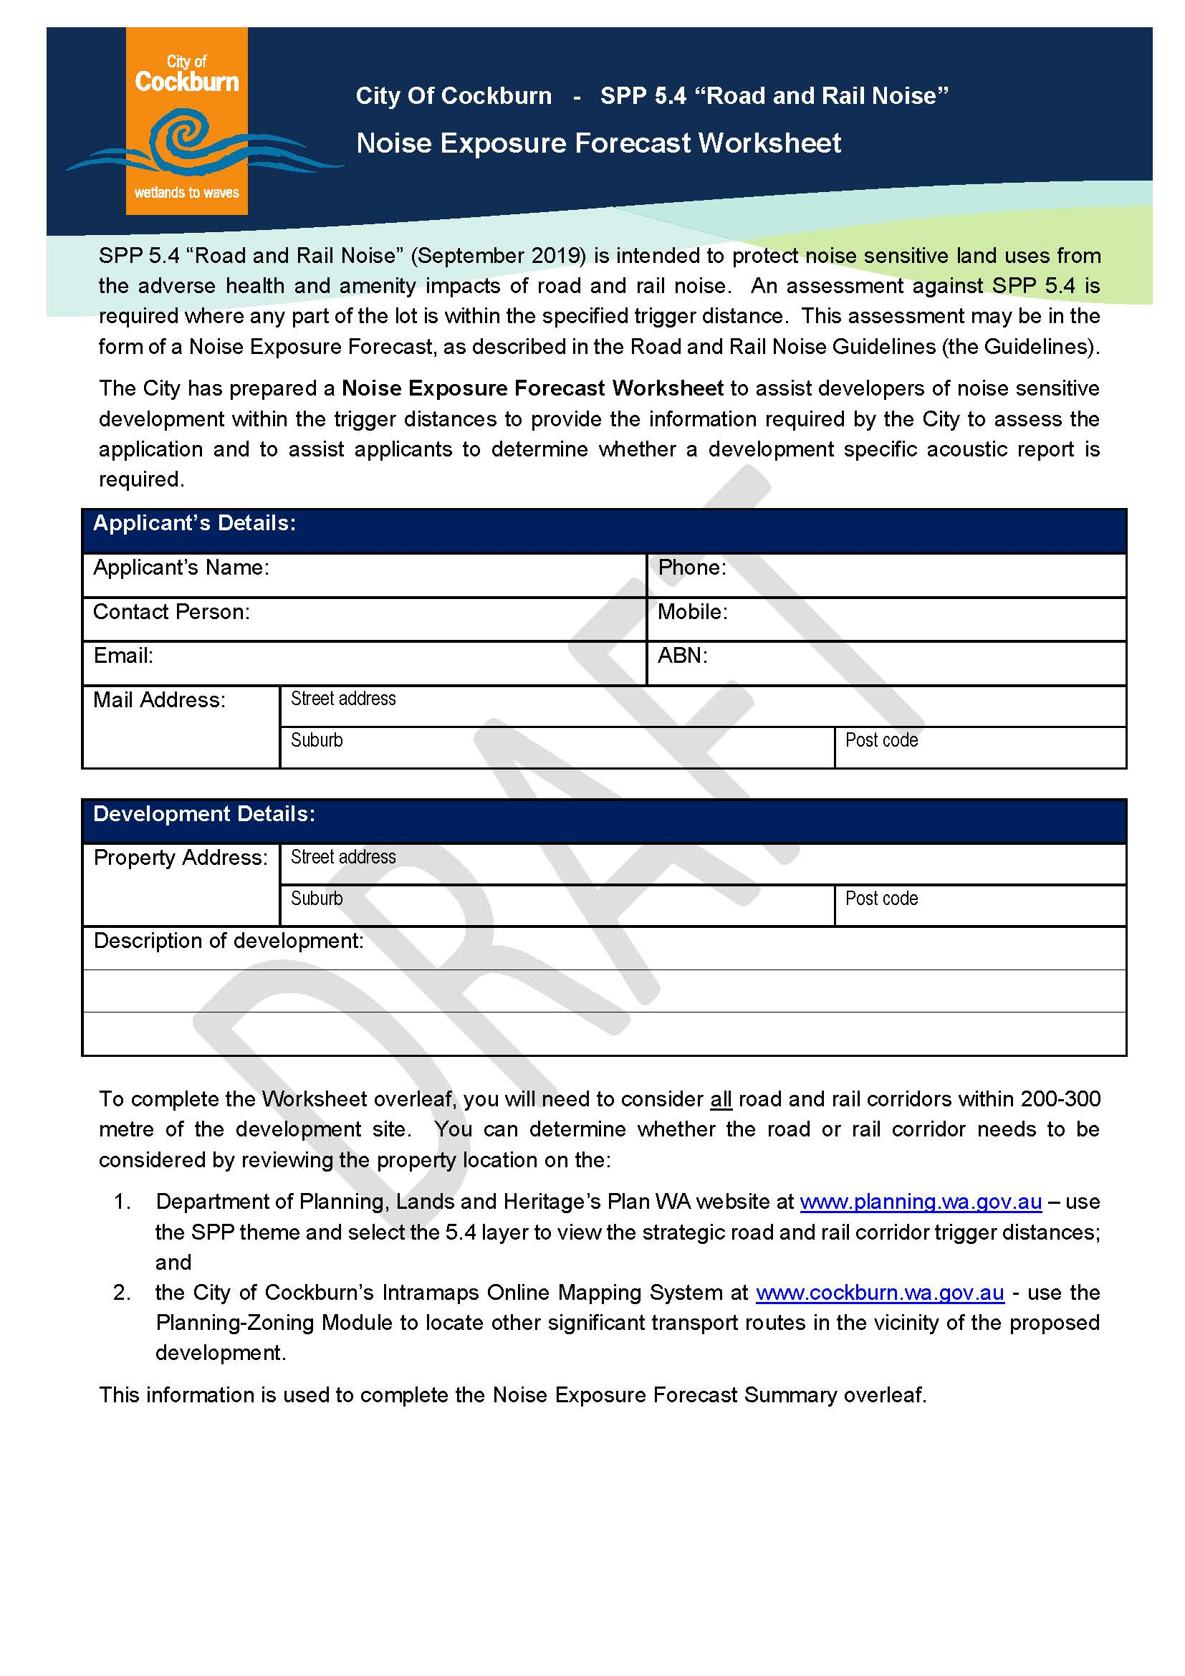

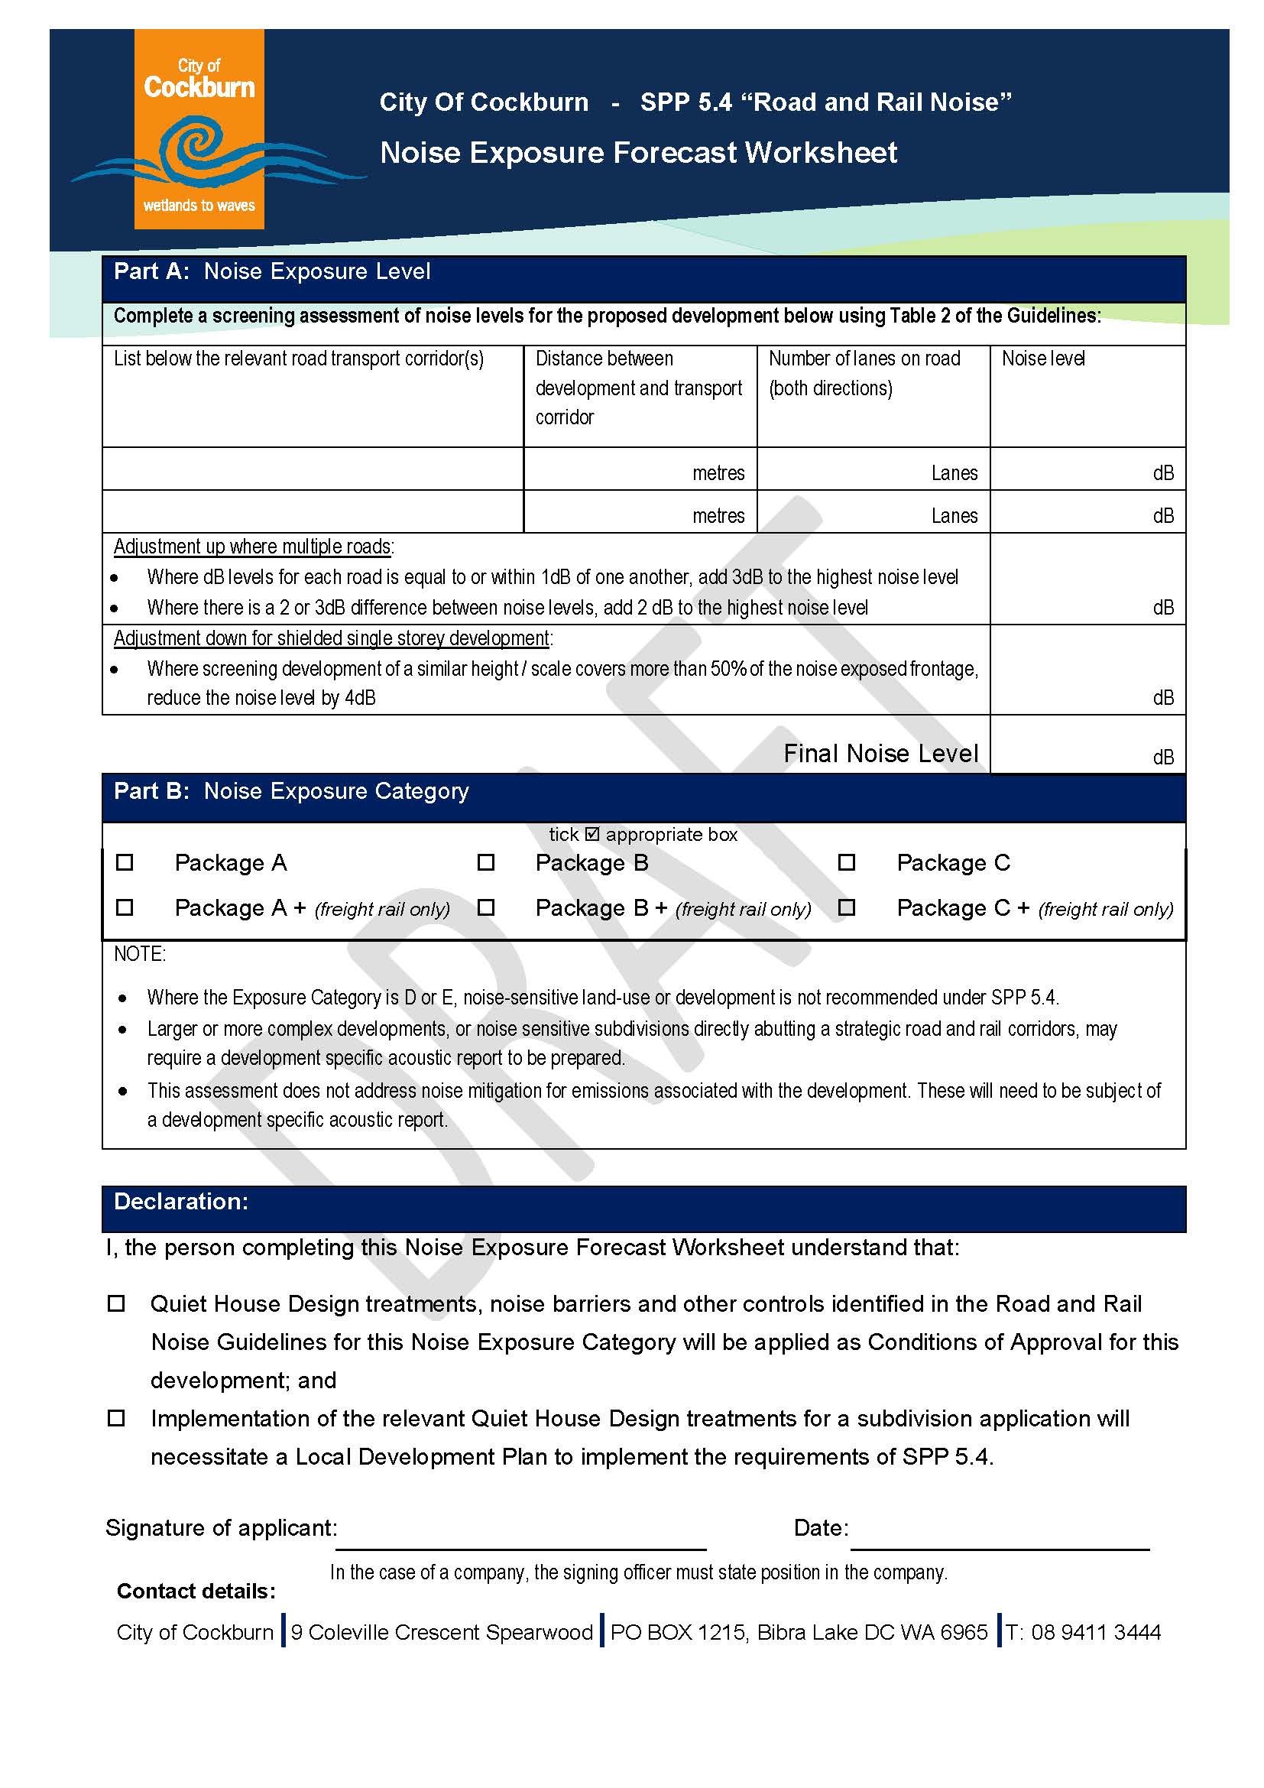

Strategic Link: | Town Planning Scheme No. 3
Category | Planning - Town Planning & Development
Lead Business Unit: | Statutory Planning
Public Consultation:  (Yes or No) | Yes
Adoption Date:  (Governance Purpose Only) | 10 November 2022
Next Review Due:  (Governance Purpose Only) | November 2024
ECM Doc Set ID:  (Governance Purpose Only) | 4518974

