**Cockburn Coast**

**Robb Jetty and Emplacement Precincts Development Contribution Plan 14 (DCP 14) Report**

**2023/24**

**Table of Contents**

Development Contribution Area 3

Purpose 3

Period of the plan 3

Operation of DCP 4

Application requirements 4

Items included in the plan 4

Estimated costs 7

Method of calculating contribution 8

Priority and timing of delivery 12

Payment of contributions 13

Review 13

Annexes 14

Annex 1 – Maps 15

Annex 2 – Infrastructure sheets 21

Annex 3 – Cost Apportionment Schedule (CAS) 32

Annex 4 – Capital Expenditure Plan (CEP) 38

Annex 5 – Schedule of Costs 39

Acknowledgement of Country

The Mayor, Councillors and staff of the City of Cockburn acknowledge the Whadjuk Nyungar people of Beeliar boodja as the traditional custodians of this land. We pay our respect to the Elders, past and present.

**Cockburn Coast: Robb Jetty and Emplacement Precincts Development Contribution Plan Report**

Note: This report does not form part of the planning scheme but provides the rationale and justification for the Development Contribution Plan (DCP), the calculation of costs, and the cost apportionment schedule specifying the costs for each owner.

# Development Contribution Area

The Development Contribution Area (DCA) is shown on the Scheme Map as: ‘DCA 14’

# Purpose

The purpose of the DCP Report is to:

1. enable the applying of infrastructure contributions for the development of new, and the upgrade of existing infrastructure which is required because of increased demand generated in the DCA
2. provide for the equitable sharing of the costs of infrastructure and administrative items between owners
3. ensure that cost contributions are reasonably required because of the subdivision and development of land in the DCA
4. coordinate the timely provision of infrastructure.

The DCP provides for the sharing of costs associated with various infrastructure necessary to support subdivision and development within Development Area 33 (Cockburn Coast) and is subject of the following Cockburn Coast Structure Plans:

1. [Cockburn Coast District structure plan 2009](https://www.wa.gov.au/system/files/2021-07/DSP-cockburn_coast.pdf)
2. Robb Jetty Local Structure Plan [**Part 1**](https://www.wa.gov.au/system/files/2024-02/robb-jetty-locl-structure-plan-33a-wapc-reference-spn_0477.pdf)
3. Emplacement Local Structure Plan[**Part 1**](https://www.wa.gov.au/system/files/2024-02/cockburn-coast-emplacement-local-structure-plan-33b-wapc-reference-spn_0478.pdf)

# Period of the plan

19 years commencing 17 March 2015 to 30 June 2034.

The plan may also be extended for further periods (with or without modification) by subsequent Scheme Amendments.

# Operation of DCP

DCP 14 has been prepared in accordance with the provisions of the City of Cockburn Town Planning Scheme No. 3 (TPS 3) and State Planning Policy 3.6 - Infrastructure Contributions (SPP 3.6). It came into effect upon the gazettal of Amendment 94 to TPS 3 on 17 March 2015.

DCP 14 operates in accordance with TPS 3 and requires landowners to make a financial contribution towards the cost of common infrastructure works within Cockburn Coast Structure Plan Areas.

The requirement to contribute under DCP 14 would typically arise as a condition of subdivision approval, however it may occur through other arrangements as specified in clause 5.3.14 of TPS 3.

DCP 14 is operational in the same area as DCP 13, which relates to community infrastructure. Landowners will be required to satisfy their contribution obligations under both DCPs.

# Application requirements

Where an application for subdivision, strata subdivision, development or an extension of land use is lodged which relates to land to which this plan applies, the local government shall take the provisions of the plan into account in making a recommendation on or determining that application.

# Items included in the plan

The DCP provides for a portion of the cost of land and works associated with the delivery of key infrastructure identified in the Cockburn Coast Structure Plan Area, to be equitably distributed between developing landowners within the DCA.

The following infrastructure items are included in the DCP as set out in Table 10 of TPS 3:

**Road and Service Infrastructure (including land):**

Cockburn Road

Upgrade of Cockburn Road (Between Rollinson Road and McTaggart Cove) including the following:

* Land required for Cockburn Road widening (between Rollinson Road and McTaggart Cove)
* Construction of the signalised intersection, traffic management devices and drainage infrastructure associated with the proposed Robb Jetty Main Street
* Relocation of service infrastructure because of the intersection construction
* Provision of a pedestrian foot path and landscaping along Cockburn Road (between Rollinson Road and McTaggart Cove)

Main Street

Provision of a Main Street between Cockburn Road intersection and Robb Road as follows:

* Acquisition of 6m of land for the full length of the Main Street (over and above land requirement for a local road)
* Over and above construction requirements (granite paving or similar, landscaping, lighting, street furniture)
* Construction of an at-grade rail crossing including vehicle and pedestrian signalisation associated with the new Robb Road intersection
* Fencing (of a sufficient length to deter unsafe pedestrian crossing)

Bus Rapid Transit Route

Provision of a north-south spine road required to service the project area with Bus Rapid Transit (BRT) infrastructure.

Upgrade of a section of Rollinson Road and construction of north-south spine road for future BRT service:

* Acquisition of Lots 18 Garston Way and 0.5m of land the full length of the route (over and above land requirement for a local road)
* Over and above construction requirements including stations (raised platform stops), IT, roadway (priority lane or queue jumper), landscaping and street furniture

Rollinson Road Pedestrian Signals (Rail)

Upgrade of the Rollinson Road pedestrian crossing to provide safe east-west pedestrian access across the railway.

Provision of an upgraded pedestrian crossing comprising:

* Pedestrian signals
* Fencing (of a sufficient length to deter unsafe pedestrian crossing)
* Pavement

**Public Realm and Environmental Improvements**

Land for Public Open Space

Acquisition of land required for public open space (POS) within the Robb Jetty Precinct and Emplacement Precinct.

The Robb Jetty and Emplacement Precinct Local Structure Plans allocate at least 10% of the gross subdividable land area for POS.

The area to be acquired (excluding existing reserves) is as follows:

* 28,582m2 of public open space within the Robb Jetty Precinct
* 18,936m2 of public open space within the Emplacement Precinct

This area includes land for:

* active and passive recreation,
* dual purpose POS and drainage
* drainage

Contamination and remediation measures are not included in this DCP.

Public Open Space Improvements

Enhancement of Public Open Space to service the needs of existing and future residents within the Robb Jetty Precinct and Emplacement Precinct.

To construct Local Parks, Neighbourhood Parks, and a District Park in accordance with the Robb Jetty Precinct and Emplacement Precinct local structure plans within the project area as follows:

* Local Parks (LP1 to LP9)
* Neighbourhood Parks (NP1 to NP8)
* District Park (DP1)

Contamination and remediation measures are not included in this DCP.

**Main Street “Local” Community Building**

Provision of a local community building near the Robb Jetty Main Street to service the needs of the project area.

The new Community Building is to be located next to the public open space and commercial core of the Cockburn Coast. The building and outside areas will provide 2,000m2 of community use over ground/upper floors on a 1,000m2 site.

The abovementioned infrastructure represents typical subdivision works, however given the fragmentation of land in the precinct and the scale of some infrastructure it is not reasonable to expect one subdivider to fund the infrastructure.

The cost of infrastructure includes all the initial capital costs associated with the provision of the infrastructure item and excludes ongoing maintenance and operating costs of the infrastructure.

Maps detailing the proposed location of the infrastructure included within this DCP are included in Annex 1 – Maps.

# Estimated costs

The DCP overall estimated cost of land and infrastructure works is **$44,230,888** (as of 16 October 2023).

A detailed summary of the cost breakdown for each infrastructure item is included in Table 2 Summary Sheet and Annex 4 – Schedule of Costs.

Cost estimates have been based on the best information available to the city at the time from similar projects (where an Order of Probable Costs from a Quantity Surveyor or a recently tendered cost is available) or from a specific Quantity Surveyor’s assessment or tender.

As provided for in the DCP, the cost of the infrastructure item will be reviewed at least annually. If during the year more detailed costings have been prepared, then these would be adopted in preference to broad based estimates. In all other instances the cost estimates will be adjusted to reflect current pricing and the cost indexed based on the Building Cost Index or other appropriate index as approved by an appropriately qualified independent person.

# Method of calculating contribution

All landowners within DCP 14 shall contribute to land and infrastructure works required as part of the development of the Robb Jetty and Emplacement Precinct Development Contribution Areas (except for the Mixed Business Zone).

The area which benefits from the infrastructure items can be seen in DCA14 Scheme Map

The proportional contribution is to be determined in accordance with the provisions of clause 5.3 of TPS 3.

**Cost Apportionment for the Mixed Business Zone**

Owners of land within the Mixed Business zone are not required to contribute towards:

* the cost of land for public open space
* public open space construction
* or local community facilities

All owners are required to contribute towards the costs of upgrading all DCP roads, service infrastructure and DCP administration costs.

Cost contributions for the owners of land in the Mixed Business zone shall be based on the proportion that the land the subject of the contribution bears to the total area of land within the DCA for which the cost contributions have yet to be made unless otherwise specified.

Contributions shall be calculated on a per meter square basis in accordance with the Cost Apportionment Schedule.

Notwithstanding DCP 14, applications for continuance or extension of existing non-conforming uses will be exempt from development contributions towards this DCP.

**Development Potential and Cost Apportionment Calculation for all other Zones and R-Codes**

A landowner’s contribution will be calculated based on the proportion of potential dwellings that can be constructed on the land the subject of the contribution bears to the total number of potential dwellings within the DCA.

The calculation incorporates the ‘potential dwelling’ methodology in the Development Contribution Plan and the ‘contribution summary per landholding’ methodology in the Cost Apportionment Schedule.

|  |  |
| --- | --- |
| **Zoned/R-Code** | **Method for calculating the potential dwellings** |
| District Centre R-ACO (R160 equivalent) | 1x equivalent dwellings per 62. 5m2 of net land area |
| Mixed Use (R100 equivalent) | 1x equivalent dwellings per 100m2 of net land area |
| R40 | 1x dwellings per 220m2 of net land area |
| R80 | 1x dwellings per 125m2 of net land area |
| R100 | 1x dwellings per 100m2 of net land area |
| R160 | 1x dwellings per 62.5m2 of net land area |

Notwithstanding Clause 5.3.13 of the TPS 3, applications for continuance or extension of existing non-conforming uses will be exempt from development contributions.

The Cockburn Coast: Robb Jetty Precinct and Emplacement Precincts development provisions under ‘Development Area 33’ of TPS 3 require all subdivision and development to achieve at least 85% of the potential number of dwellings achievable under the R-Code designated for the application area on the adopted Local Structure Plan.

Contributions shall be calculated on the potential number of dwellings constructed on site.

The adopted contribution rate for DCP 14 is $14,530 per potential lot or dwelling, and has been determined as follows:

*Contribution Rate ($/potential dwelling) = (Total DCP Cost – Contributions Received) / Remaining Potential Dwellings (85% yield)*

Calculation of an owner’s contribution will be based on the potential developable land area divided by the density potential (as listed in Table 10 of TPS 3) as per designated R-Codes, as follows:

*Owner’s Cost Contribution = Potential developable Area of Subject Site / density potential x contribution rate*

Calculation Examples:

Lot 65 (13) Rollinson Road North Coogee

|  |  |  |  |  |  |
| --- | --- | --- | --- | --- | --- |
| **Characteristics:** Development of site identified by the LSP with Public Open Space and Varying Zonings and R-Codes | | | | | |
| **Developable Area** | | | | | |
| **Gross Area** | 17,308m2 | |  | | |
| **POS Provided\*** | 4,093m2 | |
| **Local Roads** | 1,632m2 | |
| **DCP Roads** | 185m2 | |
| **Net Area** | 11,399m2 | |
| **Minimum Development Potential @ 85%** | | | | | |
| **Mixed Use: R100 @ 85%** | | 2,780m2 / 100m2 x 0.85 | | | 23.63 |
| **R100 @ 85%** | | 8,619m2 /100m2 x 0.85 | | | 73.26 |
| **Total Yield** | | | | | **96.89** |
| **Cost Contributions** | | | | | |
| **Contribution**  96.89 dwellings @ $14,530per unit | | | | $1,407,811* | |
| **POS offset:** 4,093m2 | | | | $2,218,406* | |
| **DCP roads offset:** 185m2 | | | | $100,270* | |
| **Total contribution** | | | | **$910,865 In Credit\*\*** | |
| *\*Example only – all cost estimates based on October 2022*  *\*\*Owners that are in credit will be refunded by the DCP in the order the credits were received and as funds become available.* | | | | | |

Lot 69 (43) Rollinson Road

|  |  |  |  |  |  |
| --- | --- | --- | --- | --- | --- |
| **Characteristics:** Development of site identified by the LSP with no Public Open Space and R160 density coding | | | | | |
| **Developable Area** | | | | | |
| **Gross Area** | 14,996m2 | |  | | |
| **POS Provided\*** | 0m2 | |
| **Local Roads** | 0m2 | |
| **DCP Roads** | 0m2 | |
| **Net Area** | 14,996m2 | |
| **Minimum Development Potential @ 85%** | | | | | |
| **Mixed Use: R160 @ 85%** | | 14,996m2 / 62.5m2 x 0.85 | | | 204 |
| **Total Yield** | | | | | **204** |
| **Cost Contributions** | | | | | |
| **Contribution**  204 dwellings @ $14,530 per unit | | | | $2,964,120* | |
| **POS offset:** | | | | $0 | |
| **DCP roads offset:** | | | | $0 | |
| **Total contribution** | | | | **$2,964,120** | |
| *\*Example only – all cost estimates based on October 2023.* | | | | | |

**Land Acquisitions**

The DCP 14 land requirements identified within the Cockburn Coast Structure Plan area is **$20,898,075,** as calculated in accordance with the valuation rates ($/m²) as set out in Table 6 Emplacement Crescent and Table 5 Robb Jetty Land Valuations in accordance with the following formula:

*Land Acquisition Cost = Land Take Area x Valuation Rate ($/m²)*

**Road and Service Infrastructure:**

The DCP 14 estimated cost for the key roads including landscaping identified within the Cockburn Coast Structure Plan Area is **$11,779,499.**

A summary of the cost breakdown for each infrastructure item is included in Table 2 Cost Summary Roads and Infrastructure and Annex 5 – Schedule of Costs.

**POS Construction**

The total estimated cost of landscaping is **$9,289,321,** a summary of the cost breakdown is included in Table 3 Cost Summary Public Realm and Environmental Improvements and Annex 5 – Schedule of Costs.

**Main Street “Local” Community Building**

The total estimated cost attributable to the Robb Jetty and Emplacement Precints for the provision of the local community building near the Robb Jetty Main Street is **$12,107,930,** a cost summary of the cost breakdown is included in Table 4 Cost Summary Local Community Building and Annex 5 – Schedule of Costs.

# Priority and timing of delivery

The DCA14 infrastructure is a significant capital works project, the current priority and timing for which is determined by the following:

1. City of Cockburn Strategic Community Plan [Strategic Community Plan 2020-2030](https://www.cockburn.wa.gov.au/getattachment/6ce4d95e-356d-4a2d-855b-7c3667cecdbd/attachment.aspx)

*Previously the City’s Plan for the District*

1. City of Cockburn [Long Term Financial Plan (LTFP) 2020-21 to 2029-30](https://www.cockburn.wa.gov.au/getattachment/879146af-ab7a-43d4-bd4f-5459cd98e4b0/ECM_9540447_v2_Long-Term-Financial-Plan-(LTFP)-2020-21-to-2029-30-(attachment-for-SCM-23-July-2020)-pdf.aspx) provides a ten year view of the financial position of the City
2. City of Cockburn [Regional Major Roadworks Map](https://www.cockburn.wa.gov.au/getattachment/43fcc1bc-1365-4661-a892-8a4ba487c123/ECM_10044878_v1_Regional-and-Major-Roadworks-2018-2031-Map-pdf.aspx)

The infrastructure items included in the plan needs to be demand driven and if development within the Rob Jetty and Emplacement Precincts is yet to proceed to a sufficient extent, the City will need to consider what the optimal timing of the infrastructure should be.

The details of the priority/timing which is based on the above can be seen in Annex 3 – Capital Expenditure Plan (CEP).

Note: these dates and timeframes are subject to change

# Payment of contributions

Payment of contributions are in accordance with the provisions of clause 5.3.14 of TPS 3:

5.3.14.1 The owner, with the agreement of the local government, is to pay the owner’s cost contribution by

1. cheque or cash
2. transferring to the local government or a public authority land in satisfaction of the cost contribution
3. the provision of physical infrastructure
4. some other method acceptable to the local government; or
5. Any combination of these methods.

5.3.14.2 The owner, with the agreement of the local government, may pay the owner’s cost contribution in a lump sum, by instalment or in such other manner acceptable to the local government.

5.3.14.3 Payment by an owner of the cost contribution, including a cost contribution based upon estimated costs in a manner acceptable to the local government constitutes full and final discharge of the owner’s liability under the development contribution plan and the local government shall provide certification in writing to the owner of such discharge if requested by the owner.

# Review

The plan will be reviewed five years from the date of gazettal of the local planning scheme or amendment to the local planning scheme to incorporate the plan, or earlier should the local government consider it appropriate, having regard to the rate of development in the area and the degree of development potential still existing.

The estimated infrastructure costs as shown in the Cost Apportionment Schedule (CAS) will be reviewed at least annually to reflect changes in funding and revenue sources and indexed based on the Building Cost Index or other appropriate index as approved by the qualified person undertaking the certification of costs.

# Annexes

1. Maps
2. Infrastructure Sheets
3. Cost Apportionment Schedule (CAS)
4. Capital Expenditure Plan (CEP)
5. Schedule of Costs

# Annex 1 – Maps

Scheme Map

i

in

Rob Jetty Structure Plan map depicting the location of POS and Community Centre

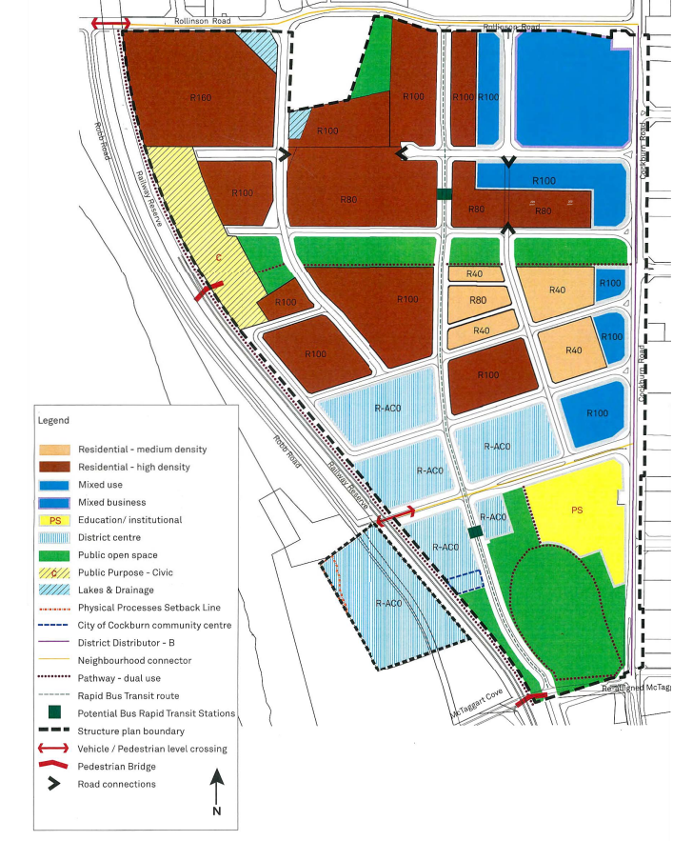

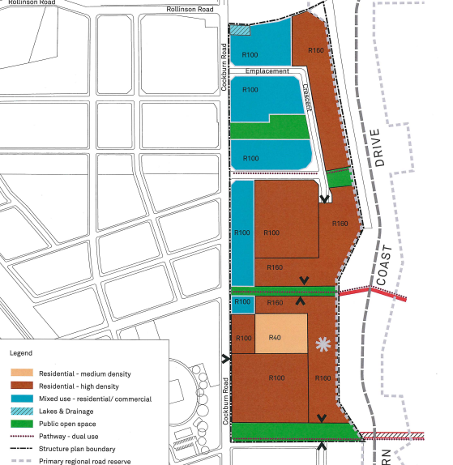

Emplacement Structure Plan map depicting the POS location

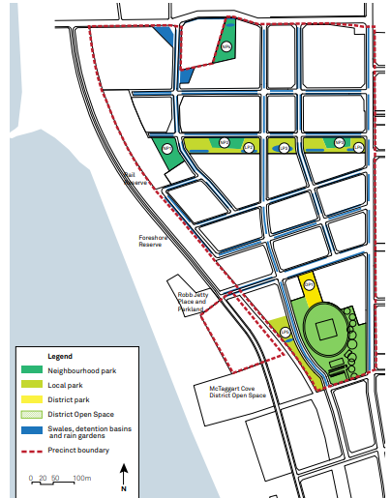

Map depicting the location of park types within Robb Jetty Precinct

Map depicting the location of park types within Emplacement Precinct

Park types

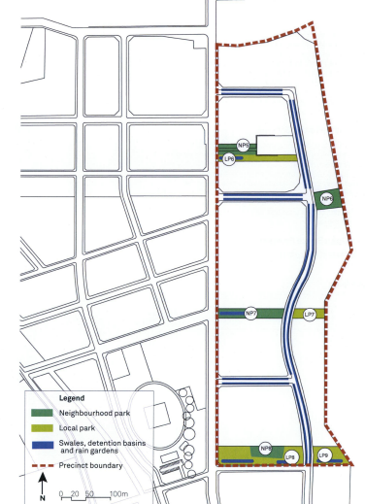

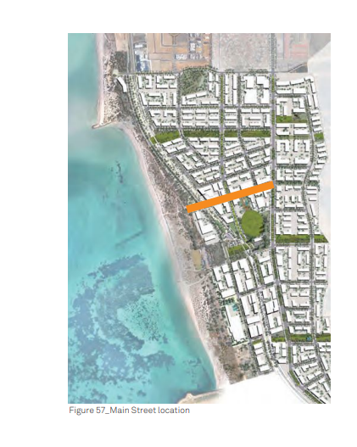

Aerial map depicting the BRT location

Map depicting Main Street location

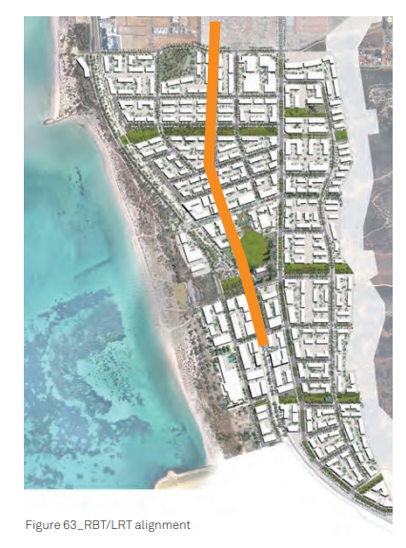

# Annex 2 – Infrastructure sheets

**Road and Services Infrastructure**

**Cockburn Road**

|  |  |
| --- | --- |
| **Proposal** | Upgrade to Cockburn Road and nominated intersections required to accommodate additional traffic movement generated by the project area. |
| **Scope** | Upgrade of Cockburn Road (Between Rollinson Road and McTaggart Cove) including the following:   * 3,850m2 of land required for Road widening (between Rollinson Road and McTaggart Cove) * Construction of the signalised intersection, traffic management devices and drainage infrastructure associated with the proposed Robb Jetty Main Street * Relocation of service infrastructure because of the intersection construction * Provision of a pedestrian foot path and landscaping along Cockburn Road (between Rollinson Road and McTaggart Cove) |
| **Need and Nexus** | Cockburn Road is critical to transport planning for the Cockburn Coast Project as it is the primary north-south road through the project area. It connects Coogee to the south and Fremantle to the north and functions as a primary north- south route for freight and regional traffic. Given its regional function Main Roads have a management order over the Cockburn Road carriageway (excluding verges).  The Cockburn Coast development will accommodate over 4-5,000 new dwellings (along with a mixture of commercial uses) over a 20-year timeframe (by 2031) thus creating additional traffic on Cockburn Road. Together with increasing existing regional traffic, the Integrated Transport Plan for the Cockburn Coast project recommends that Cockburn Road be expanded to four lanes for its entire length within the project area over the long term. However, should Cockburn Coast Drive be constructed, the ITP identifies that Cockburn Road will only need to be two lanes.  Access to the project area relies on Cockburn Road and on this basis, the upgrade of Cockburn Road is fundamental for the future of the project area but also in a regional context given the significance of the road. The scope of upgrades required for Cockburn Road has been dependent on the planning for Cockburn Coast Drive.  Originally, regional traffic was intended to be accommodated by the proposed Cockburn Coast Drive (to the east of the project area). This scenario would have resulted in Main Roads undertaking ‘base’ upgrades to Cockburn Road and project owners funding remaining upgrades to Cockburn Road. In this scenario Cockburn Road would be classified as a local connector road.  Following recent advice from Main Roads confirming that Cockburn Coast Drive would not be progressed Cockburn Road will continue to play a regional role in the road network and require upgrading to four lanes. Whilst project owners, future occupants and visitors to the Cockburn Coast Project area will utilise Cockburn Road, it will primarily be a regional road in State Government control. Main Roads will therefore retain responsibility for Cockburn Road and future carriageway upgrades in accordance with the management order.  Having regard to the current regional role of Cockburn Road and Main Roads recent advice to not progress Cockburn Coast Drive, the State Government has a primary role to play in funding the upgrade of Cockburn Road. As such, the project will be responsible only for the land required for widening, new signalised intersections (required to access the project area) and landscaping within verges along Cockburn Road.  Contributions will be collected from all landowners and proposed uses within the project area.  To reflect the timing of development (particularly the Power Station Precinct), project upgrade responsibilities will be split into two DCP schemes administered by the City of Cockburn:  Robb Jetty and Emplacement Precincts (this DCP14)  Power Station Precinct (future DCP)  The DCP for the Power Station Precinct will involve a similar scope of work (as above) for the section of Cockburn Road between the McTaggart Cove intersection and Spearwood Avenue intersection. |

**Main Street**

|  |  |
| --- | --- |
| **Proposal** | Establishment of a high-quality Main Street for the project area and provision of east-west access through the project area to the foreshore. |
| **Scope** | Provision of a Main Street between the Cockburn Road intersection and Robb Road as follows:   * Acquisition of 6m of land for the full length of the Main Street (over and above land requirement for a local road) * Over and above construction requirements (granite paving or similar, landscaping, lighting, street furniture) * Construction of an at-grade rail crossing including vehicle and pedestrian signalisation associated with the new Robb Road intersection * Fencing (of a sufficient length to deter unsafe pedestrian crossing) |
| **Need and Nexus** | The Robb Jetty Main Street is an important road access and core place making component of the project area. It connects Cockburn Road (the primary north south access to the project) to the foreshore via a new at grade rail crossing. It will play a key role in providing vehicle and pedestrian access to the foreshore for both the Robb Jetty and Emplacement Precincts.  The Main Street will also provide an essential mix of uses including commercial use (local goods and services) and employment opportunities for the local population.  Given the scale of proposals within the Cockburn Coast and regional appeal of the location it is necessary to provide a high-quality public realm and urban design outcome. Achieving a high-quality setting and Main Street is very important for the attractiveness and viability of this location for commercial and employment generating uses.  The Main Street plays a key role in achieving the sustainable planning and vibrant community outcome envisaged for the Robb Jetty and Emplacement Precincts and is necessary to support the dense residential population proposed and encourage visitors to the area. The specification of the Main Street enhancements is required to be of sufficient quality to meet future residential population and visitor expectations.  The DCP therefore includes the additional land required to establish a high-quality Main Street which is attractive and safe for visitors as well as functional from a commercial point of view.  This includes the requirement for full verge pavements, appropriate street lighting, pedestrian crossing treatments, bike stands, planting and landscaping that distinguishes the Main Street from typical local access roads in the project area. Fencing associated with the rail crossing will be of a sufficient length to deter unsafe pedestrian crossing.  Adjoining landowners will fund the equivalent cost of a typical local road. |

**Bus Rapid Transit Route**

|  |  |
| --- | --- |
| **Proposal** | Provision of a north-south spine road required to service the project area with Bus Rapid Transit (BRT) infrastructure. |
| **Scope** | Upgrade of a section of Rollinson Road and construction of north-south spine road for future BRT service:   * Acquisition of Lots 18 Garston Way and 0.5m of land the full length of the route (over and above land requirement for a local road) * Over and above construction requirements including stations (raised platform stops), IT, roadway (priority lane or queue jumper), landscaping and street furniture. |
| **Need and Nexus** | The BRT route is required to support and service the project area. Cockburn Coast is part of a Transit Oriented Development (TOD) because of the introduction of the Bus Rapid Transit (BRT).  Only one bus service (service 825) currently runs north-south along the extent of the Cockburn Coast study area between Fremantle Station and Rockingham Station.  The frequency of this service is limited with a maximum of two services operating in the peak hours. On this basis, a fundamental consideration in ensuring the success of the project is effective public transport.  The BRT will help encourage public transport use within Cockburn Coast and will reduce the reliance on private car travel, additional the BRT can provide a similar service quality to rail (speed, reliability, and comfort).  The local, district and regional services that currently operate in the study area will remain and will benefit from being able to use the dedicated facilities on the BRT route.  As it provides certainty through investment in infrastructure while still being cost effective, the BRT is the favoured approach to servicing the Cockburn Coast and surrounding communities.  Access to frequent public transit is necessary to support the density of population and scale of commercial uses envisaged for the Cockburn Coast Project.  As all landowners benefit from the ability to develop to a high density which generates the need for public transport infrastructure, it is justified the project landowners fund the additional land requirement needed to provide the BRT route (above a typical local access road reserve) and associated supporting infrastructure such as bus shelters and additional pavement and landscaping requirements.  Adjoining landowners will fund the equivalent cost of a typical local road. |

**Rollinson Road Pedestrian Signals (Rail)**

|  |  |
| --- | --- |
| **Proposal** | Upgrade of the Rollinson Road pedestrian crossing to provide safe east-west pedestrian access across the railway. |
| **Scope** | Provision of an upgraded pedestrian crossing comprising:   * Pedestrian signals * Fencing (of a sufficient length to deter unsafe pedestrian crossing) * Pavement |
| **Need and Nexus** | Rollinson Road is one of two existing rail crossings to the foreshore. Given increasing freight movements and future intensification of the area with residential development it is necessary to upgrade of the pedestrian crossing to provide safe access to the foreshore. This upgrade will benefit all landowners and meet the future residential populations (and visitors) expectations. |

**Public Realm and Environmental Improvements**

**Land for Public Open Space**

|  |  |
| --- | --- |
| **Proposal** | Acquisition of land required for public open space (POS) within the Robb Jetty Precinct and Emplacement Precinct. |
| **Scope** | The Robb Jetty and Emplacement Precinct Local Structure Plans allocate at least 10% of the gross subdividable land area for POS.  The area to be acquired (excluding existing reserves) is as follows:   * 28,582m2 of public open space within the Robb Jetty Precinct * 18,936m2 of public open space within the Emplacement Precinct   This area includes land for:   * active and passive recreation, * dual purpose POS and drainage * drainage   Contamination and remediation measures are not included in this DCP. |
| **Need and Nexus** | Pursuant to Clause 20A of the *Town Planning and Development Act 1928* (as amended) a minimum of 10% of gross subdividable land is required to be given up free of cost by the subdivider for Public Open Space (POS).  Where a structure plan indicates the location of POS, sites without POS identified are required to make cash payment in lieu of providing land for open space. In these circumstances cash-in-lieu funds are collected by the local authority and placed in a standalone bank account and expended on either acquiring land in the locality for POS or making improvements to POS.  The DCP includes all land requirements for public open space (minimum 10% required) to ensure equitable apportionment of costs associated with meeting statutory requirements. Including these costs in the DCP will not only avoid duplication of administration costs for the City of Cockburn, however, increase the effectiveness and transparency of the DCP as a consolidated coordination mechanism for the equitable cost sharing of traditional project related costs.  Together with the capital expenditure plan accompanying the DCP, the detailed costings and scope for landscape costs provide increased transparency for landowners (than the traditional cash in lieu arrangement) as the intent and timing for public open space enhancements are set out very clearly. |

**Public Open Space Improvements**

|  |  |
| --- | --- |
| **Proposal** | Enhancement of Public Open Space to service the needs of existing and future residents within the Robb Jetty Precinct and Emplacement Precinct. |
| **Scope** | To construct Local Parks, Neighbourhood Parks, and a District Park in accordance with the Robb Jetty Precinct and Emplacement Precinct local structure plans within the project area as follows:  **Local Parks (LP1 to LP9)**  Local Parks should be provided for local children’s play and as resting places, designed as small intimate spaces, where appropriate, to allow pedestrian connectivity, and create a sense of place.  Local parks are less intensively developed park areas for the local community to enjoy. They are predominantly lawn and planted areas with pockets of paved areas for seating nodes and winding pathways. Planted garden beds are predominantly endemic species to attract native wildlife.  Adequate shade should be provided through structures and trees to provide comfortable resting spaces for people to enjoy.  The proposal includes:   * + Minor earthworks and drainage   + Irrigated planting   + Irrigated turf   + Paved areas (stone and concrete areas)   + Footpaths (in-situ concrete, stabilized gravel)   + Custom and proprietary play equipment   + Furniture (benches, shelters, bins, bike racks, water fountains, BBQ’s, exercise equipment)   + Lighting and electrical   + Interim Maintenance (to facilitate handover to Council)   **Neighbourhood Parks (NP1 to NP8)**  The Robb Jetty and Emplacement precincts have eight proposed neighbourhood parks which have been strategically located so that all residents are within close walking distance to a neighbourhood park.  The neighbourhood park is to act as a “backyard” for families to enjoy and to promote interaction with the local community. Neighbourhood parks are designed to promote an active lifestyle with play equipment for youth and children, sporting facilities, general open kick around areas and BBQ facilities.  Plentiful shade and seating should be provided to create comfortable enjoyable places for people to rest. Neighbourhood parks should be designed to allow passive surveillance through CEPTED principles to provide a safe space for people to enjoy day and night. Neighbourhood parks should be predominantly lawn and garden bed areas to provide a tranquil place of refuge with pockets of paved areas at seating nodes.  Neighbourhood Parks are to include the following works:   * + - Minor earthworks and drainage     - Irrigated planting     - Irrigated turf     - Paved areas (stone and concrete pavers)     - Footpaths (in-situ concrete, stabilized gravel)     - Furniture (benches, shelters, bins, bike racks, water fountains, BBQ’s, exercise equipment)     - Lighting and electrical     - Interim Maintenance (to facilitate handover to Council)   **District Park (DP1)**  There is one District Park in the project area, nominally named ‘Heritage Plaza’. The Heritage Plaza is a high-quality urban space with the focus on the heritage Robb Chimney element.  A potential interactive water feature can provide playfulness whist reflecting the Chimney, emphasising its scale. Resting opportunities with shade and seating will make this space a tranquil escape from the proposed vibrant development.  This space interfaces with Main Street to the north and the Community infrastructure associated with the sports oval to the south (refer to Community infrastructure DCP 13).  The District Park will incorporate the following works:  **District Park 1**   * Minor earthworks and drainage * Irrigated planting * Paved areas (stone and concrete pavers) * Footpaths (in-situ concrete, stabilised gravel) * Custom and proprietary play equipment * Furniture (benches, shelters, bins, bike racks, water fountains, barbeques) * Water features * Lighting and electrical * Interim Maintenance (to facilitate handover to Council)   **Consultancy Fees**  Consultant input is required to design, plan, and deliver the public open spaces. Consultant costs include:   * Design Consultancy (e.g., Landscape Architecture etc.) * Project Management   Contamination and remediation measures are not included in this DCP |

**Main Street “Local” Community Building**

|  |  |
| --- | --- |
| **Proposal** | Provision of a local community building near the Robb Jetty Main Street to service the needs of the project area. |
| **Scope** | To construct a new Community Building adjacent to the public open space and commercial core of the Cockburn Coast. The building and outside areas will provide 2,000m2 of community use over ground/upper floors on a 1,000m2 site. |
| **Need and Nexus** | The Cockburn Coast District Structure Plan envisages that circa 10,000 future residents will reside in approximately 5,000 dwellings within the project area.  Liveable Neighbourhoods outlines that site for community purposes such as community centres, meeting halls, branch libraries and kindergartens are increasingly important for community development. The document recommends that community purpose sites should generally be provided based on one for each group of three neighbourhoods (1500-1800 dwellings) located wither adjoining public open space or in centres.  There is expected to be a significant increase in population and demand for community facilities in the locality. Further, other local community centres will not be able to support the Cockburn Coast population.  Based on Liveable Neighbourhood recommendations, the resultant community will therefore require the development of a Community Building to satisfy local community needs of the area. The building has been designed to accommodate the needs of a 10,000-person community. For comparative purposes, the size of the community building required would be double the size and capacity of the local community facility located in Port Coogee which has been designed to serve a smaller population.  Given that the local community building will also serve future residents of the Power Station  Precinct, the cost of the facility will be apportioned to reflect the planned number of dwellings within each precinct.  The following identifies the number of dwellings envisaged by the District Structure Plan (Part 2) and subsequent apportionment of the community building cost between the two DCP areas.   |  |  |  | | --- | --- | --- | | Local Structure Plan | No Dwellings | % | | Rob Jetty | 2,439 | 47.97% | | Emplacement | 1,538 | 29.62% | | **Sub Total** | **3,977** | **76.58%** | | Power Station | 1,216 | 23,42% | | **Total** | **5,193\*** | **100.00%** |   Source: 85% Scheme approach of DCP  *Indicative total referred to in the Master Plan DCP2. |

# Annex 3 – Cost Apportionment Schedule (CAS)

Table 1 Cost Apportionment Methodology

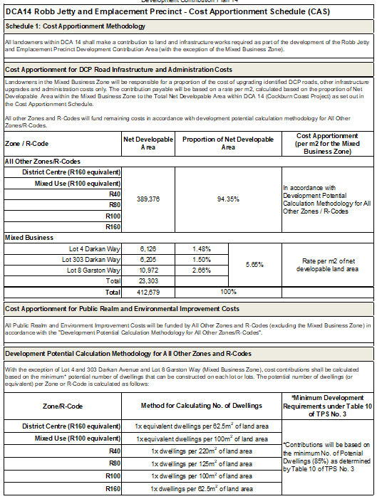

Table 2 Cost Summary Roads and Infrastructure

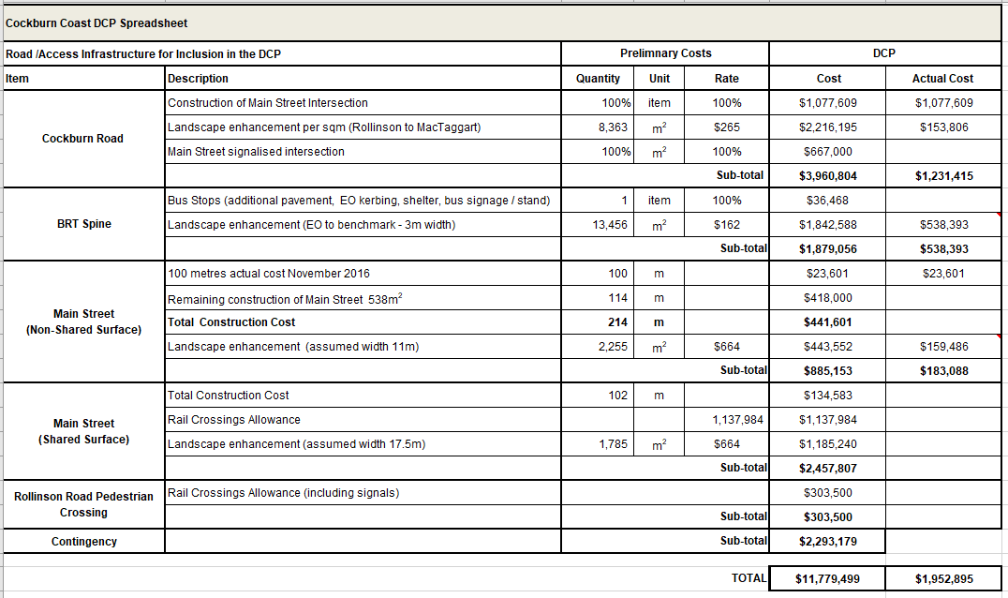

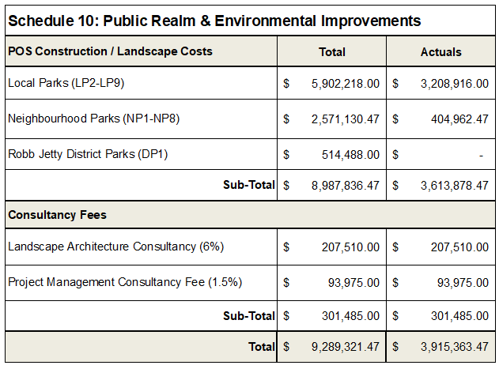

Table 3 Cost Summary Public Realm and Environmental Improvements

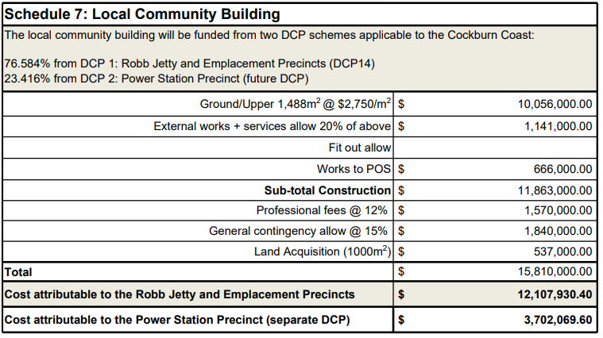

Table 4 Cost Summary Local Community Building

Table 5 Robb Jetty Land Valuations

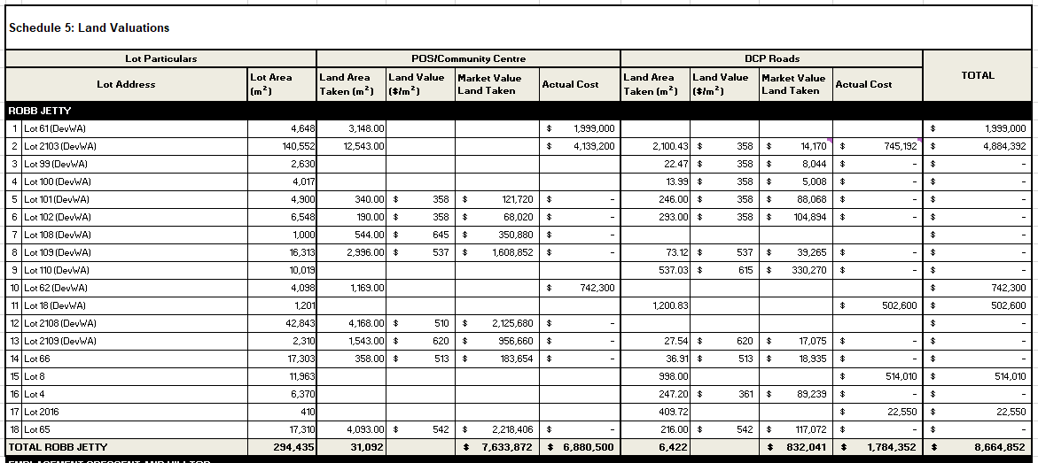

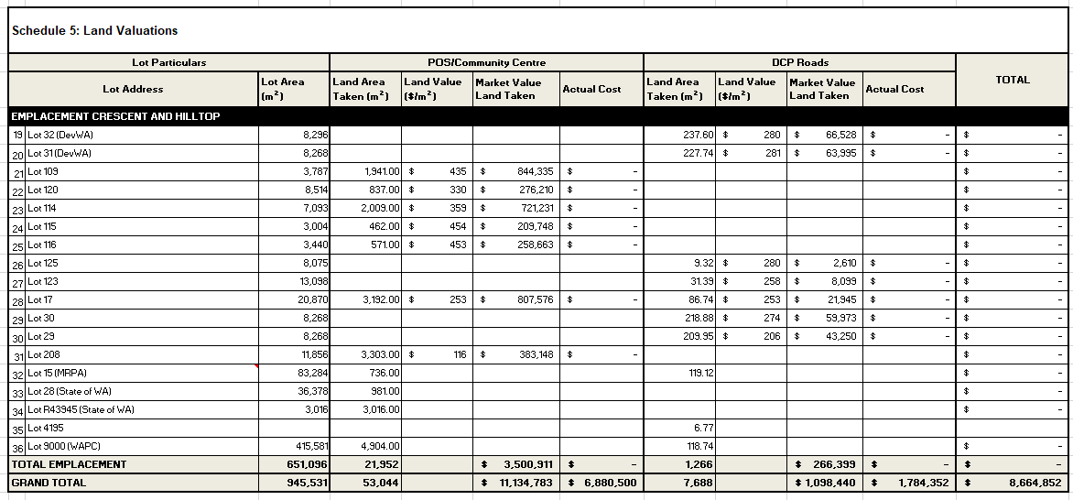

Table 6 Emplacement Crescent

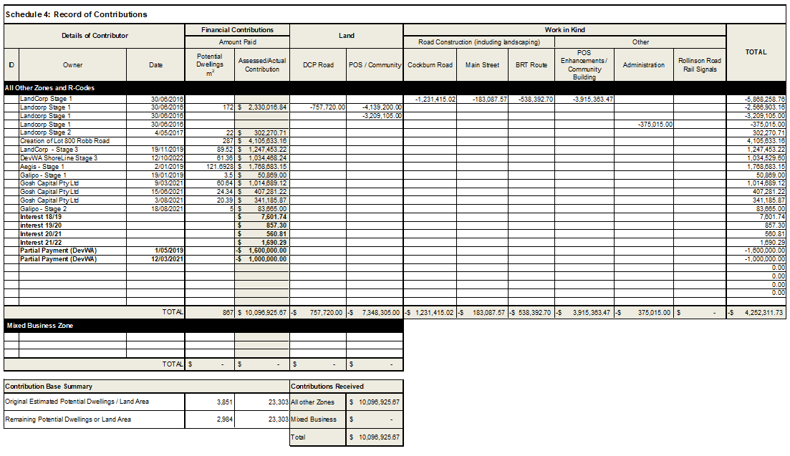

Table 7 Contribution Register

|  |  |  |
| --- | --- | --- |
| **DCP Reserve Balance as of 31 August 23** | **Note 3 Value of credits** | **Interest earned on DCP funds 2021/22** |
| 398,996 | 4,826,124 | 1,690 |

# Annex 4 – Capital Expenditure Plan (CEP)



*Notes:*

1. *Project costs = DCP element only and not full upgraded costs*
2. *Timeframe is subject to change*
3. Owners that are in credit will be refunded by the DCP in the order the credits were received and as funds become available in the reserve

The following recurring annual payment obligation for DCA14 is not included in table above:

* costs to administer cost sharing arrangements
* valuations, professional fees for infrastructure cost estimates
* annual audit and administration costs.

# Annex 5 – Schedule of Costs

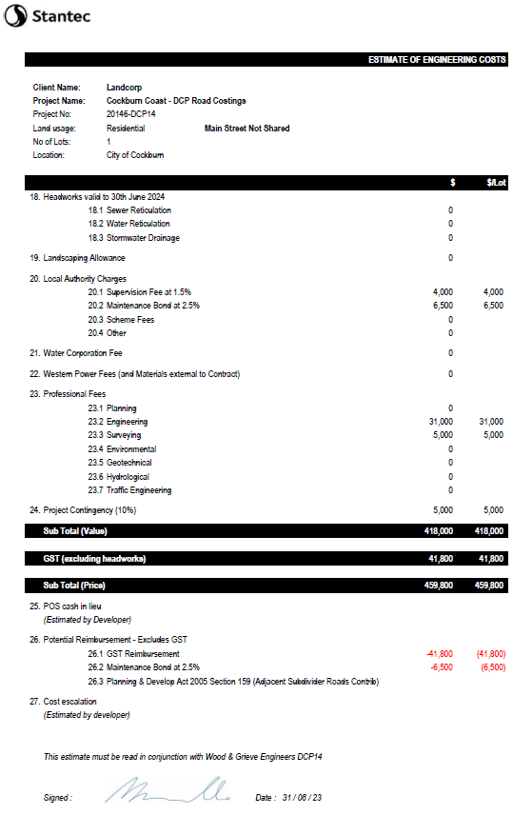

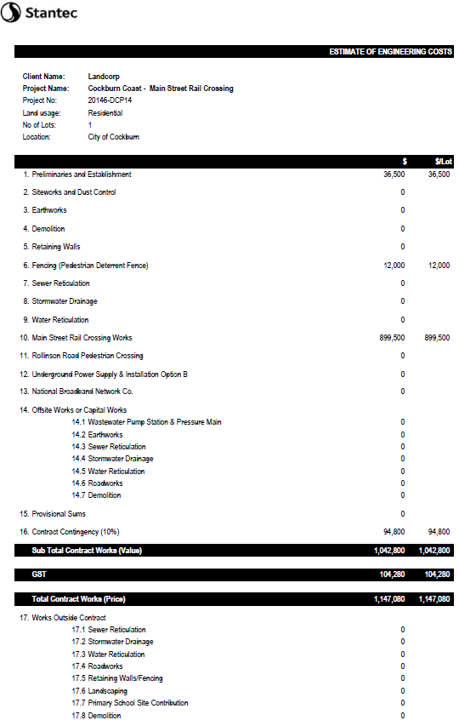

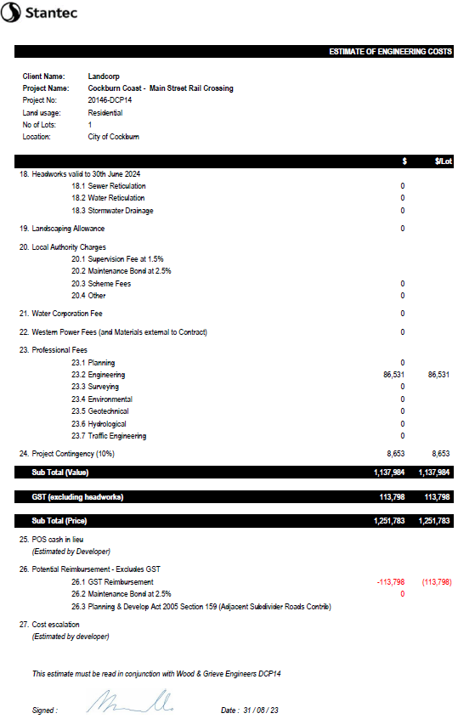

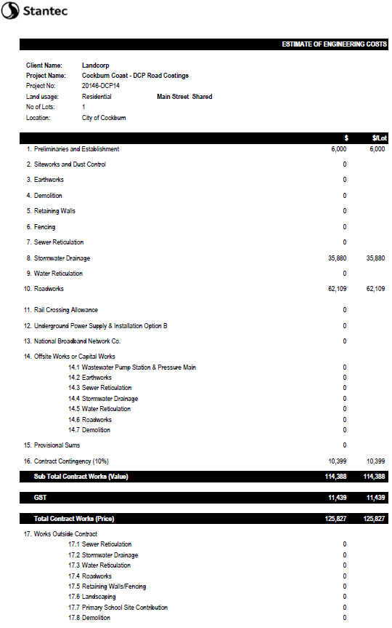

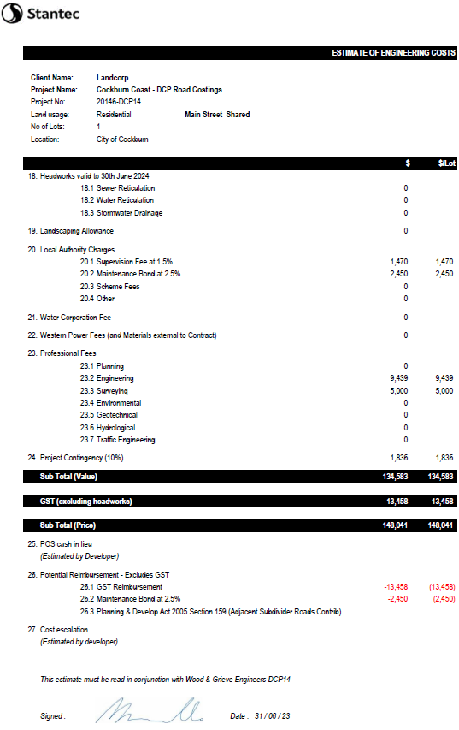

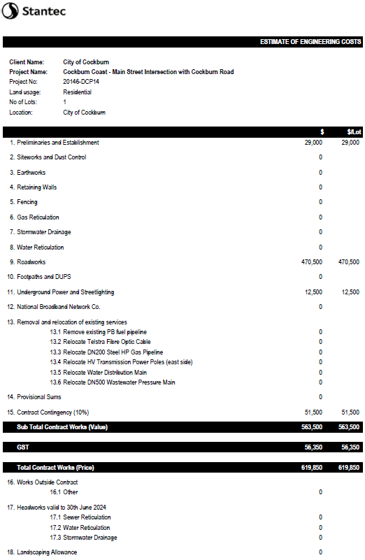

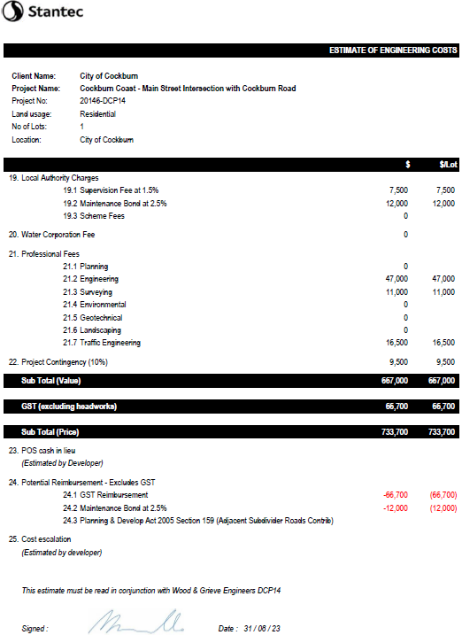

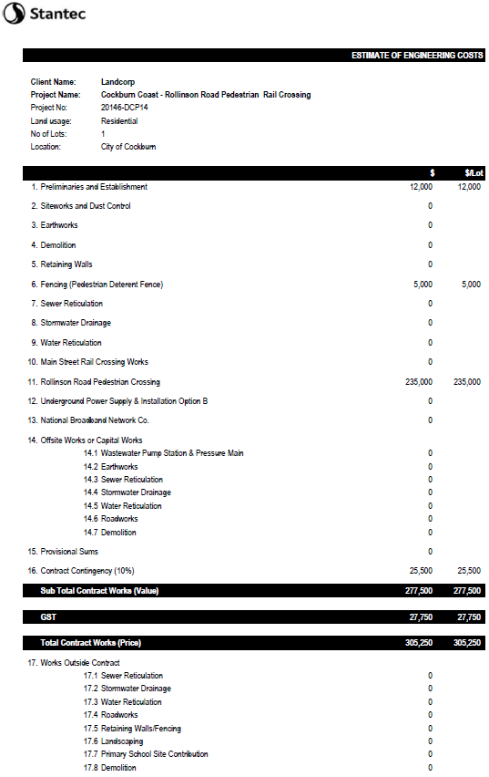

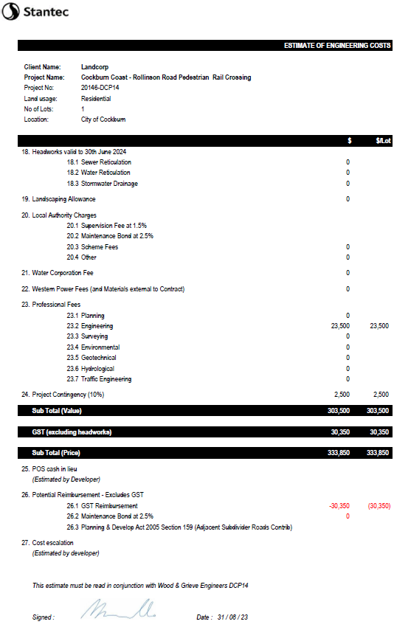

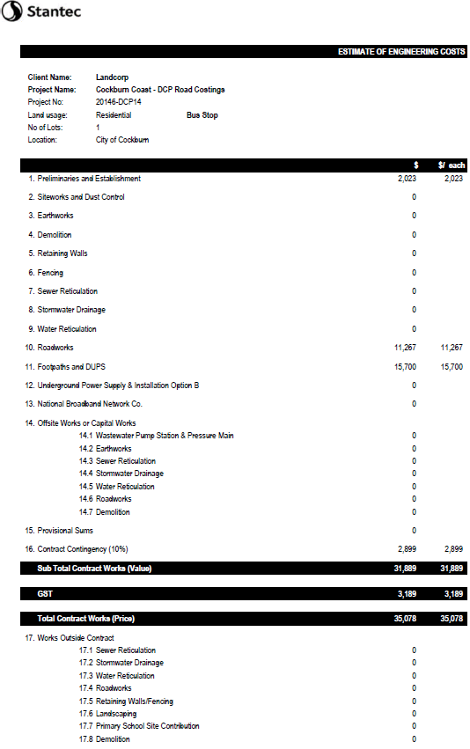

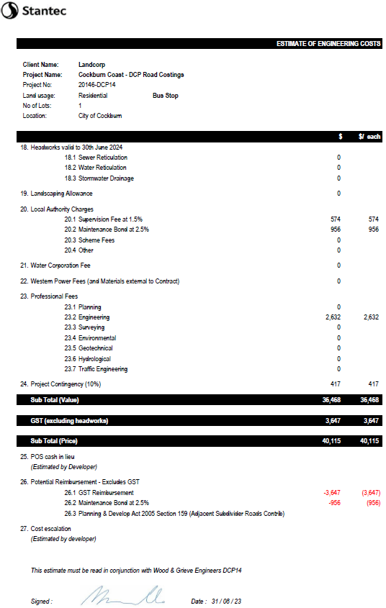



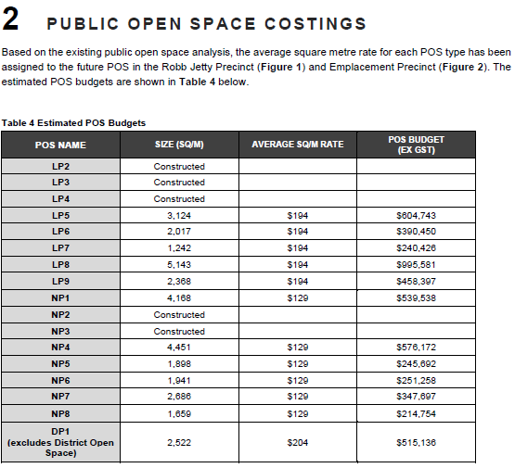

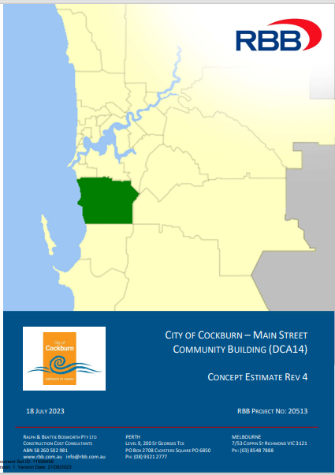

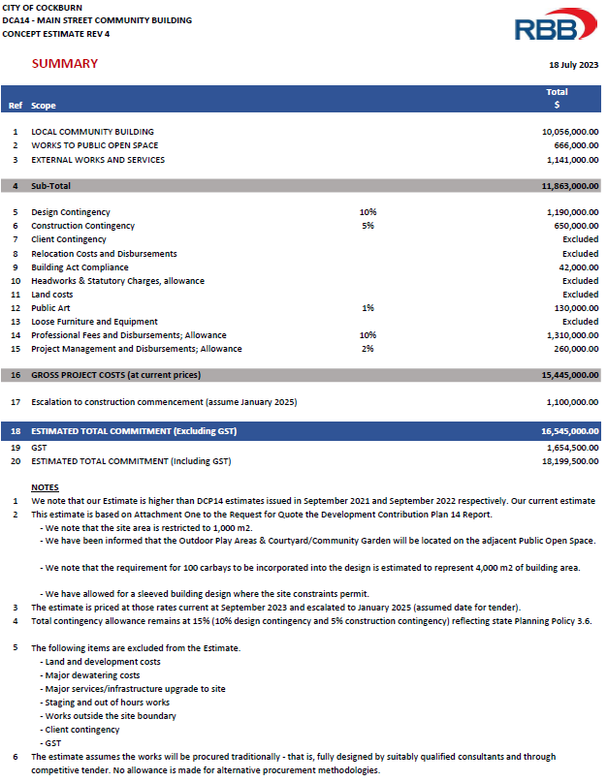

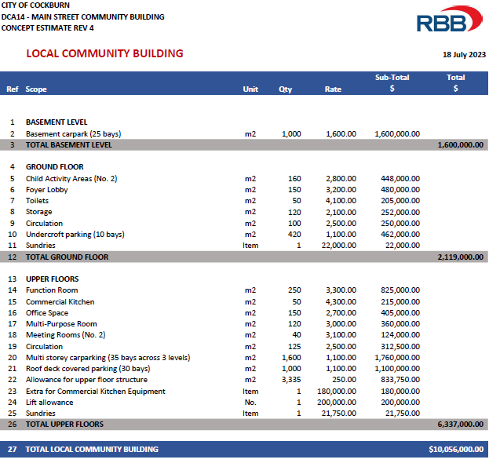

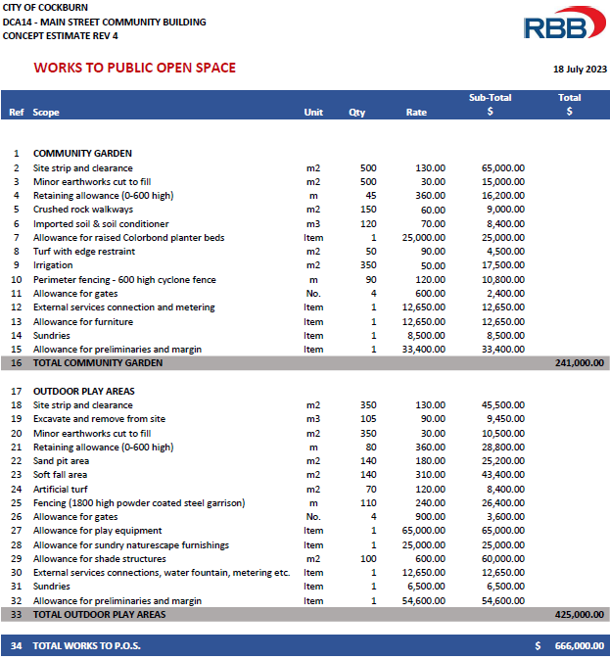

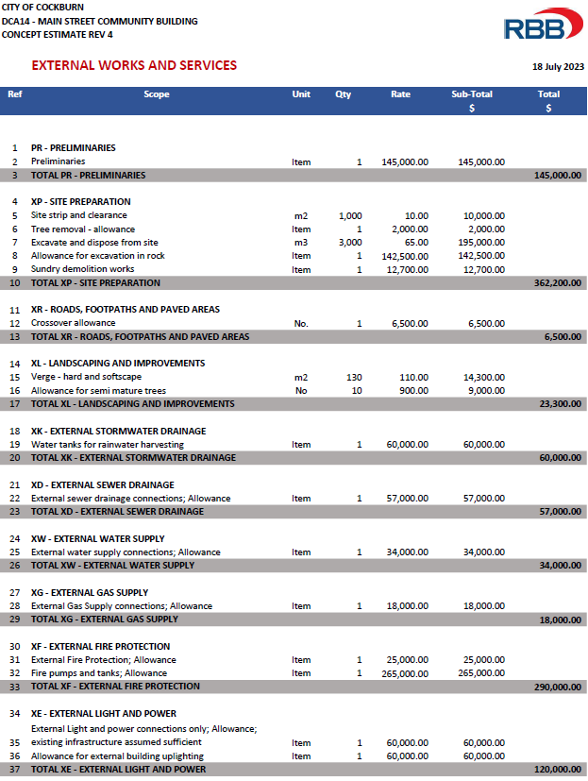

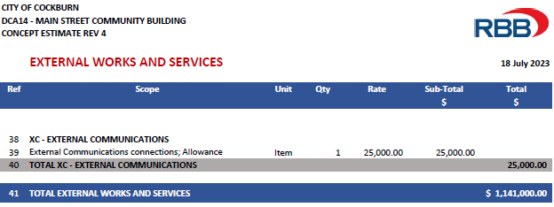

Contact Us

**City of Cockburn**

9 Coleville Crescent, Spearwood WA 6193

PO Box 1215, Bibra Lake DC Western Australia 6965

Telephone: 08 9411 3428 Fax: 08 9411 3444

Email: [rlong@cockburn.wa.gov.au](mailto:rlong@cockburn.wa.gov.au)

[City of Cockburn website: cockburn.gov.wa.au](http://www.cockburn.gov.wa.au)

Socila media logos: Facebook, Twitter, Instagram and YouTube.