Tender Title: |  | RFT 19/2024 – Leachate Pond Construction & Associated Works
Request ID: |  | 50343
Tender Description: |  | The City of Cockburn (The Principal) is seeking a suitably qualified and experienced contractor for the construction of a new leachate pond at the Principal’s Henderson Waste Recovery Park, 920 Rockingham Road, Henderson WA.
Advert Approval: |  | Decision to Advertise: Acting Director Infrastructure Services  Decision Date: Wednesday, 28 August 2024
Closing Date and Time: |  | 2:00PM (AWST) Thursday, 19 September 2024
Opening Date and Time: |  | 2:00PM (AWST) Saturday, 31 August 2024
 | Tenderer’s Name:
1 | Comiskeys Contracting Pty Ltd
2 | DM Drainage & Constructions Pty Ltd T/as DM Civil
3 | Doolee Construction Pty Ltd
4 | Egan Civil Pty Ltd T/as Castle Civil
5 | Griffin Plant Hire Pty Ltd T/as Griffin Civil
6 | Jaytona Pty Ltd T/as Multiplant Holdings
7 | Raubex Construction Pty Ltd
8
9
10
11

Advertisement
Method 1: City of Cockburn | Method 2: Yammer
Method 3:  The Western Australian, Saturday 31st August 2024 | Tender Awarded by:
Copy of Statewide Notice:  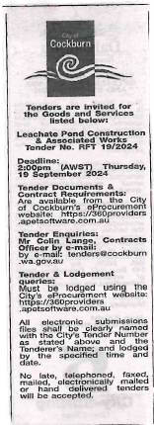 | OCM  Tuesday 8th October 2024
 | Date of Council Meeting:
Tuesday 8th October 2024
Minutes: 0220
Item No: 14.3.2
Name of Successful Tenderer(s): | Raubex Construction Pty Ltd
Amount of Successful Tender(s): (ex GST) | Estimated Value $1,726,879.59

