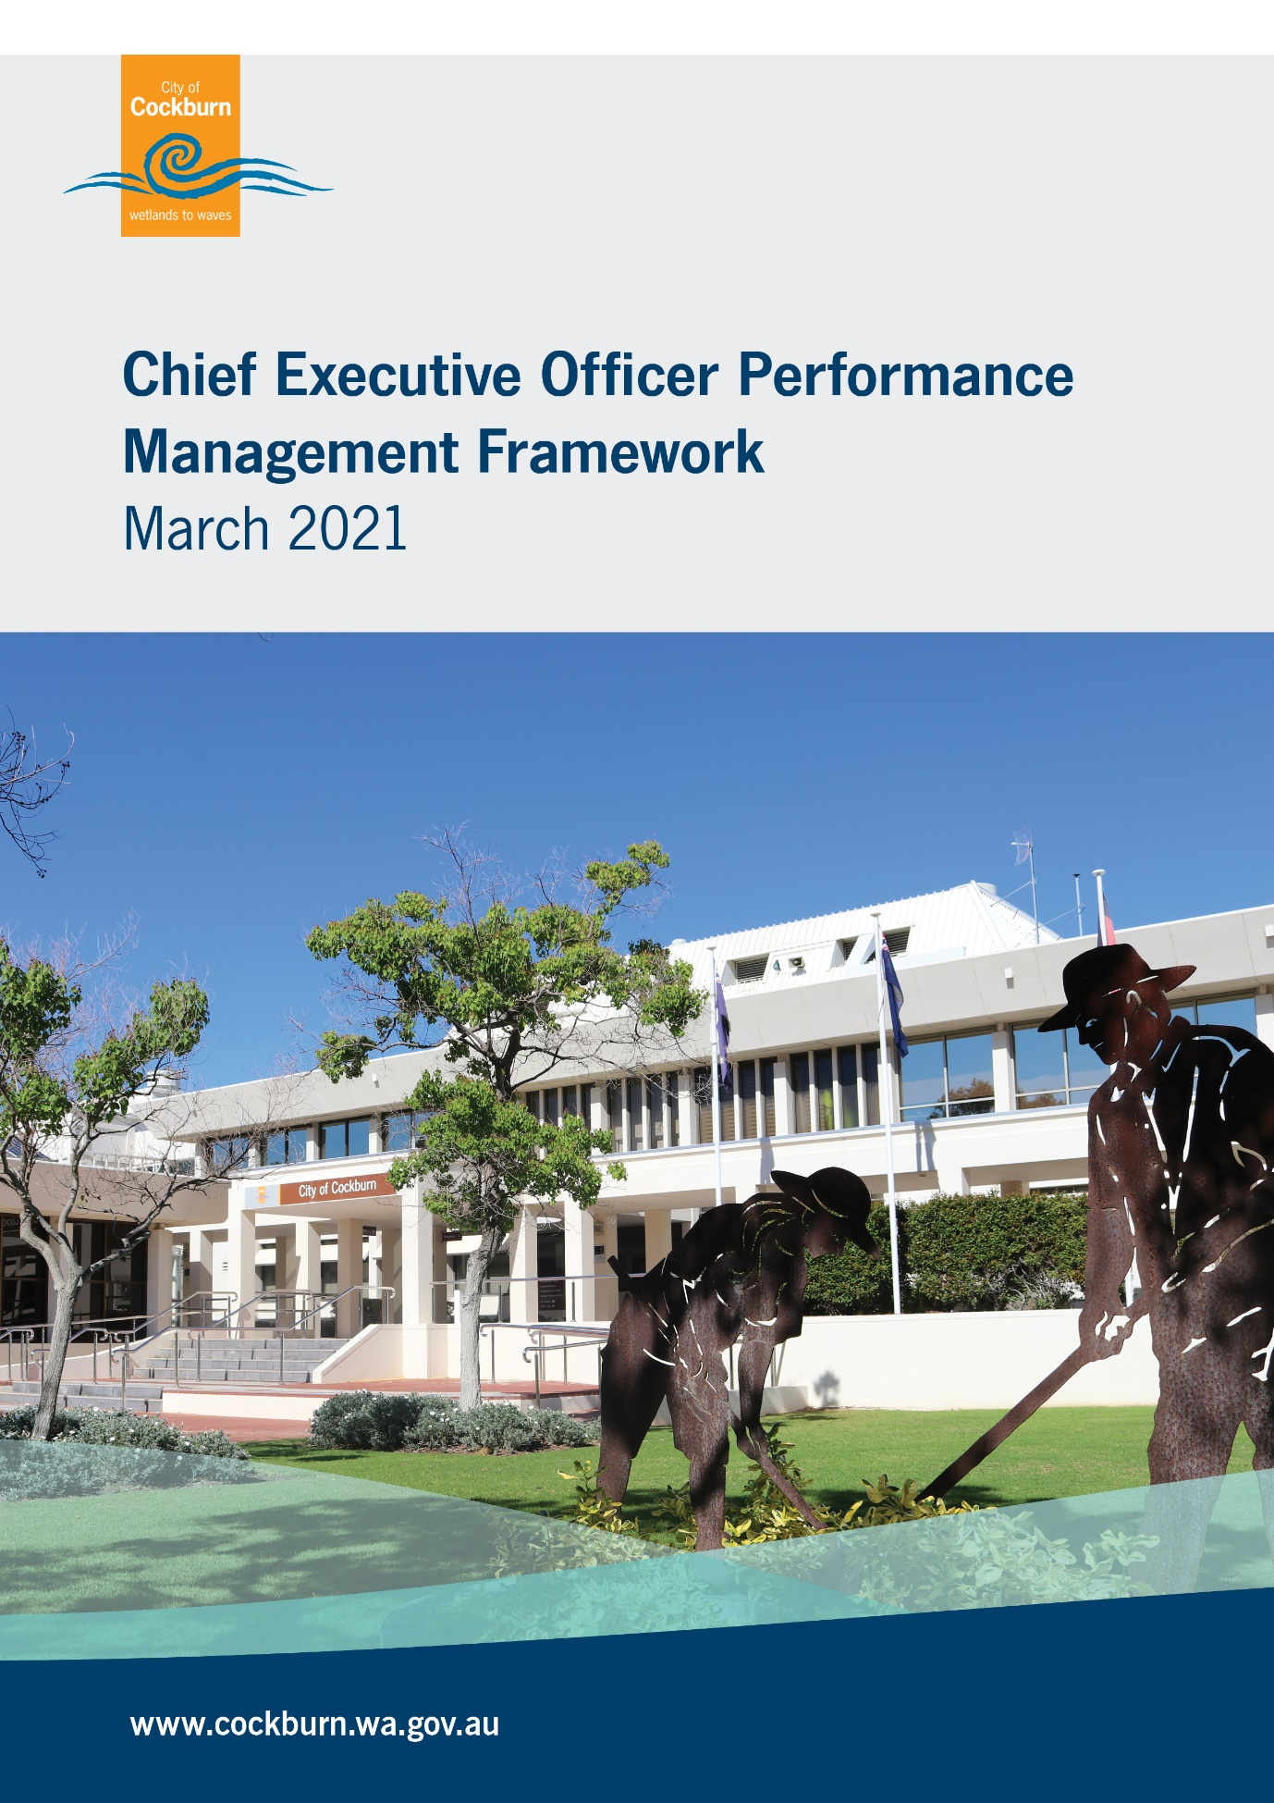

Table of Contents

Page

1. Background 1
2. CEO Performance Review 1
(1) Key Principles 1
3. Performance Review Process 1
(1) Establishment 1
(2) Review Process 2
(3) Finalisation 2
4. Facilitator/Independent Consultant 2
5. Performance Measurement 3

1. Background
Efficient and effective local government requires efficient and effective leadership. Therefore under S.5.38 and S.5.39 of the Local Government Act, the performance of the CEO must be reviewed at least once each year of their employment by Council. Their employment contract must specify the performance criteria for the purpose of reviewing the CEO’s performance.
Specifically, this performance management framework establishes the process by which Council measures and manages the CEO performance review annually and must be agreed upon by the CEO and Council. A 6 monthly Performance Review Report will be required from the CEO.

2. CEO Performance Review
(1) Key Principles
Performance review process to:
- be objective, based on facts and evidence;
- ensure assessment is conducted in a fair and reasonable manner, based on agreed performance criteria;
- support and facilitate CEO development; and
- recognise achievement and support performance improvement.

3. Performance Review Process
(1) Establishment
- The Chief Executive Officer Performance Review and Key Projects Appraisal Committee (CEOPRKPA Committee) mutually agree with the CEO on the planned and structured review process.
- An independent facilitator is appointed by the City and selected from a Preferred Supplier Panel with specialist expertise in Local Government Executive level employment performance reviews. This process will be undertaken by the City’s most senior Governance Officer (Executive Governance and Strategy) and will exclude any input from the CEO.
- Prior to formalising this appointment, relevant information will be provided to all Elected Members for assessment and feedback.
- The CEO performance review is a confidential governance process and as such the agenda should only reflect the review. Council staff members will not be involved in the review process.
- The Council’s Corporate Business Plan (CBP), as aligned to the Strategic Community Plan and the Key Result Areas (KRAs) within, to be used as the performance framework to drive Council priorities each year and is the basis for clear, achievable and measurable objectives.
- Key Performance Indicators (KPIs) are linked to the Council’s priorities through the CBP and budget, and are by mutual agreement with the CEO as the performance criteria following the consideration and adoption by the Council on recommendation from the CEOPRKPA Committee.

(2) Review Process
- The CEO is given adequate advance notice by the Mayor that a review will be initiated and asked to provide a report on evidence against the agreed performance criteria.
- The CEO submits a report to the appointed independent facilitator outlining the evidence and achievements against KPIs.
- The facilitator will provide a confidential, independent assessment of the evidence provided by the CEO which will be summarised in the survey form before being submitting to the Elected Members.
- Following receipt of the report, all Elected Members will be individually interviewed and surveyed by the facilitator to gain their feedback, rate CEO performance and provide additional comments as necessary.

(3) Finalisation
- A confidential Performance Review Report is generated by the facilitator which includes the Elected Members’ consolidated feedback, performance recommendations suggested KPIs for the following year.
- Performance Report is discussed at Committee, (single purpose confidential meeting only), to determine performance level, and any other contract considerations required to be recommended to the Council.
- The Committee Meeting recommends agreed KPIs and deliverables for the following twelve months with the CEO.
- Report provided to the CEO by the facilitator for feedback prior to Council approval of mutually agreed new KPIs.
- Recommendations to be approved and adopted by Council.

4. Facilitator/Independent Consultant
The City will engage an independent facilitator to assist with the performance management process. The role of the facilitator in the review process can include the following:
- Prepare the performance agreement and assessment plan;
- Set performance goals and criteria;
- Collect, collate and report performance evidence;
- Survey and interview Elected Members;
- Assist with provision of feed-back to the CEO, providing an objective view regarding any performance management-related issues;
- Formulate plans to support improvement (if necessary);
- Assist Council and CEO in determination of KPIs and deliverables.

5. Performance Measurement
An important step in the process is setting the performance measurement criteria.
One of the key responsibilities of the CEO is to oversee the implementation of the Council’s strategic direction. Aligning the CEO’s performance criteria to the goals contained in the City’s Strategic Community Plan and Corporate Business Plan is an important requisite.
Goals are to be specific, measurable, achievable and time-based, defining clear deliverables.
Key results areas focus on the Council’s priorities each year. Council and the CEO will set KPIs to target priorities for the CEO within the KRAs.
Consideration may also be given to Financial Governance, Stakeholder Relations, Leadership and Organisational Improvement.
Key Performance Indicators (KPIs) will be measured yearly with defined deliverables and progress being reported every 6 months.
In addition to the achievement of KPIs by the CEO, Council will consider:
- that the CEO’s methods of achieving outcomes are acceptable and sustainable;
- that the CEO has demonstrated change management and risk management skills when circumstances change and impact on performance outcomes;
- that Council, staff and community have been inspired to maintain trust in local government.
For a new CEO, the KPIs will initially relate to CBP priorities and any key issues from the recruitment process of the CEO. These will be in place for the first six month period of probation before annual targets are set at the ongoing six month performance review cycle.

