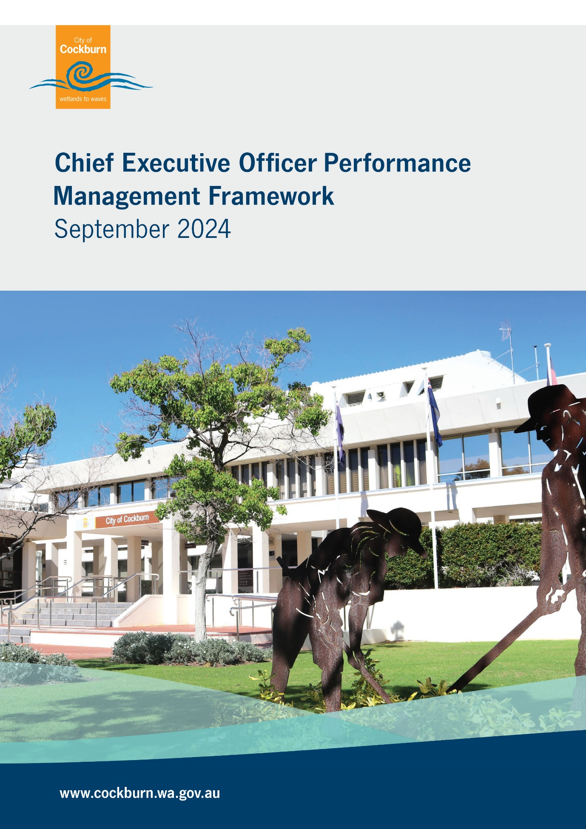

Table of Contents

Page

1. Background 1
2. Definitions 1
3. Key Principles 1
4. Independent Consultant 1
5. Performance Review Process 2
5.1 Establishment 2
5.2 Review Process 2
5.3 Finalisation 2

1. Background
Under S.5.38 of the Local Government Act 1995, the performance of the CEO who is employed for more than one year must be reviewed by Council at least once each year of their employment.
The review must be conducted in accordance with Schedule 2 of the Local Government (Administration) Regulations 1996, adopted as the City of Cockburn Standards for CEO Recruitment, Performance and Termination (the Standards).
The Standards require that the process for the review is agreed upon by the CEO and Council.
The CEO’s contract of employment and this framework establishes the agreed process by which Council measures and manages the CEO performance review annually.

2. Definitions
• Additional Performance Criteria means any performance criteria, in addition to the Performance Criteria, which have been agreed to by the CEO and Council under clause 16(1)(b) of the Standards.
• Performance Criteria means the performance criteria specified in the CEO’s contract of employment as required under s.5.39(3)(b) of the Local Government Act 1995.
• Key Performance Indicators (KPIs) means the outcomes by which the CEO’s Performance Criteria are assessed.

3. Key Principles
The CEO performance review process is to:
• be objective, based on facts and evidence;
• ensure assessment is conducted in a fair and reasonable manner, based on agreed Performance Criteria;
• support and facilitate CEO development; and
• recognise achievement and support performance improvement.

4. Independent Consultant
The City will engage an independent consultant to assist with the performance management process. The role of the consultant in the review process can include the following:
• Collect, collate, review and report performance evidence;
• Survey and interview Elected Members;
• Assist with provision of feedback to the CEO, providing an objective view regarding any performance management-related issues;
• Formulate plans to support improvement (if necessary);
• Recommend Performance Criteria and KPIs.

5. Performance Review Process
5.1 Establishment
• An independent consultant is engaged by the City with specialist expertise in Local Government Executive level employment performance reviews.
• The CEO performance review is a confidential governance process and as such the agenda should only reflect the review. Council staff members will not be involved in the review process.

5.2 Review Process
• The CEO is given no less than 30 days’ notice by the Council that a review will be initiated and asked to provide a statement of performance against the Performance Criteria and any Additional Performance Criteria.
• The CEO submits the statement of performance to the appointed independent consultant and/or Council outlining the evidence and achievements against Performance Criteria and KPIs.
• The consultant will review the statement of performance and determine whether the KPIs for that year have been achieved, and if not, noting any reasons or special circumstances.
• The consultant will prepare a preliminary report documenting the annual performance review including the matters outlined in the preceding paragraph and circulate the preliminary report to all Elected Members.
• Following receipt of the preliminary report, all Elected Members will be individually interviewed and surveyed by the consultant to provide their feedback, rating of the CEO’s performance and additional comments as necessary.

5.3 Finalisation
• The consultant report is to be provided to the CEO for feedback prior to Committee consideration of proposed Additional Performance Criteria (if any) and new KPIs.
• A confidential report is presented to the relevant Committee
• The report is considered at a meeting of the relevant Committee, (single purpose confidential meeting only), to determine performance level, and any other contract considerations required to be recommended to the Council.
• The Committee will consider Additional Performance Criteria (if any), agreed KPIs and deliverables for the following twelve months with the CEO.
• Recommendations of the Committee are to be considered by Council.
• Council must endorse the review by an absolute majority.



