8 August 2018
Compostable dog poo bags on a roll in Cockburn
Compostable, non-plastic dog bags designed to breakdown in three to six months are being installed in dog parks across the City of Cockburn.
The Dog Poo-ch Pouches are derived from renewable resources like corn starch, cassava root and sugarcane, and are truly compostable.
They will disintegrate in landfill and home composters in three months and fully degrade in six months, unlike the plastic bags they will replace.
The City’s Parks and Waste Services team has ordered 150 weather-proof dispensers for the bags and they will be rolled-out across the City’s large parks until June 30, 2019 with another 100 dispensers the following financial year.
Waste Education Officer Nicki Ledger said the compostable bags were less damaging to the environment as they were likely to break down quickly if they ended up in local waterways, not crumble into tiny pieces of plastic like the ‘degradable’ or ‘biodegradable’ bags.
“Wildlife often mistakes these tiny pieces of plastic for food as they break down into smaller and smaller pieces,” Miss Ledger said.
“They can work their way into the food chain and make the birds and animals sick and even kill them and that doesn’t include the tangling hazard of plastic bags.”
Miss Ledger said the bags were certified compostable to AS4736 meaning they break down completely in the industrial composters at the Regional Resource Recovery Centre in Canning Vale if placed in any City of Cockburn general waste bin.
“They’re also compostable to AS5810 for home composting systems so they will break down in backyard composters,” Miss Ledger said.

“This is good news because the bag and the poop will become compost, rather than being sent to landfill where they contribute to emissions of methane, a potent greenhouse gas that contributes to climate change.”
While more expensive than plastic dog bags, the new bags do represent an economic benefit.
“The new rolls hold 400 bags, compared with the old flat bag stations which only held 250. This means they need to be refilled less often,” Miss Ledger said.
The new material has up to 30 per cent more stretch than other compostable products on the market, ensuring a very high resistance to punctures, tears or splits.
The starch material is less likely to become brittle in the early stages of degradation and has nearly twice the storage time of other compostable bags currently available.
The weather-proof dispensers are manufactured in South Australia and supplied by a Perth company.

Caption: Dion Bain and his pup Odie, seen here with Mayor Logan Howlett, are already making good use of new compostable Dog Poo-ch Pouches at City of Cockburn parks.

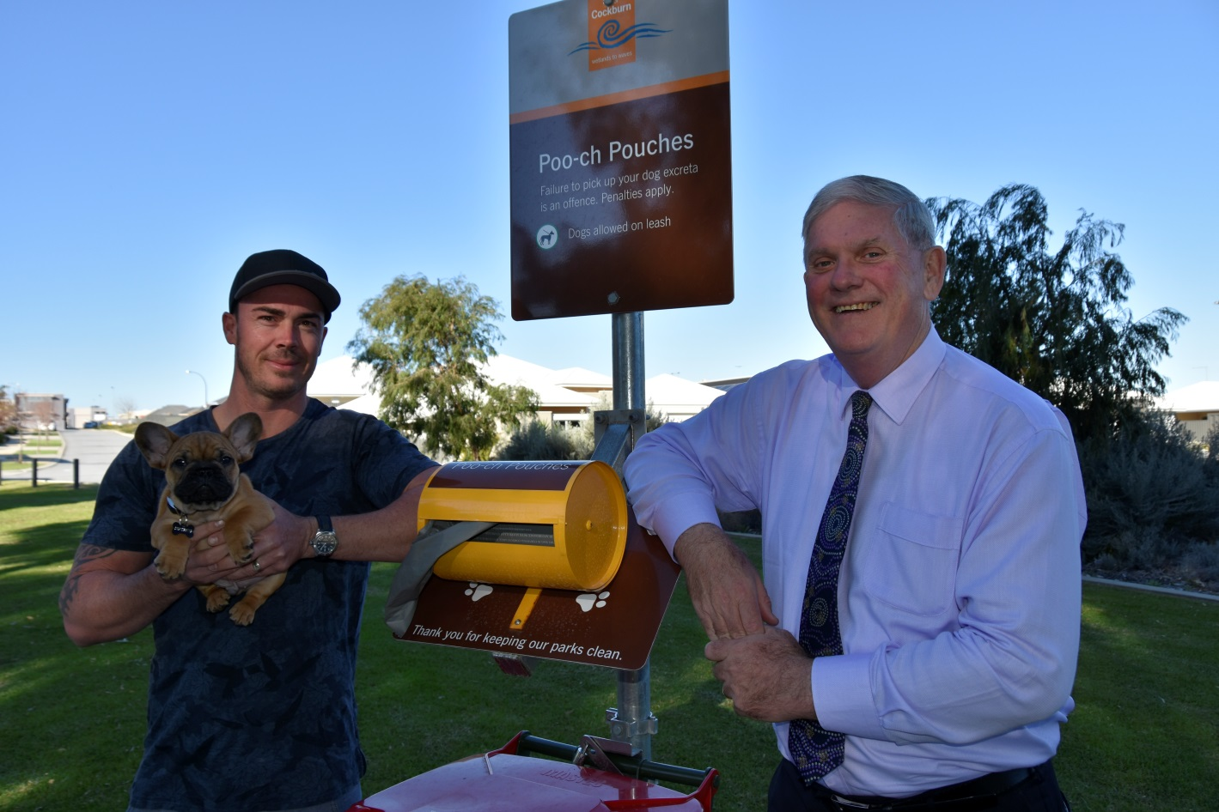
______
ENDS

For more information contact:
Media and Communications Officer
City of Cockburn
T: 08 9411 3551
E: media@cockburn.wa.gov.au

