Tender Title: |  | RFT15/2025: GID (Groundwater Intercepting Drain) Management & Monitoring Services - Port Coogee Alternative Water Supply System
Request ID: |  | 63485
Tender Description: |  | The City of Cockburn (The Principal) is seeking a suitably qualified and experienced contractor for the management and monitoring of the Port Coogee Alternative Water Supply System (AWSS) including the Port Coogee Groundwater Inception Drain (GID), located at North Coogee, Western Australia.
Advert Approval: |  | Decision to Advertise: Director Infrastructure Services  Decision Date: Friday, 16 May 2025
Closing Date and Time: |  | 2:00PM (AWST) Thursday, 12 June 2025
Opening Date and Time: |  | 2:00PM (AWST) Thursday, 12 June 2025
 | Tenderer’s Name:
1 | ALTRUM PTY. LTD t/as Engineered Efficiency
2 | The Trustee for RM Houlihan Trust t/as Green Values Australia
3 | WESTERN IRRIGATION PTY. LTD.

Advertisement
Method 1: City of Cockburn | Method 2: Yammer
Method 3:  The Western Australian, Wednesday,  21 May 2025 | Tender Awarded by:
Copy of Statewide Notice:  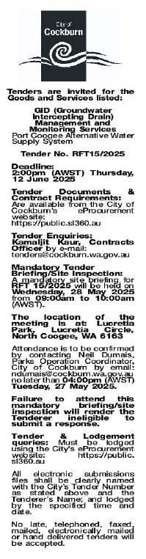 | Choose an item.  Choose an item.  Wednesday, 21 May 2025
 | Date of Council Meeting:
Click here to enter a date. or
Choose an item.
Item No:
Name of Successful Tenderer(s): | ALTRUM PTY LTD t/as Engineered Efficiency
Amount of Successful Tender(s): (ex GST) | $204,864.00

