Tender Title: |  | RFT 22/2023  Plant (Dry) Hire Services - HWRP
Request ID: |  | 47514
Tender Description: |  | The City of Cockburn (the Principal) is seeking the dry hire of two (2) excavator (20 tonne minimum) for use in landfill waste recovery at the Principal’s Henderson Waste Recovery Park, 920 Rockingham Road, Henderson WA.
Advert Approval: |  | Decision to Advertise: Chief Operations Officer  Decision Date: Thursday, 14 September 2023
Closing Date and Time: |  | 2:00PM (AWST) Thursday, 5 October 2023
Opening Date and Time: |  | 2:00PM (AWST) Thursday, 5 October 2023
 | Tenderer’s Name:
1 | BROOKS HIRE SERVICE PTY LTD (BROOKS HIRE)
2 | MCS Civil Contracting
3 | ALLWEST PLANT HIRE AUSTRALIA PTY LTD t/a Allwest Plant Hire Australia (Contracting)
4 | REX RENTALS PTY LTD
5 | PLATINUM PLANT & EQUIPMENT HIRE
6
7
8
9
10

Advertisement
Method 1: City of Cockburn | Method 2: Yammer
Method 3:  The Western Australian,  Wednesday, 20th September 2023 | Tender Awarded by:
Copy of Statewide Notice:  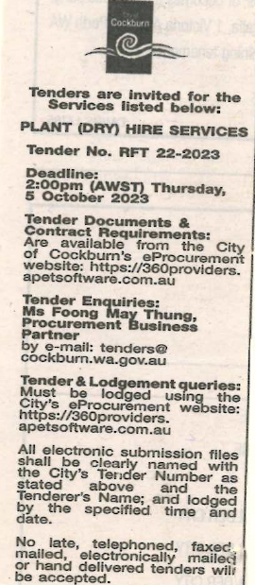 | Chief Operations Officer  25 January 2024
 | Date of Council Meeting:
 | Not applicable
Name of Successful Tenderer(s): | ALLWEST PLANT HIRE AUSTRALIA PTY LTD
Amount of Successful Tender(s): (ex GST) | $309,840 for a period of two (2) years

