Tender Title: |  | RFP 01/2025 – Client Management Software – Cockburn Care
Request ID: |  | 55148
Tender Description: |  | The City of Cockburn (the Principal) requires the provision of a client management system for the electronic management of the City’s Commonwealth Home Support Programmes, Home Care Packages and the National Disability Insurance Scheme services. The client management system must include applications for client and staff scheduling, budgeting and billing, client records and information, employee’s information and timesheets.  The objective of this contract is to ensure that the City of Cockburn Aged Care and NDIS meets regulatory standards in producing, keeping client records to assist in the safe provision of coordinated services, scheduling of staff, reporting, billing and budgeting.
Advert Approval: |  | Decision to Advertise: Director Community and Place  Decision Date: Monday, 6 January 2025
Closing Date and Time: |  | 2:00PM (AWST) Wednesday, 29 January 2025
Opening Date and Time: |  | 8:30AM (AWST) Friday, 31 January 2025
 | Tenderer’s Name:
1 | NIGHTINGALE SOFTWARE (WA, Perth)
2 | Civica (Care Sales)
3 | AYLA SOLUTIONS PTY LTD t/a AYLA Solutions

Advertisement
Method 1: City of Cockburn | Method 2: Yammer
Method 3:  The Western Australian,  Saturday, 11January 2025 | Tender Awarded by:
Copy of Statewide Notice:  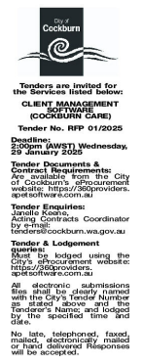 | Non-Award
 | Date of Council Meeting:
 | Not applicable
Name of Successful Tenderer(s): | Not Applicable
Amount of Successful Tender(s): (ex GST) | Not Applicable

