Tender Title: |  | RFT 12-2023  Outdoor (Street) Furniture Maintenance – Sanding, Oiling and Repair (Parks)
Request ID: |  | 47372
Tender Description: |  | The City of Cockburn is seeking a suitably qualified and experienced Contractor to conduct annual maintenance of outdoor timber furniture across its municipal area.
Advert Approval: |  | Decision to Advertise: Chief Operations Officer  Decision Date: Thursday, 10 August 2023
Closing Date and Time: |  | 2:00PM (AWST) Thursday, 31 August 2023
Opening Date and Time: |  | 2:00PM (AWST) Thursday, 31 August 2023
 | Tenderer’s Name:
1 | Jasmin Carpentry and Maintenance
2 | ICS Australia Pty Ltd
3 | Graffiti Systems Australia (Office)
4
5
6
7
8
9
10

Advertisement
Method 1: City of Cockburn | Method 2: Yammer
Method 3:  The Western Australian,  Wednesday, 16th August 2023 | Tender Awarded by:
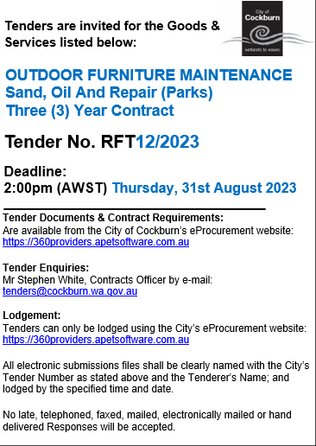  Copy of Statewide Notice: | Chief Operations Officer  A/ Chief Financial Officer  Thursday, 5 October 2023
 | Date of Council Meeting:
 | Not applicable
Name of Successful Tenderer(s): | Jasmin Carpentry and Maintenance
Amount of Successful Tender(s): (ex GST) | $512,596

