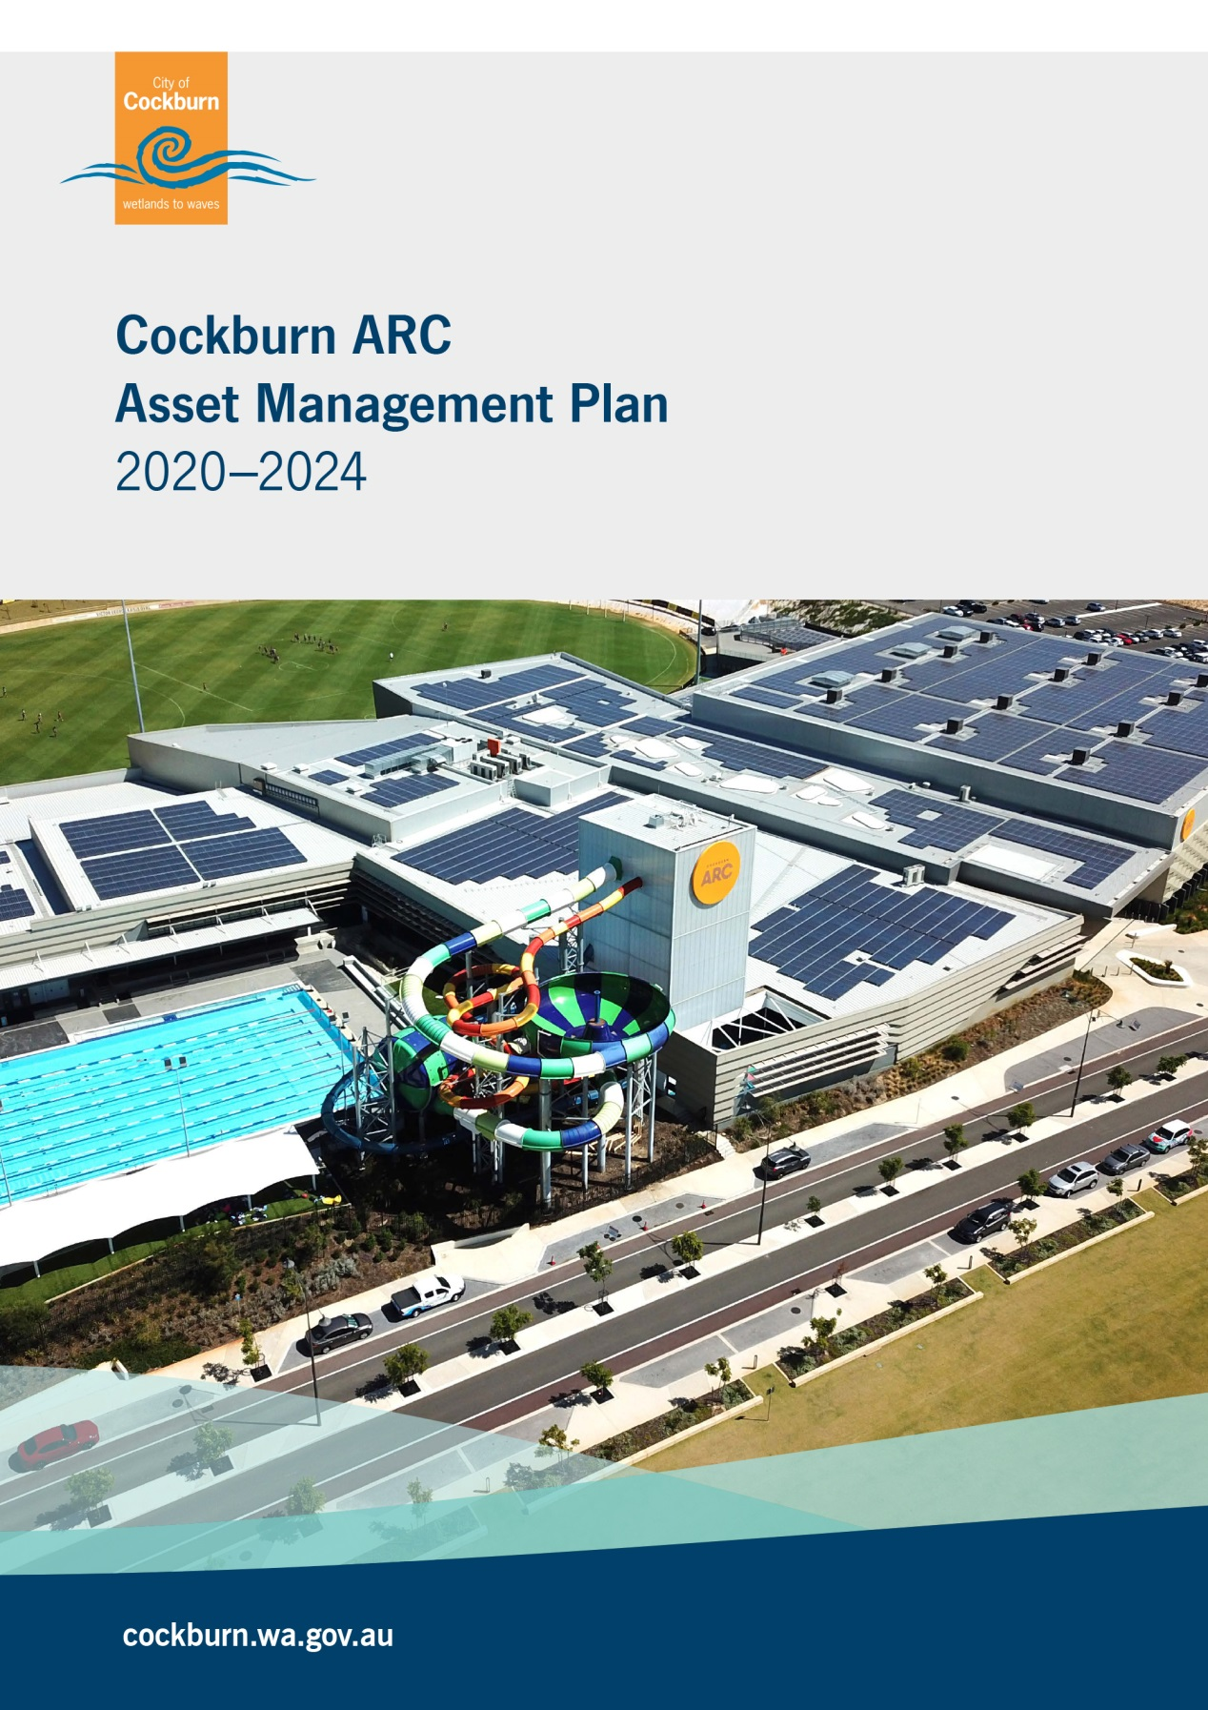

*Front cover image is taken at Cockburn ARC in Cockburn Central, constructed in 2017.*

|  |  |  |  |  |  |
| --- | --- | --- | --- | --- | --- |
| Document Control | | IPWEA logo col | | | |
| Version No | Date | Version Details | Author | Reviewer | Approver |
| 1 | June 2021 | Draft to Managers | Asset Services | Manager Property & Assets | Manager Cockburn ARC |
| 2 | September 2021 | Final version for Adoption | Asset Services | Executive Committee (ExCo) | Council |
|  |  |  |  |  |  |
|  |  |  |  |  |  |

Acknowledgement of Country

The Mayor, Councillors and staff of the City of Cockburn acknowledge the Whadjuk Nyungar people of Beeliar boodja as the traditional custodians of this land. We pay our respect to the Elders, past, present and emerging.

Table of Contents

Glossary ii

1. Executive Summary 1

2. Introduction 5

2.1 Background 5

2.2 Goals and Objectives of Asset Management 10

2.3 Plan Framework…………………………………………………………… 13

2.4 Asset Management Maturity ………………………………………… 13

2.5 Asset Management Plan Maturity & Data Confidence Assessment 15

3. Levels Of Service 16

3.1 Current Levels of Service 17

3.2 Enterprise Risk Management 22

3.3 Legislative Requirements 26

3.4 Asset Capacity and Performance 26

4. Future Growth and Demand 28

4.1 Growth Forecast 28

4.2 Changes in Technology 29

4.3 Demand Management Plan 30

4.4 New Assets from Growth 31

5. Lifecycle Management 33

5.1 Asset Data 33

5.1.1 Asset Age 33

5.1.2 Useful Life 34

5.1.3 Asset Condition 35

5.1.4 Asset Valuations 36

5.2 Maintenance and Operating Expenditure 37

5.2.1 Standards and Specifications 39

5.3 Renewal and Replacement Plan 39

5.4 New and Upgrade Plan 39

5.5 Disposal Plan 40

6. Financial Analysis 41

6.1 Financial Statements and Projections 41

6.2 Funding Strategy 44

6.3. Sustainability of Service Delivery. 44

6.3.1 Asset Consumption Ratio (ACR) 44

6.3.2 Asset Sustainability Ratio (ASR) 45

6.3.3 Asset Renewal Funding Ratio (ARFR) 46

6.4 Valuation Forecasts 46

6.5 Key Assumptions made in Financial Forecasts. 48

6.6 Revenue 49

7. Asset Management Practices 50

7.1 Accounting / Financial Systems 50

7.2 Asset Management Systems 50

7.3 Information Flow Requirements and Processes. 51

7.4 Standards and Guidelines 51

8. Plan Improvement and Monitoring 52

8.1 Performance Measures 52

8.2 Improvement Strategy 52

8.3 Monitoring and Review Procedures 53

References 55

Appendices 56

Appendix A Legislative Requirements 56

Appendix B Asset Type Breakdown of ARC Infrastructure 57

Appendix C Useful Life Component Classification Breakdown 61

Appendix D Income and Expense Account Breakdown 64

Appendix E Preliminary 5 Year Capital Works Program 65

Appendix F Preliminary 10 Year Renewal Program 66

Appendix G Revenue Breakdown 68

**Glossary**

**ASPEC (M, O, R, D) Specification**

ASPEC data Specification and the City’s operational register classification i.e. Marina and Coastal Infrastructure, Open Space, Road and Drainage Specification

**Asset**

A physical component of a facility which has value, enables a service to be provided and has an economic life of greater than 12 months.

**Asset Class**

Groupings of assets of similar nature and use in a local government’s operations (AASB 166.37)

**Asset Classification**

A division of the asset class regarded as having particular shared characteristics

**Asset Type**

Defines the range of assets held in the asset classification i.e. A Spec

**Asset Condition**

Is a measure of the asset’s physical integrity to enable prediction of maintenance, rehabilitation and renewal requirements.

**Asset Management**

The combination of management, financial, economic, engineering and other practices applied to physical assets with the objective of providing the required level of service in the most cost effective manner.

**Capital Renewal Expenditure**

Expenditure/ works on an existing asset which returns the service potential or the life of the asset to that which it had originally.

**Capital New Expenditure**

Expenditure used to create new assets or to increase the capacity of existing assets beyond their original design capacity or service potential.

**Capital Upgrade Expenditure**

Expenditure which enhances an existing asset to provide a higher level of service or expenditure that will increase the life of the asset beyond that which it had originally.

**Current Replacement Cost (CRC)**

The cost of replacing the service potential of an existing asset, by reference to some measure of capacity, with an appropriate equivalent asset.

**Depreciation**

The wearing out, consumption or other loss of value of an asset whether arising from use, passing of time or obsolescence through technological and market changes.

*The systematic allocation of the depreciable amount (service potential) of an asset over its useful life.

**Depreciated Replacement Cost**

The replacement cost of an existing asset less an allowance for wear and consumption, having regard for the remaining economic life of the existing asset.

**Expenditure**

The spending of money on goods and services.

**Fair Value**

Fair value is defined as the price that would be received to sell an asset or paid to transfer a liability in an orderly transaction between market participants at the measurement date.

**Funding Gap \***

Difference between estimated budgets and projected expenditures from the Long Term Financial Plan for maintenance and renewal of assets, totalled over a defined time.

**Gap Analysis**

A method of assessing the gap between a business’s current asset management practices and the future desirable asset management practices.

**Integrated Planning and Reporting**

A framework for establishing community priorities and linking this information into different parts of a local government’s functions.

**Level of Service \***

The defined service quality for a particular activity or service area against which service performance can be measured. Service levels usually relate to quality, quantity, reliability, responsiveness, environmental, acceptability and cost.

**Life Cycle Management**

The total cost of an asset throughout its life including costs for planning, design, construction, acquisition, operation, maintenance, rehabilitation and disposal.

**Long Term Financial Plan (LTFP)**

Supported by the Asset Management Planning Process the LTFP is a ten year rolling plan that informs the Corporate Business Plan to activate Strategic Community Plan priorities. From these planning processes, Annual Budgets that are aligned with strategic objectives can be developed.

**Maintenance**

All actions necessary for retaining as asset as near as practicable to its original condition, but excluding rehabilitation or renewal.

**Non-Asset Solution**

The process used to identify the alternative methods of addressing, reducing and/ or increasing demand for services other than by adjusting asset capacity.

**Operating Expenditure \***

Recurrent expenditure, which is continuously required excluding maintenance and depreciation, e.g. power, fuel, staff, plant equipment, on-costs and overheads.

**Planned Maintenance \***

Repair work that is identified and managed through a maintenance management system, activities include inspection, assessing the condition against failure/breakdown criteria/experience, prioritising scheduling, actioning the work and reporting what was done to develop a maintenance history and improve maintenance and service delivery performance.

**Reactive Maintenance \***

Unplanned repair work that is carried out in response to service requests and management/supervisory directions.

**Remaining Life \***

The time remaining until an asset ceases to provide the required service level or economic usefulness. Age plus remaining life is economic life.

**Replacement Cost**

The cost of replacing an existing asset with a substantially identical new asset.

**Risk Management \***

The application of a formal process to determine the range of possible values relating to key factors associated with a risk in order to determine the resultant ranges of outcomes and their probable occurrence.

**Strategic Community Plan**

The strategy and planning document that reflects the longer term (10+ year) community and local government aspirations and priorities.

**Useful Life \***

Either:

(a) the period over which an asset is expected to be available for used; or

(b) the number of production or similar units (i.e. intervals, cycles) that is expected to be obtained from the asset.

Source: **Government** of WA Asset management framework and guidelines, Glossary

**\***Source: DVC 2006, Glossary ‘Asset Investment Guidelines

**1. Executive Summary**

With the implementation of the City’s Integrated Corporate planning Framework, the Cockburn Aquatic and Recreation Centre AMP (ARC AMP) has been developed to establish sustainable financial management, robust governance, continuous improvement and best practice management of the City’s infrastructure assets.

The ARC AMP covers the 2020-21 to 2023-24 financial years, outlines the services provided by Recreation and Community Services in delivering strategic and operational asset management activities for communities that utilise the City’s Aquatic and Recreation Centre (ARC).

The ARC AMP is one of eight AMPs developed by the City and forms part of the City’s Strategic Asset Management Planning Framework. The ARC AMP will be developed every four years in alignment with the Corporate Planning Framework ensuring that the City’s long term financial planning (LTFP) is supported by timely and accurate asset information and financial projections derived from a structured and strategic asset management planning process.

The 2020 - 2024 version of the ARC AMP is the first developed by the City and in accordance with the International Infrastructure Maintenance Manual (IIMM) has achieved ‘core’ level status. Future versions of the ARC AMP will be developed in alignment with IIMM to ensure that an intermediate plan is presented, similar to the City’s seven other Infrastructure AMPs.

The ARC AMP improvement strategy will guide the Recreation Services Business Unit to continuously improve services provided, establishing best practice strategic and operational asset management methodologies across people, processes and systems.

**Table 1.1 Cockburn ARC Component Summary Table as at May 2021**

| Asset Group | Asset Classification | Replacement Value |
| --- | --- | --- |
| Component Infrastructure | **Roof** | $5,492,600 |
| **External Site** | $948,060 |
| **Fitout** | $2,790,074 |
| **Finishes** | $6,372,289 |
| **Disability Services** | $29,800 |
| **Electrical Services** | $946,040 |
| **Hoists & lifts** | $160,650 |
| **Fire Services** | $119,625 |
| **HVAC Services** | $340,284 |
| **Hydraulic Services** | $33,800 |
| **Security Services** | $117,420 |
| **ARC Assets** | $9,966,596 |
| TOTAL $ | | 27,209,238 |

**Table 1.2 Cockburn ARC Building Summary Table as at May 2021**

| Asset Group | Current Replacement Cost (CRC) | Fair Value( FV) |
| --- | --- | --- |
| ARC Building Infrastructure | **$85,709,556** | $79,734,389 |

The key messages from the 2020 Cockburn ARC Asset Management Plan are summarised below:

**Asset Data & Condition Analysis**

* The data utilised to develop the ARC AMP is considered to be approximately 85% accurate and of medium confidence.
* ARC Infrastructure assets are in an excellent to moderate condition with 99% of the assets in condition 1, and 1% in condition 3. See legend at Graph 5.1.3 Asset Condition Profile.

See **(Section 5)** for further information

**Level of Service and Risk Management**

**Level of Service Management:**

Level of service management is a measurable target which determines the type and extent of services delivered to the community. Cockburn ARC Infrastructure levels are measured internally and, by the community to determine adequate provision.

* Analysis of the Community scorecard performance rating, occupancy and attendance data provides great results across these areas.

**Risk Management:**

**The following risk treatments / strategies have been implemented to mitigate the City’s risk.**

* Existing controls and expenditure to mitigate risk are considered adequate, thus reducing the impact on service delivery.
* Risk management strategies are in place to ensure that identified risks have a low to moderate residual risk rating.

See **(Section 3)** for further information

**Future Growth and Demand Management**

Future growth projections are supported by the City’s Strategic Planning Service Units Population and demographic research, whilst demand for new services will be catered for through upgrading existing and providing new assets.

* + New assets are estimated at a total of $5.8 million for the next 5 years with this value inclusive of the 2% CPI compounded yearly.
  + By the year 20290-30 Cockburn ARC current replacement cost total will be approximately $109.3 million, representing a 26% increase with the inclusion of the 2% CPI compounded yearly.

See **(Section 4)** for further information

See **(Appendix E)** for the preliminary 5 year capital works program

**Lifecycle Management**

The lifecycle management section details how the City plans to manage and operate both current and future assets to the agreed levels of service whilst optimising life cycle costs.

* Planned maintenance work was 21% of the total maintenance expenditure for the 2019-20 period.
* By 2029-30 required expenditure for Operations and Maintenance is expected to be approximately $16 million, this figure includes new assets growth from capital works and the Health & Fitness Expansion Plan.

See **(Section 5)** for further information

**Financial Analysis**

**Cockburn ARC Infrastructure Asset Renewal Forecasts**

The City has developed a 10 year renewal plan which will inform the budget planning process and the City’s long term financial planning.

* The 10 year projected renewal expenditure value totals $6.8 million inclusive of 2% compound CPI.
* There is no 10 year cumulative funding gap for ARC infrastructure, this is based on the ARC receiving 100% renewal funding from the City’s LTFP funding strategies.

See **(Section 6)** for further information

See **(Appendix F)** for the 10 year Renewal program

**Sustainability of Service Delivery**

The City will compile and report on ARC assets and their performance in relation to the Dept. of Local Government’s Asset Management Guidelines and Framework.

Based on actual expenditure in 2019-20, Table 1.2 indicates the City’s performance in managing ARC infrastructure assets as at February 2021.

**Table 1.2 Cockburn ARC Asset Ratio Summary Table**

|  |  |  |  |
| --- | --- | --- | --- |
| Asset Class | Consumption Ratio  2019-20 | Sustainability Ratio  10 Years | Renewal Funding Ratio  10 Years |
| Cockburn ARC Components | 86.9% | 39% | 100% |
| Cockburn ARC Building | 93% | N/A | N/A |
| Dept of LG Framework Standard | Standard is met | Standard is not met | N/A |

Sustainability ratios for ARC Components have been forecast for the next 10 years. For the 2029-30 period is predicted to be 39%, the renewal funding ratio for the same period is predicted to be 100%. 2019-20 Consumption Ratios for both the ARC Building and ARC Components are higher than desired which is typical of new infrastructure.

See **(Section 6)** for further information

**AMP Improvement Strategy and Monitoring**

A number of strategic improvements have been identified throughout the organisation which will improve future revisions of the plan and provide greater financial alignment with the next revision of the Long Term Financial Plan.

* Build unit rate codes specific to the ARC and facilities infrastructure along with a targeted useful life application which better represents the consumption of assets at the site.
* Improve the set-up of Cockburn ARCs financial reporting to better align the City’s other AMPs and make future versions of this plan more refined and improve current limitations.

See **(Section 8)** for further information

**2. Introduction**

**2.1 Background**

Cockburn Aquatic and Recreation Centre (ARC) is a first-class sport and recreation facility located in Cockburn Central. The $109 million purpose-built, multi-function centre caters for thousands of residents across Perth's southern metropolitan corridor and has recorded over 4 million visitors since opening in 2017.

With population growth forecasted to continue and existing sporting facilities reaching the end of their useful life, the City saw an opportunity to build a unique community facility for residents and visitors of the area.

The ARC is also home to AFL’s Fremantle Football Club, the Fremantle Dockers and Curtin University, demonstrating the capacity of partnership between local government, a professional sporting body and a distinguished public research institution to deliver an integrated, environmentally sustainable community for people of all abilities.

Employing more than 250 staff and hosting an average of 3,835 attendees per day the ARC offers contemporary recreation, community, elite sporting and educational facilities including:

* Three recreation pools, two recovery pools, a 50m outdoor, a 25m indoor, a learn to swim pool and a leisure pool
* Three 18m high waterslides, 125m in length
* Wellness facilities including a warm water pool, spa, sauna and steam room
* Six-court multi-purpose indoor sports stadium
* State of the art technology throughout e.g. Wi-Fi, My Wellness app, Technogym equipment in health club
* RPM (Indoor cycling studio), group fitness studios and wellness studio
* Specialist event facilities e.g. birthday party rooms and indoor play centre
* A standard AFL oval and a community oval
* 140 seat lecture theatre, multimedia studio, meeting rooms and spaces available for community bookings
* Café, crèche and Allied Health centre

With an emphasis on sustainability, the passive solar building design is word class technology and includes a 1MW Solargain rooftop solar installation, a $3 million investment into geothermal energy heating all eight pools, LED lighting, high efficiency pool water filtration and a Building Management System (BMS) with digital air-conditioning and ventilation control.

This asset management plan has been developed to assist the Infrastructure Services unit to outline the management of assets, compliance with regulatory requirements and to highlight the funding required to provide the appropriate Levels of Service. The ARC AMP refers to the planning and renewal of internal components, the depreciation and CRC are at building level and referred throughout.

The assets covered by this plan are summarised in Table 2.1.1. Figures as at December 2020 and have been extracted from Council’s Technology One Enterprise Asset Management System (EAM). See Appendix A for a full asset breakdown by type and group.

**Table 2.1.1 Cockburn ARC Infrastructure Assets Covered by this plan**

| **Building Component** | **Asset Group** | **Quantity (m, m2, no)** |
| --- | --- | --- |
| **ARC Assets** | **Play Equipment** | **1no** |
| **Stadium Equipment** | **69no** |
| **Plantroom Equipment** | **190no** |
| **Pool Equipment** | **86no** |
| **Pool Deck** | **3657m2** |
| **Disability Access** | **Disabled Toilet** | **3no** |
| **Disabled Access Lift** | **1no** |
| **Electrical Services** | **Emergency Lighting** | **166no** |
| **Exit Sign (illuminated)** | **71no** |
| **External Electrical** | **68no** |
| **Internal Electrical** | **1332no** |
| **External Site** | **Wall Finish - External** | **4299m2** |
| **Finishes** | **Ceiling Finish** | **9980m2** |
| **Floor Finish** | **14408m2** |
| **Floor Finish** | **400m2** |
| **Floor Finish** | **11792m2** |
| **Wall Finish - External** | **90m2** |
| **Wall Finish - Internal** | **12113m2** |
| **Fire Services** | **Fire Services Assets** | **315no** |
| **Fixtures** | **312no** |
| **Fire Hydrant** | **5no** |
| **Fire - Portable** | **17no** |
| **Fitouts and Fittings** | **Doors - Auto** | **18no** |
| **Doors - External** | **55no** |
| **Doors - Internal** | **154no** |
| **Doors - Roller** | **23no** |
| **General Fittings** | **39m** |
| **Kitchen Facility** | **5no** |
| **Signs** | **158no** |
| **Toilet Facility** | **7no** |
| **Windows - External** | **1074m2** |
| **Windows - Internal** | **921m2** |
| **HVAC Services** | **Air Handling Unit** | **5no** |
| **Condensing Unit** | **16no** |
| **Cool Room** | **2no** |
| **Evaporative Cooler** | **12no** |
| **Packaged System** | **1no** |
| **Supply/Return Air Fan** | **4no** |
| **Split System** | **6no** |
| **Ducting, VAV and Outlets** | **269no** |
| **HVAC Services** | **Boiling/Cold Water Unit** | **4no** |
| **Gas Services** | **1no** |
| **Water Heater** | **9no** |
| **Lifts** | **Lift** | **1no** |
| **Roof** | **Roof Fittings** | **958m2** |
| **Height Safety System** | **4no** |
| **PV System** | **3592no** |
| **Roof Surface** | **16071m2** |
| **Security Services** | **Security and Communication** | **57no** |

**Figure 2.1.1 Aerial view of Cockburn ARC, November 2019**

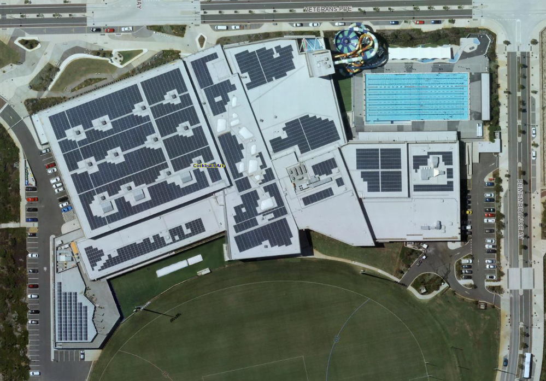

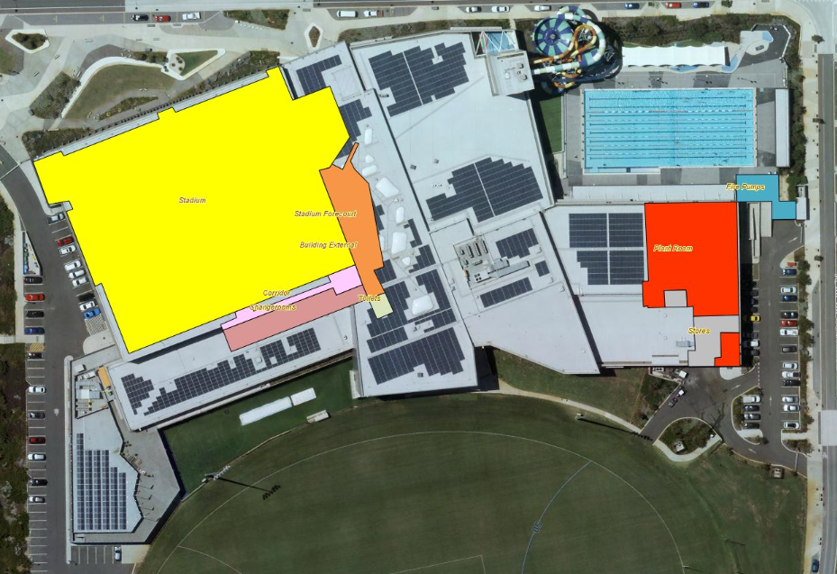**Figure 2.1.2 Aerial view of Level One, Cockburn ARC**

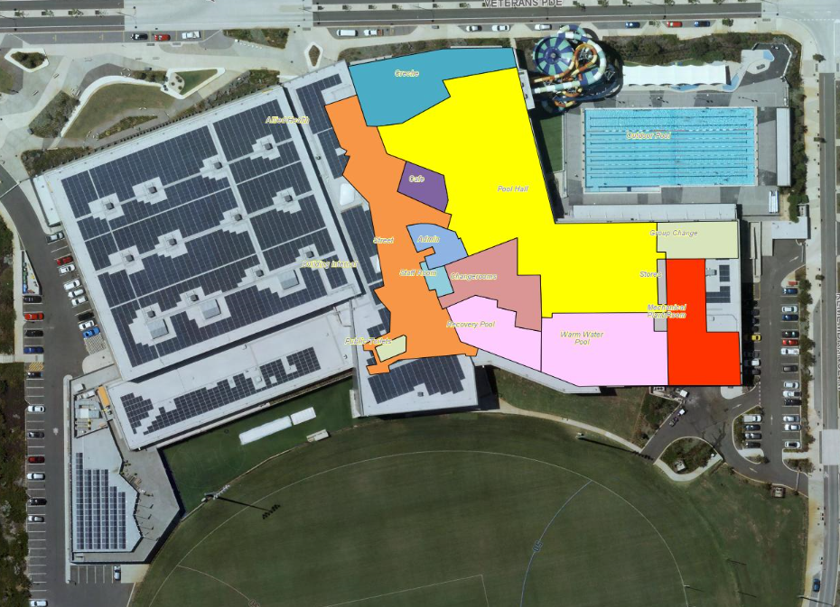**Figure 2.1.3 Aerial view of Level Two, Cockburn ARC**

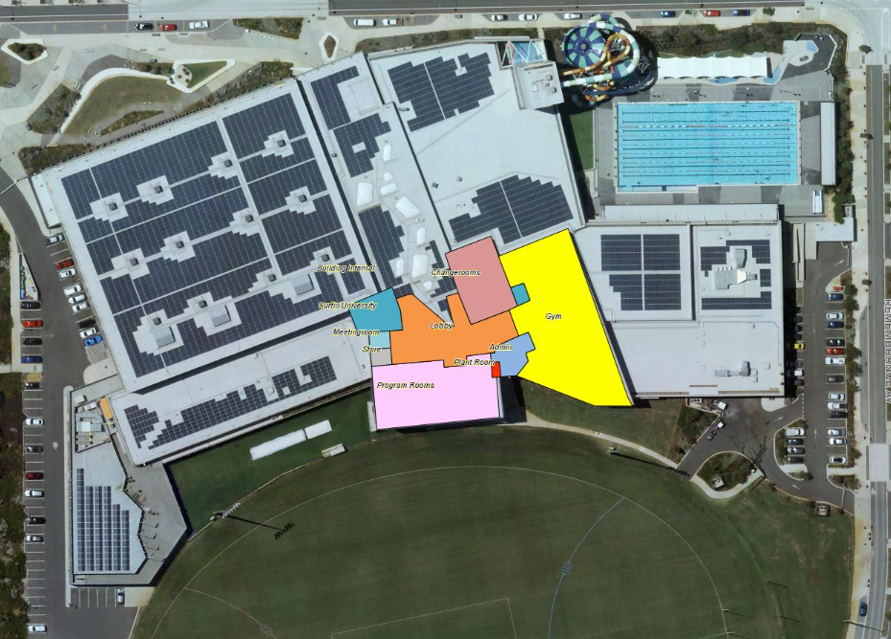**Figure 2.1.4 Aerial view of Level Three, Cockburn ARC**

The Cockburn ARC asset management plan is to be read in conjunction with the following associated planning documents:

City of Cockburn Strategic Community Plan 2020 – 2030

City of Cockburn Corporate Business Plan 2016/17 – 2019/20

City of Cockburn Annual Business Plan 2019 – 2020

City of Cockburn Long Term Financial Management Plan 2019/20 – 2032/33

City of Cockburn Community, Sport and Recreation Facilities Plan 2018 - 2033

Key stakeholders in the preparation and implementation of this asset management plan are shown in Table 2.1.2.

**Table 2.1.2 Key Stakeholders in the AMP**

|  |  |
| --- | --- |
| ENTITY | NATURE OF INVOLVEMENT |
| INTERNAL STAKEHOLDERS: |  |
| The Elected Council | Community representation |
| Chief Executive Officer (CEO) | Asset management direction and leadership |
| Executive Committee (ExCo) | Executive management endorsement, sign off and executive ownership |
| Chief of Community Services | Review and strategic management sign off |
| Cockburn ARC Manager and Staff | Review and line management sign off and implementation of the AMP maintenance actions |
| Property and Asset Services | Asset management plan development, review and continuous improvement |
| EXTERNAL STAKEHOLDERS: |  |
| Insurers | Assist to manage financial risk of the City |
| City of Cockburn Community | Service and facility users |
| Outer Council Area Community | Service and facility users |
| City of Cockburn Businesses | Service and facility users |
| Leaseholders of the ARC | Fremantle Football Club, Curtin University, Lifecare, Beaumonde Catering |

**2.2 Goals and Objectives of Asset Management**

The City of Cockburn exists to deliver services to its community supported by the City’s infrastructure assets. The City acquires infrastructure assets by ‘purchase’, ‘contract’, construction by council and by handover of ‘donated’ assets constructed by developers in order to meet the increased demand for services.

The City of Cockburn’s goal in managing infrastructure assets is to meet the required level of service in the most cost effective manner for present and future consumers.

The key elements of infrastructure asset management are:

* Taking a life cycle approach,
* Developing cost-effective management strategies for the long term,
* Providing a defined level of service and monitoring performance,
* Understanding and meeting the demands of growth through demand management and infrastructure investment,
* Managing risks associated with asset failures,
* Sustainable use of physical and financial resources, and
* Continuous improvement in asset management practices.

This AMP is prepared under the direction of Council’s vision, purpose, goals and objectives.

The City of Cockburn’s vision is:

Cockburn, the best place to be

The City of Cockburn’s purpose is:

Support our communities to thrive by providing inclusive and sustainable services which reflect their aspirations

The five key outcomes as detailed in the Strategic Community Plan (SCP) 2020-2030 are:

* Local Economy
* Environmental Responsibility
* Community, Lifestyle & Security
* City Growth and Moving Around
* Listening and Leading

The relevant outcomes and objectives as outlined in the Strategic Community Plan and how these are addressed in this asset management plan are detailed in Table 2.2.1.

**Table 2.2.1 Council Goals and how these are addressed in this Plan**

|  |  |  |
| --- | --- | --- |
| Strategic Outcome | Strategic Objective | How Outcomes and Objectives are addressed |
| Local Economy  A sustainable and diverse local economy that attracts increased investment and provides local employment | 1.Ensure the City is ‘easy to do business with’ | **Levels of Service:**  Section 3 |
| Environmental Responsibility  A leader in environmental management that enhances and sustainably manages our local natural areas and resources | 1.Sustainable resource management including waste, water and energy | **Future Growth and Demand:**  Section 4 |
| Community, Lifestyle & Security  A vibrant, healthy, safe, inclusive and connected community | 1. Accessible and inclusive community, recreation and cultural services and facilities that enrich our community | **Levels of Service:**  Section 3 |
| City Growth and Moving Around  A growing City that is easy to move around and provides great places to live | 1. An attractive, socially connected and diverse built environment  2. Cockburn Central as the capital of Perth’s South Metro Region | **Future Growth and Demand:**  Section 4 |
| Listening and Leading  A community focused, sustainable, accountable and progressive organisation | 1. Best practice governance, partnerships and value for money  2. High quality and effective community engagement and customer service experiences | **Financial Analysis:**  Section 6  **Levels of Service:**  Section 3 |

## **2.3 Plan Framework**

Key elements of the AMP are:

* Levels of Service and Enterprise Risk Management – outlines the levels of service provided by Council and identifies risks to the City.
* Future Growth and Demand – how this will impact on future service delivery and how this is to be met.
* Lifecycle Management – how the City will manage its existing and future assets to provide the required services.
* Financial Analysis – what funds are required to provide the required services.
* Asset management practices.
* Asset management monitoring and improvement plan - how the plan will be monitored and improved to ensure it is meeting Council’s objectives.

**2.4 Asset Management Maturity**

The 2020-2024 AMP has been developed in accordance with the International Infrastructure Management Manual (IIMM) and complies with the Department of Local Government & Communities Asset Management Framework.

As part of the City’s Strategic Asset Management Framework, the ARC AMP will formalise the City’s future forecasting for Aquatic and Recreation Infrastructure, enabling the organisation to determine future budgeting requirements, sustain the current and future asset base, whilst ensuring that optimisation of activities and programs facilitate for the capture and reporting of adopted service levels.

The ARC AMP has reached a ‘core’ level of maturity and provides Executive level monitoring and reporting of key improvement areas from the Improvement Strategy.

With the continued implementation of the Strategic Asset Management Framework, the City will commence measuring service levels for planned and reactive maintenance to determine operational performance and asset utilisation.

The City strives to improve its strategic and operational asset management practices and to continue its journey towards advanced asset management. The Department of Local Government, Sport and Cultural Industries (DLGSC) has developed the Western Australia Local Government Integrated Planning and Reporting Framework. The future direction and need for advanced level practices are continually assessed in accordance with this and the City’s Asset Management Policy. The Integrated Planning and Reporting Framework is shown Figure 2.4.1.

**Figure 2.4.1 The City’s Integrated Corporate Planning Framework**

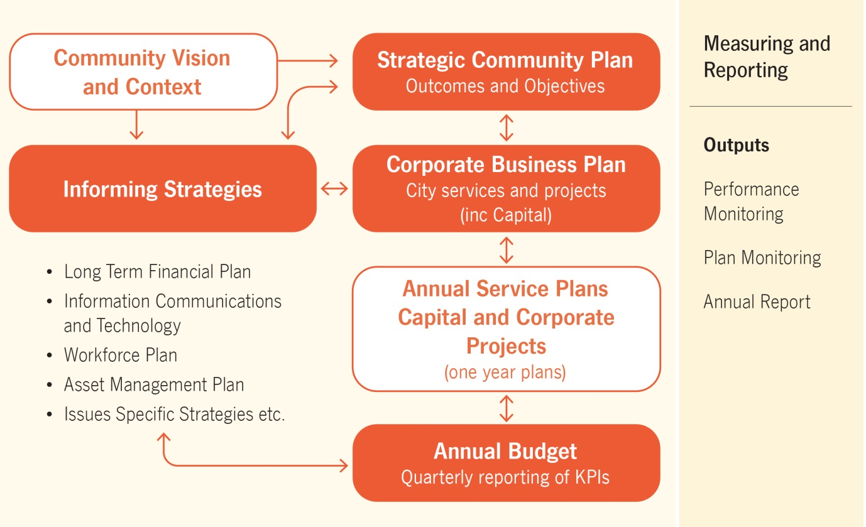

The ARC AMP forms part of the City’s Assets Informing Strategies, which consists of the following strategy and asset management plans:

Asset Management Strategy - 2017 - 2024

Buildings AMP - 2020 – 2024

Drainage AMP - 2020 - 2024

Footpath AMP - 2020 - 2024

Fleet and Plant AMP - 2020 - 2024

Marina and Coastal Infrastructure AMP - 2020 - 2024

Parks & Environment AMP - 2020 - 2024

Road Infrastructure AMP - 2020 – 2024

**2.5 Asset Management Plan Maturity & Data Confidence Assessment**

Each of the five sections within the ARC AMP were reviewed to determine Stakeholder confidence as to the accuracy and maturity of the City’s asset data and services.

**Table 2.5.1 Data Accuracy**

| AMP | Contents | Data Confidence |
| --- | --- | --- |
| Section 2 | Strategic goals & objectives | **B** |
| Section 3 | Levels of Service  Risk Management | **A**  **A** |
| Section 4 | Growth, Demand, New Assets | **B** |
| Section 5 | Asset data; Age, Condition  Operating & Maintenance Expenditure, Renewal Expenditure | **B**  **B** |
| Section 6 | Financial statements; Renewals Gap, Ratios | **A** |

Ratings are based on the following criteria / inputs.

**Table 2.5.2 Data Confidence Criteria**

|  |  |
| --- | --- |
| **Confidence Grade** | **Description** |
| A Highly reliable | Data based on sound records, procedures, investigations and analysis, documented properly and agreed as the best method of assessment. Dataset is complete and estimated to be accurate ± 2% |
| B Reliable | Data based on sound records, procedures, investigations and analysis, documented properly but has minor shortcomings, for example some of the data is old, some documentation is missing and/or reliance is placed on unconfirmed reports or some extrapolation. Dataset is complete and estimated to be accurate ± 10% |
| C Uncertain | Data based on sound records, procedures, investigations and analysis which is incomplete or unsupported, or extrapolated from a limited sample for which grade A or B data are available. Dataset is substantially complete but up to 50% is extrapolated data and accuracy estimated ± 25% |
| D Very Uncertain | Data is based on unconfirmed verbal reports and/or cursory inspections and analysis. Dataset may not be fully complete and most data is estimated or extrapolated. Accuracy ± 40% |
| E Unknown | None or very little data held. |

# 3. Levels of Service

To support the management of aquatic and recreational assets the City has developed industry best practice asset management and customer focussed levels of service (LOS) for infrastructure and associated services. These LOS’s provide the City with a mechanism to deliver operational activities that endeavour to meet community expectations in the most cost effective manner possible.

The City administers Community and Technical Services levels to ensure that quality service provision is provided in accordance with the City’s customer Service Charter and Community Engagement Framework, whilst Technical Services are sustainable, and adhere to all relevant compliance and safety industry standards.

Similar to the City’s existing Asset Management Plans, future ARC AMP Service level reporting will be derived from the City’s Enterprise Asset Management System (EAM). The Implementation of the EAM will establish improved reporting of operational and maintenance budget expenditure providing increased confidence in projecting future budget needs.

The City operates and evaluates Cockburn ARC in a highly accountable manner, financial performance and participation levels at the facility are the primary indicator as to the success of the centre. Notably, the leadership team track, report and review a number of metrics on a weekly basis that inform decision making and improvement initiatives through a variety of dashboards.

The City of Cockburn administered the CATALYSE Business and Community Performance Scorecard to evaluate and monitor performance across a range of services and facilities. 697 Residents and 138 businesses participated in the studies. The surveys were conducted by CATALYSE Pty Ltd and provide Council with valid performance measures that can be benchmarked and consistently monitored over time.

The City of Cockburn has defined service levels in two terms:

* Community Levels of Service relate to how the community receives the service in terms of safety, quality, quantity, reliability, responsiveness, cost efficiency and legislative compliance.
* Supporting the community service levels are operational or technical measures of performance developed to ensure that at least the minimum community levels of service are met. Technical Levels of Service relate to how the City provides the service using technical terms.

The most recent customer satisfaction surveys were undertaken in April 2020 and the performance comparison of satisfaction levels since construction are shown below. The ARC AMP community and technical levels of service are defined to an asset group level and enable the City to monitor and report operational performance against adopted community and technical targets. The ARC scored highest out of all programs, services and facilities available to local residents and the community.

Tables 3.1.1, 3.1.2 and 3.1.3 outline the City’s current Community Service Levels, measures and performance demonstrating the diversity and quality of services provided by the Cockburn ARC Staff.

Key to status reported below:

Drop in customer satisfaction of 3% or more

Change in customer satisfaction of 2% or less

Increase in customer satisfaction of 3% or more

**3.1 Current Levels of Service**

**Table 3.1.1 Community Scorecard Performance Rating**

|  |  |  |  |  |
| --- | --- | --- | --- | --- |
| **Performance Measure** | **Satisfaction Level (Delighted & Satisfied)** | | | |
| **2017-18** | **2018-19** | **2019-20** | **Status from previous year** |
| **% Satisfaction**  **with Cockburn ARC** | 97% | 98% | 96% |  |
| **% engagement**  **ARC Membership of surveyed** | 19% | 18% | 20% |  |

**Table 3.1.2 Occupancy and Attendance Data**

|  |  |  |  |
| --- | --- | --- | --- |
| **Performance Measure** | **2017-18** | **2018-19** | **2019-20\*** |
| **Annual enrolments across various water programs including Swimming Lessons, ARCademy, Learn To Swim** | 2724 | 2828 | 2851 |
| **Annual occupancy % swim program only** | 86.80% | 87.70% | 82.80% |
| **Average Group Fitness attendances/month** | 8506 | 7952 | 6612 |
| **Annual attendances to facility** | 1,370,979 | 1,394,850 | 1,016,933 |

*Reduced class sizes for COVID-19 compliancy, future versions of this plan will continue to report occupancy and attendance numbers despite restrictions resulting from the Corona virus pandemic.

Cockburn ARC had the following closures due to COVID – 19, Friday 20 March 2020 - Monday 25 May, 2020, Friday 31 February - Sunday 7 March 2021 and Friday 23 April - Saturday 1st May 2021 totalling 88 days over the 2019/20 and 2020/21 financial years.

Table 3.1.3 shows the current Community levels of service being provided under ARC AMP. The ‘desired’ position in the table, documents the position being recommended in this AM Plan.

**Table 3.1.3 Community Levels of Service**

| **Service Attribute** | **Service Objective** | | | **Performance Measure Process** | **Current Performance** | | **Expected Position in 10 Years based on current LTFP** |
| --- | --- | --- | --- | --- | --- | --- | --- |
| **COMMUNITY LEVELS OF SERVICE** | | | | | | | |
| **Service Provision** | | Provision of a safe, reliable and enjoyable swimming facility to residents and visitors of the City | Complaints and public enquiries relating to services provided at the ARC | | Requests/complaints are responded to in accordance with the City’s Customer Service Charter standards | Increase staff in line with ARC expansion plan business case. Future introduction of CX Framework to exceed the City’s current standards | |
| Net Promoter Score, a benchmarking process based on customer satisfaction metrics where 50 is excellent and 70+ is world class  *19/20 is for non-Covid restricted months only | | Average Annual Net Promoter Score  Year Score  2017 45.9  2018 47.5  2019 59.7 2020* 66.7 | Maintain or improve current performance level | |
| Cockburn ARC offers a high level of availability to members and casual users | Current Opening Hours | | 24hr Health Club | Cockburn ARC continues to offer a high level of availability to members and casual users | |
| **Quality** | | Pools comply with regulations and guidelines | Internal and external water/facility compliance audits | | 100% compliance with Aquatics Code of Practice, External Chemical Audit and Safety Audit | 100% compliance with Aquatics Code of Practice, External Chemical Audit and Safety Audit | |
| Fitness equipment is of a high standard, regularly maintained or replaced when required | Internal and external equipment audits | | Monthly equipment audit by contractor, replaced when required | Fitness equipment is of a high standard, regularly maintained or replaced when required | |
| **Service Attribute** | | **Service Objective** | **Performance Measure Process** | | **Current Performance** | **Expected Position in 10 Years based on current LTFP** | |
| **Function** | | Provision of a safe leisure environment | Cockburn ARC Emergency Response Plan | | Compliant | No change current performance, actively working towards reducing accidents and promotion of safe practices | |
| Satisfaction with aquatics and fitness facilities | Customer Satisfaction | | Provision of aquatics and fitness facilities are satisfactory for requirement | Satisfaction with aquatics and fitness facilities | |
| Ensure Cockburn ARC is accessible to all users | Continued provision of inclusive sports programs and accessible aquatic facilities and fitness equipment. Disability Access Audit 2020 confirmed Cockburn ARC is compliant under the building code and compliant with the Disability Access and Inclusion Plan | | Redbacks Basketball Team is an inclusive basketball club catering for people with disabilities  Specialist accessible gym equipment  One platypus access stairs and three Wet Area water wheelchairs available for free  Companion Cards free entry for carers  Disability Access ramps to pools  11 ACROD parking bays  Disability hoist & change bed | Continued or increased provision of inclusive equipment, facilities and programs. All processes are being met and compliant as per current performance | |
| **Capacity/ Utilisation – is the service over or under used** | | Facility capacity is not exceeded (4245 pax) | People count upon entry | | Safe Occupancy Dashboard | Facility is not over capacity, completion of the ARC expansion will ensure this | |
| Planned Service disruptions | Number of days facility is closed per annum | | Two days per annum  (Christmas Day and Good Friday) | No increase in facility closures or reduction in service | |

Table 3.1.4 shows the current technical levels of service being provided under the ARC AMP. The ‘desired’ position in the table, documents the position being recommended in this AM Plan

**Table 3.1.4 Technical Levels of Service**

| **Service Attribute** | **Service Objective** | **Activity Measure Process** | **Current Performance** | **Desired for Optimum Lifecycle Cost** | **Agreed Sustainable Position** | |
| --- | --- | --- | --- | --- | --- | --- |
| **TECHNICAL LEVELS OF SERVICE** | | | | | | |
| **Operations** | Cockburn ARC services are reliable, accessible and sufficient | Period of days when the ARC facilities cannot be used or shut down | Cockburn ARC operates 363 days per year, unless scheduled maintenance/shut down has been advertised | As per current performance | | As per current performance with consideration given for essential maintenance |
| Cost Effectiveness | Facility demonstrates a financially responsible operating model and operating costs are maintained within approved budget | Cockburn ARC is currently running a cost neutral model | As per current performance | | As per current performance with consideration given to increased operational costs following expansion |
| Effectively utilise assets which will sustainably consume resources such as energy and water | Daily utility reporting along with annual energy & water audits | All processes are being met | As per current performance | | As per current performance |
| **Maintenance** | Maintain a clean facility at all times | 12x general cleaning inspections per year auditing cleaners (minimum), 4x periodical inspections per year and compliance with cleaning contracts | A high level of compliance currently exists | All processes are being met | | As per current performance |
| Maintain and report on ARC infrastructure with scheduled inspections across a variety of maintenance contractors | Undertake regular facility inspections and audits of equipment | Maintenance and renewal work is undertaken in accordance with annual business plans  Compliance with maintenance contracts (electrical, HVAC, Plumbing, Carpentry) | As per current performance | | As per current performance with consideration given to increased maintenance requirements following expansion |
| Cockburn ARC is a safe leisure facility | Number of reported accidents  # of employee or contractor safety inductions completed per year  Ensure compliance with the code of practise for the design, construction, operation, management & maintenance of aquatic facilities  AS 3745-2010 Planning for emergencies in facilities | Currently in the process of implementing an online contractor management system  ARC infrastructure is free from hazards/defects and customer requests and/ incidents | No increase in reported accidents/incidents  All mandatory contractor safety inductions completed  Compliant in all areas | | All processes are being met |
| **Upgrade/New** | Cockburn ARC infrastructure meets user needs and requirements | Demand additional equipment and infrastructure | Currently meeting user group needs | No increase in requests for additional equipment | | All processes are being met |

**3.2 Enterprise Risk Management**

In 2015 the City implemented a Risk Management & Safety System (RMSS) in which all operational and strategic risks are captured, rated and receives ongoing monitoring based on their level of risk.

Additionally, in 2017 the Risk Management Framework was adopted with the aim of supporting an integrated and effective organisation wide approach to risk management.

The implementation of the Framework sought to:

* Ensure a consistent approach to the risk management process across Council;
* Establish a structured process for undertaking the risk management process to identify, assess and control/treat risks;
* Encourage the integration of risk management into the strategic and operational process across all Business Units of the Council

There are currently no Extreme and one High Risk associated with ARC Infrastructure, these are managed by risk treatment plans.

The City uses a matrix based approach when addressing risk level, treatment and responsibility as detailed in Table 3.3.1.

**Table 3.2.1 Risk Treatment Matrix**

| **Risk Level** | **Code** | **Criteria** | **Treatment** | **Responsibility** |
| --- | --- | --- | --- | --- |
| **LOW** | L | Risk acceptable with adequate controls, managed by routine procedures. Subject to annual monitoring or continuous review throughout project lifecycle. | Management through routine operations/project, Risk Registers to be updated. | Service Unit Manager/Project Manager |
| **MODERATE** | M | Risk acceptable with adequate controls, managed by specific procedures. Subject to semi- annual monitoring or continuous review throughout project lifecycle. | Communication and awareness of increasing risk provided to SM, Risk Registers to be updated. | Senior Manager/Project Manager |
| **SUBSTANTIAL** | S | Accepted with detailed review and assessment. Action Plan prepared and continuous review. | Assess impact of competing Service Unit/Business Unit Projects. Potential redirect of Service Unit/Business Unit resources. Risk registers to be updated. | Director/Steering Committee |
| **HIGH** | H | Risk acceptable with effective controls, managed by senior management/executive. Subject to quarterly monitoring or continuous review throughout project lifecycle. | Escalate to CEO, report prepared for Audit & Strategic Finance Committee. Quarterly monitoring and review required. Risk Registers to be updated. | Executive/ Steering Committee/Project Sponsor |
| **EXTREME** | E | Risk only acceptable with effective controls and all treatment plans to be explored and implemented where possible, managed by highest level of authority and subject to continuous monitoring. | Escalate to CEO, report prepared for Audit & Strategic Finance Committee. Monthly monitoring and review required. Risk Registers to be updated. | CEO/Council/Project Sponsor |

Each of the risks are reviewed with current and proposed control measures being assessed yearly to ensure industry standards and potential advancements are considered and are incorporated as required.

**Table 3.2.2 Cockburn ARC – Operational Risk and Proposed Treatments**

| **Service or Asset at Risk** | **What can Happen** | **Risk Rating** | **Risk Treatment Plan** | **Residual Risk** | **Treatment Costs** |
| --- | --- | --- | --- | --- | --- |
| Equipment & infrastructure e.g. Waterslides/ Stadium Equipment | Damage to equipment, vandalism, theft. Disrepair due to over or improper use | M | Proactive maintenance schedules, regular equipment audits, reporting system for reactive maintenance, training on use of equipment & treatment  Emergency Response Plan | L |  |
| Contractor Safety | Failure to provide a safe environment for contractors at the ARC | M | Contractor performance reviews  Maintain relevant staff qualifications  Contractors' insurance/permit checks  Risk management plans for high risk activities | L | N/A |
| Fire System | Facility fire resulting in damage to ARC infrastructure and risk to personal safety | S | Ensure all fire protection measures are in good working order at all times and inspected regularly | L | $11,000 per annum for inspection and maintenance program of all fire, Emergency Warning (EWIS) and mobile equipment |
| Automatic doors | Automatic door failure | M | Regular inspections and maintenance of doors and motors to ensure they don’t fail in emergencies as these are a primary exit | L | $8,000 per annum for inspection program |
| Site Security | Loss or damage to Council and personal items due to theft/vandalism. Unauthorised access throughout site | L | On site static security guard, 10-12hrs/day, 7 days a week | L | $128K per annum |
| Air Conditioners | Failure of the air conditioning system | M | Ensure regular maintenance and reporting of the system  Replace equipment before life expectancy by increasing intervention levels | L | $18,000 per annum HVAC program |
| Various electrical items including  switchboards, water heating system, emergency exits doors | Power failure | H | Ensure regular maintenance and reporting of the system, carry out maintenance based on these findings  General Electrical Contract  Cockburn ARC Operations and Maintenance Manual | M | $86K per annum Covered by the General Electrical Contract (GEC) |
| Dosing and Filtration System | Dosing or filter system malfunctions or failures | S | Ensure regular inspections and maintenance of the systems, ensure all required staff are trained in proper use of the units  Pool Services Contract  Cockburn ARC Operations and Maintenance Manual | M | Covered by the Pool Service Contract |
| Plant Room Equipment e.g. Pumps | Supply pump failures | S | Regular inspections and maintenance of the pumps, ensure all required staff are trained in proper use of the units  Pool Services Contract  Cockburn ARC Operations and Maintenance Manual | M | Pool Service Contract total $130K per annum |

**3.3 Legislative Requirements**

The City of Cockburn has to meet many legislative requirements including Australian and State legislation and regulations.

**See (Appendix A)** for the Legislative Requirements

**3.4 Asset Capacity and Performance**

The City of Cockburn services are generally provided to meet design and performance standards where these are available.

Locations where deficiencies in service performance are known have been identified by Cockburn ARC Staff and are detailed in the following table.

| **Location** | **Service Deficiency** |
| --- | --- |
| Geothermal Pumps | During routine preventative maintenance, the geothermal pump failed in February 2020. Contractors have said it’s a similar fault as experienced during the commissioning stages of the system in which various motors failed resulting in the system being inoperative. There is urgency to resolve the failure prior to the winter period, where heat requirements for the aquatic facilities are in higher demand, a contract for replacement has been awarded estimated completion Q1 21/22. The centre continues to use natural gas supply for all heating in the meantime. |
| Waterslides (Rocket) | The City has experienced a number of issues with the Rocket slide during the 2020 summer period. Remedial works were required in February 2020 to recommission the slide following a closure of two months. High levels of corrosion were evident within the electronics of the slide system which is believed to have contributed to the critical failure in late 2019; this is currently still out of action. |
| IT Systems and Support | Since the opening of the facility there have been challenges associated with performance of virtual PC’s, Wi-Fi equipment and general computer systems. It is understood this is a corporate issue across more service areas and not isolated to Cockburn ARC operations. |
| Lighting System | The lighting at the facility is aligned with the latest technologies, the fittings are energy efficient LED’s, these are controlled via a combination of timers and motion sensors, there is also daylight harvesting present. The current lighting system is underperforming and the annual software upgrade required is estimated at approximately $25K, this was excluded from the O&M manual and is classified as essential. |
| Bus Access Zone | At present, school busses are using Remembrance Avenue for turning however as this road is still under construction the current provision for a turn-around is inadequate. There is currently no planned date for these works to commence. |
| Outdoor Pool Concourse | The City has experienced extensive concrete cancer and cracking to the outdoor pool concourse. This defect was identified during the construction of the facility, with repair measures being undertaken. However is has become apparent these repairs have been unsuccessful and the performance of the concrete remains a significant issue. |
| Harmonics Power Issue | A power monitoring study had been commissioned and is due to be completed in June 2021; this is to further investigate the frequency of failures in new infrastructure. |

**4. Future Growth and Demand**

**4.1 Growth Forecast**

Cockburn is one of the major Coastal Cities found in the state of Western Australia, totalling 170 square kilometres. This coastal City is renowned for its historical and tourism features along with agriculture and ship building industries.

The City of Cockburn’s 2020 forecasted population and dwelling is 120,417 and 46,800 dwellings respectively. The population is forecast to reach 169,700 by 2041, an increase of 40.92%.

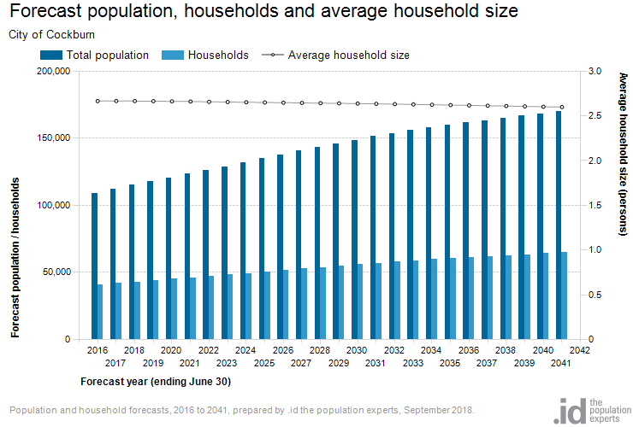

Growth factor trends and the impacts these have on service delivery across the Council are summarised in Table 4.1.

**Table 4.1 Growth Projections and Impact on Services**

| **Factor** | **Present Position** | **Projection** | **Impact on Services** |
| --- | --- | --- | --- |
| **Population** | 120,417 as at year 2020 | Change between 2020 and 2041 is projected to be 49,283 a 41% increase | Increase demand for the provision of new aquatic facility assets, parking areas and traffic management requirements |
| **Demographic change** | Population increases across all age groups | Likely to continue as projected | Shifts in demand and utilisation of the facility |
| **Development pattern changes** | New and existing land areas being developed and redeveloped around Cockburn Central and the Eastern suburbs | Likely to continue | Increased demand on the facility and services provided from increasing resident base, visitors and commuters |
| **Legislative changes** | Current compliance for the facility under building and health areas | New legislative changes will require compliancy updates | New changes may require new technologies, or facility users requirements |
| **Energy cost increases** | High energy demands for peak operating periods outside of solar hours | Likely to have continued cost increases | Facility charges may increase to cover utility costs |
| **Safety and environment protection measures** | Current compliance for the facility in the safety and environment protection areas | Measures may change with new/updated regulations | Increase compliance in the safety and environment areas may increase costs and charges |

Overall increased population in the City will increase customer expectations with regards to the performance and services provided. This may mean an increase in administrative and supervisory roles required to support the operational staff.

The City of Cockburn is a large Local Government employing over 500 people in fulltime, part time and casual roles. With the projected growth and demand on services the Cockburn ARC Business Unit may need to increase, in order to adequately deliver the levels of service the community require.

**4.2 Changes in Technology**

The City of Cockburn has implemented a renewable energy program, which incorporates a blend of initiatives such as investing in renewable energy systems, establishing research partnerships, trialling new technology and campaigns to raise awareness on renewable energy as a viable and sustainable energy option.

* The $2 million agreement with Solargain to supply, install and maintain Western Australia’s largest 1MW rooftop solar installation generates 1550 MWh per year providing roughly one third of the facilities annual load helping to run the centres heated indoor and outdoor pools and comprises of 3592 panels and spans 6841m2. It is estimated to save the facility $300,000 annually and a carbon dioxide offset of 1170 tonnes per year,
* The ‘passive solar’ building design utilises the suns energy providing natural heating and cooling for increased cost effectiveness and usage efficiency.
* High efficiency pool filtration, low water usage ‘Defender’ filters use less backwashing which results in lower usage of scheme water.
* Geothermal energy infrastructure, a $3 million investment in geothermal energy infrastructure will have a payback period of between seven to 10 years and heats the Centre’s eight pools ranging from 27 degrees in the outdoor pool to 34 degrees in the community pool and spas at 37 degrees.
* Building Management System (BMS) with direct digital controllers (DDC) to control air-conditioning, lighting and ventilation equipment for optimum efficiency and cost.
* Water efficient infrastructure located throughout the building including showers, dual flush toilets and push button taps with set run times supporting the Waterwise Aquatic Centre Program certification earned in 2019 and the Water Management Plan.

**4.3 Demand Management Plan**

Demand management strategies provide alternatives to the creation of new assets in order to meet demand, and look at ways to modify customer demands in order that the utilisation of existing assets is maximised and the need for new assets deferred or reduced. The objective of demand management is to actively seek to modify customer demands for services in order to;

* Optimise the utilisation and performance of existing assets,
* Reduce or defer the need for new assets,
* Meet organisation’s strategic objectives,
* Deliver a more sustainable service, and
* Respond to changing customer needs.

The opportunities identified to date for demand management, the impact these drivers may have on future service delivery and the utilisation of these assets are shown in the Table 4.3.

Demand for new services will be recognised through a combination of managing and upgrading of existing assets and providing new assets. Demand management practices include non-asset solutions, insuring against risks and managing failures.

**Table 4.3 Demand Management Plan Summary**

| **Demand Driver** | **Impact on Services** | **Demand Management Plan** |
| --- | --- | --- |
| **Population and Geographic Increase** | Increased demand for provision of new facility assets, upgrading of existing assets and changes to facility access times | Health and Fitness Expansion Business Case |
| **Program, Services and Facilities** | Health and Fitness spaces considered inadequate for current and future demand. Gym usage during peak time above sector average. | Health and Fitness Expansion Business Case |
| **Insufficient parking provision** | Cockburn ARC visitors are currently using a temporary car park under a rental agreement, this is to be developed and two new car parks to be created | Health and Fitness Expansion Business Case |
| **Facility Memberships** | The number of active members continues to present a significant risk to the City, in which cancellations may continue to occur due to lack of gym and programmable space. | This is being addressed as a priority project as part of the 2020-21 Business Plan. |

**4.4 New Assets from Growth**

The new assets required to meet growth will be mainly acquired from new and upgraded works. This may also include some minor construction works being completed by the City. New projects to be funded by the City are taken from the Preliminary 5 year Capital Works Program shown in Appendix E.

These figures have been used throughout this AMP where growth has been considered.

* + Continued population growth within the City of Cockburn area and surrounding Council areas,
  + Development of residential and commercial infrastructure areas throughout the City of Cockburn and surrounding Council areas, and
  + The service and reputation of the Cockburn ARC has become better established and thus creating a more desirable facility for local and visiting users of the facility.
  + Offering additional facilities to locals and visitors in support of the increasing demand at the facility e.g. additional parking areas, and
  + Maintain the high standards of service and facilities expected by both locals and visitors to the Cockburn ARC facility.

**Graph 4.4 New Assets from Growth**

Over the next five years the City will fund and deliver major new assets with an estimated budget of $5.8 million including 2% CPI.

**5. Lifecycle Management**

The lifecycle management area details how the City of Cockburn plans to manage and operate the Cockburn ARC infrastructure assets while optimising lifecycle costs. The data is based on the City’s financial and operational asset registers.

## **5.1 Asset Data**

The City’s operational asset register is derived from an internally developed specification ‘BSPEC’ based on similar principles to the City’s RSPEC & OSPEC which align to the ASPEC data industry standard for the supply of digital data relating to “As Constructed” Infrastructure asset information. This is the classification of assets to best capture and manage Infrastructure for the City, for further information on ASPEC please refer to the glossary.

### 5.1.1 Asset Age

The age profile for Cockburn ARC infrastructure assets are shown in Graph 5.1.1.

**Graph 5.1.1 Asset Age Profile**

Graph 5.1.1 confirms that 100% of ARC assets are within the first 10 years of their operational life. Further, infrastructure within the first 10 years equates to a CRC of $27.3m. Following completion of the expansion and as infrastructure is replaced the asset age profile graph will mature in line with the facility.

### 5.1.2 Useful Life

A useful life has been applied to all aquatic and recreation infrastructure this is calculated using industry/technical knowledge and shown in Table 5.1.2.

**Table 5.1.2 Asset Useful Life for Cockburn ARC Infrastructure**

| **Building Component** | **Asset Group** | **Type** | **Useful Life** |
| --- | --- | --- | --- |
| **ARC Infrastructure** | AR_POEQ (Pool equipment) | CLEAN_EQ | 5 |
| AR_POEQ | ARC_INF |
| AR_POEQ | BLANKET | 8 |
| AR_POEQ | AQU_LADR |
| AR_PLAN (Plant) | CHEM_SYS | 10 |
| AR_PLAN | DIS_SYS |
| AR_PLAN | FILT_SYS |
| AR_PLAN | ULTR_FIL |
| AR_PLAN | CO2_UNIT |
| AR_PLAN | AIR_COMP |
| AR_PLAN | UV_UNIT |
| AR_POEQ | TROLLEY |
| AR_POEQ | LANE_ROP |
| AR_POOL (Pool) | GRATED |
| AR_PLAN | BKWA_SEN | 12 |
| AR_PLAN | POOL_PUM |
| AR_PLAN | BKWA_PUM |
| AR_PLAN | HEAT_SYP |
| AR_POEQ | DIV_BLOK | 15 |
| AR_POEQ | SWM_WL |
| AR_CHIL (Children’s play equipment) | PLY_CNTR |
| AR_POEQ | WATR_EQU | 20 |
| AR_PLAN | HYPO_GEN |
| AR_PLAN | FLOW_MET |
| AR_EQUI (Equipment) | BASK_BAK |
| AR_EQUI | FXEQ_WIN |
| AR_EQUI | SCR_BRD |
| AR_EQUI | MOB_EQUI |
| AR_EQUI | ARC_NETS |
| AR_POEQ | WATR_SLD |
| AR_PLAN | HEAT_SYE | 25 |
| AR_PLAN | GEO_SYS | 30 |
| AR_PLAN | HYPO_TNK |
| AR_PLAN | CHEM_TNK |

See Appendix B & C for a full breakdown of useful life’s for internal building components.

### 5.1.3 Asset Condition

The condition profile of the Cockburn ARC infrastructure assets are measured using a 1 to 5 rating system as outlined in Table 5.1.3.

**Table 5.1.3 Asset Condition Rating System**

|  |  |  |
| --- | --- | --- |
| Rating | Condition Description | |
| 1 | Excellent | A new asset or an asset in overall excellent condition with only a slight condition decline  Normal maintenance required |
| 2 | Good | An asset in an overall good condition, with minor signs of deterioration evident, serviceability may be slightly impaired  Minor maintenance required |
| 3 | Moderate | An asset with obvious signs of deterioration  Maintenance required to return to accepted level of services  Significant maintenance required |
| 4 | Poor | An asset in poor condition  Condition deterioration is severe and serviceability is becoming limited  Significant renewal or upgrade required |
| 5 | Very poor | An asset that has failed and no longer serviceable  There would be a risk leaving the asset in service  Replacement required |

**Graph 5.1.3 Asset Condition Profile**

Graph 5.1.3, 100% of the City’s ARC assets are rated as condition 1 to 3 (excellent, good or moderate). Further, 0.9% of infrastructure is rated as good with a CRC of $24,009, 0.04% rated as moderate and the remaining 99.87% is considered to be in excellent condition with a CRC of $27.2 million. There is no infrastructure with a condition rating of 4 or 5.

### 5.1.4 Asset Valuations

The value of assets as covered by this asset management plan are summarised in Table 5.1.4.

**Table 5.1.4 Current Replacement Cost (CRC) by component**

| **COMPONENT CLASSIFICATION** | **CRC** |
| --- | --- |
| **Roof** | $5,492,600 |
| **External Site** | $948,060 |
| **Fitout** | $2,790,074 |
| **Finishes** | $6,372,289 |
| **Disability Services** | $29,800 |
| **Electrical Services** | $946,040 |
| **Hoists & lifts** | $160,650 |
| **Fire Services** | $119,625 |
| **HVAC Services** | $340,284 |
| **Hydraulic Services** | $33,800 |
| **Security Services** | $117,420 |
| **ARC Assets** | $9,966,596 |
| **TOTAL** | **$27,317,238** |

**Table 5.1.5 ARC Building Current Replacement Cost (CRC)**

| Building Infrastructure | Asset Classification |
| --- | --- |
| TOTAL | $85,700,000 | |

**5.2 Maintenance and Operating Expenditure**

Maintenance work includes reactive or planned maintenance work activities.

Reactive maintenance is unplanned repair work carried out in response to service requests, from Management or Supervisory directions.

Planned maintenance is work that is identified and managed through a maintenance schedule, these activities include inspection, assessing the condition against failure or breakdown experience, prioritising, scheduling, actioning the work and reporting what was done to develop a maintenance history and improve maintenance and service delivery performance.

Operating expenditure is continuously required expenditure e.g. power, fuel, staff, plant equipment, on-costs and overheads.

Maintenance and operating expenditure trends are shown in Table 5.2.

**Table 5.2 Maintenance and Operating Expenditure Trends**

|  |  |  |  |  |  |  |  |  |
| --- | --- | --- | --- | --- | --- | --- | --- | --- |
| Year | Reactive ($) | Reactive (%) | Planned ($) | Planned (%) | Total Maintenance ($) | Operating Expenditure ($) | Total Operating and Maintenance ($) | Annual Budget ($) |
| **2016/17** | 3,643 | 55 | 2,967 | 45 | **6,610** | 4,361,276 | **4,367,889** | **4,325,044** |
| **2017/18** | 273,073 | 84 | 60,087 | 18 | **333,161** | 11,442,776 | **11,775,937** | **11,840,336** |
| **2018/19** | 354,768 | 62 | 213,210 | 32 | **567,977** | 12,286,278 | **12,854,255** | **12,623,964** |
| **2019/20** | 473,454 | 79 | 127,214 | 21 | **600,668** | 11,886,217 | **12,486,885** | **13,337,984** |

Planned maintenance work for the financial year 2019/20 was 21**%** of the total maintenance expenditure. A heavily reactive maintenance model is less cost-effective and sustainable; whilst the desired services levels are being met and the facility is under five years old moving to a more planned maintenance should see improvements to overall maintenance expenditure.

The future maintenance and operating expenditure is forecast to grow in line with the value of the asset stock and this increase needs to be budgeted for to ensure new infrastructure at the ARC is maintained to the service levels identified in section 3. This is further discussed in Section 6.2 of the Financial Analysis.

Total maintenance is calculated using both the planned and reactive OPs (operational budget code) for ARC building and grounds maintenance. The operating expenditure is calculated using the GLs (general ledger) account lines, employee costs, depreciation and utilities have been included in this figure. The annual budget is derived from allocated budget funds for both the OPs and GLs accounts.

A breakdown of expenses by account type can be found in Appendix D.

**Graph 5.2 Forecast Operating and Maintenance Expenditure**

Data for the Graph 5.2 is based on 2019-20 actual maintenance and operating expenditure, with these values coming from the Table 5.2 Maintenance and Operating Expenditure Trends table. These costs are shown in current 2019/20 dollar values and increasing by 2% CPI each year forward.

### 5.2.1 Standards and Specifications

Maintenance, renewals and upgrade works are carried out in accordance with maintenance and specification manuals and other documentation as provided upon acquisition of the assets from works providers

5.3 Renewal and Replacement Plan

Renewal expenditure is major work which does not increase the asset’s design capacity but restores, rehabilitates, replaces or renews an existing asset to its original service potential.

The projected 10 Year Renewals program is detailed in Appendix E. Renewals are incorporated into the City’s capital works program. This is further explored in Section 6.2.

5.4 New and Upgrade Plan

New works are those works that create a new asset that did not previously exist, or works which upgrade or improve an existing asset beyond its existing capacity. They may result from growth, social or environmental needs.

The projected 5 Year New and Upgrade program is detailed in Appendix E.

5.5 Disposal Plan

Disposal includes any activity associated with the disposal of a decommissioned asset including sale, demolition or relocation.

Due to the infant nature of infrastructure at Cockburn ARC there is one asset identified for decommissioning or disposal at this time, as the infrastructure matures and the asset base ages along with increased consumption, asset disposals will be updated.

**Table 5.5 Assets Identified for Disposal**

| Asset Category | Reason for Disposal | Timing |
| --- | --- | --- |
| Chlorine Generator | Not fit for purpose | 21/22 |

**6. Financial Analysis**

The Financial Analysis section of this report provides the recommended financial forecasts for the next 10 years. This section brings together the various types of expenditure described throughout the previous sections of the AMP and provides recommended budgets for Council to achieve the appropriate level of service through Municipal funding.

6.1 Financial Statements and Projections

From the financial asset register, the value of assets as covered by this asset management plan are summarised in Table 6.1.1 Current Replacement Cost and Depreciation. The current replacement cost, fair value (also known as written down value or depreciated replacement cost), depreciation and the annual depreciation values are shown.

**Table 6.1.1 Component Current Replacement Cost and Depreciation**

| Component Classification | Replacement Value | Fair Value | Annual Depreciation Value |
| --- | --- | --- | --- |
| Roof | $5,492,600 | $4,806,967 | $272,746 |
| External Site | $948,060 | $841,481 | $23,546 |
| Fitout | $2,790,074 | $2,449,617 | $131,962 |
| Finishes | $6,372,289 | $5,583,495 | $284,908 |
| Disability Services | $29,800 | $26,243 | $1,153 |
| Electrical Services | $946,040 | $821,656 | $59,561 |
| Hoists & lifts | $160,650 | $141,372 | $6,426 |
| Fire Services | $119,625 | $105,357 | $4,609 |
| HVAC Services | $340,284 | $294,246 | $24,019 |
| Hydraulic Services | $33,800 | $28,732 | $3,393 |
| Security Services | $117,420 | $99,807 | $11,742 |
| ARC Assets | $9,858,596 | $8,447,406 | $748,972 |
| TOTAL | **$27,209,238** | **$23,646,380** | $1,573,037 |

**Table 2.1.1 Building Valuation and Depreciation**

|  |  |  |  |
| --- | --- | --- | --- |
| **Building** | **Current Replacement Cost (CRC)** | **Fair Value**  **(FV)** | **Annual Depreciation Expense** |
| **Cockburn ARC** | $85,709,556 | $79,734,389 | $1,611,340 |
| **TOTAL** | **$85,709,556** | **$79,734,389** | **$1,611,340** |

The financial projections are shown in Graph 6.1.1, for the forecasted operating (operations and maintenance) and capital expenditure (renewal and upgrade/ new assets).

**Graph 6.1.1 Forecast Operating and Capital Expenditure**

The costs shown are in 2019 dollar replacement values and also include the 2% CPI increase. Renewal and capital expenditure is low due to the infrastructure at Cockburn ARC being less than five years old and with significant remaining useful life. The operations and maintenance expenditure is expected to reach $15.9 million by 2029-30.

**Graph 6.1.2 Projected Component Renewals and Annual Depreciation**

In Graph 6.1.2, data for the projected renewals are obtained from the Appendix F preliminary 10 year renewal program, the projected depreciation expense takes into account all new asset values and the budget allocation has been based on the funding for the renewals per year.

These costs are shown in 2019 dollar values and also include the 2% CPI increase per year forward.

**Table 6.1.2 Projected Renewals and Budget Allocation Gap**

| **Year** | **Projected Renewals** | **Proposed Budget allocation from LTFP** | **Funding Gap** | **Cumulative Gap** |
| --- | --- | --- | --- | --- |
| **2020-21** | $200,000 | $200,000 | $0 | $0 |
| **2021-22** | $0 | $0 | $0 | $0 |
| **2022-23** | $0 | $0 | $0 | $0 |
| **2023-24** | $0 | $0 | $0 | $0 |
| **2024-25** | $194,838 | $194,838 | $0 | $0 |
| **2025-26** | $13,216 | $13,216 | $0 | $0 |
| **2026-27** | $13,964 | $13,964 | $0 | $0 |
| **2027-28** | $311,812 | $311,812 | $0 | $0 |
| **2028-29** | $0 | $0 | $0 | $0 |
| **2029-30** | $6,098,070 | $6,098,070 | $0 | $0 |
| **TOTAL** | **$6,831,900** | **$6,831,900** | **$0** |  |

The LTFP intends to provide 100% renewal funding up to 2029-30 ensuring that the 10 year cumulative funding gap for aquatic infrastructure assets base will be Zero.

6.2 Funding Strategy

Renewal expenditure identified in Section 6.1 is to be funded from the City’s Cockburn ARC Building Maintenance Reserve. The funding strategy is detailed in the City’s Long Term Financial Plan 2019-2020 to 2029-2030.

In order to provide effective management of aquatic and recreation infrastructure asset base it is imperative that LTFP funding strategies are adequate and timely to support asset renewal projections and new projects outlined within the ARC AMP.

6.3. Sustainability of Service Delivery

There are three key performance indicators for financial sustainability as recommended in the Department of Local Government (LG) Asset Management National Framework and Guidelines that have been considered in the analysis of the Cockburn ARC Infrastructure financial data.

The aim of the Framework is to enhance the sustainable management of Local Government assets by encouraging ‘whole of life’ and ‘whole of organisation’ approaches and the effective identification and management of risks associated with the use of the assets.

### 6.3.1 Asset Consumption Ratio (ACR)

* This ratio shows the written down current value of the City’s depreciable assets relative to their ‘as new’ value in up to date prices.
* These values are calculated by dividing the fair value by the current replacement cost. These figures are shown in table below.

|  |  |  |
| --- | --- | --- |
| **Asset Category** | **Consumption Ratio 2019-20** | **Standard Achieved** |
| **ARC Building** | 93.03% | Standard is met |
| **Components** | 86.93% | Standard is met |

The target ratio should be between 50% and 75%. A ratio of less than 50% indicates a rapid deterioration of the asset base, whilst a ratio greater than 75% may indicate an over investment in the asset base.

Integrated Planning and Reporting Advisory Standard KPI targets are outlined below.

**Standard is not met** if ratio data cannot be identified or ratio is less than 50%.

**Standard is met** if ratio data can be identified and ratio is 50% or greater.

**Standard is improving** if this ratio is between 60% and 75%.

As ARC infrastructure is new this % is higher than most other consumption ratios.

### 6.3.2 Asset Sustainability Ratio (ASR)

* This ratio indicates whether assets are being replaced or renewed at the same rate that the overall asset stock is wearing out
* It is calculated by dividing the annual capital expenditure spent on replacements (reserve funding required) by the annual depreciation expense. If capital expenditure on renewing or replacing assets is at least equal to depreciation on average over time, then the value of the existing stock will be maintained. If capital expenditure on existing assets is less than depreciation then underspending on replacement of assets will occur and this is likely to result in additional maintenance costs for assets that have exceeded their useful life that may exceed the cost of renewal or replacement.
* This ratio can only be measured accurately if an assessment is made of the total amount spent on capital renewal and replacement.

The target ratio should be between 90% - 110%. The forecast asset sustainability ratios shown below have been calculated on an accumulative basis.

|  |  |  |  |  |  |  |  |  |  |  |
| --- | --- | --- | --- | --- | --- | --- | --- | --- | --- | --- |
| Asset Category | Forecast Asset Sustainability Ratio | | | | | | | | | |
| 2020-21 | 2021-22 | 2022-23 | 2023-24 | 2024-25 | 2025-26 | 2026-27 | 2027-28 | 2028-29 | 2029-30 |
| Components only | 6% | 4% | 3% | 5% | 4% | 4% | 6% | 5% | 43% | 39% |

The ASR for 20/21 is 6%, currently the standard is not met at this time however does improve over the next 10 years.

Integrated Planning and Reporting Advisory Standard KPI targets are outlined below.

**Standard is not met** if ratio data cannot be identified or ratio is less than 90%.

**Standard is met** if ratio data can be calculated and ratio is 90% or greater.

**Standard is improving** if this ratio is between 90% and 110%

### 6.3.3 Asset Renewal Funding Ratio (ARFR)

* This is an indicator as to the ability of the City to fund the projected asset renewals and replacements in the future and therefore continue to provide existing levels of service, without additional operating income or reductions in operating expenses, or an increase in net financial liabilities above that currently projected.
* The ratio is calculated by dividing the planned capital expenditure (from the long term financial plan) on renewals over the next 10 years by the required (projected) capital expenditure on renewals over the same period.
* The standard is met if the ratio is between 75% and 95%.

The forecast asset renewal funding ratios shown below have been calculated on an accumulative basis.

|  |  |  |  |  |  |  |  |  |  |  |
| --- | --- | --- | --- | --- | --- | --- | --- | --- | --- | --- |
| Asset Category | Forecast Asset Renewal Funding Ratio | | | | | | | | | |
| 2020-21 | 2021-22 | 2022-23 | 2023-24 | 2024-25 | 2025-26 | 2026-27 | 2027-28 | 2028-29 | 2029-30 |
| Components only | 100% | 100% | 100% | 100% | 100% | 100% | 100% | 100% | 100% | 100% |

The target ratio should be between 95% and 105% which indicates that adequate provision / expenditure is being made for the *future* renewal and replacement of assets. The standard is improving.

Integrated Planning and Reporting Advisory Standard KPI targets are outlined below.

**Standard is not met** if ratio data cannot be identified or ratio is less than 75%.

**Standard is met** if ratio data can be identified and ratio is between 75% and

95%.

**Standard is improving** if this ratio is between 95% and 105% and the ASR falls within the range 90% to 110% and ACR falls within the range of 50% to 75%.

6.4 Valuation Forecasts

Asset values are forecast to increase as additional assets are added to the asset stock from construction and acquisition by Council, and from assets constructed by developers then donated to Council.

Graph 6.4.1 shows the projected depreciated replacement cost / asset values over the next 10 years, and the fair value also known as the depreciated replacement cost (WDV) is the current replacement cost less accumulated depreciation. These figures include the projected growth and capital upgrade / new as mentioned in section 6.1.

**Graph 6.4.1 Projected Building Asset Values (CRC) & Fair Value (WDV)**

The fair value will vary over the forecast period depending on the rates of addition of new assets, disposal of old assets and consumption and renewal of existing assets.

**Graph 6.4.2 Projected Building Depreciation Expense**

Depreciation expense values are forecast to trend in line with asset values as shown in the Graph 6.3.2. The highlighted line above provides the current depreciation expense note that all costs are shown in current 2019 dollar values and a 2% CPI increase per year forward.

6.5 Key Assumptions made in Financial Forecasts

This section details the key assumptions made in presenting the information contained in this asset management plan and in preparing forecasts of required operating and capital expenditure and asset values, depreciation expense and carrying amount estimates. It is presented to enable readers to gain an understanding of the levels of confidence in the data behind the financial forecasts.

Key assumptions made in this asset management plan are:

* The data supplied was as accurate as possible at the time of compilation of this asset management plan.
* The breakdown of the actual reactive, planned and operational expenditure is considered accurate.

6.6 Revenue

Net position has been calculated using the total income of Service Area - General minus Service Area General - Expenses this figure includes income and expenses generated from leased contracts also, such as Fremantle Football Club.

|  |  |
| --- | --- |
| **Year** | **Net Position** |
| **2016/17** | -$660,599 |
| **2017/18** | -$133,402 |
| **2018/19** | $1,891,401 |
| **2019/20** | $1,056,258 |

A comprehensive breakdown of both income streams Service Area – General and Leasee’s has been included in Appendix G, Revenue Breakdown.

**7. Asset Management Practices**

**7.1 Accounting / Financial Systems**

7.1.1 Summary of Accounting and Financial Systems

Technology One Financials version 11.09.19.011

7.1.2 Accountabilities and Responsibilities for Financial System

Financial Services – for the accounts and costing methodologies

7.1.3 Accounting Standards / Regulations / Guidelines

* Various Australian Accounting Standards including:
* AASB116 - Property, Plant and Equipment
* AASB13 Fair Value Measurement
* AASB136 - Impairment of Assets
* AASB 140 Investment Property
* AASB 5 Non-current Assets Held for Sale and Discontinued Operations
* Local Government Act 1995
* Local Government (Financial Management) Regulations 1996
* Local Government (Functions & General) Regulations 1996

**7.2 Asset Management Systems**

7.2.1 Summary of Asset Management System

Technology One Enterprise Asset Management version 11.09.19.011

Technology One Intramaps 8.1

7.2.2 Summary of how the Works and Assets system matches the Accounting / Financial system

The operational asset register within the Enterprise Asset Management system acts as the master for determining renewal projections and future refurbishment.

The financial asset register with Financials system acts as the master for Asset Valuations.

7.2.3 Accountabilities and Responsibilities for AM System(s)

Asset Services (AS) is accountable and responsible for the AM system, with other service areas assisting with the currency and maintenance of the data sets within the system databases.

7.2.4 Changes to the Asset Management Systems resulting from the AMP

All proposed/agreed system changes will be documented in Section 8 Plan Improvement and Monitoring.

**7.3 Information Flow Requirements and Processes**

The key information flows *into* this asset management plan are:

* The asset register data on size, age, condition, value and remaining life of the network;
* The unit rates for categories of work/material;
* The adopted service levels;
* Projections of various factors affecting future demand for services;
* Correlations between maintenance and renewal, including decay models; and
* Data on new assets acquired by council.

The key information flows *from* this asset management plan are:

* The assumed Works Program and trends;
* The resulting budget, valuation and depreciation projections; and
* The useful life analysis.

These will impact the Long Term Financial Plan, Strategic Community Plan, annual budget and departmental business plans and budgets.

**7.4 Standards and Guidelines**

Asset Management Policy Statement (SC 39) 2017

**8. Plan Improvement and Monitoring**

8.1 Performance Measures

The effectiveness of the asset management plan can be measured in the following ways:

* The degree to which the required cash flows identified in this asset management plan are incorporated into Council’s Long Term Financial Plan and Strategic Community Plan,
* The degree to which 1-5 year detailed works programs, budgets, business plans and organisational structures take into account the ‘global’ works program trends provided by the asset management plan, and
* The degree to which existing and projected service levels and consequences, risks and residual risks are incorporated into Council’s plans.

8.2 Improvement Strategy

The asset management improvement strategy generated from the Cockburn ARC Asset Management Plan is shown below in Table 8.2.

**Table 8.2 Cockburn ARC Improvement Strategy**

|  |  |  |  |  |
| --- | --- | --- | --- | --- |
| **Task No** | **Task** | **Responsibility** | **Resources Required** | **Timeline** |
| 1 | Include Water Efficiency Audit Data and Remedial Recommendations in next AMP revision/version | Property & Asset Services  ARC Staff | Internal | 2023-24 |
| 2 | Inclusion of HFM Energy Audit Data and Remedial Recommendations in next AMP revision/version | Property & Asset Services  ARC Staff | Internal | 2023-24 |
| 3 | Include outcomes from Oceanis, 2020 Plant Review | Property & Asset Services  ARC Staff | Internal | 2023-24 |
| 4 | Include environmental performance data from onsite power generation including solar production and energy consumption | Property & Asset Services  ARC Staff | Internal | 2023-24 |
| 5 | Improvement to current financial reporting leading to more efficient expenditure projections through smarter usage of (OPs and GLs) accounts and revenue | Property & Asset Services  ARC Staff  Finance Services | Internal | 2023-24 |
| 6 | Improve data accuracy of HVAC Services including location and value | Property & Asset Services  ARC Staff | Internal | 2023-24 |
| 7 | Inclusion of specific ARC rates and useful lifes for internal building components | Property & Asset Services  ARC Staff | Internal | 2023-24 |
| 8 | Inclusion of findings from Harmonix Power report | Property & Asset Services  ARC Staff | Internal | 2023-24 |
| 9 | Further development to data and text surrounding valuation of ARC building and ARC components | Property & Asset Services | Internal | 2023-24 |

8.3 Monitoring and Review Procedures

The ARC AMP forms part of the City’s Strategic Asset Management Planning Framework (SAMPF), covers four financial years (2020-21 – 2023-24) and acts as an informing strategy to the City’s Corporate Planning Framework.

Future iterations of the ARC AMP will be developed every 4 years and be subject to a 2 year desktop review. The ARC AMP review will focus on core elements required by the LTFP, for example asset valuations, growth projections, financial analysis including operating, sustainability ratios and 10 year renewals. This will ensure that future revisions of the LTFP will be derived from a structured AMP development cycle which has received Executive and or Council approval, increasing confidence and integration of asset management data and methodologies into the City’s long term financial planning.

The following diagram provides a visual representation and timeline of the Strategic Asset Planning Frameworks plans and strategies.

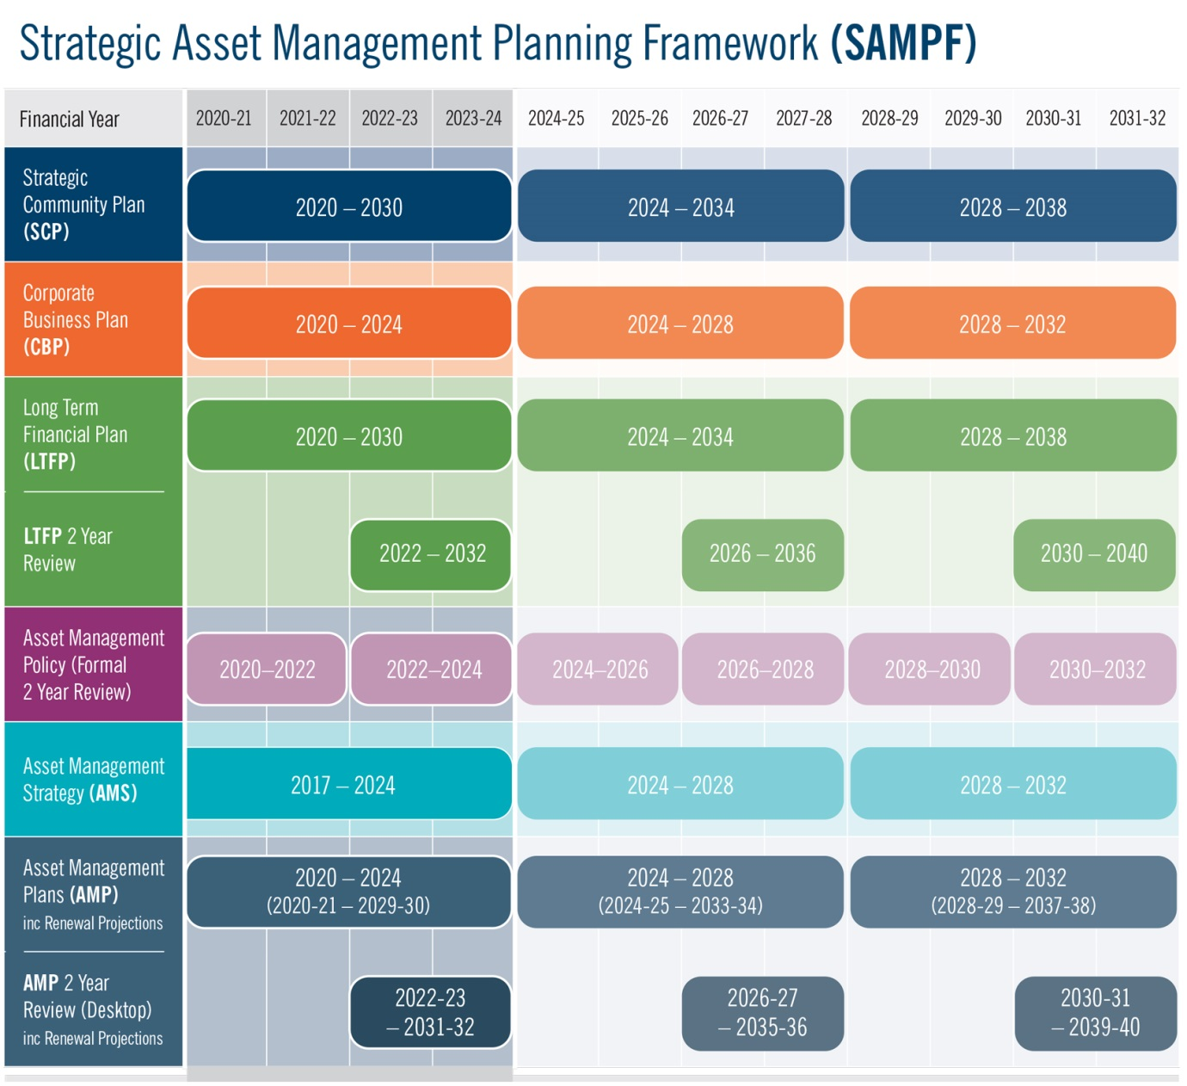

The formalisation and alignment of the City’s SAMPF (Asset Management Policy, Strategy and AMP’s) within the Integrated Corporate Planning Framework reflects the City’s increasing maturity and recognises the importance of Asset Management in supporting the City in delivering long term financial sustainability of services and capital asset renewal.

Supported by the relevant business area and the Asset Management Sections of the Project & Asset Service Unit, the Project & Asset Manager has overall responsibility and management for each of the Improvement Strategies identified within section 8 of the ARC AMP.

**References**

City of Cockburn – Asset Management Strategy 2017 – 2024

City of Cockburn – Disability Access and Inclusion Plan 2017 - 2022

City of Cockburn – Strategic Community Plan 2020 – 2030

City of Cockburn – Long Term Financial Plan 2020-2021 to 2029 – 2030

City of Cockburn – Management Budget 2019 – 2020

City of Cockburn – Management Budget 2020 – 2021

City of Cockburn – Enterprise Risk Management

City of Cockburn – Population Forecast

City of Cockburn – Sustainability Strategy 2017 – 2022

Cockburn ARC Emergency Response Plan, January 2017

Aquatic Facilities Regulations 2007

Code of Practice for the design, construction, operation, management and maintenance of aquatic facilities

<http://forecast2.id.com.au/Default.aspx?id=349&pg=5000>

IPWEA, 2011, ‘International Infrastructure Management Manual’, Institute of Public Works Engineering Australia, Sydney

Government of Western Australia, Department of The Premier and Cabinet –

[Western Australian Legislation – Acts in force](http://www.slp.wa.gov.au/legislation/statutes.nsf/main_actsif.html)

The Local Government and Municipal Knowledge Base – [LGAM Knowledge Base](http://www.lgam.info/start)

DVC, 2006, ‘Asset Investment Guidelines’, ‘Glossary’, Department for Victorian Communities, Local Government Victoria, Melbourne, http://www.dvc.vic.gov.au/web20/dvclgv.nsf/allDocs/RWP1C79EC4A7225CD2FCA257170003259F6?OpenDocument

Local Government of Western Australia – Asset Management Framework and Guidelines

Summary Report - Cockburn ARC (executive brief March 2020)

Cockburn ARC 12 Monthly Summary

Ask Nicely Summary Report 2017, 2018, 2019, 2020

City of Cockburn Community Scorecard Report 2020

Disability Access Audit Report – Cockburn ARC May 2020

**Appendices**

Appendix A Legislative Requirements

|  |  |
| --- | --- |
| **Legislation** | **Requirement** |
| Local Government Act 1996  LG (Miscellaneous Provisions) Act 1960 (WA)  LG Regulations 2008 | Sets out role, purpose, responsibilities and powers of Local Governments including the preparation of a long term financial plan supported by asset management plans for sustainable service delivery. |
| Occupational Safety and Health Act 1984 (WA)  OSH Regulations 1996 | Provides for the promotion, coordination, administration and enforcement of Safety and Health in WA. Places emphasis on the prevention of accidents and injury. |
| Disability Discriminations Act 1992 | Sets out requirements to eliminate as far as possible discrimination against persons on the grounds of disability in the areas of work, accommodation, clubs and sport and in the provision of facilities, services and land. |
| Disability Services Act 1993 | An Act for the establishment of the Disability Services commission and the Ministerial Advisory Council on Disability, for the furtherance of principles applicable to people with disabilities, for the funding and provision of services to such people that meet certain objectives and for the resolution of complaints by such people. |
| Building Code of Australia 2011 | The building code of Australia provides a nationally accepted and uniform set of technical requirements for all areas of building from design to construction. |
| Australian Accounting Standards | Sets out the financial reporting standards for the revaluation and depreciation of assets. |
| Emergency Management Act, 2005 (WA) | Requires lifeline utilities to function at the fullest possible extent during and after an emergency and to have plans for such functioning (business continuity plans) |
| Australian Standards | Standards are published documents setting out specifications and procedures designed to ensure products, services and systems are safe, reliable and consistently perform the way they were intended to. They establish a common language which defines quality and safety criteria. |

## Appendix B Asset Type Breakdown of ARC Infrastructure

| **Building Component** | **Asset Group** | **Asset Type** | **Quantity** |
| --- | --- | --- | --- |
| **ARC Assets** | **Play Equipment** | Play Centre | **1 no** |
| **Stadium Equipment** | Basketball Backboard | **12 no** |
|  | Fixed Equipment Winches | **12 no** |
|  | Score Boards | **6 no** |
|  | Mobile Competition Equipment | **36 no** |
|  | Dividing Nets | **3 no** |
| **Plantroom Equipment** | Air Compressor | **2 no** |
|  | Backwash Disposal Pump | **1 no** |
|  | Backwash Level Sensor | **1 no** |
|  | Chemical Dosing System | **9 no** |
|  | SB Chemical Storage Tank | **1 no** |
|  | CO2 Detector-Controller | **9 no** |
|  | Disinfection System | **18 no** |
|  | Filtration System | **47 no** |
|  | Flow Meters | **9 no** |
|  | Geothermal System | **1 no** |
|  | Heating System Exchanger | **9 no** |
|  | Heating System | **9 no** |
|  | Hypo Generator | **1 no** |
|  | Hypo Chemical Storage Tank | **1 no** |
|  | Pool Pumps | **53 no** |
|  | Ultra Fine Filters | **10 no** |
|  | UV units | **9 no** |
| **Pool Equipment** | Aqua Ladder | **22 no** |
|  | Recreation Inflatables | **5 no** |
|  | Pool Blanket | **8 no** |
|  | Cleaning Equipment | **8 no** |
|  | Diving Block | **16 no** |
|  | Not Applicable | **1 no** |
|  | Lane Ropes | **16 no** |
|  | Swim Wall | **2 no** |
|  | Trolley - pool blanket | **6 no** |
|  | Water Play Equipment | **1 no** |
|  | Water Slide | **1 no** |
| **Pool Deck** | Grated | **3657 m2** |
| **Disability Access** | **Disabled Toilet** |  | **3 no** |
| **Disabled Access Lift** |  | **1 no** |
| **Electrical Services**            **Electrical Services** | **Emergency Lighting** |  | **166 no** |
| **Exit Sign (illuminated)** |  | **71 no** |
| **External Electrical** | Lighting | **67 no** |
|  | Switchboard | **2 no** |
| **Internal Electrical** | Distribution Board Main | **3 no** |
|  | Distribution Board Local | **4 no** |
|  | Exhaust Fan | **33 no** |
|  | Lighting | **1233 no** |
|  | Motion Sensor | **55 no** |
|  | PE Sensor | **2 no** |
|  | Main Switchboard | **2 no** |
| **External Site** | **Wall Finish - External** | Aluminium | **2436 m2** |
|  | Colorbond | **225 m2** |
|  | Timber Weatherboard | **90 m2** |
|  | Zincalume | **1548 m2** |
| **Finishes** | **Ceiling Finish** | Acoustic | **524 m2** |
|  | Lining - Gyprock | **4195 m2** |
|  | Lining - Other | **1085 m2** |
|  | Prefinished Metal | **3193 m2** |
|  | Suspended | **373 m2** |
|  | Timber | **610 m2** |
| **Floor Finish** | Carpet | **1649 m2** |
|  | Paint | **372 m2** |
|  | Rubber | **984 m2** |
|  | Softfall | **161 m2** |
|  | Tactiles | **62 m2** |
|  | Tile | **4676 m2** |
|  | Timber | **4963 m2** |
|  | Vinyl | **1541 m2** |
| **Paint External** | Paint | **400 m2** |
| **Paint Internal** | Paint | **11792 m2** |
| **Wall Finish - External** | Cladding | **90 m2** |
| **Wall Finish - Internal** | Folding Partition | **22 m2** |
|  | Glass Block | **196 m2** |
|  | Lining - Gyprock | **6848 m2** |
|  | Lining - Other | **471 m2** |
|  | Other | **2 m2** |
|  | Plaster | **319 m2** |
|  | Plywood | **745 m2** |
|  | Tile | **2516 m2** |
|  | Timber | **426 m2** |
|  | Vinyl | **20 m2** |
|  | Wallpaper | **548 m2** |
| **Fire Services** | **Fire Services Assets** | Pump | **1 no** |
|  | Water Tank | **2 no** |
| **Fixtures** | Detectors | **312 no** |
| **Fire Hydrant** |  | **5 no** |
| **Fire - Portable** |  | **17 no** |
| **Fitouts and Fittings** | **Doors - Auto** | External | **4 no** |
|  | Gate | **4 no** |
|  | Internal | **10 no** |
| **Doors - External** | Double | **2 no** |
|  | External | **53 no** |
| **Doors - Internal** | Fire Door | **14 no** |
|  | Internal | **140 no** |
| **Doors - Roller** | Auto Roller | **3 no** |
|  | Roller - Shutter | **20 no** |
| **General Fittings** |  | **39 m** |
| **Kitchen Facility** | Fittings and Fixtures | **5 no** |
|  | Whitegoods | **20 no** |
| **Signs** |  | **158 no** |
| **Toilet Facility** |  | **7 no** |
| **Windows - External** |  | **1074 m2** |
| **Windows - Internal** | Blinds | **189 m2** |
|  | Windows | **732 m2** |
| **HVAC Services** | **Air Handling Unit** |  | **5 no** |
| **Condensing Unit** |  | **16 no** |
| **Cool Room** |  | **2 no** |
| **Evaporative Cooler** |  | **12 no** |
| **Packaged System** |  | **1 no** |
| **Supply/Return Air Fan** |  | **4 no** |
| **Split System** |  | **6 no** |
| **Ducting, VAV and Outlets** |  | **269 no** |
| **Boiling/Cold Water Unit** |  | **4 no** |
| **Gas Services** |  | **1 no** |
| **Water Heater** |  | **9 no** |
| **Lifts** | **Lift** |  | **1 no** |
| **Roof** | **Roof Fittings** | Louvres | **188 m2** |
|  | Skylight | **225 m2** |
|  | Soffit | **545 m2** |
| **Height Safety System** |  | **4 no** |
| **PV System** |  | **3592 no** |
| **Roof Surface** | Colorbond | **16071 m2** |
| **Security Services** | **Security and Communication** | CCTV Camera | **57 no** |

Appendix C Useful Life Component Classification Breakdown

| **USEFUL LIFE (YRS)** | **ASSET COMPONENT GROUP** | **BUILDING GROUP DESCRIPTION** | **ASSET TYPE** |
| --- | --- | --- | --- |
| **5** | **HVAC SERVICES** | Ducting VAV and Outlets |  |
| **7** | **FINISHES** | Paint - External |  |
| **HYDRAULIC SERVICES** | Gas Services |  |
| **HVAC SERVICES** | Heating | Gas, Electric, Other |
| **8** | **FITTINGS AND FITOUTS** | Kitchen Facility | Whitegoods |
| Windows - Internal | Blinds |
| **ROOF** | Roof Plumbing | PVC |
| **10** | **ELECTRICAL SERVICES** | External Electrical | Ceiling Fan, Lighting |
| Internal Electrical | Ceiling Fan |
| **EXTERNAL SITE** | Fencing & Walls | Electric |
| Water Pump | Electric, Engine, Pressure |
| Water Heater | Electric, Gas, Pressure, Solar |
| External Paving | Softfall |
| **FITTINGS AND FITOUTS** | Kitchen Facility | Ovens |
| Toilet Facility |  |
| **FINISHES** | Ceiling Finish | Paint |
| Floor Finish | Paint, Rubber, Softfall |
| Paint - Internal | Paint |
| Wall Finish - External | Plaster |
| Wall Finish - Internal | Paint, Plywood |
| **FIRE SERVICES** | Fire - Portable |  |
| **HYDRAULIC SERVICES** | Boiling/Cold water unit |  |
| **HVAC SERVICES** | Condensing Unit |  |
| Split System Ducted |  |
| Supply/return air fan |  |
| Split System |  |
| VRF |  |
| **ROOF** | Height Safety System |  |
| **SECURITY SERVICES** | Security and Communication | Access Control, CCTV, CCTV Camera, External, Internal |
| **11** | **FINISHES** | Wall Finish - Internal | Wallpaper |
| **15** | **DISABILITY SERVICES** | Universal Access Toilet |  |
| **ELECTRICAL SERVICES** | Exhaust Fan | Exhaust Fan |
| Exit Sign (illuminated) | Not Applicable |
| Internal Electrical | Exhaust Fan, Lighting, Motion Sensor |
| **EXTERNAL SITE** | Fencing & Walls | Steel Garrison |
| Gate |  |
| Outbuildings | Pergola |
| External Paving | Asphalt / sealed areas |
| Wall Finish - External | Timber Weatherboard |
| **FINISHES** | Gate | Gate |
| Floor Finish | Carpet, Epoxy, Stair Nosing, Tactile |
| **FITOUTS & FITTINGS** | Doors - External | Roller - Shutter |
| Doors - Roller | Auto Roller |
| General Fittings |  |
| Signs |  |
| **FIRE SERVICES** | Fire - Fixed | Panel |
| Fire Hose Reel |  |
| Fire Hydrant |  |
| **HVAC SERVICES** | Evaporative Cooler |  |
| Packaged System |  |
| **ROOF** | Roof Fittings | Louvres |
| PV System |  |
| Roof Surface | Polycarbonate |
| Suspended Ceiling |  |
| Suspended Ceiling | Soffit |
| **20** | **EXTERNAL SITE** | Water Tank | Not Applicable |
| **FITOUTS & FITTINGS** | Doors - Auto | External |
| Doors - External | Double, Security Shutters |
| Doors - Roller | External, Roller - Shutter, Security Shutters |
| Kitchen Facility | Fittings and Fixtures |
| Windows - External |  |
| Floor Finish | Tile |
| Wall Finish - External | Render |
| **FIRE SERVICES** | Fire Services Assets | Pump, Water Tank |
| **HVAC SERVICES** | Kitchen Exhaust Fan |  |
| Air Handling Unit |  |
| Exhaust Fan | Exhaust Fan |
| Supply Air Fan | Ceiling Fan |
| Toilet Exhaust Fan |  |
| **ROOF** | Roof Plumbing | Zincalume |
| **25** | **ELECTRICAL SERVICES** | Emergency Lighting | Not Applicable |
| **EXTERNAL SITE** | Fencing & Walls | Chain Mesh |
| Outbuildings | Carport, Gazebo, Patio, Shed |
| External Paving | Access Ramp, Decking, Tile |
| Wall Finish - External | Zincalume |
| **FITTINGS AND FITOUTS** | Doors - Auto | Gate |
| Windows - External | Security Screens |
| **FINISHES** | Floor Finish | Vinyl |
| Wall Finish - External | Cladding, Colorbond |
| Wall Finish - Internal | Colorbond, Vinyl |
| **HVAC SERVICES** | Cool Room |  |
| **LIFTS** | Lift |  |
| **ROOF** | Roof Fittings | Skylight |
| Roof Plumbing | Colorbond |
| Roof Structure | Colorbond, Concrete, Steel |
| Roof Surface | Colorbond, Concrete |
| **30** | **DISABILITY SERVICES** | Disabled Access Lift |  |
| **ELECTRICAL SERVICES** | External Electrical | Switchboard |
| **ELECTRICAL SERVICES** | Internal Electrical | Distribution Board Main, Distribution Board Local, Switchboard, Main Switchboard |
| **EXTERNAL SITE** | Fencing & Walls | Colorbond |
| External Paving | Brick Paving, Stone |
| **FITOUTS & FITTINGS** | Doors - Auto | Internal |
| Doors - External | External, Fire Door |
| Doors - Internal | Double Door, Internal |
| Doors - Roller | Roller - Servery |
| Windows - Internal | Windows |
| **FINISHES** | Ceiling Finish | Acoustic, Lining - Gyprock, Lining Other, Plaster, Suspended Acoustic, Suspended, Timber |
| Floor Finish | Concrete, Timber |
| Wall Finish - Internal | Brick, Cladding, Concrete, Glass Block, Other, Plaster, Tile |
| **HYDRAULIC SERVICES** | Plumbing and Pipework | Not Applicable |
| **ROOF** | Roof Fittings | Soffit |
| Roof Surface | Tile |
| **35** | **FITOUTS & FITTINGS** | Doors - Roller |  |
| **FIRE SERVICES** | Fire - Fixed | Detectors |
| **40** | **EXTERNAL SITE** | Fencing & Walls | Wall |
| **FINISHES** | Ceiling Finish | Prefinished Metal |
| **50** | **EXTERNAL SITE** | Handrail |  |
| Outbuildings | Garage, Veranda |
| Wall Finish - External | Aluminium |
| External Paving | Concrete Slab, Concrete |
| Septic Tank |  |
| **FITOUTS & FITTINGS** | Doors - Internal | Fire Door |
| **EXTERNAL SITE** | Wall Finish - External | Aluminium |
| **FINISHES** | Wall Finish - Internal | Folding Partition, Lining Gyprock, Lining Other |
| **55** | **EXTERNAL SITE** | Outbuildings | Walkway |
| **65** | **FINISHES** | Wall Finish - Internal | Timber |

## Appendix D GL and OP Income and Expense Account Breakdown

|  |  |  |
| --- | --- | --- |
| **Service Areas - Summary** | **INCOME 19/20 Actual** | **EXPENSE 19/20 Actual** |
| Total Fees and Charges Revenue | XXXX |  |
| Total Contributions, Donations | XXXX |  |
| Employee Costs – Direct (GL) |  | XXXX |
| Employee Costs – Indirect (GL) |  | XXXX |
| Materials & Contracts (GL) |  | XXXX |
| Utilities (GL) |  | XXXX |
| ESL Levy (OP) |  | XXXX |
| Depreciation (GL& OP) |  | XXXX |
| Building Maintenance (OP) |  | XXXX |
| Grounds Maintenance (OP) |  | XXXX |
| **SUBTOTAL** | XXXX | XXXX |
| **SURPLUS/DEFICT** | XXXX | |

## Appendix E Preliminary 5 Year Capital Works Program

|  |  |  |
| --- | --- | --- |
| **Asset Project** | **Project Type** | **Project Value** |
| Health & Fitness Expansion Phase 1 | Capital Works | $ 500,000 |
| Internal Cladding Sports Stadium | Upgrade | $ 200,000 |
| Geothermal Filter Installation | Capital Works | $ 67,000 |
| 50m Pool Concourse Upgrade | Upgrade | $ 157,500 |
| **Total Year 20/21** |  | **$ 924,500** |
| Health & Fitness Expansion Phase 2 | Capital Works | $ 4,500,000 |
| Chlorine Generator Replacement | Capital Works | $ 160,000 |
| Pool Filtration Backwash Upgrade | Upgrade | $ 90,000 |
| Curtain Stadium Renew | Capital Works | $ 35,000 |
| **Total Year 21/22** |  | **$ 4,785,000** |
| **Total Year 21/22 inc 2% CPI** |  | **$ 4,880,700** |
|  |  |  |
| **Total Year 22/23** |  | **$ -** |
| **Total Year 22/23 inc 2% CPI** |  | **$ -** |
|  |  |  |
| **Total Year 23/24** |  | **$ -** |
| **Total Year 23/24 inc 2% CPI** |  | **$ -** |
|  |  |  |
| **Total Year 24/25** |  | **$ -** |
| **Total Year 24/25 inc 2% CPI** |  | **$ -** |

Appendix F Preliminary 10 Year Renewal Program

| **Asset Project** | **Project Value** |
| --- | --- |
| Geothermal Pump Replacement | $ 200,000 |
| **Total Year 20/21** | **$ 200,000** |
|  |  |
| **Total Year 21/22** | **$ -** |
| **Total Year 21/22 inc 2% CPI** | **$ -** |
|  |  |
| **Total Year 22/23** | **$ -** |
| **Total Year 22/23 inc 2% CPI** | **$ -** |
|  |  |
| **Total Year 23/24** | **$ -** |
| **Total Year 23/24 inc 2% CPI** | **$ -** |
| Cleaning Equipment for pools | $ 80,000 |
| ARC Pool Equipment - Inflatables | $ 100,000 |
| **Total Year 24/25** | **$ 180,000** |
| **Total Year 24/25 inc 2% CPI** | **$ 194,838** |
| Finishes - Paint (Internal & External) | $ 11,970 |
| **Total Year 25/26** | **$ 11,970** |
| **Total Year 25/26 inc 2% CPI** | **$ 13,216** |
| Finishes - Paint External | $ 12,400 |
| **Total Year 26/27** | **$ 12,400** |
| **Total Year 26/27 inc 2% CPI** | **$ 13,964** |
| ARC Pool Equipment - Blankets | $ 120,000 |
| ARC Pool Equipment - Aqua Ladder | $ 6,600 |
| Finishes - Paint Internal | $ 4,410 |
| Finishes - Floor, Softfall | $ 19,599 |
| Fitouts - Kitchen Whitegoods | $ 72,080 |
| Fitouts - Windows Internal, Blinds | $ 48,762 |
| **Total Year 27/28** | **$ 271,451** |
| **Total Year 27/28 inc 2% CPI** | **$ 311,812** |
|  |  |
| **Total Year 28/29** | **$ -** |
| **Total Year 28/29 inc 2% CPI** | **$ -** |
| ARC Plant Equipment - Various | $ 2,554,672 |
| ARC Pool Equipment - Lane Ropes | $ 291,200 |
| ARC Pool Equipment - Trolley | $ 90,000 |
| ARC Pool Decking | $ 760,656 |
| ARC Signs - Various | $ 43,044 |
| Electrical Services - Lighting | $ 85,358 |
| Finished - Various including internal paint | $ 1,004,848 |
| Fire Services - Portable Devices | $ 2,210 |
| Fitouts - Toilets | $ 14,000 |
| HVAC Services - Various | $ 104,964 |
| Hydraulic Services - Various | $ 33,500 |
| Roof - Height Safety System | $ 720 |
| Security Services - CCTV Cameras | $ 117,420 |
| **Total Year 29/30** | **$ 5,102,592** |
| **Total Year 29/30 inc 2% CPI** | **$ 6,098,070** |

## Appendix G Revenue Breakdown

|  |  |
| --- | --- |
| Service Areas - General | Leasees – General |
| 599 - Overheads | **642 - Café** |
| 600 - Aquatics | **643 - Allied Health** |
| 601 - Swim School | **644 - Fremantle Football Club** |
| 602 - Programs | **649 - Curtin University** |
| 603 - Group Fitness |  |
| 608 - Memberships |  |
| 640 - Customer Service |  |
| 641 - Childrens Services |  |
| 645 - Stadium |  |
| 646 - Retail |  |
| 647 - Operations |  |
| 648 - Health Club |  |

|  |  |  |  |
| --- | --- | --- | --- |
| FY | Income Service Areas - General | Income Leasee | Total Income |
| 16/17 | $1,830,777 | $0 | $1,830,777 |
| 17/18 | $7,266,645.00 | $487,216.00 | $7,753,861.00 |
| 18/19 | $11,133,776.85 | $522,826.00 | $11,656,602.85 |
| 19/20 | $11,169,040.24 | $519,170.00 | $11,688,210.24 |

|  |  |  |  |  |  |  |  |
| --- | --- | --- | --- | --- | --- | --- | --- |
| FY | Income Service Areas - General | Income Leasee | Total Income | Expenses Service Area -General | Expenses Leasee | Total Expenses | Net Position |
| 16/17 | $1,830,777 | $0 | $1,830,777 | $2,491,376 | $0 | $2,491,376 | -$660,599 |
| 17/18 | $7,266,645 | $487,216 | $7,753,861 | $7,832,763 | $54,500 | $7,887,263 | -$133,402 |
| 18/19 | $11,133,776 | $522,826 | $11,656,602 | $9,716,383 | $48,819 | $9,765,202 | $1,891,401 |
| 19/20 | $11,169,040 | $519,170 | $11,688,210 | $10,554,151 | $77,801 | $10,631,952 | $1,056,258 |

