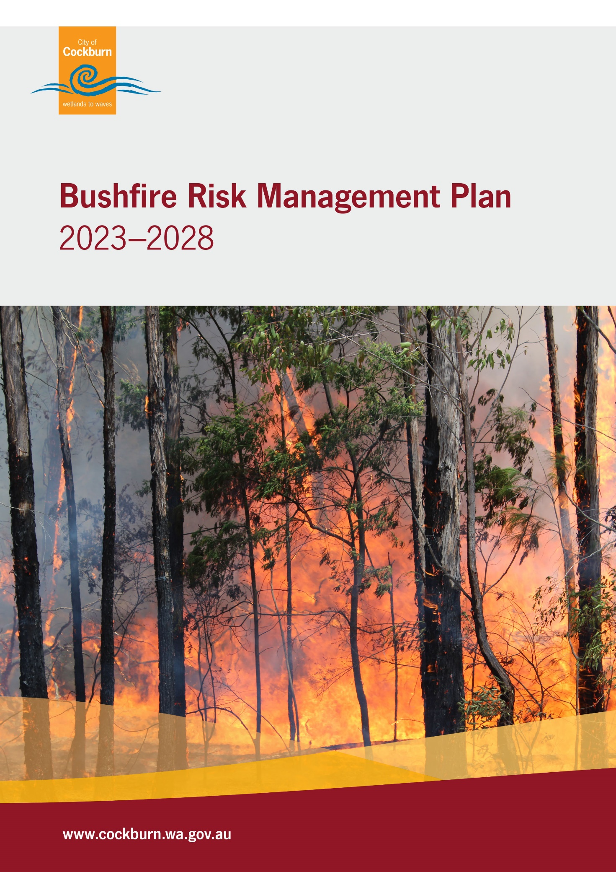
Contents
Foreword 3
1. Introduction 4
1.1 Background 4
1.2 Aim & Objective 4
1.3 Legislation, Policy and Standards 5
2. The Risk Management Process 6
2.1 Roles and Responsibilities 7
2.2 Communication and Consultation 9
3. Establishing the Context 9
3.1 Local Government and Community Context 9
3.1.1 Related Plans and Strategies 9
3.1.2 Location, Boundaries and Tenure 11
3.1.3 People and the Economy 12
3.1.4 Resourcing the Bushfire Risk Management Plan 13
3.2 Environment and Bushfire Context 14
3.2.1 Climate and Bushfire Season 14
3.2.2 Vegetation and Biodiversity 15
3.2.3 Threatened Species and Communities 19
3.2.4 Bushfire Frequency and Causes of Ignition 20
3.2.5 Topography and Landscape 22
4. Asset Identification and Risk Assessment 22
4.1 Planning Areas 23
4.2 Asset Identification 23
4.3 Assessment of Bushfire Risk 26
4.3.1 Likelihood Assessment 26
4.3.2 Consequence Assessment 26
5. Evaluating Bushfire Risk 27
5.1 Treatment Priorities 27
5.2 Risk Acceptability 27
6. Risk Treatment 29
6.1 Local Government-Wide Controls 29
6.2 Asset-Specific Treatment Strategies 30
6.3 Determining the Treatment Schedule 31
7. Review and Reporting 31
7.1 Review 32
7.2 Reporting 32
8. Glossary 33
9. Common Abbreviations 36
10. Appendices 37

Foreword
Fire has been inherently a part of Australia’s natural landscape for thousands of years through Aboriginal people caring for Country and maintaining cultural and spiritual connections. Fire continues to play a role in land management and managing bushfire risk with coordinated multi-agency treatments conducted to address identified bushfire risks and enhancing community resilience.
Ensuring the City of Cockburn (City) is The Best Place to Be includes enshrining the safety of our communities and natural environment by taking action to prevent and prepare for bushfires.
Under the State Hazard Plan - Fire, an integrated Bushfire Risk Management Plan (BRMP) is to be developed for local government areas with significant bushfire risk. This BRMP is a strategic document that facilitates a coordinated approach towards the identification, assessment and treatment of assets exposed to bushfire risk to reduce the impact of severe bushfires on the community. The BRMP supports and underpins the Strategic Community Plan 2020–2030 (SCP) and forms part of the City’s Local Emergency Management Arrangements.

1. Introduction
Bushfires cannot be eliminated from the landscape, and there are circumstances when fire cannot be controlled. However, planning and preparedness activities can reduce bushfire events' frequency, spread, and impact.

1.1 Background
Under the State Hazard Plan - Fire, an integrated BRMP is to be developed for local government areas with significant bushfire risk. This BRMP has been prepared for the City in accordance with the requirements of the Guidelines for Preparing a Bushfire Risk Management Plan (the Guidelines) (Office of Bushfire Risk Management 2020) from the Office of Bushfire Risk Management (OBRM) within the Department of Fire and Emergency Services (DFES). The risk management processes used to develop this BRMP are aligned to the key principles of ISO 31000:2018 Risk Management and those described in the National Emergency Risk Assessment Guidelines. This approach is consistent with State Emergency Management (SEM) Policy and SEM Prevention and Mitigation Procedure 1.
Government agencies and other land managers responsible for implementing treatments participate in developing the BRMP and Treatment Schedule to ensure treatment strategies are collaborative and efficient, regardless of land tenure.

1.2 Aim & Objective
For the purpose of protecting people, the environment and infrastructure, the BRMP aims to document a shared coordinated and efficient approach towards identifying, assessing, and treating assets exposed to bushfire risk within the City.
The objectives of this BRMP are to:
- Guide and coordinate a tenure-blind, multi-agency bushfire risk management program over five years
- Document the process used to identify, analyse and evaluate risk, determine priorities and develop a plan to systematically treat risk
- Facilitate the effective use of the financial and physical resources available for bushfire risk management activities
- Integrate bushfire risk management into the business processes of local government, landowners and other agencies
- Ensure there is integration between landowners and bushfire risk management programs and activities
- Document processes used to monitor and review the implementation of treatments to ensure treatment plans are adaptable and risk is managed at an acceptable level.

1.3 Legislation, Policy and Standards
This BRMP has been prepared by the City in accordance with the requirements of the Guidelines. The risk management processes used to develop this BRMP are aligned to the key principles of ISO 31000:2018 Risk Management, as described in the Second Edition of the National Emergency Risk Assessment Guidelines (NERAG). This approach is consistent with State Emergency Management Policy (State EM Policy) 3.2 - Emergency Risk Management Planning.
The following legislation, policy and standards were considered to be applicable in the development and implementation of the BRMP.
- Aboriginal Heritage Act 1972  - Biodiversity Conservation Act 2016  - Building Act 2011  - Bush Fires Act 1954  - Conservation and Land Management Act 1984  - Country Areas Water Supply Act 1947  - Emergency Management Act 2005  - Environmental Protection Act 1986  - Environmental Protection and Biodiversity Conservation Act 1999 (Cth)  - Fire Brigades Act 1942  - Fire and Emergency Service Act 1998  - Metropolitan Water Supply, Sewerage and Drainage Act 1909  - Rottnest Island Authority Act 1987  - Bush Fires Regulations 1954  - Emergency Management Regulations 2006 | - Planning and Development (Local Planning Scheme) Regulations 2015  - City (Local Government Act) Local Laws 2000  - SEM Policy (SEMC 2019)  - SEM Plan (State Emergency Management Committee (SEMC 2019))  - SEM Prevention and Mitigation Procedure 1 (SEMC 2019)  - State Hazard Plan - Fire (SEMC 2019)  - State Planning Policy 3.4: Natural Hazards and Disasters (Western Australian Planning Commission (WAPC) 2006) (SPP 3.4)  - State Planning Policy 3.7: Planning in Bushfire Prone Areas (WAPC 2015, as amended) (SPP 3.7)

2. The Risk Management Process
The risk management processes used to identify and address risk in this BRMP are aligned with the international standard for risk management, ISO 31000:2018 Risk Management, as described in NERAG. This process is outlined in Figure 1.
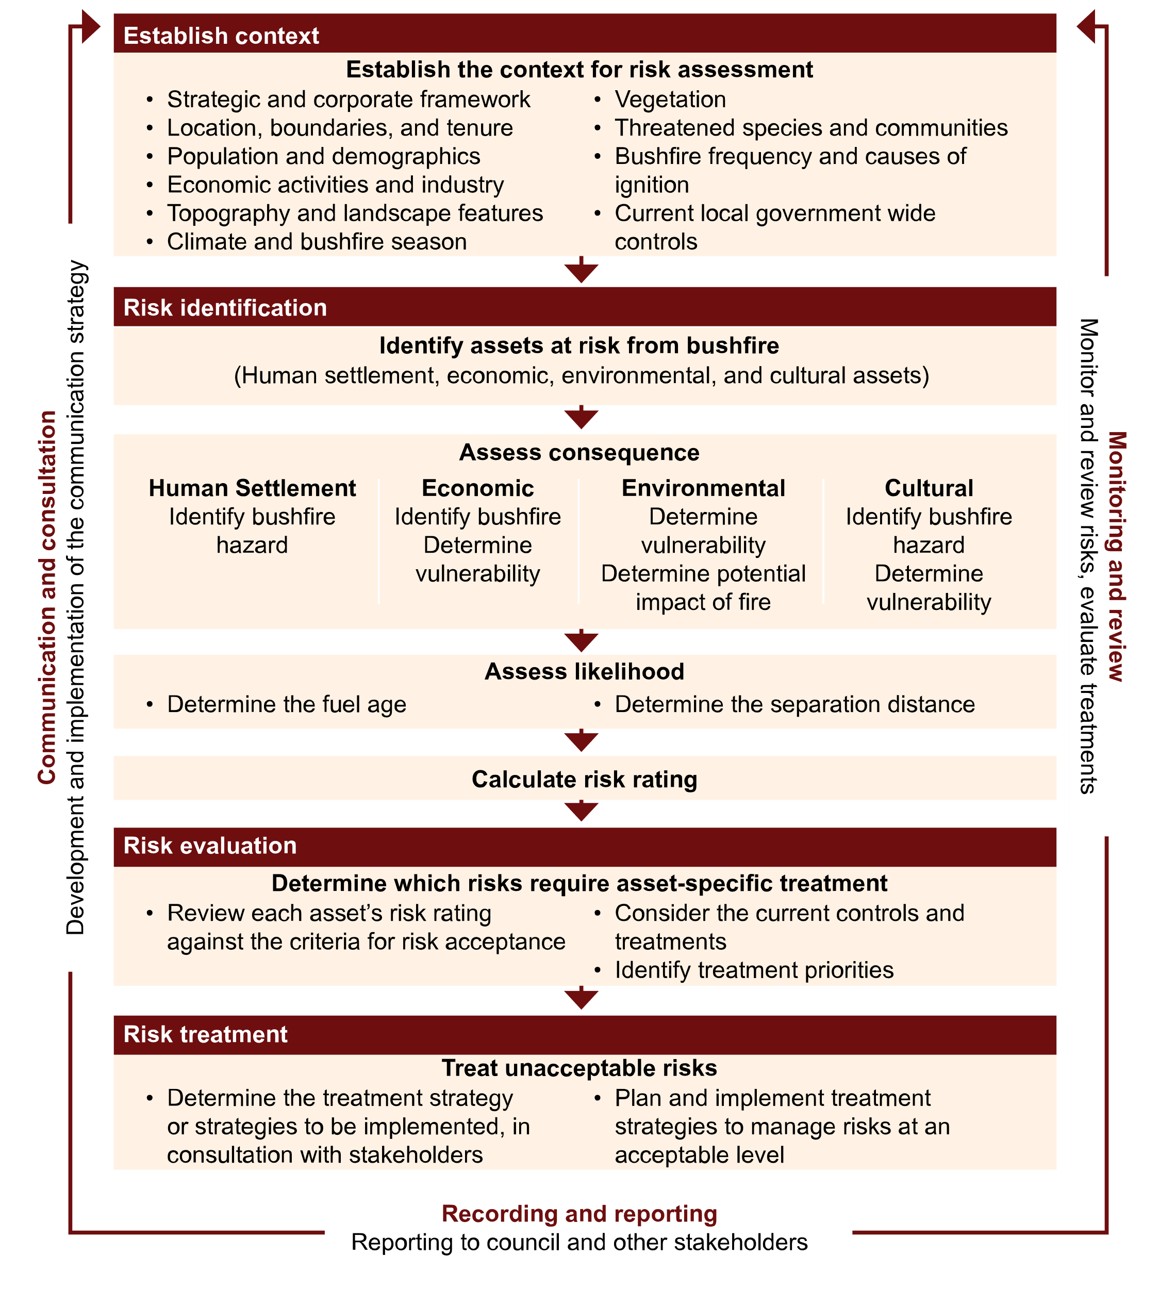
Figure 1 – An overview of the risk management process adapted from ISO 31000:2018 Risk Management.

2.1 Roles and Responsibilities
The roles and responsibilities of the key stakeholders involved in the development of the BRMP are outlined in Table 1.
Table 1 – Roles and Responsibilities
Stakeholder Name | Roles and Responsibilities
All Landowners (State and Local Govt, Private etc) | - Implement treatment strategies.  - Comply with the City’s Fire Control Order if applicable.
City of Cockburn | - As custodian of the BRMP, coordinate the development and ongoing review of the integrated BRMP  - Negotiate a commitment from landowners to treat risks identified in the BRMP, with the appropriate compliance requirements and protecting environmental assets  - As treatment manager, implementation of treatment strategies, in consultation with land managers and environmental policy and planning staff and groups, and appropriate compliance requirements and protecting environmental assets  Submit the draft BRMP to OBRM for review and endorsement  - Enforce compliance with the City’s Fire Control Order as per the Bush Fires Act 1954.
Department of Fire and Emergency Services (DFES) | - Participation in and contribution to the development and implementation of BRMPs, as per their agency responsibilities as the Hazard Management Agency for bushfire  - Support to local government through expert knowledge and advice in relation to the identification, prevention and treatment of bushfire risk  - Undertake treatment strategies, including prescribed burning on behalf of the Department of Planning, Lands and Heritage (DPLH) for Unmanaged Reserves and Unallocated Crown Land within gazetted town site boundaries  - In accordance with Memorandums of Understanding and other agreements, implementation of treatment strategies for other landholders  - Administer and coordinate the Mitigation Activity Fund Grants Program.
Office of Bushfire Risk Management (OBRM) | - Ensure bushfire risk is managed in accordance with ISO 31000 and reporting on the state of bushfire risk across Western Australia.  - Review BRMP’s for consistency with the Guidelines prior to final approval by Council.
Public Utilities | - Assist the local government by providing information about their assets and current risk treatment programs.  - Participation in and contribution to the development and implementation of BRMP’s.  - Implementation of treatment strategies.
Department of Biodiversity, Conservation and Attractions (DBCA) - Parks and Wildlife Service | - Participation in and contribute to the development and implementation of BRMP.  - Providing advice for the identification of environmental assets that are vulnerable to fire and planning appropriate treatment strategies for their protection.  - Implementation of treatment strategies on Department managed land and for Unmanaged Reserves and Unallocated Crown Land outside gazetted town site boundaries.  - In accordance with Memorandums of Understanding and other agreements, implementation of treatment strategies for other landholders.
Other State and Federal Government Agencies | - Assist the local government by providing information about their assets and current risk treatment programs.  - Participation in and contribution to the development and implementation of BRMP.  - As treatment manager, implementation of treatment strategies.
Bushfire Advisory Reference Group (BFARG) and Local Emergency Management Committee (LEMC) | - Provide advice and feedback.  - Monitor the effectiveness of the currency and implementation of BRMP.
Corporations and Private Landowners | - Implementation of treatment strategies.  - Comply with the City’s Fire Control order.

2.2 Communication and Consultation
Communication and consultation throughout the risk management process are fundamental to preparing an effective BRMP.
As part of the development of the BRMP the City engaged an external consultant to assess the City's bushfire risk according to State methodology before commencing community consultation. Once a draft BRMP was prepared with an indicative treatment schedule, the City invited community feedback and targeted key local stakeholders to provide input.
A Communication Strategy (appendix one) has been prepared to ensure appropriate and effective communication occurs with relevant stakeholders in the development, implementation and evaluation of this BRMP.

3. Establishing the Context
This section outlines the context in which the BRMP is developed and local factors that should be considered throughout the risk management process.

3.1 Local Government and Community Context

3.1.1 Related Plans and Strategies
All superseded version of related plans and strategies should be adopted into practices and considered in the context of the BRMP.

Strategic Community Plan 2020-2030
The City’s SCP is a roadmap to ensure we focus on achieving the highest desirable outcome and maintain the City’s vision of being The Best Place To Be. It reflects the priorities of our community and builds on our history and the previous plans we have to shape our community. The SCP provides a brief description and projections of the population and demographics of the local government area
The BRMP supports the SCP by facilitating and advocating for increased community safety and resilience by outlining the framework by which the City will identify, analyse and evaluate bushfire risks and integrating these practices into business processes. The objectives of the BRMP align with the City’s objective to promote a vibrant, healthy, safe, inclusive and connected community (Outcome 3: Community, Lifestyle and Security).

Local Emergency Management Arrangements
The BRMP forms part of the City’s Local Emergency Management Arrangements (LEMA) which aim to enhance the community’s resilience and preparedness for emergencies through strategies that apply prevention/mitigation, preparedness, response and recovery measures.

Climate Change Strategy 2020-2030
The City’s Climate Change Strategy 2020-2030 (CCS) is a roadmap with 14 objectives to mitigate and adapt to the impacts of climate change. Damage to or loss of biodiversity, natural habitat, infrastructure, and public health caused by the impacts of climate change is identified in the CCS as having the potential to impact the City’s service delivery, natural environmental, local community and infrastructure.
The BRMP facilitates outcomes for objective’s 10 Conserve Biodiversity, 13 Protect Community Infrastructure, and 14 Enhance Health and Wellbeing in reducing the impact of bushfires.

Natural Area Management Strategy 2012-2022
The City’s Natural Area Management Strategy 2012-2022 (NAMS) outlines the City’s approach to managing its vested natural areas and builds its capacity to maintain them for the conservation of biodiversity. The purpose of the NAMS is to protect and enhance the City’s natural environment by monitoring environmental changes and managing key threats.
The BRMP supports the NAMS by embedding the objectives of the Strategy into the risk assessment process by understanding the values of the natural environment to be considered in bushfire risk management planning.
The NAMS also outlines the City’s approach to limiting unauthorised access into reserves and undertaking fuel load reduction.

Other related City plans and strategies
- Community Safety and Crime Prevention Plan 2022-2027
- Urban Forest Plan 2018-2028
- Local Government Inventory Heritage List Significant Tree List
- Economic Development Framework

3.1.2 Location, Boundaries and Tenure
The City is located just south of Perth, approximately 15 kilometres from the Perth CBD. The Cities of Fremantle and Melville bound the City to the north. The Cities of Canning and Armadale to the east, the City of Kwinana to the south. Figure 2 shows the locations of the City within Perth, WA.
Figure 2 – Map of the City
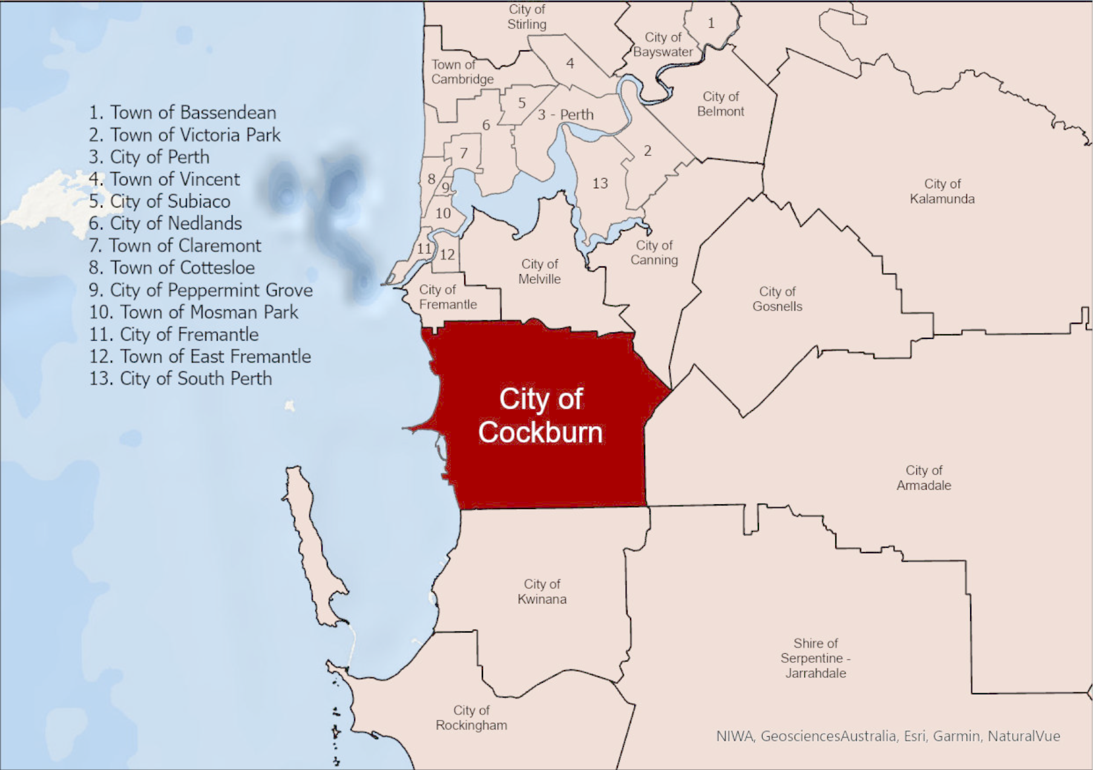
The City of Cockburn local government boundaries include Rottnest Island and Carnac Island, located 18 and 10 kilometres respectively, offshore to the west.
The Rottnest Island Authority is a statutory non-Government agency established by the Western Australian State Government to maintain the day-to-day operation of Rottnest Island. As Rottnest Island falls under the control of DBCA, the Island has not been assessed as part of the BRMP.
Carnac Island is an uninhabited island and is principally managed by the Department of Biodiversity, Conservation and Attractions (DBCA).
Table 2 provides an overview of the land tenure within the City and thus the land managers the City works with to prepare and implement the BRMP.

Table 2 – Overview of Land Tenure and Management within the City.
Land Manager/Agency | Local Government Area (approximate)  %
Private | 21
City | 45
State of WA (Mgt order: DBCA) | 10
WA Land Authority | 9
Department of Planning, Lands and Heritage | 3
Other (State Government, Federal Government) | 12
Total | 100

3.1.3 People and the Economy
The City has a diverse community with a mix of residential, light and heavy industry. The City is home to 125,123 people and has a median age of 37 years (City REMPLAN, 2023). Figure 3 provides a snapshot of the population in City
The City LEMA has provisions to ensure identified vulnerable communities have been considered in how the City prepares, prevents, responds and recovers from emergencies.
The eastern side of Cockburn is characterised by rural zoned blocks in Jandakot, Banjup and Treeby. Many of these blocks contain remnant bushland. Wattleup, and parts of Munster and Beeliar also contain remnant bushland and are characterised as market gardens and private businesses. These areas are more susceptible to the impacts of a bushfire.
The manufacturing industry sector makes the greatest contribution to economic output in the region, which at $8 Billion accounts for 28.87% of total output. With 7,766 jobs representing 14.95% of total employment, it is the construction industry sector that is the region's largest employer (City REMPLAN, 2023). The City is home to the Australian Marine Complex, Western Australia's leading shipbuilding and sustainment industrial precinct, and Jandakot Airport, Western Australia’s busiest general aviation airport and home to a large range of businesses and tenants. Jandakot Airport supports statewide emergency services and bushfire activities, including the Department of Biodiversity and Conservation Aviation Operations for aerial fire surveillance and suppression, DFES emergency rescue helicopter service, and the Royal Flying Doctor Service of Australia.
Figure 3: Overview of the City Population from the City Annual Report 2021-2022.
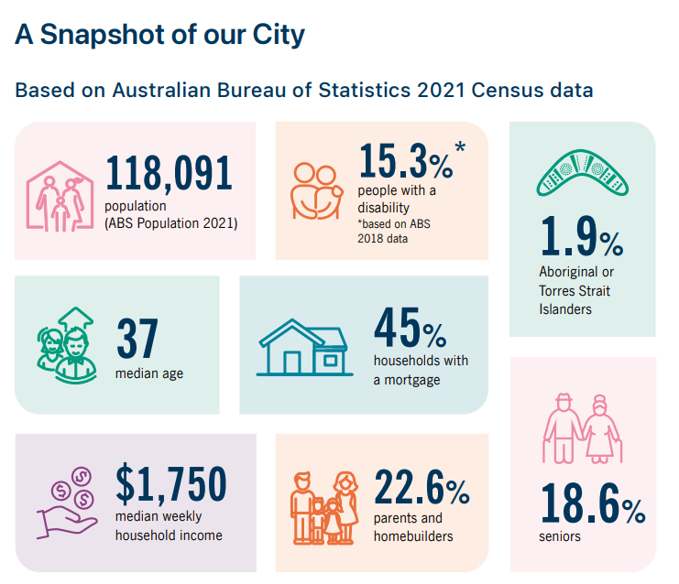
These sectors could be impacted should a significant bushfire occur as the City has several major traffic routes connecting industry to Fremantle port (City of Fremantle), the largest and busiest general cargo port in Western Australia and Western Trade Coast (partially in the City).
A comprehensive breakdown of information, trends and forecasts about the City population and economy can be viewed on the City’s online interactive demographic, economic and community tools.

3.1.4 Resourcing the Bushfire Risk Management Plan
Bushfire risk management is currently managed through several areas within the City, including the:
- Environment, Parks and Streetscapes Team (responsible for maintenance of reserve firebreaks, fuel load reduction activities on City land, fire response plans)
- Environment Management, Planning and Policy (provide advice and technical expertise on natural area management and advise on impact of fuel management treatment strategies)
- Fire and Emergency Management team (enforcement of bushfire legislation, issuing of burning approval and section 33 notices and provide advice on bushfire risk management, owner of the Bush Fire Risk Management Plan)
- Planning and Development Services (responsible for enforcement of State Planning Strategy 3.7).
The City does not have a role dedicated to bushfire risk management or implementing asset-specific treatments.

3.2 Environment and Bushfire Context

3.2.1 Climate and Bushfire Season
The City is characterised as having a Mediterranean climate as it experiences warm, dry summers and cool, wet winters. The bushfire season is typically from late spring through to early autumn, peaking in summer, when the moisture content in vegetation is low. These characteristics, as well as evidence indicating an increase in extreme fire weather days (State of Climate Report 2022, Bureau of Meteorology; Sixth Assessment Report of the Intergovernmental Panel on Climate Change 2022) will mean that treatment strategies to bushfire risk management are required to be dynamic and timely, and multiple treatments applied to comprehensively mitigate risks.
Weather conditions, including humidity, wind, rainfall, lightning and temperature, influence fire weather behaviour such as the size, intensity, and speed of bushfires. The State of Climate 2022 report indicates anthropogenic (human-caused) climate change is increasing weather and climate extremes resulting in an increase in the number of dangerous fire weather days and a longer fire season for southern and eastern Australia. Adverse weather and climate change also have large impacts on vegetation and therefore their capacity as fuel for fire.
Summer days with high temperatures, low humidity and strong winds are especially conducive to the spread of fires. This risk of bushfires is enhanced if thunderstorms develop, accompanied by lightning with little or no rain.
As part of the development of the CCS, the City engaged Ernst and Young to undertake a risk assessment and update the climate change risk register. The final report concluded that the loss or damage to properties, buildings and infrastructure, and community safety, health and wellbeing due to bushfire are extreme risks.
The Bureau of Meteorology (BoM) states that extreme fire weather conditions in the Perth region typically occur with strong easterly or north easterly winds associated with a strong high to the south of the state and a trough offshore. Easterly winds represent about 60% of extreme fire weather days compared to less than 5% associated with southerly winds.
The City, along with the majority of the Metropolitan local governments, follows the seasonal patterns detailed above when implementing their prohibited and restricted burning times, the City on average will maintain the following seasonal restrictions:
Prohibited burning is declared during the periods from December 1 through until March 31, restricted burning period April 1 through till May 31 and October 1 through until November 30, and the City maintains an unrestricted period of June 1 through till September 30 where the conditions support a decreased risk to the spread of fire. These are subject to change on seasonal conditions.

3.2.2 Vegetation and Biodiversity
The City is located within the South West Botanical Province of Western Australia, which is recognised as one of the world’s top 25 biodiversity hotspots (Natural Heritage Trust, 2003). Biodiversity hotspots are recognised as globally significant due to a high diversity and endemism (occur nowhere else) of species. These hotspots are also under threat as a result of significant habitat loss through clearing and urban development (NAMS, 2012-22).
There is a range of vegetation types and floristics communities within the City’s boundaries as depicted in Figure 4. Within the City, six different vegetation complexes are represented. The most western section supports coastal vegetation and coastal heath underlain by limestone outcrops.
Across the City, vegetation condition has been subject to degradation due to past land uses causing invasion by non-native species. The majority of the non-native species are grasses which significantly increases bushfire risk. These grasses increase the risk of fast-moving and intense bushfires that threaten life, property and the environment.
In managing bushfire risks, treatments should aim to protect natural areas and biodiversity, and any impacts of fuel management treatments should thoroughly be considered. The City’s NAMS objectives to consider in undertaking the bushfire risk management include;
- Threatened Ecological Communities (TEC)
- threatened fauna species habitat, such as Black Cockatoo species
- maintaining ecological corridors
- weed and disease management
- minimise illegal access and dumping
- reducing the likelihood of unplanned fires
- rehabilitation of degraded natural areas.
Bushland reserves contain large amounts and continuous vegetation in large areas. They are at risk of damage by bushfire and provide risks to nearby property if a large and out of control bushfire occurs. They are the largest fuel loads that occur and can aggravate any bushfire situation. All reserves within the City of Cockburn are listed in the Asset Risk Register and risk ratings have been assigned in accordance with the risk assessment process. Courses of action and the hierarchy of treatments are found at Table 7 and Figure 8 of this Plan.
Figure 4 – Vegetation Mapping within the City of Cockburn 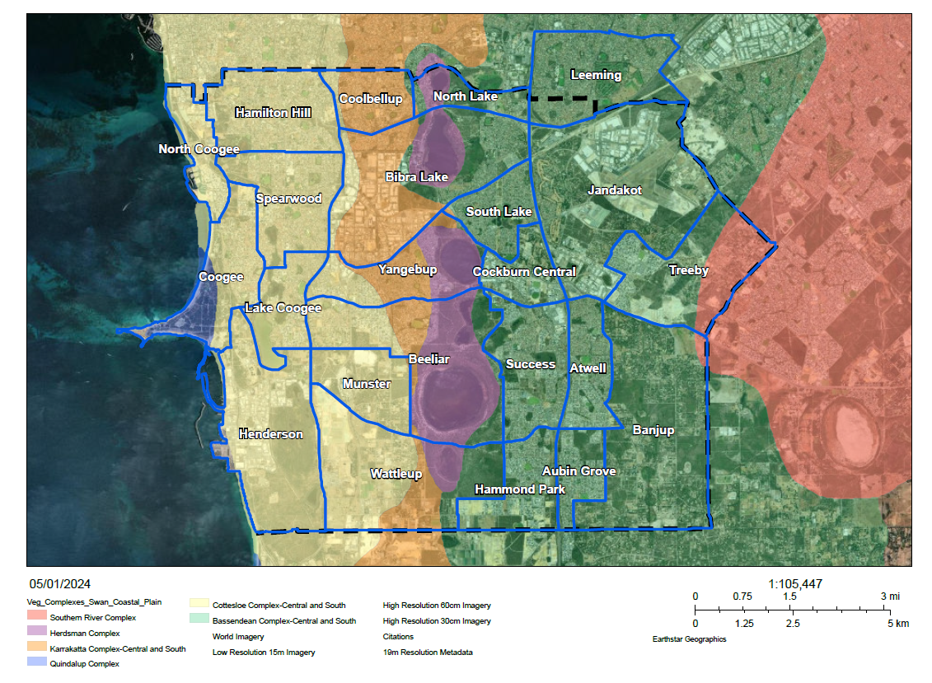
Figure 5 – Acid Sulphate soil risk within the City of Cockburn 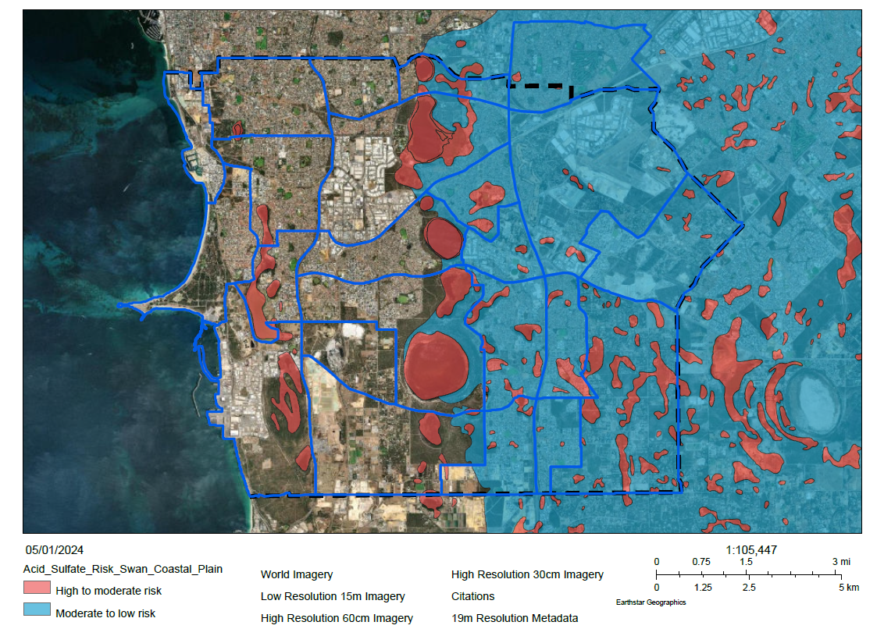

3.2.3 Threatened Species and Communities
The City contains a variety of native vegetation types as depicted in Figure 4. Much of which is representative of the Banksia Woodlands of the Swan Coastal Plain, a TEC.
Banksia woodlands was listed as endangered under the Environment Protection and Biodiversity Conservation Act 1999 (EPBC Act), on 16 September 2016. The threatened community predominantly occur within on the Bassendean soil complex, which is widespread on the eastern half of the City of Cockburn. Banksia woodlands are a fire-managed eco-system and low intensity burning can be used to stimulate regeneration with appropriate planning and post-fire weed control. Intervals between fire is recommended to be a minimum of 8 to 16 years and a maximum of 40 years (DBCA, Fire Information Note - Banksia Woodlands of the Swan Coastal Plain).
Tuart woodlands and forests of the Swan Coastal Plain are listed as critically endangered under the EPBC Act and are predominantly found on the Quindalup and Spearwood dunes. There are parcels of Tuart woodlands present in Manning Park, Woodman Point Regional Park and reserves in Henderson, as well as reserves along the Beeliar wetlands chain. Extensive weed management post-fire and fauna conservation for should be planned for when conducting prescribed burns as Tuart woodlands are vulnerable to invasive weeds and fauna sensitivity in mature trees (EPBC Act, Approved Conservation Advice, 2019). Intervals between burning may be required to be more than 10 years to allow regeneration and maturity of seedlings (EPBC Act, Approved Conservation Advice, 2019, C.5).
Some areas of the City contain a population of Caledenia Huegelii (a rare orchid), in addition of nine species considered to be ‘conservation significant flora’ by DBCA. Significant flora is defined as species at varying risks of extinction, depending on their classification.
Numerous wetlands are found throughout the City which support Melaleuca (Paperbark) and native sedge vegetation communities. The eastern parts of the City support the abovementioned Banksia Woodland TEC which is highly diverse in the floristic makeup. Vegetation which supports several threatened flora and fauna species, such as Black Cockatoos and Quendas, is also located within most of the City’s reserves.
Dieback (Phytophthora cinnamomi) has been listed as a key threatened process and is one of the major threats to Banksia Woodland TEC. Whilst Banksia Woodland is fire dependent (over long time intervals), it is highly susceptible to dieback. Dieback has been identified in a number of bushland reserves and can be easily spread through the movement of infected soil on car tyres, boots and equipment (City 2018). Wash down of vehicles, including those involved in fire suppression and prescribed burns, is recommended where operating in dieback infested reserves to limit the spread (Department of the Environment and Energy 2018).
The presence of weeds and invasive grasses within bushland areas, road reserves and public open spaces also adds to the likelihood of fires being started by accidental, deliberate or natural causes. There is an ongoing need to effectively manage grass fuels to help minimise fire risk (Attorney-General’s Department, 2014).
The City undertakes fuel load reduction works in City managed reserves including:
  - Control of illegal vehicle access to reduce instances of arson
  - Control of environmental weeds, particularly Perennial Veldt Grass
  - Fire retardant species selection for revegetation projects in proximity to dwellings
  - Asset specific treatments in selected reserves, such as
    - Mechanical works
    - Removal of vegetation
    - Hazard reduction burns
More information on threatened species and communities is available in the City’s NAMS.

3.2.4 Bushfire Frequency and Causes of Ignition
Ignition frequency of unplanned fires can vary on seasonal conditions and location. Table 3 demonstrates that human causes, such as arson, have contributed to most bushfires within the City. Most occurrences of arson within the City are believed to be carried out within or close to residential areas. However, the frequency of arson in rural areas may be higher than expected due to the difficulty in identifying fire ignition causes within these areas.
The City’s Community Safety and Crime Prevention Plan 2022-2027 (CSCP Plan) outlines initiatives the City will implement to deter criminal activity and ensure the community feel safe. The CSCP Plan aims to reduce the opportunity for crime through technology, namely CCTV, and facilitate early intervention initiatives to improve the wellbeing of our community.
Table 3 - Summary of Ignition Causes 2018-2023 By Highest Average Ignition Cause (as of July 2023 Department of Fire and Emergency Services, City of Cockburn Local Government Report Package)
Year | 2018-19 | 2019-20 | 2020-21 | 2021-22 | 2022-23
Total no. of bushfires | 133 | 150 | 133 | 159 | 184
Suspicious/Deliberate | 86 | 89 | 71 | 107 | 89
Cigarette | 23 | 22 | 25 | 23 | 36
Year | 2018-19 | 2019-20 | 2020-21 | 2021-22 | 2022-23
Reignition of previous fire | 5 | 4 | 6 | 8 | 24
Burn off fires | 3 | 8 | 5 | 4 | 3
Power lines | 6 | 4 | 4 | 5 | 4
Hot works (grinding, cutting, drilling etc..) | 1 | 5 | 3 | 2 | 3
Other open flames or fire | 1 | 2 | 5 | 2 | 3
Improper Fuelling/Cleaning/Storage/Use of  material ignited | 2 | 1 | 5 | 2 | 1
Campfires/bonfires/outdoor cooking | 2 | 4 | 1 | 1 | 2
Unreported (incomplete report) | - | 0 | 0 | 0 | 8
Vehicles (incl. Farming Equipment/Activities) | 1 | 2 | 3 | 1 | 1
Weather Conditions (High winds, natural  combustion etc. Excludes Lightning) | - | 1 | 2 | 1 | 2
Electrical distribution (excl. power lines) | - | 2 | 1 | 1 | 1
Undetermined | 1 | 2 | 0 | 2 | 0
Weather Conditions - Lightning | 1 | 1 | 0 | 0 | 3
Children misadventure | 1 | 2 | 0 | 0 | 0
Fireworks/flares | 0 | 0 | 0 | 0 | 2
Construction, installation, design deficiency | - | 0 | 0 | 0 | 1
Equipment - Mechanical or electrical fault | - | 0 | 1 | 0 | 0
Human Error (Left on, knock over, unattended  etc.) | - | 0 | 1 | 0 | 0
Sleeping/Alcohol/Drugs/Physical-Mental  impairment | 0 | 1 | 0 | 0 | 0
Yard maintenance, hand held equipment | - | 0 | 0 | 0 | 1

Planned fires, utilising the City’s Fire Control Order and permit system, account for most planned/controlled burning activities undertaken within the City’s rural landholdings. The permit system is heavily utilised by many residents, with 686 permits being issued between 2017-2022.
Historical evidence indicates the City has experienced multiple fires that required a significant multi-agency response, including the 2014 Banjup bushfire, which burnt through several reserves and rural residential properties before impacting urban areas in Atwell. This fire resulted in community evacuations, minor damage to several homes and the loss of outbuildings, sheds and fencing. The 2020/21 bushfire season saw an increase in multiagency incidents compared to previous years of note Aubin Grove bushfires which resulted in the community being impacted by severe ember attacks and sheltering in place.

3.2.5 Topography and Landscape
The City is relatively flat and low lying. Ground elevation across the City varies between 0.09 m and 78.9 m above sea level. Some areas with the highest elevation in bushfire prone areas include Manning Park, areas of Munster, and parks and businesses immediately west of Bibra Lake. Steep slopes and prevailing winds can increase fire intensity.
The Beeliar wetlands chain pass through the centre of the City, creating a series of wetlands and seasonal damplands. Controlled burns should not be undertaken in wetland areas because the organic-rich soils have the potential to smoulder underground for weeks or months (Fire Facts DBCA, 2023). Peatlands store more carbon than any other ecosystem and burning would result in large carbon emissions (Pemberton 2005) as well as potentially trigger the presence of acid sulphates that could pollute groundwater and waterways, killing flora and fauna (Fire Facts DBCA, 2023). Figure 5 depicts acid sulphate soil risks within the City of Cockburn which is taken into consideration when planning controlled burns.

4. Asset Identification and Risk Assessment
Risk assessment uses a combination of consequence and likelihood to determine the level of bushfire risk. Once the City has identified, mapped and categorised an asset, a risk assessment can be conducted to determine an asset’s exposure to bushfire risk. The level of exposure to bushfire risk is called the risk rating.
Detailed information about asset identification and risk assessments are available for viewing and recorded in the City's on-line Cockburn Mapping Hub, within the "Fire Management" web maps under the “BRMS Assets” layer. Cockburn Mapping Hub can be viewed here: https://maps-cockburn.hub.arcgis.com/

4.1 Planning Areas
The City is divided into six bushfire risk planning areas. The planning areas were determined using existing geographical features.
- Banjup / Atwell /Aubin Grove
- Jandakot / Treeby
- Southern Coast to Hammond Park
- Beeliar Regional Park
- North Lake / Yangebup Lake
- Northern Coastal Strip
Figure 6 Map of Planning Areas
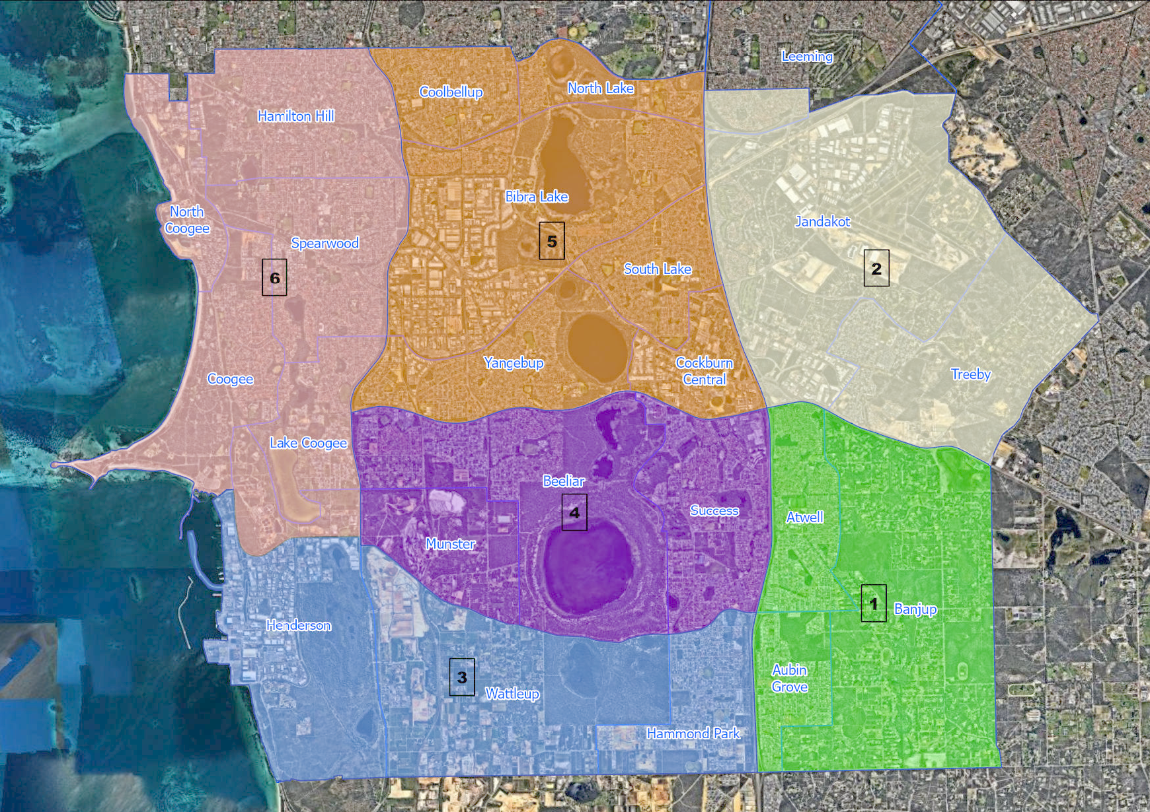

4.2 Asset Identification
Asset identification and risk assessment have been conducted at the local level using the methodology described in the Guidelines using Bushfire Risk Management System (BRMS). In reviewing the BRMP, all previously identified assets have been reviewed. New assets identified during the review have been mapped, recorded and assessed in the (DFES provided) BRMS. Identified assets are categorised into the following categories and subcategories provided in Table 4.
Table 4 – Asset Categories and Subcategories
Asset Category | Asset Subcategories
Human Settlement | - Residential areas  Dwellings including rural urban interface areas and rural properties.  - Places of temporary occupation  Commercial, mining and industrial areas located away from towns and population centres.  - Special risk and critical facilities  Locations and facilities where occupants may be especially vulnerable to bushfire for one or more of the following reasons:  • Occupants may have limited knowledge about the impact of bushfires  • Occupants may have a reduced capacity to evaluate risk and respond adequately to a bushfire event  • Occupants may be more vulnerable to stress and anxiety arising from a bushfire event or the effects of smoke  • There may be significant communication barriers with occupants  • Relocation and/or management of occupants may present unique challenges or difficulties, such as transportation, or providing alternative accommodation, healthcare or food supplies  Facilities that are critical to the community during a bushfire emergency.
Economic | - Agricultural  Pasture, grazing, livestock, crops, viticulture, horticulture and other farming infrastructure.  - Commercial and industrial  Major industry, waste treatment plants, mines, mills and processing and manufacturing facilities and cottage industry.  - Critical infrastructure  Power lines and substations, water and gas pipelines, telecommunications infrastructure, railways, bridges, port facilities and waste water treatments plants.  - Tourist and recreational  Tourist attractions and recreational sites that generate significant tourism and/or employment within the local area.  - Commercial forests and plantations  - Drinking water catchments
Environmental | - Protected  Rare, protected and threatened flora and fauna, ecological communities and wetlands as listed in the aforementioned environmental legislation.  - Priority  Priority Flora and Priority Fauna Lists held by DBCA (Priorities 1-3), PEC and wetlands.  - Locally important  Nature conservation and research sites, habitats, species and communities, areas of visual amenity and local value, and Priority Flora and Priority Fauna Lists held by DBCA (Priorities 4-5).
Cultural | - Aboriginal heritage  Places of indigenous significance identified by DPLH or the local community.  - Recognised heritage  Assets afforded legislative protection through identification by the National Trust, State Heritage List or Local Planning Scheme Heritage List.  - Local heritage  Assets identified in a Municipal Heritage Inventory or by the community.  - Other  Other assets of cultural value, for example community centres and recreation facilities.

A risk profile for the local government is provided in Table 5. This table shows the proportion of assets at risk from bushfire in each risk category at the time the BRMP was endorsed.

Table 5: Asset Risk Summary within the City of Cockburn (%)

Asset Category | Risk Rating
 |  | Low | Medium | High | Very High | Extreme | TOTALS (%)
 | Human Settlement | 4 | 3 | 16 | 12 | 39 | 72
 | Economic | 0 | 2 | 2 | 3 | 1 | 8
 | Environmental | 0 | 1 | 9 | 2 | 0 | 13
 | Cultural | 0 | 1 | 1 | 4 | 0 | 6
 | TOTALS (%) | 4 | 7 | 28 | 20 | 41 | 100

4.3 Assessment of Bushfire Risk
Risk assessments have been undertaken for each asset or group of assets identified using the methodology described in the Guidelines. The Asset Risk Register will be maintained in BRMS and will be updated as new assets are identified.

4.3.1 Likelihood Assessment
Likelihood is described as the chance of a bushfire igniting, spreading and reaching an asset. The approach used to determine the likelihood rating is the same for each asset category: Human Settlement, Economic, Environmental and Cultural.
There are four possible likelihood ratings:
Almost certain, likely, possible, and unlikely.

4.3.2 Consequence Assessment
Consequence is described as the outcome or impact of a bushfire event on the local community, infrastructure, natural environment and local economy. The approach used to determine the consequence rating is different for each asset category: Human Settlement, Economic, Environmental and Cultural.
There are four possible consequence ratings:
Minor, moderate, major and catastrophic.
The methodology used to determine the consequence rating for each asset category is based on the following:
Human Settlement, Economic and Cultural Assets
The outcome or impact of a bushfire event on the asset, or a group of assets, measured by the hazard posed by the classified vegetation and the vulnerability of the asset.
Environmental Assets
The outcome or impact of a bushfire event on the asset, or a group of assets, measured by the vulnerability of the asset and the potential impact of a bushfire or fire regime.

5. Evaluating Bushfire Risk
The risk rating for each asset has been assessed against the likelihood and consequence descriptions to ensure:
- The rating for each asset reflects the relative seriousness of the bushfire risk to the asset
- Likelihood and consequence ratings assigned to each asset are appropriate
- Local issues have been considered.

5.1 Treatment Priorities
The treatment priority for each asset has been automatically assigned by BRMS, based on the asset’s risk rating. Table 6 shows how likelihood rating (4.3.1) and consequence assessment (4.3.2) combine to give the risk rating and subsequent treatment priority for an asset.
Table 6 – Treatment Priorities based on likelihood rating and consequence assessment.
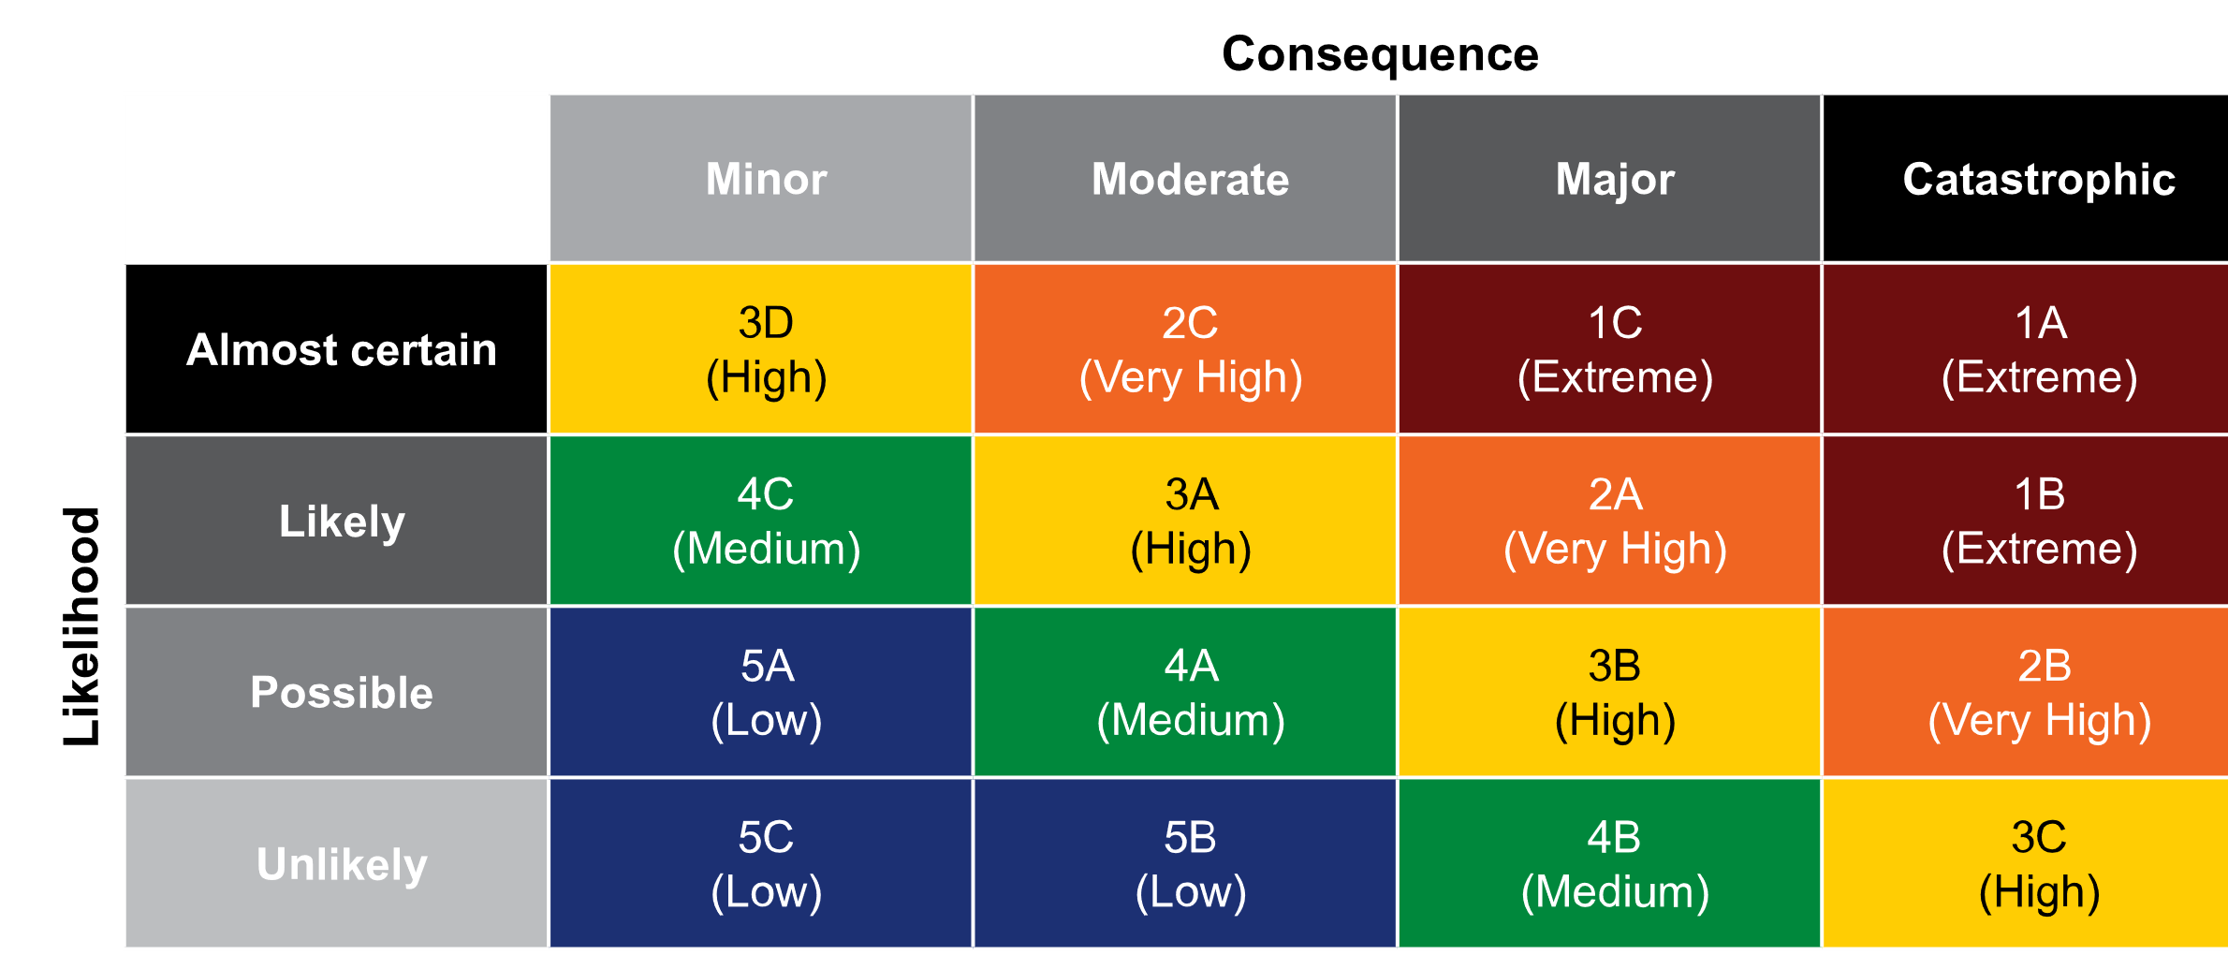

5.2 Risk Acceptability
Risks of ‘high’ and below were not considered to require specific treatment during the life of this BRMP. They will be managed by local government-wide controls and monitored for any significant change in risk. The City’s approach with this element of the BRMP has been supported by DFES and the Guidelines.
In most circumstances, the landowner will determine risk acceptability and treatment in collaboration with the City and other relevant authorities. However, the following courses of action, as illustrated in Table 7, have been adopted for each risk rating as a general rule.
Table 7 – Criteria for Acceptance of Risk and Course of Action
Risk Rating | Criteria for Acceptance  of Risk | Course of Action
Extreme  (Priorities  1A, 1B, 1C) | Only acceptable with excellent controls. Urgent treatment action is required. | Routine controls are not enough to adequately manage the risk. Immediate attention required as a priority. Specific action is required in first year of BRMP. Annual monitoring is required, or more frequently if required in the treatment schedule.  Treatments will be approached by:  - Treatments will be prioritised where maximum benefits are achieved for multiple assets and or critical infrastructure.  - Treatments that benefit vulnerable communities will be given priority.  - Tenure blind strategic mitigation with multiple stakeholders/partnerships.  Communication with asset owners will be in line with the City Communications Plan.
Very High  (Priorities  2A, 2B, 2C) | Only acceptable with excellent controls. Treatment action is required. | Routine controls are not enough to adequately manage the risk. Specific action will be required during the period covered by the BRMP.  Quarterly monitoring is required.
High  (Priorities  3A, 3B, 3C, 3D) | Only acceptable with adequate controls. Treatment action may be required. | Risk may be managed with routine controls and monitored annually.
Medium  (Priorities  4A, 4B, 4C) | Acceptable with adequate controls. Treatment action is not required but risk must be monitored regularly. | Risk may be managed with routine controls and monitored periodically throughout the life of the BRMP.
Low  (Priorities  5A, 5B, 5C) | Acceptable with adequate controls. Treatment action is not required but risk must be monitored. | Risk will be managed with routine controls and monitored as required.

6. Risk Treatment
The purpose of risk treatment is to reduce the likelihood of a bushfire occurring and the potential impact of a bushfire on the community, economy and environment. This is achieved by implementing treatments that modify the characteristics of the hazard, the community or the environment.
There are many strategies available to treat bushfire risk. The treatment strategy (or combination of treatment strategies) selected will depend on the level of risk and the type of asset being treated. Not all treatment strategies will be suitable in every circumstance.

6.1 Local Government-Wide Controls
Local government-wide controls are activities already being undertaken by the City, State agencies and other stakeholders that reduce the overall bushfire risk. These treatments are not linked to specific assets and are applied across the City:
- Enforcement of the Bush Fires Act 1954, including applicable fuel management requirements, firebreak standards and annual enforcement programs
- Distribution and capability of local fire and emergency services
- Public education campaigns and the use of PWS and DFES state-wide programs, tailored to suit local needs
- State-wide arson prevention programs developed in conjunction with WA Police and DFES
- State planning framework and local planning schemes, implementation of appropriate land subdivision and building standards in line with DFES, Western Australian Planning Commission and Building Commission policies and standards, such as State Planning Policy 3.7 Planning in Bushfire Prone Areas; and
- Monitoring performance against the BRMP and reporting annually to the Council and OBRM.
Further information about the local government-Wide Controls and how they will support the treatment of bushfire risk can be found in Appendix Two – Local Government-Wide Controls.

6.2 Asset-Specific Treatment Strategies

Asset-specific treatments are implemented to protect an individual asset or group of assets, identified and assessed in the BRMP as being at risk from bushfire. There are six asset specific treatment strategies:

Fuel management – Treatment reduces or modifies the bushfire fuel through manual, chemical and prescribed burning methods

Ignition management – Treatment aims to reduce potential human and infrastructure sources of ignition in the landscape

Preparedness – Treatments aim to improve access and water supply arrangements to assist firefighting operations

Planning – Treatments focus on developing plans to improve the ability of firefighters and the community to respond to bushfire

Community Engagement – Treatments seek to build relationships, raise awareness and change the behaviour of people exposed to bushfire risk
Other – Local government-wide controls, such as enforcement of the Bush Fires Act 1954 and planning policies, will be used to manage the risk. Asset-specific treatment is not required or not possible in these circumstances
As part of the treatment hierarchy, the BRMP proposed a tiered treatment solution as depicted in Figure 7. This depicts the City of Cockburn’s approach to applying asset-specific treatments, ensuring that community engagement and planning and preparedness activities are the first priority to reduce bushfire risks. When they do not adequately reduce risks to an acceptable standard, tier 2 treatments are required and so on.

Figure 7: City Treatment Hierarchy for Asset-Specific Treatment Strategies

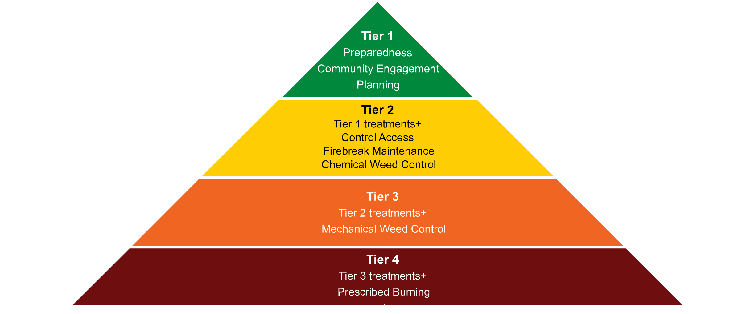

6.3 Determining the Treatment Schedule
The Treatment Schedule list bushfire risk treatments recorded within the BRMS. The City will develop a program of works that covers activities to be undertaken over the life of the BRMP. The Treatment Schedule will evolve and develop through successful mitigation works or changing climate and resources.
Landowners are ultimately responsible for treatments implemented on their land. This includes any costs associated with the treatment and obtaining the relevant approvals, permits or licences to undertake an activity. Where agreed, another agency may manage treatments on behalf of a landowner. However, the onus is still on the landowner to ensure treatments detailed in this BRMP’s Treatment Schedule are completed.
The City works closely with land owners to ensure adequate treatments are put in place to address bushfire risk. The City’s recommended treatments will be communicated with stakeholders according to the Communication Strategy (appendix one) with land owners during the implementation of this Plan and will report on these activities to Council. However, it is ultimately the responsibility of land owners to implement treatments.

7. Review and Reporting
Review and reporting processes are in place to ensure that the BRMP remains current and valid. These processes are detailed below to ensure outcomes of the BRMP are achieved.
The LEMC will be encouraged to be actively involved during the life cycle of the BRMP. The LEMC has many stakeholder group leaders that will be able to provide important advice and feedback to assist in guiding the BRMP process. The advice received in relation to implementing appropriate land treatments and during the review stages will be highly valued.

7.1 Review
A comprehensive review of this BRMP will be undertaken at least once every five years, from the date of adoption by the City. Significant circumstances that may warrant an earlier review of the BRMP include:
- Changes to the BRMP area, organisational responsibilities, or legislation
- Changes to the bushfire risk profile of the area
- Following a major fire event.
BRMS will be used to monitor the risk ratings for each asset identified in the BRMP and record the treatments implemented. Risk ratings are reviewed on a regular basis.

7.2 Reporting
Regular reporting on the activities undertaken to implement the BRMP will ensure transparency with key stakeholders to the BRMP, including private landowners.
Progress and review of the BRMP will be reported by utilising the ongoing information input into BRMS. Progress against the BRMP will be continuously monitored and reported to the City’s Executive monthly and then to Council via the LEMC and BFARG.
At any time, landowners may request from the City a copy of the treatment plans for their locality.
The City will provide an annual report to Council and a bi-annual pre and post bushfire season report to community groups. The reports will outline extreme and very high-risk assets, describe the objective of their risk treatment, the works to be undertaken and their timings, the progress towards their completion, and the outcome.
The City will on request of DFES submit an annual report to OBRM each year summarising progress made towards implementation of the BRMP.

8. Glossary
Asset | A term used to describe anything of value that may be adversely impacted by bushfire. This may include residential houses, infrastructure, commercial, agriculture, industry, environmental, cultural and heritage sites.
Asset Category | There are four categories that classify the type of asset – Human Settlement, Economic, Environmental and Cultural.
Asset Owner | The owner, occupier or custodian of the asset itself. Note: this may differ from the owner of the land the asset is located on, for example a communication tower located on leased land or private property.
Asset Register | A component within BRMS used to record the details of assets identified in the BRMP.
Asset Risk Register | A report produced within the BRMS that details the consequence, likelihood, risk rating and treatment priority for each asset identified in the BRMP.
Bushfire | Unplanned vegetation fire. A generic term which includes grass fires, forest fires and scrub fires both with and without a suppression objective.
Bushfire Hazard | The hazard posed by the classified vegetation, based on the vegetation category, slope and separation distance.
Bushfire Risk Management Plan | A development related document that sets out short, medium and long term bushfire risk management strategies for the life of a development.
Bushfire Risk | The chance of a bushfire igniting, spreading and causing damage to the community or the assets they value.
Bushfire Risk Management | A systematic process to coordinate, direct and control activities relating to bushfire risk with the aim of limiting the adverse effects of bushfire on the community.
Bushfire Risk | The chance of a bushfire igniting, spreading and causing damage to the community or the assets they value.
Consequence | The outcome or impact of a bushfire event.
Draft Bushfire Risk Management Plan | The finalised draft BRMP is submitted to the Office of Bushfire Risk Management (OBRM) for review. Once the OBRM review is complete, the BRMP is called the ‘Final BRMP’ and can be progressed to local government Council for approval.
Geographic Information System (GIS) | A data base technology, linking any aspect of land-related information to its precise geographic location.
Landowner | The owner of the land, as listed on the Certificate of Title; or leaser under a registered lease agreement; or other entity that has a vested responsibility to manage the land.
Likelihood | The chance of something occurring. In this instance, it is the potential of a bushfire igniting, spreading and impacting on an asset.
Locality | The officially recognised boundaries of suburbs (in cities and larger towns) and localities (outside cities and larger towns).
Map | The mapping component of the BRMS. Assets, treatments and other associated information is spatially identified, displayed and recorded within the Map.
Planning Area | A geographic area determine by the local government which is used to provide a suitable scale for risk assessment and stakeholder engagement.
Priority | See Treatment Priority.
Risk Acceptance | The informed decision to accept a risk, based on the knowledge gained during the risk assessment process.
Risk Analysis | The application of consequence and likelihood to an event in order to determine the level of risk.
Risk Assessment | The systematic process of identifying, analysing and evaluating risk.
Risk Evaluation | The process of comparing the outcomes of risk analysis to the risk criteria in order to determine whether a risk is acceptable or tolerable.
Risk Identification | The process of recognising, identifying and describing risks.
Risk Register | A component within the BRMS used to record, review and monitor risk assessments and treatments associated with assets recorded in the BRMP.
Risk treatment | A process to select and implement appropriate measures undertaken to modify risk.
Rural | Any area where in residences and other developments are scattered and intermingled with forest, range, or farm land and native vegetation or cultivated crops.
Rural Urban Interface | The line or area where structures and other human development adjoin or overlap with undeveloped bushland.
Slope | The angle of the ground’s surface measured from the horizontal.
Tenure Blind | An approach where multiple land parcels are consider as a whole, regardless of individual ownership or management arrangements.
Treatment | An activity undertaken to modify risk, for example a planned burn.
Treatment Objective | The specific aim to be achieved or action to be undertaken, in order to complete the treatment. Treatment objectives should be specific and measurable.
Treatment Manager | The organisation, or individual, responsible for all aspects of a treatment listed in the Treatment Schedule of the BRMP, including coordinating or undertaking work, monitoring, reviewing and reporting.
Treatment Planning Stage | The status or stage of a treatment as it progresses from proposal to implementation.
Treatment Priority | The order, importance or urgency for allocation of funding, resources and opportunity to treatments associated with a particular asset. The treatment priority is based on an asset’s risk rating.
Treatment Schedule | A report produced within the BRMS that details the treatment priority of each asset identified in the BRMP and the treatments scheduled.
Treatment Strategy | The broad approach that will be used to modify risk, for example fuel management.
Treatment Type | The specific treatment activity that will be implemented to modify risk, for example a planned burn.
Vulnerability | The susceptibility of an asset to the impacts of bushfire.

9. Common Abbreviations
BFARG | Bush Fire Advisory Reference Group
BRM | Bushfire Risk Management
BRM Branch | Bushfire Risk Management Branch (DFES)
BRMP | Bushfire Risk Management Plan
BRMS | Bushfire Risk Management System
CCS | Climate Change Strategy
CSCP | Community Safety and Crime Prevention
DBCA | Department of Biodiversity, Conservation and Attractions
DFES | Department of Fire and Emergency Services
DPLH | Department of Planning, Lands and Heritage
EPBC Act | Environmental Protection and Biodiversity Conservation Act
LEMA | Local Emergency Management Arrangements
LEMC | Local Emergency Management Committee
NAMS | Natural Area Management Strategy
OBRM | Office of Bushfire Risk Management (DFES)
PEC | Priority Ecological Community
SEMC | State Emergency Management Committee
SCP | Strategic Community Plan
TEC | Threatened Ecological Community
UCL | Unallocated Crown Land
WA | Western Australia
WAPC | Western Australian Planning Commission

10. Appendices
- Communication Strategy
- Local Government Wide Controls Table

Appendix 1 – Communications Strategy
1. Introduction
This Communication Strategy accompanies the BRMP and documents the following;
- communication objectives
- roles and responsibilities for communication
- key stakeholders
- stakeholders engaged in the development of the BRMP and Treatment Schedule, and
- Communication Plan for the implementation and review of the BRMP including: target audiences and key messages at each project stage; communication risks and strategies for their management; and communication monitoring and evaluation procedures.
2 Communications Overview
2.1 Communication Objectives
The communication objectives for the development, implementation and review of the BRMP are as follows:
- key stakeholders understand the purpose of the BRMP and their role in the planning process
- stakeholders who are essential to the bushfire risk management planning process, or can supply required information, are identified and engaged in a timely and effective manner
- relevant stakeholders are involved in decisions regarding risk acceptability and treatment
- key stakeholders engage in the review of the BRMP as per the schedule in place for the local government, and
- the community and other stakeholders engage with the bushfire risk management planning process and as a result are better informed about bushfire risk and understand their responsibilities to address bushfire risk on their own land.
2.2 Roles and Responsibilities
The City is responsible for the development, implementation and review of the Communication Strategy. Key stakeholders support local government by participating in the development and implementation of the Communications Strategy as appropriate. An overview of communication roles and responsibilities follows:
- Communications and Marketing team, City of Cockburn, responsible for external communication with the local government area.
- Fire and Emergency Management team, City of Cockburn, responsible for operational-level communication between the City and DFES.

2.3 Key Stakeholders
The following table identifies key stakeholders in bushfire risk management planning process, its implementation and review. These are stakeholders that are identified as having a significant role or interest in the planning process or are likely to be significantly impacted by the outcomes.
Stakeholder | Role or interest | Level of Impact | Level of Engagement
Who is the stakeholder?  Consider government agencies, interest groups and service providers. | What is their role or interest that makes them a stakeholder?  Consider if they are an asset owner, landowner or manager, treatment manager or interested party. | Consider how the implementation of the BRMP will impact each stakeholder and then assign them a rating of High, Medium or Low. | What level of engagement is necessary for the stakeholder?  Inform, consult, involve, collaborate or empower?
Bushland Friends of Groups (including Roe 8 Rehabilitation) | Interested Party | Medium | Consult
Community Residents Groups | Interested Party | Medium | Consult
City | Asset/Landowner and Treatment Manager | High | Consult
City Bushfire Advisory Reference Group (includes local Bush Fire Brigades) | Interested Party | High | Consult
City Local Emergency Management Committee | Interested Party | Medium | Inform
DFES (BRM Branch, OBRM) | Treatment Manager and Bushfire Risk management Program Coordinator | High | Collaborate
DBCA (including Regional Park Community Advisory Committees) | Asset/Landowner and Treatment Manager | Medium | Consult
Department of Education/other private schools | Asset/Landowner and Treatment Manager | Low | Consult
DPLH | Asset/Landowner | Low | Consult
Land Leases on City reserves and properties | Interested party | Medium | Consult
Main Roads | Asset/Landowner and Treatment Manager | Low | Consult
Private landowners | Asset/Landowner and Treatment Manager | High | Consult
Water Corporation | Asset/Landowner and Treatment Manager | Low | Consult
Western Power | Asset/Landowner and Treatment Manager | Low | Consult
Other Local Governments | Interested Party | Low | Inform

3. Communications Log
The City will maintain a communications log that captures the communications with key internal and external stakeholders that occurred during the development of the BRMP, associated Treatment Schedule, implementation and review of the BRMP. The Log will be a record of any significant conversations, community engagement events, emails, meetings, presentations, workshops and other communication initiatives. The Communications Log will be provided to City BFARG and LEMC each year as part of the reporting on the progress of the BRMP, and to OBRM as requested.
Appendix 2 – Local Government Wide Controls Table
Local government-wide controls are activities already being undertaken by the City, State agencies and other stakeholders that reduce the overall bushfire risk. The table below also lists controls that are desirable or should be implemented in the future.
Control |  | Action or activity description | Lead agency | Other stakeholder(s) | Notes and comments
Ref No | What is the control in place? | What is the name of the specific action or activity? | Who is the agency responsible for implementation of the control? | Are there any other key stakeholders who contribute to the success of the control? | Provide a brief description of the action or activity, its contribution to bushfire risk management in the local government, target areas, key timeframes and any work being undertaken to improve the control.
1 | Enforcement of the Bush Fires Act 1954 | City Fire Control Order (Section 33) | City | Landowners | The City’s Fire Control Order is distributed annually with the City’s Rates Notices and the City undertakes a proactive inspections program of properties to ensure compliance with the Fire Control Order.
2 |  | Declaration of Total Fire Bans | DFES | City | A Total Fire Ban (TFB) is declared because of extreme fire weather conditions or when current operational commitments have reduced state-wide resources/capabilities. A TFB is declared by DFES following consultation with the LG.
3 |  | Declaration of Harvest Vehicle Movement Bans | City, Chief Bushfire Control Officer | DFES, Fire Control Officers | Bans imposed when the CBFCO and FCOs are of the opinion that the use of engines, vehicles, plant or machinery is likely to cause/contribute to the spread of a bushfire.
4 |  | Restricted and prohibited burning times and issuing of permits to set fire to the bush | City | Chief Bushfire Control Officer, Fire Control Officers, DFES | Regulate burning requirements in the City during the restricted and prohibited burning times.
5 |  | Distribution and capability of local fire and emergency services, including Cockburn Career Fire and Rescue Service (DFES), South Coogee and Jandakot Volunteer Bush Fire Brigades (City). | DFES/City | Chief Bushfire Control Officer, DBCA | Ensure local emergency services are appropriately capable and equipped to respond effectively to bushfires within the City.
6 | State Planning Policy 3.7 – Planning in Bushfire Prone Areas | Enforcement of SPP 3.7 in declared bushfire prone areas | City | DFES, DPLH | Implement the Guidelines for Planning in Bushfire Prone Areas to ensure bushfire risk is addressed when planning, designing or assessing a planning proposal within a designated bushfire prone area. Bushfire prone areas mapping can be viewed here: https://www.dfes.wa.gov.au/hazard-information/bushfire/bushfire-prone-areas#map-of-bpa
7 | Local Emergency Management Arrangements | Local emergency management plan is maintained. | Local Emergency Management Committee membership, hazard management agencies, and support organisations. | - | Local plan including Local Recovery Plan, resource register and is regularly reviewed, exercised, and updated.
8 | Bushfire Advisory Reference Group | Strategic oversight of bushfire risk management within the City. | Membership, includes local bushfire brigades | - | Advise and advocate on effective bushfire risk management.
9 | Local Community Education Campaigns | Implement local emergency and bushfire education and preparedness campaigns. | City | DFES | Public education campaigns and the use of PWS and DFES state-wide programs, tailored to suit local needs to ensure the community is actively undertaking bushfire risk management activities and prepared should a bushfire occur in their local area. Examples of community education include;  - Maintaining Australian Fire Danger Rating Signs  - Providing resources and advice to the community  - Providing community events/workshops on bushfire safety and readiness
10 | State-wide Education Campaigns | Implement State-wide emergency and bushfire education and preparedness campaigns. | DFES, WA Police | City, DBCA | State-wide messaging and information to raise community awareness and resilience, including arson prevention programs developed by WA Police and DFES.
11 | South Metro Bushfire Risk Management Working Group | Coordinate and advise on local bushfire risk management. | DFES | Membership, including Local Governments, public utilities and State agencies | Advise and advocate on effective bushfire risk management. The Group is a formal avenue for the City to advocate with public utilities and State agencies about priority risks.
12 | Annual weed and maintenance works in City managed road and bushland reserves | Implement an annual program of works to maintain road and bushland reserves to an acceptable level of risk. | City | Private landowners | The City’s Environment, Parks and Streetscapes coordinate regular works to be completed throughout the City, including verge mowing, weed control, and maintaining existing firebreaks and asset protection zones.
13 | Residential Bulk Garden Organics Verge Collections | Provide bulk garden organics verge collection service to residential landowners. | City | Private residential landowners | The City’s Waste Services provide bulk garden organic services to the community and assists in removing dead vegetation and assisting the community in maintaining their properties.
14 | Illegal access to conservation areas | Implement measures to limit unauthorised access to conservation reserves in accordance with the Natural Area Management Strategy. | City | DBCA | Preventing access to vegetated areas reduces the spread of weeds and the likelihood of arson.
15 | Weed control for Cockburn residents living in the rural, rural living and resource zones | Landowner Biodiversity Conservations Grant | City | Private landowners | The City’s Sustainability and Environment Team coordinate a grant program for residents to apply for up to $3,000 per property to conserve and enhance the natural bushland, including weed control services.

Desirable/proposed Local Government wide controls
The following is a list of proposed local government wide controls to adopt during the life of the BRMP that were identified through the development and consultation of the BRMP.

Control |  | Action or activity description | Lead agency | Other stakeholder(s) | Estimated cost | Notes and comments
1 | Bushfire Risk Management Officer | Dedicated Bushfire Risk Management position in the City to implement Bushfire Risk Management Plan | City | Landowners (private, State agencies and others) | $100,000 per annum | The City to employ a dedicated resource to oversee the coordination of bushfire risk management, including regular review of Asset Risk Register and Treatment Schedule maintained in BRMS, report on progress of BRMP, and oversee the implementation of asset-specific treatments, such as tailored community education programs and working with all land owners and managers to refine and implement the Treatment Schedule.  The position is estimated to result in a net increase in expenditure by $40,000, as the City currently outsources part of this work to a consultant for $60,000. Due to the volume of work required by this position, the current consultancy arrangement is only used for significant mitigation programs and periodically.
2 | Capture FDR data to inform future controls | Report on Fire Danger Rating Days over the life of the BRMP under the new Australian Fire Danger Rating System (AFDRS). | Bureau of Meteorology | City | n/a | Feedback received during the consultation of the BRMP expressed that the City should report on any trends on Fire Danger Rating day, particularly any increases. As the new AFDRS was adopted from September 2022, there is limited contemporary data to inform any further controls required.
3 | Local bushfire risk management funding for private properties | Investigate the feasibility of a coordinated or co-funded program for bushfire risk management activities on private properties | City/DFES (ESL 1 areas) | Private landowners | Business as usual | The City to investigate implementing a program to support private landowners to implement bushfire risk management strategies on their properties, including but not limited to, maintaining water supply (including a power supply) for firefighting purposes and private property burning subsidy. This will be achieved by liaising with local Bushfire Brigades and reviewing State and National reviews into significant bushfires. Feedback received during consultation on the BRMP, noted that the City could co-fund the supply of resources.
4 | Fire and smoke detection technology | Investigate the market for fire and smoke detection technology to enhance local firefighting capabilities and opportunities to invest in technology to increase bushfire resilience. | City | - | Indicative costs if deemed feasible to implement = $120,000 over two years | The City to investigate emerging technologies for early fire and smoke detection to enhance firefighting capabilities and opportunities to partner with education institutions for learning and knowledge development.



