Tender Title: |  | RFT 25/2024 – Automatic Doors, Gates & Shutters (Maintenance, Repairs & Upgrades
Request ID: |  | 50235
Tender Description: |  | The City of Cockburn (The Principal) is seeking a suitably qualified and experienced Contractor for the maintenance, repairs and upgrades of roller doors, roller shutters, motorised/non- motorised/automatic sliding doors and automated gates throughout the City, including Cockburn ARC.
Advert Approval: |  | Decision to Advertise: Director Infrastructure Services  Decision Date: Wednesday, 30 October 2024
Closing Date and Time: |  | 2:00PM (AWST) Tuesday, 19 November 2024
Opening Date and Time: |  | 2:00PM (AWST) Tuesday, 19 November 2024
 | Tenderer’s Name:
1 | Go Doors Pty Ltd
2 | Westax Pty Ltd T/as Litestart Automatic Gates
3
4
5
6
7
8

Advertisement
Method 1: City of Cockburn | Method 2: Yammer
Method 3:  The Western Australian, Saturday 2nd November 2024 | Tender Awarded by:
Copy of Statewide Notice:  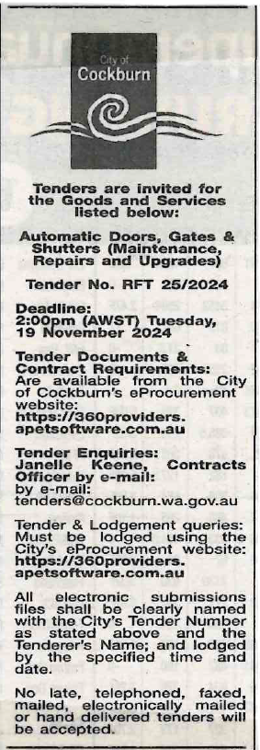 | Director of Infrastructure Services  Director of Corporate and System Services  5th December 2024
 | Date of Council Meeting:
 | N/A
Name of Successful Tenderer(s): | Go Doors Pty Ltd
Amount of Successful Tender(s): (ex GST) | $695,500.00 Estimated Contract Sum

