Tender Title: |  | RFT 25/2025 – Success Netball Courts Lighting Upgrade
Request ID: |  | 70229
Tender Description: |  | The City of Cockburn (the principal) is seeking the services of a licensed and qualified WA Electrical Contractor to undertake the supply, delivery, installation and commissioning of sports lighting works at Success Netball Courts, Western Australia.  The Netball courts upgrade project seeks to improve the sports lighting to meet the relevant Australian Standards for Sport lighting Specific applications AS2560.2:2021.  The Contractor will be required to provide all labour, plant, tools and equipment, materials, fees and charges, chemicals, transport/cartage etc. and anything else necessary for the completion of the proposed Contract.  It is the principal’s intention that the Contract shall be awarded in September 2025 and shall commence immediately upon receipt of the contract with an estimated total supply/manufacture, delivery, installation, and commissioning period of 24 weeks, with a 12-month defects liability
Advert Approval: |  | Decision to Advertise: Director Infrastructure Services  Decision Date: Friday, 25 July 2025
Closing Date and Time: |  | 2:00PM (AWST) Thursday, 21 August 2025
Opening Date and Time: |  | 2:00PM (AWST) Thursday, 21 August 2025
 | Tenderer’s Name:
1 | PEAP Contractors Pty Ltd
2 | Civcon Civil & Project Management Pty Ltd
3 | Stiles Electrical & Communication Services Pty Ltd

Advertisement
Method 1: City of Cockburn Website | Method 2: City of Cockburn Public Libraries Notice Boards
Method 3:  The Western Australian, Wednesday 30 July 2025 | Tender Awarded by:
Copy of Statewide Notice:  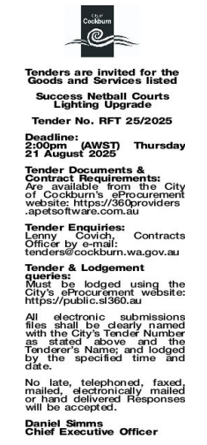 | Director Infrastructure Services  A/Director Corporate and System Services  Thursday, 4 September 2025
 | Date of Council Meeting:
 | N/A
Name of Successful Tenderer(s): | PEAP Contractors Pty Ltd
Amount of Successful Tender(s): (ex GST) | $591,920.00

