Policy Type

Local Planning Policy

Policy Purpose

In Jandakot and Treeby there remain several large lots which have yet to reach their full subdivision and development potential under the provisions of State Planning Policy No. 2.1 (Peel-Harvey Coastal Plain Catchment Policy), State Planning Policy No. 2.3 (Jandakot Groundwater Protection Policy) and the provisions of the 'Resource' zone under City of Cockburn Town Planning Scheme No. 3 (TPS 3).
Sand extraction operations, which have occurred or are occurring on these remaining sites, have ceased or are likely to cease within a relatively short time frame. As the sand resource is exhausted, landowners are expected to seek Western Australian Planning Commission (WAPC) approval to subdivide.
There is a need to ensure that subdivision proposals resolve issues arising from prior land uses are carried out within a comprehensive planning framework, to ensure that they are developed with regard to the relevant opportunities and constraints of the locality and comply with the 'Resource' zone provisions under TPS 3.
NOTE: This Policy needs to be read in conjunction with LPP2.1 ‘Rural Subdivision Policy’.
The purpose of the policy is:
- To identify a series of precinct areas encompassing current and former sand extraction sites and other land in Jandakot and Treeby with subdivision and development potential.
- To establish subdivision recommendations and requirements for the precincts.

Policy Statement

Planning Principles

- Ensure subdivision over the Jandakot Groundwater Mound is compatible with the long term use of the groundwater for public water supply.
- Maintain the operational integrity of Jandakot Airport, Kennel/Cattery Precinct and Solomon Road Industrial Area.
- Provide a permeable and logical road layout
- Maintain vegetation of local significance as identified by the City.
- Identification of site specific environmental features worthy of protection through a detailed land capability and site suitability assessment by proponents in consultation with the City.
- Maintain and enhance the high level of the visual and landscape qualities of the natural environment for the benefit of future generations.
- Ensure subdivision design and associated rehabilitation works reflect appropriate bushfire safety principles as detailed within State Planning Policy SPP3.7 and relevant TPS 3 provisions.
Refer to the attached Precincts and Subdivision Concept Plan with regard to the following precinct delineations.

(1) Precinct: 1
1. Properties:
Lot 98 Prinsep Road and Lots 51, 99 and 9 Jandakot Road, Jandakot.
The intention of the Precincts and Subdivision Concept Plan of subdivision is to provide an indicative road layout for future subdivision and demarcate the area
2. Current Status:
All lots have remnant bushland and most have houses on them.
The land remains heavily vegetated.
3. Subdivision recommendations and requirements:
(a) The City shall not support subdivision unless the general intentions of the Precincts and Subdivision Concept Plan for Precinct 1 are complied with.
(b) Any proposed plan of subdivision will be required to address matters consistent with the structure planning provisions of TPS 3.
(c) The City shall only support the creation of lots less than 2 hectares to the extent that the reduction in lot area is required to facilitate the construction of subdivisional roads.
(2) Precinct: 2
1. Properties:
Lot 130 Jandakot Road, Treeby.
2. Current Status:
Lot 130 Jandakot Road is a 41ha site and still subject to sand extraction at the northern extremity.
3. Subdivision recommendations and requirements:
(a) The City shall not support subdivision unless the general intentions of the Precincts and Subdivision Concept Plan for Precinct 2 are complied with.
(b) Any proposed plan of subdivision will be required to address matters consistent with the structure planning provisions of the TPS 3.
(c) The City shall require comprehensive rehabilitation works to be undertaken and completed at the time of subdivision of the land, in accordance with an adopted Rehabilitation Management Plan approved by the City. Rehabilitation works undertaken on public land will have a standard maintenance period associated, and will be audited at the end of the maintenance period to assess whether works have been appropriately undertaken in accordance with the adopted Rehabilitation Management Plan prior to the public land being taken over by the City. The City will only takeover public land once rehabilitation and maintenance works have been undertaken in accordance with the requirements of the adopted Rehabilitation Management Plan. For rehabilitation works on private land, affected lots are to include on their titles the requirement to care for and maintain the rehabilitation works in accordance with the minimum standards set out in the adopted Rehabilitation Management Plan.
(d) The City shall recommend a geotechnical investigation of proposed building envelopes for areas where inappropriate backfilling and/or compaction is suspected. In the event that inappropriate backfilling/compaction has occurred, this will need to be rectified to make the building envelopes capable for accommodating development prior to the issue of subdivision clearances.
(e) The City shall recommend investigation for soil and groundwater contamination in areas known or suspected to have contamination potential (e.g. previous storage of fuel). In the event that contamination has occurred, all remediation works including validation of remediation is to be completed to the specifications of the Department of Water and Environment Regulation prior to the commencement of any site works.
(f) The City shall recommend a notification under Section 165 of the Planning and Development Act 2005 be placed on the title of all lots within 500m of the Kennel/Cattery Precinct advising of potential noise and amenity impacts. This is considered to represent a hazard/other factor seriously affecting the use/enjoyment of the land.
(h) The City shall require that the Structure Plan and subdivision layout design minimise the number of lots with boundaries to the Jandakot Botanical Park.
(j) The City shall not support the creation of lots with excessive areas of batter slopes or excessive unevenness. As a guide no greater than one third of the area of any lot is to be affected by this.
(k) The City shall request revegetation to enhance or create vegetated linkages, enhance areas of remnant vegetation or provide for landscape or screening purposes.
(3) Precinct: 3
1. Properties:
Lot 186 Acourt Road, Jandakot.
2. Current Status:
Lot 186 is occupied by soil blending and fertiliser operations.
3. Subdivision recommendations and requirements:
(a) The City shall not support subdivision unless the general intentions of the Precincts and Subdivision Concept Plan for Precinct 3 are complied with.
(b) The City shall require comprehensive rehabilitation works to be undertaken and completed at the time of subdivision of the land, in accordance with an adopted Rehabilitation Management Plan approved by the City. Rehabilitation works undertaken on public land will have a standard maintenance period associated, and will be audited at the end of the maintenance period to assess whether works have been appropriately undertaken in accordance with the adopted Rehabilitation Management Plan prior to the public land being taken over by the City. The City will only takeover public land once rehabilitation and maintenance works have been undertaken in accordance with the requirements of the adopted Rehabilitation Management Plan. For rehabilitation works on private land, affected lots are to include on their titles the requirement to care for and maintain the rehabilitation works in accordance with the minimum standards set out in the adopted Rehabilitation Management Plan.
(c) The City shall not support subdivision until the soil blending operation and the soil blending/fertiliser factory on Lot 186 have ceased operating and all associated materials and structures have been removed.
(d) The City shall recommend a geotechnical investigation of proposed building envelopes for areas where inappropriate backfilling and/or compaction is suspected. In the event that inappropriate backfilling/compaction has occurred, this will need to be rectified to make the building envelopes capable for accommodating development prior to the issue of subdivision clearances.
(e) The City shall recommend investigation for soil and groundwater contamination in areas known or suspected to have contamination potential (e.g. previous storage of fuel). In the event that contamination has occurred, all remediation works including validation of remediation is to be completed to the specifications of the Department of Water and Environment Regulation prior to the commencement of any site works.
(f) The City shall require that the subdivision layout design provide Lukin Swamp with an adequate buffer of public open space, and that frontage to a subdivisional road be provided to enable public and City access to the swamp and public open space.
(g) The City shall recommend a notification under Section 165 of the Planning and Development Act 2005 be placed on the title of all lots created from subdivision advising of odour from the City of Canning’s Kennel Zone affecting the land. These are considered to represent hazards/other factors seriously affecting the use/enjoyment of the land.
(h) All new building envelopes are to be located outside the 30 ANEF noise contour of the Jandakot Airport.
(i) The City shall not support the creation of lots with excessive areas of batter slopes or unevenness. As a guide no greater than one third the area of any lot is to be affected by this.
(j) The City shall request strategic revegetation to enhance areas of remnant vegetation, buffer zones to Lukin Swamp and provide vegetated linkages to the Jandakot Botanical Park.
(4) Precinct: 4
1. Properties:
Lot 5131 Jandakot Road, Treeby.
2. Current Status:
Lot 1531 is vegetated (including revegetation areas) and contains no buildings.
3. Subdivision recommendations and requirements:
(a) The City shall not support subdivision unless the general intentions of the Precincts and Subdivision Concept Plan for Precinct 4 are complied with.
(b) The City shall require comprehensive rehabilitation works to be undertaken and completed at the time of subdivision of the land, in accordance with an adopted Rehabilitation Management Plan approved by the City. Rehabilitation works undertaken on public land will have a standard maintenance period associated, and will be audited at the end of the maintenance period to assess whether works have been appropriately undertaken in accordance with the adopted Rehabilitation Management Plan prior to the public land being taken over by the City. The City will only takeover public land once rehabilitation and maintenance works have been undertaken in accordance with the requirements of the adopted Rehabilitation Management Plan. For rehabilitation works on private land, affected lots are to include on their titles the requirement to care for and maintain the rehabilitation works in accordance with the minimum standards set out in the adopted Rehabilitation Management Plan.
(c) The City shall not support subdivision unless relevant recommended buffer distances [in accordance with the Environmental Protection Authority's Guidance Statement No. 3 (Separation Distances between Industrial and Sensitive Land)] are achieved to operational sand excavation sites and other land uses with buffer zones.
(e) The City shall require that the subdivision layout design not provide lot frontages onto Jandakot or Armadale Roads, unless exceptional circumstances dictate otherwise. Access to lots is to be provided by internal subdivisional roads.
(f) The City shall recommend a geotechnical investigation of proposed building envelopes for areas where inappropriate backfilling and/or compaction is suspected. In the event that inappropriate backfilling/compaction has occurred, this will need to be rectified to make the building envelopes capable for accommodating development prior to the issue of subdivision clearances.
(g) The City shall recommend investigation for soil and groundwater contamination in areas known or suspected to have contamination potential (e.g. previous storage of fuel). In the event that contamination has occurred, all remediation works including validation of remediation is to be completed to the specifications of the Department of Environment and Conservation prior to the commencement of any site works.
(h) No greater than two thirds of any lot is to be located within the Western Power Transmission Line Easement.
(i) The City shall not support the creation of lots with excessive areas of batter slopes or unevenness. As a guide no greater than one third the area of any lot is to be affected by this.
(j) The City shall require revegetation to enhance or create vegetated linkages, enhance areas of remnant vegetation or provide for landscape or screening purposes.

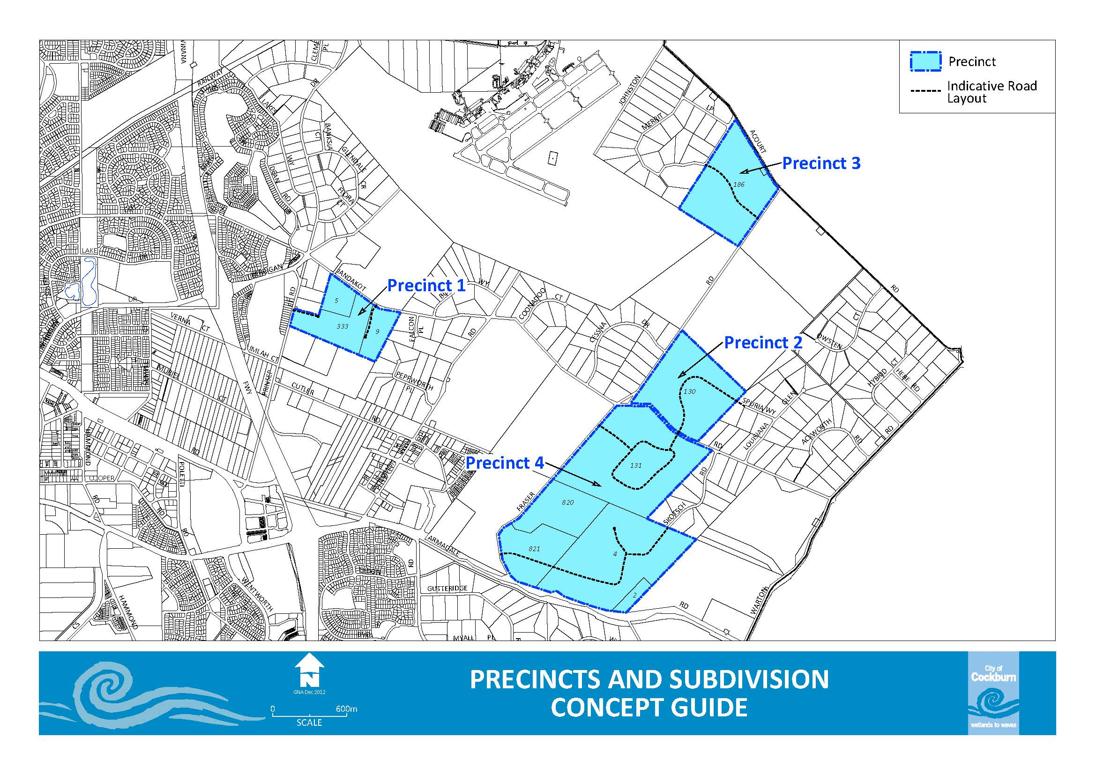

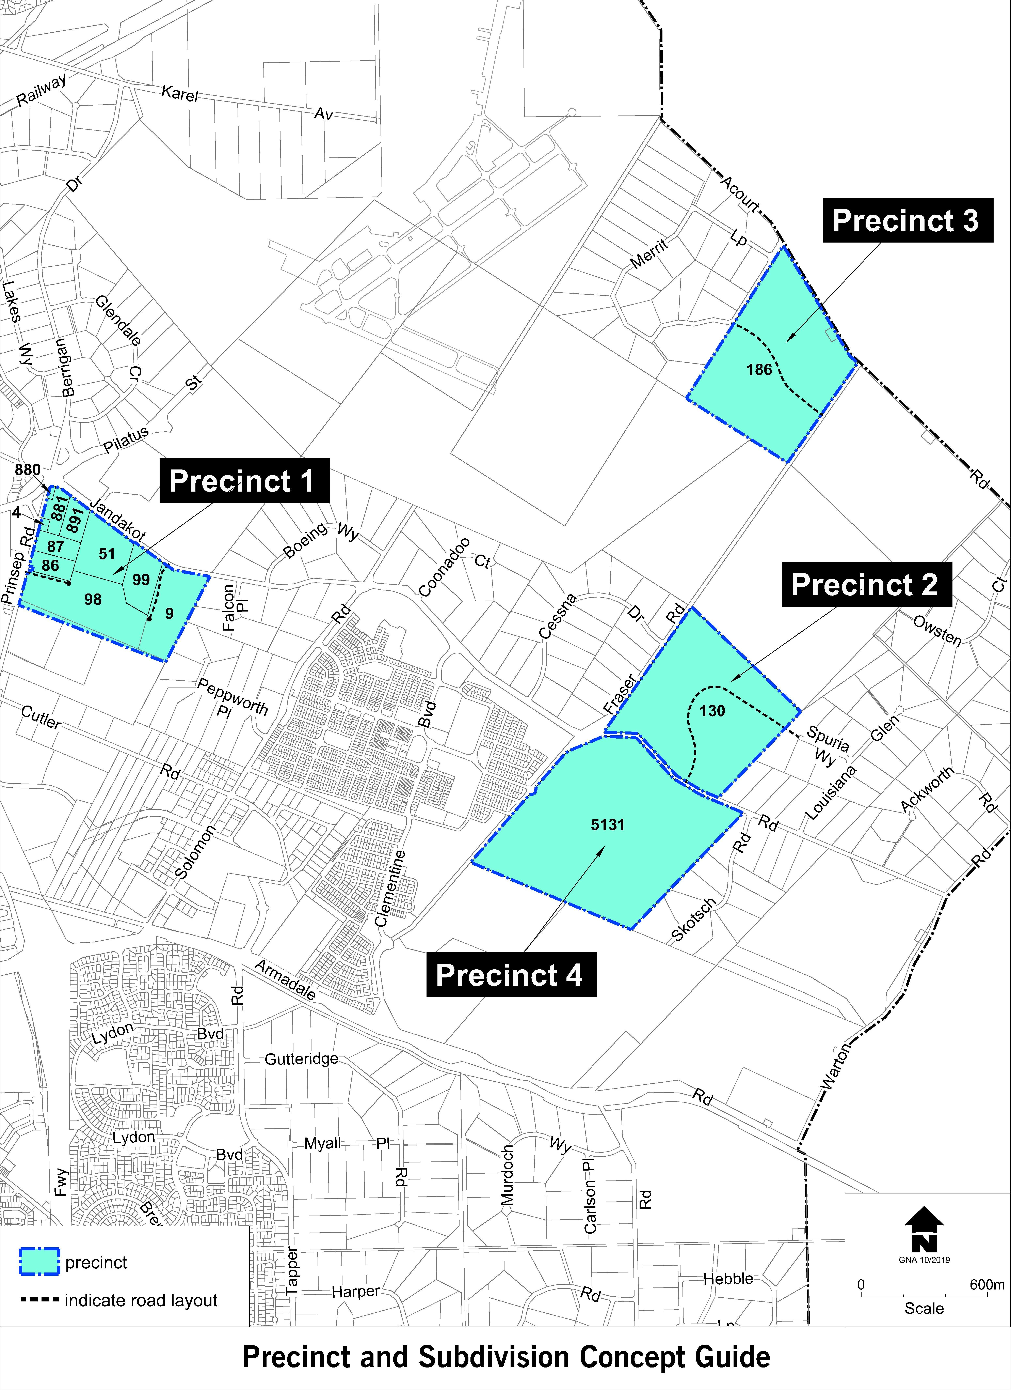

Strategic Link: | Town Planning Scheme No. 3
Category | Planning - Town Planning & Development
Lead Business Unit: | Statutory Planning
Public Consultation:  (Yes or No) | Yes
Adoption Date:  (Governance Purpose Only) | 10 November 2022
Next Review Due:  (Governance Purpose Only) | November 2024
ECM Doc Set ID:  (Governance Purpose Only) | 4514840

