

**PARKING GUIDE**

**City of Cockburn**

This document provides **guidance and direction only** for on-street parking within the road reserve and Parking Station facilities. **Note: Anything on signs that are depicted may be differently arranged**

**FOOTPATH**

A person shall not stop or park a vehicle so that any portion of the vehicle is:

1. on or over a footpath or a place of refuge for pedestrians

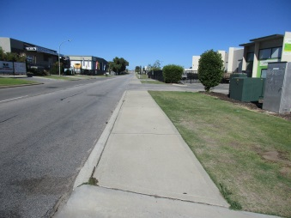

Footpaths provide pedestrians with a safe alternative to walking on roads. Parking vehicles on and blocking any portion of a footpath, including the crossover, could force pedestrians onto the road. For people with prams, disabilities or young children if forced onto the road places them at risk of serious injury or death

**NO PARKING AREAS**

A person shall not stop or park a vehicle on a thoroughfare, or portion of a thoroughfare to which a ‘no parking’ sign applies, unless the driver is

1. dropping off, or picking up, passengers or goods;

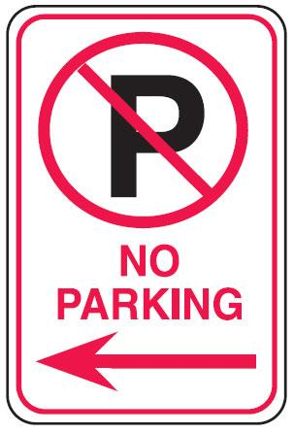 

**NO STOPPING AREAS**

No Stopping areas can be defined by signage or a continuous yellow line painted along the edge of a carriageway.

A person shall not stop or park a vehicle on a thoroughfare, or portion of a thoroughfare;

1. to which a ‘no stopping’ sign applies;
2. the side of which is marked with a continuous yellow edge line

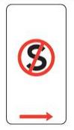 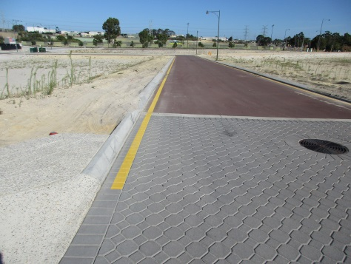

**VERGE PARKING**

**Signage:** A person shall not stop or park on a verge where signs prohibit the stopping or parking of vehicles on that verge

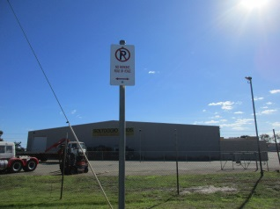 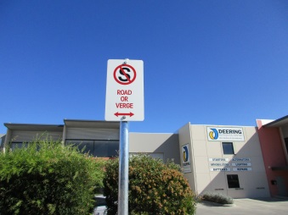

**No signage:** A person, not being the owner or the occupier of the land abutting on to a verge, shall not without consent of that owner or occupier, drive, park or stop a vehicle upon that verge

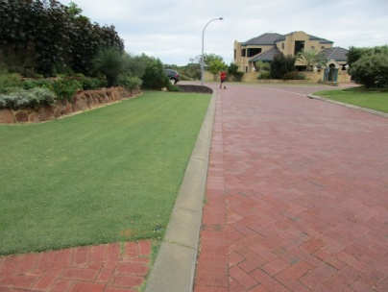 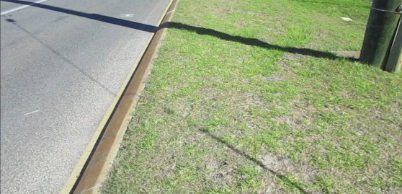

A person shall not park a commercial vehicle on a verge unless it is being loaded or unloaded with reasonable expedition with goods, merchandise or materials collected from or delivered to the premises adjacent to the portion of the verge on which the commercial vehicle is parked, provided no obstruction is caused to the passage of any vehicle or person using a carriageway or a path **(**for purposes of this clause the definition of a “commercialvehicle”means a vehicle whether licenced or not which is used or designed for use for business, trade or commercial purposes or in conjunction with a business, trade or profession)

**UNREGISTERED VEHICLES PARKED ON A CARRIAGEWAY, VERGE or PUBLIC RESERVE**

A person shall not park a vehicle that is not licensed under the Road Traffic Act on any

portion of a thoroughfare: including

1. verge
2. public reserve

For the purposes of clause – verge includes council verge abutting residential and

commercial properties

­­­­­­­­­­­­­­­**OBSTRUCTION**

A person parking a vehicle on a carriageway other than in a parking space shall park it:

1. so that it does not obstruct any vehicle on the carriageway;

A person shall not park a vehicle in a public place so as to cause an obstruction:

For the purposes of sub-clause:

1. a vehicle which is parked in any portion of a public place where vehicles may not lawfully be parked is deemed to be causing an obstruction;
2. a vehicle that is parked in any portion of a public place where vehicles may lawfully be parked does not cause an obstruction, unless –
3. the vehicle is so parked for any period exceeding 24 hours, without the consent in writing of the CEO or an authorised person; or
4. the vehicle is so parked during any period in which the parking of vehicles is prohibited or restricted by sign

**CUL-DE-SAC – (see OBSTRUCTION)**

A person shall not stop or park a vehicle so that any portion of the vehicle is:

1. in a cul-de-sac- so as to obstruct the turning of vehicles within the cul-de-sac

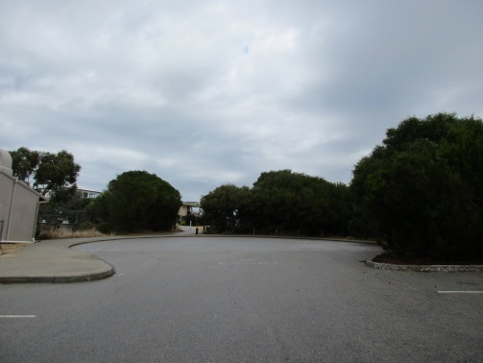 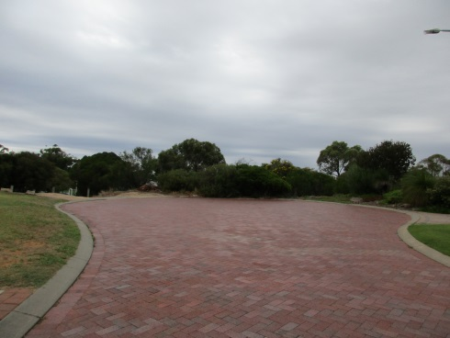

**­PARKING WITHIN 10 METRES OF AN INTERSECTION (near corners) – OBSTRUCTION:** A person shall not stop or park a vehicle so that any portion of the vehicle is:

1. within 10 metres of the nearest property line of any thoroughfare intersecting the thoroughfare on the side on which the vehicle is parked

 

___________________________________________________________________________

**PEDESTRIAN AND CHILDREN’S CROSSING**

A person shall not stop or park a vehicle on a thoroughfare or any portion of a thoroughfare so that any portion of the vehicle is within 10 metres of:

1. a pedestrian crossing or a children’s crossing established on a thoroughfare (regardless of whether there are any signs or lines)

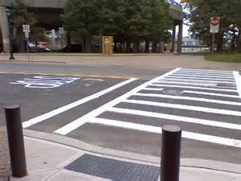  

**BUS STOPS – (Bus means a motor vehicle built mainly to carry people, that seats over 12 adults - including the driver)**

A person shall not stop or park a vehicle on a thoroughfare so that any portion of the vehicle is within 10 metres of the **departure** side of:

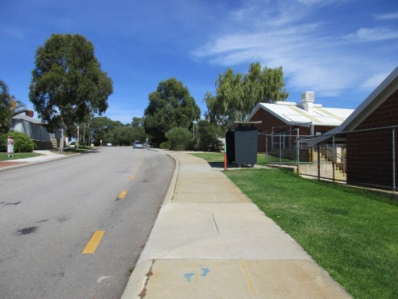

1. a sign inscribed with the words “Bus Stop” of “Hail Bus Here” (or with equivalent symbols depicting these purposes), unless that vehicle is a bus taking up or setting down passengers, or;

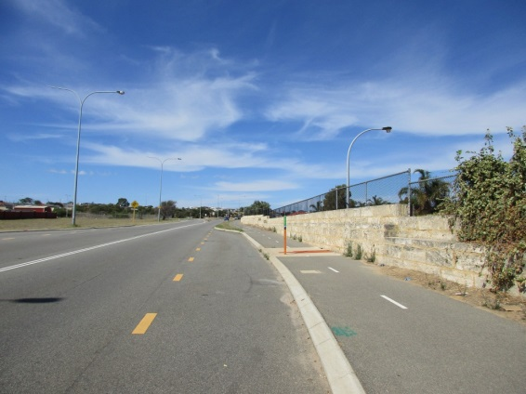

A person shall not stop of park a vehicle on a thoroughfare so that any portion of the vehicle is within 20 metres of the **approach** side of:

1. a sign inscribed with the words “Bus Stop” of “Hail Bus Here” (or with equivalent symbols depicting these purposes), unless that vehicle is a bus taking up or setting down passengers

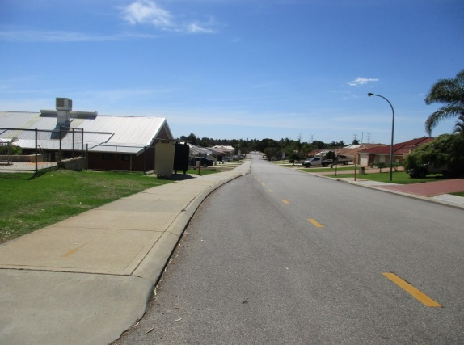

**MEDIUM STRIPS and TRAFFIC ISLANDS**

A person shall not stop or park a vehicle on any part of a thoroughfare so that any portion of the vehicle is:

1. on a median strip;
2. adjacent to a median strip otherwise than in a parking space; or
3. on or within 9 metres of any portion of a carriageway bounded on one or both sides by a traffic island

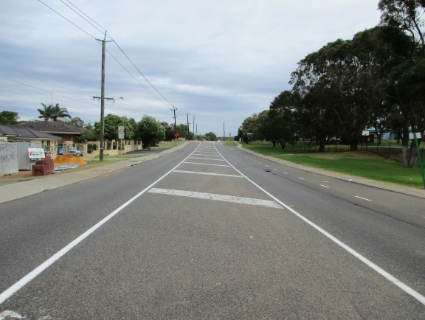 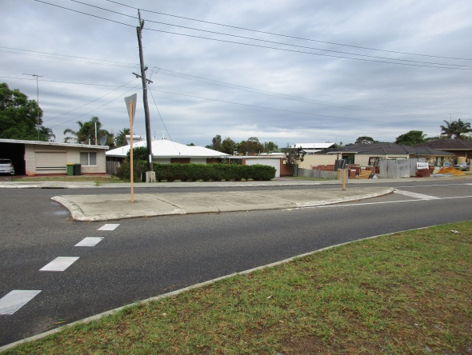

**DOUBLE PARKING**

A person shall not stop or park a vehicle on a thoroughfare so that any portion of the vehicle is between any other stopped or parked vehicle and the centre of that thoroughfare - this clause does not apply to a driver stopped in traffic)



**DISABLE BAYS – Stopping in a parking area for people with disabilities**

A driver shall not stop in a parking area for people with disabilities unless:

1. the driver’s vehicle displays a “**disability parking permit**”, and
2. either the driver or a passenger in that vehicle is a person with disabilities 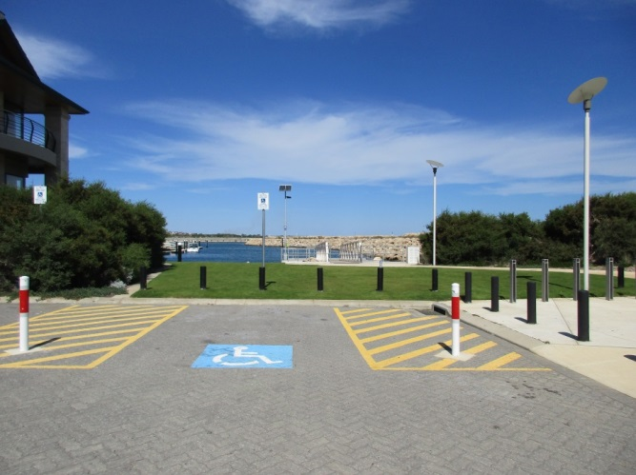

Non **disability parking permit** holders are prohibited **unconditionally** from parking in these locations

**People with disabilities symbols**

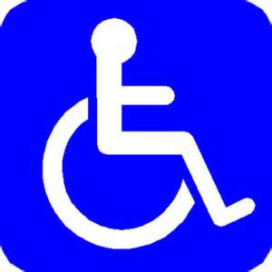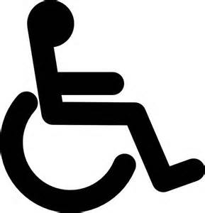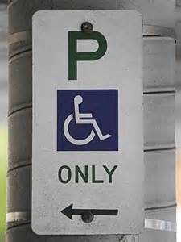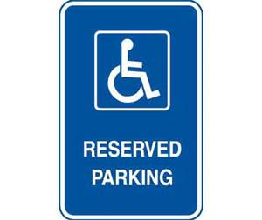

**PARKING OVER A DRIVEWAY**

A person shall not stop or park a vehicle so that any portion of the vehicle is:

1. in front of a right of way, crossover, passage or private drive or so close to one as to deny vehicles reasonable access to, or egress from, the right of way, crossover, passage or private drive

 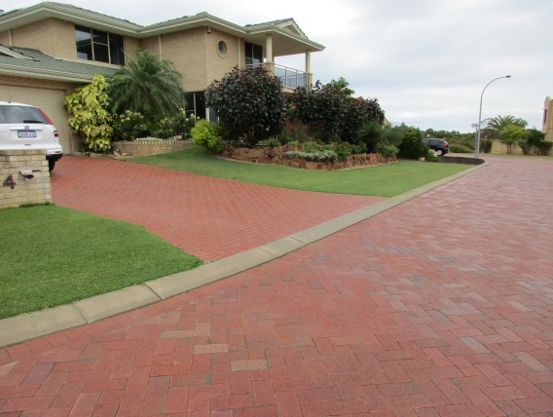

**CONTINUOUS LINE – OBSTRUCTION (medium strip, vehicle, furthest boundary)**

A person parking a vehicle on a carriageway other than in a parking space shall park:

1. so that at least 3 metres of the width of the carriageway lies between the vehicle and the farther boundary of the carriageway, or any continuous line or medium strip, or between the vehicle and a vehicle parked on the farther side of the carriageway

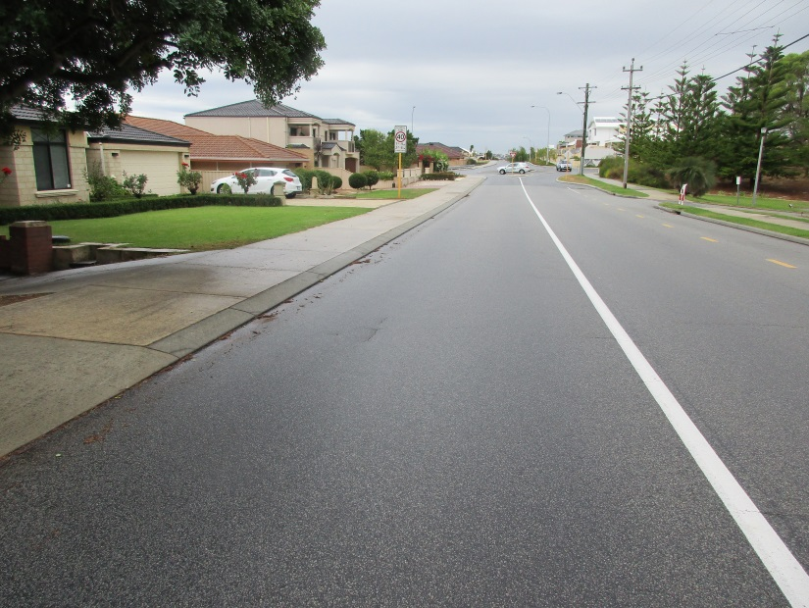

­­­­­­­­­­­­­­­­­­­­­

**PARKING AGAINST THE FLOW OF TRAFFIC – Facing the wrong direction**

A person parking a vehicle on a carriageway, **other than in a parking space**, shall park it:

1. in the case of a two-way carriageway, so that it is as near as practicable to and parallel with, the left boundary of the carriageway and headed in the direction of the movement of traffic on the side of the thoroughfare on which the vehicle is parked. and;
2. in the case of a one-way carriageway, so that it is as near as practicable to and parallel with either boundary of the carriageway and headed in the direction of the movement of traffic on the side of the thoroughfare on which the vehicle is parked

**FIRE HYDRANT**

A person shall not stop or park a vehicle on a thoroughfare so that:

1. any portion of the vehicle is within 1 metre of a fire hydrant or fire plug or of any sign or mark indicating the existence of a fire hydrant of fire plug

 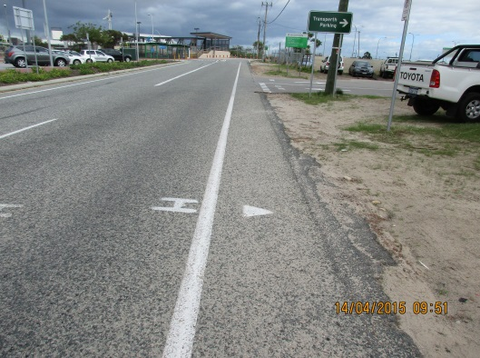

__________________________________________________________________________

**PUBLIC POST BOX**

A person shall not stop or park a vehicle on a thoroughfare so that any portion of the vehicle is within:

1. 3 metres of a public post box; or
2. within a mail zone

 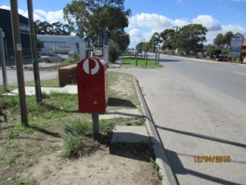 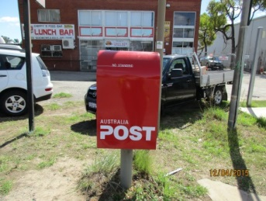

**BICYCLE LANES**

The driver of a vehicle, other than a bicycle, shall not:

1. drive or park in a bicycle lane;
2. The driver of a public bus, or a taxi, may drive in a bicycle lane for up to 50 m if the driver is dropping off, or picking up, passengers

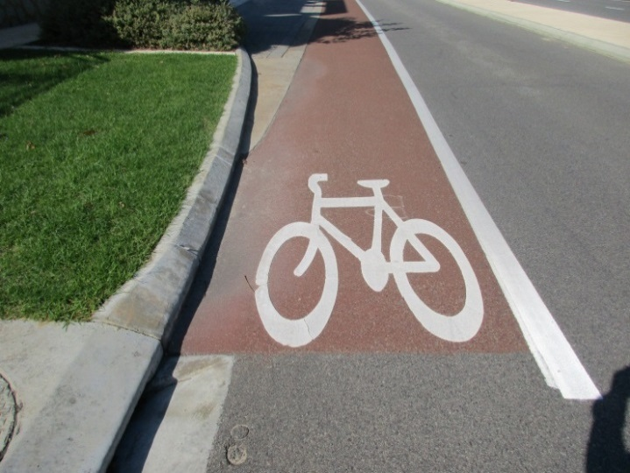

­­­­­­­­­­­­­­­­­­­­

**PARKING IN A THOROUGHFARE FOR PURPOSE OF SALE and in other circumstances**

A person shall not park a vehicle on any portion on a thoroughfare:

1. for the purpose of exposing it for sale

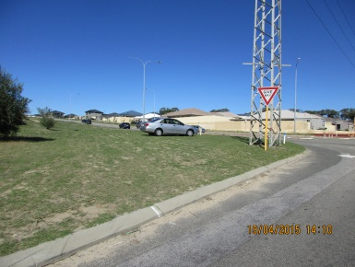

(**In other circumstances**) a person shall not park a vehicle on any portion of a thoroughfare:

1. if that vehicle is not licensed under the Road Traffic Act
2. if that vehicle is a trailer or a caravan unattached to a motor vehicle; or
3. for the purpose of effecting repairs to it, other than the minimum repairs necessary to enable the vehicle to be moved to a place other than a thoroughfare

**PARKING ON A PUBLIC RESERVE**

A person shall not stop or park a vehicle in a public reserve:

1. Other than within a parking facility or parking station on that reserve, unless the person is an employee of the City in the course of their duties, or
2. Has obtained the permission of the local government or an authorised person

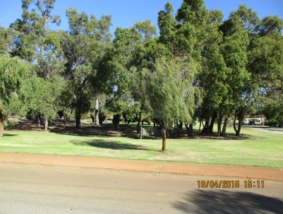 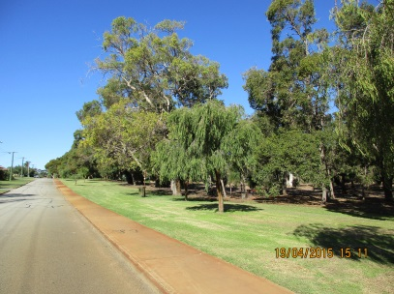 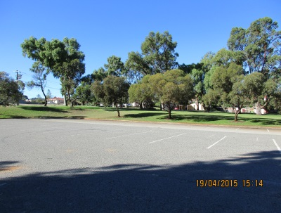

**PARKING STATIONS**

A person shall not stop or park a vehicle in a parking station**:**

1. other than wholly within a parking space

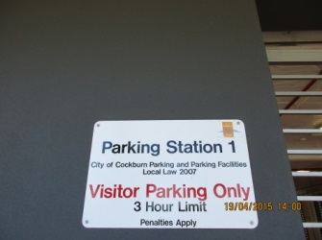 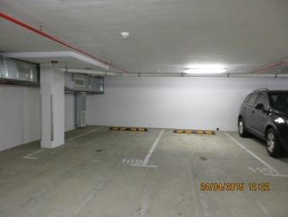 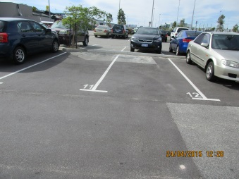

**N.B**. If the Parking Station has timed bays a person shall not park for more than the maximum time specified by a sign

**STOPPING OR PARKING CONTRARY TO SIGNS – TIMED PARKING**

A person shall not stop or park a vehicle on a thoroughfare, or portion of a thoroughfare:

1. Whether or not that part or not that part is marked as a parking space, for more than the maximum time specified by a sign

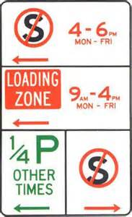 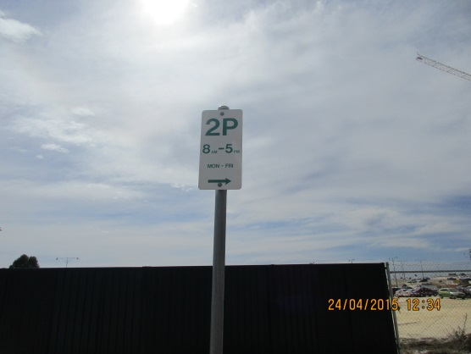

**No parking within One (1) hour**

1. when the parking restriction time has expired a person shall not park that vehicle again in the same thoroughfare on that day unless it has first been removed from the thoroughfare for at least one (1) hour

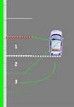 **MUST LEAVE THE THOROUGHFARE FOR ONE HOUR**

**STOPPING HEAVY, COMMERCIAL AND OTHER TYPES OF VEHICLES IN BUILT UP AREA**

A person shall not park on a carriageway or verge in a built-up area between the hours

of **6pm one day and 7am** the following day; and for more than **three (3) hours**

consecutively between the hours of **7am and 6pm**:

1. a vehicle of any combination of vehicles that, together with any projection on, or load carried by, the vehicle or combination of vehicles, is 7.5m or more in length or exceeds a GVM of 4.5t
2. a commercial vehicle
3. a caravan
4. a bus
5. a tow truck
6. a tractor, or
7. a trailer

**STOPPING IN A TAXI ZONE**

A driver shall not:

1. stop in a taxi zone, unless the driver is driving a taxi

[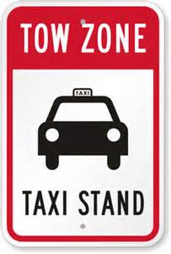](http://www.bing.com/images/search?q=taxi+zone+symbols&view=detailv2&&qpvt=taxi+zone+symbols&id=09596D1A519C2200C625C98E4CA86FF4B38F9CDD&selectedIndex=12&ccid=PNqaWoJt&simid=608006828100488125&thid=JN.1y9drXkSHP9BKTkjDAlahA) 