Tender Title: |  | RFT 24/2023  Customer Satisfaction Research
Request ID: |  | 47395
Tender Description: |  | The City of Cockburn (the Principal) is seeking of a suitably qualified, experienced and resourced Market Research Consultant to conduct comprehensive customer satisfaction research.
Advert Approval: |  | Decision to Advertise: Executive Corporate Affairs  Decision Date: Thursday, 17 August 2023
Closing Date and Time: |  | 2:00PM (AWST) Thursday, 7 September 2023
Opening Date and Time: |  | 2:00PM (AWST) Thursday, 7 September 2023
 | Tenderer’s Name:
1 | AEC Group Pty Ltd
2 | CommunitiesThrive Pty Ltd
3 | Research Solutions (WA) Pty Ltd
4
5
6
7
8
9
10

Advertisement
Method 1: City of Cockburn | Method 2: Yammer
Method 3:  The Western Australian,  Wednesday, 23rd August 2023 | Tender Awarded by:
Copy of Statewide Notice:  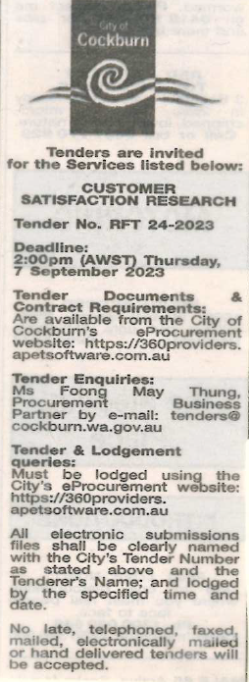 | Acting Director Corporate & System Services  Tuesday, 16 April 2024
 | Date of Council Meeting:
 | Not applicable
Name of Successful Tenderer(s): | CommunitiesThrive Pty Ltd
Amount of Successful Tender(s): (ex GST) | Estimated Contract Value $89,995 for one (1) year.

