Tender Title: |  | RFT 18/2023  Construction Services - Cockburn ARC & Fremantle Football Club Expansion
Request ID: |  | 46720
Tender Description: |  | The City of Cockburn (the Principal) is seeking the services of a suitably qualified, registered and experienced Commercial Building Contractor to undertake the refurbishment and expansion of the Cockburn ARC Leisure Centre as well as the Fremantle Football Clubs Training Facility.
Advert Approval: |  | Decision to Advertise: Chief Operations Officer  Decision Date: Friday, 16 June 2023
Closing Date and Time: |  | 2:00PM (AWST) Thursday, 3 August 2023
Opening Date and Time: |  | 2:00PM (AWST) Thursday, 3 August 2023
 | Tenderer’s Name:
1 | Geared Construction Pty Ltd (WA)
2 | Shelford Group (Commercial)
3
4
5
6
7
8
9
10

Advertisement
Method 1: City of Cockburn | Method 2: Yammer
Method 3:  The Western Australian,  Wednesday, 21st June 2023 | Tender Awarded by:
Copy of Statewide Notice:  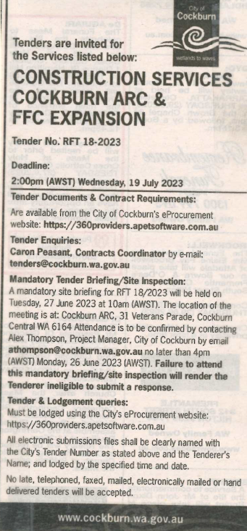 | OCM  Thursday, 9 November 2023
 | Date of Council Meeting:
Minutes: 0296
Item No: 14.3.3

Name of Successful Tenderer(s): | Shelford Construction Pty Ltd
Amount of Successful Tender(s): (ex GST) | $16,277,454 (Ex GST)

