Tender Title: |  | RFT 13/2024 – Arboricultural Consultancy Services (Parks, Streetscapes and Reserves)  Three (3) Year Contract
Request ID: |  | 50223
Tender Description: |  | The City of Cockburn (The Principal) requires the services of a suitably qualified and experienced contractor to provide Arboricultural reports, provide technical advice and conduct qualified tree risk assessments of trees in the Principals Parks, Reserves and Streetscapes on both a scheduled basis and an ‘as required’ basis.
Advert Approval: |  | Decision to Advertise: Chief Executive Officer  Decision Date: Wednesday, 14 August 2024
Closing Date and Time: |  | 2:00PM (AWST) Thursday, 5 September 2024
Opening Date and Time: |  | 2:00PM (AWST) Thursday, 5 September 2024
 | Tenderer’s Name:
1 | Arbor Urban Pty Ltd
2 | Paperbark Technologies Pty Ltd
3 | Trace Enterprise Group
4 | Westworks Consultancy
5
6
7
8
9
10
11

Advertisement
Method 1: City of Cockburn | Method 2: Yammer
Method 3:  The Western Australian, Saturday 17th August 2024 | Tender Awarded by:
Copy of Statewide Notice:  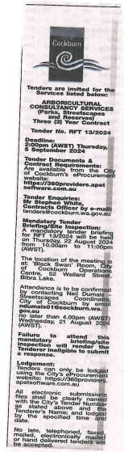 | Director of Infrastructure Services  A/Director Corporate and System Services  23rd October 2024
 | Date of Council Meeting:
 | N/A
Name of Successful Tenderer(s): | Paperbark Technologies Pty Ltd
Amount of Successful Tender(s): (ex GST) | Estimated Value $534,000

