Tender Title: |  | RFT14/2025 – Security System and Services
Request ID: |  | 63380
Tender Description: |  | The City of Cockburn (the Principal) is seeking a licensed, experienced and reliable Security Systems Contractor(s) to provide Security Monitoring, Systems, Maintenance Services at the Principal’s buildings and properties throughout the City of Cockburn.  Sites includes various administration buildings, community centres, sports clubrooms, libraries, public facilities etc.  The Specification is to be read in the context it is written and will be the basis upon which the Contractor is to achieve an acceptable standard and level of service.  The proposed Contract shall be in force for a period of three (3) years from the date of contract award, with a Principal instigated option to extend up to One (1) year and then for up to Twelve (12) months after that to a maximum of Five (5) years; the Contract is expected to commence in June 2025.
Advert Approval: |  | Decision to Advertise: Director Infrastructure Services  Decision Date: Monday, 14 April 2025
Closing Date and Time: |  | 2:00PM (AWST) Thursday, 15 May 2025
Opening Date and Time: |  | 2:15PM (AWST) Thursday, 15 May 2025
 | Tenderer’s Name:
1 | ARA SECURITY SERVICES PTY LIMITED (WA Office)
2 | Blue Force Pty Ltd t/a Blueforce (WA Branch)
3 | NORTH STAR SECURITY NOMINEES PTY LTD
4 | SATELLITE SECURITY SERVICES (SATELLITE SECURITY SERVICES PTY LTD)
5 | SEME SOLUTIONS PTY LTD (SEME WA)
6 | SNS GROUP SERVICES t/a Safer Community Security (Perth)

Advertisement
Method 1: City of Cockburn | Method 2: Yammer
Method 3:  The Western Australian, Wednesday,  16 April 2025, Page 47 | Tender Awarded by:
Copy of Statewide Notice:  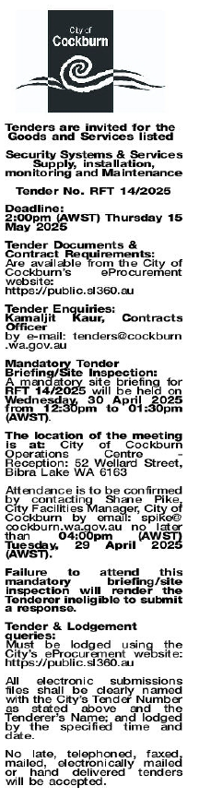 | Choose an item.  Choose an item.  Wednesday, 16 April 2025
 | Date of Council Meeting:
Click here to enter a date. or
Choose an item.
Item No:
Name of Successful Tenderer(s): | SATELLITE SECURITY SERVICES
Amount of Successful Tender(s): (ex GST) | $634,040.00 (Excl Gst)

