Tender Title: |  | RFT 01/2024 BUILDING CONSTRUCTION SERVICES – Omeo Amenities Building, Port Coogee
Request ID: |  | 47722
Tender Description: |  | The City of Cockburn (the Principal) is seeking the services of a suitably qualified, registered, and experienced Commercial Building Contractor to undertake the construction of the Omeo Amenities Building located at Lot 8025, corner of Napoleon Parade and Socrates Parade, Port Coogee.
Advert Approval: |  | Decision to Advertise: Chief Operations Officer  Decision Date: Thursday, 22 February 2024
Closing Date and Time: |  | 2:00PM (AWST) Friday, 19 April 2024
Opening Date and Time: |  | 2:00PM (AWST) Friday, 19 April 2024
 | Tenderer’s Name:
1 | SCHLAGER GROUP PTY LTD
2 | CONSTRUCT360 PTY LTD (Osborne Park Office)
3 | BURGIO CONSTRUCTION PTY LTD
4 | Kilmore Group
5 | PRECISE BUILD PTY LTD (Western Australia)
6 | The Trustee for the Pennant Unit Trust t/a Pennant Construction Pty Ltd (Pennant Construction)
7
8
9
10

Advertisement
Method 1: City of Cockburn | Method 2: Yammer
Method 3:  The Western Australian, Wednesday 28th February 2024 | Tender Awarded by:
Copy of Statewide Notice:  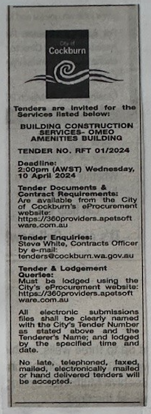 | OCM  Tuesday, 9 July 2024
 | Date of Council Meeting:
Tuesday, 9 July 2024
Minutes: 0140
Item No: 14.2.1
Name of Successful Tenderer(s): | The Trustee for the Pennant Unit Trust t/a Pennant Construction Pty Ltd (Pennant Construction)
Amount of Successful Tender(s): (ex GST) | $1,828,306 Ex GST

