Tender Title: |  | RFT 08/2024 Fencing Services (City Wide)  Three (3) Year Contract
Request ID: |  | 49811
Tender Description: |  | The City is seeking the services of an experienced and suitably qualified fencing contractor to supply, install and repair a wide range of fences, bollards, and gates.  The works are to be primarily delivered to a network of parks, reserves, road reservations and freehold land owned by the City. Works will range in volume from fencing entire reserves to undertaking minor repairs.
Advert Approval: |  | Decision to Advertise: Chief Operations Officer  Decision Date: Thursday, 21 March 2024
Closing Date and Time: |  | 2:00PM (AWST) Wednesday, 17 April 2024
Opening Date and Time: |  | 2:00PM (AWST) Wednesday, 17 April 2024
 | Tenderer’s Name:
1 | The Trustee for Sam Smith Family Trust (T/a SCP Conservation and Land Management)
2 | The Trustee For Barra Civil And Fencing Trust (T/a Barra Civil and Fencing)
3
4
5
6
7
8
9
10

Advertisement
Method 1: City of Cockburn | Method 2: Yammer
Method 3:  The Western Australian, Saturday 23 March 2024 | Tender Awarded by:
Copy of Statewide Notice:  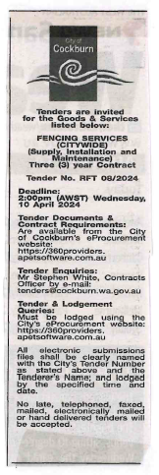 | Chief Executive Officer  Director of Infrastructure Services  Friday, 19 July 2024
 | Date of Council Meeting:
 | Not applicable
Name of Successful Tenderer(s): | The Trustee for Sam Smith Family Trust (T/a SCP Conservation and Land Management)
Amount of Successful Tender(s): (ex GST) | $729,666.00 Ex GST

