Tender Title: |  | RFT 07/2024 – Tree Watering Services – Parks, Streetscapes & Reserves – One (1) Year Contract
Request ID: |  | 49812
Tender Description: |  | The City of Cockburn (the Principal) requires the services of a suitably qualified and experienced a Contractor to conduct truck and mobile tank watering of the following (but not limited to):  • Trees  • Shrubs  • Roll On Turf  • Tube Stock  The water will be supplied by the Principal.  Most of the watering will be on a scheduled basis; however, some ad-hoc watering may also be required.  The Contractor; under the proposed Contract, will be required to provide all labour, plant, tools and equipment, materials, transportation/cartage, administrative costs, travelling expenses etc. and anything else necessary for the completion of the works/services.
Advert Approval: |  | Decision to Advertise: Acting Chief Operations Officer  Decision Date: Saturday, 23 March 2024
Closing Date and Time: |  | 2:00PM (AWST) Tuesday, 9 April 2024
Opening Date and Time: |  | 2:00PM (AWST) Tuesday, 9 April 2024
 | Tenderer’s Name:
1 | Environmental Industries Pty Ltd (Maintenance)
2 | Total Landscape Redevelopment Service Pty Ltd
3 | Baroness Holdings Pty Ltd t/a Tree Planting and Watering
4
5
6

Advertisement
Method 1: City of Cockburn | Method 2: Yammer
Method 3:  The Western Australian, Tuesday 9th April 2024 | Tender Awarded by:
Copy of Statewide Notice:  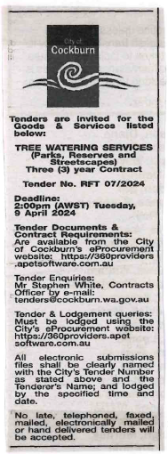 | A/Director of Infrastructure Services  A/Director of Corporate and System Services  Monday, 9 September 2024
 | Date of Council Meeting:
 | Not Applicable
Name of Successful Tenderer(s): | Baroness Holdings Pty Ltd t/a Tree Planting and Watering
Amount of Successful Tender(s): (ex GST) | Estimated Value $658,793 Ex GST

