Policy Type

Council

Policy Purpose

The City’s vision ‘Cockburn, the best place to be’ is underpinned by our purpose ‘Support our communities to thrive by providing inclusive and sustainable services which reflect their aspirations’. To achieve this vision high level long term strategic objectives and business planning processes have been established. The Strategic Community Plan outlines the community’s long-term vision, aspirations and priorities. It contains details of the City’s Vision, the desired outcomes and the key factors that will help deliver these outcomes – referred to as the ‘Strategic Objectives’.

The Strategic Community Plan undergoes a major review (including community consultation) every four years and a desktop review every two years. The Strategic Community Plan is functionally delivered and resourced through the Corporate Business Plan and the Annual Budget process. The Corporate Business Plan is reviewed annually and outlines the actions, projects, and services that the City’s administration will undertake over a four year period to achieve the Strategic Community Plan outcomes and objectives. Whereas the Annual Budget provides the financial allocations and resources for the relevant financial year.

The Local Government (Administration) Regulations 1996, Regulations 19C and 19D, set the requirements for the Strategic Community Plan and Corporate Business Plan. They derive from the Local Government Act 1995 Section 5.56.

Section 6.2 (1) of the Local Government Act 1995 requires Council to prepare and adopt a budget for it municipal fund during the period 1 June to 31 August for the following financial year.

Section 6.2 (2) requires Council to have regard to the contents of the plan for the future of the district in the preparation of the annual budget and to prepare estimates for revenues and expenditure in order to determine the amount required to be raised from rates.

Section 6.34 puts a limit on budget surpluses or deficits at no more than 10% of the rates amount required to achieve a balanced budget. Ministerial approval is required to vary this limit.

Part 3 of the Local Government (Financial Management) Regulations 1996 prescribes the form and content for the annual budget and the requirement to review the performance of the budget between 1 January and 31 March each year.

This policy has been formulated to articulate Council’s requirements and processes for Strategic and Corporate planning and managing the annual budget in a manner that is both compliant with legislative requirements and pertinent to Council’s operating needs.

Policy Statement

This policy establishes a framework for the City of Cockburn’s Strategic and Corporate Planning processes that focuses on community priorities, statutory requirements, and the Integrated Planning and Reporting Framework and Guidelines. This policy provides the strategic guidance for an integrated business planning and resourcing approach when considering major decisions which will affect the City into the future.

This policy establishes a framework for the formulation, administration and management of Council’s budget that meets both statutory and Council’s requirements. It serves to provide strategic guidance to staff and sets out various guiding principles to be followed when developing the annual budget.

(1) Budget Formulation Principles

The following principles shall guide the preparation of the initial draft budget:

1. The Strategic Community Plan, Corporate Business Plan, Council adopted strategies, informing strategies the Community Survey and the Customer Satisfaction Survey should provide strategic guidance to management in determining budget priorities.

2. The projects and financial indicators listed within Council’s Long Term Financial Plan (10 year Plan), and the Corporate Business Plan will form the basis and provide the general parameters for the annual budget. Budget submissions should be congruent with the objectives listed within the Strategic Community Plan.

3. Rating revenue is to be set at a level that will produce a balanced or small surplus budget. For this purpose, surplus/deficit calculations will be made in accordance with Local Government Operational Guidelines - Number 08 June 2013 “Net Current Assets (Opening and Closing Funds) Used in the Annual Budget and the Annual Financial Report.

4. Provisional allocation for Donations, Sponsorships and Grants is to be up to a maximum of 1.5% of Rates Revenue (excluding any specified area rates). The Expenditure Review Committee (ERC) makes recommendations to Council regarding individual donations, sponsorships and grants.

5. Provisional allocation for Community Events is to be up to a maximum of 0.8% of Rates Revenue (excluding any specified area rates). The ERC recommends to Council the annual calendar of events each year.

6. All budget submissions are to include detailed cash flow requirements in order to facilitate budget variance reporting each month.

7. Sustainability issues need to be considered when assessing all new initiatives, as well as value for money.

8. Standards established in other City policies, (such as verge maintenance), are to be adhered to. Where this causes a significant increase in costs, alternatives may be recommended.

9. The end of year current surplus/deficit position will need to be estimated during the formulation of the annual budget. This estimate, together with carried forward works and projects, will be brought to Council as a budget amendment to reflect actual positions once the end of year accounts have been finalised.

10. General Rates revenue will be budgeted using a Differential Rates model pursuant to the Local Government Act 1995 that seeks to rate land in the district equitably and proportionally based on appropriate land use/type characteristics.

11. Modelling of the proposed Differential Rates is to be presented to the Elected Members at a Budget Forum, with a focus on the residential improved rate in the dollar/minimum payment, particularly during a Gross Rental Value (GRV) revaluation year.

12. Specified Area Rates adopted by Council will be reviewed annually and set at levels that raise sufficient funding to meet anticipated needs (both short and long term).

(2) Budget Considerations for Reserve Funds

The requirement for each Reserve Fund and associated target values will be reviewed each budget cycle and net transfers to Reserves will be managed in line with the objective of attaining target values set within Council’s Long Term Financial Plan (LTFP). Any budget surplus identified at the end of each financial year is to be transferred to an appropriate Reserve consistent with the objective of attaining target values.

A number of Reserves are subject to budget discipline and quarantining requirements as follows:

- Carried Forwards Reserve – Municipal funding for carried forward works and projects included in the end of year surplus is to be quarantined into this reserve to fund the completion of those works in the following year.

- Plant & Vehicle Reserve - the replacement program for major plant and fleet vehicles will be funded from the annual replenishing of this reserve, that based on the depreciation charge for applicable assets.

- CIHF Building Maintenance Reserve – is replenished from the net commercial lease revenue from the Cockburn Integrated Health & Community Facility.

- Waste & Recycling Reserve – net surplus/deficit for the Henderson Waste Recovery Park is managed through this reserve.

- Waste Collection Reserve – transfers to this reserve are based on a hypothetical profit and loss for the Waste Collection Service.

- Land Development & Investment Fund Reserve – net proceeds from land sales under the City’s Land Management Strategy are transferred into this reserve, as is net commercial lease revenue from the Coogee caravan park and other commercial properties.

- Developer Contribution Area (DCA) Reserves – net contributions from each DCA area are transferred into each respective reserve in accordance with the City’s Town Planning Scheme.

- Specified Area Rate Reserves – surplus funds raised and unspent at year end are to be quarantined into the respective reserve for future use in accordance with the LG Act.

- Naval Base Shack/Shack Removal Reserves – net lease revenue is managed through these reserves for current and future maintenance and capital costs.

- Marina Asset Replacement Reserve – net revenue from the lease of pens is required to be transferred into this reserve for future asset renewal and replacement needs. This should at least cover annual depreciation.

- Insurance Reserve – any annual savings attained and surplus dividends given by LGIS are to be quarantined to this reserve, which is used to smooth out future spikes in premiums and excess payments.

- Restricted Grants and Contributions Reserve – some external funding remaining unspent at year end and not resulting in an accounting liability will be quarantined within this reserve.

(3) Form and Content of Budget and Working Papers

Before presentation to Council, the budget will be developed and considered at a series of executive briefings and budget forums involving the Elected Members.

The draft budget to be presented to and considered at the various executive briefings and budget forums is to include the following elements:

1. A Rating Objects and Reasons paper.
2. A summary of all Reserve Funds and their anticipated movements based on known capital works/replacement programs and any other relevant information.
3. Details of proposed new initiatives, both capital and operating.
4. Details of proposed Capital Works program for Infrastructure.
5. Details of proposed new Staff positions.
6. Details of proposed new Information Technology.
7. A fees and charges schedule.
8. A summary of the Corporate Business Plan projects, service changes, strategies and actions for the upcoming year

The formal budget presented to Council for adoption will be in a format that complies with the Part 3 of the Local Government (Financial Management) Regulations 1996 and is to include any other information deemed relevant (e.g. summaries of the new initiatives and capital programs).

Council’s significant accounting policies are to be updated and included within the formal budget to provide direction for the year ahead and explain the basis of preparation for the statutory financial statements

(4) Adjustment for Estimated Surplus/Deficit and Addition of Carried Forwards

Once the end of financial year accounts have been finalised and audited, the actual opening budget surplus/deficit will be determined and reported to Council. Any excess surplus to the estimated final position will be transferred to Reserves in accordance with this policy. Also at this time, a detailed listing of carried forward works and projects will be presented to Council for incorporation into the City’s amended annual budget.

(5) Mid-Year Budget Review and Corporate Business Plan Progress Report

Council will conduct a mid-year budget review for the principal purpose of addressing budget variations that may arise or come to the attention of management during the first half of the year, in line with financial regulations.

The review is not intended for the purpose of funding new initiatives or capital works. New initiatives will only be submitted to Council where they are deemed essential and have an identified funding source. The Project Contingency Fund should be considered a funding source for essential items.

Council is bound by legislation to conduct a review of the budget between January and March each year.

Annually after the adoption of the Corporate Business Plan, the CEO and Executive Team in conjunction with the Senior Leadership Team will assign Key Performance Indicators (KPIs) to individual Corporate Business Plan outcomes.

Each financial year, quarterly status reports on the progress of the KPIs will be contained within a report to a Council meeting.

(6) Community Engagement of Draft Budget

Upon the completion of the draft Municipal Budget, (due by the end of April each year), the draft capital and operating new initiatives, the rating objects and reasons and the draft fees and charges schedule will be:

- Placed on Comment on Cockburn providing 28 days to allow feedback
- Presented to a meeting of the Cockburn Community Development Group (community resident groups).
- Elected Members will be provided the feedback in June each year, either at a briefing or by email.
- The proposed differential rates will be advertised in accordance with the Local Government Act 1995, seeking additional (and formal) feedback. All feedback received on the budget will be summarised and included in the budget adoption report to Council.

(7) Budget Management Timetable

The following timetable includes all the major activities comprising Council’s budgeting regime including the adoption of the Budget by a Special Meeting of Council in June of each financial year. It is indicative and may be subject to minor variations.

October | • Community Resident Groups invited to consider budget requests and priorities for the following financial years’ budget.
November | • Community Resident Groups submissions to be submitted by the end of November.  • First quarterly status progress report for KPIs to Council for noting.  - Mid-year draft service plans issued to Senior Leadership Team.
December | • Long Term Financial Plan reviewed and adopted (Biennially) .  • Mid-year budget review procedures and submission templates issued to Managers.  • Community and Business Group submissions to be assessed by relevant Business Unit Managers in line with LTFP, Corporate Business Plan, adopted Strategies and Asset Management Plans.
January | • Mid-year budget review submissions due back from Managers.  • Executive to consider the proposed budget review.  • Completion of budget and mid-year service plans review for Council adoption or consideration.  • Budget guidelines, procedures and submission templates issued to Managers for next year’s budget.  • Budget Review amendments included in the monthly reports for February
February | • New initiatives/capital works submissions due back to Management Accounting.  • Proposed new initiatives/capital works considered by the Executive.  • Advertising of differential rates.  • Review of fees and charges register by management.  • Completed operational budgets returned to Finance  • Council to adopt the Budget Review.  - Second quarterly status progress report for KPIs to Council for noting.  • Mid-year review of service plans to Council for decision (adoption)
March | • Review & Update of Activity Based Costing Model.  • Annual review of the Corporate Business Plan prepared by management.  • The Executive considers initial draft of Budget and Corporate Business Plan review.  • First Budget and Corporate Business Plan Forum for Elected Members. Summary of Corporate Business Plan, service plans, corporate projects, capital works projects and community resident group submissions.  • Fees & Charges Schedule updated.
April | • Second Budget Forum for Elected Members covering the operational budget and differential rating model.  • Review of completed budget by the Executive.  • Finalisation of Statutory Budget and draft annual review of the Corporate Business Plan.
May | • At beginning of May, commence community engagement of draft budget on Comment on Cockburn providing 28 days to provide feedback.  • Presentation to Cockburn Community Development Group meeting  • Advertise proposed differential rates including objects and reasons seeking feedback.  • Third quarterly status progress report for KPIs to Council for noting.
June | • Briefing to Elected Members on feedback from community engagement  • Report back to Community Resident Groups on the draft budget submissions included in the draft budget for consideration by Council  • Carried forward projects estimated by management  • Adoption of reviewed Corporate Business Plan and Budget at Special Council Meeting.
July | • Fourth quarterly status progress report for KPIs to Council for noting.
September | • Budget amended to reflect final position with regard to estimated carried forward projects and end of financial year current surplus/deficit.

Corporate Strategic Planning Process
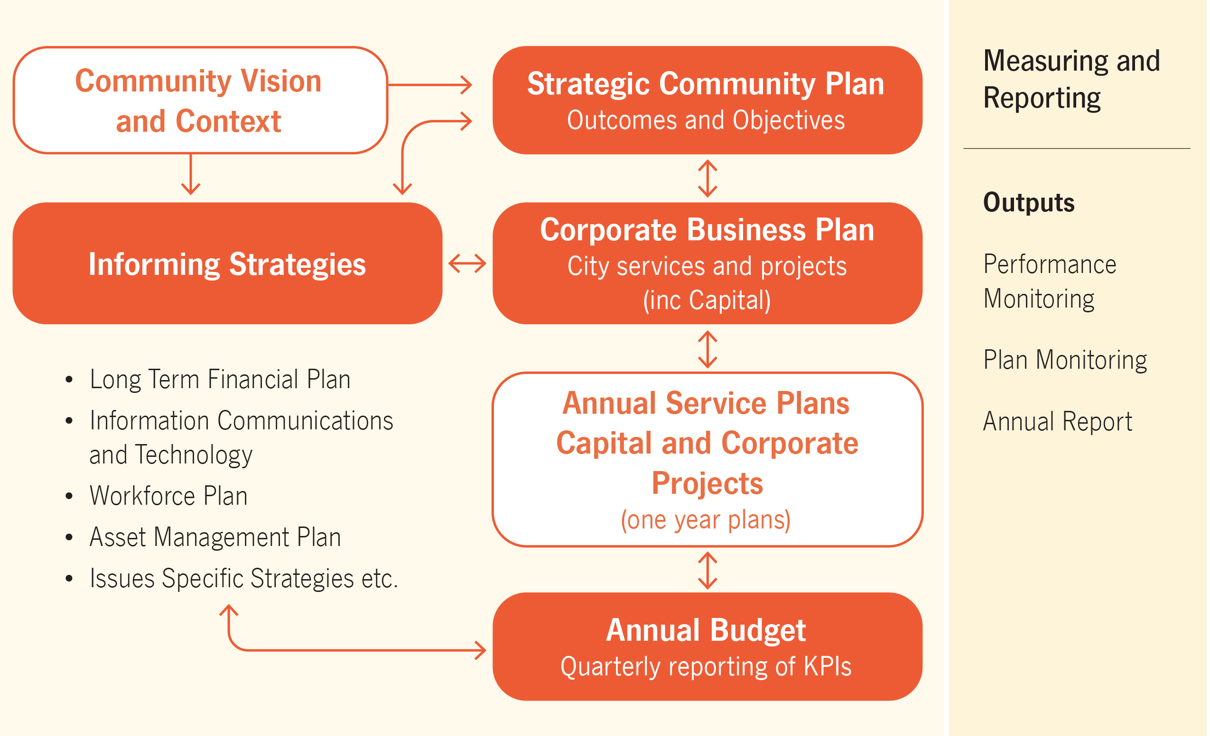

Bookmark 2
Bookmark 3
Strategic Link: | Long Term Financial Plan, Strategic Community Plan
Category | Corporate Planning, Budgeting & Procurement
Lead Business Units: | Finance; Strategy
Public Consultation:  (Yes or No) | Yes (budget only)
Adoption Date:  (Governance Purpose Only) | 14 July 2022
Next Review Due:  (Governance Purpose Only) | July 2024
ECM Doc Set ID:  (Governance Purpose Only) | 4134024

