Tender Title: |  | RFT 18/2024 – PROVISION OF IRRIGATION PARTS AND MATERIALS - PARKS (Supply) Three (3) Year Contract
Request ID: |  | 50245
Tender Description: |  | The City of Cockburn is seeking a suitably qualified and experienced Contractor for the supply of irrigation parts and materials. These materials include PVC pipe & fittings, polyethylene pipe & fittings, sprinklers, controllers, valves, valve boxes, cabling, and miscellaneous parts.
Advert Approval: |  | Decision to Advertise: Chief Executive Officer  Decision Date: Tuesday, 13 August 2024
Closing Date and Time: |  | 2:00PM (AWST) Thursday, 5 September 2024
Opening Date and Time: |  | 2:00PM (AWST) Thursday, 5 September 2024
 | Tenderer’s Name:
1 | Double G (WA) Pty Ltd T/as Think Water Perth
2 | Total Eden Pty Ltd
3
4
5
6
7
8
9
10
11

Advertisement
Method 1: City of Cockburn | Method 2: Yammer
Method 3:  The Western Australian, Saturday 17th August 2024 | Tender Awarded by:
Copy of Statewide Notice:  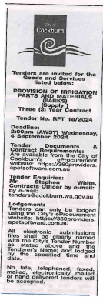 | Director of Infrastructure Services  13th December 2024
 | Date of Council Meeting:
 | N/A
Name of Successful Tenderer(s): | Total Eden Pty Ltd
Amount of Successful Tender(s): (ex GST) | $295,065.11 Estimated Contract Sum

