Tender Title: |  | RFT03/2024 - AUTO ELECTRICAL SERVICES - FLEET
Request ID: |  | 49752
Tender Description: |  | The City of Cockburn is seeking a suitably qualified and experienced contractor to provide Auto-electrical services to its fleet. The successful contractor will be responsible for maintaining, repairing, fault diagnosis, new installations, and (upon request) inspecting repairs to the Principal’s fleet assets, to ensure they are functioning in accordance with manufacturers’ guidelines and specifications. The extent of services covers all the Principal’s Fleet; and the Contractor is expected to provide scheduled, 24 hour on-call and ad-hoc services.
Advert Approval: |  | Decision to Advertise: Chief Operations Officer  Decision Date: Wednesday, 28 February 2024
Closing Date and Time: |  | 2:00PM (AWST) Thursday, 28 March 2024
Opening Date and Time: |  | 2:00PM (AWST) Thursday, 28 March 2024
 | Tenderer’s Name:
1 | Aust West Auto Electrical Pty Ltd
2 | Ready Resources Pty Ltd
3
4
5
6
7
8
9
10

Advertisement
Method 1: City of Cockburn | Method 2: Yammer
Method 3:  The Western Australian, Wednesday 6 March 2024 | Tender Awarded by:
Copy of Statewide Notice:  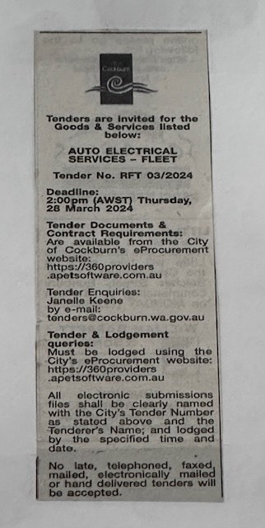 | Acting Director Infrastructure Services  Acting Director Corporate & System Services  02/05/2024
 | Date of Council Meeting:
 | Not applicable
Name of Successful Tenderer(s): | Aust West Auto Electrical Pty Ltd
Amount of Successful Tender(s): (ex GST) | Estimated contract value $857,082.00 Ex GST for three (3) years

