Tender Title: |  | RFT 20/2023  Property and Facility Management Services
Request ID: |  | 47406
Tender Description: |  | The City of Cockburn requires the services of a suitably qualified and experienced licensed real estate agent to undertake the Property and Facility Management Services as follows:  - Property & Facility Manager for Cockburn Health & Community Facility which includes medical and allied health suites; office accommodation and supporting evidence such as a café.  - Property Manager (Leased Areas) for the Cockburn Youth Centre.
Advert Approval: |  | Decision to Advertise: Chief Operations Officer  Decision Date: Thursday, 17 August 2023
Closing Date and Time: |  | 2:00PM (AWST) Wednesday, 13 September 2023
Opening Date and Time: |  | 2:00PM (AWST) Wednesday, 13 September 2023
 | Tenderer’s Name:
1 | The Trustee for Chesterton Unit Trust t/a Cygnet West
2 | The Trustee for The Lake Cryov Unit Trust t/a MMJ Real Estate (WA)
3 | Empire Commercial Property
4 | The Trustee for Burgess Rawson WA Unit Trust t/a Burgess Rawson (WA) Pty Ltd
5
6
7
8
9
10

Advertisement
Method 1: City of Cockburn | Method 2: Yammer
Method 3:  The Western Australian,  Wednesday, 23rd August 2023 | Tender Awarded by:
Copy of Statewide Notice:  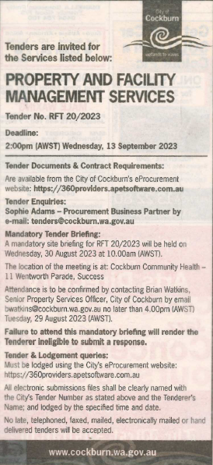 | Acting Chief Financial Officer  Tuesday, 21 November 2023
 | Date of Council Meeting:
 | Not applicable
Name of Successful Tenderer(s): | The Trustee for Burgess Rawson WA Unit Trust t/a Burgess Rawson (WA) Pty Ltd
Amount of Successful Tender(s): (ex GST) | $240,038 Ex GST

