**Community Infrastructure Development Contribution Plan 13 (DCP 13)**

**Report**

**2023/24**

**Table of Contents**

Development Contribution Area 3

Purpose 3

Period of the plan 4

Operation of DCP 4

Application requirements 4

Items included in the plan 4

Estimated costs 6

Method of calculating contribution 7

Priority and timing of delivery 8

Payment of contributions 9

Review 9

Annexes 10

Annex 1 – Maps 11

Annex 2 – Cost Apportionment Schedule (CAS) 14

Annex 3 – Infrastructure Sheets 19

Annex 4 – Capital Expenditure Plan (CEP) 60

Annex 5 – Schedule of Costs 62

Annex 6 – Dwelling Forecast 83

Acknowledgement of Country

The Mayor, Councillors and staff of the City of Cockburn acknowledge the Whadjuk Nyungar people of Beeliar boodja as the traditional custodians of this land. We pay our respect to the Elders, past and present.

**Community Infrastructure Development Contribution Plan Report**

Note: This report does not form part of the planning scheme but provides the rationale and justification for the Development Contribution Plan (DCP), the calculation of costs, and the cost apportionment schedule specifying the costs for each owner.

# Development Contribution Area

The Development Contribution Area (DCA) is shown on the Sheet 26 Scheme Map as: ‘DCA 13’

# Purpose

The purpose of the DCP Report is to:

1. enable the applying of infrastructure contributions for the development of new, and the upgrade of existing infrastructure which is required as a result of increased demand generated in the DCA
2. provide for the equitable sharing of the costs of infrastructure and administrative items between owners
3. ensure that cost contributions are reasonably required as a result of the subdivision and development of land in the DCA
4. coordinate the timely provision of infrastructure.

The DCP provides for the equitable sharing of costs associated with the upgrade of existing, and the provision of new community infrastructure to service the regional, sub-regional and local catchment areas within the City of Cockburn, as identified by:

* The Plan for the District (now called the ‘Strategic Community Plan’)
* Bibra Lake Landscape, Recreation and Environmental Management Plan (2009)
* Bicycle Network and Footpath Plan (2010)
* Sport and Recreation Plan (2010)
* Review of City of Cockburn Library Services (2007)
* North Coogee Foreshore Management Plan
* Cockburn Coast Foreshore Management Plan

# Period of the plan

20 years commencing 30 August 2011 to 30 June 2031.

The plan may also be extended for further periods (with or without modification) by subsequent Scheme Amendments.

# Operation of DCP

DCP 13 has been prepared in accordance with the provisions of the City of Cockburn Town Planning Scheme No. 3 (TPS 3) and State Planning Policy 3.6 - Infrastructure Contributions (SPP 3.6). It came into effect upon the gazettal of Amendment 81 to TPS 3 on 30 June 2011.

DCP 13 operates in accordance with TPS 3 and requires landowners to make a financial contribution towards the cost of community infrastructure within the City of Cockburn.

The requirement to contribute under DCP 13 would typically arise as a condition of subdivision approval, however it may occur through other arrangements as specified in clause 5.3.14 of TPS 3.

DCP 13 is operational over the same as several other DCPs that relate to development infrastructure, except for DCP15 (Treeby East) which also provides for community infrastructure.

Landowners will be required to satisfy their contribution obligations under all the DCPs.

# Application requirements

Where an application for subdivision, strata subdivision, development or an extension of land use is lodged which relates to land to which this plan applies, the local government shall take the provisions of the plan into account in making a recommendation on or determining that application.

# Items included in the plan

The following infrastructure items are included in DCP 13 as defined in Table 10 of TPS 3:

***Regional Facilities - All Suburbs***

R1 Coogee Beach Surf Club

R2 Wetlands Education Centre/Native Arc

R3 Cockburn Central Recreation and Aquatic Centre

R4 Cockburn Central Community Facilities

R5 Visko Park Bowling and Recreation Club

R6 Coogee Golf Complex (excl. pro-shop and restaurant component)

R7 Bibra Lake Management Plan Proposals

R8 Atwell Oval

R9 Cockburn Coast Foreshore Reserve (excl. coastal protection measures)

R10 Cockburn Coast Beach Parking

***Sub* Regional *East***

SRE1 Cockburn Central Library and Community Facilities

SRE2 Cockburn Central Playing Fields

SRE3 Anning Park Tennis

SRE4 Cockburn Central Heritage Park

SRE5 Bicycle Network – East

***Regional* - Western *Suburbs 1***

SRW1 North Coogee Foreshore Management Plan Proposals (excl. rebuilding of the groyne)

SRW2 Phoenix Seniors and Lifelong Learning Centre

SRW3 Beale Park Sports Facilities

SRW4 Western Suburbs Skate Park

SRW5 Bicycle Network – West

SRW6 Dixon Reserve/Wally Hagen Facility Development (excl. café component)

***Local* - Specific Suburbs *1***

L1 Lakelands Reserve

L2 Southwell Community Centre

L3 Hammond Park Recreation Facility

L4 Frankland Reserve Recreation and Community Facility

L5 Munster Recreation Facility

L6 Banjup Playing Field

L7 Banjup Community Centre

L8 Cockburn Coast Sport Oval and Clubroom (including land cost)

Maps detailing the proposed location of the infrastructure included within this DCP is shown in Annex 1 – Maps.

A map showing the areas which benefit from, and contribute to, each infrastructure item identified above is provided in Annex 1 and reflected in Sheet 26 of TPS 3.

The cost of infrastructure includes all the initial capital costs associated with the provision of the infrastructure item and excludes ongoing maintenance and operating costs of the infrastructure.

Details of each infrastructure item included within the DCP, and the rationale for its inclusion, is outlined in Annex 3 – Infrastructure Sheets.

# Estimated costs

The DCP overall cost of the infrastructure works is **$142,422,502** (as of 16 October 2023).

A detailed summary of the cost breakdown for each infrastructure item is included in:

* Annex 2 – Cost Apportionment Schedule (CAS)
* Annex 5 – Schedule of Costs

Cost estimates have been based on the best information available to the city at the time from similar projects (where an Order of Probable Costs from a Quantity Surveyor or a recently tendered cost is available) or from a specific Quantity Surveyor’s assessment or tender.

The estimated cost of the infrastructure items will be reviewed at least annually. If during the year more detailed costings have been prepared, then these would be adopted in preference to broad based estimates. In all other instances the cost estimates will be adjusted to reflect current pricing and the cost indexed based on the Building Cost Index or other appropriate index as approved by an appropriately qualified independent person.

Notwithstanding clauses 5.3.11.1, 5.3.11.2(ii), 5.3.11.3 and 5.3.11.4 of TPS3, where the development contribution plan relates to community infrastructure, the local government may adopt a lesser rate than the independent certification recommends and make up the shortfall in accordance with clause 5.3.17.1.

# Method of calculating contribution

All landowners within DCA 13 shall make a financial contribution towards the cost of upgrades to existing, and provision of new, community infrastructure within the City of Cockburn.

Calculation of an owner’s contributions will be based on the number of new dwellings or lots, multiplied by the applicable contribution rate for the suburb in which the land is situated, as follows:

*Number of New Dwellings or Lots Proposed x Contribution Rate = Required Development Contributions*

The calculation of the number of new lots and/or dwellings created through the relevant subdivision or development application process is subject to:

* Existing dwellings on a lot or lots to be subdivided or developed will be exempt from the contribution.
* Land required for public roads, public open space, drainage, and other uses not including residential development will not be assessable in accordance with clause 5.3.9 of TPS 3.
* Where a lot may have further subdivision potential, for example as a grouped dwelling site, contributions will be sought at the next development approval stage where additional dwellings or lots are created.
* Contributions applying to development of aged or dependent persons dwellings or single bedroom dwellings shall be calculated on the number of dwelling units permitted prior to the application of the variations permissible under clause 5.1.3.A3.i of State Planning Policy - Residential Design Codes.

Notwithstanding the definitions of ‘lot’ listed in Schedule 1, for the purposes of calculating cost contribution liability within DCA 13, the term lot will be inclusive of green title, survey strata and built strata subdivisions.

The contribution rate calculated for each suburb is premised on the following:

* The identification of infrastructure demand based on regional, sub-regional and local catchments (as depicted in Sheet 26 of the Scheme Map).
* An assessment of future growth for each catchment area in respect to new dwellings/lots forecast to be created between 2009 and 2031, as identified by id Consulting, and considered when DCP13 was initially contemplated (as depicted in Annex 6 – Dwelling Forecast)
* A calculation of future growth for each suburb as a percentage of the total forecast dwellings for each catchment area.

The above methodology equitably apportions the cost of infrastructure based on demand generated in each catchment area and according to the growth potential in each suburb.

The adopted contribution rate per suburb for DCP 13 is outlined in Table 2 Contribution rates per suburb.

# Priority and timing of delivery

The DCP 13 infrastructure items are major capital works projects, the priority and timing for which is determined by the following:

1. City of Cockburn Strategic Community Plan [Strategic Community Plan 2020-2030](https://www.cockburn.wa.gov.au/getattachment/6ce4d95e-356d-4a2d-855b-7c3667cecdbd/attachment.aspx)

*previously the City’s Plan for the District*

1. City of Cockburn [Long Term Financial Plan (LTFP) 2020-21 to 2029-30](https://www.cockburn.wa.gov.au/getattachment/879146af-ab7a-43d4-bd4f-5459cd98e4b0/ECM_9540447_v2_Long-Term-Financial-Plan-(LTFP)-2020-21-to-2029-30-(attachment-for-SCM-23-July-2020)-pdf.aspx)  provides a ten year view of the financial position of the City
2. City of Cockburn [Community, Sport and Recreation Facilities Plan 2018-2033](https://www.cockburn.wa.gov.au/getattachment/e45e7563-7a6c-47e0-8e96-013ab307d872/attachment.aspx)

Details of the priority/timing can be seen in Annex 4 – Capital Expenditure Plan (CEP),however, these dates are subject to change.

# Payment of contributions

Payment of contributions are in accordance with the provisions of clause 5.3.14 of TPS 3:

5.3.14.1 The owner, with the agreement of the local government, is to pay the owner’s cost contribution by

1. cheque or cash
2. transferring to the local government or a public authority land in satisfaction of the cost contribution
3. the provision of physical infrastructure
4. some other method acceptable to the local government; or
5. Any combination of these methods.

5.3.14.2 The owner, with the agreement of the local government, may pay the owner’s cost contribution in a lump sum, by instalment or in such other manner acceptable to the local government.

5.3.14.3 Payment by an owner of the cost contribution, including a cost contribution based upon estimated costs in a manner acceptable to the local government constitutes full and final discharge of the owner’s liability under the development contribution plan and the local government shall provide certification in writing to the owner of such discharge if requested by the owner.

# Review

The plan will be reviewed five years from the date of gazettal of the local planning scheme or amendment to the local planning scheme to incorporate the plan, or earlier should the local government consider it appropriate, having regard to the rate of development in the area and the degree of development potential still existing.

The estimated infrastructure costs as shown in the Cost Apportionment Schedule (CAS) will be reviewed at least annually to reflect changes in funding and revenue sources and indexed based on the Building Cost Index or other appropriate index as approved by the qualified person undertaking the certification of costs.

# Annexes

1. Maps
2. Cost Apportionment Schedule (CAS)
3. Infrastructure Sheets
4. Capital Expenditure Plan (CEP)
5. Schedule of Costs

# Annex 1 – Maps

Sheet 26 Scheme Map

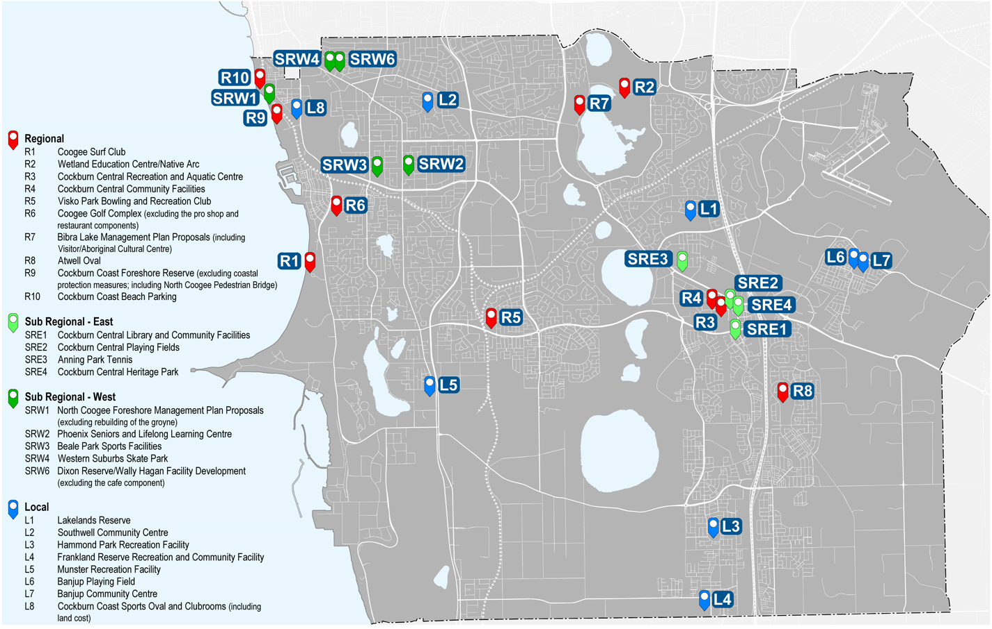

Map depicting the infrastructure items

Bicycle Network Plan (note: this is and edited map which excluded segment of path not covered in DCP13

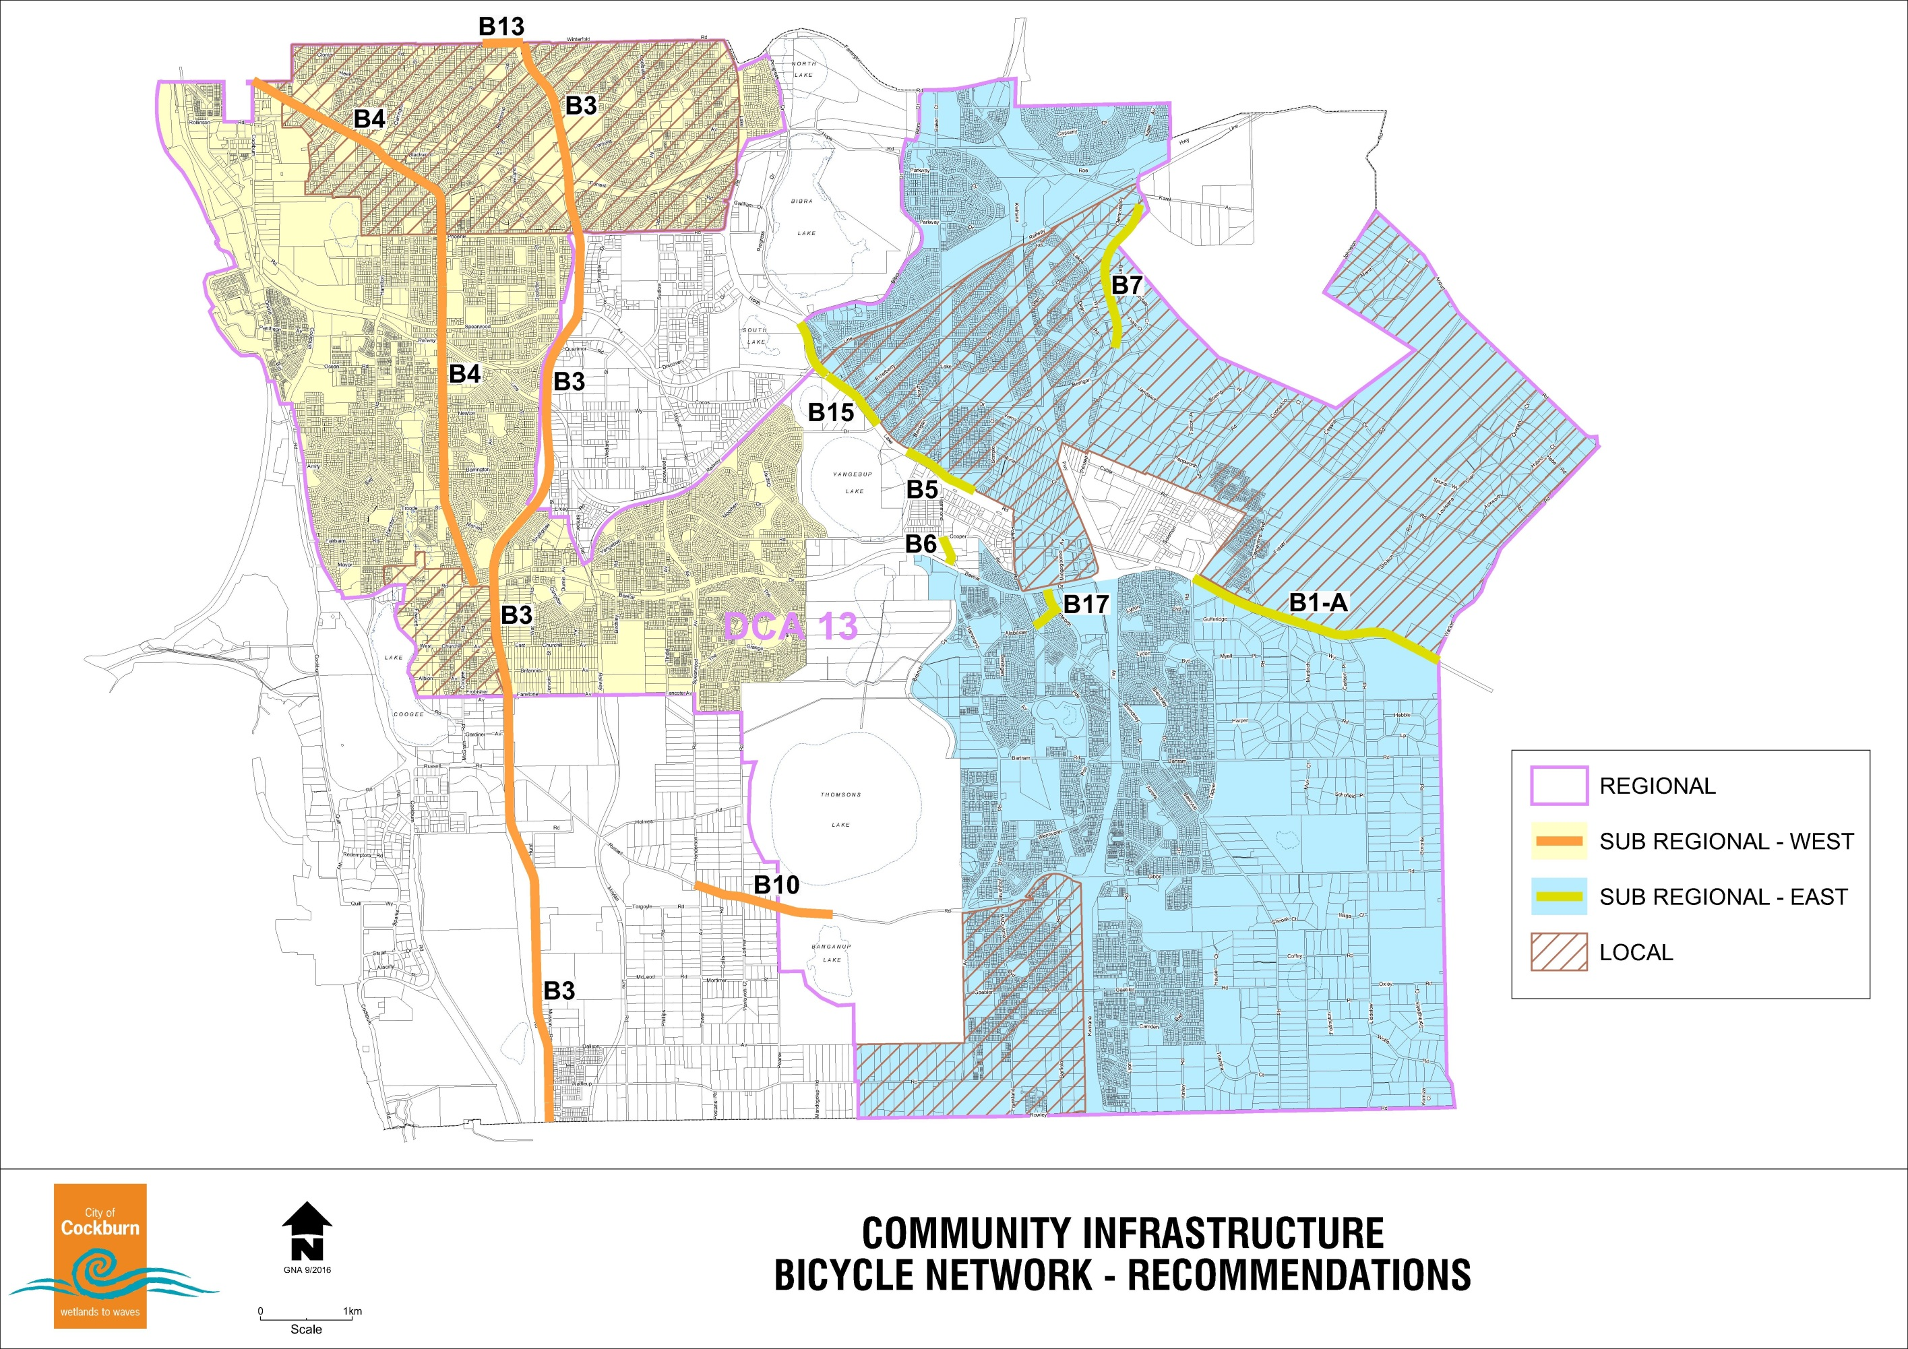

# Annex 2 – Cost Apportionment Schedule (CAS)

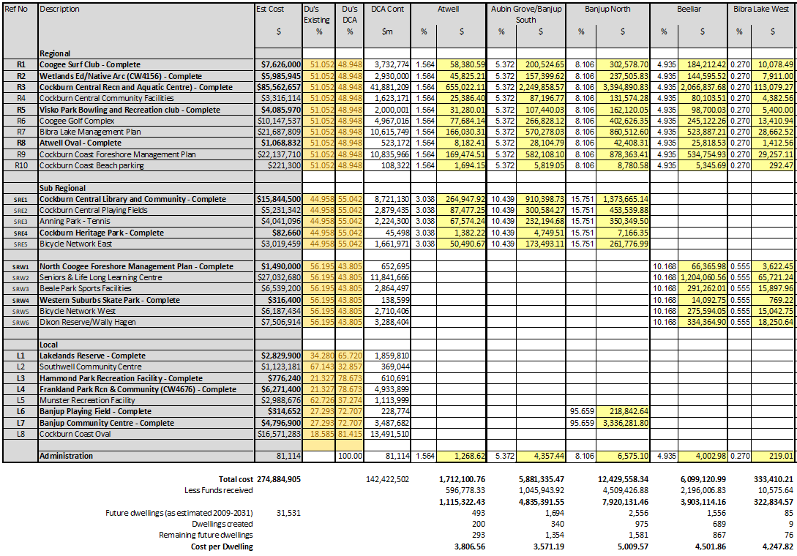

Table 1 Summary Sheets

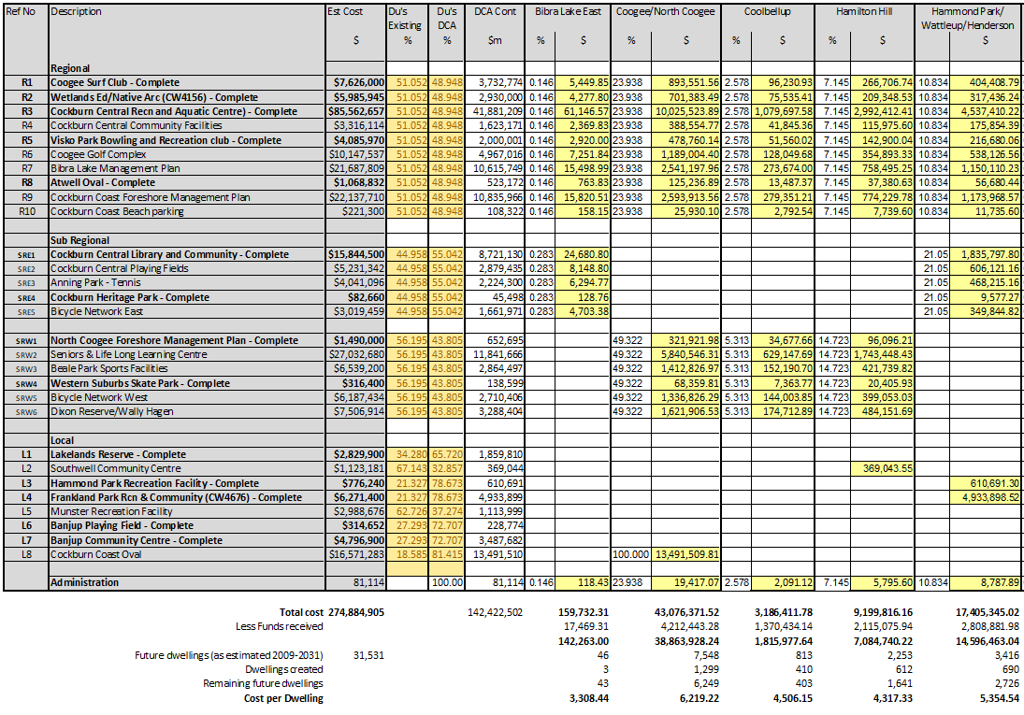

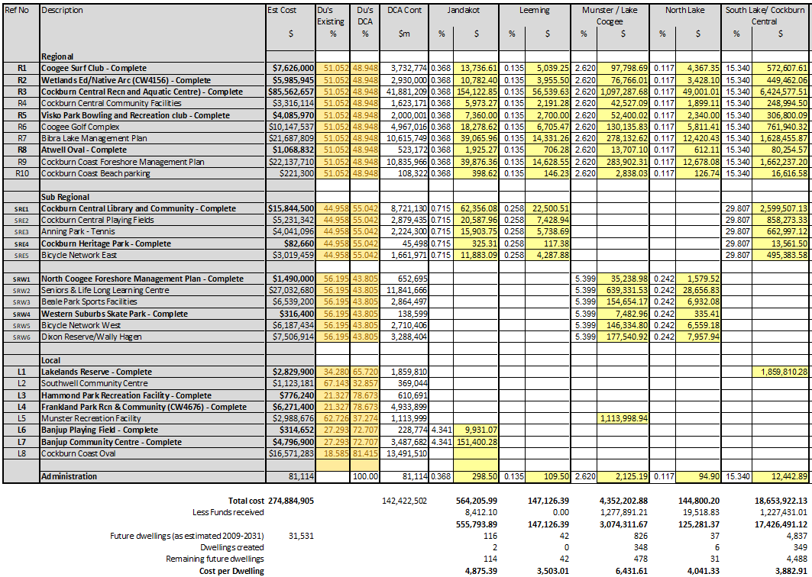

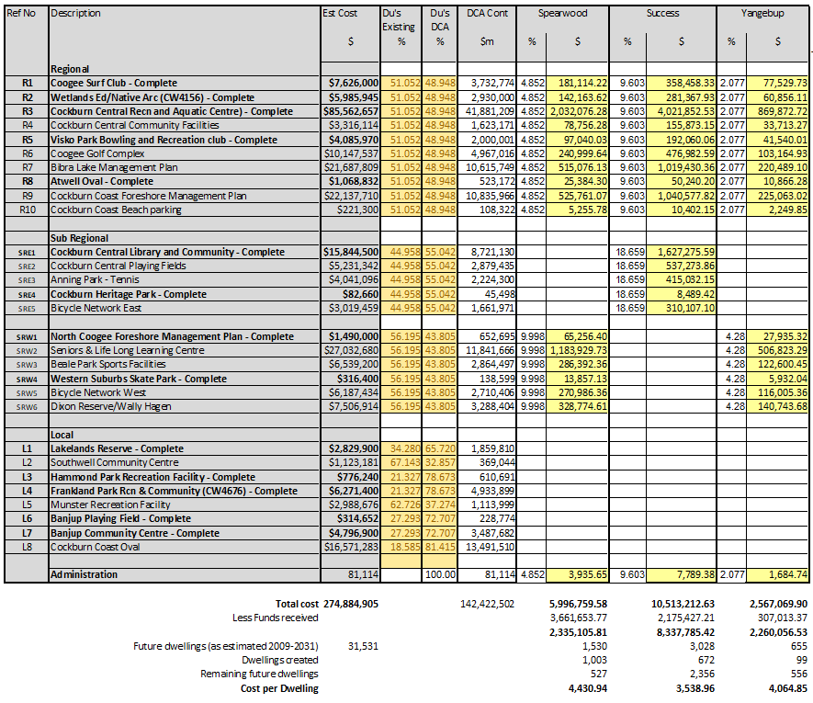

|  |  |
| --- | --- |
| **Suburbs** | **$ per lot/dwelling rate**  **as of October 23** |
| Atwell | $3,806.56 |
| Aubin Grove/Banjup South | $3,571.19 |
| Banjup North / Treeby | $5,009.57 |
| Beeliar | $4,501.86 |
| Bibra Lake West | $4,247.82 |
| Bibra Lake East | $3,308.44 |
| Coogee / North Coogee | $6,219.22 |
| Coolbellup | $4,506.15 |
| Hamilton Hill | $4,317.33 |
| Hammond Park / Wattleup / Henderson | $5,354.54 |
| Jandakot | $4,875.39 |
| Leeming | $3,503.01 |
| Munster / Lake Coogee | $6,431.61 |
| North Lake | $4,041.33 |
| South Lake / Cockburn Central | $3,882.91 |
| Spearwood | $4,430.94 |
| Success | $3,538.96 |
| Yangebup | $4,064.85 |

Table 2 Contribution rates per suburb

# Annex 3 – Infrastructure Sheets

**Regional Facilities - All Suburbs**

|  |  |
| --- | --- |
| **R1 Coogee Beach Surf Club - Complete** | |
| **Description** | This will be the sole facility to serve the needs of existing and future residents within the whole of the City of Cockburn. |
| **Proposal** | This is the original scope of works on gazettal of the item, scope of items might expand over time, but the expanded scope is not covered by DCP.  To develop an integrated surf club and community facility at Poore Grove Coogee that satisfies the needs of the Coogee Beach Surf Life Saving Club, provides for increased beach access and facilities for the growing population of the city and incorporates community facilities.  The proposed development will be undertaken in stages and includes site works, servicing infrastructure extension, construction of a 2000 (m2) two (2) story building, a main car parking area and beach access ways, grassed areas with public facilities and an overflow car park area. |
| **Need and Nexus** | The Department of Sport and Recreation’s Decision-Making Guide 2007 cites an example from the North Metropolitan Region Recreation Advisory Committee (NMRRAC) for facility provision needs based on a population of 100,000. The ratio indicated for surf lifesaving clubs is 1.07.  Translating this ratio to Cockburn’s projected growth; this would indicate at least one surf club is warranted at the regional level. It is also noteworthy that the Australian Sports Commission’s Participation in Exercise, Recreation and Sport Survey 2009 (WA) indicates participation rate of 2.9% for surf sports. To put this in context, AFL has a participation rate of 3.9%.  Development of a new facility at Poor Grove will satisfy the current and future needs of the club enabling it to grow with the increase in population within the city. The development at Poore Grove will also include community facilities available to the wider community as well as providing much needed beach access to relieve Coogee Beach and John Graham Reserve. |

| **R2 Wetlands Education Centre/Native Arc - Complete** | |
| --- | --- |
| **Description** | This will be the sole environmental education and wildlife care facility to serve the needs of existing and future residents within the whole of the City of Cockburn. |
| **Proposal** | This is the original scope of works on gazettal of the item, scope of items might expand over time, but the expanded scope is not covered by DCP.  The Wetlands Education Centre and Native Arc operate out of a few buildings located along Hope Road, Bibra Lake. The local scout group also uses the Wetland Education buildings. The building occupied by Native Arc is an old house which is inadequate and past its economic life.  It is proposed to establish an integrated environmental facility at Bibra Lake which serves the environmental education and animal welfare needs of the City and is suitable for the ongoing use by the Scouts.  The proposal includes buildings for Native Arc, a new shed to accommodate vehicles and equipment, an extension to the existing Wetlands Education Building, additional parking for 50 vehicles and new pathways. |
| **Need and Nexus** | There is a demonstrated need for both the Wetland Education Centre and Native Arc. Facilities for the Wetland Education Centre need to be expanded to cope with the additional use generated by the projected increased population within the city whilst the Native Arc building needs to be replaced with a purpose-built structure that is appropriate to the needs and requirements of the Native Arc group.  Usage of the centre will increase as the population of the city grows. It is expected that membership of existing clubs and groups using the facilities will also increase requiring the increase in size and capacity of the centre. |

| **R3 Cockburn Central Recreation and Aquatic Centre - Complete** | |
| --- | --- |
| **Description** | This will be the sole Recreation and Aquatic Centre to serve the needs of existing and future residents within the whole of the City of Cockburn. |
| **Proposal** | This is the original scope of works on gazettal of the item, scope of items might expand over time, but the expanded scope is not covered by DCP.  To construct a new multi-functional recreation facility that includes a suite of aquatic and related recreation facilities. The building would be approximately 10,000m2 with parking for approx. 300 vehicles.  The land is currently owned by the Western Australian Planning Commission and will need to be acquired or the subject of a long lease to the city. |
| **Need and Nexus** | The current site (South Lake Leisure Centre) on which the current facility is located is almost fully developed and is a major constraint for redevelopment/expansion. The fact that the city does not own the land on which the facility has been constructed further limits development potential and is a cause for uncertainty regarding the long-term access to the site by the City of Cockburn.  It is proposed to construct a new multi-functional aquatic and recreational facility at Cockburn Central on land to the west of Midgegooroo Drive and south of North Lake Road. The site is only a short walk from the Cockburn Central train and bus interchange and is therefore readily accessible by public transport from the whole district thus making it easier and more convenient to access for students, elderly and persons who do not drive to access the facility. The site is also well served with road access being on the major arterial road network that conveniently connects to the whole district. A major advantage of the site is that it is located adjacent to the area being promoted by the city for a major sporting stadium which, if realised, could generate significant synergies.  The new facility will include an expanded range of facilities including a larger gym, meeting facilities and indoor and outdoor pools required to meet the needs of the growing population and to meet user expectations. |

| **R4 Cockburn Central Community Facilities** | |
| --- | --- |
| **Description** | This development will serve the needs of the whole of the city providing by either providing specific services not available elsewhere in the city or similar services in a location that is more convenient and easily accessible. |
| **Proposal** | This is the original scope of works on gazettal of the item, scope of items might expand over time, but the expanded scope is not covered by DCP.  The development of a community facility in conjunction with the recreation and aquatic centre at Cockburn Central. The development will include the provision of specialised welfare offices, meeting rooms and function space. The provision of these services on the same site as the recreation facility will optimise parking and create a viable community hub. |
| **Need and Nexus** | Continued residential development in the district requires the establishment of further core community facilities including welfare services and space for meetings and functions. Development of these facilities at Cockburn Central will provide a greater level of service to existing and future residents in the central and eastern portion of the district. |

|  |  |
| --- | --- |
| **R5 Visko Park Bowling and Recreation Club - Complete** | |
| **Description** | The proposed development has been located centrally so that it can serve the whole district. It is not planned to provide any further bowling facilities within the city. |
| **Proposal** | This is the original scope of works on gazettal of the item, scope of items might expand over time, but the expanded scope is not covered by DCP.  To relocate the Cockburn Bowling club from the old premises adjacent to the City’s administration centre to a central location fronting Beeliar Drive Yangebup which can also serve the growing needs of the eastern side of the city.  The proposal is for new 800m2 club rooms with a mix of synthetic and grass greens and car parking. The balance of Visko Park will be upgraded with enhanced landscaping, walkways and public amenities including tennis courts. Acknowledging that the balance of Visko Park forms part of the local public open space for the surrounding residential area, upgrades which would ordinarily be part of local POS (play equipment, seating, barbeques, and pathways other than those connecting the bowling club, tennis courts and car parking) are not part of this DCP item. |
| **Need and Nexus** | The current Cockburn Bowling Club is accommodated in dated facilities adjacent to the City’s administration centre in the western part of the district. The facilities are in poor condition and in need of refurbishment. There is also a need for some of the greens to be provided with a synthetic surface.  The existing bowling club is not well located to be able to serve the eastern portion of the district and whilst the growing residential areas will need such facilities, it is feasible to retain the existing club premises and develop a new facility in the eastern portion of the district. It is more appropriate to develop a new central facility that will serve the needs of the whole district providing for both the current and future needs of the community.  Visko Park is centrally located to the whole district and is readily accessible by car and bus services which connect to both Cockburn Central and the Rockingham Road high frequency service.  The proposal has the support of the bowling club and has been agreed to by the Council. The Western Australian Planning Commission has agreed to the use of a portion of Visko Park for this purpose and the structure plan has been amended accordingly. |

|  |  |
| --- | --- |
| **R6 Coogee Golf Complex** | |
| **Description** | The golf course will attract players from the whole district. |
| **Proposal** | This is the original scope of works on gazettal of the item, scope of items might expand over time, but the expanded scope is not covered by DCP.  To construct a 9-hole public golf course, driving range together with associated buildings and infrastructure on Region Open Space land east of Cockburn Road Coogee. The complex will include club facilities, restaurant, pro shop, maintenance shed and a car park which will be accessed off Cockburn Road. Note the pro shop and restaurant are not part of the DCP and costs reflect this. |
| **Need and Nexus** | The Department of Sport and Recreation’s Decision-Making Guide (2007) cites an example from the North Metropolitan Region Recreation Advisory Committee (NMRRAC) for facility provision needs based on a population of 100,000. The ratio indicated for golf clubs (municipal) is 0.89. The ratio for golf clubs (private) is 1.96.  Translating this ratio to Cockburn’s projected growth, this would indicate at least one municipal club is warranted at the regional level as well as two private clubs. It is also noteworthy that the Australian Sports Commission’s Participation in Exercise, Recreation and Sport Survey 2009 (WA) indicates participation rates of 6.3% for golf. To put this in context, AFL has a participation rate of 3.9%. This is consistent with the national results which indicated golf as having the highest club participation rate of club-based activities, with AFL as second.  The only course available within the city is Glen Iris which is privately owned. The demand for golf facilities will increase with the increased development within the city. A general ratio for the provision of a golf course for every 30,000 persons. On that basis alone the forecast increase in population justifies a further 18 holes. The need is further justified because some time in the future, the Fremantle 9-hole public course will be adversely affected by the widening of High Street reducing that course to par 3 and reducing its capacity by some 25%.  The above demonstrates the need for the golf course to service both the existing and future population within the district. Additionally, the course will provide local employment, increased visual amenity of a highly degraded area, provide much needed local restaurant facilities and make use of water from the Port Coogee intercept drain. |

|  |  |
| --- | --- |
| **R7 Bibra Lake Management Plan Activities** | |
| **Description** | Bibra Lake is located centrally within the city and, due to its attractions; it is visited by people from all suburbs, not just those in proximity. The planned works will expand the range of facilities available increasing the attractiveness of the area and thus reinforce the regional status of Bibra Lake. |
| **Proposal** | This is the original scope of works on gazettal of the item, scope of items might expand over time, but the expanded scope is not covered by DCP.  It is proposed to undertake a range of works which includes the upgrading of the existing picnic area and the provision of new and additional facilities such as playgrounds, table settings, shade structures, gazebos, BBQ, toilets, exercise circuit, skate park, dual use paths and tracks, board walks, lookouts, lake edge promenade, interpretive signage and artwork, entry statements, traffic calming and construction of a visitor centre.  The works which are consistent with this DCP item are described in the Bibra Lake Landscape Plan, Recreation and Environmental Management Plan 2009.  A revision to this plan has been undertaken since gazettal of DCP13 and items which have substantially changed are either:   * excluded from what the DCP contributes to, or * only fund to the extent of their original proposal. |
| **Need and Nexus** | There is a need to provide for the passive needs of the existing and future community which includes walking, cycling, picnicking, and enjoying nature.  Bibra Lake is recognised as one of the prime areas in the city for passive recreation and accordingly is well used. The proposed works build on and expand the existing infrastructure at Bibra Lake and will provide further capacity for the growing population to use the area without overcrowding or significant environmental impact. The environmental values of the area will be significantly enhanced through planned bushland and wetland rehabilitation, interpretive signage, and a visitor information centre. |

|  |  |
| --- | --- |
| **R8 Atwell Oval - Complete** | |
| **Description** | With two senior size football ovals the reserve currently hosts the City’s largest junior football club in the winter shared with softball, and during the summer months accommodating T‐ball and softball. Atwell Oval is one of the more heavily utilised reserves within the city. |
| **Proposal** | This is the original scope of works on gazettal of the item, scope of items might expand over time, but the expanded scope is not covered by DCP.  The Sport and Recreation Strategic Plan 2009 discusses options for this site:  Short term - current use of football, upgrading of clubrooms/car parking to include junior cricket  Long term - either retain current use OR repurpose to a dedicated hockey facility  Since the publication of the SRSP 2009 it has been confirmed this site will not be used for a dedicated hockey facility, the current use will be retained and the DCP costs will reflect this.  The SRSP 2009 describes the following short-term upgrades to this existing facility:   * Extension of club room area to accommodate Senior Football Club and allow for Junior Cricket (this would involve extension to the existing club rooms, additional change rooms, cricket pitch, practice nets) * Parking upgrade to resolve existing issues.   It should be noted, as the parking is an existing problem (described as ‘inadequate’ in the SRSP 2009 the DCP will only contribute proportionally to the car parking created by the clubroom addition proposed. If additional parking is to be provided on the reserve, the car parking strategy should clearly establish the amount (shown as ‘E’ and ‘F’ below) as follows:   |  |  |  | | --- | --- | --- | | Description of parking | Bays (bitumen) | Bays  (overflow) | | Current development (as at 2009) - underprovided | 40 | 100 | | Current development (as at 2009) to meet expectations | A | B | | Proposed development requirement  (With clubhouse addition complete) | C | D | | DCP component | E  = (C-A) | F  = (D-B) |   Noting there may be site constraints, there may be no option to construct additional parking on the reserve. If this is the case, then it should be assumed that when the clubroom upgrades are completed, this project (as far as it is considered a DCP13 item) is completed. |
| **Need and Nexus** | The SRSP (2009) notes the WACA released a strategic plan for cricket in the Metro area and Cockburn had been identified to experience growth in the coming years. To ensure cricket is serviced according to growth, several actions were identified for the city, including:   * Introduction of junior club in central ward (2013‐2015) * relocation of Jandakot Junior Cricket Club to Atwell Oval (2010) * allocation of multiple overflow facilities to suit cricket needs (2010) * introduction of senior club in east ward (2011‐2013)   The SRSP 2009 also notes for Atwell Oval:   * Possible development of major Hockey Facility that would include both synthetics and grass fields with partnership approach with DET (depends on Cockburn Central Development).   As noted in the description of the proposal (section above) it has since been determined this site will not be repurposed to be a dedicated hockey facility, the current use will remain.  The facility audit contained in the SRSP (2009) notes the existing facility is used for senior and junior level. It has inadequate car parking (40 bays bitumen, 100 bays overflow) it is floodlit (to standard) and the potential upgrades are described (these are included in the scope set out above). |

|  |  |
| --- | --- |
| **R9 Cockburn Coast Foreshore Reserve (excluding coastal protection measures)** | |
| **Description** | Enhancements to the Foreshore Reserve to activate the public open space and provide efficient and sustainable access to the beach. |
| **Proposal** | This is the original scope of works on gazettal of the item, scope of items might expand over time, but the expanded scope is not covered by DCP.  The purpose of the foreshore enhancements is to activate the foreshore and beach and enhance the experience, quality, and safety of the foreshore area.  The upgrades are proposed for the foreshore reserve area (shown in Figure 5). They are divided into two typologies: A and B, with the latter being a less intensive level of development. The conceptual areas of these are set out in the table below and these should inform costing estimates until such time as detailed plans are undertaken. Detailed plans should generally accord to the level of intensity intended for each foreshore reserve area (set out in the lists below). Embellishments which are beyond this will be outside the scope of this DCP item.  There are also two pedestrian bridges over the railway line (located at Neighbourhood Park 1 and Local Park 5 respectively).  This DCP item is unique, with the ability to ‘build to cost’ and in considering the inclusion of this item City officers required a ‘cap’ of the total costs of this item to be not more than $18M (from 30 June 2016, this ‘cap’ may be indexed to CPI annually).   |  |  |  |  | | --- | --- | --- | --- | | Figure  code | Description | Area (m2) | Length (m) | | FRA1 | Foreshore reserve (type A) 1 - Robb Jetty Plaza and parkland | 6,983 | - | | Foreshore reserve (type A) 1 - prefabricated toilet block at Robb Jetty | (item) | | | FRA2 | Foreshore reserve (type A) 2 – McTaggart Cove parkland | 29,353 | - | | pedestrian bridge over railway | (item) | | | FRA3 | Foreshore reserve (type A) 3 – Catherine Point foreshore park | 5,751 | - | | Foreshore reserve (type A) - lighting |  | 560 | | Foreshore reserve (type A) 2 – drainage (N1) rate/m3 | 3,500 | - | | FRB1 | Foreshore reserve (type B) 1 – low intensity areas | 42,668 | - | | FRB | Foreshore reserve (type B) – high intensity areas (boardwalks and surrounds) | 4,000 | - | | Lighting for foreshore path | - | 1,485 | | FRB2 | Foreshore reserve (type B) 2 – medium intensity areas | 10,718 | - | | pedestrian bridge over railway | (item) | |   **Foreshore Type A**  Robb Jetty Plaza & Parkland   * Minor earthworks and drainage * Rehabilitative dunal planting works * Irrigated planting and trees * Irrigated turf * Decking * Paved areas (stone and concrete pavers) * Footpaths (in-situ, concrete, stabilised gravel) * Skateable landscape * Furniture (benches, shelters, bins, bike racks, water fountains, outdoor * showers, BBQ’s) * Plaza lighting * Foreshore Reserve Path (shared path in red asphalt) and Lighting * Toilets   McTaggart Cove Parkland   * Minor earthworks and drainage * Rehabilitative dunal planting works * Irrigated planting * Irrigated turf * Timber decks * Paved areas (stone and concrete pavers) * Footpaths (in-situ, concrete, stabilised gravel) * Skateable landscape * Furniture (benches, shelters, bins, bike racks, water fountains, outdoor * showers, BBQs) * Custom and proprietary play equipment * Youth recreation area (half ball court) * Lookouts * Foreshore Reserve Path (shared path in red asphalt) and Lighting * Pedestrian Bridge (over rail)   Catherine Point Foreshore Park  (In addition to the North Coogee Foreshore Management Plan)   * Irrigated planting * Furniture (benches, shelters, bins) * Foreshore Reserve Path (shared path in red asphalt) and Lighting * Skateable landscape   **Foreshore Type B**  Low Intensity Landscape Areas   * Minor earthworks and drainage * Minor clearing of weeds and vegetation * Rehabilitative dunal planting works * Footpaths (sand, in-situ concrete, stabilised gravel) * Skateable landscape * Foreshore Reserve Path (shared path in red asphalt) and Lighting   Medium Intensity Landscape Areas   * Minor earthworks and drainage * Extensive unirrigated planting * Limited irrigated planting * Limited irrigated turf * Footpaths (in-situ concrete) * Skateable landscape * Furniture (benches, shelters, bins) * Foreshore Reserve Path (shared path in red asphalt) and Lighting * Pedestrian Bridge (over rail)   High Intensity Landscape Areas   * Minor earthworks and drainage * Minor clearing of weeds and vegetation * Irrigated planting * Decking * Lookouts * Footpaths (in-situ concrete, stabilised gravel) * Skateable landscape * Furniture (benches, shelters, bins, bike racks, water fountains) * Foreshore Reserve Path (shared path in red asphalt) and Lighting   The foreshore proposals exclude coastal intervention and protection measures. |
| **Need and Nexus** | The Community Development Plan (2012) prepared by Place Partners identifies that other additional community infrastructure is necessary to support the future Cockburn Coast population and wider community.  The Cockburn Coast foreshore will be a popular beach and attraction within the City of Cockburn. There is limited coastal foreshore within the City of Cockburn and the Cockburn Coast Foreshore represents one of the best beaches in the municipality. Enhancing portions of the foreshore to enable recreational activity and provide a high-quality aesthetic on the beach will establish a key community focal point, particularly during the initial phases of development. The enhancement of foreshore areas will provide opportunities for the community to interact and encourage accessibility and activity on the coast. The level of enhancements to the foreshore will vary to provide passive and active recreational activities whilst maintaining the conservation value of the foreshore.  The foreshore is currently reserved under the Metropolitan Region Scheme for Parks and Recreation given its regional importance. A central objective of WAPC’s Liveable Neighbourhoods in the provision of public parkland is to ensure there is the provision of adequate land to protect and to provide public access to ocean foreshores. The Foreshore Reserve is fundamental in ensuring the access to the ocean is well designed and of a high level of amenity to service the recreational and social needs of the community. The circulation to and from the beach and movement north-south will be improved with an enhanced dual use path, decked boardwalks, and lookouts for views to the ocean.  The Cockburn Coast Foreshore Management Plan outlines that the success of the Cockburn Coast development will rely in part on the success of the foreshore as a focus of community activity and recreation. The foreshore needs to balance emphasis on the conservation of its natural elements with the provision of a vibrant and activated community space. It should be noted that the foreshore proposals exclude coastal intervention and protection measures.  Use of the facilities along the coastal strip will increase as population in the catchment grows. Current facilities such as Coogee Beach are already heavily used and there is a need to provide additional areas to ensure that aquatic and active uses such as cycling and passive needs including picnic areas are met.  The proposed development at Cockburn Coast is an integral and essential component of facilities required to satisfy the ultimate demand.  The foreshore area adjacent to the Robb Jetty remains and the Main Street location is proposed to be developed into a plaza. Robb Jetty will be a high quality flexible urban space catering for large community events such as outdoor performances and markets.  Community facilities focusing on multiple user needs will encourage diversity while retaining and enhancing the areas heritage, both Nyungar and European. The plaza will cater for activities such as markets, alfresco dining, concerts, outdoor cinema, performances, and seasonal festivals to attract people of all ages, ethnicities, and cultures.  McTaggart Cove builds on the existing recreational facilities to provide a key location for those wanting ‘green space’ facilities such as ‘kick about’ areas, BBQs, picnic areas, car parking and playgrounds. A pedestrian bridge is proposed across the rail line to allow access from the existing activity node, and future primary school at McTaggart Cove to the Foreshore Reserve. A second pedestrian bridge will be located from the east-west public open space providing access across the rail line to the Foreshore Reserve in the northern portion of the project area.  Additional foreshore enhancement is proposed at Catherine Point (beyond the North Coogee Foreshore Management Plan proposals). Further enhancement to this location (including irrigated planting, seats, shelter, lighting, and paths) is required in recognition of the scale and intensification of development proposed in this location. Given the project area’s coastal location, mixture of uses and scale of redevelopment proposals, the Cockburn Coast project will attract visitors from outside of the project area. The enhanced accessibility to the foreshore and encouragement of passive and recreation opportunities will attract residents from eastern suburbs within the City of Cockburn and contribute to the health and wellbeing of all residents. Together with the scale of retail and other active uses planned within the Cockburn Coast, the foreshore and nearby activities will be an important recreational asset and focal point for the entire City of Cockburn community. |
| R9 Cockburn Coast Foreshore Reserve indicating foreshore types | |
| **R10 Cockburn Coast Beach Parking – Partially Compete**  **(Area west of Bennett still required costings)** | |
| **Description** | Beach parking to service the Foreshore Reserve and beach. |
| **Proposal** | This is the original scope of works on gazettal of the item, scope of items might expand over time, but the expanded scope is not covered by DCP  Construct 90 degree on street parking along the northern side of the road running parallel with the linear east-west running public open space. A range of parking limits (up to 4 hours) is proposed to improve the activity and vitality of the area and to discourage long term parking. |
| **Need and Nexus** | The Foreshore Reserve and beach are a central element of the project area providing a focal point of community activity and recreation. Beach car parking is necessary at the site to ensure the Foreshore Reserve and beach can be accessed and used by the wider community. Further the local structure plans for Cockburn Coast promote alternative travel modes other than private vehicle use. Despite this, a number of parking areas are required for visitors to the area wishing to access the foreshore. These bays will be strictly for public use only and not for commercial patrons. These bays will allow for access to the many recreational amenities that span the coast.  The quantity of beach parking is limited to promote active and public transport; to reduce greenhouse gas emission, reduce the amount of time spent travelling in private motor vehicles and to increase household affordability, which are central objectives of the projects’ Integrated Transport Plan. The beach parking has been identified on the east side of the freight rail due to traffic management considerations associated with the signalised rail crossing(s) and resultant cueing impacts on the local road network. |

**Sub Regional East**

|  |  |
| --- | --- |
| **SRE1 Cockburn Central Library and Community Facilities - Complete** | |
| **Description** | The proposed library and community facilities will service the population on the eastern side of the district. |
| **Proposal** | This is the original scope of works on gazettal of the item, scope of items might expand over time, but the expanded scope is not covered by DCP  Construct a library and community facilities on Council owned land located at the intersection of Wentworth Parade and Beeliar Drive Success. The library will initially comprise 1500m2 with an additional 500m2 for community meeting rooms. As residential development in the catchment occurs and demand increases the library will be expanded to occupy the full 2000m2. |
| **Need and Nexus** | Success Public Library the third branch of the City of Cockburn Public Library & Information Service is to be constructed on the public purpose site in Wentworth Avenue, Success. This site is adjacent to and near Cockburn Gateway Shopping City. It will share the site with a Commonwealth Government supported ‘Super Clinic.’ The library will replace the very small Success (shopfront) Public Library that is located within the shopping centre.  The library is to serve the localities situated in the eastern part of the City of Cockburn. Existing library facilities except for the tiny Success shop front library (250m²) are situated in the western part of the city. These libraries are approximately six and ten kilometers away respectively and while accessible by private vehicle are not especially well linked by frequent public transport.  In addition, the standard for library space for the community of the size that Cockburn will be by 2021 (approximately 116,000 inhabitants) suggests a total library floor space of not less than 28m² per one thousand people. Based on this conservative figure the floor space required for the whole of the city should be no less than about 3250 m². |

|  |  |
| --- | --- |
| **SRE2 Cockburn Central Playing Fields** | |
| **Description** | The proposed playing fields will service the population on the eastern side of the district. |
| **Proposal** | This is the original scope of works on gazettal of the item, scope of items might expand over time, but the expanded scope is not covered by DCP  To develop multipurpose playing fields and associated car parking and change rooms on land south of North Lake Road adjacent to the proposed recreation and aquatic centre. It is proposed to develop a football oval, soccer pitch, 6 multipurpose courts, change rooms and club room facilities (1000m2) with parking for approx. seven hundred cars.  Provision is for junior and senior clubs. |
| **Need and Nexus** | AFL football and soccer are the most popular sports within the city. The Western Australian Football Commission predicts future membership on a percentage of approximately 25% of the male population aged between 5-17 playing for a local club whilst Football West expects a 7% increase in the membership of soccer clubs in the southwest zone of Fremantle, Melville, Cockburn, and Kwinana from now till 2031.  Currently the provision of active reserves within the City is well below that of other local governments. Within Cockburn the provision is 1.14 ha/1000 persons compared to 1.38ha for Melville, 1.69ha for Joondalup and 1.66ha for Gosnells. This deficiency results in heavy utilisation of grounds particularly for football and soccer and accordingly there is a need for additional active sports grounds to meet the needs of the growing community. This is particularly the case in respect to the eastern portion of the district where major growth is forecast and the overall provision of area active sports per capita is lower than elsewhere within the City.  The provision of the Cockburn Central complex is an integral and essential part of the overall strategy of meeting the projected sporting needs of the eastern portion of the district. |

|  |  |
| --- | --- |
| **SRE3 Anning Park Tennis** | |
| **Description** | Anning Park is in the suburb of South Lake and is approximately 6ha in total with active reserve space at approximately 2ha. The reserve currently provides senior football in the winter and is a cricket overflow ground for both junior and senior cricket in the summer. |
| **Proposal** | This is the original scope of works on gazettal of the item, scope of items might expand over time, but the expanded scope is not covered by DCP.  To redevelop with appropriate change rooms and car parking on Anning Reserve, North Lake Road South Lake. The building will be approximately 700m2 including facilities for sporting clubs (with possible alternate sport uses to current provision of football and soccer or conversion to more passive use). |
| **Need and Nexus** | The SRSP (2009) notes Anning Reserve is currently an active reserve which hosts Football in winter and soccer in summer. The reserve is predominantly owned by the State Government under Management Order, with a portion of land (1.4 hectares) owned as freehold land.  It also acknowledges with the development of Cockburn Central and active reserve space less than five hundred meters from Anning Park, there is an opportunity to develop Anning Reserve for an alternative use (both bowls and tennis were discussed as possibilities).  An important mention in the SRSP (2009) applies to Anning Park. Reserves that are small or near other active reserves should be identified and the future need and likely usage assessed. Those reserves that are unable to meet the needs of sport clubs into the future should be either developed for passive purposes, alternate sport purposes or alternate uses depending on the classification and zoning of the reserve.  Development of current active reserve space to a major facility to service the Eastern Sub-region was provided for in the SRSP (2009) at that time a notional cost indicated was $3 million. |

|  |  |
| --- | --- |
| **SRE4 – Cockburn Central Heritage Park - Complete** | |
| **Description** | Due to its size and location, the proposed heritage park will primarily serve the needs of residents in the eastern portion of the district and will complement the regional facilities at Bibra Lake and Manning Lake. |
| **Proposal** | This is the original scope of works on gazettal of the item, scope of items might expand over time, but the expanded scope is not covered by DCP.  Located within the Cockburn Central West (‘CCW’) development area, a ‘Memorial Walk’ will reflect heritage values appropriate to the Eastern Sub-region (such as Australia’s participation in various theatres of war, peacekeeping forces, United Nations representatives, Police, FESA and other endeavors deemed appropriate for recognition and/or reflecting Aboriginal heritage).  This (universally accessible) walk trail may connect to other elements within the development area, such as the public open space and public art installations, however these are not covered by this DCP item.  The walk trail may include the trail/pathway itself, interpretive signage of physical of manmade features along the trail, or visible from the trail where they recognise matters of related to the trail’s purpose. This does not include signage for commercial purposes, wayfinding to features which are not part of the trail (such as the aquatic centre). Consolidation of the interpretative signage is recommended where possible.  An open grassed area where recognition ceremonies could be held, barbecue areas, and seating may also be provided for within the scope of this item. This should be in addition to those which would ordinarily be provided for as part of the embellishment of the local public open space.  The proposal does not include land costs and it will make use of the public domain created by the development of CCW. |
| **Need and Nexus** | This project was discussed in the Plan for the District as recognising there were areas of high conservation and heritage value in the Cockburn Central reserve.  This project seeks to preserve these areas as well as develop some of the POS for community use. The site’s Aboriginal heritage would also be recognised. Reference was made to a 10ha site of landscaped POS with boardwalks and public amenities (e.g., BBQ and play equipment). Originally this was described as a $3 million proposal.  With the subsequent development of the Cockburn Central West structure plan, which has included an environmental assessment and POS analysis of the adjacent town centre development also, it has been established through the applicant’s proposal and the WAPC’s approval, that:   * The 10ha parcel originally deemed to be retained was not required, it would be reduced to 2.5ha (containing the wetland/drainage area) * The 2.5ha parcel forms part of the 10% POS requirement for both the CCW and town centre development to the east. * The 2.5ha parcel would be embellished as that area’s local open space.   Within the development area, there was still opportunity to provide this item (but at a reduced scope) still in line with the intent of the proposal in the form of a ‘Memorial Walk’ trail which could reflect heritage values such as Australia’s participation in various theatres of war.  Whatever values are reflected they should draw an Eastern Sub-region catchment, not simply the suburb or development level catchment. |

|  |  |
| --- | --- |
| **SRE5 Bicycle Network East** | |
| **Description** | The proposed works are in the area east of the central wetland chain and will primarily serve residents in that area as opposed to the whole district. |
| **Proposal** | This is the original scope of works on gazettal of the item, scope of items might expand over time, but the expanded scope is not covered by DCP.  To construct a comprehensive and complete bicycle path network that connects to major attractors within the area and is suitable for both recreational and commuter cyclists. The location of the proposed works is in accordance with the adopted Strategic Bicycle and Footpath Plan and is shown on Plan 2 in Appendix 5. The scope and segments of the Plan are:   |  |  |  | | --- | --- | --- | | Segment | Description | Scope | | B1-A | Armadale Rd SUP | Extension of a shared use path along southern side of Armadale Rd from Tapper Rd to the City’s boundary with the City of Armadale | | B5 | North Lake Rd | Marking of the existing path as a SUP on the northern side of North Lake Rd from Semple Court to Berrigan Drive | | B6 | Hammond Rd | Construction of a shared use path along the northeast side of Hammond Rd between Yangebup and Russell Rd, includes new bitumen seal path, signage, and line marking. | | B7 | Berrigan Drive | Construction of a shared use path on Berrigan Drive between Mason Rd and Roe Highway, includes new bitumen seal path, signage, and line marking. | | B15 | Extension of SW34 | Extension (600m) of PBN route SW34 along North Lake Rd to the Lakes Shopping Centre | | B17 | Realignment of SE41 | Realignment of PBN route SE41 |   The works subject to the DCP exclude components of the project which are to be provided through other means: existing subdivisions approvals, other DCA, or have already been constructed (prior to DCP13’s gazettal). |
| **Need and Nexus** | Cycling is an important mode of transport which will increase over time due to population growth and the need to provide a viable alternative to car use for shorter trips.  There is an identified need for an expanded and complete bicycle network throughout the eastern portion of the district to cater for the need of the cyclists. As the population grows there will be greater demand and use of the network. It also needs to be expanded into the developing areas. |

**Regional - Western Suburbs 1**

| **SRW1 North Coogee Foreshore Management Plan - Complete** | |
| --- | --- |
| **Description** | The proposed development will primarily benefit residents in the western coastal suburbs who, due to their proximity and reasons of convenience, are the major regular users of coastal facilities. |
| **Proposal** | This is the original scope of works on gazettal of the item, scope of items might expand over time, but the expanded scope is not covered by DCP.  This project covers approximately 9.5ha of coastal foreshore at North Coogee.  Stage one of this project involving contaminated site remediation and revegetation of the dunes was completed in 2009. A further two stages are planned which includes rebuilding of the groyne for beach stabilisation and the creation of additional public open space along the foreshore and public amenities. Note: the rebuilding of the groyne does not form part of the DCP (and costs reflect this), although it is part of the proposed works. |
| **Need and Nexus** | Usage of the facilities along the coastal strip will increase as population in the catchment grows. Current facilities such as Coogee Beach are already heavily used and there is a need to provide additional areas to ensure that the aquatic, active uses such as cycling and passive needs, including picnic areas are met. The proposed development at North Coogee is an integral and essential component of facilities required to satisfy the ultimate demand.  This was described in the Plan for the District as 9.5 ha of passive open space with minor recreation facilities, e.g., shelters and play equipment and included remediation of the dunes. The level of facilities provided will correspond to a western sub-region catchment, rather than be higher order items that would be required in a regional item.  Coastal protection measures such as groynes are not considered ‘community infrastructure’ in line with the direction given by the Minister for Planning when considering approval of this DCP. Therefore, this component of the project must be excluded from the DCP item. |

|  |  |
| --- | --- |
| **SRW2 Seniors and Lifelong Learning Centre** | |
| **Description** | The proposed development will include uses that are required to satisfy the need of residents in the western portion of the district. Due to factors of access and distance, it is unlikely that the centre will attract many people from the eastern portion of the district. |
| **Proposal** | To construction of a multi-functional civic facility including library, welfare services, community hall, meeting rooms and childcare. These uses will occupy approximately 3000m2. The permanent seniors centre to be develop as part of the complex will have an area of approximately 2000m2.  The proposal consolidates several civic facilities which will be part of the development of the Civic precinct. |
| **Need and Nexus** | The number of books and facilities is linked to the population and as the catchment population grows the library will need to expand to meet demand. The Library Strategic Plan clearly recognises the link between population growth and the size of library services and recommends expansion of the Spearwood library.  The proposal has been sized to meet the needs of the ultimate population in the western portion of the city having regard to national standards.  The provision and size of other uses within the development is also related to population size. The integration of these activities into single purpose designed and constructed complex will offer benefits in terms of levels of service and greater value in service provision.  As noted in the City’s Sport and Recreation Strategic Plan (2009), an increase for Cockburn overall in the median age will create a bigger need for senior clubs and more emphasis placed on low intensity recreation activities such as bowls. The Plan notes significant growth in the west ward in the next ten years of persons over 45 years of age and acknowledges there is already an existing older population in this ward. Recommendations for the west ward include merging and/or relocation of senior clubs to address a current over supply and a change in facilities to reduce focus on club facilities and increase focus on facilities to cater for the wider community. An example of such a facility is the proposed seniors and lifelong learning centre for the west ward which would include a library, welfare services, community hall, meeting rooms and childcare comprising 3000m2 and a 2000m2 Senior’s centre.  The current Spearwood Library and Seniors Centre are now quite aged and investment in substantial renovation works to increase their lifespan to 2031 is not considered warranted. Money would be better invested in a new purpose-built facility, where better economies can also be achieved through collocation of facilities. |

|  |  |
| --- | --- |
| **SRW3 Beale Park Sports Facilities** | |
| **Description** | Currently soccer is heavily concentrated in the West Ward with Beale Park being one of the largest and most used active reserves in the city. The Sport and Recreation Strategic Plan proposes to correct this imbalance by providing facilities for soccer at Aubin Grove. Beale Park would remain the main area for soccer in the western portion of the district. |
| **Proposal** | This is the original scope of works on gazettal of the item, scope of items might expand over time, but the expanded scope is not covered by DCP.  The SRSP 2009 describes this proposal as:  Upgrade and refurbishment of the existing club and change rooms as well as upgrades to reserve to accommodate premier league soccer matches. |
| **Need and Nexus** | Beale Park is in the suburb of Spearwood and is approximately 8ha in total with active reserve space at approximately 4ha. The reserve hosts junior and senior soccer in the winter (including a Premier League) and T‐Ball & baseball in the summer. Beale Park is one of the City’s largest reserves that is owned freehold and is one of few reserves that hold large annual sporting events and carnivals. The facilities were constructed in 1975 and have not been extended. They need upgrading and refurbishment to meet current requirements and expectations and to be able to accommodate premier league matches.  Soccer is the second most popular sport within the city with some 906 players. Football West expects a 7% increase in the membership of soccer clubs in the southwest zone of Fremantle, Melville, Cockburn, and Kwinana from now till 2031 due to the increasing population and increasing popularity. Clearly facilities need to be suitable to accommodate that growth and provide for all levels of competition.  The SRSP 2009 audit of the facility noted that the site’s car parking is adequate. This establishes a suitable baseline for upgrading needs (i.e., parking provision does not need to be brought up to standard before the DCA component is proportioned). |

|  |  |
| --- | --- |
| **SRW4 Western Suburbs Skate Park - Complete** | |
| **Description** | Due to factors of access and distance, this facility will only satisfy the needs of the western portion of the district. |
| **Proposal** | This is the original scope of works on gazettal of the item, scope of items might expand over time, but the expanded scope is not covered by DCP.  The Plan for the District described this proposal as:  Construction of a 1,000m2 skate park with adjacent amenities on a reserve readily accessible for young residents living in the western side of the city.  A notional location of Dixon Reserve was indicated as a possible location, though it was not committed to, with the priority being the catchment and the accessibility of a site. |
| **Need and Nexus** | The Department of Sport and Recreation’s Decision-Making Guide (2007) cites an example from the North Metropolitan Region Recreation Advisory Committee for facility provision needs based on a population of 100,000. The ratio indicated for skate parks is 3.57.  Translating this ratio to Cockburn’s projected growth, more than four skate parks would be required City wide. In 2006/07 skate parks were constructed in broad catchment areas across the City However no facility was provided for the suburbs of Coogee, Spearwood, Munster, and Hamilton Hill. The additional skate park is planned to fill this gap in provision.  In 2008 it was estimated that there were upwards of 10,000 people under the age of twenty-five living in the western suburbs who did not have easy and convenient access to a permanent skate facility. That number will significantly increase as further development occurs within the catchment. The size of the facility has regard to the future residential development and growth in the number of potential users. |

|  |  |
| --- | --- |
| **SRW5 Bicycle Network West** | |
| **Description** | The proposed works are in the area west of the central wetland chain and will primarily serve residents in that area as opposed to the whole district. |
| **Proposal** | This is the original scope of works on gazettal of the item, scope of items might expand over time, but the expanded scope is not covered by DCP.  To construct a comprehensive and complete bicycle path network that connects to major attractors within the area and is suitable for both recreational and commuter cyclists. The location of the proposed works is in accordance with the adopted Strategic Bicycle and Footpath Plan and is shown on Plan 2 in Appendix 5. The scope and segments of the Plan are:   |  |  |  | | --- | --- | --- | | Segment | Description | Scope | | B3 | Stock Rd / Rockingham Rd Shared Use Path | Construction of a SUP along Stock/Rockingham Rd between Wattleup Rd and Winterfold (ultimately as part of a route that extends north to Canning Highway in Melville and south to Rockingham, includes new bitumen seal path, signage, and line marking, excludes allowances for grade separation. | | B4 | Rockingham Rd (North) | Construction of either an on-road or off-road facility on Rockingham Rd from Mayor Road to Cockburn Rd | | B10 | Russell Rd | Provision of a SUP on Russell Rd between Henderson Rd and Kwinana Freeway and on Gibbs Rd between Lyon Rd and Kwinana Freeway, includes new bitumen seal path, signage, and line marking. | | B13 | Extension of Winterfold SUP | Provision of pavement markings for the SUP on the northern side of Winterfold Rd from Stock Rd through to Collick St |   The works subject to the DCP exclude components of the project which are to be provided through other means: existing subdivisions approvals, other DCA, or have already been constructed. |
| **Need and Nexus** | Cycling is an important mode of transport which will increase over time due to population growth and the need to provide a viable alternative to car use for shorter trips.  There is an identified need for an expanded and complete bicycle network throughout the eastern portion of the district to cater for the need of the cyclists. As the population grows there will be greater demand and use of the network. It also needs to be expanded into the developing areas. |

|  |  |
| --- | --- |
| **SRW6 Dixon Reserve/Wally Hagen Facility Development** | |
| **Description** | The facility is the current home of the Cockburn Cougars which is a state-based team. While the facility houses a state basketball team, the demand for this sport has been in decline and the upgrades to the facility will refocus this facility toward district fitness needs. |
| **Proposal** | This is the original scope of works on gazettal of the item, scope of items might expand over time, but the expanded scope is not covered by DCP.  Upgrading and a 2500 m2 extension of the existing Wally Hagen Basketball Stadium to include a café, dry side recreation and fitness and sporting club facilities to accommodate overflow sports and toilet/change room facilities.  The proposal also includes two additional car park areas, totaling approximately 124 additional car bays.  Note the café and its seating area does not form part of the DCP item and the costs reflect this. |
| **Need and Nexus** | SRSP 2009 discusses this item in some detail. Dixon Reserve is located next to the Wally Hagan Basketball stadium and is approximately 4 ha in total.  According to the SRSP 2009, the reserve is currently not utilised during the summer or winter months as the playing surface is not up to an active reserve standard. The reserve used form part of a land fill site and investigations have taken place to the development the reserve for sporting purposes, however with the proposed extension of the Wally Hagan Basketball stadium to include gym facilities, the reserve size will be compromised and therefore would not be suitable as an active reserve. The reserve will only be used for passive purposes.  The Wally Hagan Stadium was constructed in 1978 and is owned by the City of Cockburn and leased to the Cockburn Basketball Association. The facility features four Stadium Courts and offers basketball for men, women, and juniors. The facility is the home of the Cockburn Cougars, a State Basketball League team. Competition is offered on Monday and Tuesday nights for Men, Monday night for Women and Tuesday, Wednesday, Thursday, Friday, and Saturday for juniors.  While the facility was heavily utilised through the 1980’s, the development of Lakeside Recreation and the South Lake Leisure Centre combined with the decrease in popularity of basketball has significantly impacted on the utilisation of the stadium. Given the current structure and management of the facility, the Wally Hagan Stadium is unable to diversify the opportunities it offers to attract more people to the facility.  The future of the facility lies in the development of alternative services including a full suite of fitness services to provide opportunities to the community on the western side of the city.  Appendix 3 of the SRSP 2009 is a concept plan for the development of the facility. The items described in that plan as ‘proposed’ reflect the scope of the proposal set out above as far as it forms as DCP item.  In line with the development plan, management of the facility should revert to the City of Cockburn, where synergies between the redeveloped facility and the facility on the eastern side of the city can be achieved. The Cockburn Basketball Association can remain as a tenant, with SBL to continue at the facility under conditions that best suit the wider community. |

**Local - Specific Suburbs 1**

|  |  |
| --- | --- |
| **L1 Lakelands Reserve – Complete** | |
| **Description** | This is a facility is aimed at providing for the needs of the suburbs of South Lake and Cockburn Central. |
| **Proposal** | This is the original scope of works on gazettal of the item, scope of items might expand over time, but the expanded scope is not covered by DCP.  Lakelands Reserve is located on the south side of South Lake Drive between the power lines and the current South Lake Leisure Centre. The reserve has been developed for cricket and football but has no facilities. It is a collocated reserve adjacent to a high school.  As described in the SRSP 2009, it is proposed to construct new sport facilities (i.e., clubroom with associated car park) integrated with the recreational reserve for junior and senior club use. The SRSP (2009) also notes the City should identify and target alternate sport use on Lakelands’s reserve as this site is located on good transport routes. Sports may include Grid Iron, Lacrosse, ultimate frisbee and Gaelic football. |
| **Need and Nexus** | The SRSP 2009 audit of this site indicates it is currently only used for junior sport (overflow), there are no sustainable clubs based here and only has overflow parking (30 bays). With the imminent closure of the South Lake Leisure Centre, this site will need its own facilities if the use of this well-located local site is to be maximised.  A significant increase in the number of dwellings is primarily due to development within the Muriel Court (DA19) Structure Plan Area and Cockburn Central and will result in a significant increase in the population and the demand for recreation services.  The Muriel Court Structure Plan does not include any active open space reserves and accordingly residents in that area will rely on facilities developed at local reserves in the immediate vicinity. It is proposed to develop clubroom facilities on Lakelands’s reserve to satisfy the expected demand. |

|  |  |
| --- | --- |
| **L2 Southwell Community Centre** | |
| **Description** | This is a small local facility that will serve the needs of residents in the suburb of Hamilton Hill. |
| **Proposal** | This is the original scope of works on gazettal of the item, scope of items might expand over time, but the expanded scope is not covered by DCP.  The Plan for the District described the proposal to expand the current sporting clubrooms on Goodchild Reserve and relocate the community Centre into that facility.  This Building extension is described as approximately 300m2, including construction of additional parking for 300 vehicles. It will establish a multi-use community facility, with areas suitable for children’s activities meetings and community events. |
| **Need and Nexus** | The existing Community Centre is located at the end of residential cul-de-sac (Caffery Place) in Southwell. The land is owned by the Department of Housing and Works and is on lease to the city. The facility is old, of poor design and needs total replacement. As the facility is surrounded by residential development, use of the facility is limited.  The proposed development recognises the current population and has regard to providing for the projected growth in the suburbs.  Inclusion of this item is consistent with Section 5.1 of SPP 3.6 which provides that development contributions can be sought for the upgrade in the standard of provision of an existing item of infrastructure and or it has reached the end of its economic life which is clearly the case. |

|  |  |
| --- | --- |
| **L3 Hammond Park Recreation Facility - Complete** | |
| **Description** | This is a local facility comprising a single oval that is aimed at providing for the needs of the suburbs of Hammond Park/Wattleup/Henderson. |
| **Proposal** | This is the original scope of works on gazettal of the item, scope of items might expand over time, but the expanded scope is not covered by DCP.  To construct club and change rooms and a car park on a newly developed active reserve located in Macquarie Boulevard Hammond Park.  The building will have an area of approximately 250m2 and include change rooms, ablutions, and a small kitchen. |
| **Need and Nexus** | The estate developer has developed the playing field together with some play equipment in the northwest corner. It is proposed to provide club rooms so that the reserve can be used for its intended purpose of active sports.  The resultant population will require the development of the Hammond Park Reserve  Hammond Park is expected to have a significant population in the period 2010 to 2031 within the age groups of 0-14 years and 25-45 years. No other active reserve exists in the suburb and currently residents access the active reserve in Success, which caters for rugby and netball.  The City of Cockburn’s Sport and Recreation Strategic Plan identifies the Hammond Park site to be used for junior AFL. |

|  |  |
| --- | --- |
| **L4 Frankland Reserve Recreation and Community Facility - Complete** | |
| **Description** | This is a local facility comprising a single oval that is aimed at providing for the needs of the suburbs of Hammond Park/Wattleup/Henderson. |
| **Proposal** | This is the original scope of works on gazettal of the item, scope of items might expand over time, but the expanded scope is not covered by DCP.  The Plan for the District described this proposal as:   * Construction of new community facilities integrated with the recreational reserve. * This includes a building approximately 450m2, including facilities for sporting clubs and community activities, located on 4 ha of active reserve   The SRSP 2009 also mentions this proposal, as follows:  The reserve is expected to be around 4ha in size that would include facilities to accommodate junior football in the winter and cricket overflow in the summer. |
| **Need and Nexus** | Frankland Reserve will be located in the suburb of Wattleup and will border the Town of Kwinana’s suburb of Mandogalup. Frankland Reserve is not currently developed.  The growing population will require the development of the Hammond Park Reserve and Frankland Avenue Reserve to satisfy the local active sporting and community needs of this area.  The facilities will serve the population of Hammond Park. The suburb has a small active reserve identified (Hammond Park) which will be suitable for limited junior sport (AFL), complementing the activities at Frankland Reserve. |

|  |  |
| --- | --- |
| **L5 Munster Recreation Facility** | |
| **Description** | This is a local facility aimed at providing for the needs of the suburb of Munster. |
| **Proposal** | This is the original scope of works on gazettal of the item, scope of items might expand over time, but the expanded scope is not covered by DCP.  The proposal as described in the SRSP 2009 is to:   * Develop a recreation reserve with requisite change rooms. * Building approximately 1,000m2, including facilities for sporting clubs   It is noted the land for the reserve will be as part of a relocation of the current South Coogee reserve as part of the Development WA development of Australian Marine Park – Technology Precinct.  The new reserve will be a similar size (3.2ha) and as this will effectively be a ‘land swap’ there is no land component to this DCP item.  The Council item (January 2005) which dealt with the above structure plan also noted the existing facilities would be replicated by Development WA at the new reserve, so this will provide for the rectangular field, parking, and tennis courts. Mention was also made of the clubroom; however, this building has nearly reached the end of its lifecycle.  Noting the above, this DCP item only provides for a new building as described, along with associated car parking required (in addition to the amount which Development WA will replicate from South Coogee) If additional car parking is required, they should be calculated as per table below:   |  |  |  | | --- | --- | --- | | Description of parking | Bays (bitumen) | Bays (overflow) | | Current development as of 2009 | 50 | 100 | | Proposed development requirement | A | B | | DCP component | C  = (A-50) | D  = (B-100) | |
| **Need and Nexus** | As part of the development of the Technology Park, Development WA proposes to relocate the existing oval which fronts Russell Road to this more northern position, so it is adjacent to the Munster residential area and for the former site to be developed as part of the Technology Park.  This facility is the only active open space area within that portion of Munster bounded by Mayor Road, Stock Road, Frobisher Road, and Lake Coogee and is therefore essential to satisfy the local active sporting and community needs of this area.  The existing Russell Road site is the subject of widening requirements for Russell Road and only has a small building of approximately 200m2. The resultant playing area would have been smaller than that required for active sports and the building is significantly smaller than that required. Accordingly, the city would have faced significant difficulties and costs to provide an active recreation facility for the western Munster area. The proposed development, which is designed to cater for future growth in the catchment area, is a good planning outcome by providing a larger purpose-built facility in a better location. |

|  |  |
| --- | --- |
| **L6 Banjup Playing Field - Complete** | |
| **Description** | This is a local facility comprising a single full-size oval that is aimed at providing for the needs of the suburb of Banjup North and Jandakot. |
| **Proposal** | This is the original scope of works on gazettal of the item, scope of items might expand over time, but the expanded scope is not covered by DCP.  To develop a full-sized playing field containing one full sized senior AFL oval, one cricket oval and two senior soccer fields (multi-marked in the same space) and including a playground area and equipment, picnic furniture and BBQs on land within the Banjup Quarry Local Structure Plan area adjacent to the proposed primary school.  The general intent is to provide playground equipment that caters all age groups of children. However, the playground within the playing field area will focus on lower and upper primary school aged children, on the basis that a playground catering for younger pre-school aged children is proposed to be provided within the adjacent community centre.  The land for the oval is not part of DCA 13, it is part of the local POS (this leads to other exclusions from the DCP item which are set out further below). A small area (maximum 0.6211ha) overlaps into the adjacent school site. A subdivision approval relates to this site and indicates the site will be 2.2788ha. Lighting of the oval is not included in this DCP item.  To ensure there is no ‘doubling up’ of costs, it is important to be clear that this DCP item must exclude the cost the developer of the Calleya Estate has to provide for a neighbourhood park under ordinary subdivision conditions. The developer has chosen to include this site as part of their minimum 10% POS calculation and therefore it attracts the normal embellishment condition, which in this case reads:  *Arrangements being made for the proposed public open space to be developed by the landowner/applicant to a minimum standard and maintained for two summers through the implementation of an approved landscape plan providing for the development and maintenance of the proposed public open space in accordance with the requirements of Liveable Neighbourhoods and to the specifications of the local government.’*  The following advice note follows:  *Regarding Conditions __, the development is to include full earthworks, basic reticulation, grassing of key areas, and pathways that form part of the overall pedestrian and/or cycle network.’*  A breakdown of the elements which comprise the playing field is shown in the LSP appendix by CCS Strategic dated November 2012. Utilising this table, and noting the condition and advice note above, the following separation of these costs has informed the cost of this DCP item, under guidance from the City’s Parks and Environment Manager as to the reasonable inclusions as part of a Neighbourhood Park:   |  |  |  | | --- | --- | --- | | Playing field element | Covered by Calleya subdivision condition | Included in DCP13 cost | | Landscape Preliminaries | 100% |  | | Site establishment and preliminaries | 100% |  | | Clearing and earthworks | 66.66% | 33.33% | | Fine grading to all soft and hard works areas |  | 100% | | Soil treatments and grading | 66.66% | 33.33% | | External drainage to oval | 100% |  | | Paving and hardscape | 66.66% | 33.33% | | Turf | 100% |  | | Trees and shrub plantings | 100% |  | | Lighting (paths and oval and amenity lighting) |  | 100% | | AFL goal posts |  | 100% | | Soccer nets |  | 100% | | Playground equipment | 100% |  | | Picnic furniture | 100% |  | | BBQs (2) | 1 BBQ unit | 1 BBQ unit | | Drinking fountain (1) | 1 |  | | Bins (5) | 2 bins | 3 bins | | Wooden bollards | 100% |  | | Reticulation | 100% |  | | Mature tree transplants |  | 100% | | Irrigation bore and pump | 100% |  | | Iron filtration unit (1) | 100% |  | | Power connection | 100% |  | | Water supply | 100% |  | | Consolidation (12 weeks) plus 2 years maintenance period | 100% |  | |
| **Need and Nexus** | The Banjup Quarry (Calleya) site has recently been rezoned under the Metropolitan Region Scheme for Urban purposes. The size and scale of the Banjup Quarry development will not increase the overall number of dwellings in the city to a level that would warrant additional regional or subregional facilities to be provided. However, the new local community needs to be serviced with a suite of local scale community facilities, outlined in the LSP appendix by CCS Strategic dated November 2012. |

|  |  |
| --- | --- |
| **L7 Banjup Community Centre - Complete** | |
| **Description** | This is a local facility comprising a community centre that is aimed at providing for the needs of the suburb of Banjup North and Jandakot. |
| **Proposal** | This is the original scope of works on gazettal of the item, scope of items might expand over time, but the expanded scope is not covered by DCP.  The aim of the community centre is to provide a multi-functional community space that offers a variety of independent and compatible uses including sporting club change rooms, multi-purpose clubhouse, food and beverage areas, separate multi-function community activity space, art and craft spaces, playground area, toilets, covered viewing areas for adjacent playing field and car parking areas for the community centre. The intent is to provide playground equipment that caters for young and pre- school aged children as this is the age group most likely to be using playground at the community centre as part of playgroups and other organised community activities. A playground focused on lower and upper primary school aged children is proposed to be provided in the adjacent playing field area.  The total building area is 885m2 with a further 400m2 under verandah. It will be serviced by 50 car bays.  The land for the community centre is not part of DCA13; it is part of the local 10% POS calculation (which can also include a civic/community use site). A subdivision approval relates to this site and indicates the site will be 7526m2. |
| **Need and Nexus** | The Banjup Quarry site has recently been rezoned under the Metropolitan Region Scheme for Urban purposes. The size and scale of the Banjup Quarry development will not increase the overall number of dwellings in the city to a level that would warrant additional regional or subregional facilities to be provided. However, the expanding local community needs to be serviced with a suite of local scale community facilities outlined in the LSP appendix by CCS Strategic dated November 2012. |

|  |  |
| --- | --- |
| **L8 Cockburn Coast Sport Oval and Clubroom** | |
| **Description** | The Cockburn Coast district open space, comprising sports oval and clubroom will service the sport and recreation needs of the Coogee and North Coogee community. |
| **Proposal** | This is the original scope of works on gazettal of the item, scope of items might expand over time, but the expanded scope is not covered by DCP.  A single storey dual use club house building with a gross floor area of 525m2 located on the southern side of the sports oval. The club house will include the following:   * General change rooms, meeting hall and under croft 2 x 200m2 * Kitchen 40m2 * General Toilets & Showers 2 x 42.5m2 * 34 car parking bays * External works & services   The 2.82-hectare facility comprises a 1.3-hectare sports oval and associated club house building and will allow for close interaction with the adjacent primary school. The oval will provide sports facilities such as goals and goal posts for a variety of sports and be floodlit to maximum usage. The surrounding open space will include irrigated turf and local native planting, paved areas in stone/concrete pavers, footpaths in in-situ concrete, boardwalks, custom and proprietary play equipment, furniture including benches, shelters, bins, bike racks, water fountains, BBQ’s and exercise equipment and custom shade shelters for play areas.  The land is included in this DCP item as it is in addition to the local public open space. |
| **Need and Nexus** | The City’s Sports and Recreation Strategic Plan 2009 identifies the site as “future Cockburn Coast POS” required for active district open space to support active recreational needs of the locality for AFL and cricket overflow.  The sport oval and clubroom are also identified by the Robb Jetty Precinct local structure plan as district open space. The oval and clubroom facilities will accommodate dual season (winter and summer) sports ground and club room.  The proposed club house building will provide a high quality, well planned and sustainable facility and will be a catalyst for bringing the community from the Coogee and North Coogee catchment together for sport and recreation. |

# Annex 4 – Capital Expenditure Plan (CEP)

|  |  |  |
| --- | --- | --- |
| **DCP Reserve Balance as of 31/08/2023** | **Value of credits** | **Interest earned on DCP funds 2021/22** |
| 1,617,348 | 19,9M | 26,819 |







*note: this timeframe is subject to change*

The following recurring annual payment obligation for DCA13 is not included in the table below:

* costs to administer cost sharing arrangements,
* valuations, professional fees for infrastructure cost estimates
* annual audit and administration costs

# Annex 5 – Schedule of Costs

# 

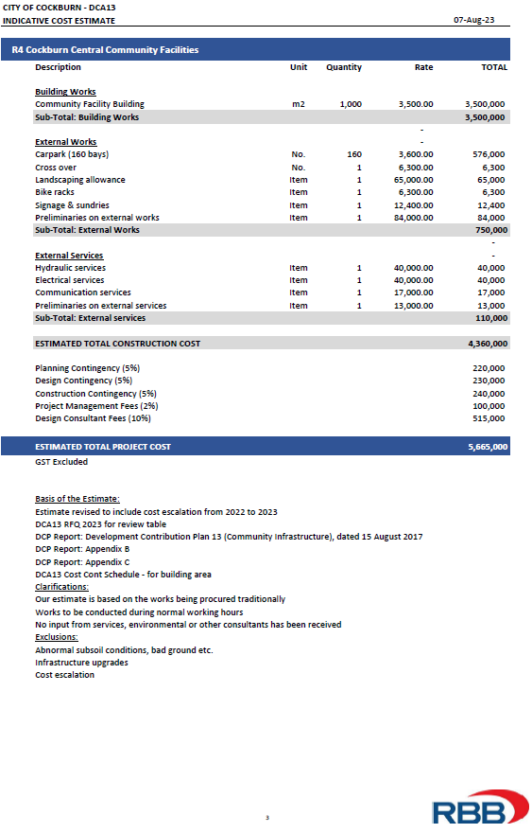

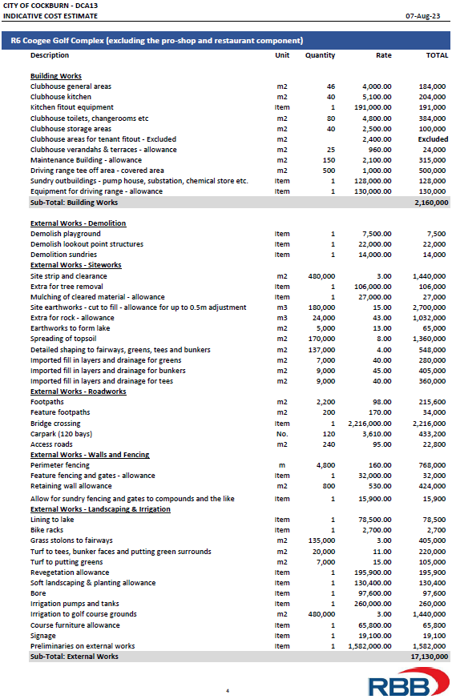

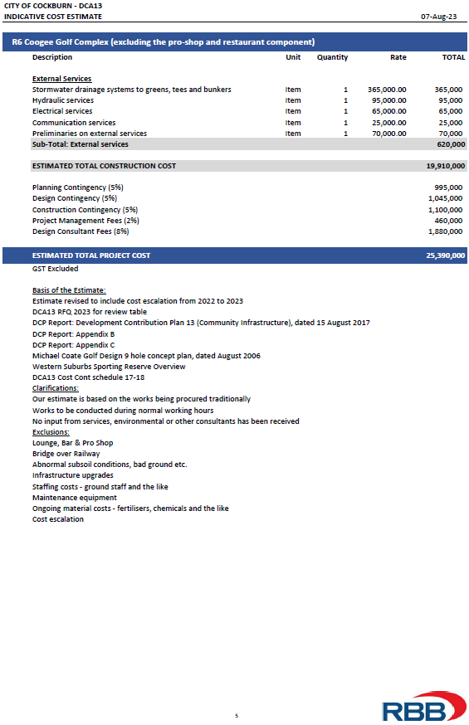

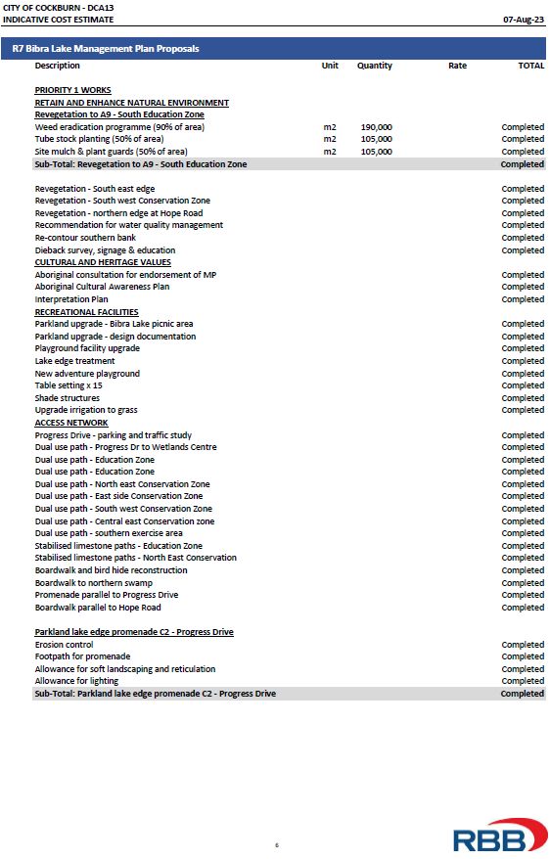

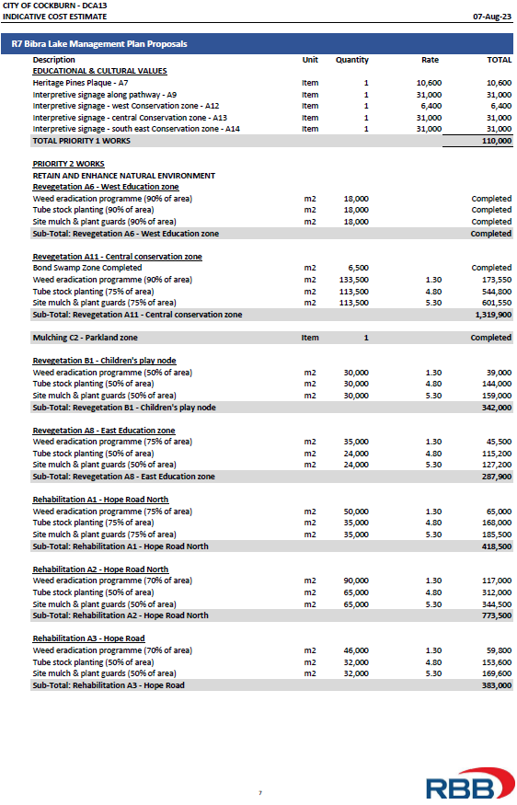

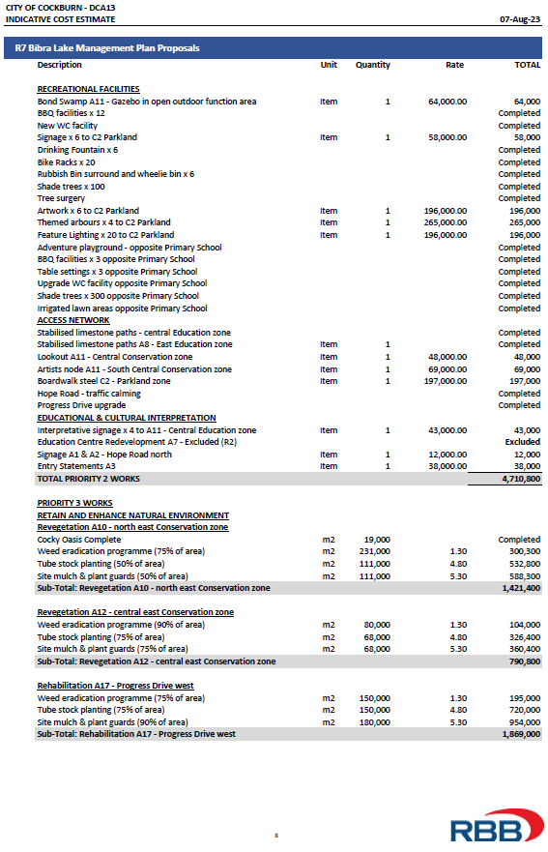

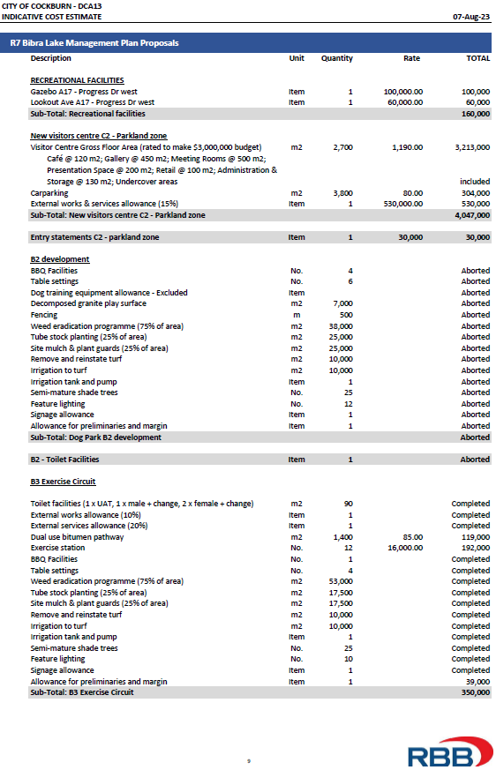

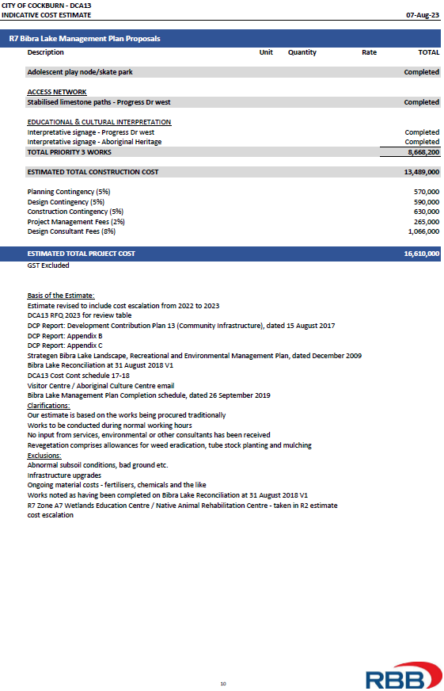

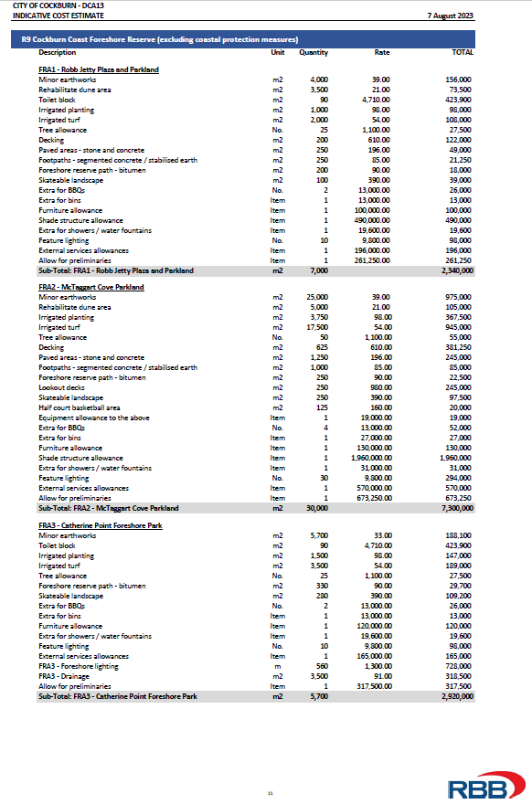

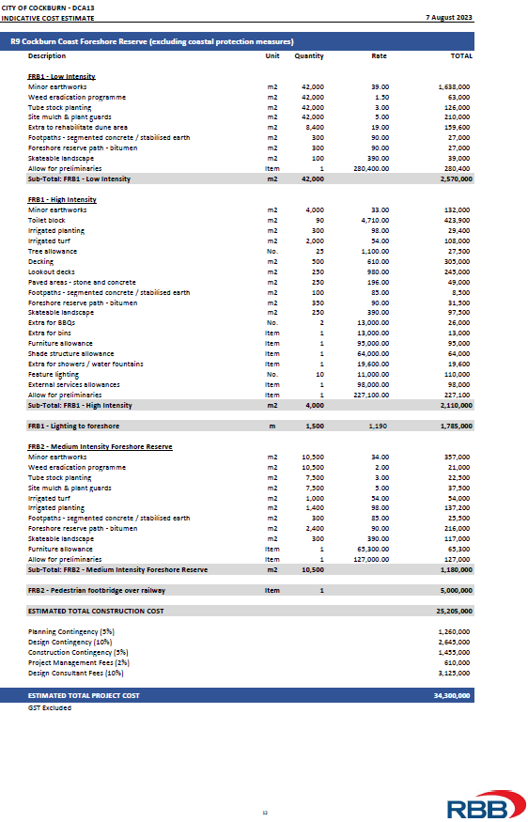



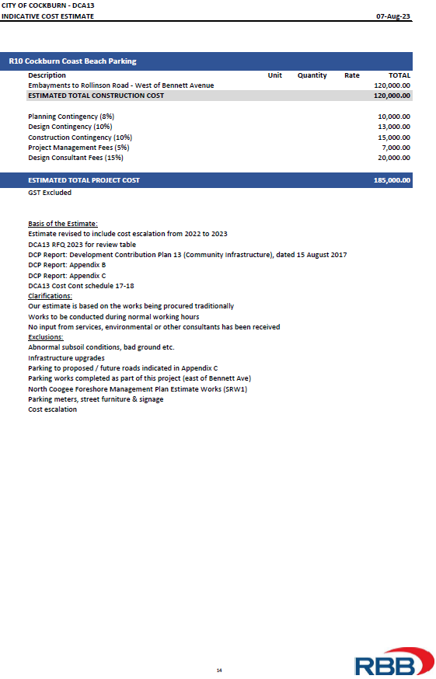

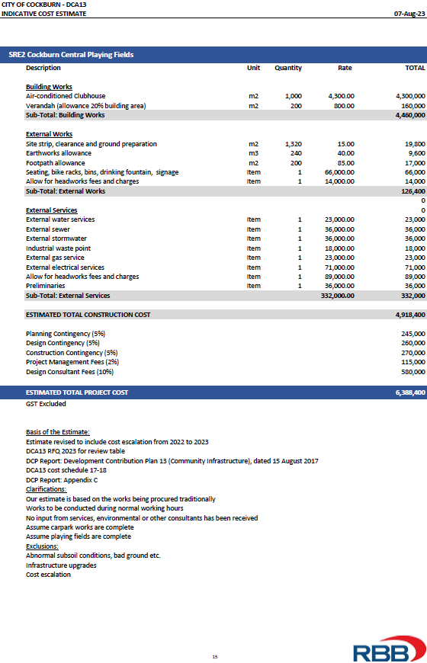

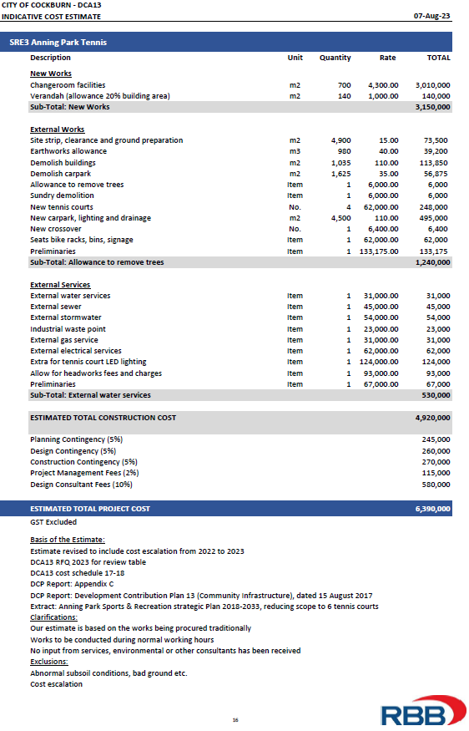

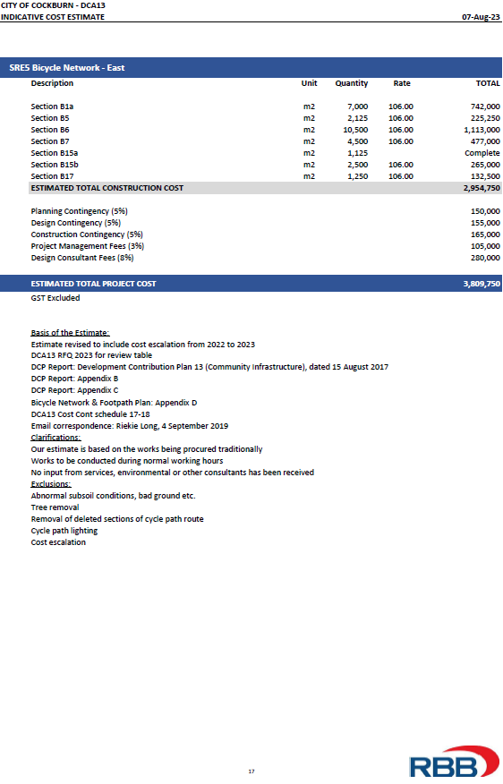

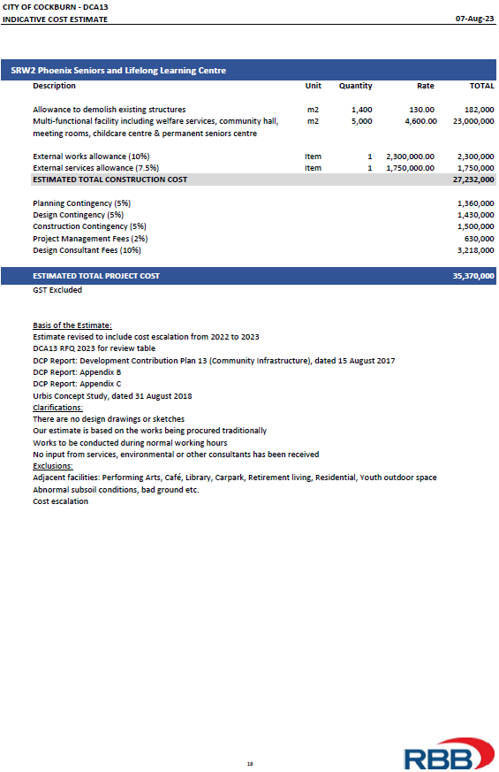

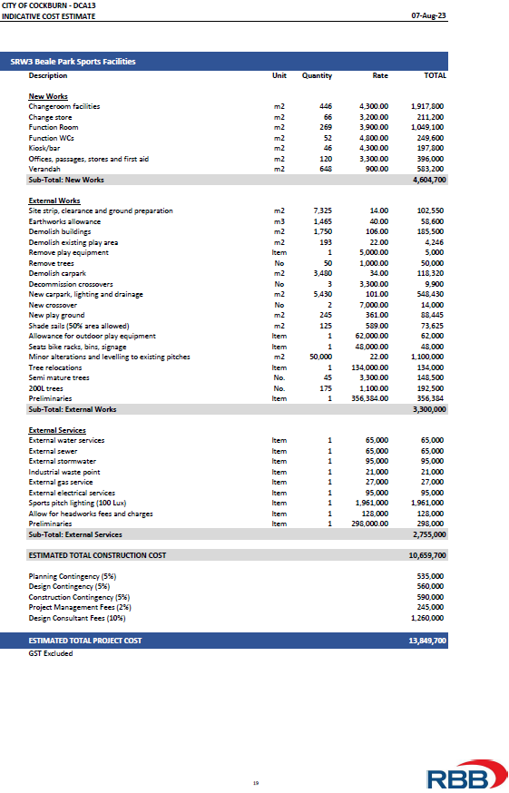



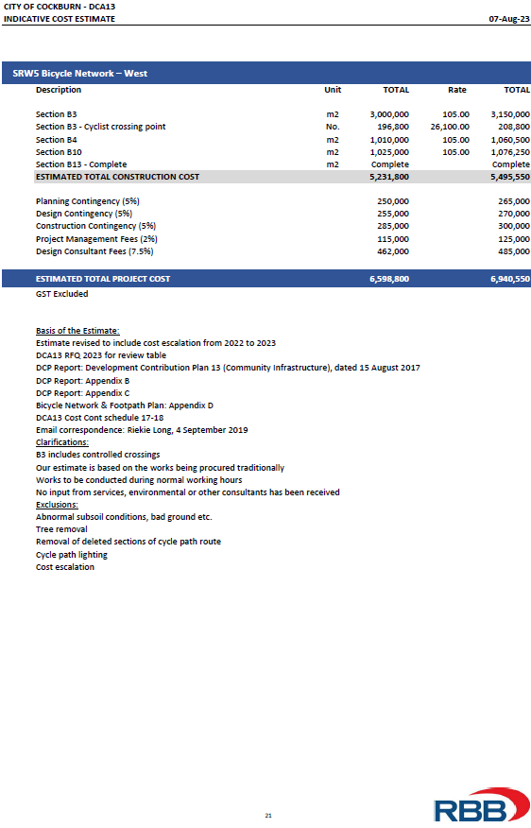

# 

# 

# 

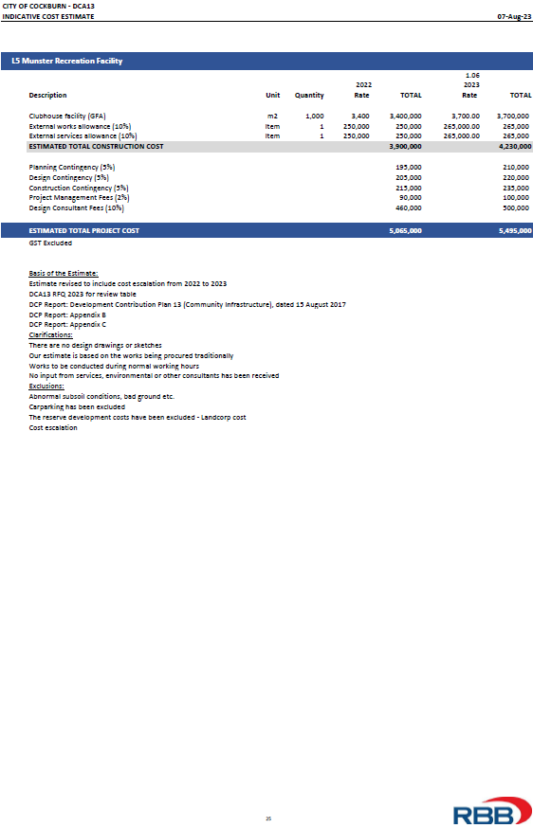

# 



# Annex 6 – Dwelling Forecast

|  |  |  |  |  |  |  |
| --- | --- | --- | --- | --- | --- | --- |
| **Suburb** | **2009** | **2011** | **2016** | **2021** | **2026** | **2031** |
| Atwell | 2,657 | 2950 | 3102 | 3140 | 3145 | 3150 |
| Aubin Grove / Banjup (South) | 1,175 | 1939 | 2519 | 2730 | 2854 | 2869 |
| Banjup (North) | 99 | 92 | 95 | 390 | 1560 | 2655 |
| Beeliar | 1,708 | 2074 | 2548 | 2967 | 3226 | 3264 |
| Bibra Lake (West) | 753 | 762 | 778 | 800 | 812 | 838 |
| Bibra Lake (East) | 1,672 | 1632 | 1644 | 1654 | 1680 | 1718 |
| Coogee / North Coogee | 1,723 | 2088 | 3036 | 5189 | 7341 | 9271 |
| Coolbellup | 2,403 | 2390 | 2604 | 3001 | 3091 | 3216 |
| Hamilton Hill | 4,604 | 4688 | 4850 | 5441 | 6157 | 6857 |
| Hammond Park  / Wattleup / Henderson | 926 | 1213 | 1944 | 2799 | 3842 | 4342 |
| Jandakot | 904 | 939 | 965 | 1004 | 1014 | 1020 |
| Leeming | 737 | 747 | 760 | 765 | 770 | 779 |
| Munster | 1,390 | 1275 | 1841 | 2092 | 2199 | 2216 |
| North Lake | 478 | 479 | 487 | 493 | 503 | 515 |
| South Lake / Cockburn Central | 2,523 | 2698 | 3340 | 4549 | 6031 | 7360 |
| Spearwood | 3,998 | 3972 | 4358 | 5012 | 5278 | 5528 |
| Success | 2,562 | 3219 | 3817 | 5135 | 5554 | 5590 |
| Yangebup | 2,574 | 2780 | 3058 | 3153 | 3179 | 3229 |
| **TOTAL** | **32,886** | **35,937** | **41,746** | **50,314** | **58,236** | **64,417** |

*Note: the columns highlighted grey provide input into the tables below to assess dwellings/lots as a proportion of catchment areas*

**Assessment of dwellings/lots by catchment areas**

**Regional**

|  |  |  |  |  |
| --- | --- | --- | --- | --- |
| **Suburbs** | **Dwellings**  **2009\*** | **Dwellings**  **2031** | **Increase** | **% Of Total Inc** |
| Atwell | 2,657 | 3,150 | 493 | 1.564 |
| Aubin Grove / Banjup South | 1,175 | 2,869 | 1,694 | 5.372 |
| Banjup North | 99 | 2,655 | 2,556 | 8.106 |
| Beeliar | 1,708 | 3,264 | 1,556 | 4.935 |
| Bibra Lake (West) | 753 | 838 | 85 | 0.270 |
| Bibra Lake (East) | 1,672 | 1,718 | 46 | 0.146 |
| Coogee / North Coogee | 1,723 | 9,271 | 7,548 | 23.938 |
| Coolbellup | 2,403 | 3,216 | 813 | 2.578 |
| Hamilton Hill | 4,604 | 6,857 | 2,253 | 7.145 |
| Hammond Park/Wattleup/Henderson | 926 | 4,342 | 3,416 | 10.834 |
| Jandakot | 904 | 1,020 | 116 | 0.368 |
| Leeming | 737 | 779 | 42 | 0.133 |
| Munster | 1,390 | 2,216 | 826 | 2.620 |
| North Lake | 478 | 515 | 37 | 0.117 |
| South Lake / Cockburn Central | 2,523 | 7,360 | 4,837 | 15.340 |
| Spearwood | 3,998 | 5,528 | 1,530 | 4.852 |
| Success | 2,562 | 5,590 | 3,028 | 9.603 |
| Yangebup | 2,574 | 3,229 | 655 | 2.077 |
| **Totals**  **Percent** **Percent** | **32,886** | **64,417** | **31,531** | **100.000** |
|  |  |  |  |
| **51.052** |  | **48.948** |  |

**Sub-Regional West**

|  |  |  |  |  |
| --- | --- | --- | --- | --- |
| **Suburbs** | **Dwellings**  **2009\*** | **Dwellings**  **2031** | **Increase** | **% Of Total Inc** |
| Beeliar | 1,708 | 3,264 | 1,556 | 10.168 |
| Bibra Lake (West) | 753 | 838 | 85 | 0.555 |
| Coogee / North Coogee | 1,723 | 9,271 | 7,548 | 49.322 |
| Coolbellup | 2,403 | 3,216 | 813 | 5.313 |
| Hamilton Hill | 4,604 | 6,857 | 2,253 | 14.723 |
| Munster | 1,390 | 2,216 | 826 | 5.399 |
| North Lake | 478 | 515 | 37 | 0.242 |
| Spearwood | 3,998 | 5,528 | 1,530 | 9.998 |
| Yangebup | 2,574 | 3,229 | 655 | 4.280 |
| **Totals**  **Percent** | **19,631** | **34,934** | **15,303** | **100.000** |
|  |  |  |  |
| **56.195** |  | **43.805** |  |

**Sub-Regional East**

|  |  |  |  |  |
| --- | --- | --- | --- | --- |
| **Suburbs** | **Dwellings**  **2009\*** | **Dwellings**  **2031** | **Increase** | **% Of Total**  **Inc** |
| Atwell | 2,657 | 3,150 | 493 | 3.038 |
| Aubin Grove / Banjup South | 1,175 | 2,869 | 1,694 | 10.439 |
| Banjup North | 99 | 2,655 | 2,556 | 15.751 |
| Bibra Lake (East) | 1,672 | 1,718 | 46 | 0.283 |
| Hammond Park / Wattleup / Henderson | 926 | 4,342 | 3,416 | 21.050 |
| Jandakot | 904 | 1,020 | 116 | 0.715 |
| Leeming | 737 | 779 | 42 | 0.259 |
| South Lake / Cockburn Central | 2,523 | 7,360 | 4,837 | 29.807 |
| Success | 2,562 | 5,590 | 3,028 | 18.659 |
| **Totals**  **Percent** | 13,255 | **29,483** | **16,228** | **100.000** |
|  |  |  |  |
| **44.958** |  | **55.042** |  |

**Local**

|  |  |  |  |  |
| --- | --- | --- | --- | --- |
| **Suburbs** | **Dwellings**  **2009\*** | **Dwellings**  **2031** | **Increase** | **% Of Total Inc** |
| South Lake/Cockburn Central | 2,523 | 7,360 | 4,837 |  |
| **Percent** | **34.280** |  | **65.720** |  |
|  |  |  |  |  |
| Hamilton Hill | 4,604 | 6,857 | 2,253 |  |
| **Percent** | **67.143** |  | **32.857** |  |
|  |  |  |  |  |
| Hammond Park / Wattleup/ Henderson | 926 | 4,342 | 3,416 |  |
| **Percent** | **21.327** |  | **78.673** |  |
|  |  |  |  |  |
| Munster | 1,390 | 2,216 | 826 |  |
| **Percent** | **62.726** |  | **37.274** |  |
|  |  |  |  |  |
| Jandakot | 904 | 1,020 | 116 | 4.341 |
| Banjup North | 99 | 2,655 | 2,556 | 95.659 |
| **Total** | **1,003** | **3,675** | **2,672** |  |
| **Percent** | **27.293** |  | **72.707** |  |
|  |  |  |  |  |
| Coogee / North Coogee | 1,723 | 9,271 | 7,548 | 100.000 |
| **Percent** | **18.585** |  | **81.415** |  |

*Notes for updating Cost Contribution Schedule (as a minimum at the 5-year review - should also do each time the Id data/Remplan figures are updated relative to new census)*

*\* 2009 dwelling figures as per original set up of DCA13 - this starting point must not change - 5 yearly updates to 2031 figures should be only new input*

*Grey cells are used to update the municipal v future dwelling units splits in Cost Contribution Schedule*

*Blue cells are used to update the proportion of each suburb’s 'share' at each category (note different between Regional, Subregional and Local) Use the Regional % for the admin component*

Contact Us

**City of Cockburn**

9 Coleville Crescent, Spearwood WA 6193

PO Box 1215, Bibra Lake DC Western Australia 6965

Telephone: 08 9411 3428 Fax: 08 9411 3444

Email: [rlong@cockburn.wa.gov.au](mailto:rlong@cockburn.wa.gov.au)

[City of Cockburn website: cockburn.gov.wa.au](http://www.cockburn.gov.wa.au)

Socila media logos: Facebook, Twitter, Instagram and YouTube.