Tender Title: |  | RFT 09/2024 - HYGIENE EQUIPMENT SERVICES – (Supply, Maintenance & Servicing)
Request ID: |  | 49929
Tender Description: |  | The City of Cockburn (the Principal) is seeking a suitably qualified, experienced and reliable contractor to provide Hygiene Equipment Services throughout the City of Cockburn.
Advert Approval: |  | Decision to Advertise:  Acting Director Infrastructure Services  Decision Date: Wednesday, 24 April 2024
Closing Date and Time: |  | 2:00PM (AWST) Thursday, 16 May 2024
Opening Date and Time: |  | 2:00PM (AWST) Thursday, 16 May 2024
 | Tenderer’s Name:
1 | Fresh and Clean Perth (T/as Alsco Pty Limited)
2 | CleanPro (T/as CleanPro Work Place Services Pty Ltd)
3 | Rentokil Pest Control (T/as Rentokil Initial Pty Ltd)
4
5
6
7
8
9
10

Advertisement
Method 1: City of Cockburn | Method 2: Yammer
Method 3:  The Western Australian, Wednesday, 1st May 2024 | Tender Awarded by:
Copy of Statewide Notice:  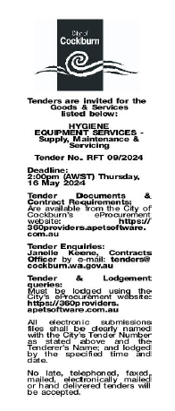 | Acting Director Infrastructure Services  Tuesday, 11 June 2024
 | Date of Council Meeting:
 | Not applicable
Name of Successful Tenderer(s): | Rentokil Pest Control (T/as Rentokil Initial Pty Ltd)
Amount of Successful Tender(s): (ex GST) | $410,638 Ex GST

