# 

**Success North Development Contribution Plan 1 (DCP 1)**

**Report**

**2023/24**

Table of Contents

Development Contribution Area 3

Purpose 3

Period of the plan 3

Operation of DCP 4

Application requirements 4

Items included in the plan 4

Estimated costs 5

Method of calculating contribution 5

Priority and timing of delivery 6

Payment of contributions 7

Review 7

Annexes 8

Annex 1 – Scheme Map 9

Annex 2 – Cost Apportionment Schedule (CAS) 10

Annex 3 – Capital Expenditure Plan (CEP) 17

Annex 4 – Infrastructure Project Designs 18

**Success North Development Contribution Plan Report**

Acknowledgement of Country

The Mayor, Councillors and staff of the City of Cockburn acknowledge the Whadjuk Nyungar people of Beeliar boodja as the traditional custodians of this land. We pay our respect to the Elders, past and present.

Note: This report does not form part of the planning scheme but provides the rationale and justification for the Development Contribution Plan (DCP), the calculation of costs, and the cost apportionment schedule specifying the costs for each owner.

# Development Contribution Area

The Development Contribution Area (DCA) is shown on the Scheme Map as: ‘DCA 1’

# Purpose

The purpose of the DCP Report is to:

1. enable the applying of infrastructure contributions for the development of new, and the upgrade of existing infrastructure which is required as a result of increased demand generated in the DCA
2. provide for the equitable sharing of the costs of infrastructure and administrative items between owners
3. ensure that cost contributions are reasonably required as a result of the subdivision and development of land in the DCA
4. coordinate the timely provision of infrastructure.

The DCP provides for the sharing of costs associated with the widening and upgrading of Hammond Road between Beeliar Drive and Bartram Road, Success.

DCP 1 relates to development undertaken in the following planning areas:

* Development Area 13 (Hammond Road)
* Development Area 14 (Beenyup Road)
* Development Area 24 (Cockburn Central)
* Development Area 36 (Bartram Road)

# Period of the plan

10 years commencing 20 October 2023 to 30 June 2033.

The plan may also be extended for further periods (with or without modification) by subsequent Scheme Amendments.

# Operation of DCP

DCP 1 has been prepared in accordance with the provisions of TPS 3 and SPP 3.6. It came into effect upon the gazettal of Amendment 197 to TPS 3 on 12 December 2002.

DCP 1 operates in accordance with TPS 3 and requires landowners to make a financial contribution towards a portion of the cost of widening and upgrading Hammond Road between Beeliar Drive and Bartram Road, Success.

The requirement to contribute under DCP 1 would typically arise as a condition of subdivision approval, however it may occur through other arrangements as specified in clause 5.3.14 of TPS 3.

DCP 1 is operational in the same area as DCP 13, which relates to community infrastructure. Landowners will be required to satisfy their contribution obligations under both DCPs.

# Application requirements

Where an application for subdivision, strata subdivision, development or an extension of land use is lodged which relates to land to which this plan applies, the local government shall take the provisions of the plan into account in making a recommendation on or determining that application.

# Items included in the plan

This DCP provides for the cost of land and works associated with the widening and upgrading of Hammond Road, between Beeliar Drive and Bartram Road (2,200m), to be equitably distributed between all developing landowners within the DCA.

The following infrastructure items are included in the DCP as set out in Table 10 of TPS 3:

* Land reserved for Hammond Road under the Metropolitan Region Scheme (MRS)
* Full earthworks
* Construction of a two-lane road and where the reserve width is less than 40 metres wide, kerbing to the verge side of the carriageway shall be provided
* Dual use path (one side only)
* Pedestrian crossings (where appropriate at the discretion of the local government)
* Drainage
* Costs to administer cost sharing arrangements - preliminary engineering design and costings, valuations, annual reviews, and audits and administrative costs
* Servicing infrastructure relocation where necessary.

The cost of infrastructure includes all the initial capital costs associated with the provision of the infrastructure item and excludes ongoing maintenance and operating costs of the infrastructure.

These works are required to support additional traffic demand generated from development undertaken within the DCA.

The extent of the Hammond Road upgrade generally includes the area within DCA 1 reserved for ‘Other Regional Roads’ under the MRS, as shown in Annex 1 – Scheme Map.

# Estimated costs

The overall cost of the infrastructure works is **$8,514,323.05** (as of 16 October 2023).

A detailed summary of the cost breakdown for each infrastructure item is included in Table 1 - Summary Sheet.

All infrastructure works outlined in this DCP were pre-funded by the city and the works are expected to be completed during the 2023/24 financial year, and a partial drawdown of $4.1M from the DCP1 Reserve is budgeted for the end of June 2024.

There would be no further expenses other than administrative costs.

There are still landowners who have yet to develop and pay a contribution toward the DCP. The remaining balance owed to the DCP, including interest, will be paid to the City when funds become available in the Reserve Account.

# Method of calculating contribution

All landowners within DCA 1 shall make a proportional contribution to the widening and upgrading of Hammond Road between Beeliar Drive and Bartram Road, Success.

The proportional contribution is to be determined in accordance with the provisions of clause 5.3 of TPS 3.

Contributions shall be calculated on a per hectare basis.

The adopted contribution rate for DCP 1 is **$154,724.56/ha**, and has been determined as follows:

*Contribution Rate ($/ha) = (Total DCP Cost – Reserve Balance) / Net Developable Area (23.0014ha)*

Calculation of an owner’s cost contribution will be based on the area of land developed, multiplied by the applicable contribution rate for the DCP in which the land is situated, as follows:

*Owner’s Cost Contribution = Contribution Rate x Area of Subject Site*

A summary of the total cost is included in Table 1 - Summary Sheet.

**Hammond Road Land Acquisition**

The total cost of acquiring land identified under the MRS for ‘Other Regional Roads’, as per DCP 1 was **$1,972,879.64,** as set out in Table 2 - Hammond Road Land Costsand in accordance with the following formula:

*Land Acquisition Cost = MRS Reserved Area x Valuation Rate ($/m²)*

**Hammond Road Construction**

As part of DCP 1, an allowance of 75.725% of the total cost of **$9,476,586.73** is made for the widening and upgrading of Hammond Road between Beeliar Drive and Bartram Road, Success.

The following formula was used to calculate the DCP 1 share:

*DCP 1 Contribution = Total Cost of Construction less grant funding x 75.725%*

A summary of the cost breakdown for each infrastructure item is included in Table 3 - Hammond Road Construction Costsand Annex 3 – Cost Schedules.

# Priority and timing of delivery

The widening and upgrade of Hammond Road is a significant capital works project, the priority and timing for which is determined by the following:

1. City of Cockburn Strategic Community Plan [Strategic Community Plan 2020-2030](https://www.cockburn.wa.gov.au/getattachment/6ce4d95e-356d-4a2d-855b-7c3667cecdbd/attachment.aspx)

*previously the City’s Plan for the District*

1. City of Cockburn [Long Term Financial Plan (LTFP) 2020-21 to 2029-30](https://www.cockburn.wa.gov.au/getattachment/879146af-ab7a-43d4-bd4f-5459cd98e4b0/ECM_9540447_v2_Long-Term-Financial-Plan-(LTFP)-2020-21-to-2029-30-(attachment-for-SCM-23-July-2020)-pdf.aspx) provides a ten year view of the financial position of the City
2. City of Cockburn [Regional Major Roadworks Map](https://www.cockburn.wa.gov.au/getattachment/43fcc1bc-1365-4661-a892-8a4ba487c123/ECM_10044878_v1_Regional-and-Major-Roadworks-2018-2031-Map-pdf.aspx)

Construction works for this project is expected to be complete during the 2023/24 financial year, as detailed in Annex 4 – Capital Expenditure Plan (CEP).

Note: these timeframes are subject to change.

# Payment of contributions

Payment of contributions are in accordance with the provisions of clause 5.3.14 of TPS 3:

5.3.14.1 The owner, with the agreement of the local government, is to pay the owner’s cost contribution by

1. cheque or cash
2. transferring to the local government or a public authority land in satisfaction of the cost contribution
3. the provision of physical infrastructure
4. some other method acceptable to the local government; or
5. Any combination of these methods

5.3.14.2 The owner, with the agreement of the local government, may pay the owner’s cost contribution in a lump sum, by instalment or in such other manner acceptable to the local government.

5.3.14.3 Payment by an owner of the cost contribution, including a cost contribution based upon estimated costs in a manner acceptable to the local government constitutes full and final discharge of the owner’s liability under the development contribution plan and the local government shall provide certification in writing to the owner of such discharge if requested by the owner.

# Review

The plan will be reviewed five years from the date of gazettal of the local planning scheme or amendment to the local planning scheme to incorporate the plan, or earlier should the local government consider it appropriate, having regard to the rate of development in the area and the degree of development potential still existing.

The estimated infrastructure costs as shown in the Cost Apportionment Schedule (CAS) will be reviewed at least annually to reflect changes in funding and revenue sources and indexed based on the Building Cost Index or other appropriate index as approved by the qualified person undertaking the certification of costs.

# Annexes

1. Scheme Map
2. Cost Apportionment Schedule (CAS)
3. Schedule of Cost of Infrastructure
4. Capital Expenditure Plan (CEP)
5. Infrastructure Project Designs

Annex 1 – Scheme Map

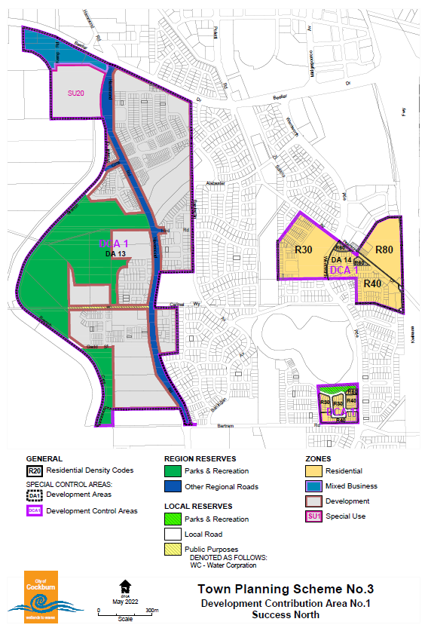

Annex 2 – Cost Apportionment Schedule (CAS)

Table 1 - Summary Sheet

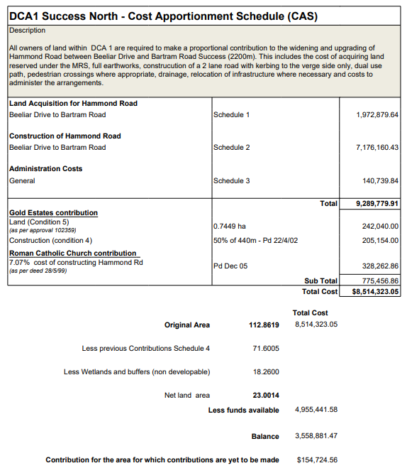

Table 2 - Hammond Road Land Costs

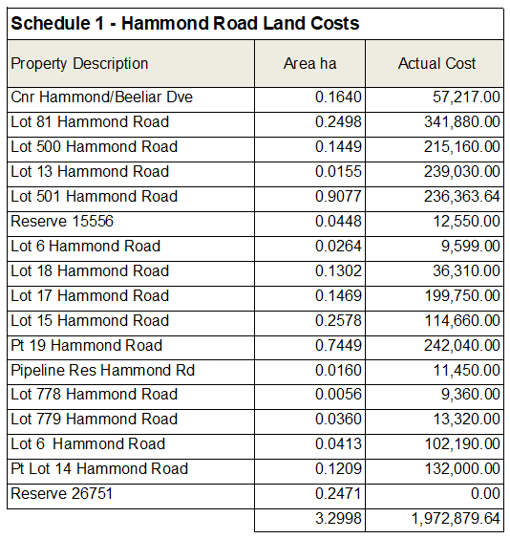

Table 3 - Hammond Road Construction Costs

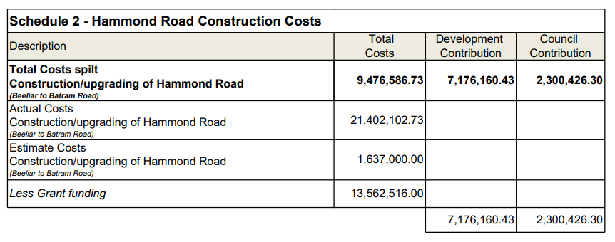

Table 4 - Administration Costs

|  |  |  |
| --- | --- | --- |
| **Schedule 3 - Administration Costs** | | |
| General |  | Total |
| Cost |
| Initial Valuation cost | Sullivans Pro-rata (20.86% of actual cost) | 851.09 |
| Valuations (Sept 01) + Reviews | McGee’s | 5,480.00 |
| Initial Engineering costs | HGM Pro-rata (20.86% actual cost) | 5,401.93 |
| Independent Audit | Cossill Webley Pro-rata (20.86%) | 1,355.90 |
| Verification of Gold Estates Contribution | HGM 15/11/01 | 1,600.00 |
| Administration advice | Knight Frank Pro-rata (20.86% actual cost) | 2,179.87 |
| Hammond Road cost review | Mansell June 2004 | 1,500.00 |
| Revaluations | McGee’s May 2004 | 800.00 |
| Survey Hammond Rd - Lot 76 acquisition | Russell Wellington & Assoc (05/03) | 1,020.00 |
| Administration cost | City of Cockburn (03/04) | 3,000.00 |
| Survey data | Brook and Marsh surveyors | 6,727.00 |
| Hammond Road cost review | Mansell (06/05) | 2,000.00 |
| Revaluations | McGee’s (06/05) | 750.00 |
| Audit Fees | Barrett and Partners (05) | 660.00 |
| Administration cost | City of Cockburn (04/05) | 3,000.00 |
| Administration cost | City of Cockburn (05/06) | 3,000.00 |
| Revaluations | McGee’s (06/07) | 833.00 |
| Hammond Road cost review | Mansell (06/07) | 928.00 |
| Survey costs Lot 14 acquisition | Russell Wellington & Assoc (05/03) | 2,090.00 |
| Water cost lot 14 acquisition | Water Corp | 123.50 |
| Power relocation cost - lot 14 acquisition | Western Power | 6,763.64 |
| Hammond Road cost review | Mansell (05/07) | 1,212.50 |
| Revaluations | Mc Gees (06/07) | 625.00 |
| Lot 14 Hammond Rd | McLeod’s | 373.20 |
| Power lot 14 Hammond Rd | J F Covich | 1,409.00 |
| Administration Fee | City of Cockburn (06/07) | 3,000.00 |
| Revaluations | McGee’s (07/08) | 835.00 |
| Hammond Road cost review | Mansell (07/08) | 1,360.00 |
| Audit Fees | Macri (04/05,05/06,06/07) | 1,200.00 |
| Administration Fee | City of Cockburn (07/08) | 3,000.00 |
| Administration Fee | City of Cockburn (08/09) | 3,120.00 |
| Audit Fees | Grant Thornton (07/08, 08/09) | 228.58 |
| Hammond Road cost review | Mansell (6/09) | 1,424.00 |
| Administration fee | City of Cockburn (09/10) | 4,000.00 |
| Hammond Road cost review | AECOM (09/10) | 1,360.33 |
| Revaluations | McGee’s (09/10) | 733.00 |
| Audit Fees | (09/10) | 229.00 |
| Administration fee | City of Cockburn (10/11) | 3,120.00 |
| Revaluations | McGee’s (2012) | 733.00 |
| Hammond Road cost review | AECOM (2012) | 1,980.00 |
| Revaluations | McGee’s (6/13) | 1,650.00 |
| Hammond Road cost review | AECOM (6/13) | 2,310.00 |
| Audit Fees |  | 330.00 |
| Administration costs |  | 5,310.00 |
| Revaluations | McGee’s (6/14) | 780.00 |
| Hammond Road cost review | AECOM (6/14) | 3,264.00 |
| Audit Fees |  | 220.00 |
| Administration costs |  | 1,362.00 |
| Annual revaluations | McGee’s (6/15) | 1,100.00 |
| Annual review of construction cost | AECOM (6/15) | 2,112.00 |
| Annual Audit costs |  | 207.00 |
| Administration costs |  | 811.00 |
| Annual revaluations | McGee’s | 697.00 |
| Annual review of construction cost | AECOM | 1,500.00 |
| Annual Audit costs |  | 216.00 |
| Administration costs |  | 839.00 |
| Annual land revaluations | McGee’s (2016/17) | 466.00 |
| Annual review of construction cost | AECOM (2016/17) | 1,666.00 |
| Annual Audit costs (2016/17) |  | 375.00 |
| Administration costs (2016/17) |  | 848.00 |
| Annual land valuations | McGee’s (2017/18) | 0.00 |
| Annual review of construction cost | AECOM (2017/18) | 0.00 |
| Annual Audit costs (2017/18) |  | 480.91 |
| Administration costs (2017/18) |  | 0.00 |
| Annual land valuations | McGee’s (2018/19) | 990.00 |
| Annual review of construction cost | AECOM (2018/19) | 3,108.60 |
| Annual Audit costs (2018/19) |  | 398.18 |
| Administration costs (2018/19) |  | 864.66 |
| Annual land valuations | McGee’s (2019/20) | 990.00 |
| Annual review of construction cost | AECOM (2019/20) | 2,897.50 |
| Annual Audit costs (2019/20) |  | 403.64 |
| Administration costs (2019/20) |  | 864.66 |
| Professional Costs | Stantec & McGee’s (2020/21) | 10,300.00 |
| Annual Audit costs (2020/21) |  | 407.27 |
| Administration costs (2020/21) |  | 1,090.62 |
| Professional Costs (2021/22) | Stantec | 4,500.00 |
| Annual Audit Costs (2021/22) |  | 383.64 |
| Administration Costs (2021/22) |  | 1,090.62 |
| Professional Costs (2022/23) | Stantec | 4,500.00 |
| Annual Audit Costs (2022/23) |  |  |
| Administration Costs (2022/23) |  | 1,400.00 |
| **Total** | | 140,739.84 |

Table 5 - Contribution Register

|  |  |  |  |  |  |  |
| --- | --- | --- | --- | --- | --- | --- |
| **Schedule 4 - Contribution Register** | | | | | | |
| Owner | Date | Area (Ha) | Value of land vested | Works | Contribution  made | Total |
| Martinovich - Lot 15 Hammond Road | Apr-02 | 2.3954 | 83,362.41 |  |  | 83,362.41 |
| Southern Cross | Apr-02 | 5.3593 |  |  | 186,509.21 | 186,509.21 |
| **Interest 01/02** |  |  |  |  |  | **4,252.76** |
| Peet & Co | Oct-02 | 3.6512 |  |  | 128,539.11 | 128,539.11 |
| **Interest 02/03** |  |  |  |  |  | **17,724.15** |
| Silver Knight Holdings - Lot 18 Hammond Road | Aug-03 | 2.1714 | 36,310.00 |  | 40,133.31 | 76,443.31 |
| **Interest 03/04** |  |  |  |  |  | **17,588.71** |
| **Interest 04/05** |  |  |  |  |  | **19,199.00** |
| Maincity Investments Lot 9 Hammond Rd | Jun-06 | 1.8490 |  | 10,535.00 | 87,047.31 | 97,582.31 |
| Water Corp lot 9000 | Jun-06 | 0.6091 |  |  | 0.00 | 0.00 |
| **Interest 05/06** |  |  |  |  |  | **37,680.06** |
| A & L Amaranti Lot 10 Pearson Drive | Jul-06 | 0.4041 |  |  | 25,185.48 | 25,185.48 |
| 52/52 Pty Ltd Lot 768 Branch Circus | Nov-06 | 1.3395 |  |  | 87,261.73 | 87,261.73 |
| **Audit adjustment incl. indexation** |  |  |  |  |  | **-3,373.80** |
| Suncorp Lot 779 and 780 Hammond Rd | May 07 | 1.6675 |  |  | 118,225.00 | 118,225.00 |
| **Audit adjustment incl. indexation** |  |  |  |  |  | **-17,571.14** |
| **Interest 06/07** |  |  |  |  | **61,601.74** | **61,706.02** |
| Maincity Investments Lot 9 Hammond Rd Stg2 | Aug-07 | 0.1972 |  |  | 13,108.28 | 13,108.28 |
| **Audit adjustment incl. indexation** |  |  |  |  |  | **-367.84** |
| Wise Blend Investments Pty Ltd Lot 778 Hammond | Sep-07 | 1.6702 | 9,360.00 |  | 118,497.42 | 127,857.42 |
| **Audit adjustment incl. indexation** |  |  |  |  |  | **-13,394.77** |
| T Scolaro Lots 503, 145 Beeliar Drive | Sep-07 | 2.2880 |  |  | 152,088.14 | 152,088.14 |
| **Audit adjustment incl. indexation** |  |  |  |  |  | **-4,268.11** |
| **Interest 07/08** |  |  |  |  |  | **7,230.92** |
| **Interest 08/09 (estimated)** |  |  |  |  |  | **27,108.00** |
| Dunn Rae Super Fund (portion of) 256 Hammond Rd | Jun-10 | 0.4000 |  |  | 36,812.00 | 36,812.00 |
| **Audit adjustment incl. indexation** |  |  |  |  |  | **-11,208.52** |
| **Interest (09/10)** |  |  |  |  |  | **22,682.95** |
| **Interest (10/11)** |  |  |  |  |  | **30,505.88** |
| **Interest (11/12)** |  |  |  |  |  | **26,871.85** |
| **Interest (12/13)** |  |  |  |  |  | **19,451.57** |
| 167 Hammond Road Success Lakeside Stage 1 | Nov-13 | 0.3387 |  |  | 26,093.38 | 26,093.38 |
| 167 Hammond Road Success Lakeside Stage 2 | Apr-14 | 3.4938 |  |  | 347,469.31 | 347,469.31 |
| 264 Hammond Road Success - Muntoc Pty Ltd | Jun-14 | 2.0060 |  |  | 198,965.91 | 198,965.91 |
| **Interest (13/14)** |  |  |  |  |  | **17,229.09** |
| 167 Hammond Road Success Lakeside Stage 3 | Jul-14 | 3.1284 |  |  |  | 311,129.14 |
| 167 Hammond Road Success Lakeside Stage 4 | Nov-14 | 1.9602 | 215,656.13 |  |  | 215,656.13 |
| 167 Hammond Road Success Lakeside State 5 | May-15 | 2.7956 |  |  |  | 170,619.77 |
| **Interest (14/15)** |  |  |  |  |  | **37,682.00** |
| Lot 760 (1) Gadd Street Vivardi & Gasbarro 7.5651 - 405, 281.41 see line 52 |  |  |  |  |  |  |
| 167 Hammond Road Success Lakeside Stage 6 | Aug-15 | 3.2451 |  |  |  | 384,573.07 |
| 77 Bartram Road Success | May-16 | 0.2424 |  |  |  | 28,726.55 |
| 32 Sciano Road Success | Jul-16 | 2.0125 |  |  |  | 238,499.06 |
| **Interest (15/16)** |  |  |  |  |  | **49,572.80** |
| 167 Hammond Road Lakeside Success land swap | Nov-16 | 0.1206 |  |  |  | 13,122.90 |
| 167 Hammond Road Success City of Cockburn | Nov-16 | 0.1677 |  |  |  | 18,248.02 |
| 167 Hammond Road Lakeside Success Stage 7 | Apr-17 | 1.9438 |  |  |  | 211,511.58 |
| 167 Hammond Road Lakeside Success Stage 8 | May-17 | 0.781 |  |  |  | 8,498.33 |
| **Interest (16/17)** |  |  |  |  |  | **55,174.59** |
| Lot 9000 (9000) Deptford Street Success (6028162) | Nov-17 | 2.3227 |  |  | 270,659.33 | 270,659.33 |
| Lot 9017 Hammond Road Success Stage 9 (6029406) | Dec-17 | 1.2064 |  |  | 140,527.89 | 140,527.89 |
| Lot 1 Gadd Street Success - Stage 1A (6018058) | Dec-17 | 1.0694 |  |  | 124,614.93 | 124,614.93 |
| **Interest (17/18)** |  |  |  |  |  | **63,263.38** |
| Lot 9501 Batram Road Success - (6027951) | Oct-18 | 1.7372 |  |  | 202,432.25 | 202,432.25 |
| Lot 9000 Wentworth Parade (6032765) DP416059 | May-19 | 2.0990 |  |  | 297,267.64 | 297,267.64 |
| **Interest (18/19)** |  |  |  |  |  | **74,590.62** |
| Lot 9002 Darlot Ave Succes (6031593) Stage 1 B (DP419355) | Jun-20 | 1.0548 |  |  | 145,366.67 | 145,366.67 |
| Lot 9002 Darlot Ave Succes (6031593) Stage 1 C (DP410573) | Sep-20 | 0.4040 |  |  | 55,677.03 | 55,677.03 |
| Lot 9006 Branch Circus Success (5509207) Stage 2A (DP421435) | May-21 | 0.4539 |  |  | 97,843.21 | 97,843.21 |
| **Interest (19/20)** |  |  |  |  |  | **45,034.02** |
| Lot 761 Branc Circus Success (5509207) Stage 2D (DP422570) | Nov-21 | 2.2998 |  |  | 72,849.64 | 72,849.64 |
| Lot 9005 Darlot Ave Success (6035971) Stage 1D (DP422563) | Nov-21 | 1.4650 |  |  | 355,986.42 | 355,986.42 |
| Lot 141 (275) Hammond Road (6036069) | Jan-22 | 0.6908 |  |  | 167,860.35 | 167,860.35 |
| **Interest (20/21)** |  |  |  |  |  | **30,230.08** |
| Lot 106 (210) Hanmond Road (6036435) Stage 1 | Sep-22 | 0.7438 |  |  | 80,003.54 | 80,003.54 |
| Lot 9008 Yellowstone Grave (6037157) Success Gardens Stage 2B - (DP424107) | Oct-22 | 1.5012 |  |  |  | 364,782.80 |
| **Interest (21/22)** |  |  |  |  |  | **14,817.54** |
| Lot 9007 (65) Yellowstone Grove - 6037150 | Sep-23 | 0.0254 |  |  |  | 7,607.45 |
| Lot 9009 Branch Circus - Success Gardens Estate Stage 2E (DP426664) | Sep-23 | 0.4351 |  |  |  | 130,314.97 |
|  | Total | 71.6005 | 344,688.54 | 10,535.00 | 4,024,183.00 | $6,834,850.25 |

Annex 3 – Capital Expenditure Plan (CEP)

|  |  |  |
| --- | --- | --- |
| **DCP Reserve Balance as of 31 August 2023** | **Value of Credits** | **Interest earned on DCP funds 2021/22** |
| $4,955,411 |  | 14,817.54 |



Notes:

1. This timeframe is subject to change
2. The City is prefunding the construction of Hammond Road, the balance plus indexation will be paid to the City when funds become available in the DCA1 Reserve.

The following recurring annual payment obligation for DCA1 is not included in the table above:

* costs to administer cost sharing arrangements,
* valuations, professional fees for infrastructure cost estimates
* annual audit and administration costs.

Annex 4 – Infrastructure Project Designs

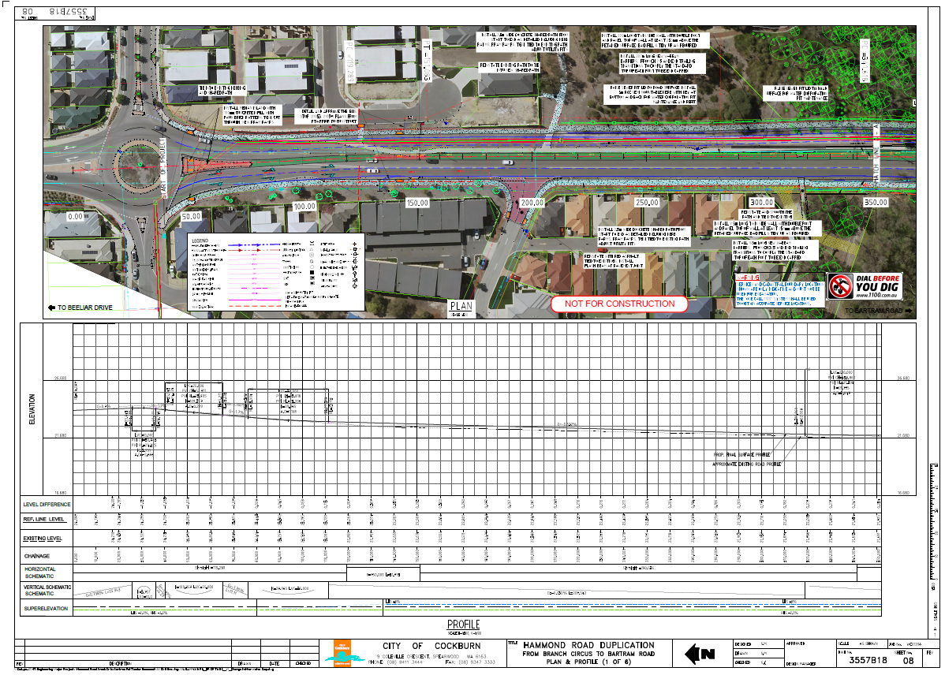

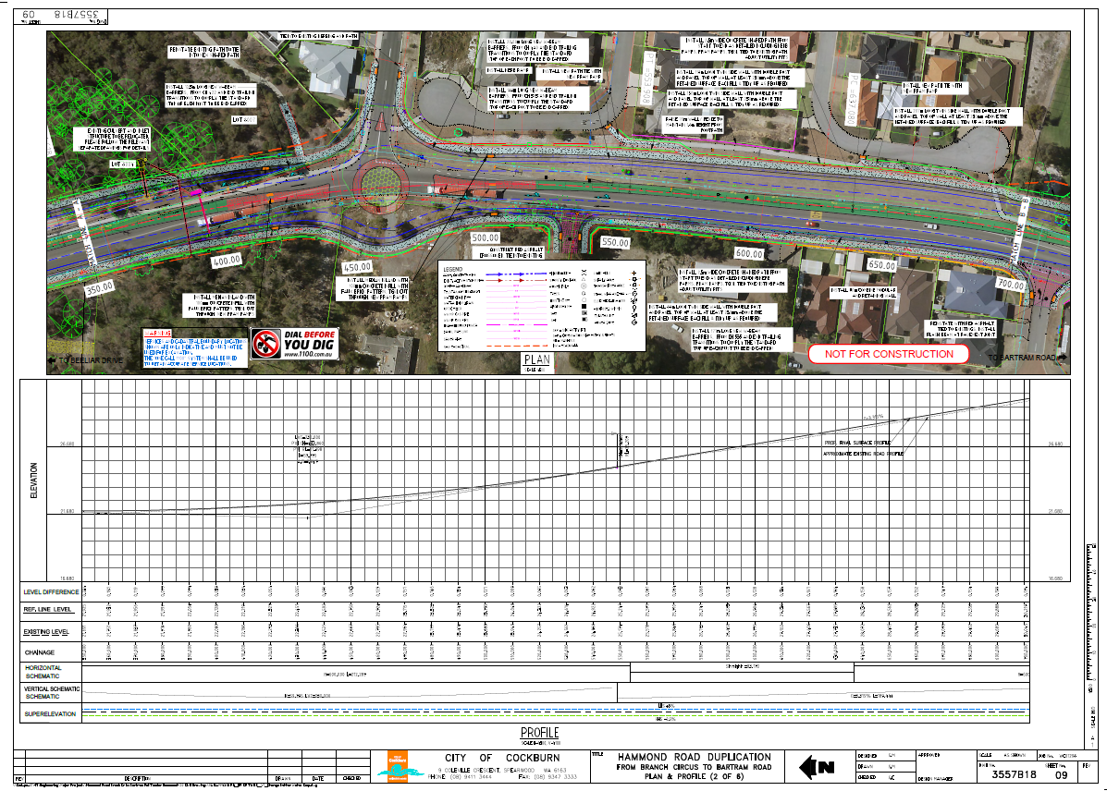

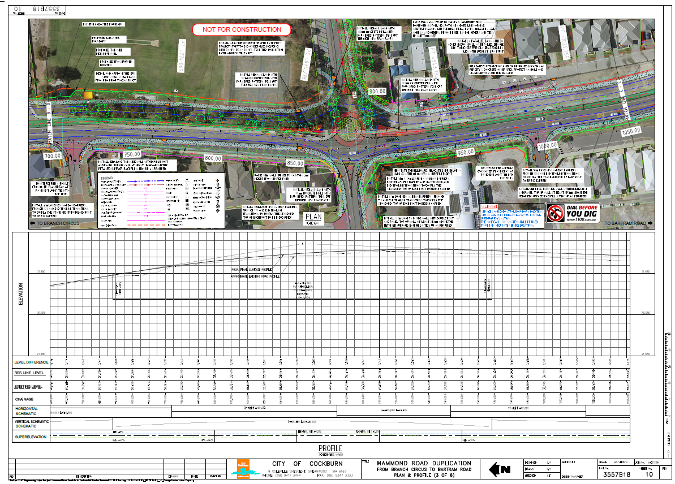

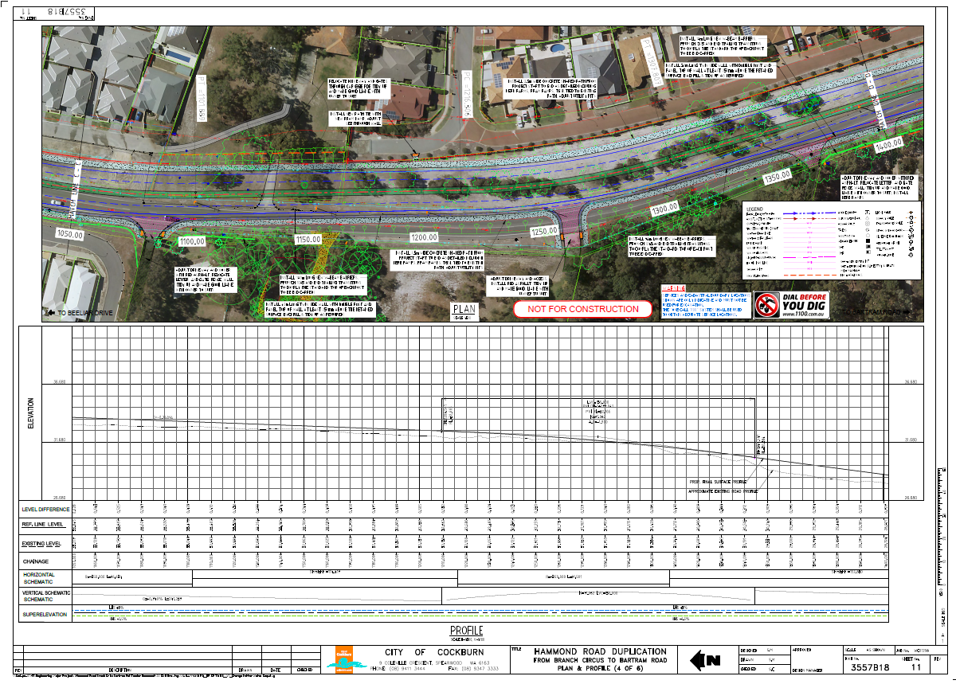

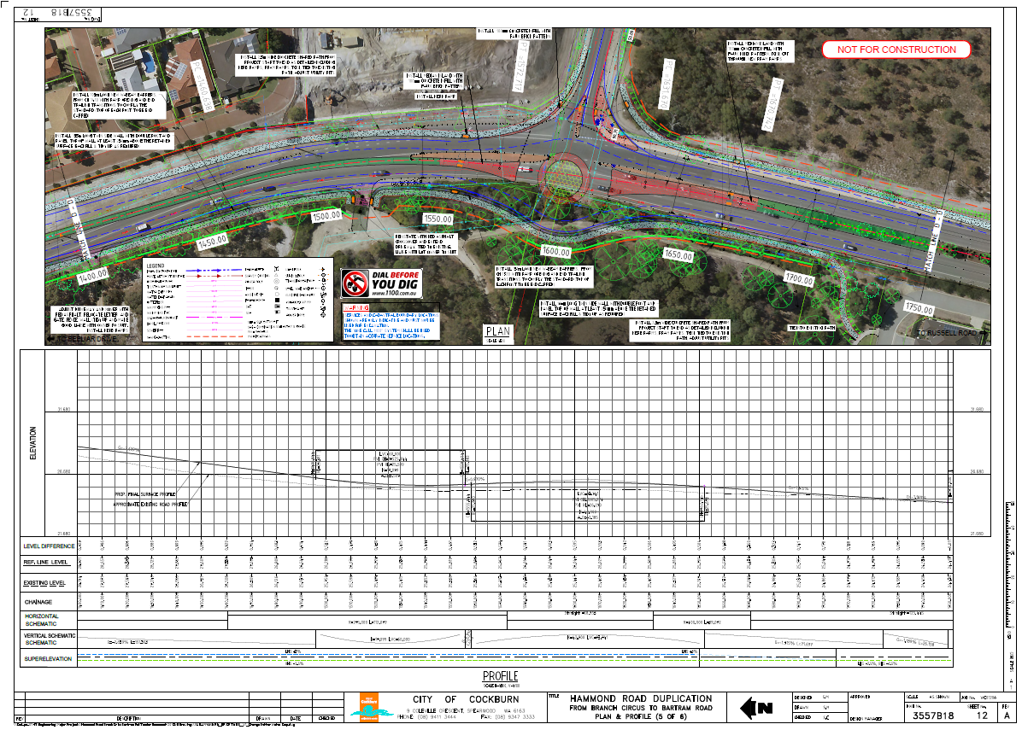

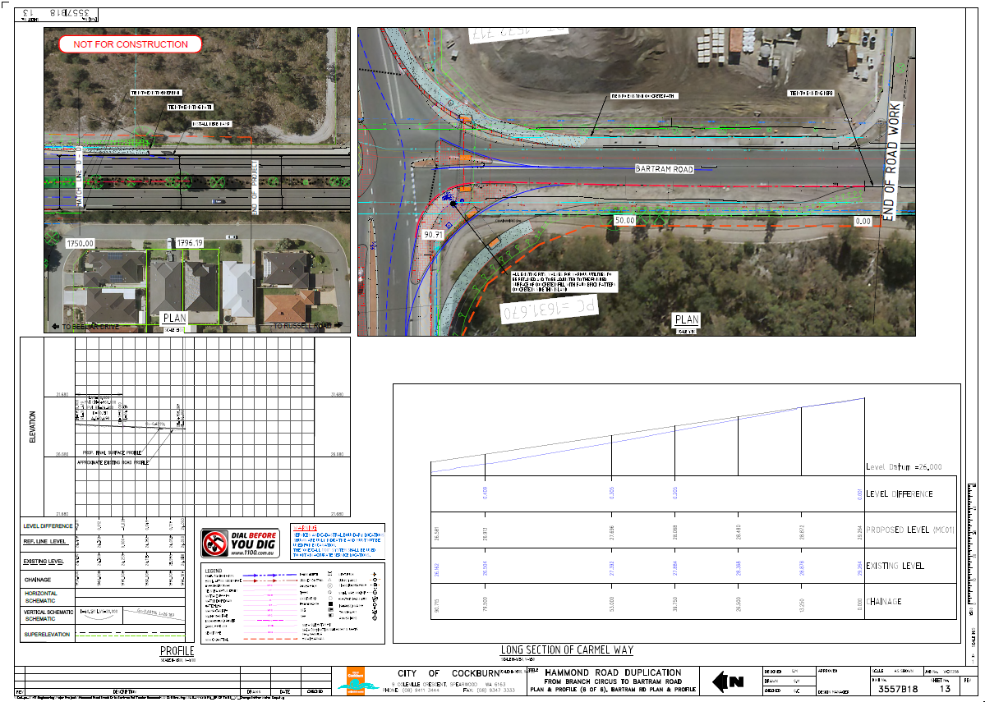

Contact Us

**City of Cockburn**

9 Coleville Crescent, Spearwood WA 6193

PO Box 1215, Bibra Lake DC Western Australia 6965

Telephone: 08 9411 3428 Fax: 08 9411 3444

Email: [rlong@cockburn.wa.gov.au](mailto:rlong@cockburn.wa.gov.au)

[City of Cockburn website: cockburn.gov.wa.au](http://www.cockburn.gov.wa.au)

Socila media logos: Facebook, Twitter, Instagram and YouTube.