Tender Title: |  | RFT 22/2024 – Proposed Transfer Station – Concrete Slabs and Walls
Request ID: |  | 51535
Tender Description: |  | The City of Cockburn is seeking a suitably qualified and experienced contractor for the construction of Proposed Transfer Station - Concrete Slabs and Walls at the Henderson Waste Recovery Park, 920 Rockingham Road, Henderson WA.
Advert Approval: |  | Decision to Advertise: A/Director Infrastructure Services  Decision Date: Wednesday, 25 September 2024
Closing Date and Time: |  | 2:00PM (AWST) Monday, 14 October 2024
Opening Date and Time: |  | 2:00PM (AWST) Saturday, 14 September 2024
 | Tenderer’s Name:
1 | Raubex Construction Pty Ltd
2 | Tyrone Construction Pty Ltd
3 | Doolee Construction Pty Ltd
4 | DCL Formwork Pty Ltd
5 | After Builder Pty Ltd t/as Concity
6
7
8
9
10
11

Advertisement
Method 1: City of Cockburn | Method 2: Yammer
Method 3:  The Western Australian, Saturday 28th September 2024 | Tender Awarded by:
Copy of Statewide Notice:  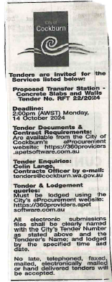 | Director of Infrastructure Services  A/Director Corporate and System Services  31st October 2024
 | Date of Council Meeting:
 | N/A
Name of Successful Tenderer(s): | Doolee Construction Pty Ltd
Amount of Successful Tender(s): (ex GST) | $958,544.15 Lump Sum Amount

