**Solomon Road Development Contribution Plan 8 (DCP 8)**

**Report**

**2023/24**

**Table of Contents**

Development Contribution Area 3

Purpose 3

Period of the plan 3

Operation of DCP 4

Application requirements 4

Items included in the plan 4

Estimated costs 5

Method of calculating contribution 6

Priority and timing of delivery 6

Payment of contributions 6

Review 7

Annexes 7

Annex 1 – Maps 8

Annex 2 – Cost Apportionment Schedule (CAS) 10

Annex 3 – Capital Expenditure Plan (CEP) 13

Annex 4 – Schedule of Cost of Infrastructure 14

Acknowledgement of Country

The Mayor, Councillors and staff of the City of Cockburn acknowledge the Whadjuk Nyungar people of Beeliar boodja as the traditional custodians of this land. We pay our respect to the Elders, past and present.

**Solomon Road Development Contribution Plan Report**

Note: This report does not form part of the planning scheme but provides the rationale and justification for the Development Contribution Plan (DCP), the calculation of costs, and the cost apportionment schedule specifying the costs for each owner.

# Development Contribution Area

The Development Contribution Area (DCA) is shown on the Scheme Map as: ‘DCA 8’

# Purpose

The purpose of the DCP Report is to:

1. enable the applying of infrastructure contributions for the development of new, and the upgrade of existing infrastructure which is required as a result of increased demand generated in the DCA
2. provide for the equitable sharing of the costs of infrastructure and administrative items between owners
3. ensure that cost contributions are reasonably required as a result of the subdivision and development of land in the DCA
4. coordinate the timely provision of infrastructure

The DCP provides for the sharing of costs associated with common infrastructure for the Solomon Road Arterial Drainage System in Jandakot.

DCP 8 relates to development undertaken in the following planning areas:

* Development Area 20 (Solomon Road)
* Development Area 25 (Imla Court & Prinsep Road)

# Period of the plan

10 years commencing 20 October 2023 to 30 June 2033.

The plan may also be extended for further periods (with or without modification) by subsequent Scheme Amendments.

# 

# Operation of DCP

DCP 8 has been prepared in accordance with the provisions of TPS 3 and SPP 3.6. It came into effect upon the gazettal of Amendment 20 to TPS 3 on the 19 August 2011.

DCP 8 operates in accordance with TPS 3 and requires landowners to make a financial contribution towards the Solomon Road arterial drainage system in Jandakot. The requirement to contribute is specified in clause 5.3.14 of TPS 3.

The requirement to contribute under DCP 8 would typically arise as a condition of subdivision approval, however it may occur through other arrangements as specified in clause 5.3.14 of TPS 3.

DCP 8 is operational in the same areas as DCP 13 and DCP 15, which relate to community infrastructure. Landowners will be required to satisfy their contribution obligations under all three DCPs.

# Application requirements

Where an application for subdivision, strata subdivision, development or an extension of land use is lodged which relates to land to which this plan applies, the local government shall take the provisions of the plan into account in making a recommendation on or determining that application.

# Items included in the plan

This DCP provides for the cost of land and works associated with the Solomon Road arterial drainage system in Jandakot to be equitably distributed between all developing landowners within the DCA.

The following infrastructure items are included in the DCP as set out in Table 10 of TPS 3:

* Full earthworks
* Provision of drainage infrastructure
* Supply and boring of a pressure main under the Kwinana Freeway and work associated with the proposed pump station
* Servicing infrastructure relocation where necessary
* Landscaping works around the drainage basin
* Cost of land required for the Arterial Drainage basin
* Costs to administer cost sharing arrangements including preliminary engineering design and costings, valuations, annual reviews, and audits and administrative costs

The cost of infrastructure includes all the initial capital costs associated with the provision of the infrastructure item and excludes ongoing maintenance and operating costs of the infrastructure.

These works are required to increase the drainage capacity of the arterial drainage network to support new development within the DCA.

A map detailing the proposed location of the infrastructure in relation to the DCP is included in Solomon Arterial Drainage Scheme Map

# Estimated costs

The overall estimated cost of the common infrastructure works is **$1,998,444.81** (as of 16 October 2023).

A detailed summary of the cost breakdown for each infrastructure item are included in Table 1 - Summary Sheet and Annex 4 Schedule of Cost of Infrastructure.

The costs allocated to this DCP have been derived based on preliminary concept plans and will need to be reviewed when detailed briefs and plans have been prepared.

The estimated cost of the infrastructure item will be reviewed at least annually. If during the year more detailed costings have been prepared, then these would be adopted in preference to broad based estimates. In all other instances the cost estimates will be adjusted to reflect current pricing and the cost indexed based on the Building Cost Index or other appropriate index as approved by an appropriately qualified independent person.

The percentage contingencies applied to the estimates is at the higher end when the design is still in early phases with the intention they reduce as certainty over design and costs become more certain.

Details of infrastructure designs upon which costs are based are included in Map Solomon Arterial Drainage Scheme.

# 

# Method of calculating contribution

All landowners within DCA 8 shall make a proportional contribution to the cost of common infrastructure for the Solomon Road Arterial Drainage System in Jandakot.

The proportional contribution is to be determined in accordance with the provisions of clause 5.3 of TPS 3.

Contributions shall be calculated on a per hectare basis.

The adopted contribution rate for DCP 8 is **$21,028.39/ha** and has been determined as follows:

*Contribution Rate ($/ha) = (Total DCP Cost – Reserve Balance) / Net Developable Area (57.7528ha)*

Calculation of an owner’s contribution will be based on the area of land developed, multiplied by the applicable contribution rate for the DCP in which the land is situated, as follows:

*Owner’s Cost Contribution = Contribution Rate x Area of Subject Site*

A summary of the overall estimated costs is included Table 1 - Summary Sheet.

# Priority and timing of delivery

The Solomon arterial drainage network is a significant capital works project, the design and associated approval for the Kwinana Freeway crossing and linking the drainage strategy in the area is currently being undertaken. On this basis, the priority and timing for this project is still under review and will be determined when the design is complete and necessary approvals have been obtained.

Construction works for this project are forecast to be delivered within 10 years.

Details of the proposed timing and delivery is outlined in Annex 3 – Capital Expenditure Plan (CEP).

Note: these timeframes are subject to change.

# Payment of contributions

Payment of contributions are in accordance with the provisions of clause 5.3.14 of TPS 3:

5.3.14.1 The owner, with the agreement of the local government, is to pay the owner’s cost contribution by

1. cheque or cash
2. transferring to the local government or a public authority land in satisfaction of the cost contribution
3. the provision of physical infrastructure
4. some other method acceptable to the local government; or
5. Any combination of these methods.

5.3.14.2 The owner, with the agreement of the local government, may pay the owner’s cost contribution in a lump sum, by instalment or in such other manner acceptable to the local government.

5.3.14.3 Payment by an owner of the cost contribution, including a cost contribution based upon estimated costs in a manner acceptable to the local government constitutes full and final discharge of the owner’s liability under the development contribution plan and the local government shall provide certification in writing to the owner of such discharge if requested by the owner.

# Review

The plan will be reviewed five years from the date of gazettal of the local planning scheme or amendment to the local planning scheme to incorporate the plan, or earlier should the local government consider it appropriate, having regard to the rate of development in the area and the degree of development potential still existing.

# Annexes

1. Map
2. Cost Apportionment Schedule (CAS)
3. Capital Expenditure Plan
4. Schedule of Cost of infrastructure

# Annex 1 – Maps

Scheme Map

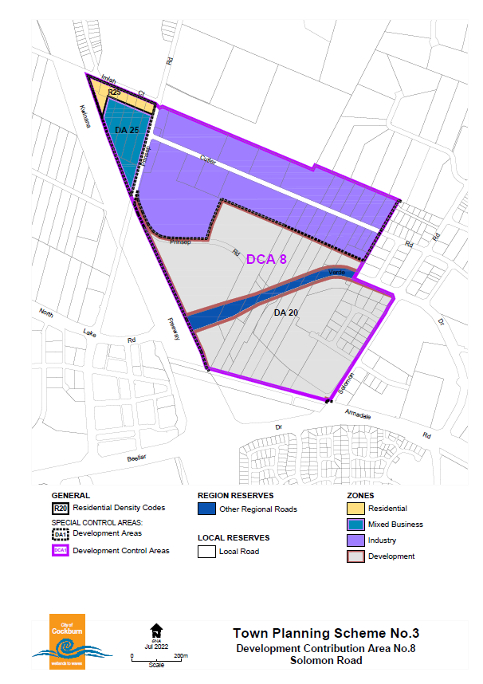

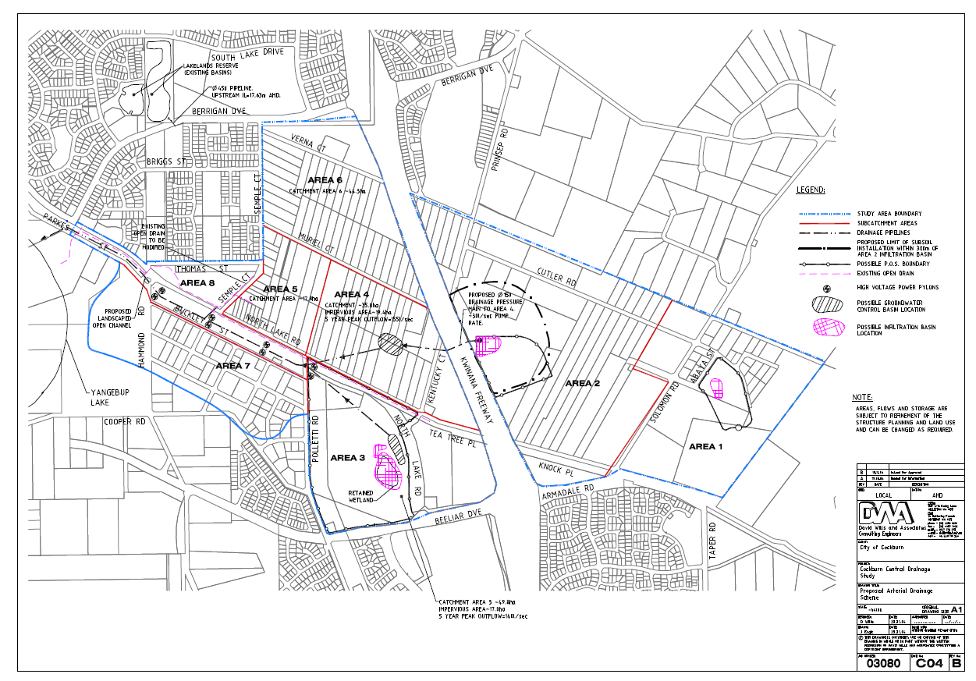

Map Solomon Arterial Drainage Scheme

# Annex 2 – Cost Apportionment Schedule (CAS)

Table 1 - Summary Sheet

Table 2 – Administration Cost

|  |  |  |
| --- | --- | --- |
| **Schedule 1 - Administration Costs** | | |
| GENERAL |  | Total |
| Cost |
| Constructions costs | DWA Consulting (2013) | 1,800.00 |
| Land valuations | McGee’s (2013) | 250.00 |
| Landscaping | Emerge (2013) | 350.00 |
| Administration | 2013 | 3,451.00 |
| Audit | 2013 | 330.00 |
| Annual land revaluations | McGee’s (June 2014) | 195.00 |
| Annual review of construction costs | DWA Consulting (2014) | 2,640.00 |
| Audit costs | 2014 | 220.00 |
| Administration | 2014 | 3,807.00 |
| Landscaping | 2014 | 350.00 |
| Annual review of construction costs | DWA Consulting (2015) | 2,750.00 |
| Land valuations | McGee’s (2015) | 2,200.00 |
| Landscaping | Emerge (2015) | 528.00 |
| Administration | 2015 | 1,216.00 |
| Audit costs | 2015 | 207.00 |
| Annual review of construction costs | DWA Consulting (2015/16) | 2,000.00 |
| Land valuations | McGee’s (2015/16) | 174.28 |
| Landscaping | Emerge (2015/16) | 480.00 |
| Administration | 2015/16 | 1,260.00 |
| Audit costs | 2015/16 | 216.00 |
| Annual review of construction costs | DWA Consulting (2016/17) | 2,000.00 |
| Landscaping | Emerge (2016/17) | 480.00 |
| Administration | 2016/17 | 1,695.42 |
| Audit costs | 2016/17 | 375.14 |
| Administration (2017/18) |  | 1,729.32 |
| Audit costs (2017/18) |  | 480.91 |
| Annual review of construction costs | DWA Consulting (2018/19) | 1,980.00 |
| Landscaping | Emerge (2018/19) | 398.18 |
| Administration (2018/19) |  | 1,729.32 |
| Audit costs (2018/19) |  | 398.00 |
| Consultant (2019/20) | DWA Consulting + Emerge | 2,480.00 |
| Administration (2019/20) | City of Cockburn | 1,729.32 |
| Audit (2019/20) |  | 403.64 |
| Consultant (2020/21) | DWA Consulting + Emerge | 2,520.00 |
| Administration (2020/21) |  | 1,955.29 |
| Audit (2020/21) |  | 407.27 |
| Consultant (2021/22) |  | 2,690.00 |
| Administration (2021/22) |  | 1,955.29 |
| Audit (2021/22) |  | 383.63 |
| Consultant (2022/23) |  | 3,150.00 |
| Administration (2022/23) |  | 7,000.00 |
| Audit (2022/23) |  |  |
| **Totals** | | 60,365.01 |

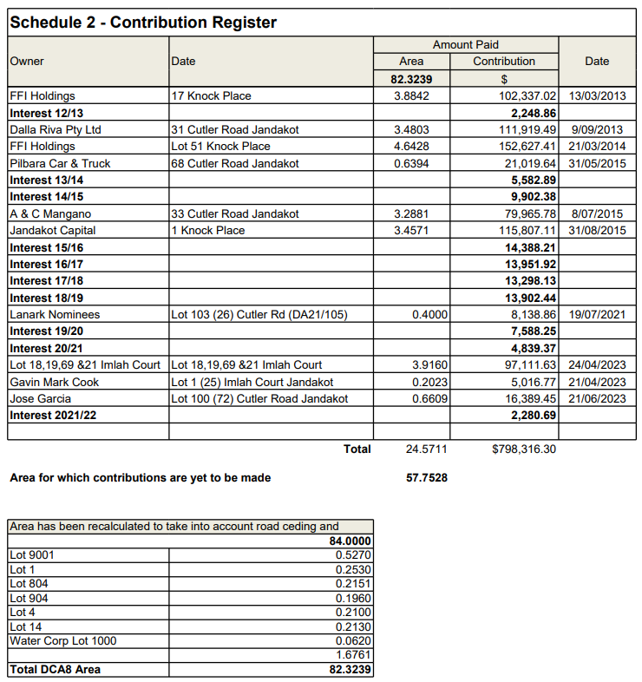Table 3 Contribution Register

# Annex 3 – Capital Expenditure Plan (CEP)

|  |  |  |
| --- | --- | --- |
| **DCP Reserve balance as of 31/08/23** | **\*Value of credits** | **Interest earned on DCP funds 2021/22** |
| 786,011 |  | 2,280.69 |



Notes:

1. this timeframe is subject to change

The following recurring annual payment obligation for DCA8 is not included in table above:

* costs to administer cost sharing arrangements,
* valuations, professional fees for infrastructure cost estimates
* annual audit and administration costs

# Annex 4 – Schedule of Cost of Infrastructure

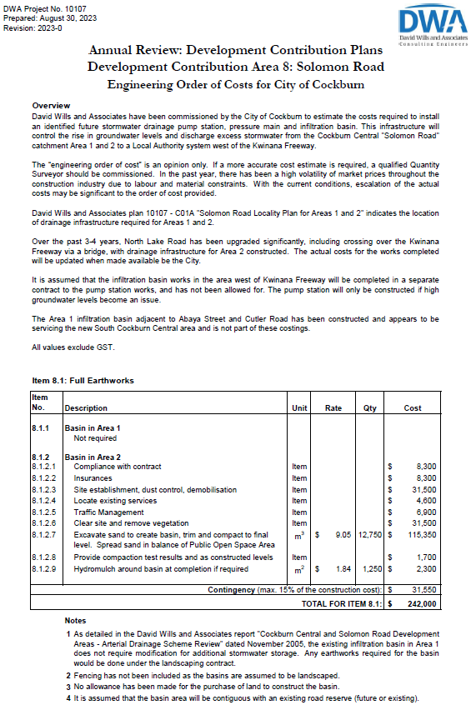

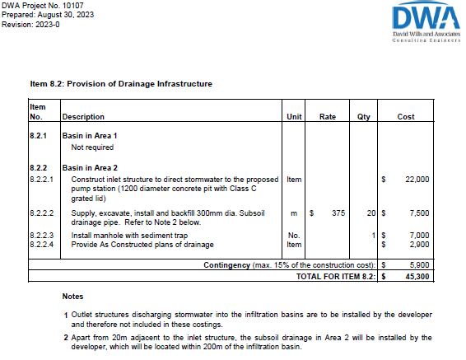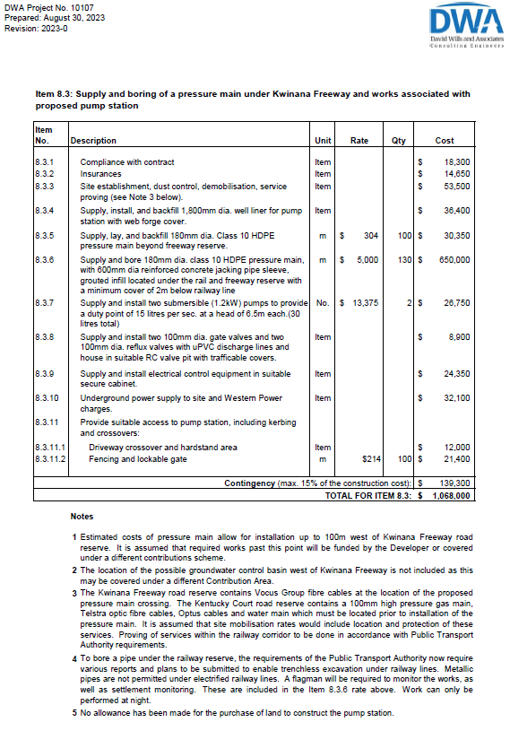

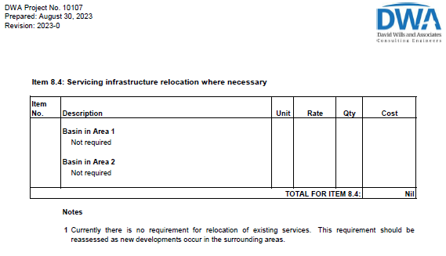

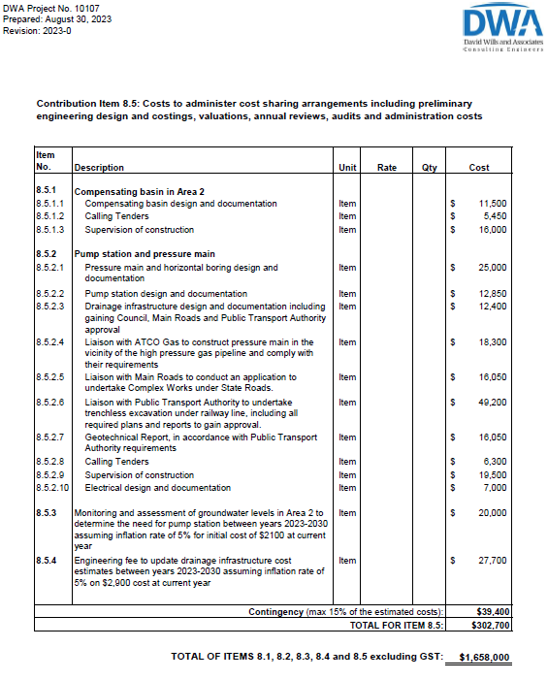

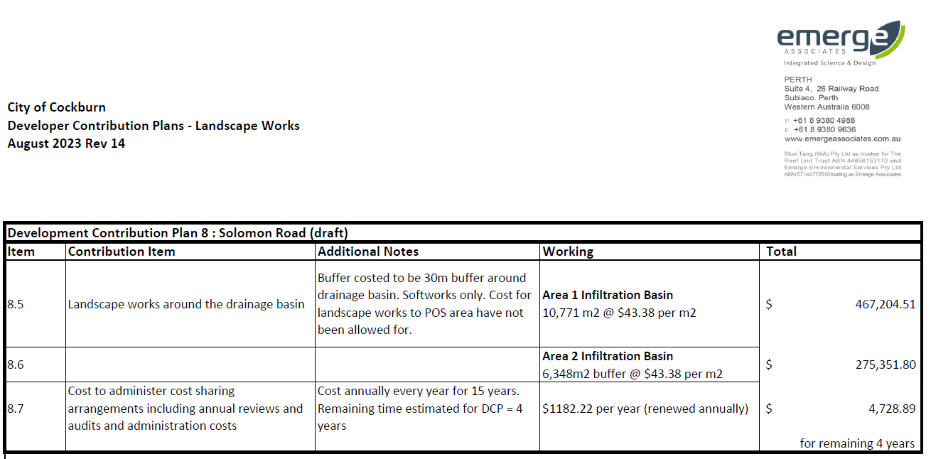

**Contact Us**

**City of Cockburn**

9 Coleville Crescent, Spearwood WA 6193

PO Box 1215, Bibra Lake DC Western Australia 6965

Telephone: 08 9411 3428 Fax: 08 9411 3444

Email: [rlong@cockburn.wa.gov.au](mailto:rlong@cockburn.wa.gov.au)

[City of Cockburn website: cockburn.gov.wa.au](http://www.cockburn.gov.wa.au)

Socila media logos: Facebook, Twitter, Instagram and YouTube.