**Policy**

Filling and Retaining of Land

**Policy Number**

LPP 5.11

# Policy Type

Local Planning Policy

# Policy Purpose

There have been instances where developers have erected retaining walls and fences as part of the subdivisional works without first applying for and receiving a building permit from the City. This presents a difficulty for the City's Building Services in the issue of building permits for buildings and structures on lots retained by unauthorised retaining walls, because of uncertainty regarding possible applied loads (buildings or vehicles) and wall foundations.

It is necessary to have guidelines for the filling of land within the district. This policy should be read in conjunction with the Western Australian Planning Commission’s Planning Bulletin No. 10 (Jan 1996) - “Geotechnical Reports for Subdivisions”.

The purpose of this policy is to establish a procedure for the Engineering certification of filled sites prior to future subdivision and/or development, recognising the proposed end use of the land.

Developers trying to maximise lot potential on an undulating site have constructed excessively high retaining walls which have impacted on the amenity of the adjoining residential development and the street. The purpose of this policy is:

1. To enable a developer with unauthorised retaining walls to have them certified to the satisfaction of Manager Public Building and Health Services so that a subdivision clearance advice can be issued to the Western Australian Planning Commission.

1. To advise owners/developers of their rights and responsibilities before commencing retaining wall building works.

1. To advise on the development of residential building sites with minimal slope through the provision of bulk earthworks and subdivision retaining walls.

1. To minimise the need for large retaining walls as part of dwelling construction.

# Policy Statement

1. Unauthorised Retaining Walls (Subdivision)

If retaining walls are constructed as part of a subdivision without a building permit being issued by the City the developer shall provide the Manager Public Building and Health Services with a certificate from a suitably qualified independent structural engineer stating that any or all of the retaining walls comply with Australian Standard AS 1170 2002 & 2011 and are capable of supporting the surcharge of a standard (1.8m) fibre cement or powder coated steel timber fence. Details of acceptable surcharge loads for a single or double storey residence on the retaining walls are required. Unauthorised retaining walls will be considered in accordance with provisions of the Building Act 2011.

1. All subdivision works on sloping topography within the district shall follow the existing contours of the land in order to minimise earthworks, retaining walls and impacts on amenity, solar access and existing views (see Figure 1)

The City may give a direction for a developer to modify or install a retaining wall to ensure a suitable grade for house construction to the extent that no subsequent retaining is required by prospective purchasers.

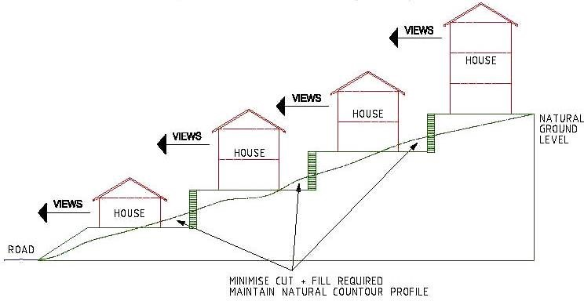

Figure 1: Retaining following existing topography.

1. Planning approval is required for subdivision retaining walls that exceed 2m in height above natural ground level which abut areas of public domain including a primary and/or secondary streets and/or public open space.

1. Planning approval is required for subdivision retaining walls that exceed 0.5m in height above natural ground level which abut existing residential development outside the subdivision area.

1. Concrete post and panel retaining walls will only be permitted where they are not visible from the public domain.

1. Application

* 1. The City must receive and determine an application for a building permit before any work commences.

* 1. A retaining wall may be required if building foundation earth filling extends to a property boundary or if building foundation earth is excavated near a building, including fences.

* 1. Retaining walls are generally required to be designed by a suitably qualified structural engineer and materials must be durable such as concrete, brick or stone.

* 1. The City may require comments from adjoining landowner(s) if a proposed retaining wall does not meet the deemed to comply standards of the Residential Design Codes (R-Codes).

* 1. A delegated Building Surveyor is authorised to approve any retaining wall which is a subdivision retaining wall approved by a suitably qualified structural engineer where it:

* + 1. complies where necessary with an Approval to Commence Development;
    2. complies with the R-Codes where applicable;
    3. is any subdivision retaining wall; or
    4. where a prior subdivision approval has been granted by the Western Australian Planning Commission (WAPC).

* 1. Design details of the retaining wall must be submitted together with the engineer’s certification.

1. Exemption

Pursuant to Clause 157 of the *Planning and Development Act 2005* the development of earthworks and retaining walls is exempt from requiring the approval of the Local government where the WAPC have granted subdivision approval for works shown on the plan of subdivision.

1. Certification

At the completion of the subdivisional earthworks, and in any event prior to applying for subdivision clearance or a Building Permit for any form of development, the Applicant/landowner shall provide the following form of certification.

A qualified Engineer’s geotechnical report and a Certificate classifying the site as Class A in accordance with Section 2 of Australian Standard AS 2870-2011 (in respect of proposed residential sites); or a similar classification in respect of nonpresidential sites. Geotechnical reports are to be prepared by a member of the Association of Consulting Engineers Australia that specialises in geotechnical investigations.

1. Where the geotechnical report classifies the site other than Class “A” in accordance with AS 2870-2011 a notification under section 70A of the Transfer of Land Act is to be prepared in a form acceptable to the Council and judged with the Registrar of Titles for endorsement on the Certificate of Title for the subject lot. Class “P”, “H” and “E” sites will generally not be accepted by the City.

Consideration or acceptance of “P”, “H” and “E” sites would only be given under unusual and exceptional circumstances at discretion of the Manager Public Building and Health Services.

Where subdivision or development is proposed on land the subject of extensive fill the Director of Planning & Development may require the provision of a geotechnical report prior to giving consideration recommending an approval to a subdivision or recommending to Council the approval of an associated structure plan

|  |  |
| --- | --- |
| Strategic Link: | Town Planning Scheme No.3 |
| Category: | Planning – Town Planning & Development |
| Lead Business Unit: | Development Services |
| Public Consultation:  (Yes or No) | Yes |
| Adoption Date:  (Governance Purpose Only) | 12 November 2024 |
| Next Review Due: (Governance Purpose Only) | November 2026 |
| ECM Doc Set ID: (Governance Purpose Only) | 4515127 |