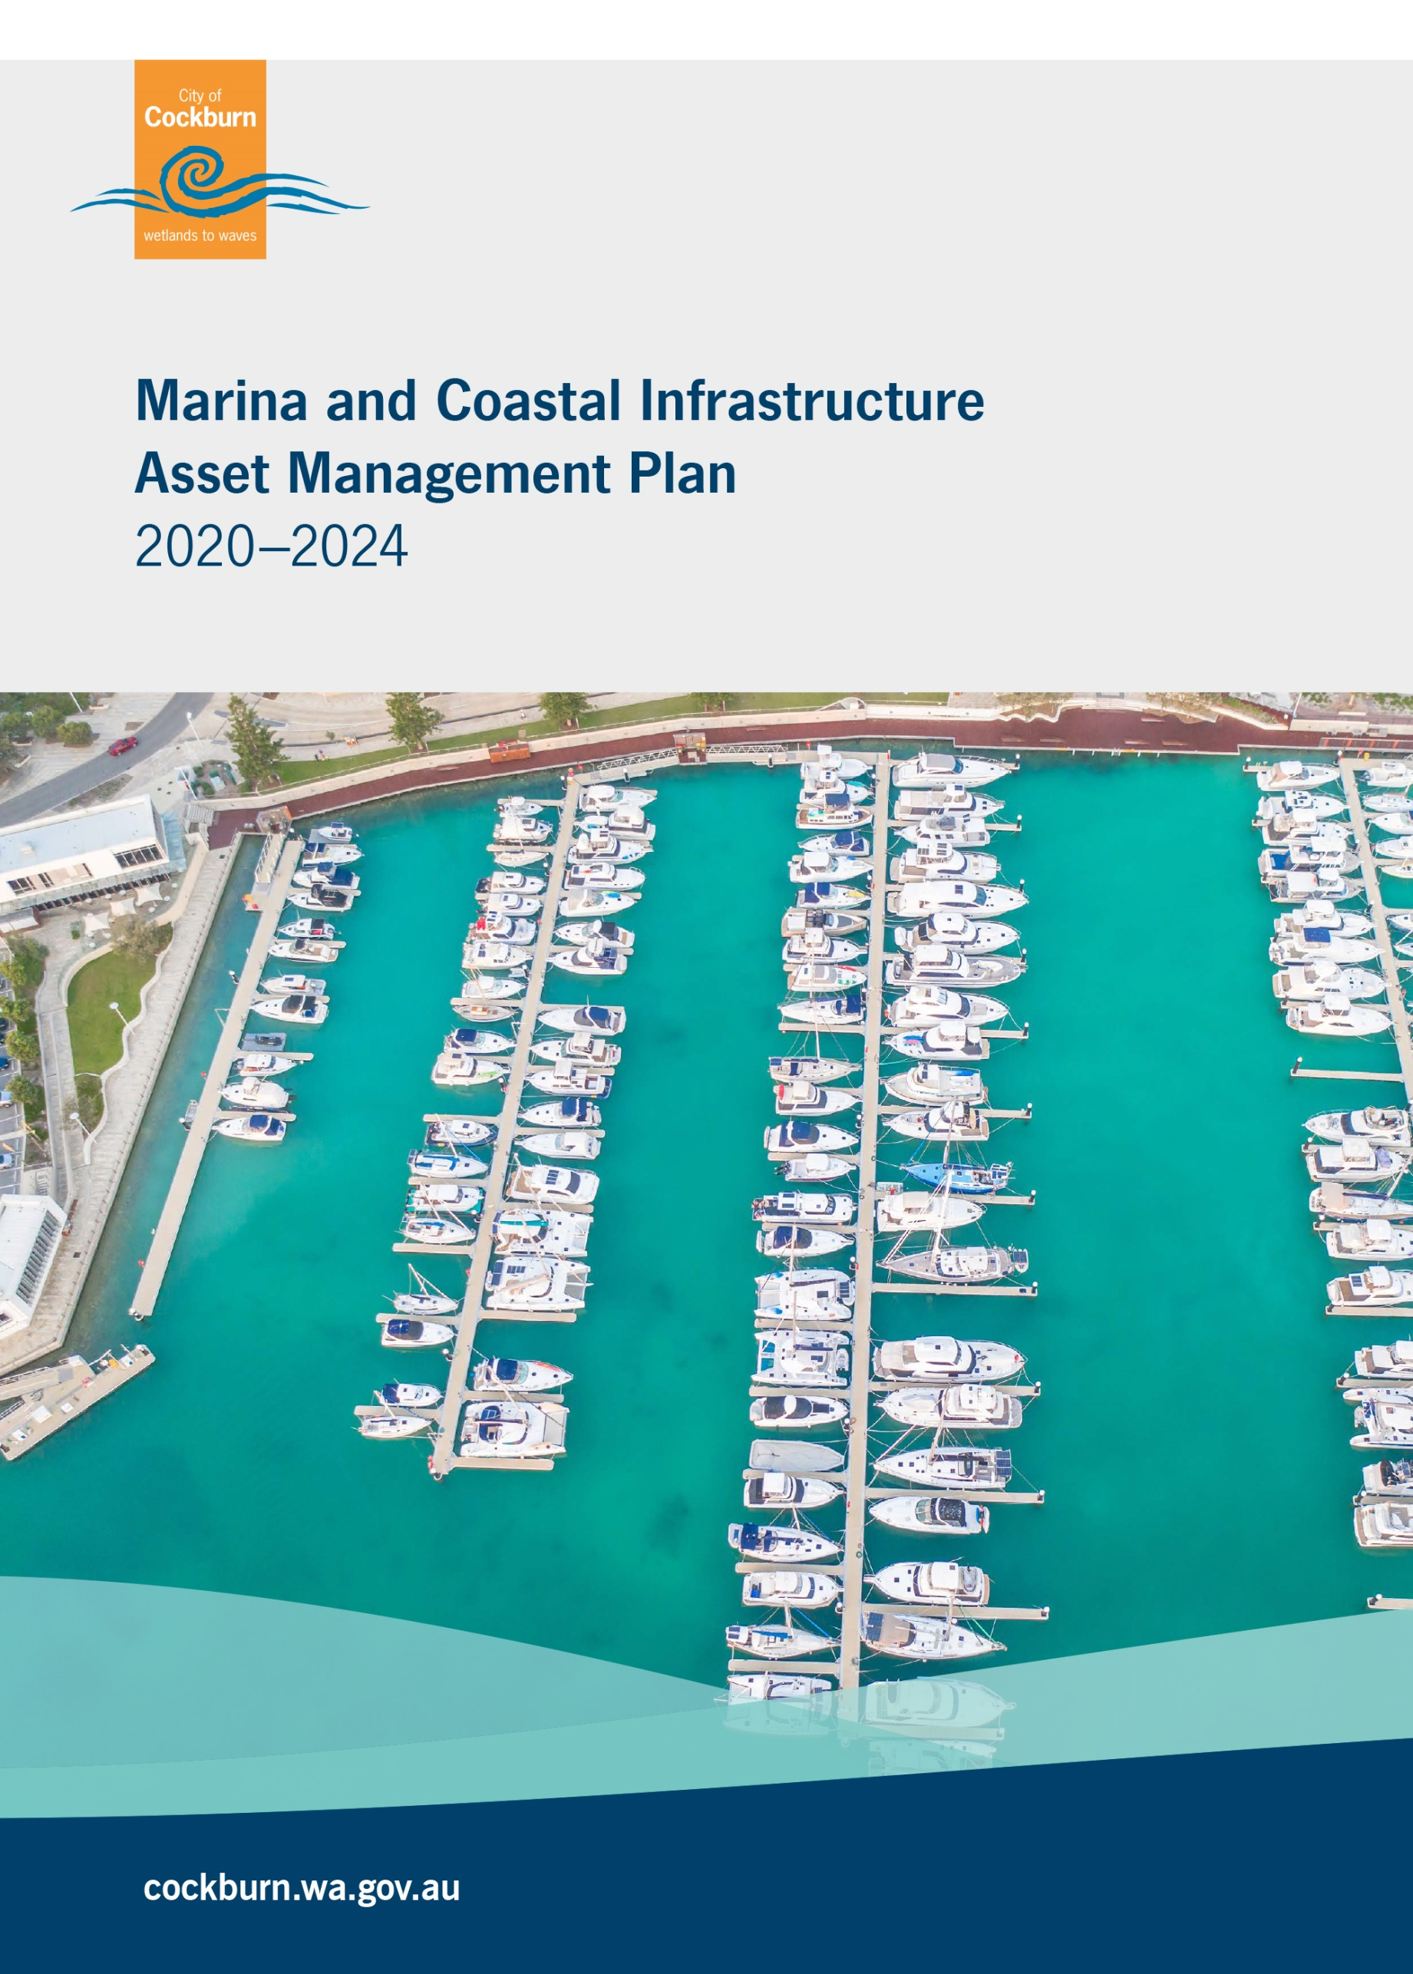

*Front cover image is an aerial of the Marina at Port Coogee.*

|  |  |  |  |  |  |
| --- | --- | --- | --- | --- | --- |
| Document Control | | IPWEA logo col | | | |
| Version No | Date | Version Details | Author | Reviewer | Approver |
| 1 | April 2020 | Draft to Managers | Asset Management | Property & Asset Services |  |
| 2 | June 2021 | Final version for adoption | Asset Management | Executive Committee  (ExCo) | Council |
| 3 |  |  |  |  |  |
| 4 |  |  |  |  |  |
| 5 |  |  |  |  |  |

Acknowledgement of Country

The Mayor, Councillors and staff of the City of Cockburn acknowledge the Whadjuk Nyungar people of Beeliar boodja as the traditional custodians of this land. We pay our respect to the Elders, past, present and emerging.

**Table of Contents**

Glossary 6

1. Executive Summary 1

2. Introduction 6

2.1 Background 6

2.2 Goals and Objectives of Asset Management 12

2.3 Plan Framework 14

2.4 Asset Management Maturity 14

3. Levels Of Service 17

3.1 Current Levels of Service 17

3.3 Enterprise Risk Management 25

3.4 Climate Change and Coastal Risks 31

3.5 Legislative Requirements 31

3.6 Asset Capacity and Performance 31

4. Future Growth And Demand 34

4.1 Growth Forecast 34

4.2 Changes in Technology 36

4.3 Demand Management Plan 37

4.4 New Assets from Growth 39

5. Lifecycle Management 42

5.1 Asset Data 42

5.1.1 Asset Age 43

5.1.2 Useful Life 43

5.1.3 Asset Condition 44

5.1.4 Asset Valuations 46

5.2 Maintenance and Operating Expenditure 47

5.2.1 Standards and Specifications 48

5.3 Renewal and Replacement Plan 48

5.4 New and Upgrade Plan 49

5.5 Disposal Plan 49

6. Financial Analysis 50

6.1 Financial Statements and Projections 50

6.2 Funding Strategy 53

6.3 Sustainability of Service Delivery 53

6.4 Valuation Forecasts 56

6.5 Key Assumptions made in Financial Forecasts 58

6.6 Revenue 59

7. Asset Management Practices 60

7.1 Accounting / Financial Systems 60

7.2 Asset Management Systems 60

7.3 Information Flow Requirements and Processes 61

7.4 Standards and Guidelines 61

8. Plan Improvement And Monitoring 62

8.1 Performance Measures 62

8.2 Improvement Strategy 62

8.3 Monitoring and Review Procedures 63

References 64

Appendices 65

Appendix A Legislative Requirements 66

Appendix B Preliminary 5 Year Capital Works Program 67

Appendix C Preliminary 10 Year Renewal Program 69

**Glossary**

**ASPEC (M, O, R, D) Specification**

ASPEC data Specification and the City’s operational register classification i.e. Marina and Coastal Infrastructure, Open Space, Road and Drainage Specification

**Asset**

A physical component of a facility which has value, enables a service to be provided and has an economic life of greater than 12 months.

**Asset Class**

Groupings of assets of similar nature and use in a local government’s operations (AASB 166.37)

**Asset Classification**

A division of the asset class regarded as having particular shared characteristics

**Asset Type**

Defines the range of assets held in the asset classification i.e. A Spec

**Asset Condition**

Is a measure of the asset’s physical integrity to enable prediction of maintenance, rehabilitation and renewal requirements.

**Asset Management**

The combination of management, financial, economic, engineering and other practices applied to physical assets with the objective of providing the required level of service in the most cost effective manner.

**Capital Renewal Expenditure**

Expenditure/ works on an existing asset which returns the service potential or the life of the asset to that which it had originally.

**Capital New Expenditure**

Expenditure used to create new assets or to increase the capacity of existing assets beyond their original design capacity or service potential.

**Capital Upgrade Expenditure**

Expenditure which enhances an existing asset to provide a higher level of service or expenditure that will increase the life of the asset beyond that which it had originally.

**Current Replacement Cost (CRC)**

The cost of replacing the service potential of an existing asset, by reference to some measure of capacity, with an appropriate equivalent asset.

**Depreciation**

The wearing out, consumption or other loss of value of an asset whether arising from use, passing of time or obsolescence through technological and market changes.

*The systematic allocation of the depreciable amount (service potential) of an asset over its useful life.

**Depreciated Replacement Cost**

The replacement cost of an existing asset less an allowance for wear and consumption, having regard for the remaining economic life of the existing asset.

**Expenditure**

The spending of money on goods and services.

**Fair Value**

Fair value is defined as the price that would be received to sell an asset or paid to transfer a liability in an orderly transaction between market participants at the measurement date.

**Funding Gap \***

Difference between estimated budgets and projected expenditures from the Long Term Financial Plan for maintenance and renewal of assets, totalled over a defined time.

**Gap Analysis**

A method of assessing the gap between a business’s current asset management practices and the future desirable asset management practices.

**Integrated Planning and Reporting**

A framework for establishing community priorities and linking this information into different parts of a local government’s functions.

**Level of Service \***

The defined service quality for a particular activity or service area against which service performance can be measured. Service levels usually relate to quality, quantity, reliability, responsiveness, environmental, acceptability and cost.

**Life Cycle Management**

The total cost of an asset throughout its life including costs for planning, design, construction, acquisition, operation, maintenance, rehabilitation and disposal.

**Long Term Financial Plan (LTFP)**

Supported by the Asset Management Planning Process the LTFP is a ten year rolling plan that informs the Corporate Business Plan to activate Strategic Community Plan priorities. From these planning processes, Annual Budgets that are aligned with strategic objectives can be developed.

**Maintenance**

All actions necessary for retaining as asset as near as practicable to its original condition, but excluding rehabilitation or renewal.

**Non-Asset Solution**

The process used to identify the alternative methods of addressing, reducing and/ or increasing demand for services other than by adjusting asset capacity.

**Operating Expenditure \***

Recurrent expenditure, which is continuously required excluding maintenance and depreciation, e.g. power, fuel, staff, plant equipment, on-costs and overheads.

**Planned Maintenance \***

Repair work that is identified and managed through a maintenance management system, activities include inspection, assessing the condition against failure/breakdown criteria/experience, prioritising scheduling, actioning the work and reporting what was done to develop a maintenance history and improve maintenance and service delivery performance.

**Reactive Maintenance \***

Unplanned repair work that is carried out in response to service requests and management / supervisory directions.

**Remaining Life \***

The time remaining until an asset ceases to provide the required service level or economic usefulness. Age plus remaining life is economic life.

**Replacement Cost**

The cost of replacing an existing asset with a substantially identical new asset.

**Risk Management \***

The application of a formal process to determine the range of possible values relating to key factors associated with a risk in order to determine the resultant ranges of outcomes and their probable occurrence.

**Strategic Community Plan**

The strategy and planning document that reflects the longer term (10+ year) community and local government aspirations and priorities.

**Useful Life \***

Either:

(a) the period over which an asset is expected to be available for used; or

(b) the number of production or similar units (i.e. intervals, cycles) that is expected to be obtained from the asset.

Source: **Government** of WA Asset management framework and guidelines, Glossary**\***

Source: DVC 2006, Glossary ‘Asset Investment Guidelines’

**1. Executive Summary**

With the implementation of the City’s Integrated Corporate planning Framework, the Marina & Coastal Infrastructure Asset Management Plan (MCIAMP) has been developed to establish sustainable financial management, robust governance, continuous improvement and best practice management of the City’s infrastructure assets.

The MCIAMP covers the 2020-21 to 2023-24 financial years and outlines the services provided by the Marina & Coastal Service Unit in delivering strategic and operational asset management activities for communities that utilise the City’s Marina and Coastal Infrastructure assets.

The MCIAMP is the eighth infrastructure AMP developed by the City and forms part of the City’s Strategic Asset Management Planning Framework. The MCIAMP will be developed every four years in alignment with the Corporate Planning Framework ensuring that the City’s long term financial planning (LTFP) is supported by timely and accurate asset information and financial projections derived from a structured and strategic asset management planning process.

The 2020 - 2024 version of the MCIAMP is the first developed by the City and in accordance with the International Infrastructure Maintenance Manual (IIMM) has achieved ‘core’ level status. Future versions of MCIAMP will be developed in alignment with IIMM to ensure that an intermediate level AMP is developed, similar to the City’s seven Infrastructure AMPs.

The MCIAMP’s improvement strategy will guide the Marina & Coastal Service Unit to continuously improve services provided, establishing best practice strategic and operational asset management methodologies across people, processes and systems.

**Table 1.1 Marina and Coastal Infrastructure Assets as at February 2020**

|  |  |  |  |
| --- | --- | --- | --- |
| Asset Group | Asset Classification | Quantity | Replacement Value |
| Marine Specific | Edge Walls and Retaining Walls | 11 | $6,601,932 |
| Gangways, Jetties and Pontoons | 96 | $11,894,492 |
| Piles | 150 | $2,014,505 |
| Sea Walls and Breakwaters | 5 | $23,691,000 |
| Service Lines | 19 | $302,098 |
| Service Points | 122 | $185,700 |
| Open Space Specific | Boardwalk | 1 | $4,400,000 |
| Fences | 3 | $19,359 |
| Minor Structures | 15 | $247,430 |
| Rubbish Bins | 17 | $30,350 |
| Seats | 9 | $8,100 |
| Road Specific | Lighting | 55 | $68,785 |
| Signs | 19 | $4,710 |
| TOTAL | | **522** | $49,468,461 |

The key messages from the 2020 Marina and Coastal Infrastructure Asset Management Plan are summarised below:

**Asset Data & Condition Analysis**

* The data utilised to develop the MCIAMP is considered to be approximately 85% accurate and of medium confidence.
* The City’s Marina and Coastal Infrastructure assets are in an excellent to moderate condition with 48.8% of the assets in condition 1, 51.1% in condition 2 and <1% in condition 3. See legend at Graph 5.1.3 Asset Condition Profile.
* See **(Section 5)** for further information

**Level of Service and Risk Management**

**Level of service management:**

Level of service management is a measurable target which determines the type and extent of services delivered to the community. Marina and Coastal Infrastructure levels are measured internally and, by the community to determine adequate provision.

* Berth occupancy has increased annually since opening in 2016 from 47% to 98% in 2019.
* Marina & coastal assets are in good order and free from hazards, there have been no public liability claims received.
* Attendance numbers to City hosted annual social events are increasing from 87 in 2016 to 100 in 2019.
* See **(Section 3)** for further information

**Risk management:**

**The following risk treatments / strategies have been implemented to mitigate the City’s risk.**

* $20K Annual Coastal monitoring program to prevent the loss or damage to land and assets due to erosion resulting from climate change.
* $5K Annual Marine Monitoring Programme to monitor waterways and fish diversity in the Port Coogee Waterways
* $15K Annual jetty inspections as part of a five year maintenance contract for the marina, including additional ‘after storm event’ inspections at $1,500 to identify specific storm damage.
* Mandatory 3-yearly fire and safety inspection of all boats by qualified contractor to comply with marina rules to assist with prevention of incidents, including boat fires, infrastructure damage and personal safety risks $30K/year.

See **(Section 3)** for further information

**Future Growth and Demand Management**

Projected future growth is supported by the City’s Strategic Planning Business Unit’s population and demographic research study’s, whilst demand management is catered for by the upgrade and construction of existing and new assets through the delivery of the City’s adopted Major Capital Work strategies, programs and plans.

Continued population growth within the City of Cockburn and activation of Cockburn’s coastline has resulted in the City establishing the following strategies / projects to meet demand and increase the services provided.

The City has developed a Preliminary 5 Year Capital Works Program with estimated project costs of $14.7million inclusive of 2% compound CPI. A summary of the major projects of the program is provided below:

* + During 2020-21 Stage 3 of the Marina Expansion will be constructed, an investment of $5.2m will establish approximately 80 new berths and provide increased capacity to service the berth waitlists. The number of people on the waitlists is approximately 40.
* During 2022-23 an investment of $5m is planned to deliver Phase 1 of the Erosion Protection Structures at C Y O'Connor
* During 2023-24 $0.75m is proposed to develop the Cockburn Coast Foreshore Plan at C Y O’Connor Beach
* During 2024-25 a budget of $1.4m will install new floating jetties at the southern side of Port Coogee Marina being Stage 4 of the marina expansion.

See **(Section 4 & Appendix B)** for further information

See **(Appendix B)** for the preliminary 5 year capital works program

**Lifecycle Management**

The lifecycle management section details how the City plans to manage and operate both current and future assets to the agreed levels of service whilst optimising life cycle costs.

* Current Maintenance & Operational expenditure is adequate however future budgeting requirements to meet appropriate service levels need to be assessed for the Marina Expansion.
* Planned maintenance work was 98% of the total maintenance expenditure for the 2018-19 period.
* By 2029-30 required expenditure for Operations and Maintenance is expected to be approximately $2.9 million, this figure includes new assets growth from capital works and the marina expansion plan.

See **(Section 5)** for further information.

**Financial Analysis**

**Marina and Coastal Infrastructure Asset Renewal Forecasts**

The City has developed a 10 year renewal plan which will inform the budget planning process and the City’s long term financial planning.

* As at 2029-30 the total Replacement Cost, based on the 2019-20 dollar value, is $74.1 million.
* The 10 year projected renewal expenditure value totals $1.9 million inclusive of 2% compound CPI.
* There is no 10 year cumulative funding gap for marina and coastal infrastructure assets, this is based the MCIAMP receiving 100% renewal funding from the City’s funding strategies.

See **(Section 6)** for further information

See **(Appendix C)** for the 10 year Renewal program

**Sustainability of Service Delivery**

The City will compile and report its Marina and Coastal infrastructure assets performance in relation to the Dept. of Local Government’s Asset Management Guidelines and Framework.

Based on actual expenditure in 2018-19, Table 1.2 indicates the City’s performance in managing marina and coastal infrastructure assets as at February 2020.

**Table 1.2 Marina and Coastal Infrastructure Asset Ratio Summary Table**

|  |  |  |  |
| --- | --- | --- | --- |
| Asset Class | Consumption Ratio  2018/19 | Sustainability Ratio  10 Years | Renewal Funding Ratio  10 Years |
| Marina and Coastal Infrastructure | **79%** | **13%** | **100%** |
| Dept of LG Framework Standard | **Met** | **Not Met** | **Met** |

Sustainability ratios for marina and coastal infrastructure have been forecast for the next 10 years to reflect the improvements the City will make following the completion of the LTFP. The sustainability ratio for the 2029-30 period is predicted to be 13%, the renewal funding ratio for the same period is predicted to be 100%.

See **(Section 6)** for further information

**AMP Improvement Strategy and Monitoring**

A number of strategic improvements have been identified that will improve future revisions of the plan and provide greater financial alignment with the Long Term Financial Plan 2020-21 to 2029-30.

* Condition assessments for all marina and coastal infrastructure assets to better inform renewal planning and continue ‘whole of life’ approach to asset management.
* Revaluation of marina and coastal assets in 2021-22 to improve confidence in financial reporting. The valuation methodology is based upon the Australia and New Zealand Valuation and Property Standards and Mark IV Industrial Special Risk Insurance Policy using Australian Accounting Standard AASB 13 and AASB 116.
* Implementation of Technology One Enterprise Asset Management System.

See **(Section 8)** for further information

**2. Introduction**

2.1 Background

The Port Coogee Marina was constructed in 2011 and for the first five years was operated as a managed service by Frasers Property Australia. The management of the Marina was transferred to the City in 2016.

During 2016 the City created the Marina & Coastal Service Unit, which now consists of 3 full time staff members. The Service Unit resides within the Engineering & Works Directorate and Infrastructure Services Business Unit and provides day to day operational management for the 150 floating berths, associated ancillary assets and coastal infrastructure along the Cockburn coastline.

The Marina & Coastal Service Unit is responsible for the Management of the Port Coogee marina facility including business development, Licence holders’ liaison and daily service operations including the delivery of coastal infrastructure and management initiatives

The Port Coogee Marina features include:

* Four floating jetties containing boat bays ranging from 10 – 20m in length for both mono and multihull vessels,
* Metered power and water facilities provided at each boat bay,
* A timber boardwalk with secure gatehouses which provide access to the jetties,
* Onshore showers and toilets for Licence holders,
* A service jetty with fuel system, a sullage pump-out facility and a public visitor berthing area.

Other key infrastructure in the marina and waterways include waterway edge walls, piles, protective seawalls and breakwaters, public fishing jetty and general landscaping features.

In addition other coastal assets within the City of Cockburn managed by the Service Unit include the Coogee Jetty, Coogee Maritime Trail stairs, rock groynes, four swimming pontoons, the eco swimming enclosure and the largest asset being the beaches themselves, ranging from CY O’Connor Beach in the City’s North to the Woodman Point Launching Ramps Beach in the South see Figure 2.1, 2.2. and 2.3.

**Figure 2.1 Aerial view of Port Coogee Marina, November 2018**

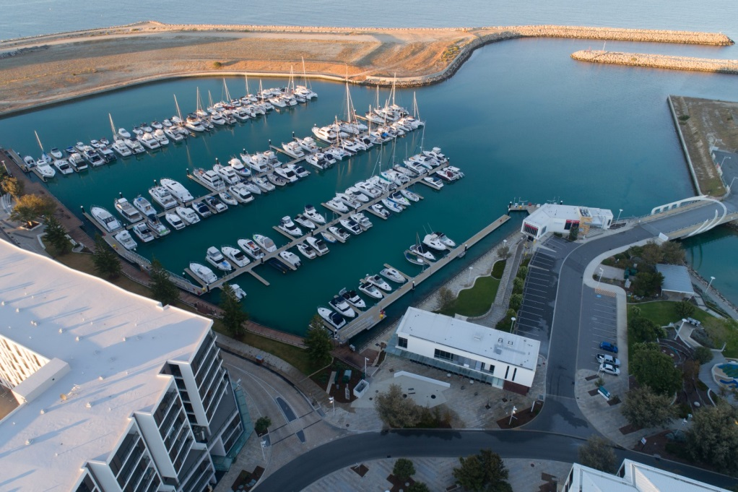

**Figure 2.2 Overview of the Marina and Coastal assets covered by this plan**

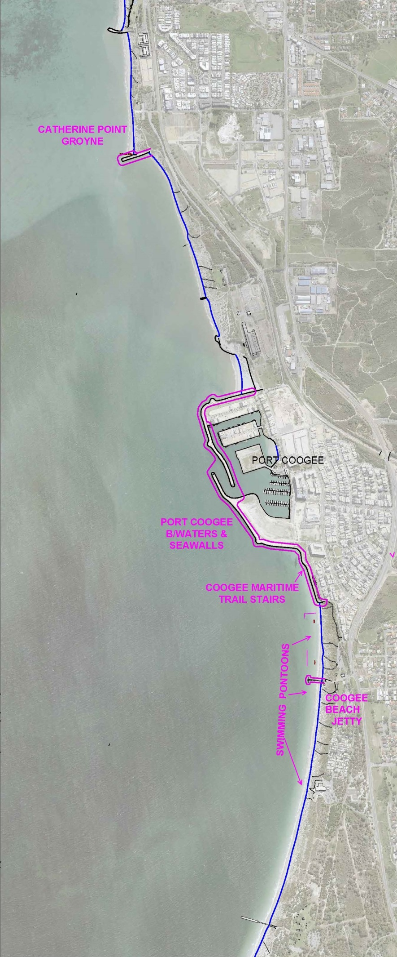

**Figure 2.3 Detailed view of Marina and Coastal Assets within Port Coogee**

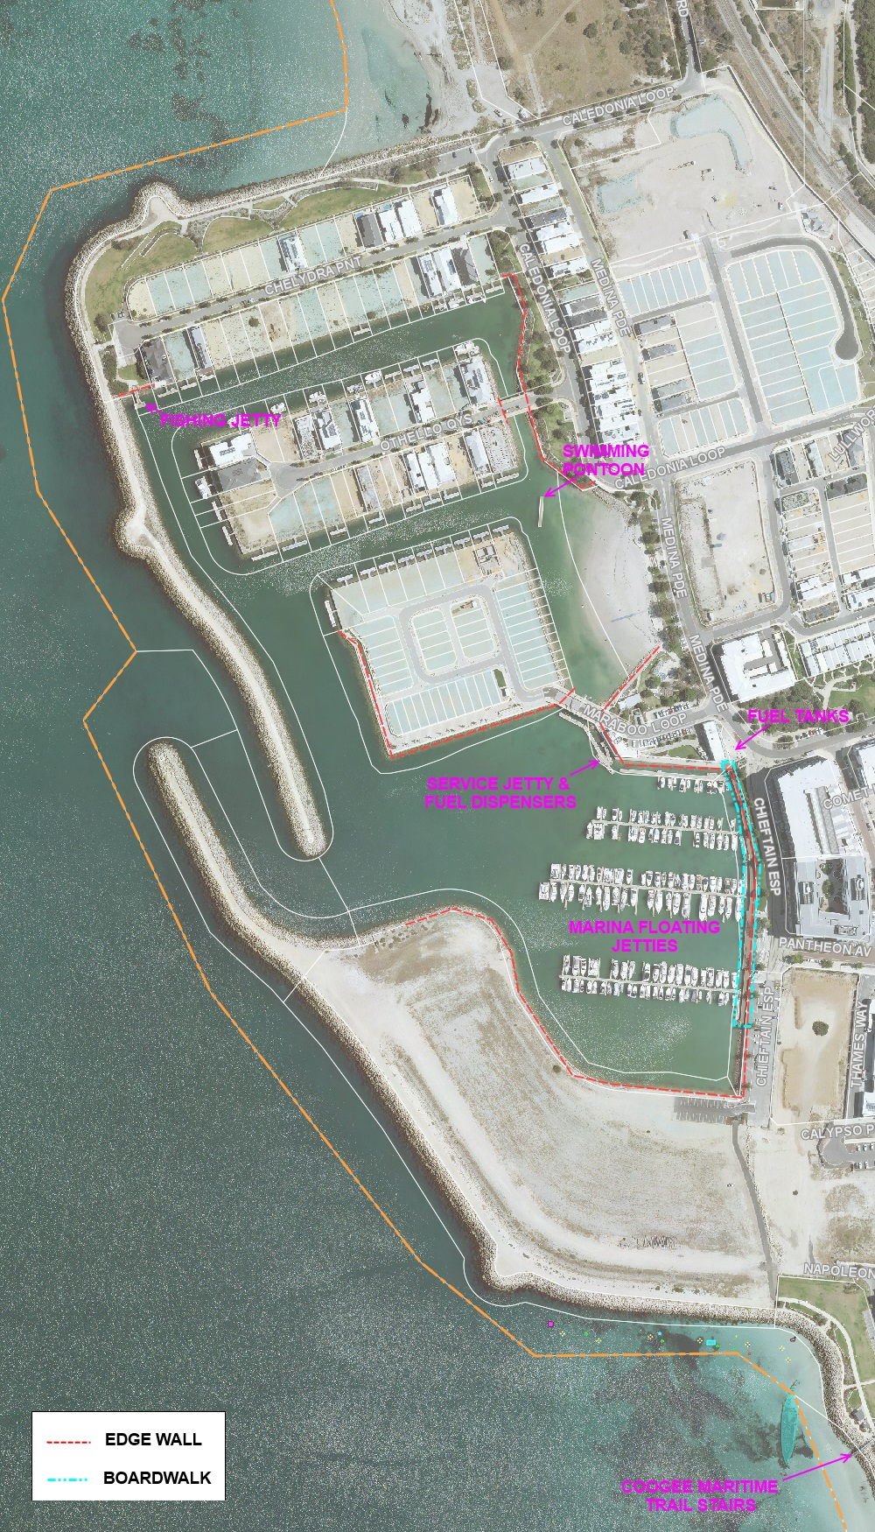

As at February 2020, the assets covered by this plan are summarised in Table 2.1.1 and have been extracted from Council’s Technology One Enterprise Asset Management System (EAM).

**Table 2.1.1 Marina and Coastal Infrastructure Assets Covered by this Plan**

|  |  |  |
| --- | --- | --- |
| Asset Group | Asset Classification | Quantity |
| M Spec - Edge Walls and Retaining Walls | Retaining Walls | 8 |
| High and Low Edge Walls | 3 |
| M Spec – Gangways, Jetties and Pontoons | Access Gangways | 7 |
| Central Jetties (Floating) | 4 |
| Coogee Beach Jetty | 1 |
| Finger Jetties | 78 |
| Fuel Jetty | 1 |
| Public Jetties | 2 |
| Swimming Pontoons | 3 |
| M Spec – Piles | Boardwalk Piles | 92 |
| Floating Jetty Piles | 58 |
| M Spec – Sea Walls and Breakwaters | Sea Walls | 2 |
| Breakwaters | 3 |
| M Spec – Service Lines | Electrical | 7 |
| Fire | 4 |
| Fuel | 2 |
| Sand Bypass Pipe | 2 |
| Water | 4 |
| M Spec – Service Points | Fuel Tanks | 2 |
| Emergency Cabinets | 5 |
| Fire Hose Reels | 21 |
| Fire Hydrants | 8 |
| Fuel Dispensers | 2 |
| Fuel Payment Terminal | 1 |
| Service Pillars | 80 |
| Spill Kits | 2 |
| Sullage Facility | 1 |
| O Spec – Boardwalk | Boardwalk | 1 |
| O Spec – Fences | Fences | 3 |
| O Spec – Minor Structures | Gatehouses | 3 |
| Steel Frames | 11 |
| Beach Access Stairs | 1 |
| O Spec – Rubbish Bins | Rubbish Bins / Sea Bin | 16 / 1 |
| O Spec – Seats | Seats | 9 |
| R Spec – Lighting | Feature Wall | 28 |
| Fuel Pontoon Lighting | 1 |
| Gatehouses | 3 |
| Floodlights | 1 |
| Park Lights | 4 |
| Sensor Lights / Solar Lights | 10 / 1 |
| R Spec – Signs | Signs | 19 |
| TOTAL | | 522 |

The AMP is to be read in conjunction with the following associated planning documents:

City of Cockburn Strategic Community Plan 2020 to 2030

City of Cockburn Corporate Business Plan 2016/17 – 2019/20

City of Cockburn Annual Business Plan 2019 – 2020

City of Cockburn Long Term Financial Management Plan 2020/21-2029/30

Port Coogee Marina Safety and Emergency Management Plan

Waterways Environmental Management Plan (WEMP)

Key stakeholders in the preparation and implementation of this asset management plan are shown in Table 2.1.2

**Table 2.1.2 Key Stakeholders in the AM Plan**

|  |  |
| --- | --- |
| ENTITY | NATURE OF INVOLVEMENT |
| INTERNAL STAKEHOLDERS: |  |
| The Elected Council | Community representation |
| Chief Executive Officer (CEO) | Asset management direction and leadership |
| Executive Committee (ExCo) | Executive management endorsement, sign off and executive ownership |
| Manager Infrastructure Services | Review and strategic management sign off |
| Marina Manager | Review and line management sign off and implementation of the AMP maintenance actions |
| Property and Asset Services | Asset management plan development, review and continuous improvement |
| EXTERNAL STAKEHOLDERS: |  |
| Insurers | Assist to manage financial risk of the City |
| City of Cockburn Community  Coogee Beach Surf Lifesaving Club  Port Coogee Community Association | Service and facility users |
| Marina Facility Pen Holders | Service and facility users |
| City of Cockburn Businesses  Developers e.g. Frasers and Megara | Service and facility users |
| Emergency Services  Water Police  Cockburn Sea Rescue  DFES (Department of Fire and Emergency Services)  MEER (Maritime Environmental Emergency Response) | Attendance to call-outs and security |
| Government Agencies  Department of Transport  Department of Lands | Attend emergencies, provide assistance and security |

2.2 Goals and Objectives of Asset Management

The City of Cockburn exists to deliver services to its community supported by the City’s infrastructure assets. The City acquires infrastructure assets by ‘purchase’, ‘contract’, construction by council and by handover of ‘donated’ assets constructed by developers in order to meet the increased demand for services.

The City of Cockburn’s goal in managing infrastructure assets is to meet the required level of service in the most cost effective manner for present and future consumers.

The key elements of infrastructure asset management are:

* Taking a life cycle approach,
* Developing cost-effective management strategies for the long term,
* Providing a defined level of service and monitoring performance,
* Understanding and meeting the demands of growth through demand management and infrastructure investment,
* Managing risks associated with asset failures,
* Sustainable use of physical and financial resources, and
* Continuous improvement in asset management practices.

This AMP is prepared under the direction of Council’s vision, purpose, goals and objectives.

The City of Cockburn’s vision is:

Cockburn, the best place to be

The City of Cockburn’s purpose is:

Support our communities to thrive by providing inclusive and sustainable services which reflect their aspirations

The 5 key outcome areas as detailed in the Strategic Community Plan (SCP) 2020-2030 are:

* Local Economy,
* Environmental Responsibility
* Community, Lifestyle & Security
* City Growth and Moving Around
* Listening and Leading

The relevant goals and objectives as outlined in the Strategic Community Plan and how these are addressed in this asset management plan are detailed in Table 2.2.1.

**Table 2.2.1 Council Goals and how these are addressed in this Plan**

| Strategic Outcome | Strategic Objective | How Goals and Objectives are addressed |
| --- | --- | --- |
| Local  Economy: A sustainable and diverse local economy that attracts increased investment and provides local employment | Increased investment, economic growth and local employment.  Thriving local commercial centres, local  businesses and tourism industry.  A City that is ‘easy to do business with’. | **Future Growth and Demand:**  Section 4  **Levels of Service:** Section 3 |
| Environmental Responsibility: A leader in environmental management that enhances  and sustainably manages our local natural areas and resources | Protection and enhancement of our natural areas, bushland, parks and open spaces.  Sustainable resource management including waste, water and energy.  Address Climate Change. | **Future Growth and Demand:**  Section 4  **Lifecycle Management:** Section 5  **Levels of Service:** Section 3 |
| Community, Lifestyle & Security: A vibrant, healthy, safe, inclusive and connected  community | A safe and healthy community that is socially connected.  Accessible and inclusive community, recreation and cultural services and facilities that enrich our community. | **Levels of Service:**  Section 3 |
| City Growth and Moving Around: A growing City that is easy to move around and  provides great places to live | An attractive, socially connected and diverse built environment. | **Levels of Service:**  Section 3 |
| Listening and Leading: A community focused, sustainable, accountable and progressive organisation | An attractive, socially connected and diverse built environment.  High quality and effective community engagement and customer service experiences. | **Financial Analysis:**  Section 6  **Levels of Service:**  Section 3 |

2.3 Plan Framework

Key elements of the AMP are:

* Levels of Service and Enterprise Risk Management – outlines the levels of service provided by Council and identifies risks to the City.
* Future Growth and Demand – how this will impact on future service delivery and how this is to be met.
* Lifecycle Management – how the City will manage its existing and future assets to provide the required services.
* Financial Analysis – what funds are required to provide the required services.
* Asset management practices.
* Asset management monitoring and improvement plan – how the plan will be monitored and improved to ensure it is meeting Council’s objectives.

2.4 Asset Management Maturity

The 2020-2024 AMP has been developed in accordance with the International Infrastructure Management Manual (IIMM) and complies with the Department of Local Government & Communities Asset Management Framework.

As part of the City’s Strategic Asset Management Framework, the MCIAMP will formalise the City’s future forecasting for Marina & Coastal Infrastructure, enabling the organisation to determine future budgeting requirements, sustain the current and future asset base, whilst ensuring that optimisation of activities and programs facilitate for the capture and reporting of adopted service levels.

The MCIAMP has reached a ‘core’ level of maturity and provides Executive level monitoring and reporting of key improvement areas from the Improvement Strategy.

With the continued implementation of the Strategic Asset Management Framework, the City will commence measuring service levels for planned and reactive maintenance to determine operational performance and asset utilisation.

The City strives to improve its strategic and operational asset management practices and to continue its journey towards advanced asset management. The Department of Local Government, Sport and Cultural Industries (DLGSC) has developed the Western Australia Local Government Integrated Planning and Reporting Framework. The future direction and need for advanced level practices are continually assessed in accordance with this and the City’s Asset Management Policy. The Integrated Planning and Reporting Framework is shown Figure 2.4.1.

**Figure 2.4.1 The City’s Integrated Corporate Planning Framework**

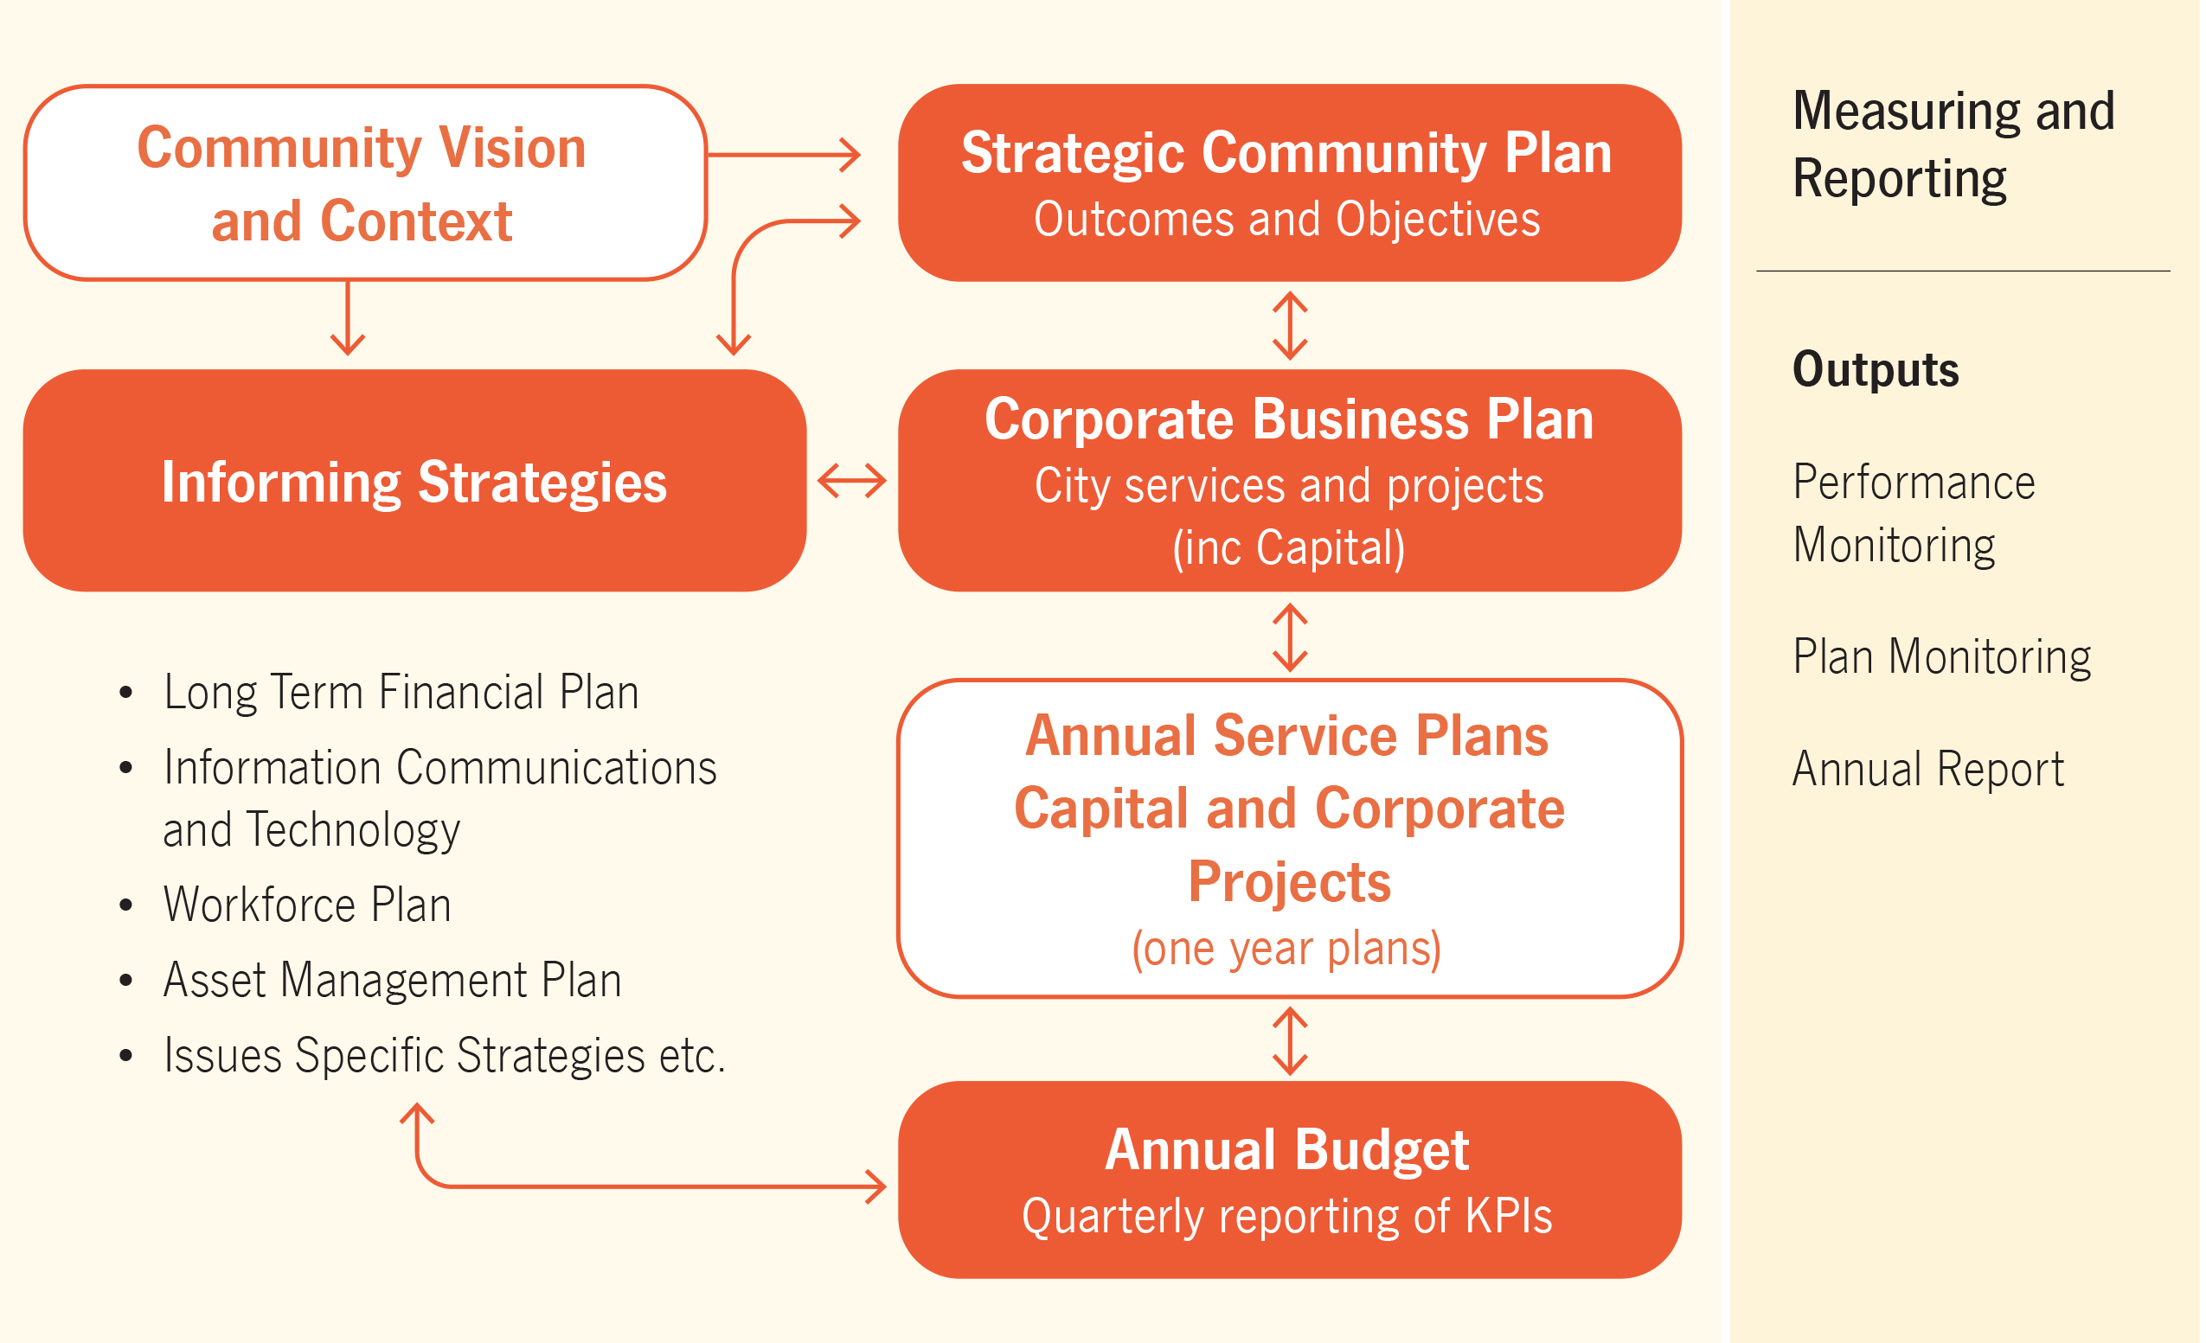

The MCIAMP forms part of the City’s Assets Informing Strategies, which consists of the following strategy and asset management plans:

Asset Management Strategy - 2017 - 2024

Buildings AMP - 2020 - 2024

Cockburn Aquatic and Recreation Centre (ARC) AMP – 2020 - 2024

Drainage AMP - 2020 - 2024

Footpath AMP - 2020 - 2024

Fleet and Plant AMP - 2020 -2024

Parks & Environment AMP - 2020 -2024

Road Infrastructure AMP - 2020 – 2024

2.5 Asset Management Plan Maturity & Data Confidence Assessment

Each of the five sections within the MCIAMP were reviewed to determine Stakeholder confidence as to the accuracy and maturity of the City’s asset data and services.

**Table 2.5.1 Data Accuracy**

|  |  |  |
| --- | --- | --- |
| **AMP** | **Contents** | **Data Confidence** |
| **Section 2** | Strategic goals & objectives | **A** |
| **Section 3** | Levels of Service  Risk Management | **B** |
| **Section 4** | Growth, Demand, New Assets | **A** |
| **Section 5** | Asset data; Age, Condition  Operating & Maintenance Expenditure, Renewal Expenditure | **C** |
| **Section 6** | Financial statements; Renewals Gap, Ratios | **B** |

Ratings are based on the following criteria / inputs.

**Table 2.5.2 Data Confidence Criteria**

| **Confidence Grade** | **Description** |
| --- | --- |
| A  Highly reliable | Data based on sound records, procedures, investigations and analysis, documented properly and agreed as the best method of assessment. Dataset is complete and estimated to be accurate ± 2% |
| B  Reliable | Data based on sound records, procedures, investigations and analysis, documented properly but has minor shortcomings, for example some of the data is old, some documentation is missing and/or reliance is placed on unconfirmed reports or some extrapolation.  Dataset is complete and estimated to be accurate ± 10% |
| C  Uncertain | Data based on sound records, procedures, investigations and analysis which is incomplete or unsupported, or extrapolated from a limited sample for which grade A or B data are available.  Dataset is substantially complete but up to 50% is extrapolated data and accuracy estimated ± 25% |
| D  Very Uncertain | Data is based on unconfirmed verbal reports and/or cursory inspections and analysis.  Dataset may not be fully complete and most data is estimated or extrapolated.  Accuracy ± 40% |
| E  Unknown | None or very little data held. |

**3. Levels of Service**

To support the management of Marina & Coastal assets the City has developed industry best practice asset management and customer focussed levels of service (LOS) for infrastructure assets and associated services. These LOS’s provide the City with a mechanism to deliver operational activities that endeavour to meet community expectations in the most cost effective manner possible.

The City administers Community and Technical Services levels to ensure that quality service provision is provided in accordance with the City’s customer Service Charter and Community Engagement Framework, whilst Technical Services are sustainable, and adhere to all relevant compliance and safety industry standards.

The MCIAMP community and technical levels of service are defined to an asset group level and enable the City to monitor and report operational performance against adopted community and technical targets.

Similar to the City’s existing Asset Management Plans, future MCIAMP Service level reporting will be derived from the City’s Enterprise Asset Management System (EAM). The Implementation of the EAM will establish improved reporting of operational and maintenance budget expenditure providing increased confidence in projecting future budget needs.

3.1 Current Levels of Service

The City of Cockburn has defined service levels in two terms:

* Community Levels of Service relate to how the community receives the service in terms of safety, quality, quantity, reliability, responsiveness, cost efficiency and legislative compliance.
* Supporting the community service levels are operational or technical measures of performance developed to ensure that at least the minimum community levels of service are met. Technical Levels of Service relate to how the City provides the service using technical terms.

Tables 3.1.1 and 3.1.2 outline the City’s current Community and Technical Service Levels objectives, measures and performance demonstrating the diversity and quality of services provided by the City’s Marina Services Team.

Table 3.1.1 shows the current Community levels of service being provided under MCIAMP. The ‘desired’ position in the table, documents the position being recommended in this AM Plan.

**Table 3.1.1 Community Levels of Service**

| **Service Attribute** | **Service Objective** | **Performance Measure Process** | **Current Performance** | **Expected Position in 10 Years Based on Current LTFP** |
| --- | --- | --- | --- | --- |
| **COMMUNITY LEVELS OF SERVICE** | | | | |
| **Service Provision** | Marina staff deliver a high level of availability to customers | Marina office is manned or after hours support is available | Marina Manager can be reached by phone 24 hrs a day in case of emergency  Office hours are M-F 8:30am-4:30pm  Sat 9am-1pm | Maintain current performance level  Extend operational hours to 7 days a week  Create a presence in the marina itself (not office)  Increase staff as marina expands as per expansion plan business case |
| **Quality/Service Provision** | Marina and coastal services meet user’s needs and community standards | Public enquires relating to marina and coastal services as logged and managed in T1 CRM system | Requests/complaints are responded to in accordance with Customer Service Charter standards | Requests completed within time frame |
| Quality Customer Service | Provide opportunity for customers to comment on service levels | Attendance numbers to annual social events  Marina Soiree 2016 - 87  Spring Sundowner 2017 – 96  Sunset Social 2019 – 100 | Attendance numbers increased at annual events and to include pen holders and marina stakeholders |
|  | Quality Communication to Customers | Quarterly E-Newsletter, regular email updates and SMS alerts | Bi-annual newsletters with an open rate of  2018 – 72.2%  2019 – 82.5%  Regular (monthly) email updates sent to 150 recipients  6 SMS alerts per year to 150 recipients | Maintain level of communication across a range of platforms |
|  | Provide a reputable Marina Business | Vessel Occupancy Levels and waitlist numbers | Monthly KPI reporting on vessel occupancy and recording of waitlist numbers | Maintain high occupancy levels by way of quality infrastructure and service levels |
| **Function** | Marina and Coastal Infrastructure fit for the community | Number of complaints regarding current provision to community | Community are satisfied assets are functioning as expected | Community continue to be satisfied with asset provision and functionality |
| **Capacity/ Utilisation** | Marina at high occupancy levels | Monthly KPI reporting through the City’s Internal KPI reporting | Berth occupancy  2016 – 47%  2017 – 79%  2018 – 90%  2019 – 98% | With increased pen capacity following completion of the marina expansion, occupancy to remain at a high level |
|  | Users are aware of and have opportunity to comment on works impacting Marina and Coastal assets | Public notifications are undertaken and community engagement occurs for significant projects | Public notifications (online, on-site or in print as advised by Corporate Communications) are issued for all planned works impacting use of the public space | Public notifications (online, on-site or in print as advised by Corporate Communications) are issued for all planned works impacting use of the public space |
| **Safety** | Marina & coastal assets are in good order and free from hazards | Maintain a high level of hazard monitoring and remedial program  Public liability claims received relating to marina & coastal facilities | No claims | Recurrent operation budget to ensure high level of hazard monitoring and remedial program  No claims |

Table 3.1.2 shows the current technical levels of service being provided under the MCIAMP. The ‘desired’ position in the table, documents the position being recommended in this AM Plan.

**Table 3.1.2 Technical Levels of Service**

| **Service Attribute** | **Service Objective** | **Activity Measure Process** | **Current Performance** | **Desired for Optimum Lifecycle Cost** | **Agreed Sustainable Position** |
| --- | --- | --- | --- | --- | --- |
| **TECHNICAL LEVELS OF SERVICE** | | | | | |
| **Operations** | Monitor coastal assets to ensure safety and maintenance of service lives | Monitor and report on shoreline movements and condition of coastal structures annually | Annual monitoring program in place under contract to consultant until 2022 | Data collection, inspection and reporting annually in October | Data collection, inspection and reporting annually in October |
| Maintain safe swim conditions and public amenity at Ngarkal Beach in Port Coogee | Monitor, re-profile and remove rocks from beach as required | Annual monitoring survey and sand re-profiling works.  Rock pick-ups as required | Annual monitoring survey and sand re-profiling works plus rock pick-ups for approx. $12k/year cost | Annual monitoring survey and sand re-profiling works plus rock pick-ups for approx. $12k/year cost |
| Provide swimming pontoons through swimming season with safe amenity and water depth | Check water depths before installation each year, inspect prior to install and via boat throughout season | Pontoons are cleaned, inspected and maintained by contractor during installation & removal  Water depths surveyed before installation | As per current performance | As per current performance |
| **Maintenance** | Maintain and report on infrastructure and identify early signs of fatigue | Annual inspections and after major weather events | 5 year maintenance contract for Marina jetties  Maintenance & inspection schedule for other assets | Once per year and after major weather events | Once per year and after major weather events |
| Prevent undue erosion and damage to assets at C Y O’Connor Beach | Nourish beach with sand as required to balance sand loss and hold shoreline position | Sand nourishment undertaken annually based on Coastal Monitoring recommendations | As per current performance with consideration given to rate of erosion | As per current performance with consideration given to rate of erosion |
| Maintain coastal sediment transport across Port Coogee to prevent excessive erosion and sand build-up | Undertake mechanical sand bypassing as required | Undertake sand bypassing every three years with quantity advised by coastal engineers | 15-20,000m3 sand bypassed every three years for approx. cost of $250,000 per campaign | 15-20,000m3 sand bypassed every three years for approx. cost of $250,000 per campaign |
| **Upgrade/New** | Provide additional boat bays to facilitate pen holder demand and marina area capabilities | Marina developed with planned expansion and current waiting list developed to record future pen interest | 40 customers on wait lists across varying pen sizes | Approximately 100 additional pens | Expand marina as pen occupancy increases and Port Coogee develops |
| Provide erosion protection to C Y O’Connor Beach as/when required to stabilise shoreline | Implement erosion control structures in accordance with engineering study as required. | Engineering design study underway | Subject to design study | Subject to design study |

3.2 Enterprise Risk Management

In 2015 the City implemented a Risk Management & Safety System (RMSS) in which all operational and strategic risks are captured, rated and receives ongoing monitoring based on their level of risk.

Additionally, in 2017 the Risk Management Framework was adopted with the aim of supporting an integrated and effective organisation wide approach to risk management.

The implementation of the Framework sought to:

* Ensure a consistent approach to the risk management process across Council;
* Establish a structured process for undertaking the risk management process to identify, assess and control/treat risks;
* Encourage the integration of risk management into the strategic and operational process across all Business Units of the Council

There are currently five Extreme and six High Risks associated with the Marina and Coastal Infrastructure.

The City uses a matrix based approach when addressing risk level, treatment and responsibility as detailed in Table 3.3.1.

**Table 3.2.1 Risk Treatment Matrix**

| **Risk Level** | **Code** | **Criteria** | **Treatment** | **Responsibility** |
| --- | --- | --- | --- | --- |
| **LOW** | L | Risk acceptable with adequate controls, managed by routine procedures. Subject to annual monitoring or continuous review throughout project lifecycle. | Management through routine operations/project, Risk Registers to be updated. | Service Unit Manager/Project Manager |
| **MODERATE** | M | Risk acceptable with adequate controls, managed by specific procedures. Subject to semi- annual monitoring or continuous review throughout project lifecycle. | Communication and awareness of increasing risk provided to SM, Risk Registers to be updated. | Senior Manager/Project Manager |
| **SUBSTANTIAL** | S | Accepted with detailed review and assessment. Action Plan prepared and continuous review. | Assess impact of competing Service Unit/Business Unit Projects. Potential redirect of Service Unit/Business Unit resources. Risk registers to be updated. | Director/Steering Committee |
| **HIGH** | H | Risk acceptable with effective controls, managed by senior management/executive. Subject to quarterly monitoring or continuous review throughout project lifecycle. | Escalate to CEO, report prepared for Audit & Strategic Finance Committee. Quarterly monitoring and review required. Risk Registers to be updated. | Executive/ Steering Committee/Project Sponsor |
| **EXTREME** | E | Risk only acceptable with effective controls and all treatment plans to be explored and implemented where possible, managed by highest level of authority and subject to continuous monitoring. | Escalate to CEO, report prepared for Audit & Strategic Finance Committee. Monthly monitoring and review required. Risk Registers to be updated. | CEO/Council/Project Sponsor |

Each of the risks are reviewed with current and proposed control measures being assessed yearly to ensure industry standards and potential advancements are considered and are incorporated as required.

**Table 3.2.2 Marina and Coastal Infrastructure – Operational Risk and Proposed Treatments**

| **Service or Asset at Risk** | **What can Happen** | **Risk Rating** | **Risk Treatment Plan** | **Residual Risk** | **Treatment Costs** |
| --- | --- | --- | --- | --- | --- |
| Marina jetty infrastructure (floating pontoons, piles, services) | Damage due to weather events, lack of maintenance and routine safety checks | H | Sufficient funding strategies as a part of LTFP  Implement a documented inspection / preventative maintenance program | M | $15k/year for jetty inspection program + rectification costs |
| Seawalls, groynes and breakwaters | Damage to assets, nearby infrastructure and residential and commercial areas from weather and lack of maintenance | H | Annual inspections and reporting via coastal monitoring program  Periodic condition assessment by expert consultants | L | Visual inspections covered by Coastal Monitoring Program  $75,000 every 4 years for condition assessment (cost shared with other coastal assets) |
| Fixed jetties | Damage and premature deterioration due to weather damage and lack of maintenance | H | Regular walk-over inspections by staff  Annual contractor in-water inspection & maintenance  Annual visual inspection& reporting via coastal monitoring program  Periodic condition assessment by expert consultants | L | $10k/year contract inspection and maintenance  $75,000 every 4 years for condition assessment (cost shared with other assets)  Visual inspections covered by Coastal Monitoring Program |
| Security | Loss or damage to personal items due to theft | E | Replace CCTV every 3 years and assess condition  Regular security patrols | M | $15k per annum |
| Car park Capacity | Decline of customer satisfaction | E | Acquire land or designated area for marina car parking needs | M | $25k per annum |
| Penholders licence management | Failure to manage penholder licences | L | Utilise Marina specific software until Tech 1 has marina business capabilities | L | Marina Focus Customer Care ~ $2k |
| Boat bay demand | Failure to accurately identify demand for penholders | M | Build accurate database of prospective customers via a waitlist system in ECM or Marina Focus | L | Marina Focus Customer Care ~ $2k |
| Marina electrical services | Deterioration in harsh marine environment leading to damage and safety risks | E | Annual electrical maintenance program (test RCDS, thermal scan circuit boards, etc)  Annual test & tag inspection of boat leads | M | $5k |
| Fire risk to marina jetties and nearby infrastructure | Boat fire leading to significant infrastructure damage and personal safety risks | E | Mandatory 3-yearly safety inspection of all boats by qualified contractor | M | $30k/year |
| Marina environment | Failure to provide a safe and secure environment | M | Safety and Emergency Management Plan (SEMP)  Waterway and Environmental Management Plan (WEMP)  Upgraded CCTV | L |  |
| Marina fuelling facility | Failure to provide adequate and safe fuelling environment | M | SEMP  Fuel contractor expertise  Fuel users induction with Baileys Marine | L |  |
| Coastal lands and assets | Loss or damage to land and assets due to erosion | H | Annual coastal monitoring program | M | $20k/year |
| Coastal interface | Failure to provide a safe, clean and amenable public environment, coastal interface | M | Meetings with other business and service units  Maintain meetings with other stakeholders  Signage | L |  |
| Waterways pollution | Failure to control pollution within the waterways | M | WEMP  Signage  Penholder education  Response equipment  Rubbish collection  Policing  Seabin | L |  |
| Waterway Marine Life | Failure to monitor waterways impact on marine life | H | Regular Marine Monitoring programme focusing on Fish assemblage | L | $5k/year |
| Swimming pontoons | Asset damage or public injuries due to poor condition of moorings & equipment, or shallow water depth | M | Thoroughly inspect, clean and maintain Coogee Beach pontoons while onshore over winter  Annual diver inspection of moorings  Check seabed depths at start of each season | L | $20k/year for contractor inspection & maintenance  $5K for survey to check depths |
| All marina & coastal infrastructure | Damage due to coastal hazards that are exacerbated by sea level rise | H | Follow guidance of Coastal Adaptation Plan | M |  |
| Marina distribution boards | Water ingress due to current position of Db’s and tidal surge or sea level rise | E | Raise DB’s to give good clearance from water during a storm event and or sea level rise | L | Initial expense for DB modifications $60k |

3.3 Climate Change and Coastal Risks

The City has assessed the probable risks and impacts of climate change on the coastline via the Cockburn Sound Coastal Vulnerability and Flexible Adaptation Pathways project. Marina and coastal assets are expected to be increasingly vulnerable to the impacts of coastal erosion and inundation over the coming decades, which will be exacerbated by the effects of climate change.

The City’s 2016 Coastal Adaptation Plan sets out recommended responses to address these risks and adequately manage marina and coastal assets accordingly. Key management actions recommended to be undertaken over the coming 10 year period pursuant to coastal hazard management includes:

* Ongoing annual coastal monitoring to track shoreline and sediment movements as well as the condition of key coastal built infrastructure along the coast,
* Annual sand back-passing at C Y O’Connor Beach to nourish the eroding areas either side of the Catherine Point Groyne and hold off shoreline recession and prevent damage to assets in this area,
* Preparation of Foreshore Management Plans for Coogee Beach and C Y O’Connor Beach to guide the management and adaptation of assets over the coming decades.

Many Marina and Coastal assets are expected to require adaptation to withstand sea level rise and increased erosion in the future; however these actions are not expected to be required within the 10 year horizon. Consideration of climate change and coastal risks is however a current and important design consideration for the development of new marina and coastal assets.

3.4 Legislative Requirements

The City of Cockburn has to meet many legislative requirements including Australian and State legislation and regulations.

**See (Appendix A)** for the Legislative Requirements

3.5 Asset Capacity and Performance

The City of Cockburn services are generally provided to meet design and performance standards where these are available.

Locations where deficiencies in service performance are known have been identified by Marina & Coastal Services and are detailed in the following table.

***Table 3.5 Known Capacity & Performance Deficiencies***

|  |  |
| --- | --- |
| **Location** | **Service Deficiency** |
| Marina | Communal Area for marina customers to interact for example a Meeting Room or an outdoor floating pontoon with chairs, shade to encourage social interactions.  Strategic Plan – no plan has been prepared for the marina to work toward the City’s vision for the business since handover in July 2016  Destination Marina - provide a direction/vision for the marina attracting healthy occupancy rates from customers wanting to keep their boat at Port Coogee as opposed to another marina.  Alternative water activities - currently no services are provided to include other members of the community aside from boat owners. As the marina expands, facilities such as kayak and SUP racks should be considered to widen the customer platform.  Accreditation - Marina Industries Association, Gold Anchor, Clean Marina and Fish Friendly awards  Staff – currently there are not enough suitably experienced and qualified resources to provide extra customer services, extra full time staff are required now and for the expansion.  Penholder ablution facility upgrade to marina building.  Security – existing CCTV provision and improvements. |
| Carpark Areas | No marina specific car parks – AS3962 requires an allocation of marina car bays. Currently there are 0, marina specific secure car bays and ~ 74 are required on full expansion of the marina. No car bays or a suitable alternative will affect the success or fall of the business and hub of the entire Marina Village |
| Marina Services | Customer service – provide service to customers out in the harbour e.g. tying up vessels, assisting with services on the Service Jetty i.e. fuel and black water pump out.  Provide many customer services, including arranging contractors for various works i.e. servicing and cleaning, stocking vessels with food and ice, detailing and repair works.  Contractor Service – provide a preferred list to customers with marina accredited contractors who provide excellent, reputable service to our customers.  Commercial Opportunities e.g. commercial vessel periodically selling seafood from the marina jetty to customers and residents, coffee cart, ice-cream.  Customer complaints and requests system – integrate the current requests and enquiries into the City’s Tech1 Customer Request Management system |
| Storage Facilities | Limited onsite storage – required to be designed in to the marina expansion concept to ensure appropriate waste management, housing of emergency response equipment and marina specific maintenance items. |
| Ngarkal Beach and Waterways | No recreational activity provided – encourage businesses such as Stand Up Paddle Boards, Kayaks, Learn to Sail Dinghy’s, Inflatable Water Park to operate from Ngarkal Beach and the waterways to activate the area and further integrate the waterways with the community |
| C Y O’Connor Beach | Erosion control structures required to address shoreline recession that risks loss of land and assets |
| Marina Vessel | Current provision unable to be utilised for shunting/towing vessels in the harbour and is not adequate for sea conditions aside from very calm, outside the waterway breakwaters. A periodic vessel change-out plan is recommended |

**4. Future Growth and Demand**

4.1 Growth Forecast

Cockburn is one of the major Coastal Cities found in the state of Western Australia, totalling 170 square kilometres. This coastal City is renowned for its historical and tourism features along with agriculture and ship building industries.

The City of Cockburn’s 2020 forecasted population and dwelling is 120,417 and 46,800 dwellings respectively. The population is forecast to reach 169,700 by 2041, an increase of 40.92%.

Port Coogee Marina and coastal lifestyle areas are averaging a population growth of 4.4% per year.

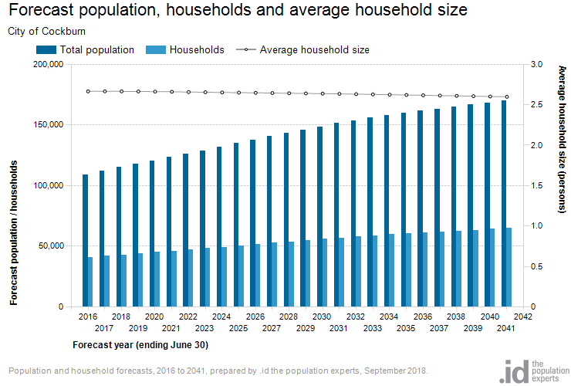

Growth factor trends and the impacts these have on service delivery across the City are summarised in Table 4.1.

**Table 4.1 Growth Projections and Impact on Services**

|  |  |  |  |
| --- | --- | --- | --- |
| **Factor** | **Present Position** | **Projection** | **Impact on Services** |
| Population – City of Cockburn | 120,417 as at year 2020 | An increase to 169,700 by 2041 is projected; an increase at an average 2.02% per year | Increase demand for provision of new mooring facility assets, marina parking and traffic requirements, higher usage of public beaches, swimming pontoons and jetty |
| Demographic of Port Coogee | Median age around 55 | Allowances for older/younger people | Other sporting interests besides boating |
| Geographic (marina pen holders only) | Port Coogee (North Coogee) 31 = 21%  The City of Cockburn (includes North Coogee) 79 = 53%  Outside the City of Cockburn 68 = 47% | Increase population and household growth in Coogee and North Coogee area | Increase demand for provision of new mooring facility assets, parking and traffic requirements |
| Consumer preference | Standard Pens  10m pens – 59  12m pens – 40  15m pens – 20  20m pens – 21  Catamaran Pens  12 x 7m pens – 4  12 x 7.5m pens – 2  15 x 7.5m pens – 3  15 x 8.5m pens – 1 | Expected popular demand for 15m +pens, also catamaran pens.  Allocation of some larger boat bays with the marina expansion 22-30m | Requirements to accommodate certain pen sizes as a part future pen layout plan |
| Customer interest | Waiting lists for boat bays | Consideration for 80 additional boat bays | AS 3962 Design of Marinas |
| Neighbouring commercial businesses | Construction zones | Continued development | Increased demand on marina and coastal infrastructure through increasing visitor numbers |

The City’s “Age Friendly Strategy 2016-2021” demographic projections include where Port Coogee Marina is located, the suburb of Coogee and North Coogee:

* In 2015 29% of residents were people over 55 years
* Will experience the most substantive change in population aged 55 years and older will increase 140% from 2015 to 2025

4.2 Changes in Technology

Technology changes for the marina and coastal infrastructure environment as a result of growth and demand include:

* Marina Management Software – Marina Focus has been implemented as a means to better manage the day to day operations, emergency response, improve running of the marina business and provide efficient customer service.
* Implementation of the Technology One Enterprise Asset Management System consisting of the following functionality:
* Operational Register developed in GIS and Technology One.
* Works system to capture service levels and risk for Planned and Reactive maintenance activities.
* Maintenance Processing functionality for scheduled 20/21 planned maintenance.
* System reporting including AMP related data extracts and reports.
* Scheduling of Inspections and defect management.
* Contractor Work – Increasing visibility and communication with contracted staff.
* Fire System, installation of camera with heat sensor to detect a fire in the marina area and raise the alarm.
* Number Plate Recognition Camera or similar – to replace the current camera that captures a still image of each vessel entering and exiting the harbour entrance. This new technology can also capture registration numbers to adequately identify vessels, especially those reported as lost or stolen.
* CCTV for individual vessels – City to research and provide opportunity for individual boat owners to purchase and install a monitoring camera aboard their vessel, to be connected to the marina WIFI to provide greater marina surveillance.
* Drone Service – to deliver marine parts to individual vessels, or similar.

Technology is rapidly evolving in the field of spatial data capture and beach monitoring for improved monitoring of coastal assets.

* Automated time-lapse monitoring cameras have been rolled out at C Y O’Connor Beach, and there are opportunities to improve data collection methods for more extensive and potentially more cost-effective coastal monitoring.

4.3 Demand Management Plan

Demand management strategies provide alternatives to the creation of new assets in order to meet demand, and look at ways to modify customer demands so that the utilisation of existing assets is maximised and the need for new assets deferred or reduced. The objective of demand management is to actively seek to modify customer demands for services in order to;

* Optimise the utilisation and performance of existing assets,
* Reduce or defer the need for new assets,
* Meet organisation’s strategic objectives,
* Deliver a more sustainable service, and
* Respond to changing customer needs.

The opportunities identified to date for demand management, the impact these drivers may have on future service delivery and the utilisation of these assets are shown in the Table 4.3.1.

Demand for new services will be recognised through a combination of managing and upgrading of existing assets and providing new assets. Demand management practices include non-asset solutions, insuring against risks and managing failures.

**Table 4.3.1 Demand Management Plan Summary**

| **Demand Driver** | **Impact on Services** | **Demand Management Plan** |
| --- | --- | --- |
| Population and Geographic Increase | Increased demand for provision of new jetty assets | Wait list currently in operation as a short term measure to manage new customer applications  Marina Expansion Business Case |
| Development at Port Coogee | Increased asset consumption on existing infrastructure  Useful lives of assets may be impacted.  More traffic and congestion from construction and heavy goods vehicles transporting materials | Port Coogee Local Structure Plan  Port Coogee Marina Village Built Form Codes  Port Coogee Transport Report |
| Insufficient parking provision | No designated secure marina car parking resulting in lack of pen holder satisfaction and strain on local parks and illegal parking | Marina Expansion Business Case |
| Consumer preference | Requirements to accommodate certain pen sizes as a part of the future pen layout plan | Marina Expansion Business Case and associated Community Engagement |
| Aging local population | Increased demand for accessible marina and coastal facilities | Create better / more accessible beach access points  Consider Universal Access in the design of all new assets |

Figure 4.3.1 indicates the existing coverage of jetties in the marina and details of pen sizes.

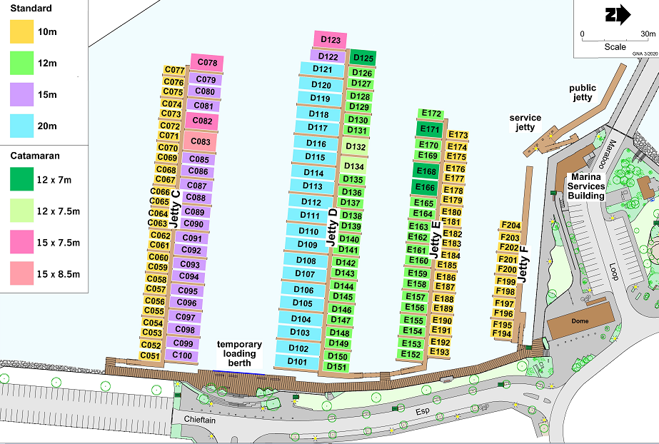**Figure 4.3.1 Port Coogee Marina Boat Pen Map as at 2020**

4.4 New Assets from Growth

The new assets required to meet growth will be mainly acquired from new and upgraded works, demands from marina and coastal users and prospective users to the marina and its facilities. This may also include some minor construction works being completed by the City.

New projects to be funded by the City are taken from the Preliminary 5 year Capital Works Program shown in Appendix B.

These figures have been used throughout this AMP where growth has been considered.

**Graph 4.5 New Assets from Growth**

Over the next five years the City will fund and deliver major new assets with an estimated budget of $14.7million, please refer to Appendix B for further information.

The following Major projects have been identified for delivery:

1. The Marina Expansion

The City is actively investigating the expansion of Port Coogee Marina to meet the growing needs of the surrounding community and as part of the handover requirements established during the management transfer in 2016.

* Stage 3 will install approx. 80 new boat bays, a boardwalk and reconfiguration works to parking bays on Maraboo Island in addition to upgrading pen holder ablution facilities at the Marina Services Building.
* Stage 4 has an expected completion date of 2025-26 but is dependent on the occupancy rates following Stage 1 and successful development of the Southern Peninsula at Port Coogee.
* A business case for the Port Coogee Marina Expansion was approved by Council in November 2019, a link to the Business case document is provided in the References section.
* The City is in the process of working up detailed design and specification documents to go out to Tender later in 2020 for the construction of Stage 3 of the marina expansion.
* Stage 4 Construction is due to be complete in 2021.

**Figure 4.3.2 Visual Representation of the Future Stages at Port Coogee Marina**

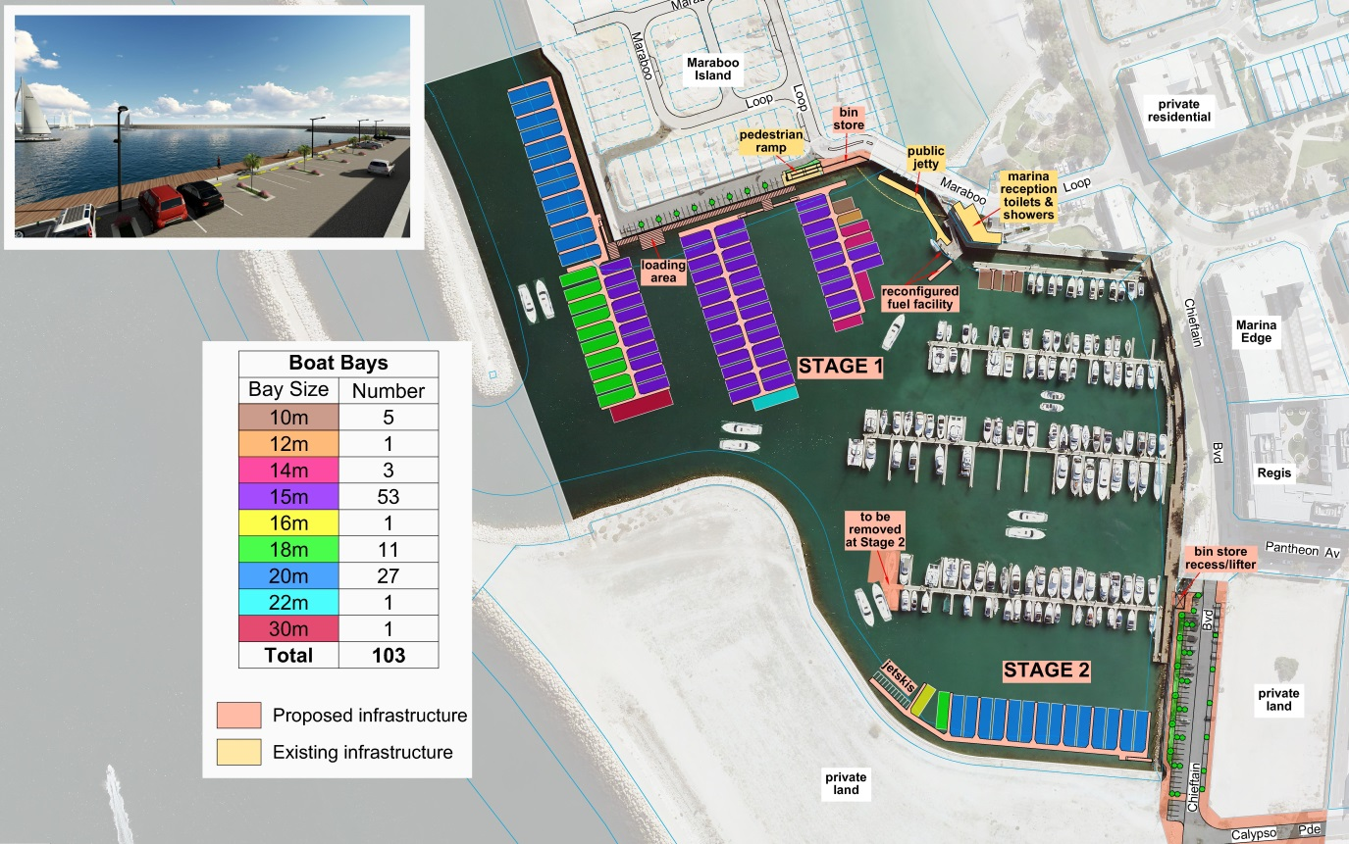

The existing jetties (C, D, E, F and G) were completed in 2012 across 2 stages being Stage 1 and Stage 2, the next stage will be Stage 3. Stage 4 will be the further expansion of the southern Marina basin in approximately 5 years. Stage 3 and Stage 4 are referred to as Stage 1 and 2 in the Marina Expansion Business Case and the diagram picture above but not throughout this plan.

C Y O’Connor Beach Erosion Protection

* The establishment of coastal protection structures at C Y O’Connor Beach to stabilise the shoreline is a key recommendation of the City’s Coastal Adaptation Plan. Current status: Design Phase
* A design study is currently underway to plan and select a preferred design, options being considered are a groyne, breakwater or artificial reef structures.
* Construction of these assets is subject to funding within the next decade to prevent undue loss of land and municipal assets and provide certainty for the planned development of the surrounding foreshore.

**5. Lifecycle Management**

The lifecycle management area details how the City of Cockburn plans to manage and operate the marina and coastal infrastructure assets while optimising lifecycle costs. The data is based on the City’s financial and operational asset registers.

5.1 Asset Data

The City’s Marina & Coastal operational asset register is derived from three Asset groups (specifications) as detailed below. The City’s RSPEC & OSPEC specifications align to the ASPEC digital data specification which provides an industry standard for the supply of digital data relating to “As Constructed” infrastructure asset information, whilst the MSPEC was developed internally to capture and manage marine based assets for the City. For further information on ASPEC please refer to the References section.

**Table 5.1 Breakdown of Marina & Coastal Assets**

|  |  |  |
| --- | --- | --- |
| Asset Group | Asset Classification | Quantity |
| Marine Specific Assets  MSPEC | Edge Walls and Retaining Walls | 11 |
| Gangways, Jetties and Pontoons | 96 |
| Piles | 150 |
| Sea Walls and Breakwaters | 5 |
| Service Lines | 19 |
| Service Points | 122 |
| Open Space Specific Assets  OSPEC | Boardwalk | 1 |
| Fences | 3 |
| Minor Structures | 15 |
| Rubbish Bins | 17 |
| Seats | 9 |
| Road Specific Assets  RSPEC | Lighting | 55 |
| Signs | 19 |

5.1.1 Asset Age

The age profile for the marina and coastal infrastructure assets are shown in Graph 5.1.1.

**Graph 5.1.1 Asset Age Profile**

From graph 5.1.1, 100% of the City’s Marina and Coastal assets are within the first 20 years of their operational life. Further, infrastructure within the first 10 years equates to 48% and a CRC of $23.5m whilst the remaining 52% (between 11 and 20 years) has a CRC of $25.9m.

5.1.2 Useful Life

A useful life has been applied to all marina and coastal infrastructure assets. The useful life’s are based on existing or similar assets within the City based on industry or technical knowledge or in the case of specific Marina and Coastal assets these were provided by Asset Val. The useful life by asset type is shown in Table 5.1.2.

**Table 5.1.2 Asset Useful Life**

| Asset Group | Asset Classification | Useful Life |
| --- | --- | --- |
| M Spec | Fuel payment terminal | 15 Years |
| Sullage facility, spill kits | 20 Years |
| Access gangways, jetties and swimming pontoons | 25 Years |
| Fuel dispensers | 35 Years |
| Fuel tanks, electrical, fire, fuel and water services, service pillars and sand bypass pipe system | 40 Years |
| Boardwalk and jetty piles | 50 Years |
| Retaining walls, low and high edge walls, sea walls and breakwaters and the Coogee Beach jetty | 100 Years |
| O Spec | Seats | 10 Years |
| Rubbish bins, sea bin and steel frames | 20 Years |
| Fences | 25 Years |
| Boardwalk | 30 Years |
| Gatehouses | 40 Years |
| Beach access stairs | 50 Years |
| R Spec | Signs and lights | 15 Years |
| Light poles | 25 Years |

5.1.3 Asset Condition

The condition profile of the City’s marina and coastal infrastructure assets are measured using a 1 to 5 rating system as outlined in Table 5.1.3.

**Table 5.1.3 Asset Condition Rating System**

|  |  |  |
| --- | --- | --- |
| Rating | Condition Description | |
| 1 | Excellent | A new asset or an asset in overall excellent condition with only a slight condition decline  Normal maintenance required |
| 2 | Good | An asset in an overall good condition, with minor signs of deterioration evident, serviceability may be slightly impaired  Minor maintenance required |
| 3 | Moderate | An asset with obvious signs of deterioration  Maintenance required to return to accepted level of service  Significant maintenance required |
| 4 | Poor | An asset in poor condition  Condition deterioration is severe and serviceability is becoming limited  Significant renewal or upgrade required |
| 5 | Very poor | An asset that has failed and no longer serviceable  There would be a risk leaving the asset in service  Replacement required |

**Graph 5.1.3 Asset Condition Profile**

The condition profiles for marina and coastal infrastructure assets were derived through various methodologies as outlined below;

1. MSPEC infrastructure was calculated based on a visual inspection and desktop based age and useful life (depreciation rate) analysis performed by Asset Val LTD in 2016.
2. OSPEC & RSPEC Infrastructure was originally established via Asset Val LTD in 2016, however during 2018 the City’s Project & Asset Service Unit performed a visual condition survey onsite to verify the original assessment and to formalise the City’s operational asset register.

Graph 5.1.3 Asset Condition Profile

Graph 5.1.3, 100% of the City’s Marina and Coastal assets are rated as condition 1 to 3 (excellent, good or moderate). Further, 51% of infrastructure is rated as good with a CRC of $25.2m, whilst infrastructure assessed as moderate is <1% with a CRC of $5K. The remaining 49% is considered to be in excellent condition with a CRC of $24.1m.

5.1.4 Asset Valuations

The City’s Marina Assets were valued by Asset Val LTD in 2016; the next scheduled valuation to be undertaken is due in 2021-22. The Replacement Cost of assets covered by this AMP are summarised in Table 5.1.4.

**Table 5.1.4 Marina and Coastal Infrastructure Current Asset Values**

| Asset Group | Asset Classification | Replacement Value |
| --- | --- | --- |
| M Spec - Edge Walls and Retaining Walls | Retaining Walls | $856,332 |
| High and Low Edge Walls | $5,745,600 |
| M Spec – Gangways, Jetties and Pontoons | Access Gangways | $523,355 |
| Central Jetties (Floating) | $4,053,000 |
| Coogee Beach Jetty | $2,150,222 |
| Finger Jetties | $3,863,475 |
| Fuel Pontoon | $780,000 |
| Public Jetties | $314,440 |
| Swimming Pontoons | $210,000 |
| M Spec – Piles | Boardwalk Piles | $1,126,080 |
| Jetty Piles | $888,425 |
| M Spec – Sea Walls and Breakwaters | Sea Walls | $15,108,000 |
| Breakwaters | $8,583,000 |
| M Spec – Service Lines | Electrical | $30,716 |
| Fire | $21,883 |
| Fuel | $4,350 |
| Sand Bypass Pipe | $225,000 |
| Water | $20,149 |
| M Spec – Service Points | Fuel Tanks | $40,000 |
| Emergency Cabinets | $4,250 |
| Fire Hose Reels | $15,750 |
| Fire Hydrants | $9,600 |
| Fuel Dispensers | $4,700 |
| Fuel Payment Terminal | $700 |
| Service Bollards | $80,000 |
| Spill Kits | $700 |
| Sullage Facility | $30,000 |
| O Spec - Boardwalk | Boardwalk | $4,400,000 |
| O Spec - Fences | Fences | $19,359 |
| O Spec – Minor Structures | Gatehouses | $180,000 |
| Steel Frames | $21,890 |
| Beach Access Stairs | $45,540 |
| O Spec – Rubbish Bins | Rubbish Bins | $24,850 |
| Sea Bin | $5,500 |
| O Spec – Seats | Seats | $8,100 |
| R Spec – Lighting | Feature Wall | $12,600 |
| Fuel Pontoon Lighting | $20,000 |
| Gatehouses | $2,800 |
| Floodlights | $900 |
| Park Lights | $11,250 |
| Sensor Lights | $11,600 |
| Solar Lights | $9,635 |
| R Spec - Signs | Signs | $4,710 |
|  | **TOTAL** | $49,468,461 |

5.2 Maintenance and Operating Expenditure

Maintenance work includes reactive or planned maintenance work activities.

Reactive maintenance is unplanned repair work, carried out in response to service requests, from Management or Supervisory directions.

Planned maintenance is work that is identified and managed through a maintenance schedule, these activities include inspection, assessing the condition against failure or breakdown experience, prioritising, scheduling and reporting along with capture of rectification works to develop a maintenance history and improve maintenance and service delivery performance.

Operating expenditure is continuously required expenditure e.g. power, fuel, staff, security patrols, plant equipment, on-costs and overheads.

Maintenance and operating expenditure trends are shown in Table 5.2.

**Table 5.2 Maintenance and Operating Expenditure Trends**

|  |  |  |  |  |  |  |  |
| --- | --- | --- | --- | --- | --- | --- | --- |
| Year | Reactive ($) | Reactive % | Planned ($) | Total Maintenance ($) | Operating Expenditure ($) | Total Operating & Maintenance ($) | Annual Budget ($) |
| 2016-17 | 70,424 | 6% | 1,122,790 | **1,193,214** | 551,804 | **1,745,018** | 2,169,707 |
| 2017-18 | 89,629 | 7% | 1,247,991 | **1,337,620** | 605,068 | **1,942,688** | 2,062,246 |
| 2018-19 | 28,493 | 2% | 1,364,765 | **1,393,258** | 996,105 | **2,389,363** | 2,794,694 |

Planned maintenance work for the financial year 2018-19 was 98**%** of the total maintenance expenditure. Maintenance expenditure levels are considered to be acceptable with minor additional maintenance required to meet desired service levels.

The future maintenance and operating expenditure is forecast to grow in line with the value of the asset stock and this increase needs to be budgeted to ensure new marina and coastal infrastructure assets are maintained to the service levels identified in section 3. This is further discussed in Section 6.2 of the Financial Analysis.

**Graph 5.2 Forecast Operating and Maintenance Expenditure**

Graph 5.2 is based on 2018-19 actual maintenance and operating expenditure, includes a 2% CPI increase and considers the projected increase in operational and maintenance budgets associated to the Port Coogee marina expansion.

5.2.1 Standards and Specifications

Maintenance, renewals and upgrade works are carried out in accordance with maintenance and specification manuals and other documentation as provided upon acquisition of the assets from works providers.

5.3 Renewal and Replacement Plan

Renewal expenditure is major work which does not increase the asset’s design capacity but restores, rehabilitates, replaces or renews an existing asset to its original service potential.

The projected 10 Year Renewals program is detailed in Appendix C. Renewals are incorporated into the City’s capital works program. This is further explored in Section 6.2.

5.4 New and Upgrade Plan

New works are those works that create a new asset that did not previously exist, or works which upgrade or improve an existing asset beyond its existing capacity. They may result from growth, social or environmental needs.

The projected 5 Year New and Upgrade program is detailed in Appendix B.

5.5 Disposal Plan

Disposal includes any activity associated with the disposal of a decommissioned asset including sale, demolition or relocation.

There are no assets identified for decommissioning or disposal at this time, as the infrastructure matures and the asset base ages along with increased consumption, asset disposals will be updated.

**6. Financial Analysis**

The Financial Analysis section of this report provides the recommended financial forecasts for the next 10 years. This section brings together the various types of expenditure described throughout the previous sections of the AMP and provides recommended budgets for Council to achieve the appropriate level of service through Municipal funding.

6.1 Financial Statements and Projections

From the financial asset register, the value of assets as covered by this asset management plan are summarised in Table 6.1.1 Current Replacement Cost and Depreciation. The current replacement cost, fair value (also known as written down value or depreciated replacement cost), depreciation and the annual depreciation values are shown.

**Table 6.1.1 Current Replacement Cost and Depreciation**

|  |  |  |  |  |
| --- | --- | --- | --- | --- |
| **Asset Classification** | **Current Replacement Cost** | **Fair Value (WDV)** | **Depreciation** | **Annual Depreciation Value** |
| **M Spec - Edge Walls and Retaining Walls** | $6,601,932 | $4,588,343 | $2,013,589 | $66,019 |
| **M Spec – Gangways, Jetties and Pontoons** | $11,894,492 | $8,197,058 | $3,697,434 | $399,573 |
| **M Spec – Piles** | $2,014,505 | $1,390,008 | $624,497 | $40,290 |
| **M Spec - Sea Walls and Breakwaters** | $23,691,000 | $ 21,203,445 | $2,487,555 | $236,910 |
| **M Spec - Service Lines** | $302,098 | $207,692 | $94,406 | $7,552 |
| **M Spec - Service Points** | $185,700 | $127,230 | $58,470 | $5,519 |
| **O Spec – Boardwalk** | $4,400,000 | $3,006,667 | $1,393,333 | $146,666 |
| **O Spec – Fences** | $19,359 | $13,751 | $5,608 | $774 |
| **O Spec - Minor Structures** | $247,430 | $179,056 | $68,374 | $6,505 |
| **O Spec - Rubbish Bins** | $30,350 | $23,496 | $6,854 | $1,517 |
| **O Spec – Seats** | $8,100 | $6,885 | $1,215 | $810 |
| **R Spec – Lighting** | $68,785 | $56,663 | $12,122 | $4,092 |
| **R Spec – Signs** | $4,710 | $4,048 | $662 | $314 |
| **TOTAL** | **$49,468,461** | **$39,004,343** | **$10,464,118** | **$916,544** |

The financial projections are shown in Graph 6.1.1, for the forecasted operating (operations and maintenance) and capital expenditure (renewal and upgrade/ new assets).

**Graph 6.1.1 Forecast Operating and Capital Expenditure**

The costs shown are in 2019 dollar replacement values and also include the 2% CPI increase.

**Graph 6.1.2 Projected Renewals and Annual Depreciation**

In the Graph 6.1.2, data for the projected renewals are obtained from the Appendix C preliminary 10 year renewal program, the projected depreciation expense takes into account all new asset values and the budget allocation has been based on the funding for the renewals per year.

These costs are shown in 2019 dollar values and also include the 2% CPI increase per year forward.

**Table 6.1.2 Projected Renewals and Budget Allocation Gap**

|  |  |  |  |  |  |  |
| --- | --- | --- | --- | --- | --- | --- |
| **Year** | **Projected Renewals (inc 2% CPI)** | **Muni** | **WEMP/SAR** | **Marina Asset Replacement Reserve** | **Funding Gap** | **Cumulative Gap** |
|
| **2020-21** | $274,900 | $169,900 | $15,000 | $90,000 | $0 | $0 |
| **2021-22** | $576,300 | $200,940 | $182,580 | $192,780 | $0 | $0 |
| **2022-23** | $12,485 | $12,485 | $- | $- | $0 | $0 |
| **2023-24** | $119,917 | $37,142 | $29,714 | $53,060 | $0 | $0 |
| **2024-25** | $337,719 | $175,354 | $162,365 | $- | $0 | $0 |
| **2025-26** | $38,643 | $27,050 | $6,072 | $5,520 | $0 | $0 |
| **2026-27** | $13,514 | $13,514 | $- | $- | $0 | $0 |
| **2027-28** | $380,330 | $195,966 | $178,621 | $5,743 | $0 | $0 |
| **2028-29** | $119,867 | $96,433 | $23,433 | $- | $0 | $0 |
| **2029-30** | $117,119 | $104,571 | $6,573 | $5,975 | $0 | $0 |
| **Total** | **$1,990,792** | **$1,033,355** | **$604,358** | **$353,080** | **$0** | **$0** |

The City will ensure provision of 100% renewal funding up to 2029-30 ensuring that the 10 year cumulative funding gap for marina and coastal infrastructure assets base will be Zero. See Appendix C for a full funding breakdown by renewal project based on infrastructure item and funding source.

6.2 Funding Strategy

Marina and Coastal Infrastructure has a shared funding model comprising of a SAR (Specified Area Rate), WEMP (Waterway Environmental Management Plan), Marina Asset Replacement Reserve and Muni funding. This funding strategy is unique and covers infrastructure at Port Coogee only.

6.3 Sustainability of Service Delivery

There are three key performance indicators for financial sustainability as recommended in the Department of Local Government (LG) Asset Management National Framework and Guidelines that have been considered in the analysis of the Marina and Coastal Infrastructure financial data.

The aim of the Framework is to enhance the sustainable management of Local Government assets by encouraging ‘whole of life’ and ‘whole of organisation’ approaches and the effective identification and management of risks associated with the use of the assets.

6.3.1 Asset Consumption Ratio (ACR)

* This ratio shows the written down current value of the City’s depreciable assets relative to their ‘as new’ value in up to date prices.
* These values are calculated by dividing the fair value by the current replacement cost. These figures are shown below.

|  |  |  |
| --- | --- | --- |
| Asset Group | Consumption Ratio 2020-21 | Standard Achieved |
| M Spec | 80% | Standard is met |
| O Spec | 69% | Standard is improving |
| R Spec | 82% | Standard is met |
| ALL ASSETS | **79%** | **Standard is met** |

The target ratio should be between 50% and 75%. A ratio of less than 50% indicates a rapid deterioration of the asset base, whilst a ratio greater than 75% may indicate an over investment in the asset base.

Integrated Planning and Reporting Advisory Standard KPI targets are outlined below.

**Standard is not met** if ratio data cannot be identified or ratio is less than 50%.

**Standard is met** if ratio data can be identified and ratio is 50% or greater.

**Standard is improving** if this ratio is between 60% and 75%.

6.3.2 Asset Sustainability Ratio (ASR)

* This ratio indicates whether assets are being replaced or renewed at the same rate that the overall asset stock is wearing out.
* It is calculated by dividing the annual capital expenditure spent on replacements (reserve funding required) by the annual depreciation expense. If capital expenditure on renewing or replacing assets is at least equal to depreciation on average over time, then the value of the existing stock will be maintained. If capital expenditure on existing assets is less than depreciation then underspending on replacement of assets will occur and this is likely to result in additional maintenance costs for assets that have exceeded their useful life that may exceed the cost of renewal or replacement.
* This ratio can only be measured accurately if an assessment is made of the total amount spent on capital renewal and replacement. The City does not presently undertake an accurate breakdown of its upgrade expenditure and the portion of this that would be replacement is not known and has therefore not been considered. A breakdown of upgrade expenditure is part of the improvement strategy.

The target ratio should be between 90% - 110%. The forecast asset sustainability ratios shown below have been calculated on an accumulative basis.

|  |  |  |  |  |  |  |  |  |  |  |
| --- | --- | --- | --- | --- | --- | --- | --- | --- | --- | --- |
| **Asset Group** | **Forecast Asset Sustainability Ratio** | | | | | | | | | |
| **2020-21** | **2021-22** | **2022-23** | **2023-24** | **2024-25** | **2025-26** | **2026-27** | **2027-28** | **2028-29** | **2029-30** |
| **M Spec** | 11% | 23% | 17% | 14% | 17% | 16% | 15% | 17% | 17% | 15% |
| **O Spec** | 0% | 0% | 0% | 0% | 0% | 0% | 0% | 1% | 1% | 0% |
| **R Spec** | 0% | 0% | 0% | 0% | 0% | 0% | 0% | 0% | 14% | 13% |
| **ALL ASSETS** | **9%** | **19%** | **14%** | **12%** | **14%** | **13%** | **12%** | **14%** | **14%** | **13%** |

The ratios for the marina and coastal infrastructure indicate that the annual expenditure is low and that overall the ASR standard is not met. This is due to the infant nature of assets and the lack of requirement for renewals.

Integrated Planning and Reporting Advisory Standard KPI targets are outlined below.

**Standard is not met** if ratio data cannot be identified or ratio is less than 90%.

**Standard is met** if ratio data can be calculated and ratio is 90% or greater.

**Standard is improving** if this ratio is between 90% and 110%

6.3.3 Asset Renewal Funding Ratio (ARFR)

* This is an indicator as to the ability of the City to fund the projected asset renewals and replacements in the future and therefore continue to provide existing levels of service, without additional operating income or reductions in operating expenses, or an increase in net financial liabilities above that currently projected.
* The ratio is calculated by dividing the planned capital expenditure (from the long term financial plan) on renewals over the next 10 years by the required (projected) capital expenditure on renewals over the same period.
* The standard is met if the ratio is between 75% and 95%

The forecast asset renewal funding ratios shown below have been calculated on an accumulative basis.

|  |  |  |  |  |  |  |  |  |  |  |
| --- | --- | --- | --- | --- | --- | --- | --- | --- | --- | --- |
| **Asset Group** | **Forecast Asset Renewal Funding Ratio** | | | | | | | | | |
| **2020-21** | **2021-22** | **2022-23** | **2023-24** | **2024-25** | **2025-26** | **2026-27** | **2027-28** | **2028-29** | **2029-30** |
| **M Spec** | 100% | 100% | 100% | 100% | 100% | 100% | 100% | 100% | 100% | 100% |
| **O Spec** | 0% | 0% | 0% | 0% | 0% | 0% | 0% | 100% | 100% | 0% |
| **R Spec** | 0% | 0% | 0% | 0% | 0% | 0% | 0% | 0% | 100% | 0% |
| **ALL ASSETS** | **100%** | **100%** | **100%** | **100%** | **100%** | **100%** | **100%** | **100%** | **100%** | **100%** |

The target ratio should be between 95% and 105% which indicates that adequate provision / expenditure is being made for the *future* renewal and replacement of assets. Overall the standard is met.

Integrated Planning and Reporting Advisory Standard KPI targets are outlined below.

**Standard is not met** if ratio data cannot be identified or ratio is less than 75%.

**Standard is met** if ratio data can be identified and ratio is between 75% and

95%.

**Standard is improving** if this ratio is between 95% and 105% and the ASR falls within the range 90% to 110% and ACR falls within the range of 50% to 75%.

6.4 Valuation Forecasts

Asset values are forecast to increase as additional assets are added to the asset stock from construction and acquisition by Council, and from assets constructed by developers then donated to Council.

Graph 6.4.1 shows the projected depreciated replacement cost / asset values over the next 10 years, and the fair value also known as the depreciated replacement cost (WRC) is the current replacement cost less accumulated depreciation. These figures include the projected growth and capital upgrade / new as mentioned in section 6.1.

**Graph 6.4.1 Projected Asset Values (CRC) and Fair Value (WDV)**

The fair value will vary over the forecast period depending on the rates of addition of new assets, disposal of old assets and consumption and renewal of existing assets.

**Graph 6.4.2 Projected Depreciation Expense**

Depreciation expense values are forecast to trend in line with asset values as shown in the Graph 6.4.2. The yellow highlighted line provides the current depreciation expense note that all costs are shown in current 2019 dollar values and a 2% CPI increase per year forward.

6.5 Key Assumptions made in Financial Forecasts

This section details the key assumptions made in presenting the information contained in this asset management plan and in preparing forecasts of required operating and capital expenditure and asset values, depreciation expense and carrying amount estimates. It is presented to enable readers to gain an understanding of the levels of confidence in the data behind the financial forecasts.

Key assumptions made in this asset management plan are:

* The data supplied was as accurate as possible at the time of compilation of this asset management plan.
* The breakdown of the actual reactive, planned and operational expenditure is considered accurate.

6.6 Revenue

Revenue at Port Coogee Marina is generated from the goods and services provided by the marina including fuel sales, chandlery items and Licence fees. Due to the additional two stages of the marina expansion taking place in the next ten years the City is unable to list 10-year revenue projections at this stage. This data will be provided in future iterations of the AMP.

**Table 6.6.1 Licence revenue reported by Port Coogee Marina**

|  |  |
| --- | --- |
| **Year** | **Marina Revenue** |
| **2016-17** | $1,419,430 |
| **2017-18** | $478,858 |
| **2018-19** | $971,898 |

The decrease in Marina Revenue from 2016-17 to 2017-18 is due to the pen holder fees received in advance and not being recognised in the correct financial year, this was rectified for FY 2018-19.

**7. Asset Management Practices**

7.1 Accounting / Financial Systems

**7.1.1 Summary of Accounting and Financial Systems**

Technology One Financials version 11.09.19.011

**7.1.2 Accountabilities and Responsibilities for Financial System**

Financial Services – for the accounts and costing methodologies

**7.1.3 Accounting Standards / Regulations / Guidelines**

* Australian Accounting Standards including:
* AASB116 - Property, Plant and Equipment
* AASB13 Fair Value Measurement
* AASB136 - Impairment of Assets
* AASB 140 Investment Property
* AASB 5 Non-current Assets Held for Sale and Discontinued Operations
* The Australian Property Institute’s practice standards
* Local Government Act 1995
* Local Government (Financial Management) Regulations 1996
* Local Government (Functions & General) Regulations 1996

7.2 Asset Management Information Systems (EAM)

**7.2.1 Summary of Asset Management System**

Technology One Enterprise Asset Management version 11.09.19.011

Technology One Intramaps 8.1

**7.2.2 Summary of how the Enterprise Asset Management system aligns to the Accounting / Financial system**

The operational asset register within the Enterprise Asset Management system acts as the master asset dataset for determining renewal projections and future refurbishment.

The financial asset register with Financials system acts as the master for Asset Valuations and calculating depreciation.

**7.2.3 Accountabilities and Responsibilities for AM System(s)**

Project & Asset Services is accountable and responsible for the EAM system, with other service areas assisting with the currency and maintenance of the data sets within the system databases.

**7.2.4 Changes to the Enterprise Asset Management Systems resulting from the AMP**

All proposed/agreed system changes will be documented in Section 8 Plan Improvement and Monitoring.

7.3 Information Flow Requirements and Processes

The key information flows *into* this asset management plan are:

* The asset register data on size, age, condition, value and remaining life of the network;
* The unit rates for categories of work/material;
* The adopted service levels;
* Projections of various factors affecting future demand for services;
* Correlations between maintenance and renewal, including decay models; and
* Data on new assets acquired by council.

The key information flows *from* this asset management plan are:

* The assumed Works Program and trends;
* The resulting budget, valuation and depreciation projections; and
* The useful life analysis.

These will impact the Long Term Financial Plan, Strategic Community Plan, annual budget and departmental business plans and budgets.

7.4 Standards and Guidelines

Asset Management Policy Statement (SC 39) 2017

**8. Plan Improvement and Monitoring**

8.1 Performance Measures

The effectiveness of the asset management plan can be measured in the following ways:

* The degree to which the required cash flows identified in this asset management plan are incorporated into council’s Long Term Financial Plan and Strategic Community Plan,
* The degree to which 1-5 year detailed works programs, budgets, business plans and organisational structures take into account the ‘global’ works program trends provided by the asset management plan, and
* The degree to which existing and projected service levels and consequences, risks and residual risks are incorporated into Council’s plans.

8.2 Improvement Strategy

The asset management improvement strategy generated from the Marina and Coastal Infrastructure asset management plan is shown in Table 8.2.

**Table 8.2 Marina and Coastal Infrastructure Improvement Strategy**

| **Task No** | **Task** | **Responsibility** | **Resources Required** | **Projected**  **Cost** | **Timeline** |
| --- | --- | --- | --- | --- | --- |
| 1 | Condition assessments of all marina and coastal infrastructure assets on a quadrennial basis | Property & Asset Services | External Expertise | $30,000 | Ongoing |
| 2 | Comprehensive audit for all marina and coastal infrastructure assets mapping and recording | Port Coogee Marina | External Expertise | $30,000 | 2020-21 |
| 3 | Implementation of Technology One EAM including Integration of financial and operational asset registers | Property & Asset Services | Internal Expertise | $15,000 | 2021-22 |
| 4 | Customer level of service surveys, integrate into Catalyst surveys | Port Coogee Marina | Internal Expertise | n/a | 2022-23 |
| 5 | Review and update historic maintenance data | Port Coogee Marina | Internal Expertise | n/a | 2022-23 |
| 6 | Strategic Asset Management (SAM) Implementation for forecasting and renewal plans | Property & Asset Services | Internal Expertise | n/a | 2022-23 |
| 7 | Differentiate between Coastal and Marina infrastructure based on management responsibility and budgets | Port Coogee Marina,  Property & Asset Services | Internal Expertise | n/a | 2023-24 |
| 8 | Improve operation and maintenance budget expenditure documentation | Port Coogee Marina | Internal Expertise | n/a | 2023-24 |
| 9 | Develop ranking criteria for asset renewal and replacement | Port Coogee Marina | Internal Expertise | n/a | 2023-24 |
| 10 | Investigate CCTV provision and improvements | Port Coogee Marina | Internal Expertise | n/a | 2023-24 |
| 11 | Add outcomes of coastal infrastructure surveys e.g. erosion and remedial recommendations to future versions of MCIAMP | Port Coogee Marina,  Property & Asset Services | Internal Expertise | n/a | 2023-24 |
| 12 | Explore including specialist depreciation models for infrastructure in the MCIAMP | Finance Services,  Property & Asset Services | Internal Expertise | n/a | 2023-24 |

8.3 Monitoring and Review Procedures

The MCIAMP forms part of the City’s Strategic Asset Management Planning Framework (SAMPF), covers four financial years (2020-21 to 2023/24) and acts as an informing strategy to the City’s Corporate Planning Framework.

Future iterations of the MCIAMP will be developed every 4 years and be subject to a 2 year desktop review. The MCIAMP review will focus on core elements required by the LTFP, for example asset valuations, growth projections, financial analysis including operating, sustainability ratios and 10 year renewals. This will ensure that future revisions of the LTFP will be derived from a structured AMP development cycle which has received Executive and or Council approval, increasing confidence and integration of asset management data and methodologies into the City’s long term financial planning.

The following diagram provides a visual representation and timeline of the Strategic Asset Planning Frameworks plans and strategies.

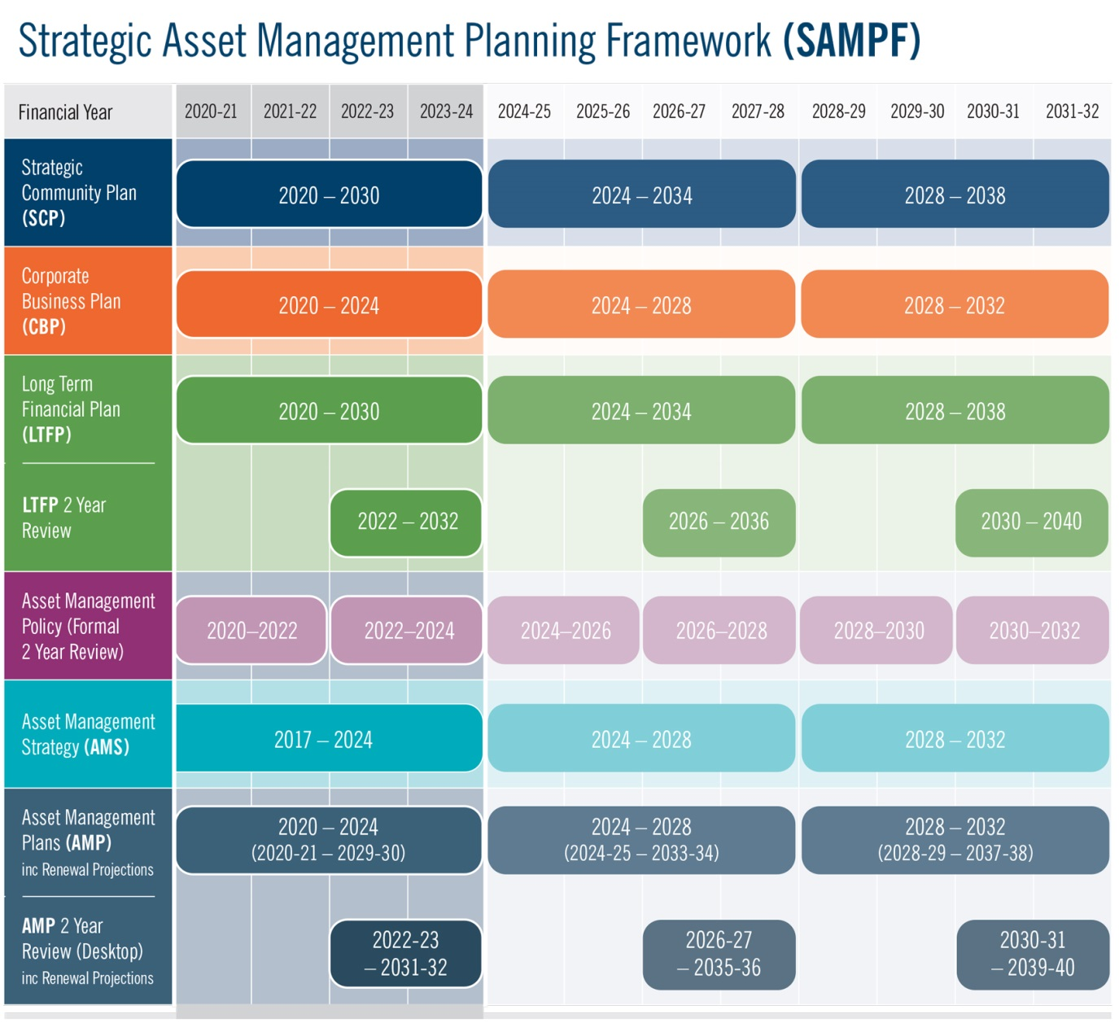

The formalisation and alignment of the City’s SAMPF (Asset Management Policy, Strategy and AMP’s) within the Integrated Corporate Planning Framework reflects the City’s increasing maturity and recognises the importance of Asset Management in supporting the City in delivering long term financial sustainability of services and capital asset renewal.

Supported by the relevant business area and the Asset Management Planning & System Sections of the Project & Asset Service Unit, the Project & Asset Manager has overall responsibility and management for each of the Improvement Strategies identified within section 8 of the MCIAMP.

# References

City of Cockburn – Asset Management Strategy 2017 – 2024

City of Cockburn – Strategic Community Plan 2020 – 2030

City of Cockburn – Long Term Financial Plan 2020-2021 to 2029-2030

City of Cockburn – Management Budget 2019 – 2020

City of Cockburn – Enterprise Risk Management

City of Cockburn – Population Forecast -

<http://forecast2.id.com.au/Default.aspx?id=349&pg=5000>

City of Cockburn – Age Friendly Strategy 2016-2021

https://www.a-specstandards.com.au/

[IPWEA](https://www.a-specstandards.com.au/IPWEA), 2011, ‘International Infrastructure Management Manual’, Institute of Public Works Engineering Australia, Sydney

Government of Western Australia, Department of The Premier and Cabinet –

[Western Australian Legislation – Acts in force](http://www.slp.wa.gov.au/legislation/statutes.nsf/main_actsif.html)

The Local Government and Municipal Knowledge Base – [LGAM Knowledge Base](http://www.lgam.info/start)

DVC, 2006, ‘Asset Investment Guidelines’, ‘Glossary’, Department for Victorian Communities, Local Government Victoria, Melbourne, http://www.dvc.vic.gov.au/web20/dvclgv.nsf/allDocs/RWP1C79EC4A7225CD2FCA257170003259F6?OpenDocument

Local Government of Western Australia – Asset Management Framework and Guidelines

<https://www.cockburn.wa.gov.au/Recreation-and-Attractions/Sport-and-Recreation/Port-Coogee-Marina>

AssetVal – Insurance Report – 24th July 2016 V1.5 – Valuation for Insurance Purposes. & AssetVal – Fair Value Report – 24th July 2016 V1.5 – Valuation for Accounting Compliance Purposes.

Port Coogee Marina Expansion Business Case <https://www.cockburn.wa.gov.au/getattachment/c4dd1423-daec-452f-9abb-2fcc8b6e6057/attachment.aspx>

Port Coogee Marina – Expansion Business Case Annexure <https://www.cockburn.wa.gov.au/getattachment/77b9d86f-9b4f-41f1-8441-b3dca55ecbb4/attachment.aspx>  
Port Coogee Marina – Expansion Business Case - Draft Concept Plan <https://www.cockburn.wa.gov.au/getattachment/dc410715-ee7f-4696-8064-9dbc8d204628/attachment.aspx>

# Appendices

Appendix A Legislative Requirements

|  |  |
| --- | --- |
| **Legislation** | **Requirement** |
| Local Government Act 1996  LG (Miscellaneous Provisions) Act 1960 (WA)  LG Regulations 2008 | Sets out role, purpose, responsibilities and powers of Local Governments including the preparation of a long term financial plan supported by asset management plans for sustainable service delivery. |
| Occupational Safety and Health Act 1984 (WA)  OSH Regulations 1996 | Provides for the promotion, coordination, administration and enforcement of Safety and Health in WA. Places emphasis on the prevention of accidents and injury. |
| Disability Discriminations Act 1992 | Sets out requirements to eliminate as far as possible discrimination against persons on the grounds of disability in the areas of work, accommodation, clubs and sport and in the provision of facilities, services and land. |
| Disability Services Act 1993 | An Act for the establishment of the Disability Services commission and the Ministerial Advisory Council on Disability, for the furtherance of principles applicable to people with disabilities, for the funding and provision of services to such people that meet certain objectives and for the resolution of complaints by such people. |
| Western Australian Marine Act 1982 | Sets out rules and regulations in relation to marine and vessel operations; such areas like mooring licence, inspections and maintenance. |
| Australian Accounting Standards | Sets out the financial reporting standards for the revaluation and depreciation of assets. |
| Emergency Management Act, 2005 (WA) | Requires lifeline utilities to function at the fullest possible extent during and after an emergency and to have plans for such functioning (business continuity plans) |
| Australian Standards | Standards are published documents setting out specifications and procedures designed to ensure products, services and systems are safe, reliable and consistently perform the way they were intended to. They establish a common language which defines quality and safety criteria. |
| Environmental Protection Act 1993 | An act to provide for the protection of the environment, to establish the Environmental Protection Authority and define its functions, powers and other purposes. |

Appendix B Preliminary Five Year Capital Works Program

|  |  |  |  |  |  |  |
| --- | --- | --- | --- | --- | --- | --- |
| **Asset Project** | **Project Value** | **Muni** | **WEMP/SAR** | **Marina Asset Replacement Reserve** | **Bank Loan** | **Grant/Developer Funding** |
| Coogee Beach Jetty Access Ramp | $290,000 | $290,000 |  |  |  |  |
| Maraboo Bridge Anti Climb | $200,000 | $100,000 | $100,000 |  |  |  |
| Marina Expansion Stage 3 | $5,277,400 |  |  |  | $5,277,400 |  |
| Beach Steps - Chelydra Park | $30,000 | $30,000 |  |  |  |  |
| Marina Stage 3 - Planning and Preliminary works | $190,000 |  |  | $190,000 |  |  |
| **Total Year 20/21** | **$5,987,400** | **$420,000** | **$100,000** | **$190,000** | **$5,277,400** | **$0** |
| Coogee Beach Observation Tower Foundations | $47,000 | $47,000 |  |  |  |  |
| Visitor Moorings Coogee Maritime Trail | $10,000 | $10,000 |  |  |  |  |
| Othello Bridge Anti Climb | $400,000 | $200,000 | $200,000 |  |  |  |
| Marina Services Building Flag Poles | $6,000 | $6,000 |  |  |  |  |
| **Total Year 21/22** | **$463,000** | **$263,000** | **$200,000** | **$0** | **$0** | **$0** |
| **Total Year 21/22 inc 2% CPI** | **$472,260** | **$268,260** | **$204,000** | **$0** | **$0** | **$0** |
| C Y O'Connor Erosion Protection Structures (Phase 1) | $5,000,000 | $2,500,000 |  |  |  | $2,500,000 |
| Edge Wall Rock Revetment Upgrade | $500,000 |  | $500,000 |  |  |  |
| **Total Year 22/23** | **$5,500,000** | **$2,500,000** | **$500,000** | **$0** | **$0** | **$2,500,000** |
| **Total Year 22/23 inc 2% CPI** | **$5,722,200** | **$2,601,000** | **$520,200** | **$0** | **$0** | **$2,601,000** |
| Cockburn Coast Foreshore Plan (C Y O’Connor Beach) | $750,000 | $750,000 |  |  |  |  |
| **Total Year 23/24** | **$750,000** | **$750,000** | **$0** | **$0** | **$0** | **$0** |
| **Total Year 23/24 inc 2% CPI** | **$795,906** | **$795,906** | **$0** | **$0** | **$0** | **$0** |
| Marina Expansion Stage 4 | $1,431,080 |  |  |  | $1,431,080 |  |
| Port Coogee Southern Breakwater Fishing Jetty | $250,000 |  |  |  |  | $250,000 |
| **Total Year 24/25** | **$1,681,080** | **$0** | **$0** | **$0** | **$1,431,080** | **$250,000** |
| **Total Year 24/25 inc 2% CPI** | **$1,819,655** | **$0** | **$0** | **$0** | **$1,549,047** | **$270,608** |

## Appendix C Preliminary 10 Year Renewal Program

| **Asset Classification** | **Asset Project** | **Project Value** | **Municipal Funding** | **WEMP/**  **SAR** | **Marina Asset Replacement Reserve** |
| --- | --- | --- | --- | --- | --- |
| Gangways, Jetties and Pontoons | Floating Jetties D and E Renewal Works | $60,000 |  |  | $60,000 |
| Gangways, Jetties and Pontoons | Swimming Pontoon SP1 Refurbishment | $12,000 | $12,000 |  |  |
| Coastal | C Y O,Connor Beach Nourishment | $135,000 | $135,000 |  |  |
| Coastal | Entry Ramp Extension - Coogee Beach Surf Life Saving Club | $7,900 | $7,900 |  |  |
| Service Lines | Marina Distribution Boards | $60,000 | $15,000 | $15,000 | $30,000 |
|  | **Total Year 20/21** | **$274,900** | **$169,900** | **$15,000** | **$90,000** |
| Boardwalk | Marina Boardwalk Refurbishment | $56,000 | $14,000 | $14,000 | $28,000 |
| Gangways, Jetties and Pontoons | Marina Jetty Decking Replacement | $146,000 |  |  | $146,000 |
| Gangways, Jetties and Pontoons | Coogee & Other Jetties Minor Renewal Works | $45,000 | $15,000 | $15,000 | $15,000 |
| Gangways, Jetties and Pontoons | Swimming Pontoons Minor Renewal Works | $18,000 | $18,000 |  |  |
| Coastal | Port Coogee Sand Bypassing | $300,000 | $150,000 | $150,000 |  |
|  | **Total Year 21/22** | **$565,000** | **$197,000** | **$179,000** | **$189,000** |
|  | **Total Year 21/22 inc 2% CPI** | **$576,300** | **$200,940** | **$182,580** | **$192,780** |
| Gangways, Jetties and Pontoons | Swimming Pontoon SP2 Refurbishment | $12,000 | $12,000 |  |  |
|  | **Total Year 22/23** | **$12,000** | **$12,000** | **$-** | **$-** |
|  | **Total Year 22/23 inc 2% CPI** | **$12,485** | **$12,485** | **$-** | **$-** |
| Gangways, Jetties and Pontoons | Coogee & Fishing Jetty Minor Renewals | $13,000 | $10,000 | $3,000 |  |
| Boardwalk | Marina Boardwalk Paint Major Renewal | $100,000 | $25,000 | $25,000 | $50,000 |
|  | **Total Year 23/24** | **$113,000** | **$35,000** | **$28,000** | **$50,000** |
|  | **Total Year 23/24 inc 2% CPI** | **$119,917** | **$37,142** | **$29,714** | **$53,060** |
| Gangways, Jetties and Pontoons | Swimming Pontoon SP3 Refurbishment | $12,000 | $12,000 |  |  |
| Coastal | Port Coogee Sand Bypassing | $300,000 | $150,000 | $150,000 |  |
|  | **Total Year 24/25** | **$312,000** | **$162,000** | **$150,000** | **$-** |
|  | **Total Year 24/25 inc 2% CPI** | **$337,719** | **$175,354** | **$162,365** | **$-** |
| Gangways, Jetties and Pontoons | Coogee & Fishing Jetty Minor Renewals | $13,000 | $10,000 | $3,000 |  |
| Gangways, Jetties and Pontoons | Swimming Pontoon SP 1 Refurbishment | $12,000 | $12,000 |  |  |
| Boardwalk | Marina Boardwalk Paint Major Renewal | $10,000 | $2,500 | $2,500 | $5,000 |
|  | **Total Year 25/26** | **$35,000** | **$24,500** | **$5,500** | **$5,000** |
|  | **Total Year 25/26 inc 2% CPI** | **$38,643** | **$27,050** | **$6,072** | **$5,520** |
| Gangways, Jetties and Pontoons | Swimming Pontoon SP 2 Refurbishment | $12,000 | $12,000 |  |  |
|  | **Total Year 26/27** | **$12,000** | **$12,000** | **$-** | **$-** |
|  | **Total Year 26/27 inc 2% CPI** | **$13,514** | **$13,514** | **$-** | **$-** |
| Seats | Seats | $8,100 | $8,100 |  |  |
| Gangways, Jetties and Pontoons | Coogee & Fishing Jetty Minor Renewals | $13,000 | $10,000 | $3,000 |  |
| Boardwalk | Marina Boardwalk Paint Major Renewal | $10,000 | $2,500 | $2,500 | $5,000 |
| Coastal | Port Coogee Sand Bypassing | $300,000 | $150,000 | $150,000 |  |
|  | **Total Year 27/28** | **$331,100** | **$170,600** | **$155,500** | **$5,000** |
|  | **Total Year 27/28 inc 2% CPI** | **$380,330** | **$195,966** | **$178,621** | **$5,743** |
| Rubbish Bins | Standard Bins | $450 | $450 |  |  |
| Lighting | Feature Wall Lights | $1,350 | $1,350 |  |  |
| Lighting | Solar Light Lumin | $4,635 | $4,635 |  |  |
| Signs | Information Sign | $170 | $170 |  |  |
| Service Points | Fuel Payment Terminal | $700 | $700 |  |  |
| Gangways, Jetties and Pontoons | Swimming Pontoon SP1 Replacement | $75,000 | $75,000 |  |  |
| Gangways, Jetties and Pontoons | Fishing Jetty Blast/Repaint | $20,000 |  | $20,000 |  |
|  | **Total Year 28/29** | **$102,305** | **$82,305** | **$20,000** | **$-** |
|  | **Total Year 28/29 inc 2% CPI** | **$119,867** | **$96,433** | **$23,433** | **$-** |
| Gangways, Jetties and Pontoons | Coogee & Fishing Jetty Minor Renewals | $13,000 | $10,000 | $3,000 |  |
| Boardwalk | Marina Boardwalk Paint Major Renewal | $10,000 | $2,500 | $2,500 | $5,000 |
| Gangways, Jetties and Pontoons | Swimming Pontoon SP2 Replacement | $75,000 | $75,000 |  |  |
|  | **Total Year 29/30** | **$98,000** | **$87,500** | **$5,500** | **$5,000** |
|  | **Total Year 29/30 inc 2% CPI** | **$117,119** | **$104,571** | **$6,573** | **$5,975** |

