Resource Recovery Calendar 2024/25
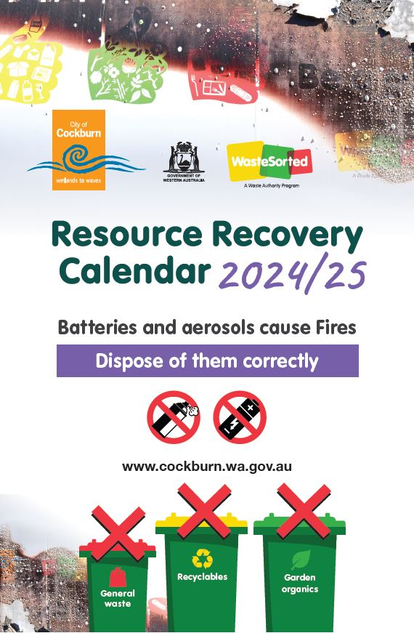
Batteries and aerosols cause Fires
Dispose of them correctly
City of Cockburn website: www.cockburn.wa.gov.au

Contents
Christmas and New Year Bin Collections 2
Recycling & General Waste Bin Collection Map 3
Garden Organics Bin Collection Map 5
Your Recycling Bin (Weekly) 8
General Waste Bin (Weekly) 9
Your Garden Organics Bin (Fortnightly) 9
Missing or Damaged Bins 10
Tips for Using Your Bins 10
Resource Recovery Guide 12
Hard Waste and Garden Organics Verge Collection 24
Important information for verge collections 31
Henderson Waste Recovery Park 37

Christmas and New Year Bin Collections
Over the festive season, bins will not be collected on Wednesday, 25 December 2024 or Wednesday 1 January 2025.
On these two weeks, Wednesday services will be on Thursday. Thursday services will be on Friday, and Friday services will be on Saturday. Monday and Tuesday collections will be unaffected.

Recycling & General Waste Bin Collection Map
The map below shows which day your recycling and general waste bins are collected.
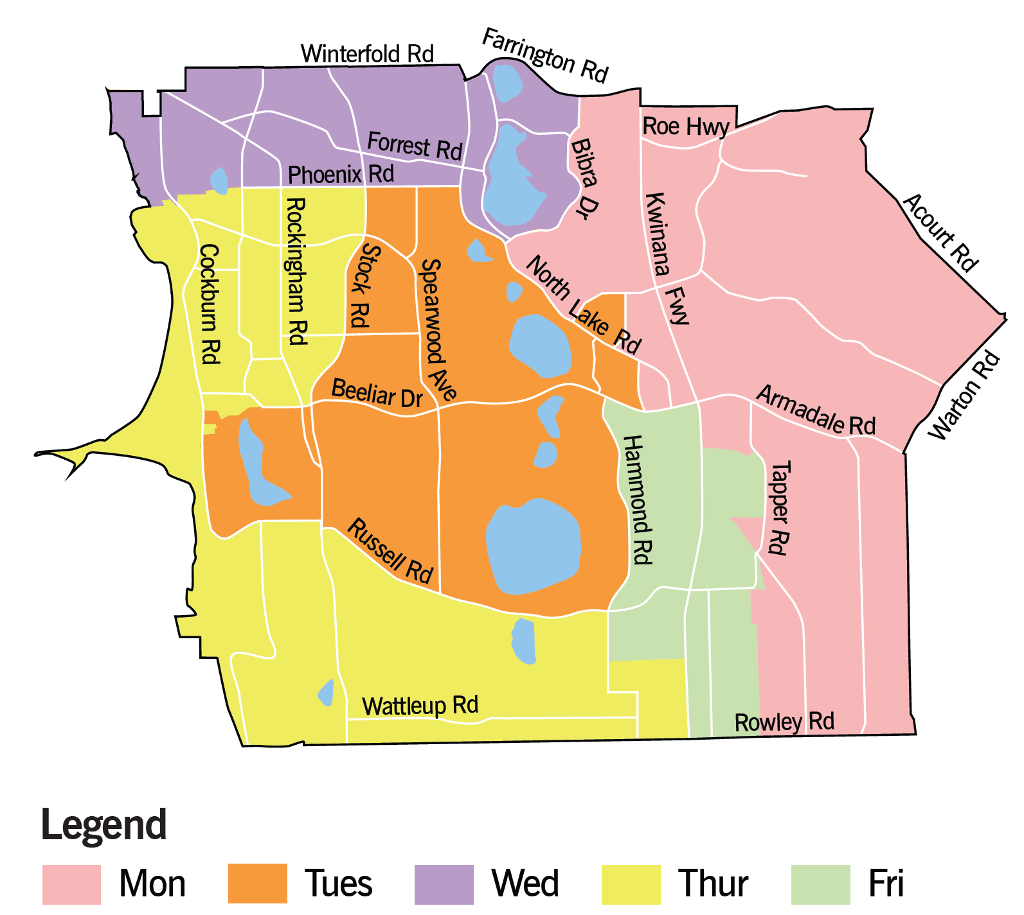
The map above shows the City of Cockburn divided into five areas, each marked with a different colour to indicate which day recycling and general waste bins are collected in this area.
Monday (pink on map):
This area encompasses a section on the eastern side of the City of Cockburn. Its boundaries include Farrington Road, Acourt Road, Warton Road, Rowley Road, Bibra Drive and North Lake Road. Roe Highway, Kwinana Freeway, Armadale Road and Tapper Road are included in this area.
Tuesday (orange on map):
This area encompasses a section in the middle of the City of Cockburn. Its boundaries include Phoenix Road, North Lake Road, Hammond Road, Russell Road, and Stock Road. Spearwood Avenue and Beeliar Drive are included in this area.
Wednesday (purple on map):
This area encompasses a section on the northern side of the City of Cockburn. Its boundaries include Winterfold Road, Farrington Road, Bibra Drive, and Phoenix Road. Forrest Road is included in this area.
Thursday (yellow on map):
This area encompasses a section on the western and southern side of the City of Cockburn. Its boundaries include Phoenix Road, Stock Road, Russell Road, and Rowley Road. Rockingham Road, Cockburn Road, and Wattleup Road are included in this area.
Friday (green on map):
This area encompasses a section towards the south-eastern side of the City of Cockburn. Its boundaries include Hammond Road, Armadale Road, Tapper Road, and Rowley Road. Kwinana Road and Russell Road are included in this area.
Transcriber’s Note: Please contact City of Cockburn for more information or clarification.
Please place bins out by 6am.

Garden Organics Bin Collection Map
The map below shows which week your garden organics bin is collected, if you have three bins.
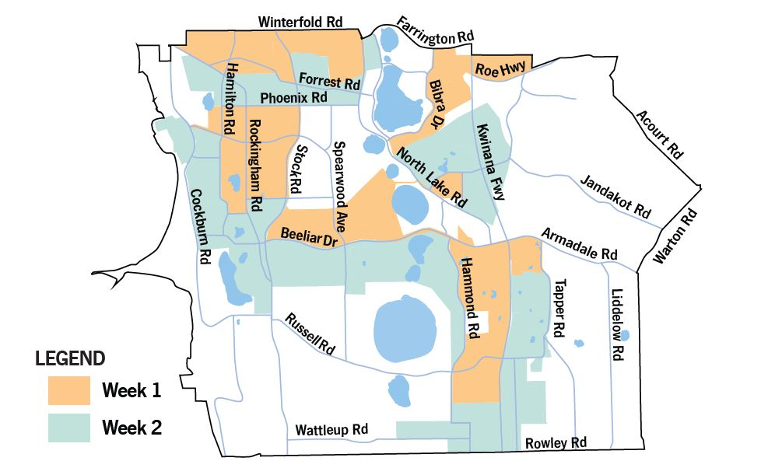
The map above shows the City of Cockburn, with areas marked by two different colours to show which week garden organics bins are collected in that area. Areas left in white do not have a garden organics bin at this time.
Week 1 (orange on map):
This includes:
- An area on the north-western side of the City of Cockburn. Its boundaries include Winterfold Road, North Lake Road, Stock Road, and Rockingham Road.
- An area towards the west of the City of Cockburn. Its boundaries include Phoenix Road, Stock Road, and Hamilton Road. Part of Rockingham Road falls within this area.
- An area extending from the mid-western section of the City of Cockburn in an easterly and southerly direction. Its boundaries include Beeliar Drive, Hammond Road, Tapper Road, Kwinana Freeway, and Armadale Road. Parts of North Lake Road and Spearwood Avenue fall within this area.
- An area extending from the north-eastern side of the City of Cockburn in a south-westerly direction. Its boundaries include Farrington Road, Bibra Drive, and Roe Highway.
Week 2 (green on map):
This includes:
- An area towards the north of the City of Cockburn. Its boundaries include Phoenix Road, North Lake Road, and Farrington Road. Forrest Road and parts of Stock Road, Rockingham Road, and Hamilton Road fall within this area.
- An area extending from the western side of the City of Cockburn in a southern and easterly direction. Its boundaries include Cockburn Road, Beeliar Drive, Hammond Road, and Stock Road. Parts of Spearwood Avenue and Rockingham Road fall within this area.
- An area towards the south of the City of Cockburn. Its boundaries include Wattleup Road, Rowley Road, Tapper Road, and Kwinana Freeway.
- An area towards the mid-eastern section of the City of Cockburn. Its boundaries include North Lake Road. Parts of Kwinana Freeway and Jandakot Road fall within this area.
Transcriber’s Note: Please contact City of Cockburn for more information or clarification.
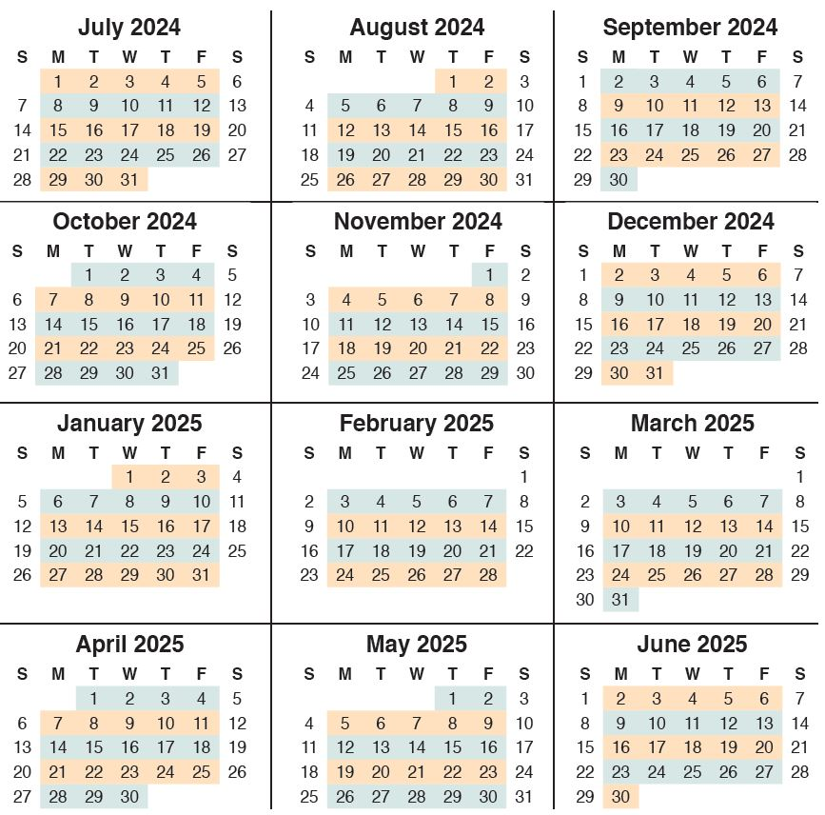
The calendar above covers July 2024 to June 2025. It highlights which week is Week 1 (orange) and which is Week 2 (green) with regards to the garden organics bin collection.
Week 1 begins the week starting Monday, 1 July. Week 2 begins the week starting Monday, 8 July. From there, the weeks alternate for the rest of the financial year.
Transcriber’s Note: Please contact City of Cockburn for more information or clarification.

Your Recycling Bin (Weekly)
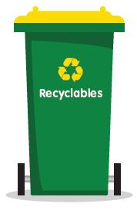
- Hard plastic bottles and containers, aluminium and steel cans, glass bottles and jars, paper and cardboard
- Place items loose in your bin
- Remove lids
- Rinse items
- No batteries or aerosols
- No soft plastics
- No clothing (textiles)
- No polystyrene
- No nappies
- No coffee cups
- No tissues

General Waste Bin (Weekly)
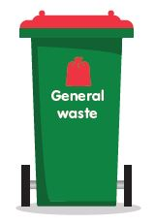
- All food scraps, nappies, hygiene products and other non-recyclable materials
- Garden organics (if you are on the two bin system)
- Soft plastic
- No recyclables
- No batteries, aerosols or chemicals

Your Garden Organics Bin (Fortnightly)
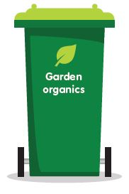
- Only natural materials that grow in the garden can be placed in this bin, including prunings, twigs, lawn clippings etc.
- Branches should be no thicker than 60mm
- No batteries or aerosols
- No food waste
- No plastic
- No pet faeces
- No recyclables

Missing or Damaged Bins
If your receptable is lost, stolen or damaged call the City on 08 9411 3444.
All damaged bins must be on the verge area.

Tips for Using Your Bins
Bin Placement
To assist us in emptying your bins safely, please:
- Place bins out by 6am on the day of collection. Your bins may not be collected at the same time every week
- Place bins within 1.5 metres of the kerb with bin handles facing towards your property and lid handles facing the road
- Place bins 30 centimetres apart to allow access for the waste truck arm
- Place smaller 140 Litre bin to left hand side of other bins (when viewed from road)
- Do not overfill your bin – the trucks cannot lift bins weighing over 70kg
- Keep bin lids closed to ensure waste doesn’t blow out or spill onto the verge
- Place your bin clear of obstacles e.g. cars, trees or overhanging branches
- Do not place batteries, aerosols, hot ash, liquids, oil, paint or solvents in your bins as they will damage bins, trucks and the environment
- Return bins to your property as soon as possible after they are emptied, within 24 hours
- Except for a reasonable period before and after collection time, keep each receptable in a storage space or area that is behind the street alignment
- Unpaid or non-Cockburn bins will not be collected.
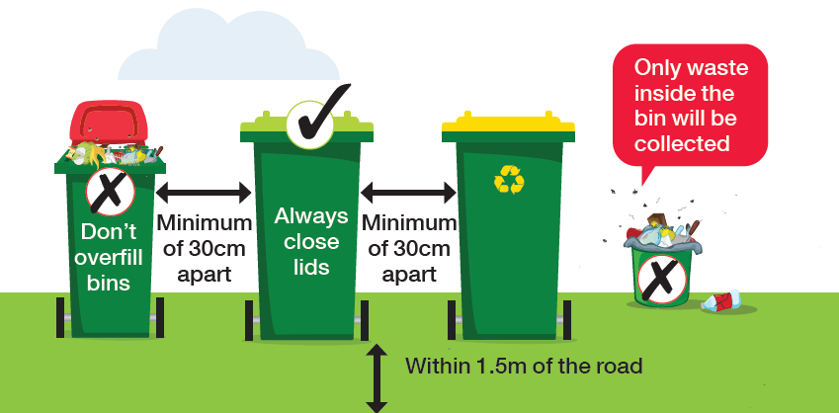
The diagram above shows you how to place your bins for collection:
- Don’t overfill bins
- Minimum 30 centimetres apart
- Within 1.5 metres of the road
- Only waste inside the bin will be collected

Resource Recovery Guide
This guide explains where you should dispose of your waste items.
Some items can be disposed of for free at Henderson Waste Recovery Park. These have been marked with an asterisk (*) and a note indicating eligibility for free disposal.
To find charities accepting donations, visit GIVIT: www.givit.org.au

A
- Acids* – Henderson Waste Recovery Park (free disposal)
- Aerosol cans* – Henderson Waste Recovery Park (free disposal), City’s libraries, Community Recycling Hubs, Cockburn ARC or City Administration Building. See “Community Recycling Hubs”, page 38.
- Aluminium cans – Recycling bin or Container for Change refund point
- Ammonia* – Henderson Waste Recovery Park (free disposal)
- Animal droppings – General waste bin
- Antennas – Hard Waste Collection
- Artificial Turf – General waste bin
- Ash (cold) – General waste bin
- Auto Batteries – Henderson Waste Recovery Park or retailer

B
- Balloons – General waste bin
- Band-Aids – General waste bin
- Barbecues – Henderson Waste Recovery Park or Hard Waste Collection
- Barbecue charcoal (cold) – General waste bin
- Baskets (cane/wooden/plastic) – Henderson Waste Recovery Park or Hard Waste Collection
- Batteries* – Henderson Waste Recovery Park (free disposal) or any of the City’s Community Recycling Hubs or search B-cycle: bcycle.com.au for battery drop off locations. See “Community Drop-Off Facility” and “Community Recycling Hubs”, pages 37-38.
- Beer cartons – Recycling bin
- Bean Bags – Henderson Waste Recovery Park (not for Bulk Verge Collection)
- Bicycles and parts – Henderson Waste Recovery Park or Hard Waste Collection
- Blankets – Give to charity or general waste bin
- Bleaches* – Henderson Waste Recovery Park (free disposal)
- Blinds – Henderson Waste Recovery Park or Hard Waste Collection
- Blister Packs – General Waste bin
- Books – Give to charity or general waste bin
- Bottles (plastic/glass) – Recycling bin
- Brake fluid* – Henderson Waste Recovery Park (free disposal)
- Broken glass – Recycling bin
- Bubble wrap – General waste bin
- Building materials/waste – Henderson Waste Recovery Park
- Bulky items – Henderson Waste Recovery Park or Hard Waste Collection

C
- Candles and wax – General waste bin
- Cans (aluminium/steel) – Recycling bin or Container for Change refund point
- Cat litter – General waste bin
- Cardboard – Recycling bin
- Car parts – Henderson Waste Recovery Park
- Carpet/underlay – Henderson Waste Recovery Park or Hard Waste Collection
- Cartons (juice/milk etc - silver lined or not - Tetra Pak) – General waste bin
- Cassette tapes and video tapes – General waste bin
- CDs and DVDs – General waste bin
- Cellophane – General waste bin
- Ceramic (broken plates, tiles, pots) – General waste bin
- Cereal boxes – Recycling bin
- Chemical drums (triple rinsed)* – Henderson Waste Recovery Park (free disposal)
- Christmas decorations – General waste bin
- Cigarette butts – General waste bin
- Cleaning products* – Henderson Waste Recovery Park (free disposal)
- Cling wrap (soiled) – General waste bin
- Clothing/fabric (reusable) – Give to charity
- Clothing/fabric (not reusable) – General waste bin
- Cockroach bait* – Henderson Waste Recovery Park (free disposal)
- Coffee cups (disposable) – General waste bin
- Coffee jars/cans – Recycling bin
- Coffee pods – General waste bin
- Compostable packaging – General waste bin
- Computer components/accessories* – Henderson Waste Recovery Park (free disposal)
- Computer paper – Recycling bin
- Concrete – Henderson Waste Recovery Park
- Condoms – General waste bin
- Cooking fat (solid) – General waste bin
- Cork – General waste bin
- Cotton wool/buds – General waste bin
- Cups and saucers – General waste bin
- Cutlery (metal) – General waste bin or give to charity
- Cutlery (plastic) – General waste bin
- Cutlery (wood) – General waste bin

D
- Dirt and soil – Henderson Waste Recovery Park
- Disposable nappies – General waste bin
- Disposable razors – General waste bin

E
- Egg cartons – Recycling bin
- Electrical appliances/cables* – Henderson Waste Recovery Park (free disposal) or Hard Waste Collection – Separated
- E-Waste* – Henderson Waste Recovery Park (free disposal) or Hard Waste Collection – Domestic quantities – Separated
- Electrical equipment* – Henderson Waste Recovery Park (free disposal) or Hard Waste Collection – Separated
- Envelopes – Recycling bin
- EPIRB locator beacons* – Henderson Waste Recovery Park (free disposal)

F
- Fertiliser* – Henderson Waste Recovery Park
- Fibre Cement/Fencing/Super 66 – Henderson Waste Recovery Park - no asbestos sheets (not for Bulk Verge Collection)
- Fibre Glass Product – Henderson Waste Recovery Park (not for Bulk Verge Collection)
- Fire extinguishers (Red)* – Henderson Waste Recovery Park (free disposal). Yellow fire extingunishers to go to Department of Fire and Emergency Services (DFES)
- Flares* – Henderson Waste Recovery Park (free disposal)
- Flooring – Henderson Waste Recovery Park
- Fly tape – General waste bin
- Foil (clean) – Recycling bin
- Food scraps – General waste bin or home compost system
- Fridges – Henderson Waste Recovery Park or Hard Waste Collection
- Furniture (broken) – Henderson Waste Recovery Park or Hard Waste Collection
- Furniture (intact) – Give to charity

G
- Garden chemicals/poison* – Henderson Waste Recovery Park (free disposal)
- Garden waste (small prunings or grass clippings) – General waste bin (two bin system) or garden organics bin (three bin system)
- Garden waste (large) – Henderson Waste Recovery Park or Garden Organics Verge Collection
- Gas cylinders* – Henderson Waste Recovery Park (free disposal)
- Glass bottles/jars – Recycling bin
- Glossy magazines/brochures – Recycling bin
- Greaseproof paper – General waste bin

H
- Hose (garden) – General waste bin when cut in short lengths. Henderson Waste Recovery Park or Hard Waste Collection

I
- Ice cream containers (plastic) – Recycling bin
- Insecticides* – Henderson Waste Recovery Park (free disposal)

J
- Juice bottles (plastic) – Recycling bin
- Junk (small items) e.g. brick-a-brac – General waste bin
- Junk (too large for bin) – Henderson Waste Recovery Park or Hard Waste Collection
- Junk mail – Recycling bin

L
- Lids (metal) – Recycling bin
- Lids (plastic bottle tops) – General waste bin or recycle at Containers for Change refund points: www.containersforchange.com.au/wa
- Light globes/fluorescent tubes* – Henderson Waste Recovery Park (free disposal) or City's Community Recycling Hubs. See “Community Recycling Hubs”, page 38.
- Lithium Batteries – Henderson Waste Recovery Park or any of the City's Community Recycling Hubs. See “Community Drop-Off Facility” and “Community Recycling Hubs”, pages 37-38.

M
- Magazines – Recycling bin
- Meat trays (coloured or clear) – General waste bin
- Meat tray pads – General waste bin
- Medicines – Return to pharmacy
- Mineral turpentine* – Henderson Waste Recovery Park (free disposal)
- Mobile phones – Mobile Muster or City's Community Recycling Hubs. See “Community Recycling Hubs”, page 38.
- Motor oil* – Henderson Waste Recovery Park (free disposal)

N
- Nappies (disposable) – General waste bin
- Needles – Refer to HealthyWA website: www.healthywa.wa.gov.au
- Newspapers – Recycling bin

O
- Oil (cooking) – General waste bin
- Oil (motor)* – Henderson Waste Recovery Park (free disposal)

P
- Paint* – Henderson Waste Recovery Park (free disposal)
- Paint tins* – Henderson Waste Recovery Park (free disposal)
- Paper (not shredded) – Recycling bin
- Paper (shredded) – General waste bin or home compost system
- Pens/biros/textas/pencils – General waste bin
- Pest control concentrates* – Henderson Waste Recovery Park (free disposal)
- Petrol/flammable liquids* – Henderson Waste Recovery Park (free disposal)
- Phone books – General waste bin
- Picture frames (broken) – General waste bin
- Picture frames (intact) – Give to charity
- Pizza boxes (clean) – Recycling bin
- Pizza boxes (soiled) – General waste bin or home compost system
- Pill packets (blister packs, tablet boxes) – General waste bin
- Placemats – General waste bin
- Plastic containers/punnets – Recycling bin
- Plastic containers (large) – Henderson Waste Recovery Park or Hard Waste Collection
- Plastic cutlery – General waste bin
- Plastic (soft, scrunchable) – General waste bin
- Plastic plant pots – General waste bin
- Plate glass – Henderson Waste Recovery Park
- Poisons (liquid/solid)* – Henderson Waste Recovery Park (free disposal)
- Polystyrene (small items) – General waste bin
- Polystyrene (large items)* – Henderson Waste Recovery Park (free disposal)
- Pool chemicals* – Henderson Waste Recovery Park (free disposal)
- Printer cartridges – City's Community Recycling Hubs. See “Community Recycling Hubs”, page 38.

R
- Rat poison* – Henderson Waste Recovery Park (free disposal)
- Rope – General waste bin when cut in short lengths. Henderson Waste Recovery Park or Hard Waste Collection
- Rubber tyres – Henderson Waste Recovery Park

S
- Sanitary pads – General waste bin
- Seedling containers – General waste bin
- Shoes (reusable) – Give to charity
- Shoes (not reusable) – General waste bin
- Silicone containers and bags – General waste bin
- Smoke alarms* – Henderson Waste Recovery Park (free disposal)
- Soap – General waste bin
- Soil – Henderson Waste Recovery Park

T
- Takeaway food containers (plastic) – Recycling bin
- Takeaway food containers (polystyrene) – General waste bin
- Tampons – General waste bin
- Terracotta tiles/pots – General waste bin
- Television* – Henderson Waste Recovery Park (free disposal) or Hard Waste Collection – Domestic quantities – Separated
- Timber – Henderson Waste Recovery Park or Hard Waste Collection
- Timber (treated) – Henderson Waste Recovery Park
- Tissues – General waste bin
- Toothbrushes – General waste bin
- Toothpaste tubes – General waste bin
- Toys (broken) – General waste bin
- Toys (intact) – Give to charity
- Tyres – Henderson Waste Recovery Park

V
- Vacuum cleaner dust – General waste bin
- Vinyl school bags (broken) – General waste bin
- Vinyl school bags (intact) – Give to charity
- Other vinyl (kitchen tiles etc) – General waste bin

W
Waxed cardboard – General waste bin
Waxed paper – General waste bin
Weeds – General waste bin (two bin system) or garden waste bin (three bin system)
White goods – Henderson Waste Recovery Park or Hard Waste Collection
Windowpanes – Henderson Waste Recovery Park
Wood (garden prunings) – General waste bin (two bin system) or garden waste bin (three bin system)
Wooden planks/furniture – Henderson Waste Recovery Park or Hard Waste Collection
Wrapping paper – Recycling bin

X
X-rays* – Henderson Waste Recovery Park (free disposal)
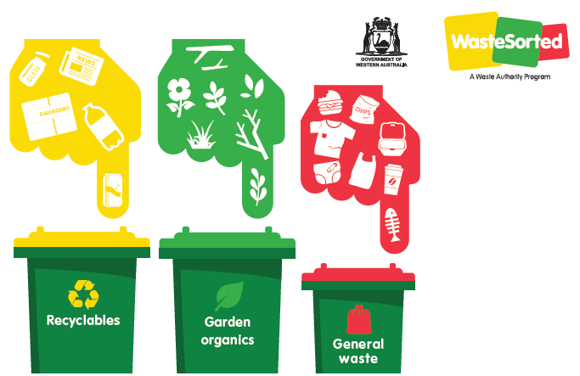

Hard Waste and Garden Organics Verge Collection
Place all verge material out by 6am on the Monday of the collection week. Do not place verge material out more than three days before the collection begins for your area. Separating your waste, as per the “Presenting your verge waste” picture on page 32, will help us recycle.

Residential Only
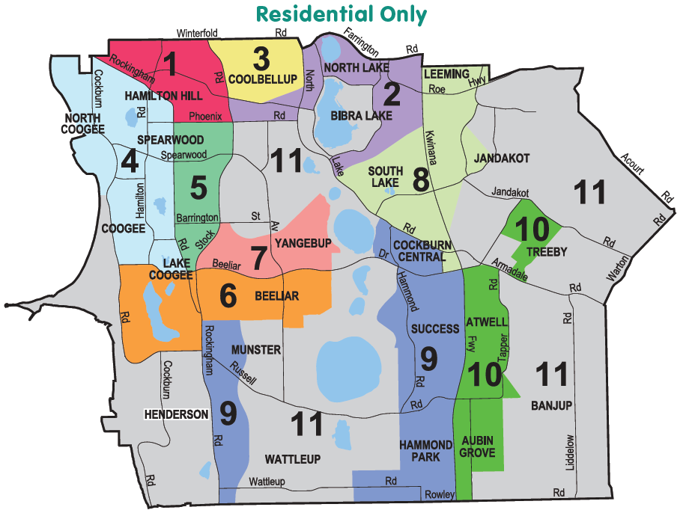
Please ensure you are aware of your correct area by number and colour.
Please do not present more than 2 cubic metres.
The image above is a colour coded map of the City of Cockburn divided into 11 verge collection areas.
Hamilton Hill, North Coogee, Coogee, Lake Coogee, Henderson, Spearwood, Coolbellup, North Lake, Bibra Lake, South Lake, Yangebup, Munster, Beeliar, Wattleup, Cockburn Central, Success, Hammond Park, Aubin Grove, Atwell, Banjup, Treeby, Jandakot, and part of Leeming fall within the City of Cockburn and are therefore represented in the verge map.
Transcriber’s Note: Please contact City of Cockburn for more information or clarification.

Area 1
(Magenta pink on map)
Area 1 includes the suburb of Hamilton Hill.
Its boundaries are Winterfold Road, Stock Road, Phoenix Road, Rockingham Road, and Hampton Road.
Carrington Street and Forrest Road run through Area 1. Area 1 shares borders with Areas 2, 3, 4, 5, and 11.

Area 2
(Purple on map)
Area 2 includes the suburbs of Coolbellup, North Lake, and Bibra Lake.
Its boundaries are Farrington Road, Kwinana Freeway, Meller Road, Bibra Drive, Hope Road, Progress Drive, North Lake Road, Phoenix Road, Stock Road, and Forrest Road.
North Lake (the lake, differentiated from the suburb) is located within Area 2. Area 2 shares borders with Areas 1, 3, 8, and 11.

Area 3
(Yellow on map)
Area 3 includes the suburb of Coolbellup.
Its boundaries are Winterfold Road, North Lake Road, Forrest Road, and Stock Road.
Area 3 shares borders with Areas 1 and 2.

Area 4
(Light blue on map)
Area 4 includes the suburbs of Hamilton Hill, North Coogee, Coogee, and Spearwood.
Its boundaries are Rockingham Road, Mayor Road, Cockburn Road, and the west coast suburb boundary of North Coogee.
Manning Lake and two other lakes are located within Area 4. Cockburn Road, Spearwood Avenue, and Hamilton Road run through Area 4. Area 4 shares borders with Areas 1, 5, 6, and 11.

Area 5
(Emerald green on map)
Area 5 includes the suburbs of Spearwood and Yangebup.
Its boundaries are Phoenix Road, Stock Road, Beeliar Drive, and Rockingham Road.
Spearwood Avenue and Barrington Street run through Area 5. Area 5 shares borders with Areas 1, 4, 6, 7, and 11.

Area 6
(Orange on map)
Area 6 includes the suburbs of Coogee, Lake Coogee, and Yangebup.
Its boundaries are Mayor Road, Beeliar Drive, Senecio Lane, Fancote Avenue, Fanstone Avenue, Rockingham Road, Russell Road, and Cockburn Road.
Lake Coogee (the lake, differentiated from the suburb) and two other lakes are located within Area 6. Area 6 shares borders with Areas 4, 5, 7, 9, and 11.

Area 7
(Baby pink on map)
Area 7 includes the suburb of Yangebup.
Its boundaries are Meller Road, Pelican Ramble, Pioneer Drive, Beeliar Drive, Stock Road, and Barrington Street.
Area 7 shares borders with Areas 5, 6, and 11.

Area 8
(Pale green on map)
Area 8 includes the suburbs of South Lake, Leeming, Jandakot, and Cockburn Central.
Its boundaries include and Prinsep Road, Kwinana Freeway, Beeliar Drive, North Lake Road, Meller Road, and the northern boundary of the City of Cockburn – including Demasson Rise, Barcombe Way, Allendale Entrance and Berswick Grove.
Two lakes are located within Area 8. Kwinana Freeway, Berrigan Drive, and Karel Avenue run through Area 8. Area 8 shares borders with Areas 2, 9, and 11.

Area 9
(Azure/indigo blue on map)
Area 9 includes the suburbs of Munster, Wattleup, Cockburn Central, Success, and Hammond Park.
Area 9 is divided into two sections
The first section includes Munster and Wattleup. Its boundaries are Fanstone Avenue, Moylan Road, Dalison Avenue, Rowley Road, and Rockingham Road.
Russell Road and Wattleup Road run through this section of Area 9. This section shares borders with Areas 6 and 11.
The second section includes Cockburn Central, Success, and Hammond Park.Its boundaries are North Lake Road, Prinsep Road, Beeliar Drive, Kwinana Freeway, Rowley Road, Jacksonia Promenade, Branch Circus, and Tamara Drive.
Four small lakes are located within this section of Area 9. Hammond Road, Russell Road, and Wattleup Road run through this section, which shares borders with Areas 8, 10, and 11.

Area 10
(Lime green on map)
Area 10 includes the suburbs of Treeby, Atwell, and Aubin Grove.
Area 10 is divided into two sections.
The first section includes Treeby. Its boundaries are Jandakot Road, Armadale Road, Dollier Street, and Solomon Road. This section of Area 10 shares a border with Area 11.
The second section includes the suburbs of Atwell and Aubin Grove. Its boundaries are Armadale Road, Tapper Road, Beenyup Road, Lyon Road, Rowley Road, and Kwinana Freeway. Several small lakes are located within this section, which shares borders with Areas 9 and 11.

Area 11
(Grey on map)
Area 11 includes the suburbs of Coogee, Henderson, Munster, Yangebup, Bibra Lake, Beeliar, Wattleup, Treeby, Jandakot, Leeming, and Banjup.
Area 11 is divided into three sections.
The first section includes Coogee and Henderson. Its boundaries are Cockburn Road, Russell Road, Rockingham Road, and the west coast suburb boundaries of Coogee and Henderson.
A small lake is located in this section and Cockburn Road runs through it.
The second section includes Yangebup, Bibra Lake, Beeliar, Munster, and Wattleup. Its boundaries are North Lake Road, Tamara Drive, Beeliar Drive, Branch Circus, Jacksonia Promenade, Rowley Road, Dalison Avenue, Moylan Road, Fancote Avenue, Senecio Lane, Pioneer Drive, Pelican Ramble, Meller Road, Barrington Street, Stock Road, Phoenix Road, Progress Drive, Hope Road, and Bibra Drive.
Eight lakes, including Bibra Lake, Kogolup Lake, Thomsons Lake, and Banganup Lake are located in this section of Area 11. North Lake Road, Beeliar Drive, Russell Road, and Wattleup Road also run through this section, which shares borders with Areas 2, 5, 6, 7, 8, and 9.
The third section includes Leeming, Jandakot, Treeby, and Banjup. Its boundaries include Rowley Road and the eastern border of City of Cockburn – Acourt Road, Johnston Road and Leeming Road, Roe Highway, and Fernleaf Court.
Karel Avenue, Farrington Road, Roe Highway, Armadale Road, Ranford Road, Nicholson Road, Acourt Road, Jandakot Road, Warton Road, and Liddelow Road run through this section of Area 11. There are three small lakes in this section.

Verge Collection Dates
Area | Hard Waste 1 (2024) | Garden Organics 1 (2024) | Hard Waste 2 (2025) | Garden Organics 2 (2025)
1 | Week Starting  8 July | Week Starting  14 October | Week Starting  30 December 2024 | Week Starting  28 April
2 | Week Starting  15 July | Week Starting  21 October | Week Starting  6 January | Week Starting  5 May
3 | Week Starting  29 July | Week Starting  28 October | Week Starting  20 January | Week Starting  12 May
4 | Week Starting  5 August | Week Starting  4 November | Week Starting  27 January | Week Starting  19 May
5 | Week Starting  12 August | Week Starting  11 November | Week Starting  10 February | Week Starting  26 May
6 | Week Starting  19 August | Week Starting  18 November | Week Starting  17 February | Week Starting  2 June
7 | Week Starting  26 August | Week Starting  25 November | Week Starting  3 March | Week Starting  9 June
8 | Week Starting  2 September | Week Starting  2 December | Week Starting  10 March | Week Starting  16 June
9 | Week Starting  16 September | Week Starting  9 December | Week Starting  24 March | Week Starting  23 June
10 | Week Starting  23 September | Week Starting  16 December | Week Starting  31 March | Week Starting  30 June
Area 11: Rural Collections will commence 30 September 2024 and 14 April 2025.

Important information for verge collections
Details on how to present verge waste:
- Do not place verge material out more than three days before the collection date for your area. A non-compliance notice will be issued for early “set outs”
- Ensure your verge material is presented before 6am on the Monday of your collection week. The City will not return for waste that was set out late
- Place away from walls, fences, water meters, power poles and letterboxes
- Separate white goods, steel, mattresses and e-waste from other verge collection items for recycling
- Keep checking your pile to ensure no illegal dumping has occurred (refer to “Garden Organics Verge Collections” and “Hard Waste Verge Collections”, pages 33-36)
- Do not place on vacant land, reserves or parklands
- Do not place on artificial turf, brick paving or driveway. Contact the City for an alternative pick up location
- Do not place under trees or over sprinklers
- Do not follow your neighbour – check your collection date
If your verge hard waste or garden organics are not compliant, we will not return to collect them.
Please do not present more than 2 cubic metres.

Presenting your verge waste
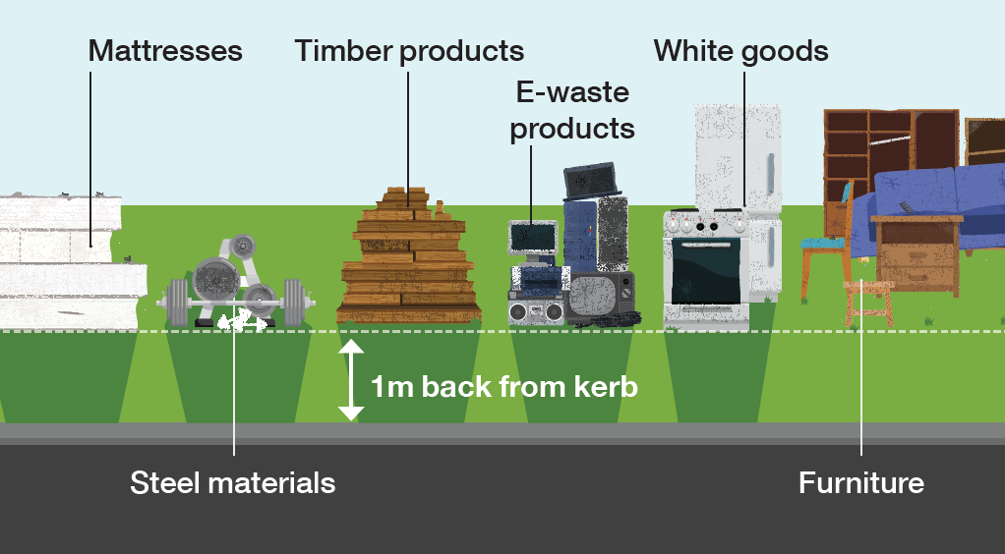
The diagram above shows how to present hard verge waste.
- 1 metre back from kerb
- Materials are separated on the verge:
  - Mattresses
  - Steel materials
  - Timber products
  - E-waste products
  - White goods
  - Furniture

Garden Organics Verge Collections
The following items will be collected:
- Prunings up to 1.5m in length and 30cm in diameter
Your verge garden organics are taken to the Henderson Waste Recovery Park where they are processed into compost off site by a contractor. The compost is free and available to people visiting HWRP.
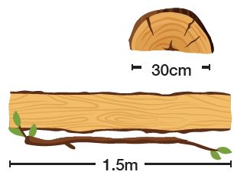
The following items will not be collected:
- Bags or boxes of leaves/grass clippings
- Dug out lawn
- General waste, junk or white goods
- Loose leaves/grass clippings
- Please do not present more than 2 cubic metres
- Sand or soil materials
- Stumps or palm logs
- Weeds and root materials
Collection as per usual on all Public Holidays, including Good Friday.
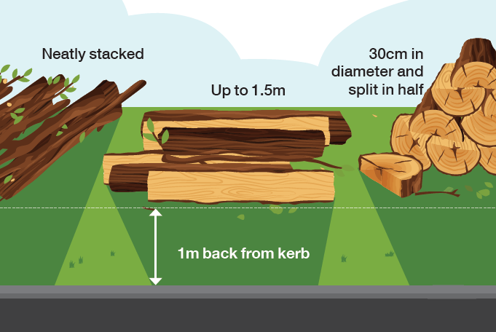
The diagram above shows how to present garden organics verge waste.
- Neatly stacked
- Up to 1.5 metres in length
- 30 centimetres in diameter and split in half
- 1 metre back from kerb

Hard Waste Verge Collections
The following items will be collected:
- General hard waste e.g. furniture, mattresses
Your verge hard waste is taken to the Henderson Waste Recovery Park where it is recycled or sent to landfill.
The following items will not be collected:
- Any items over 1.5 metres in length
- Asbestos, cement or glass fibre products
- Batteries, paints, chemicals, oils or other household hazardous waste
- Bean bags
- Construction waste e.g. bricks, sand, cement, rubble, concrete
- General waste, food
- Garden waste e.g. trees, dug out lawn, leaves
- Gas and air cylinders, fire extinguishers
- Mirrors
- Oil heaters
- Plate glass, solar panels, shower screens, glass tables etc
- Pallets
- Please do not present more than 2 cubic metres
- Tyres
- Vehicle parts
If you have difficulties presenting your waste, or are considering combining your verge waste with your neighbour, please arrange this with the City prior to the collection date.

Why waste it when you can gift it?
Have you tried selling, donating or gifting your quality items before they go on the verge?
Sell them on your local buy and sell page, donate them to a charity shop or drop them off at the Henderson Waste Recovery Park Reuse Shop.

Henderson Waste Recovery Park
The Henderson Waste Recovery Park is owned and managed by the City of Cockburn. It includes a landfill, a Community Drop-Off Facility, a methane power plant and a Reuse Shop.

Landfill
The City’s landfill site processes commercial waste, industrial waste, general household waste and verge waste. Valuable items that can be resold or recycled are removed from the waste stream to prevent them being sent to landfill. The site uses the latest methane recovery and leachate management technologies to limit its environmental impact.

Community Drop-Off Facility
Residents can drop off unwanted items at the Community Drop-Off Facility. These will be separated on-site and recovered if they are able to be reused or recycled.
The Community Drop-Off Facility accepts:
- Household hazardous waste e.g. paints, chemicals, oils, aerosols, batteries. Up to 20kg or litres will be accepted free, without any accompanying waste
- Construction and demolition waste (fees apply)
- Mattresses: four mattresses per customer can be accepted (fees apply). Commercial quantities of mattresses can be recycled at the Eastern Metropolitan Council, call (08) 9274 7807
- General waste including wood, metal, cardboard, plastic etc
- E-Waste (free)
- Green waste (fees apply)
- Cardboard (free if clean)
- Polystyrene (free if clean).

Community Recycling Hubs
You can drop off small quantities of dry-cell batteries, light globes, mobile phones and printer toner cartridges at Cockburn ARC, the Wetlands Centre Cockburn, Cockburn Gateways Shopping Centre and Cockburn Libraries in Spearwood, Coolbellup and Success.
You can also drop off aerosol cans to the front counter at the Administration Building (9 Coleville Crescent, Spearwood), Seniors Centre, Coolbellup Hub, the Wetlands Centre Cockburn, Aubin Grove Sport and Community Facility, Cockburn ARC and the Operations Centre (52 Wellard Street, Bibra Lake).

Trailer Passes
All City of Cockburn households receive six trailer passes per year to allow them to bring their waste to Henderson Waste Recovery Park. Trailer passes are non-transferable and cannot be sold. Use of trailer passes is monitored by the City and any attempt to sell, swap or trade passes on social media platforms, Gumtree or any other means will result in cancellation of all six trailer passes.
Please note: Trailer passes can also be used to drop off green waste to the Regional Resource Recovery Centre:
350 Bannister Road, Canning Vale
Phone: 08 9256 9555
Open 7 days, 8am−4pm.

Compost
Mulch used as weed suppression is no longer available at Henderson Waste Recovery Park. Instead, free compost for soil enrichment, moisture retention and the promotion of plant growth is available.
Bring along a trailer or utility vehicle and load the compost yourself. Ensure that you wear gloves, a dust mask and enclosed shoes. Staff are not able to help with loading compost into vehicles.

Reuse Shop
The Reuse Shop sells many items that have been recovered from the waste stream rather than going to landfill. Pick up a bargain at the Reuse Shop – Friday to Sunday, 8am to 4pm. Not open public holidays.
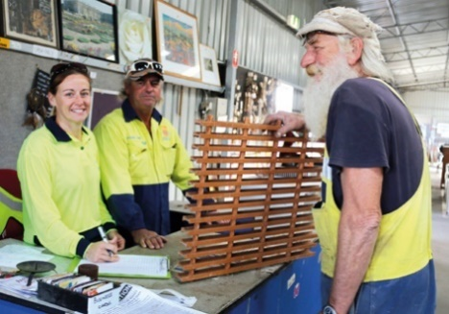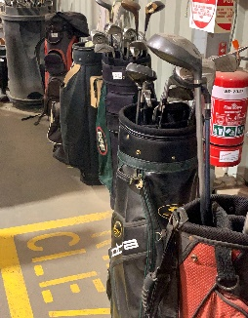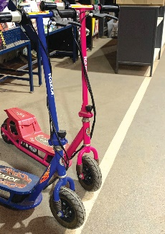
920 Rockingham Road, Wattleup
Phone: 08 9411 3444
Community Drop-Off Facility is open 7 days, 8am−4.30pm except Christmas Day, New Year’s Day and Good Friday.
Find out how the City can help you reduce waste to landfill and live more sustainably through the City’s environmental rebates. From home compost systems to cloth nappies and sanitary product subsidies, find out more at the City's website: www.cockburn.wa.gov.au
When you no longer need this calendar, please place it in the yellow-top recycling bin.
The calendar is available on the City of Cockburn’s website in PDF and in Croatian, Chinese, Tagalog, Portuguese and Italian. If you require further information please contact Customer Service on 08 9411 3444.
Hard copies of this calendar are available at City libraries and the Cockburn Administration Centre.
City of Cockburn
Whadjuk Boodja
9 Coleville Cresent, Spearwood WA 6163
Office hours 8.30am–4.30pm
Monday – Friday (closed Public Holidays)
Phone: 08 9411 3444
Email: customer@cockburn.wa.gov.au
Website: www.cockburn.wa.gov.au
This information is available in alternative formats upon request.

