Tender Title: |  | RFT 12/2024 – Building Maintenance Services
Request ID: |  | 50061
Tender Description: |  | The City of Cockburn (Principal) requires an efficient, professional and qualified Building Maintenance Contractor to carry out building and facility maintenance and minor works pertaining to the Principal’s building infrastructure.
Advert Approval: |  | Decision to Advertise: Acting Director Infrastructure Services  Decision Date: Wednesday, 3 July 2024
Closing Date and Time: |  | 2:00PM (AWST) Wednesday, 31 July 2024
Opening Date and Time: |  | 2:00PM (AWST) Wednesday, 10 July 2024
 | Tenderer’s Name:
1 | Access Without Barriers Pty Ltd t/a AWB Co.
2 | MA Bunjil Pty Ltd t/a Bunjil Service
3 | Geared Construction Pty Ltd
4 | K Craft Building Pty Ltd
5 | K2 Pty Ltd t/a K2 Build
6 | Oban Group Pty Ltd
7 | Perth Building Projects Pty Ltd
8 | Quantum Building Services Pty Ltd
9 | The Trustee for M R Hoskins Family Trust t/a AE Hoskins
10
11

Advertisement
Method 1: City of Cockburn | Method 2: Yammer
Method 3:  The Western Australian, Wednesday 10th July 2024 | Tender Awarded by:
Copy of Statewide Notice:  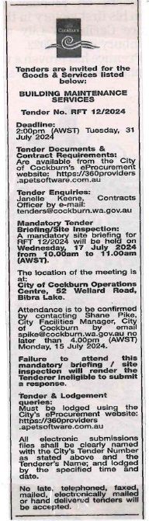 | Acting Director Infrastructure Services  Acting Director Corporate & System Services  Friday, 13 September 2024
 | Date of Council Meeting:
 | Not Applicable
Name of Successful Tenderer(s): | Quantum Building Services Pty Ltd
Amount of Successful Tender(s): (ex GST) | Estimated Value $848,808.39 Ex GST

