**Policy**

Rural Subdivision and Development

**Policy Number**

LPP 2.1

# Policy Type

Local Planning Policy

# Policy Purpose

The Rural zone, the Rural Living Zone and the Resource Zone under Town Planning Scheme No. 3 (TPS 3) are retained for rural pursuits, rural living or resource protection purposes. In addition, portions of the City are affected by the Kwinana Air Quality buffer and inappropriate subdivision within these areas has the potential to compromise strategic planning objectives.

In Jandakot and Treeby there remain several large lots which have yet to reach their full subdivision and development potential under the provisions of State Planning Policy No. 2.1 (Peel-Harvey Coastal Plain Catchment Policy), State Planning Policy No. 2.3

(Jandakot Groundwater Protection Policy) and the provisions of the 'Resource' zone under City of Cockburn Town Planning Scheme No. 3 (TPS 3). Sand extraction operations, which have occurred or are occurring on these remaining sites, have ceased or are likely to cease within a relatively short time frame. As the sand resource is exhausted, landowners are expected to seek Western Australian Planning Commission (WAPC) approval to subdivide.

There is a need to ensure that subdivision proposals resolve issues arising from prior land uses are carried out within a comprehensive planning framework, to ensure that they are developed with regard to the relevant opportunities and constraints of the locality and comply with the 'Resource' zone provisions under TPS 3.

The City is required to make recommendations to the WAPC regarding applications to subdivide land within these zones and as the matter is not addressed by TPS 3, this Policy provides the basis for consistent responses to the WAPC on subdivision proposals.

The effective management of land-use activities over the Jandakot Underground Water Mound is a matter of State planning significance. Land-use activities have the potential to adversely affect Perth’s drinking water. The Resource Zone in the City’s TPS3 and the WAPC’s State Planning Policy 2.3 *Jandakot Groundwater Protection* (SPP 2.3) specifically regulate activities such as the keeping of horses and other animals.

In accordance with SPP 2.3, applications for animal activities are to be referred to the Department of Water and Environmental Regulation (DWER) for consideration, as they have the technical expertise to evaluate the implications on ground water supplies. The guidelines used by the DWER are designed to protect the Jandakot underground water mound. The City is compelled to follow the DWER recommendation or refer the application to the WAPC for determination with its recommendation along with the DWER recommendation. In those instances where the Council does not agree with the DWER advice. On environmental grounds, it is likely the DWER recommendation will be followed in most instances.

The purpose of this policy is to recommend against the ad hoc subdivision of land that is proposed to be retained for rural pursuits, rural living or resource protection under the Town Planning Scheme or which is affected by the Kwinana Air Quality Buffer. Additionally, this policy aims to provide guidance to landowners and the City when considering future applications for horse or other animal activities in the Resource Zone. The following approach intends to ensure that decisions are made on the basis of sound environmental resource management, for the purpose of achieving the objectives outlined in SPP 2.3. Further, A consistent set of guidelines for development in the Rural, Rural Living and Resource zones is required, which is consistent with TPS 3 and takes into account local needs.

# Policy Statement

(1) Subdivision:

* 1. The Council may support subdivision in the Resource Zone if the proposal is in accordance with the Jandakot Groundwater Protection Policy (SPP No. 2.3) and the land is being suitable and capable of subdivision for the proposed purpose.

* 1. On land within Resource Zone not subject to clause 1.5 below, the following applies:

* + 1. A minimum lot size of 2ha;
    2. A building envelope no larger than 2000m2 being provided on each lot created which complies with TPS 3; and
    3. The onsite effluent disposal being located within the building envelope and complying with the provisions of TPS 3 relating to the Resource zone and Section 15 SPP2.3.

3. Subdivision within the resource zone shall be in accordance with the following planning principles:

* + - 1. Subdivision over the Jandakot Groundwater Mound shall be compatible with the long term use of the groundwater for public water supply
      2. Subdivision shall maintain the operational integrity of Jandakot Airport, Kennel/Cattery Precinct and Solomon Road Industrial Area.
      3. Subdivision shall provide a permeable and logical road layout
      4. Subdivision shall maintain vegetation of local significance as identified by the City.
      5. Proponents shall identify site specific environmental features worthy of protection through a detailed land capability and site suitability assessment by proponents in consultation with the City.
      6. Subdivision proposals shall Maintain and enhance the high level of the visual and landscape qualities of the natural environment for the benefit of future generations.
      7. Proponents shall ensure subdivision designs and associated rehabilitation works reflect appropriate bushfire safety principles as detailed within State Planning Policy SPP3.7 and relevant TPS 3 provisions.

1. The Council will not support any further subdivision in the Rural and Rural Living zones.

1. The following provisions apply to subdivision proposals located within the precincts identified in Appendix 1.

a. PRECINCT 1

* + - * 1. PROPERTIES:

Lot 98 Prinsep Road and Lots 51, 99 and 9 Jandakot Road, Jandakot.

The intention of the Precincts and Subdivision Concept Plan of subdivision is to provide an indicative road layout for future subdivision and demarcate the area

* + - * 1. CURRENT STATUS:

All lots have remnant bushland and most have house son them. The land remains heavily vegetated.

* + - * 1. SUBDIVISION RECOMMENDATIONS AND REQUIREMENTS:

The City shall not support subdivision unless the general intentions of the Precincts and Subdivision Concept Plan for Precinct 1 are complied with.

Any proposed plan of subdivision will be required to address matters consistent with the structure planning provisions of Deemed Provisions.

The City shall only support the creation of lots less than 2 hectares to the extent that the reduction in lot area is required to facilitate the construction of subdivisional roads.

b. PRECINT 2

* + - * 1. PROPERTIES

Lot 130 Jandakot Road, Treeby

* + - * 1. CURRENT STATUS

Lot 130 Jandakot Road is a 41ha site and still subject to sand extraction at the northern extremity.

* + - * 1. SUBDIVISION RECOMMENDATIONS AND REQUIREMENTS

The City shall not support subdivision unless the general intentions of the Precincts and Subdivision Concept Plan for Precinct 2 are complied with. Any proposed plan of subdivision will be required to address matters consistent with the structure planning provisions of the Deemed Provisions.

The City shall require comprehensive rehabilitation works to be undertaken and completed at the time of subdivision of the land, in accordance with an adopted Rehabilitation Management Plan approved by the City. Rehabilitation works undertaken on public land will have a standard maintenance period associated, and will be audited at the end of the maintenance period to assess whether works have been appropriately undertaken in accordance with the adopted Rehabilitation Management Plan prior to the public land being taken over by the City. The City will only takeover public land once rehabilitation and maintenance works have been undertaken in accordance with the requirements of the adopted Rehabilitation Management Plan. For rehabilitation works on private land, affected lots are to include on their titles the requirement to care for and maintain the rehabilitation works in accordance with the minimum standards set out in the adopted Rehabilitation Management Plan.

The City shall recommend a geotechnical investigation of proposed building envelopes for areas where inappropriate backfilling and/or compaction is suspected. In the event that inappropriate backfilling/compaction has occurred, this will need to be rectified to make the building envelopes capable for accommodating development prior to the issue of subdivision clearances.

The City shall recommend investigation for soil and groundwater contamination in areas known or suspected to have contamination

potential (e.g. previous storage of fuel). In the event that contamination has occurred, all remediation works including validation of remediation is to be completed to the specifications of the Department of Water and Environment Regulation prior to the commencement of any site works.

The City shall recommend a notification under Section 165 of the Planning and Development Act 2005 be placed on the title of all lots within 500m of the Kennel/Cattery Precinct advising of potential noise and amenity impacts. This is considered to represent a hazard/other factor seriously affecting the use/enjoyment of the land.

The City shall require that the Structure Plan and subdivision layout design minimise the number of lots with boundaries to the Jandakot Botanical Park.

The City shall not support the creation of lots with excessive areas of batter slopes or excessive unevenness. As a guide no greater than one third of the area of any lot is to be affected by this.

The City shall request revegetation to enhance or create vegetated linkages, enhance areas of remnant vegetation or provide for landscape or screening purposes.

c. PRECINT 3

1. PROPERTIES

Lot 186 Acourt Road, Jandakot

1. CURRENT STATUS

Lot 186 is occupied by soil blending and fertiliser operations.

1. SUBDIVISION RECOMMENDATIONS AND REQUIREMENTS

The City shall not support subdivision unless the general intentions of the Precincts and Subdivision Concept Plan for Precinct 3 are complied with.

The City shall require comprehensive rehabilitation works to be undertaken and completed at the time of subdivision of the land, in accordance with an adopted Rehabilitation Management Plan approved by the City. Rehabilitation works undertaken on public land will have a standard maintenance period associated, and will be audited at the end of the maintenance period to assess whether works have been appropriately undertaken in accordance with the adopted Rehabilitation Management Plan prior to the public land being taken over by the City. The City will only takeover public land once rehabilitation and maintenance works have been undertaken in accordance with the requirements of the adopted Rehabilitation Management Plan. For rehabilitation works on private land, affected lots are to include on their titles the requirement to care for and maintain the rehabilitation works in accordance with the minimum standards set out in the adopted Rehabilitation Management Plan.

The City shall not support subdivision until the soil blending operation and the soil blending/fertiliser factory on Lot 186 have ceased operating and all associated materials and structures have been removed.

The City shall recommend a geotechnical investigation of proposed building envelopes for areas where inappropriate backfilling and/or compaction is suspected. In the event that inappropriate backfilling/compaction has occurred, this will need to be rectified to make the building envelopes capable for accommodating development prior to the issue of subdivision clearances.

The City shall recommend investigation for soil and groundwater contamination in areas known or suspected to have contamination

potential (e.g. previous storage of fuel). In the event that contamination has occurred, all remediation works including validation of remediation is to be completed to the specifications of the Department of Water and Environment Regulation prior to the commencement of any site works.

The City shall require that the subdivision layout design provide Lukin Swamp with an adequate buffer of public open space, and that frontage to a subdivisional road be provided to enable public and City access to the swamp and public open space

The City shall recommend a notification under Section 165 of the Planning and Development Act 2005 be placed on the title of all lots created from subdivision advising of odour from the City of Canning’s Kennel Zone affecting the land. These are considered to represent hazards/other factors seriously affecting the use/enjoyment of the land.

All new building envelopes are to be located outside the 30 ANEF noise contour of the Jandakot Airport.

The City shall not support the creation of lots with excessive areas of batter slopes or unevenness. As a guide no greater than one third the area of any lot is to be affected by this.

The City shall request strategic revegetation to enhance areas of remnant vegetation, buffer zones to Lukin Swamp and provide vegetated linkages to the Jandakot Botanical Park

1. Building Envelopes:

1. A building envelope may be modified or relocated, provided that:

* + - * 1. The written request referred to in TPS 3 is in the form of an Application for Development Approval, accompanied by the appropriate fee and documentation

* + - * 1. The area of the modified building envelope is similar in size to the original building envelope but should in any event not exceed 3000m2;

* + - * 1. The modified building envelope accords with the setback distances prescribed under TPS 3;

* + - * 1. The modified building envelope has regard to the requirement that any development contained therein has a finished floor level that is a minimum of 1.2m above the highest known water table applicable to the land;

* + - * 1. The modified building envelope is located to avoid or minimise vegetation removal on-site; and

* + - * 1. The modified building envelope has regard to the placement of a dwelling and outbuildings on a lot relative to adjoining lots and buildings contained thereon (for the purpose of maintaining separation and protection of amenity in a rural setting).

2. A building envelope may be nominated where:

* + - * 1. A building envelope does not already exist on the lot;

* + - * 1. The written request referred to in TPS 3 is in the form of an Application for Development Approval, accompanied by the appropriate fee and documentation;

* + - * 1. The building envelope area does not exceed 3000m2

* + - * 1. The building envelope accords with the setback distances prescribed under TPS 3. Setback measurements shall be taken at right angles to the lot boundary (example of measurements under Figure 1 below)

e.

The building envelope has regard to the requirement that any

development contained therein has a finished floor level

that is a

minimum of 1.2m above the highest known water table applicable to

the land

f.

T

he building envelope is located to avoid or minimise vegetation

remova on

-

site

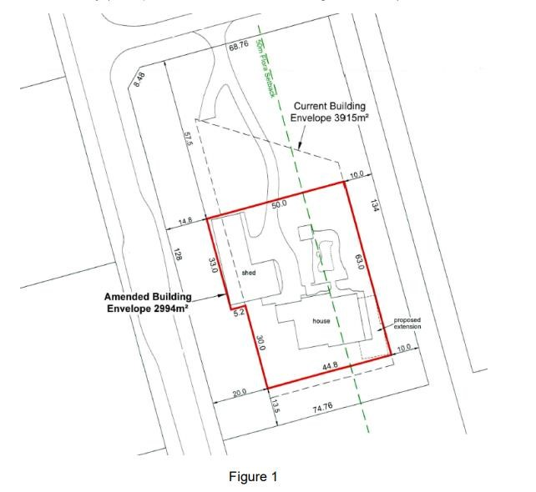

* + 1. The building envelope has regard to the placement of a dwelling and outbuildings on a lot relative to adjoining lots and buildings contained thereon (for the purpose of maintaining separation and protection of amenity in a rural setting);

* + 1. The City requires the nomination of a building envelope as part of a development application in a specific location due to planning, environmental and land constraints.

* + 1. Only one building envelope is permitted per lot.

1. Keeping of Horses:

* 1. Conditional approval may be granted for the keeping of horses where development applications for the proposed keeping of horses has been considered by the Department of Water and Environmental Regulation (DWER) to comply with the Environmental Guidelines for Horses Activities (December 2002).

* 1. Where planning applications for the keeping of horses has been considered by the DWER to not comply with the Environmental Guidelines for Horse Activities (December 2002), then the applications concerned may be refused.

* 1. The City will acknowledge lawfully established non-conforming uses relating to the keeping of horses and other animals in the Resource Zone where past planning approvals exist

* 1. Where retrospective development applications for the keeping of horses have been considered by the DWER to not comply with the Environmental Guidelines for Horse Activities (December 2002) or other relevant guidelines and advice to that effect is received by the City, then the applications concerned will be refused.

* 1. In refusing applications in accordance with clause 4 above, proponents will be given notice by the City to the effect that they will be given periods up to 12 months to ensure the animals concerned are removed from the property.

* 1. In the event that landowners identified as requiring development approval (to keep horses) do not co-operate by applying for the planning consent within the time requested, then the City will give notice to the landowners concerned requiring the animals to be removed from the property within 3 months, or risk prosecution.

* 1. All other requirements of the City’s Local Laws shall be followed. Where there is an inconsistency between this policy and a Local Law, the Local Law shall prevail.

* 1. In considering an application to keep a horse, the City may refer the application to the Department of Primary Industries and Regional Development (DPIRD).

1. Keeping of Other Large Animals (Excluding Horses):

* 1. For the purposes of this section, a large animal includes a sheep, cow, goat, deer, alpaca, pig or any other animal so classified by the local government.

* 1. No person shall keep a pig or pigs in any zone.

* 1. Development approval is required to keep any large animal (apart from pigs which are prohibited). Large animals shall not be kept on land less than 2020m2 in area.

* 1. Large animals shall not be loose in any yard, paddock or place unless due provision is made to prevent large animals from approaching within 15 metres of any dwelling, shop, church or any premises where food is stored, manufactured or sold.

* 1. All other requirements of the City’s Local Laws shall be followed. Where there is an inconsistency between this policy and a Local Law, the Local Law shall prevail.

* 1. In considering an application to keep a large animal, the City may refer the application to the Department of Primary Industries and Regional Development (DPIRD).

1. Outbuildings

* 1. For the purposes of this section, Outbuilding has the same meaning as in the Residential Design Codes of Western Australia (R-Codes). A lean-to is defined as a roofed structure attached to an outbuilding that is completely unenclosed on all sides, except to the extent that it abuts the side or sides of the outbuilding.

* 1. The combined floor area of existing and proposed outbuildings and the wall and ridge height of proposed outbuildings are not to exceed the following:

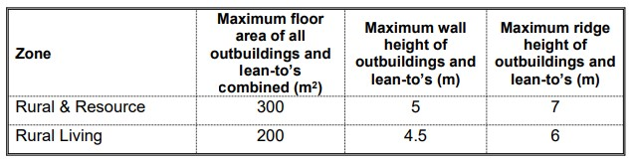

* 1. Outbuildings and lean-to’s are to be sited within a building envelope prescribed for any lot.

* 1. Outbuildings and lean-to’s are generally to be sited wholly behind the primary residence in all zones.

* 1. Subject to Clause 5.9 below of this Policy outbuildings proposed in the Development zone where there is no structure plan will be assessed on their merits having regard to the future intent of the area. In any case, the development standards shall not exceed those for outbuildings in rural areas as shown in the table above.

* 1. Outbuildings are to be constructed of a non-reflective material and colour that matches the dwelling and/or harmonises with the surrounding environment and that does not detract from the visual amenity of the area.

* 1. Where a proposal does not comply with the prescriptive requirements of the above table but it can be demonstrated by the applicant to the satisfaction of Council offers that the application will not result in any negative impacts on the amenity of neighbouring properties or the area, the application may be approved by Council officers under delegation. All applications seeking a variation to the requirements of the above table shall be advertised to nearly landowners who in the opinion of Council officers may be affected by the proposal.

Any subsequent actions as a result of refused applications are carried out in accordance with Council’s Policy.

* 1. The floor area of any approved sea containers will contribute towards the combined maximum floor area of outbuildings contained in this Policy.

* 1. Planning applications for Outbuildings and lean-to’s will not be supported in the absence of a dwelling on site. Applications may be supported where a dwelling is constructed to at least plate height level.

1. Exempt Development

* 1. Pursuant to Schedule A of TPS3, the following development exemptions apply:

* + - 1. A single house, including extensions and ancillary outbuildings with an area of less than 100m2 and a wall height not exceeding 4.5 in the Rural Zone and Rural Living Zone and the proposal is contained within a building envelope.

* + - 1. A single house, including extensions and ancillary outbuildings with an area of less than 200m2 and a wall height not exceeding 4.5 in the Resource Zone and the proposal is contained within a building envelope.

|  |  |
| --- | --- |
| Strategic Link: | Town Planning Scheme No.3 |
| Category: | Planning – Town Planning & Development |
| Lead Business Unit: | Development Services |
| Public Consultation:  (Yes or No) | Yes |
| Adoption Date:  (Governance Purpose Only) | 12 November 2024 |
| Next Review Due: (Governance Purpose Only) | November 2026 |
| ECM Doc Set ID: (Governance Purpose Only) | 4514270 |

# APPENDIX 1 – PRECINCTS AND SUBDIVISION CONCEPT GUIDE

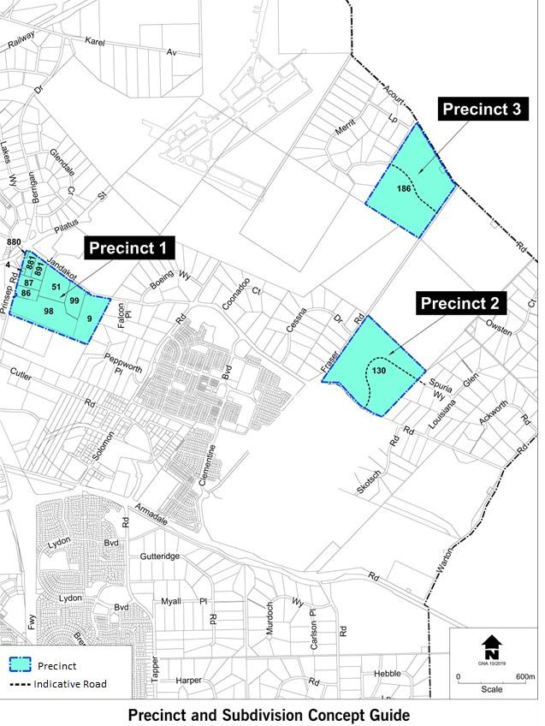

**APPENDIX 2 - RURAL SUBDIVISION GUIDE**

