Policy Type

Local Planning Policy

Policy Purpose

Building Envelopes are used in the Resource Zone to guide and contain development on a lot so that vegetation and wetlands are protected from clearing and development. They are also used for separating dwellings and buildings on lots for the purpose of achieving a high degree of amenity. Building envelope locations and shapes are determined by the developer in conjunction with the City at the time of subdivision, or by City’s Planning Officers in respect to existing lots.
Purchasers of vacant lots may sometimes wish to nominate or relocate the building envelope to better suit their development expectations.
The purpose of this policy is to provide guidance to applicants and officers in regard to the circumstances under Town Planning Scheme No. 3 (TPS 3) may be utilised to nominate or relocate or modify a building envelope.

Policy Statement

(1) A building envelope may be modified or relocated, provided that:

- The written request referred to in TPS 3 is in the form of an Application for Development Approval, accompanied by the appropriate fee and documentation;
- The area of the modified building envelope is similar in size to the original building envelope but should in any event not exceed 3000m2;
- The modified building envelope accords with the setback distances prescribed under TPS 3;
- The modified building envelope has regard to the requirement that any development contained therein has a finished floor level that is a minimum of 1.2m above the highest known water table applicable to the land;
- The modified building envelope is located to avoid or minimise vegetation removal on-site; and
- The modified building envelope has regard to the placement of a dwelling and outbuildings on a lot relative to adjoining lots and buildings contained thereon (for the purpose of maintaining separation and protection of amenity in a rural setting).

(2) A building envelope may be nominated where:

1. A building envelope does not already exist on the lot;
2. The written request referred to in TPS 3 is in the form of an Application for Development Approval, accompanied by the appropriate fee and documentation;
3. The building envelope area does not exceed 3000m²;
4. The building envelope accords with the setback distances prescribed under TPS 3. Setback measurements shall be taken at right angles to the lot boundary (example of measurements under Figure 1 below);
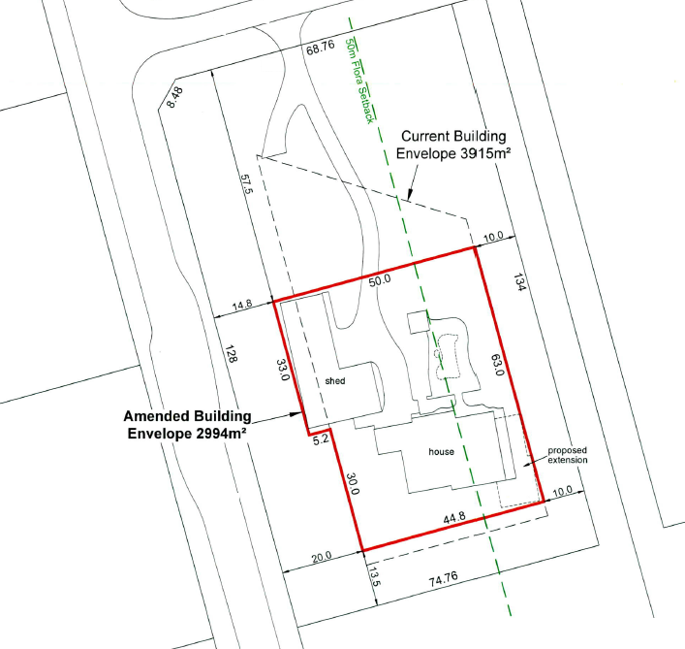
Figure 1
5. The building envelope has regard to the requirement that any development contained therein has a finished floor level that is a minimum of 1.2m above the highest known water table applicable to the land;
6. The building envelope is located to avoid or minimise vegetation removal on-site;
7. The building envelope has regard to the placement of a dwelling and outbuildings on a lot relative to adjoining lots and buildings contained thereon (for the purpose of maintaining separation and protection of amenity in a rural setting);
8. The City requires the nomination of a building envelope as part of a development application in a specific location due to planning, environmental and land constraints.
9. Only one building envelope is permitted per lot.

Strategic Link: | Town Planning Scheme No. 3
Category | Planning - Town Planning & Development
Lead Business Unit: | Statutory Planning
Public Consultation:  (Yes or No) | Yes
Adoption Date:  (Governance Purpose Only) | 10 November 2022
Next Review Due:  (Governance Purpose Only) | November 2024
ECM Doc Set ID:  (Governance Purpose Only) | 4516911

