Tender Title: |  | RFT 13/2023  Consultancy Services – Design & Documentation – Specialist Engineering Disciplines (Secondary Consultant)
Request ID: |  | 47196
Tender Description: |  | The City of Cockburn (the Principal) is seeking proposals from qualified and experienced consultants (Secondary Consultancy) to provide specialist engineering consultancy services for the Proposed Cockburn Resource Recovery Park project in Wattleup, Western Australia.
Advert Approval: |  | Decision to Advertise: Chief Operations Officer  Decision Date: Thursday, 27 July 2023
Closing Date and Time: |  | 2:00PM (AWST) Tuesday, 22 August 2023
Opening Date and Time: |  | 2:00PM (AWST) Tuesday, 22 August 2023
 | Tenderer’s Name:
1 | Talis Consultants Pty Ltd (Perth Office)
2 | The Trustee for The Acor WA Unit Trust (WA Office)
3 | BPA Consultants Pty Ltd t/a BPA Engineering (Civil & Structural)
4 | Engineering Technology Consultants
5
6
7
8
9
10

Advertisement
Method 1: City of Cockburn | Method 2: Yammer
Method 3:  The Western Australian,  Saturday, 29th July 2023 | Tender Awarded by:
Copy of Statewide Notice:  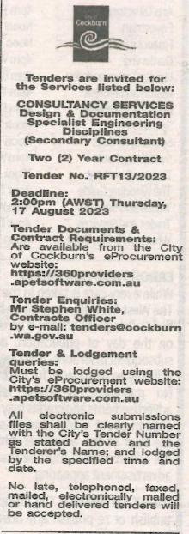 | Chief Operations Officer  A/ Chief Financial Officer  Tuesday, 19 September 2023
 | Date of Council Meeting:
 | Not applicable
Name of Successful Tenderer(s): | BPA Consultants Pty Ltd &  Engineering Technology Consultants
Amount of Successful Tender(s): (ex GST) | $123,125 (BPA)  $56,020 (ETC)

