Tender Title: |  | RFT 10/2024 – Event Management Services – Coogee Live
Request ID: |  | 50015
Tender Description: |  | The City of Cockburn (The Principal) is seeking the services of a suitably experienced Events Management Service Provider (EMSP) for the delivery of a two-day arts and cultural festival along the Cockburn Coastline in March 2025 with the possibility for extension into 2026.
Advert Approval: |  | Decision to Advertise: A/Director Community and Place  Decision Date: Wednesday, 5 June 2024
Closing Date and Time: |  | 2:00PM (AWST) Tuesday, 2 July 2024
Opening Date and Time: |  | 2:00PM (AWST) Tuesday, 2 July 2024
 | Tenderer’s Name:
1 | Amanda Ann Butler T/as Butler and Brown
2 | Premium Media Pty Ltd
3 | CMS Events T/a Campbell Management Services Pty Ltd (CMS Events)
4 | Parkdale Amber Pty Ltd
5 | Fruitbowl Productions Pty Ltd T/as Fruitbowl Productions (Events)
6 | EOG Management Group
7 | Lunar Circus Pty Ltd
8 | Big Brain Capital Pty Ltd
9
10

Advertisement
Method 1: City of Cockburn | Method 2: Yammer
Method 3:  The Western Australian, Saturday 8th June 2024 | Tender Awarded by:
Copy of Statewide Notice:  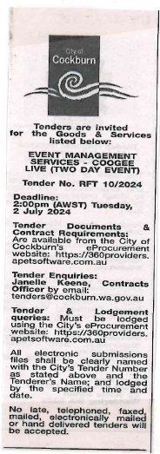 | A/Chief Executive Officer  Monday, 19 August 2024
 | Date of Council Meeting:
 | Not Applicable
Name of Successful Tenderer(s): | Amanda Ann Butler T/as Butler and Brown
Amount of Successful Tender(s): (ex GST) | Estimated Sum $410,000.00 Ex GST

