**Treeby/Jandakot**

**Development Contribution**

**Plan 15 (DCP 15)**

**Report**

**2023/24**

**Table of Contents**

Development Contribution Area 3

Purpose 3

Period of the plan 4

Operation of DCP 4

Application requirements 4

Items included in the plan 4

Estimated costs 6

Method of calculating contribution 7

Priority and timing of delivery 8

Payment of contributions 9

Review 9

Annexes 10

Annex 1 – Maps 11

Annex 2 – Cost Apportionment Schedule (CAS) 14

Annex 3 – Capital Expenditure Plan (CEP) 17

Annex 4 – Schedule of Costs 18

Annex 5 – Community Facilities Provision Analysis 22

**Treeby/Jandakot Development Contribution Plan Report**

Acknowledgement of Country

The Mayor, Councillors and staff of the City of Cockburn acknowledge the Whadjuk Nyungar people of Beeliar boodja as the traditional custodians of this land. We pay our respect to the Elders, past and present.

Note: This report does not form part of the planning scheme but provides the rationale and justification for the Development Contribution Plan (DCP), the calculation of costs, and the cost apportionment schedule specifying the costs for each owner.

# Development Contribution Area

The Development Contribution Area (DCA) is shown on the Scheme Map as: ‘DCA 15’

# Purpose

The purpose of the DCP Report is to:

1. enable the applying of infrastructure contributions for the development of new, and the upgrade of existing infrastructure which is required because of increased demand generated in the DCA
2. provide for the equitable sharing of the costs of infrastructure and administrative items between owners
3. ensure that cost contributions are reasonably required because of the subdivision and development of land in the DCA
4. coordinate the timely provision of infrastructure.

The DCP provides for the sharing of costs associated with the provision of new community infrastructure (playing field and clubrooms) within Treeby East, as identified by the City of Cockburn Community Sport and Recreation Facilities Plan (2018-2033) and the Treeby District Structure Plan (December 2017).

The DCP15 relates to new residential development within the suburbs of Treeby and Jandakot.

# Period of the plan

15 years commencing 24 November 2020 to 30 June 2036.

The plan may also be extended for further periods (with or without modification) by subsequent Scheme Amendments.

# Operation of DCP

DCP 15 has been prepared in accordance with the provisions of the City of Cockburn Town Planning Scheme No. 3 (TPS 3) and State Planning Policy 3.6 - Infrastructure Contributions (SPP 3.6). It came into effect upon the gazettal of Amendment 141 to TPS 3 on 24 November 2020.

DCP 15 operates in accordance with TPS 3 and requires landowners to make a financial contribution towards the cost of community infrastructure in Treeby East.

The requirement to contribute under DCP 15 would typically arise as a condition of subdivision approval, however it may occur through other arrangements as specified in clause 5.3.14 of TPS 3.

DCP 15 is operational in the same area as DCP 13, which also relates to community infrastructure, and DCP8 the Solomon Road Arterial Drainage System in Jandakot.

Landowners will be required to satisfy their contribution obligations under all DCPs.

# Application requirements

Where an application for subdivision, strata subdivision, development or an extension of land use is lodged which relates to land to which this plan applies, the local government shall take the provisions of the plan into account in making a recommendation on or determining that application.

# Items included in the plan

The following infrastructure items are included in the DCP as set out in Table 10 of TPS 3:

**Treeby East Playing Field**:

* The cost of land for the oval site is not included in the development contribution plan and will form part of the subdivider’s minimum 10% public open space.
* The cost of works is the cost over and above that of providing a neighbourhood park, proportioned in the same way as set out in Table 1 below.
* Constructing a multiple use playing field space capable of accommodating either:
* 1 x senior size football oval; or
* 2 x rectangular fields

Table 1 Development Contribution Plan Elements and Proportions

|  |  |  |
| --- | --- | --- |
| Playing field element | Subdivider obligation | DCP15 |
| Landscape Preliminaries | 100% |  |
| Site establishment and preliminaries | 100% |  |
| Clearing and earthworks | 66.66% | 33.33% |
| Fine grading to all soft and hard works areas |  | 100% |
| Soil treatments and grading | 66.66% | 33.33% |
| External drainage to oval | 100% |  |
| Paving and hardscape | 66.66% | 33.33% |
| Turf | 100% |  |
| Trees and shrub plantings | 100% |  |
| Lighting (paths and oval and amenity lighting) |  | 100% |
| Sports goals |  | 100% |
| Playground equipment | 100% |  |
| Picnic furniture | 100% |  |
| BBQs (2) units | 1 BBQ | 1 BBQ |
| Drinking fountain (1) | 1 |  |
| Bins (5) | 2 bins | 3 bins |
| Wooden bollards | 100% |  |
| Reticulation | 100% |  |
| Mature tree transplants |  | 100% |
| Irrigation bore and pump | 100% |  |
| Iron filtration unit (1) | 100% |  |
| Power connection | 100% |  |
| Water supply | 100% |  |
| Consolidation (12 weeks) plus 2 years maintenance period | 100% |  |

**Treeby East Clubrooms**

Is 100% of the cost of works to construct one single story clubroom building of 590m2 with a 200m2 verandahto be located on the same land as the playing field, including:

* flexible spaces to accommodate a range of potential clubs/sports
* The building shall include a standard level of finishes and amenities for a public building
* An associated car parking bays and access for 40 cars.

The City’s Community Sport and Recreation Facilities Plan (2018-2033) identifies the demand for infrastructure funded through the DCP. This calculation excludes:

* The demand for a facility that is generated by the current population in existing dwellings; and
* The proportion of costs the subdivider of the land upon which the infrastructure will be located would ordinarily be obliged to cover through subdivision conditions.

The cost of infrastructure includes all the initial capital costs associated with the provision of the infrastructure item and excludes ongoing maintenance and operating costs of the infrastructure.

Maps detailing the proposed location of the infrastructure included within this DCP are included in Location of Treeby East POS and Location of Treeby East POS on Lot 705 Armadale Road, Treeby

# Estimated costs

The DCP overall estimated cost of the infrastructure works is **$1,643,321** (as of 16 October 2023).

A detailed summary of the cost breakdown for each infrastructure item is included in Table 2 Summary Sheet and Annex 3 – Capital Expenditure Plan (CEP).

Cost estimates have been based on the best information available to the city at the time from similar projects (where an Order of Probable Costs from a Quantity Surveyor or a recently tendered cost is available) or from a specific Quantity Surveyor’s assessment or tender.

As provided for in the DCP, the cost of the infrastructure item will be reviewed at least annually. If during the year more detailed costings have been prepared, then these would be adopted in preference to broad based estimates. In all other instances the cost estimates will be adjusted to reflect current pricing and the cost indexed based on the Building Cost Index or other appropriate index as approved by an appropriately qualified independent person.

# Method of calculating contribution

All landowners within DCP 15 shall contribute to community infrastructure to support new development within the Treeby District Structure Plan area.

The area which benefits from the infrastructure items can be seen in DCA15 Scheme Map.

Contributions shall be calculated based on the number of new lots and/or dwellings created through the relevant subdivision or development application process, subject to:

* Existing dwellings on a lot or lots to be subdivided or developed will be exempt from the contribution.
* Land required for public roads, public open space, drainage, and other uses not including residential development will not be assessable in accordance with clause 5.3.9 of TPS 3.
* Where a lot may have further subdivision potential, for example as a grouped dwelling site, contributions will be sought at the next development approval stage where additional dwellings or lots are created.
* Contributions applying to development of aged or dependent persons dwellings or single bedroom dwellings shall be calculated on the number of dwelling units permitted prior to the application of the variations permissible under clause 5.1.1.C1.4. i (previously clause 5.1.3.A3.i) of State Planning Policy - Residential Design Codes.

Notwithstanding the definitions of ‘lot’ listed Schedule 1, for the purposes of calculating cost contribution liability within DCA 15, the term lot will be inclusive of green title, survey strata and built strata subdivisions.

Calculation of an owner’s contributions will be based on the number of new dwellings or lots, multiplied by the applicable contribution rate for the suburb in which the land is situated, as follows:

*Number of New Dwellings or Lots Proposed x Contribution Rate = Required Development Contributions*

The adopted contribution rate for DCP 15 Treeby is **$1,255.91** and Jandakot **$939.04** per new lot or dwelling, as outlined in Table 2 Summary Sheet .

# Priority and timing of delivery

The Treeby East (playing field and clubrooms) is a major capital works project, the priority and timing for which is determined by the following:

1. City of Cockburn Strategic Community Plan [Strategic Community Plan 2020-2030](https://www.cockburn.wa.gov.au/getattachment/6ce4d95e-356d-4a2d-855b-7c3667cecdbd/attachment.aspx)

*previously the City’s Plan for the District*

1. City of Cockburn [Long Term Financial Plan (LTFP) 2020-21 to 2029-30](https://www.cockburn.wa.gov.au/getattachment/879146af-ab7a-43d4-bd4f-5459cd98e4b0/ECM_9540447_v2_Long-Term-Financial-Plan-(LTFP)-2020-21-to-2029-30-(attachment-for-SCM-23-July-2020)-pdf.aspx)  provides a ten year view of the financial position of the City
2. City of Cockburn [Community, Sport and Recreation Facilities Plan 2018-2033](https://www.cockburn.wa.gov.au/getattachment/e45e7563-7a6c-47e0-8e96-013ab307d872/attachment.aspx)

The design planning for this project is scheduled for 2027/28, and the physical construction works are forecast to commence during the 2028/29 financial year.

Once the land is secured, the designs are completed and funding is confirmed, the construction of the project will be considered for inclusion on the City’s budget.

Details of the priority/timing can be seen in Annex 3 – Capital Expenditure Plan (CEP).

**Note:** these dates are subject to change.

# Payment of contributions

Payment of contributions are in accordance with the provisions of clause 5.3.14 of TPS 3:

5.3.14.1 The owner, with the agreement of the local government, is to pay the owner’s cost contribution by

1. cheque or cash
2. transferring to the local government or a public authority land in satisfaction of the cost contribution
3. the provision of physical infrastructure
4. some other method acceptable to the local government; or
5. Any combination of these methods.

5.3.14.2 The owner, with the agreement of the local government, may pay the owner’s cost contribution in a lump sum, by instalment or in such other manner acceptable to the local government.

5.3.14.3 Payment by an owner of the cost contribution, including a cost contribution based upon estimated costs in a manner acceptable to the local government constitutes full and final discharge of the owner’s liability under the development contribution plan and the local government shall provide certification in writing to the owner of such discharge if requested by the owner.

# Review

The plan will be reviewed five years from the date of gazettal of the local planning scheme or amendment to the local planning scheme to incorporate the plan, or earlier should the local government consider it appropriate, having regard to the rate of development in the area and the degree of development potential still existing.

The estimated infrastructure costs as shown in the Cost Apportionment Schedule (CAS) will be reviewed at least annually to reflect changes in funding and revenue sources and indexed based on the Building Cost Index or other appropriate index as approved by the qualified person undertaking the certification of costs.

# Annexes

1. Maps
2. Cost Apportionment Schedule (CAS)
3. Capital Expenditure Plan (CEP)
4. Schedule of Costs
5. Community Facilities Provisions Analysis

# Annex 1 – Maps

Scheme Map

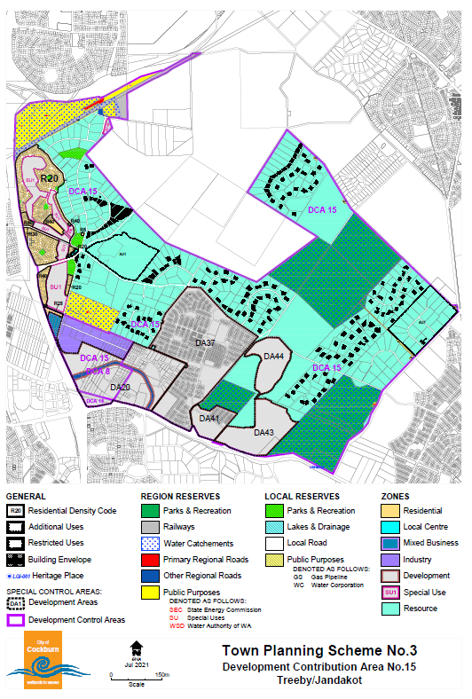

Location of Treeby East POS

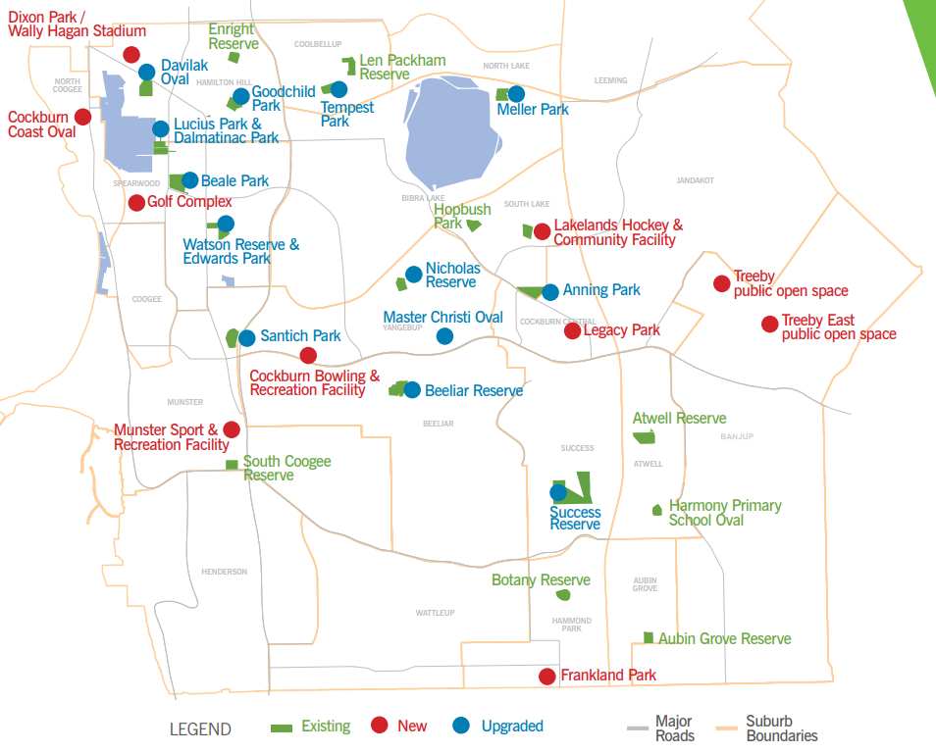

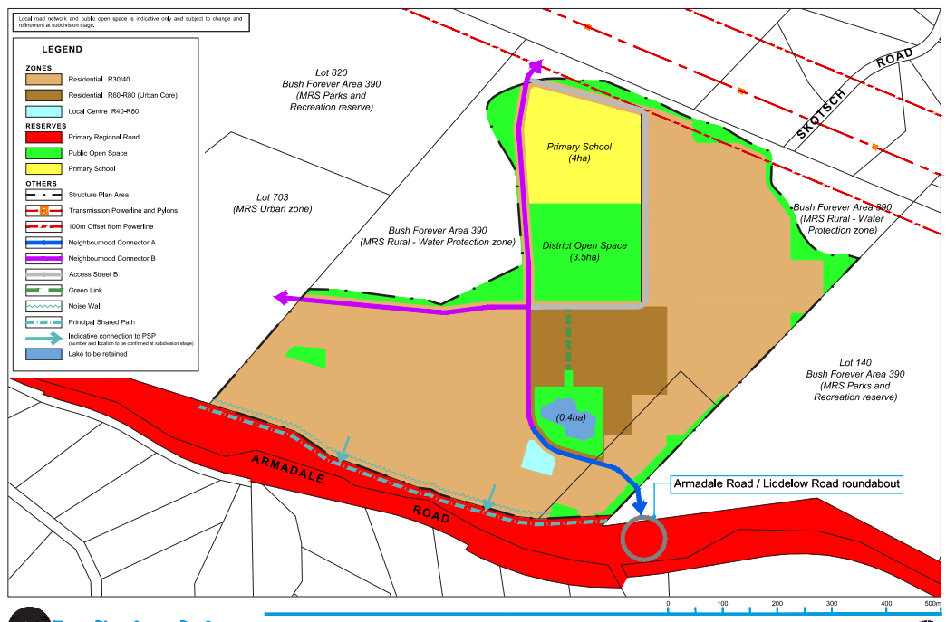

Location of Treeby East POS on Lot 705 Armadale Road, Treeby

# Annex 2 – Cost Apportionment Schedule (CAS)

Table 2 Summary Sheet

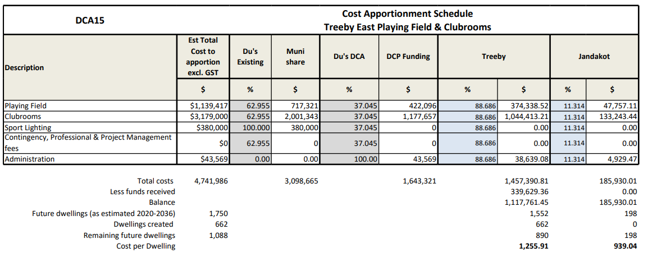

Table 3 Contribution Register

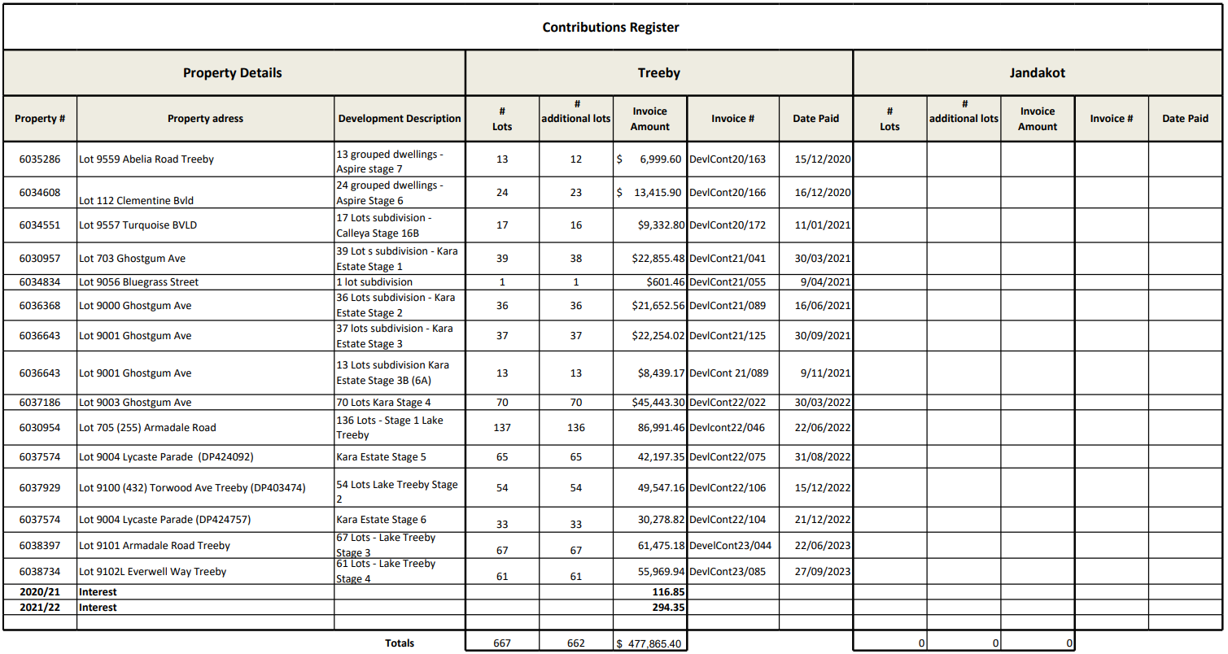

Table 4 Administration Costs

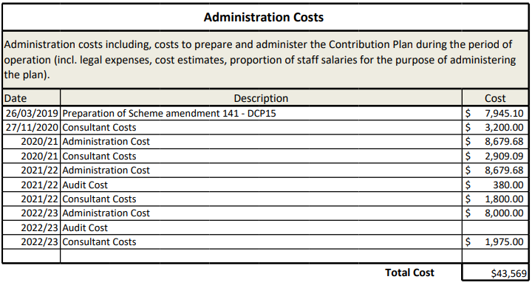

# Annex 3 – Capital Expenditure Plan (CEP)

|  |  |  |
| --- | --- | --- |
| **DCP Reserve balance as of 31/08/2023** | **\*Value of credits** | **Interest earned on DCP funds 2021/22** |
| 340,501 |  | 294 |



*note: this timeframe is subject to change*

The following recurring annual payment obligation for DCA15 is not included in table above:

* costs to administer cost sharing arrangements
* valuations, professional fees for infrastructure cost estimates
* annual audit and administration costs.

# Annex 4 – Schedule of Costs

# 

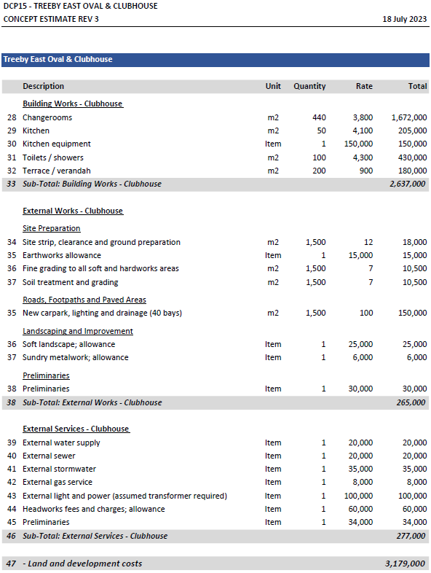

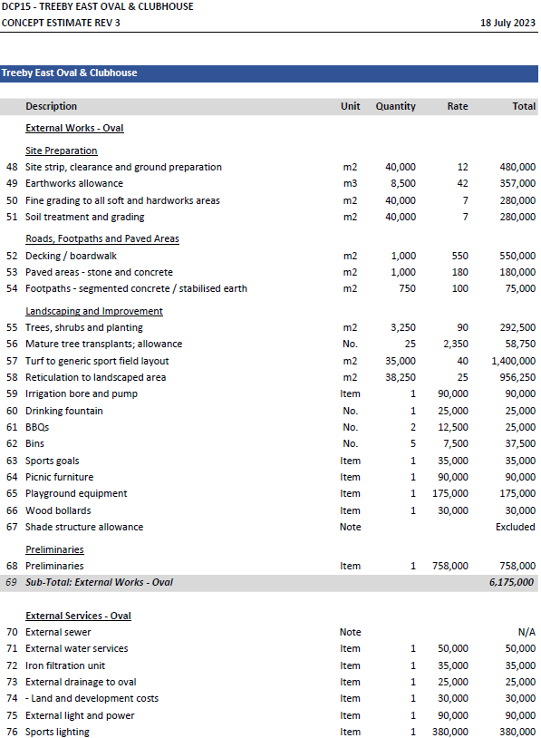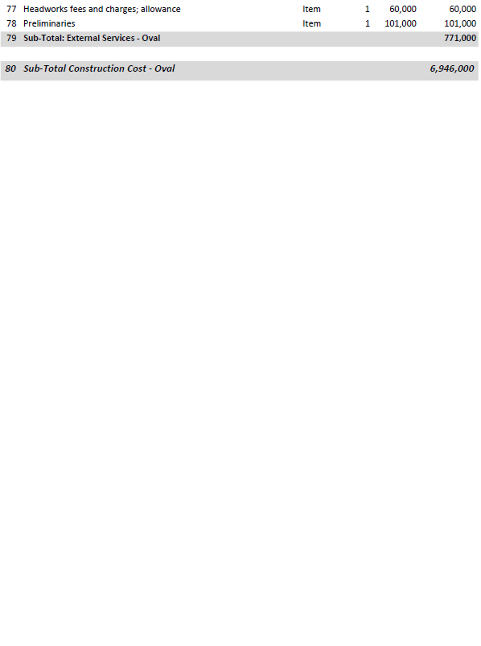

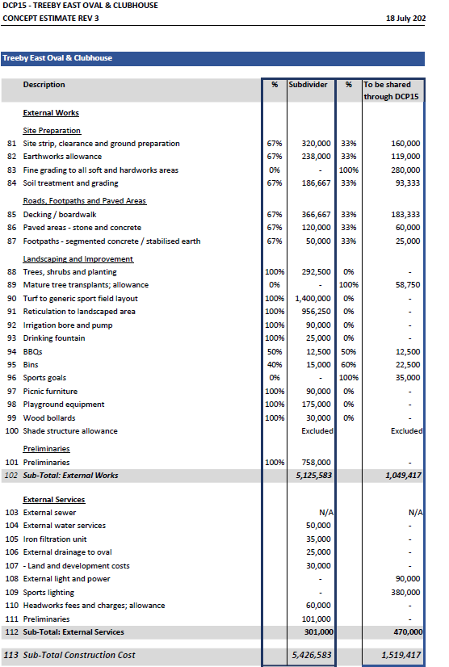

# Annex 5 – Community Facilities Provision Analysis

The below provides an overview of the application of the Community Facilities Standards of Provision against the City’s existing level of facility provision and future population forecasts.

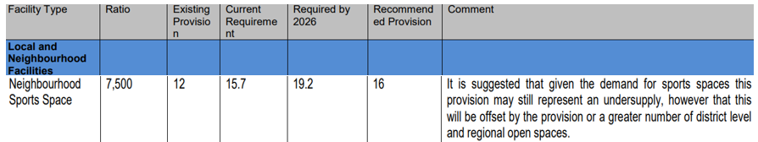This analysis has been used as a key part of the decision-making process in determining the required facilities to cater for the future growth of the Cockburn community.

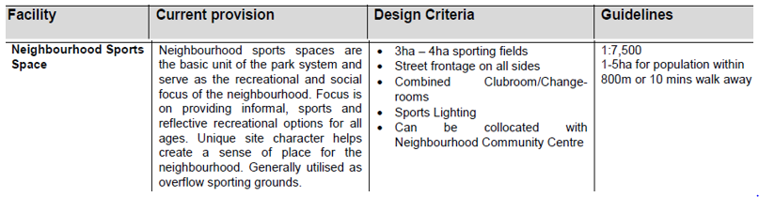Treeby East has the same catchment as the oval and facility in Treeby neighbourhoud, and is described in the Community Sport and Recreation Facilities Plan as:

It is projected the population within Treeby and Jandakot catchments to exceed 10,000 by 2036, this warrants 1 oval and clubroom.

The proportion of existing versus future dwellings in Treeby and Jandakot (as forecast until 2036) is shown below:

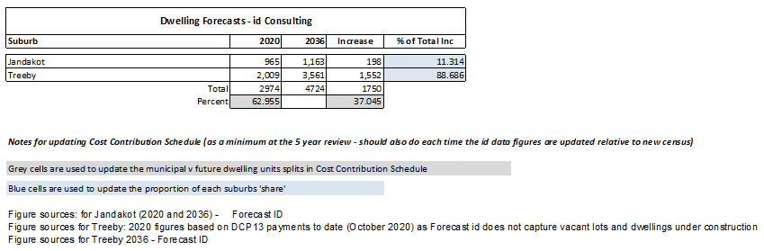

Based on the CSRFP guidelines above the area should be serviced by 3-4ha of sporting fields. The walkable catchment indicated is ambitions given some of the catchment (in Jandakot) is developed primarily as 1-2ha sized lots.

With approximately 2ha of playing field already completed within the Calleya estate to the west, the Treeby East field would round out the provision in line with the CSRFP servicing expectations.

Contact Us

**City of Cockburn**

9 Coleville Crescent, Spearwood WA 6193

PO Box 1215, Bibra Lake DC Western Australia 6965

Telephone: 08 9411 3428 Fax: 08 9411 3444

Email: [rlong@cockburn.wa.gov.au](mailto:rlong@cockburn.wa.gov.au)

[City of Cockburn website: cockburn.gov.wa.au](http://www.cockburn.gov.wa.au)

Socila media logos: Facebook, Twitter, Instagram and YouTube.