Tender Title: |  | RFT 11/2024 – Stormwater Drainage Improvements – Edeline Street and Hobley Way, Spearwood
Request ID: |  | 49976
Tender Description: |  | The City of Cockburn (Principal) is seeking the services of a suitably qualified, registered and experienced Construction Contractor to undertake stormwater drainage improvements at two drainage systems located in the suburb of Spearwood
Advert Approval: |  | Decision to Advertise: A/Director Infrastructure Services  Decision Date: Wednesday, 22 May 2024
Closing Date and Time: |  | 2:00PM (AWST) Wednesday, 19 June 2024
Opening Date and Time: |  | 2:00PM (AWST) Wednesday, 19 June 2024
 | Tenderer’s Name:
1 | Aaro Group Pty Ltd
2 | Egan Civil Pty Ltd t/as Castle Civil
3 | Civcon Civil & Project Management Pty Ltd
4 | DM Drainage & Constructions Pty Ltd t/as DM Civil
5 | Dowsing Group Pty Ltd
6 | GMF Contractors 2012 Pty Ltd
7 | Wombat Civil Pty Ltd
8
9
10
11

Advertisement
Method 1: City of Cockburn | Method 2: Yammer
Method 3:  The Western Australian, Saturday 25th May 2024 | Tender Awarded by:
Copy of Statewide Notice:  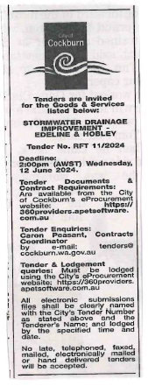 | OCM  Tuesday 10th September 2024
 | Date of Council Meeting:
Tuesday 10th September 2024
Minutes: 0184
Item No: 14.3.1
Name of Successful Tenderer(s): | Civcon Civil & Project Management Pty Ltd
Amount of Successful Tender(s): (ex GST) | $1,493,552.03 Lump Sum Amount

