**Policy**

Industrial Subdivision and Development

**Policy Number**

LPP 3.8

# Policy Type

Local Planning Policy

# Policy Purpose

(1) Provide guidance for the development of land in the City of Cockburn’s industrial and mixed business zones in an endeavour to achieve coordinated, quality development outcomes; and

(2) Support the expansion of Western Australia’s defence, marine and resource industry activities at the Australian Marine Complex (AMC) by guiding land use decisions

(3) Provide guidelines for Council recommendations to the WAPC for industrial subdivision applications with regard to minimum lot area and dimensions, fencing and access. The policy is not applicable to build strata proposals where development has already occurred on the land.

# Policy Statement

1. Scope
   1. This policy applies to all land within the following Town Planning Scheme No. 3 (TPS3) zones:
      * Strategic Industry;
      * Industry;
      * Light and Service Industry;
      * Mixed Business; and
      * Development (where an approved Structure Plan indicates the use as Industry, Light and Service Industry, Mixed Business or similar).

* 1. This policy does not apply in the following instances:
     + Where a Local Development Plan (LDP) has been adopted to guide the built form and where provisions of the LDP conflict with this policy.
     + Where there is a conflict between this policy and the ‘Cockburn

Commercial Park’ and ‘Phoenix Business Park’ Design Guidelines, those area specific design guidelines shall prevail over this policy. However, any provision of this policy that may not be included in the area specific design guidelines shall still apply (for example the Vehicle Access and Parking provisions).

1. Strategic Industry zone - Australian Marine Complex (AMC)

The strategic intent of the AMC is to provide for the national and international expansion of Western Australia’s defence, marine and resource industry activities; and to facilitate and enhance economic and diversification opportunities created by the clustering of these activities. To facilitate this, application of discretionary uses within the Strategic Industry zone shall be considered in accordance with the Precinct Map (Figure 1 - see below).

The Precinct Map contains two precincts: these are:

Precinct A

Precinct B

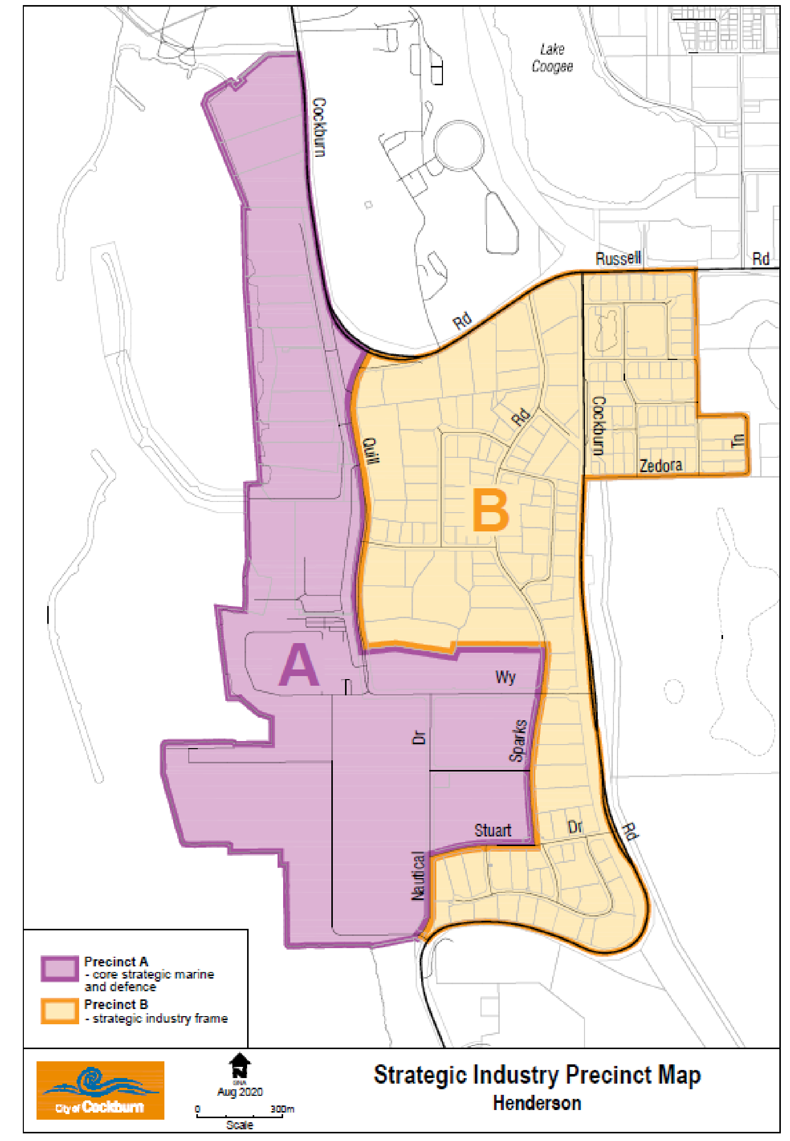

1. Precinct A

* 1. Objectives

Precinct A is located adjacent to or within proximity to the waterfront and includes mostly State owned land including the AMC Common User Facility. Land Uses are to demonstrate direct association with the objectives of the zone. In this regard, Precinct A objectives are:

To ensure that all uses are directly associated with manufacturing, fabrication, assembly, technology, repair and/or maintenance for the marine, defence and resources industries.

* + 1. To protect the ongoing functioning and viability of key strategic infrastructure, such as the Common User Facility, that support the marine, resource and defence sectors;

* + 1. To ensure safe and convenient access and movement within the precinct is maintained; and

* + 1. To create a high quality, well designed, attractive and accessible precinct that attracts investment and provides amenity for employees and visitors.

* 1. Requirements

All discretionary land uses within Precinct A should demonstrate consistency with the objectives of the precinct; and should contribute positively to the intended future character as defined in Appendix A. The following requirements also apply:

* + 1. All proposals are to be directly associated with manufacturing, fabrication, assembly, technology, repair and/or maintenance for the marine, defence and resources industries.

* + 1. All proposals must demonstrate that they support key strategic infrastructure, such as the Common User Facility; and that they assist in the support of investment attractiveness of the AMC.

* + 1. Proposals should support safe and convenient pedestrian and vehicular access, and should not compromise existing movement networks and High Wide Loads (HWL) corridors.

* 1. Supporting Information

The following information is to be provided in support of applications for development approval within Precinct A, as relevant:

* + 1. All uses are to include details demonstrating a direct relationship with the marine, resource or defence sector.

* + 1. Educational Establishments shall include evidence that the applicant holds a Registered Training Organisation Certificate for the specific purpose of maritime and oil and gas training issued by the Australian Skills Quality Authority or Training Accreditation Council of WA or other similar recognised authority together with a list of the names of the courses to be offered and a curriculum of subjects required to be undertaken within those specified courses.

1. Precinct B

* 1. Objectives

Precinct B provides for land uses associated with, and/or supporting the delivery of goods and services for the marine, resources and defence sector. In recognition of market and demand changes that will occur over time, some flexibility is provided where the strategic intent of the AMC is not compromised. In this regard Precinct B objectives are:

* + 1. To provide for land uses that support the delivery of goods and services for the marine, resources and defence sector.

* + 1. To provide some flexibility for uses that demonstrate adaptability to support delivery of goods and services for the marine, resources and defence sector in the future, where they do not compromise the strategic intent of the AMC.

* + 1. To ensure safe and convenient access and movement within the AMC;

* + 1. To ensure land uses do not compromise the ongoing delivery and operations of State and Nationally important land use activities within Precinct A;

* + 1. To create a high quality, well designed, attractive and accessible precinct that attracts investment and provides amenity for employees and visitors.

* 1. Requirements

All discretionary land uses within Precinct B should demonstrate consistency with the objectives of the precinct; and should contribute positively to the intended future character as defined in Appendix A. The following requirements also apply:

* + - * All proposals are to demonstrate that the land use proposed will not negatively impact on the strategic intent of Precinct A, or to constrain the ability of marine, resource or defence activities to function within the AMC generally.
      * Proposals must demonstrate a reasonable level of adaptability for future land uses aligned with the marine, resource or defence sector, including consideration of the built form and parking.
      * All car parking requirements are to be accommodated on-site to future-proof the precinct for its strategic purpose; provide for the safe movement of traffic; protect HWL corridors; and allow for attractive and high amenity streetscapes.
      * Proposals must not increase any existing short falls for on-site car parking for uses not directly associated with the marine, resource or defence sector.
      * To ensure future adaptability, ‘Warehouse’ land use proposals are to demonstrate there is sufficient space on-site to accommodate car parking spaces calculated at a rate of ‘Industry General’ as set out in the Scheme.
      * Proposals must contribute positively to safe and convenient pedestrian and vehicular access and connectivity.
      * In exercising discretion for uses that encourage general public access, such as a “Motor Vehicle, Boat or Caravan Sales”, consideration will be given to the following:

* + - * security risk to activities within Precinct A;
      * traffic conflicts/congestion and/or impede movement of heavy vehicle traffic servicing Precent A; and
      * ability to restrict direct access to Nautical Drive and Quill Way when alternative road frontages are available.

* + - * In exercising discretion for uses that by their nature have limited adaptability potential for specific marine, defence and resources uses, such as ‘Service Station’, consideration will be given to the following:
      * Need and demand for the use within the precinct;
      * Impact on the movement network; and
      * Contribution it makes toward the provision of amenity for the AMC workforce/visitors over and above that provided by the use itself and in addition to incidental convenience store/fast food services

* 1. Supporting Information

The following information is to be provided in support of applications for development approval within Precinct B.

* + 1. Educational Establishments shall include evidence that the applicant holds a Registered Training Organisation Certificate for the specific purpose of maritime and oil and gas training issued by the Australian Skills Quality Authority or Training Accreditation Council of WA or other similar recognised authority together with a list of the names of the courses to be offered and a curriculum of subjects required to be undertaken within those specified courses

* + 1. Change of land use applications shall demonstrate that any increase in car parking requirements can be accommodated onsite.

* + 1. Transport related uses are to be supported by a traffic study to demonstrate that access and movement can be safely accommodated within the site and on the existing road network, including access to Precinct A and impact on the HWL network.

* + 1. For uses not related to marine, defence and resources that do not demonstrate high levels of adaptability potential, such as ‘Service Station’, information and site plans are to be provided depicting the provision of features for the benefit of the AMC workforce.

(3) General Provisions

1. Land Use

* 1. For developments proposing more than one use within the same building, the building shall be provided with clear physical separation of the uses which may be achieved through a wall or other barrier to the satisfaction of the City. Delineation of uses on plan only with no physical separation will generally not be supported.

1. Built Form

* 1. Building Frontage and Entry

* + 1. The main entrance to the building is on the front elevation or close to the front of the building and should be clearly be visible, easily accessible and marked with signage.

* + 1. Entrances shall contain a covered portico, awning, canopy or verandah to further emphasise it and provide weather protection.

* + 1. Large expanses of unrelieved sections of wall or roof where seen from the primary street and (if applicable) secondary street, shall not be permitted.

* + 1. Street numbering is to be facing the primary street and to be clearly visible from the public realm as follows:

• Each number and/or letter shall be a minimum 0.2m2 in size where attached on a fence along the primary street or minimum 0.4m2 in size where on the building façade or other location.

1. Roofs

* 1. An above roof awning, creating a visual top to the building facade is to be provided where flat; skillion or similar roofs are proposed.

1. Materials, Colours and Finishes

* 1. Broad facades are to be broken down into separate sections through different materials, colours and finishes to provide interest and enhance the streetscape.

* 1. External boundary walls that are visible from the street shall be treated appropriately. This may be achieved through colour, score lines or similar. Where an adjoining site is vacant, the treatment shall be for at least half the length of the wall, measured from the portion of wall closest to the street.

* 1. Any development proposal with a construction value exceeding $500,000 shall include a set of coloured perspectives with the application.

* 1. External fixtures and equipment such as roof ventilation, exhaust towers and plumbing pipes should be effectively screened from the primary street elevation using roof structures and architectural elements.

1. Setbacks

* 1. The minimum primary street setback shall be in accordance with the following table (Table 1).

Table 1 – Setback requirements

|  |  |  |
| --- | --- | --- |
| **Primary Street Setback**  **or dual road frontage**  **(excluding secondary**  **street)** | **Secondary Street** | **Side and rear boundary** |
| 15m (may be reduced where it can be clearly demonstrated that it is consistent with the existing streetscape for land zoned outside the Strategic Industry zone). | 3m (unless it can be demonstrated that a reduced setback is consistent with the existing streetscape and/or that a reduction will not result in a detrimental impact on the streetscape). | As per the Building Code of Australia. |

1. The primary and secondary street setback areas shall not be used for any purpose other than vehicle access, car parking, loading or unloading of vehicles and landscaping.

1. The main entry and access to the building is to be obtained from the primary street frontage. (d) Where future road widening is required, the setback shall be measured from the Main Roads Western Australia Road Widening Plans.

1. Vehicle Access & Parking

(a) Car Parking

* + - * 1. Car parking provision shall be in accordance with the minimum requirements of Tables 3 and 4 of TPS 3.

* + - * 1. Any industrial use class as contained in TPS 3, containing more than one tenancy or unit, shall provide a minimum of 5 car parking bays per unit (unless TPS 3 requires more than 5 car parking bays per unit and then TPS 3 requirements shall prevail). (For example a 300m² ‘warehouse’ shall provide 5 car parking bays).

* + 1. All parking calculations shall be rounded up to the nearest number on a per unit/tenancy basis.

* + 1. Cash Payment in Lieu of Providing Car Parking Spaces contained in Clause 4.9.6 TPS 3 shall not be applied for discretionary uses.

* + 1. Joint use of car parking facilities in Clause 4.9.7 of TPS 3 shall not be applied for discretionary uses.

* + 1. Tandem car parking bays shall generally not be supported unless they are in excess of the minimum parking bay requirements of TPS 3 and this policy.

* + 1. Car parking inside an existing building will not be included in calculations for car parking provision. However, purpose-built undercover car parking will be considered.

* + 1. Car parking areas shall be designed and constructed in accordance with the most recent version of Australian Standard AS2890.1 (as amended) and the City’s relevant specifications for hardstand and drainage.

1. Bicycle Parking

(a) In addition to the requirements of TPS 3, bicycle parking facilities shall provide weather protection via an awning or similar and shall consist of rails, stands, locker or any other type of equipment designed for this purpose in accordance with Australian Standard AS2890.3-2015.

1. Service, Loading & Delivery Areas

* 1. Delivery and/or loading bays may be considered inside a building adjacent to a suitable opening however this area shall be marked, signed, easily accessible and available in perpetuity for deliveries to the building or tenancy.

1. End of Trip Facilities

* 1. All developments that are required to provide five or more bicycle parking bays in accordance with the minimum provisions of TPS 3 are required to provide End of Trip Facilities, which are to be designed in accordance with the following criteria:

* + - * A minimum of one female shower and one male shower, located in separate change rooms or a minimum of two separate unisex shower and change rooms;
      * Additional shower facilities to be provided at a rate of one female shower and one male shower for every additional 10 bicycle parking bays, to a maximum of five female and five male showers per development;
      * The showers must dispense both hot and cold water;
      * The end of trip facilities shall include non-slip surfaces, hooks and/or benches for peoples belongings, adequate lighting and ventilation;
      * The end of trip facilities should be located as close as possible to the bicycle parking facilities;
      * Secure change rooms capable of being locked; and
      * A locker for every bicycle parking bay provided.

1. Fencing

* 1. The minimum standard of fencing shall be black PVC coated chain/link mesh with black support posts and a height of 1.8m. Additional security may be provided through the provision of a maximum “3-barb” wire on top of chain/link mesh fence equivalent. All gates, posts, and fittings shall be black galvanised steel.

* 1. Fencing which exceeds the minimum standard shall complement the building and landscaping design.

1. Stormwater Management

* 1. Development shall be designed to contain all stormwater on site.

* 1. Specific drainage requirements shall be in accordance with the Building Code of Australia.

* 1. Stormwater drainage plans shall be lodged up front at the development application stage.

1. Landscaping

* 1. General

* + 1. A detailed landscape plan shall be submitted with a development application.

* + 1. The area of landscaping to be provided shall be in accordance with the requirements of TPS 3.

* + 1. Trees shall be a minimum of 2m in height (approx. 45 litre pot size at time of planting).

* + 1. Landscaping to be irrigated and maintained by landowner/occupier.

* + 1. Landscaping proposals which seek a reduction in accordance with TPS 3 shall be required to include the verge landscaping in the landscape plan.

1. Verge Improvements

* 1. Verges are to be improved in accordance with the City of Cockburn

‘Verge Improvement Guidelines’

* 1. Verge trees shall:

* + 1. Be a minimum of 2m in height (approx. 45 litre pot size at time of planting);

* + 1. Be planted on the correct utility alignment;

* + 1. be positioned to allow space for bin presentation;

* + 1. Consider tree height at maturity if under power lines; and

* + 1. Provide a shade canopy.

* 1. The verge trees shall be irrigated by the landowner/occupier until established. As the verge trees become an asset of the City’s verge, the City will be responsible for any pruning of the verge tree. The maintenance of all other forms of landscaping to the verge shall be the responsibility of the landowner /occupier.

* 1. The maintenance of shrub planting, turf or any improvement other than the trees shall be the responsibility of the landowner/occupier.

* 1. The verge shall not be used for car parking purposes unless approved by the City of Cockburn.

1. Waste Management

* 1. Every proposal shall include internal or external bin storage provisions for each tenancy or an appropriate shared bin storage area for unit developments may be permitted sized according to the waste generation rates of the on-site activities.

* 1. Internal bin storage shall be adequately sized to contain all waste bins and consist of a concrete wash-down pad of at least 2sqm graded to a

100mm diameter industrial floor waste with a hose cock, and connected to sewer.

* 1. External bin storage enclosures shall be adequately sized to contain all waste generated in one week and be a minimum of 1.8m high, fitted with a gate and graded to a 100mm diameter industrial floor waste with a hose cock, and connected to sewer.

* 1. External bin storage enclosures shall be located behind the building alignment and be screened from view of the street and roofed when greater than 20sqm.

* 1. A secondary treatment system will be required where reticulated sewerage cannot be reasonably be connected and any wash down bays required will be constructed and maintained to the satisfaction of the City.

1. Staged Development

* 1. Future stages of any development shall be considered and included on the site plan along with any necessary expansion to vehicle parking.

1. Future Road Networks

* 1. Proposals on land subject to a future road network shall ensure that provision of the future road network and vehicle access forms part of the proposal.

* 1. Proposals on land which is required for a future road network shall ensure that road reserves are ceded as part of a development application or subdivision application, whichever comes first.

* 1. Proposals incorporating road networks or as otherwise determined by the City, shall demonstrate integration with adjoining development.

1. Vehicle Crossovers

* 1. Crossovers are to be located, designed and constructed in accordance with the “*City of Cockburn Vehicle Crossover Specification and Forms*”.

(4) Subdivision

1. Where reticulated sewerage is available, the minimum recommended lot size is 1000m2, with a minimum frontage width of 25m.

a. NB: Requirements for the provision of deep sewer are determined by the WAPC on advice from the Water Corporation and Department of Health.

1. Where proposed lots have frontage to a road from which there is no access restriction, reciprocal or shared access points may be recommended. This form of access will generally be required for roads designated in Council’s Functional Road Hierarchy (date) as District Distributor B -District Distributor A, Primary Distributor or Regional Distributor (refer to attachment A).

1. Where an industrial subdivision is adjacent to a residential zone, an adequate separation distance should be provided within the industrial land. Permanent buffer strips should retain all existing vegetation or alternatively, be planted with fast growing species to provide adequate screening. Where the buffer is required for public usage, the land should be ceded free of cost for public open space. Where the land is required for buffer purposes alone, an alternative method such as a Certificate of Title restriction may be required as a subdivision condition for the purpose of protecting the buffer.

1. The Subdivider will be required to construct uniform fencing of a type deemed appropriate by the City as part of the subdivision where proposed lots back onto a road reserve or public open space reserve.

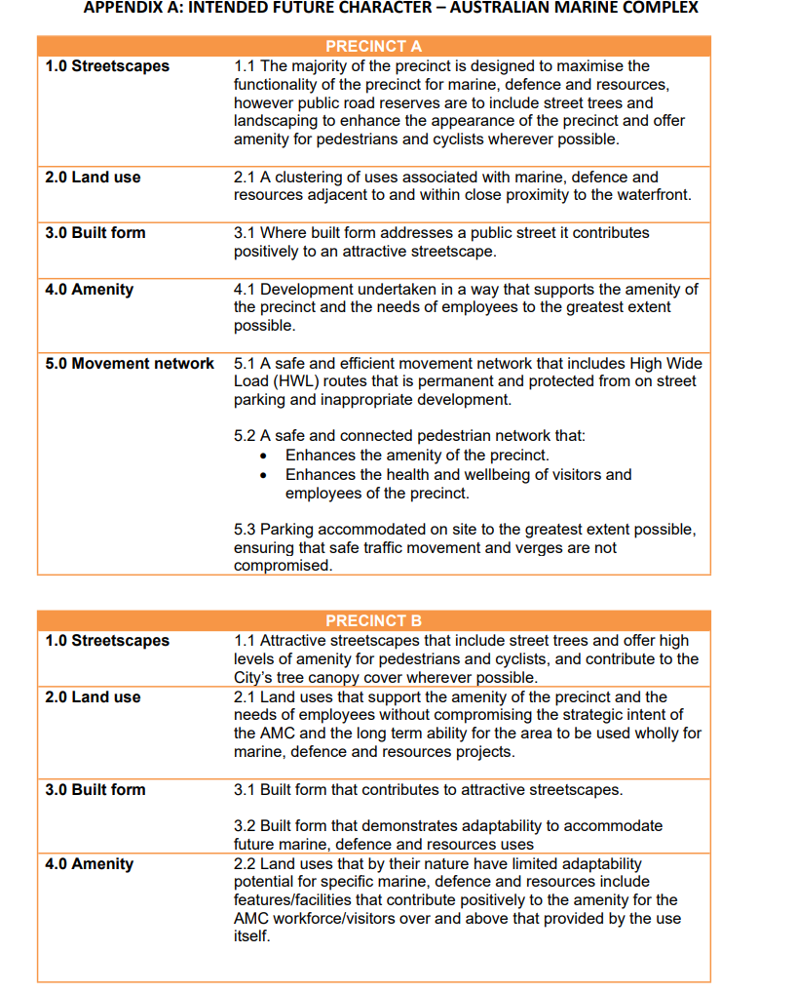

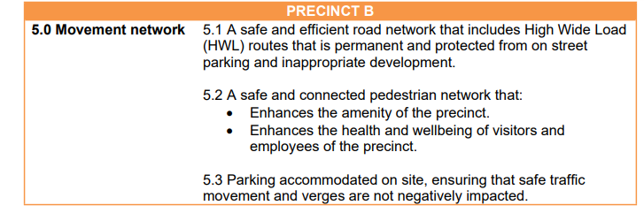

|  |  |
| --- | --- |
| Strategic Link: | Town Planning Scheme No.3 |
| Category: | Planning – Town Planning & Development |
| Lead Business Unit: | Development Services |
| Public Consultation:  (Yes or No) | Yes |
| Adoption Date:  (Governance Purpose Only) | 12 November 2024 |
| Next Review Due: (Governance Purpose Only) | November 2026 |
| ECM Doc Set ID: (Governance Purpose Only) | 4513812 |