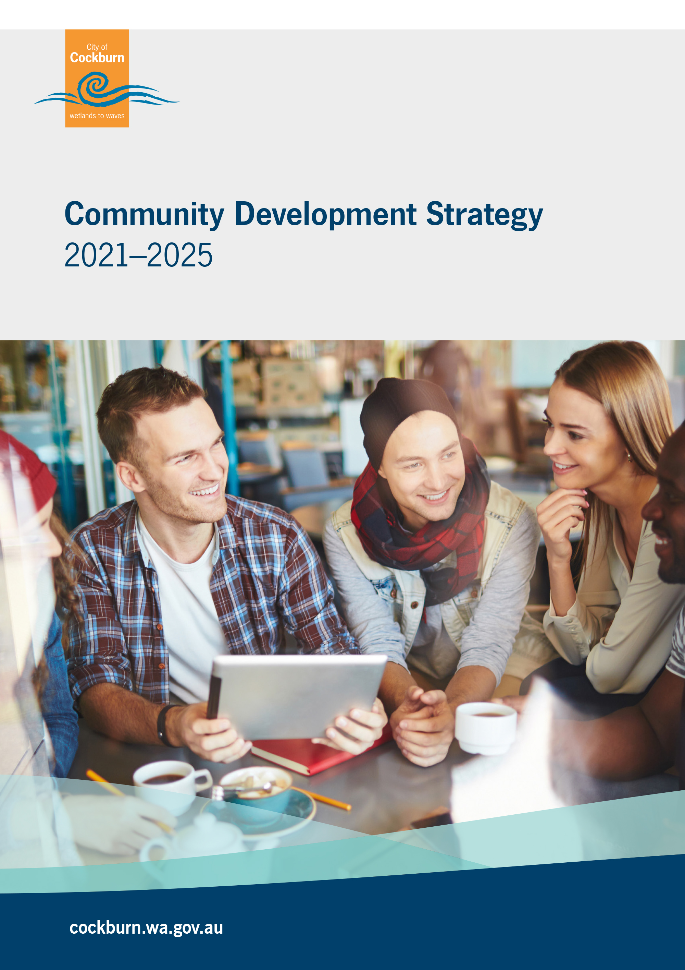

Table of Contents

Executive Summary 4
Vision 4
Purpose 4
Introduction 7
Background 8
Community Development Approach 8
Review of Achievements 10
Vision and Purpose 10
Links to the Strategic Community Plan 2020 – 2030 10
Other Informing Strategies 11
Focus Areas and Outcomes 12
Summary of Community Consultation 13
Resourcing the Plan 16
Measuring Achievement / Performance Measures 18
Reporting Format 19
Demographic Information 19
References 19
Appendices 20
Appendix 1 - Implementation Plan 20
Appendix 2 – Community Development and Volunteering Strategy Community Engagement Summary January 2021 20
Appendix 3 – Community Development Community Engagement Infographic 20
Appendix 4 – Local Government Community Development Evaluation Framework 20
Contact Us 20

Acknowledgement of Country
The Mayor, Councillors and staff of the City of Cockburn acknowledge the Whadjuk Nyungar people of Beeliar boodja as the traditional custodians of this land. We pay our respect to the Elders, past, present and emerging.

Executive Summary

The Community Development Strategy 2021–2025 sets out the strategic direction for the City of Cockburn for the next four years. The previous strategy (2016–2020) served the team and the community well, with some remarkable achievements reached over this period.
Community consultation (both face-to-face workshops and online survey), staff and Elected Member consultations took place to ascertain the goals and aspirations of the community and how the City might support and contribute to achieving these. Observations, research and analysis of City operations, emerging issues and understanding of best practice have also contributed to developing this strategy.
Overall, the strategy supports the continued ‘asset-based’ approach of community development that the team has been implementing. In addition, it continues to support the notion of ‘communities of place’ with a focus on neighbourhoods, place-activation and facilitation of grassroots community organisations. This support extends to ‘communities of interest’ whereby mutual opportunity and benefit can be achieved through collaboration with staff responsible for these areas.
This approach will achieve the overarching goals of the strategy where community development is community focused and driven, rather than service-focused, and where the understanding and practice of community development is spread more broadly throughout the City.
These goals are identified in the Strategy’s vision and purpose statements created in consultation with the community and staff:

Vision
Cockburn is a community where people feel a sense of belonging, connection and inclusiveness, and are able to create positive change in their own lives and the lives of others.

Purpose
The Community Development team will take a strengths-based approach and work together with community to generate action and positive change.

Focus areas and outcomes
This Strategy identifies four focus areas, each with their own outcomes, which will contribute to this vision and enable us to enact our purpose:

Focus Area 1
Connecting neighbourhoods – People get to know each other and are connected at a local level, creating a sense of identity, belonging, security and pride.
Focus Area 2
Working together – Fostering a strong network where people, communities and the City collaborate, share and learn.
Focus Area 3
Strengthening resilience – Ensuring communities are responsive, strong, adaptive and capable.
Focus Area 4
Building relationships - Recognising that strong relationships are the key to a healthy and thriving community

Introduction
Community Development (CD) has many definitions and approaches. The common principles are that it uses local resources to solve local problems, provides opportunities for participation and skills being transferred between people, develops self-reliance, increases the capacity of the community and ensures local ownership of projects and decisions and increases the social capital within a community.
Community Development (CD) has many definitions and approaches. However, the common principles can be listed as - community led (bottom-up); community is people in relationship; valuing wisdom, knowledge and skills at the local level; self-reliance and interdependence; common goals; do ‘with’ not ‘for’; appreciating diversity and ensuring inclusiveness.
CD is unique and complex, in simple terms community development is the bridge between the community and the City. Community Development practitioners understand, interpret and work towards achieving both the aspirations and needs of a diverse and multi-layered community and the requirements and goals of the Council. The process for this is never simple or straightforward and requires skills, abilities and attitudes including high levels of emotional intelligence along with strategic planning, systems and complexity thinking. It takes time to build the relationships that form the foundation of strong communities and appropriate resources (human, financial and physical) to do the work.
The strategy builds on previous strategies and adopts the Asset Based Community Development approach, as described in the Community Development Approach section outlined under Background.
It should be noted that this CD Strategy no longer includes volunteering objectives, due to a Council decision to create an independent Volunteer Strategy.

Background
The City of Cockburn has shown long term commitment to the importance of Community Development with strategies dating back to 2003.
Community Development Strategy 2003-2008 produced 15 suburb-based Action Plans.
Community Development Strategy 2010-2014 worked towards the development and promotion of community and business partnerships and the broadening of Community Development to include Community Engagement, and the development and implementation of the Community Engagement Framework 2014.
Local Government Reform and Restructure led to the amalgamation of the Community Development Team with the Family Services Team to form the Family and Community Development Team within the Community Development and Services strategic business unit. This change focused on both Communities of Place and Communities of Interest.
Community Development Strategy 2016-2020 set a continuation of the ‘communities of place’ approach for the Community Development team with an additional focus on building the capacity of community groups and not-for-profit organisations, which has led to an increased focus on empowerment and leadership.

Demographic Information
- Estimated population for 2021 - 117,000. Estimated population for 2025 – 135,000. Aubin Grove has the highest population density with 26.83 persons per hectare and Henderson – Munster – Wattleup the lowest with 0.12 persons per hectare.
- Aboriginal and Torres Strait Islander peoples – 1.5%
- People aged 24 years and under – 32.6%
- People aged over 65 years – 11.6%
- Median age – 35 years
- People born overseas – 40.8%
- People who did voluntary work providing assistance to a person with a disability, with a long-term illness or the aged – 9.8%
- Volunteering with an organisation or group – 15.5%
- Couples or single parents with children - 63.4%
- People needing assistance in daily lives – 3.8%
Between 2016 and 2026, the age structure forecasts for the City of Cockburn indicate the following increases:
- 25 – 34 years - 15.8%
- 35 – 49 years - 22.3%
- 50 – 59 years - 12%
- 60 – 69 years - 8.7%
- 70 – 84 years - 7.1%
- 85 and over - 1.6%

From 2016 to 2026, the population is expected to increase by a further 28,938 people, or 11,623 additional dwellings. The areas that will grow the most during this period are highlighted below (by percentage increase):
- Treeby – 405.9%
- Coogee – North Coogee – 72.5%
- Hammond Park – Wattleup – Henderson – 63.34%
- South Lake – 28.8%
- Beeliar – 27.48%

Community Development Approach
The CD Strategy proposes an Asset Based Community Development (ABCD) methodology as the informing model for the work to be undertaken over the years 2021 - 2025. This is consistent with previous and current approaches and has proven to be successful.
Asset Based Community Development is a model for sustainable community driven development. It aims to create sustainable communities through identifying the existing strengths or ‘assets’ in the community and harnessing those ‘assets’, as opposed to focusing on needs, to bring individuals and groups together to build a cohesive and connected community. From there, the collective can drive the development process – “the community is the principal actor not the client”. In this context ‘assets’ are not fixed capital, but strengths and social capital, whereby knowledge, skills, abilities, interests, time and energies (passion and commitment) or “networks, norms and trust” (Neighbourhood Transformation), are acknowledged and utilised. ABCD is based on the values of shared stories, relationship building, citizen-led, equity and justice, hope, ‘stepping back’ (institutions) and inclusivity.
The CD team remains focused on the ABCD approach and aims to continue to integrate the model across the organisation to develop a shared understanding around CD principles.

The ABCD approach can assist as it puts the focus of control much more firmly and directly at the feet of community members. This is the overarching focus of the CD Strategy is the strong emphasis on building capacity and capability within and across neighbourhoods and community organisations to undertake their own work that builds inclusion and participation. Collaboration within the organisation will also go towards further empowering the community by way of learning and understanding community development principles and applying them across workplans.
The CD approach also relies on ‘Business as Usual’ (BAU). BAU is a strength in the CD team and forms the foundation from which to grow. BAU for CD involves capacity building for community groups including residents’ associations, ongoing communication and promotion, active relationship building (meetings, informal conversations, small-scale assistance), education and training, advocacy, event planning and implementation, project development and involvement in professional development opportunities. Working concurrently with the ABCD approach the two practices build cohesion, connectedness and inclusiveness within and across neighbourhoods, suburbs and the Local Government Area more broadly.

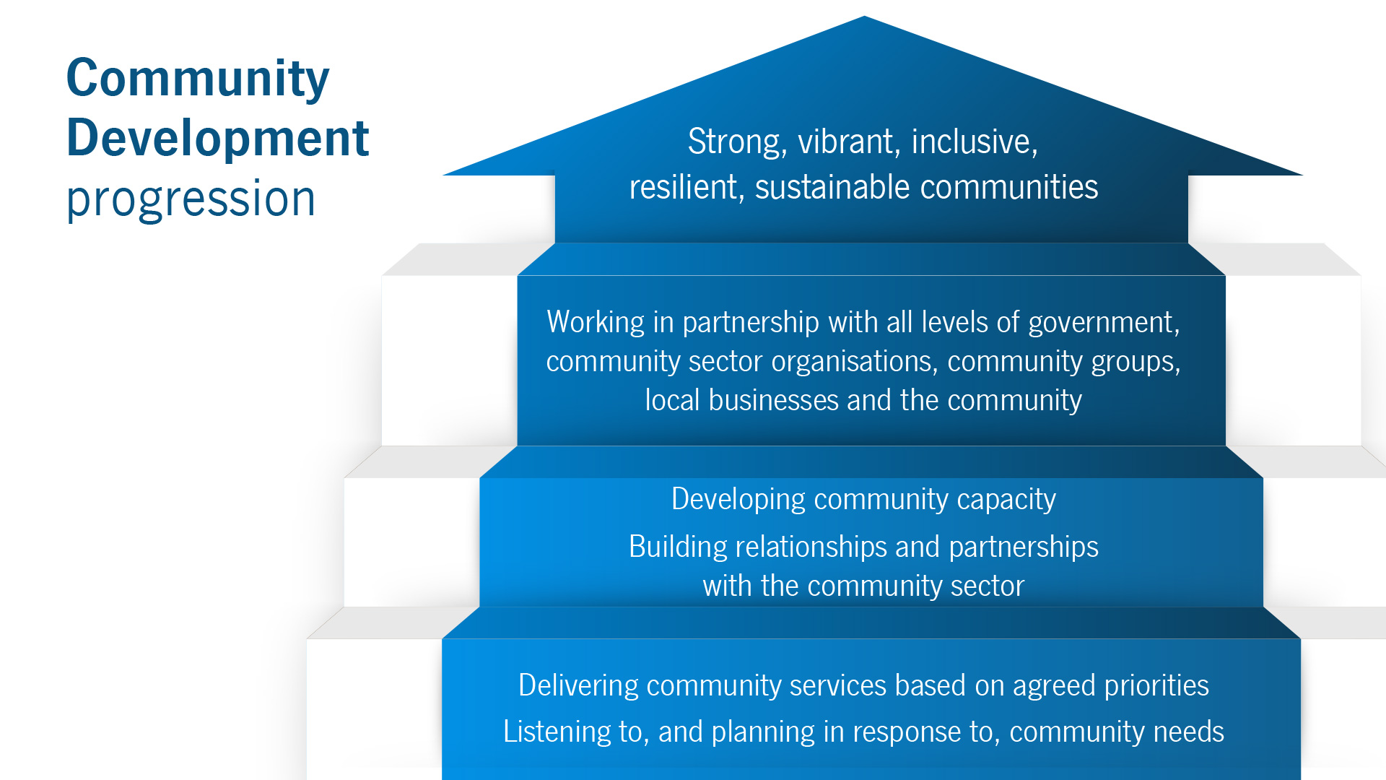

Community Development Round Table (2015) Community Development: A
Guide for Local Government Elected Members, Department of Local
Government and Communities

Review of Achievements
The CD team has achieved remarkable results in the four years since the implementation of the 2016–2020 strategy.
Key Achievements
- The team has had a strong focus on community capacity building and connectedness with new programs and training opportunities provided to community groups. These include the Neighbourhood Networker Program, leadership training, networking events, Participatory Budgeting Initiative and Conflict Resolution Open Space Forum.
- ‘Cooby Community Eats’ and ‘Yangebup Community Eats’, two community monthly gatherings that include a free meal and builds connection between individuals, religious, cultural and not-for-profit groups.
- A year-round sponsorship program for community events
- Community Engagement Advisor appointed
- Collaborative partnerships that resulted in successful projects such as the establishment of ‘The Hub 6163’, a community-run community center
- A variety of workshops delivered, including how to maintain your vehicle and building street libraries.

Vision and Purpose
Consultation with both Elected Members and members of the Cockburn Community Development Group (CCDG) developed a revised Vision and Purpose Statements as follows:

Vision
Cockburn is a community where people feel a sense of belonging, connection and inclusiveness, and are able to create positive change in their own lives and the lives of others.

Purpose
The CD team will take a strengths-based approach and work together with community to generate action and positive change.

Links to the Strategic Community Plan 2020 – 2030
The Strategic Community Plan 2020 - 2030 is the overarching strategic document that guides the City in achieving community outcomes. The Cockburn CD Strategy 2021 - 2025 supports the outcome areas of Community, Lifestyle and Security; Listening and Leading and Environmental Responsibility.
Community, Lifestyle & Security
3.1 Accessible and inclusive community, recreation and cultural services and facilities that enrich our community
3.2 A safe and healthy community that is socially connected
Listening and Leading

5.2 High quality and effective community engagement and customer service experiences

Environmental Responsibility

2.1 Protection and enhancement of our natural areas, bushland, parks and open spaces

Other Informing Strategies
The City of Cockburn has a range of other Strategies that have informed this plan including:
- Age Friendly Strategy 2016 – 2021
- Children and Families Strategy
- Community Engagement Framework 2014
- Cultural Diversity Strategy 2018 - 2021
- Disability Access and Inclusion Plan 2017-2022
- Reconciliation Action Plan 2018 – 2021
- Community, Sport and Recreation Facilities Plan 2018 -2033
- Long Term Financial Plan 2020/21 – 2029/30
- Workforce Plan 2016/17 – 2021/22
- Volunteer Strategy (in development at time of writing)
One of the key focus areas in this strategy is to increase collaboration across teams and units within the organisation to align some of the objectives outlined in the above Strategies and Plans.
Focus Areas and Outcomes
There are four focus areas in this strategy with associated outcomes and objectives. These focus areas incorporate the priorities identified in the community consultation, build on the current work of the CD team and sit alongside BAU actions. Strategies and measurements attached to these focus areas and outcomes are located in the Implementation Plan, attached as Appendix 1.
Focus Area 1
Connecting neighbourhoods – People get to know each other and are connected at a local level, creating a sense of identity, belonging, security and pride.
Outcome 1 - Newer suburbs are supported to develop neighbourhood connections.
Outcome 2 - Neighbours and neighbourhoods feel a real sense of pride, belonging and identity.
Focus Area 2

Working together – Fostering a strong network where people, communities and the City collaborate, share and learn.
Outcome 1- Adequate resources and / or assistance and accessible processes will be available for community and neighbourhood groups to network and create local events and activities.
Outcome 2 – Diverse communication methods are explored to promote Community Development programs and activities as well as inform staff and Elected Members about community development.
Outcome 3 - Internal teams will connect, share and collaborate in order to increase collective capacity.
Outcome 4 – Suitable community meeting and activity venues and spaces are created and utilised.
Focus Area 3

Strengthening resilience – Ensuring communities are responsive, strong, adaptive and capable.
Outcome 1 - Newer suburbs will be supported to develop resident groups, community organisations and events to build connection.
Outcome 2 - Communities will have opportunities to be involved in environmental protection, enhancement and create sustainable communities.
Outcome 3 - Communities will receive the training required to increase their capacity to operate effectively and be involved in decision making.
Focus Area 4
Building relationships - Recognising that strong relationships are the key to a healthy and thriving community.
Outcome 1 - Relationship building is a key focus of the Community Development team; it is recognised that this takes time and is ongoing.
Outcome 2 - Community groups, religious groups and diverse cultural groups are provided opportunities to network.

Summary of Community Consultation

Community consultation was held between 13 November 2020 and 4 January 2021. The community could have their say by:
- A survey on the Comment on Cockburn site
- Hardcopy surveys available at Cockburn libraries, administration and Seniors and Volunteer Resource Centre
- Proactive phone and email correspondence with interested volunteers and community representatives
- A workshop with representatives from resident groups, held on 30 November
- Two wider community workshops held on 24 November and 2 December 2020 and
- Feedback activities at a community volunteer sundowner event on 15 December 2020.
Promotion of the consultation included:
- Emails to a random sample of 3,000 ratepayers
- E-newsletter to 6,781 Comment on Cockburn subscribers
- Various City e-newsletters
- On the homepage of the Comment on Cockburn website
- On the homepage of the City of Cockburn website
- Social media posts
- Emails and phone calls to local resident’s groups, community groups, volunteering databases, and not-for-profit organisations
- Posters at Cockburn libraries, Seniors Centre, and Volunteer Resource Centre.
Summary of Results
A total of 238 survey responses were received and approximately 150 people attended the four community workshops. Members of the Disability Access and Inclusion Reference group were directly consulted and approximately 25 staff and 4 Elected Members participated in additional workshops and telephone consultations.The detailed summary of the online consultation is attached as Appendices 2 & 3.
Of the face-to-face community workshops included one specifically for the Cockburn Community Development Group (CCDG) and one specifically for residents in the West Ward which focused on ‘visioning’ – what the community aspired to achieve, followed by calls to action.
This community input has influenced all elements of this Strategy including the Vision and Purpose statements, Objectives and Measures, as well as the Implementation Plan.

Key Consultation Themes and Analysis
What the Community values
The community highly valued the Community Development team being ‘seen’ in the community and that they showed active participation. Personalised service and quick responses to requests and inquiries were also highly noted as well as being creative, supportive and approachable. These are vital qualities in CD practice as they identify the importance of ‘Relationship Building’ – a key focus area.
The community values the workshops, training and knowledge sharing that is provided; that there is a single point of contact for community groups at the City; assistance with grants; processes and systems are in place to provide assistance to the community and generally speaking there is good communication from the team. These values are included in BAU and the strategy focus area of ‘Working Together’.
There was also broader appreciation for the work of the City in terms of being open to ideas and the community connections that are provided.
Community Priorities
The consultation process identified the following priorities which are integrated throughout the Implementation Plan across all four focus areas of ‘Connected Neighbourhoods’, ‘Working Together’, ‘Strengthening Resilience’ and ‘Building Relationships’ and in BAU activities.
- Participation – Generally, there was a call for more ‘face to face’ connection with people; to help each other, to learn and to build respect, relationships and opportunities. People want to participate in community events, environmental protection / advocacy / clean up, community organisations and resident groups.

- Inclusion – The community wants to bring together people of diverse cultures, age groups, abilities and socio-economic means so that there was a sense that vulnerable and ‘hard to reach’ people were being cared for and that there is a shared sense of belonging.

- Local activity – Residents want neighbourhood gatherings (street parties, get to know your neighbour, informal ‘help’ etc) to build understanding and connection.

- Support for people
  - Enable and resource neighbourhoods and groups to organise events with limited ‘red tape’.
  - Environment – active involvement in planning for more ‘green spaces’, protecting the natural environment, retention of canopy, wildlife corridors, sustainability, renewable energy measures and beautification. This point was a significant change from the consultation for the 2016 – 2020 CD Strategy, where there was considerable focus on safety and security.

- Support for groups
  - Facilitate groups to network and connect with each other to build a web of community support and development from grassroots level.
  - Resource requests included financial assistance (direct or via grant writing assistance), promotion (social media, websites etc.), more workshops (at flexible times) and specific training particularly around communication governance (including conflict resolution) and recruitment plus general community advice.
  - Physical resources included access to event / meeting space, items to borrow for events and transport (e.g. trailer, bus, PPE).
  - Infrastructure resources centre predominantly around community meeting spaces. Community members emphasise that the current and planned new facilities and upgrades are not conducive to supporting grassroots community needs (more information below under Resources).
  - Communication – increase communication across multiple platforms (from digital to hard copy to face to face). Communication about what the City does and offers as well as facilitating community groups to communicate their own events and activities more broadly.

The consultation revealed that the City provides valued support and advocacy for the community. The overarching conclusion is that there is a need for more of the same, plus some additional areas that require attention such as a focus on neighbourhood development and activation (including newer suburbs), environmental participation, a stronger focus on diversity and inclusion and increased collaboration within the City to strengthen a CD approach across the organisation.

Resourcing the Plan
The City’s Long-Term Financial Plan (2020/21 -2029/30), Workforce Plan (2016/17 – 2021/22) and Community, Sport and Recreation Facilities Plan 2018 – 2033 have been considered in the following points regarding resourcing.
Staffing of Community Development within the City
The City’s CD team within the Community Development and Services Department consists of two sections; Communities of Place and Communities of Interest. There are currently three full time equivalent (FTE) Communities of Place roles; these include a full time CD Coordinator, CD Officer, Volunteer Resource Centre Coordinator and Volunteer Resource Centre Assistant. The Communities of Interest roles include an additional five and a half FTE Communities of Interest positions. The Communities of Interest positions include an Aboriginal Community Development Officers, Cultural Diversity Officer, Children’s Development Officer, Disability Access and Inclusion Officer and a Youth Development Officer. There are also a number of positions that sit within other Departments within the City that deliver elements of Community Development including Environmental Health, Family and Community Services and Libraries.
The community strongly voiced its desire to increase the capacity of the CD team by having additional staff available for support and advice.
The population in the City continues to grow. When the positions were first established in 2006 the population was approximately 78,000. The population forecast for 2025 (the end date of this strategy) is approximately 135,000 – a 73% increase. By 2030, this figure will further increase to over 148,000 – an almost 90% escalation from 2006.
Population increase means a focus on a collaborative approach, ensuring shared resources and outcomes between the Communities of Place and the Communities of Interest areas, as well as supporting, encouraging and implementing ways of working in a more cohesive way across all areas within the City delivering the varied aspects of Community Development across divisions is required.
Royal Commission into Child Sexual Abuse (Royal Commission) recommendation 6.12 that local governments should designate child safety officer positions from existing staff profiles to carry out the following functions:
- Developing child safe messages in local government venues, grounds and facilities
- Assisting local institutions to access online child safe resources
- Providing child safety information and support to local institutions on a needs basis
- Supporting local institutions to work collaboratively with key services to ensure child safe approaches are culturally safe, disability aware and appropriate for children from diverse backgrounds.
There will be impacts and resourcing requirements in the implementation of the Royal Commission recommendation and the implementation of the National Principles for Child Safe Organisations across the whole organisation and will include actions and input from Community Development.
Proposed Outcomes
The outcomes proposed in the attached Implementation Plan will require a mix of standard as well as additional operating resources.
Facilities
Community comment and consultation has identified that existing facilities and planned upgrades to existing facilities are not always meeting community needs. Although considerable consultation took place in the planning of these facilities, existing facilities and planned upgrades to existing facilities should include how we could improve community access and use the.spaces.

Measuring Achievement / Performance Measures
As noted below under Emerging Issues, current best practice for strategic planning in CD recommends ‘outcomes-based measurement’. This approach ensures that ‘collective impact’ is evaluated and reported on through both quantitative and qualitative data rather than a reductive focus of measuring and reporting on quantitative data alone (number of people attending events etc.) and completion of individual tasks (KPIs). Therefore, it is recommended that the team adopt this method, as it is presented in the Local Government Community Development Evaluation Framework, attached as Appendix 4.
Where the Evaluation Framework is not appropriate additional performance measures are noted in the attached Implementation Plan.

Reporting Format
Reporting on the Strategy will be in accordance with standard City of Cockburn practices.

References
- id profile Cockburn available https://profile.id.com.au/cockburn
- id profile Cockburn forecast available https://forecast.id.com.au/cockburn
- ABCD Institute available https://resources.depaul.edu/abcd-institute/resources/Documents/O_Essence_of_ABCD.pdf
- Measuring our Impact: Evaluation framework for measuring the impact of community development work across local government in Western Australia available https://www.lgprofessionalswa.org.au
- https://www.childabuseroyalcommission.gov.au/recommendations

Appendices

Appendix 1 - Implementation Plan

Appendix 2 – Community Development and Volunteering Strategy Community Engagement Summary January 2021

Appendix 3 – Community Development Community Engagement Infographic

Appendix 4 – Local Government Community Development Evaluation Framework

ABCD Institute, 2020 / https://resources.depaul.edu/abcd-institute/resources/Documents/O_Essence_of_ABCD.pdf
https://forecast.id.com.au/cockburn

