Tender Title: |  | RFT 25/2023  Provision of Lift Maintenance (Inspection & Repair Services)
Request ID: |  | 47505
Tender Description: |  | The City of Cockburn (the Principal) is seeking the services of a suitably qualified and experienced contractor in the field of Lift Maintenance and servicing for Passenger Lifts, lifting platforms and goods lifts throughout the City of Cockburn
Advert Approval: |  | Decision to Advertise: Chief Operations Officer  Decision Date: Monday, 18 September 2023
Closing Date and Time: |  | 2:00PM (AWST) Thursday, 12 October 2023
Opening Date and Time: |  | 2:00PM (AWST) Thursday, 12 October 2023
 | Tenderer’s Name:
1 | Schindler Lifts Australia Pty Ltd
2
3
4
5
6
7
8
9
10

Advertisement
Method 1: City of Cockburn | Method 2: Yammer
Method 3:  The Western Australian,  Wednesday, 20th September 2023 | Tender Awarded by:
Copy of Statewide Notice:  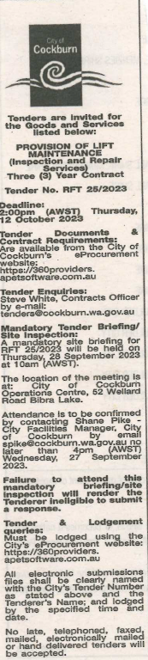 | Non-Award
 | Date of Council Meeting:
 | Not applicable
Name of Successful Tenderer(s): | Not Applicable
Amount of Successful Tender(s): (ex GST) | Not Applicable

