Tender Title: |  | RFT 26/2023  Pest Control, Termite Inspection and Treatment Services
Request ID: |  | 47489
Tender Description: |  | The City of Cockburn (The Principal) is seeking a suitably qualified and experiences Pest Control Contractor to carry out annual termite inspections and pest control services throughout the City.
Advert Approval: |  | Decision to Advertise: Chief Operations Officer  Decision Date: Friday, 22 September 2023
Closing Date and Time: |  | 2:00PM (AWST) Thursday, 12 October 2023
Opening Date and Time: |  | 2:00PM (AWST) Thursday, 12 October 2023
 | Tenderer’s Name:
1 | A.A.A Envirotechnics Pest Management
2 | Allpest WA
3 | Bug Busters
4 | Competitive Pest Control Pty Ltd
5 | Maxwell Robinson & Phelps Pest Control t/a Maxwell Robinson Phelps
6 | Rentokil Pest Control
7
8
9
10

Advertisement
Method 1: City of Cockburn | Method 2: Yammer
Method 3:  The Western Australian,  Wednesday, 27th September 2023 | Tender Awarded by:
Copy of Statewide Notice:  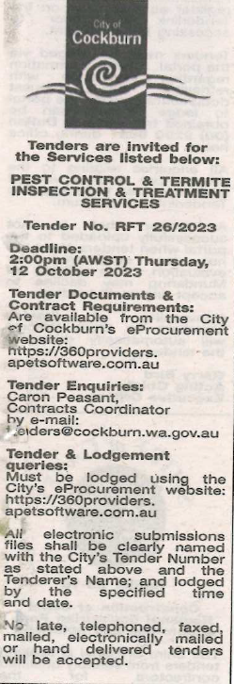 | Chief Operations Officer  Friday, 8 December 2023
 | Date of Council Meeting:
 | Not applicable
Name of Successful Tenderer(s): | The Trustee for Bugbusters Unit Trust t/a Bug Busters
Amount of Successful Tender(s): (ex GST) | $132,698 EX GST

