Tender Title: |  | RFT 21/2024 – Provision of RFID Personal Lockers (Supply, Installation and Maintenance) Cockburn Aquatic Recreation Centre (ARC)
Request ID: |  | 50949
Tender Description: |  | The City of Cockburn requires the supply, delivery and install, with ongoing servicing & maintenance of lockers at Cockburn ARC.  Due to the increased size of the facility and expected increase in patronage the additional lockers are required to meet the demand and replacement of existing lockers to ensure consistency and standardised functionality across all lockers. As a part of the Cockburn ARC expansion works the sourcing of new additional lockers are to be placed in the newly constructed areas as well as the replacement of existing lockers is required.
Advert Approval: |  | Decision to Advertise: A/Director of Community and Place  Decision Date: Wednesday, 18 September 2024
Closing Date and Time: |  | 2:00PM (AWST) Thursday, 17 October 2024
Opening Date and Time: |  | 2:00PM (AWST) Thursday, 17 October 2024
 | Tenderer’s Name:
1 | Castledex Pty Ltd
2 | Intraspace Pty Ltd
3 | Metra Australia Pty Ltd
4 | Ten3 Solutions Pty Ltd
5
6
7
8

Advertisement
Method 1: City of Cockburn | Method 2: Yammer
Method 3:  The Western Australian, Saturday 28th September 2024 | Tender Awarded by:
Copy of Statewide Notice:  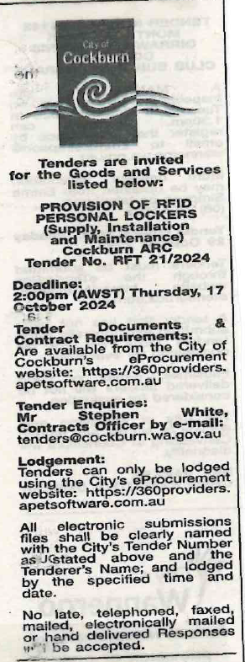 | Director of Community and Place  11th December 2024
 | Date of Council Meeting:
 | N/A
Name of Successful Tenderer(s): | Metra Australia Pty Ltd
Amount of Successful Tender(s): (ex GST) | $314,127.00 Estimated Contract Sum

