Tender Title: |  | RFT 11/2023  Construction Services – Port Coogee Marina Service Building
Request ID: |  | 47161
Tender Description: |  | The City of Cockburn (the Principal) is seeking the services of a suitably qualified, registered, and experienced Commercial Building Contractor to undertake the refurbishment of the Marina Service Building.
Advert Approval: |  | Decision to Advertise: CEO  Decision Date: Thursday, 22 June 2023
Closing Date and Time: |  | 2:00PM (AWST) Thursday, 27 July 2023
Opening Date and Time: |  | 2:00PM (AWST) Thursday, 27 July 2023
 | Tenderer’s Name:
1
2
3
4 | NO SUBMISSIONS RECEIVED
5
6
7
8
9
10

Advertisement
Method 1: City of Cockburn | Method 2: Yammer
Method 3:  The Western Australian,  Wednesday, 28th June 2023 | Tender Awarded by:
Copy of Statewide Notice:  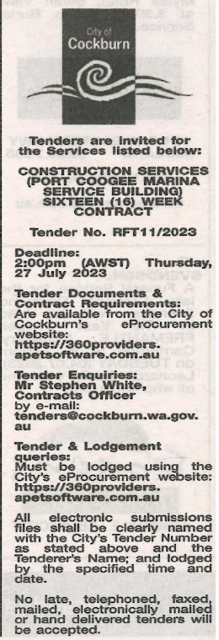 | Not applicable
 | Date of Council Meeting:
 | Not applicable
Name of Successful Tenderer(s): | N/A
Amount of Successful Tender(s): (ex GST) | Non-Award

